Supplementary Material

Quantitative Analysis of Myeloid Cell Patterns and Immunosuppressive Enzyme (IDO, ARG1) Expression in Colorectal Cancer Pulmonary Metastases and Corresponding Primary Tumours.
Authors: Topias Karjula, Hanna Elomaa, Sara A. Väyrynen, Vesa-Matti Pohjanen, Maarit Ahtiainen, Jan Böhm, Jukka-Pekka Mecklin, Erkki-Ville Wirta, Toni T. Seppälä, Eero Sihvo, Fredrik Yannopoulos, Olli Helminen, Juha P. Väyrynen

Corresponding author:
Topias Karjula
Translational Medicine Research Unit, Medical Research Center Oulu, Oulu University Hospital and University of Oulu, Oulu, Finland
ORCID: 0000-0002-2342-6034
E-mail: topias.karjula@oulu.fi

Table S1. Cut-off points for high vs. low cell densities based on receiver operating characteristics analysis (endpoint: 5-year overall survival following pulmonary metastasectomy).
Cell type | Metastasis |  | Primary tumours
Cell type | Tumour centre  Cells/mm² | Invasive margin  Cells/mm² | Tumour centre  Cells/mm² | Invasive margin  Cells/mm²
CD14⁺ | 354.1 | 467.36 | 210.59 | 243.83
CD14⁺HLA-DR⁺ | 221.92 | 433.83 | 201.14 | 340.36
CD14⁺HLA-DR⁻ | 57.97 | 30.9 | 15.88 | 33.49
CD14⁺IDO⁺ | 1.41 | 2.38 | 0.53 | 0.69
CD14⁺IDO⁻ | 348.1 | 465.12 | 208.41 | 243.83
CD14⁺FCGR3⁺ | 205.63 | 260.24 | 65.11 | 72.85
CD14⁺FCGR3⁻ | 113.94 | 136.11 | 173.08 | 177.99
CD14⁺HLA-DR⁺IDO⁺ | 1.41 | 2.38 | 0.53 | 0.69
CD14⁺HLA-DR⁺IDO⁻ | 196.85 | 431.58 | 200.03 | 340.36
CD14⁺HLA-DR⁻IDO⁺ | 0.42 | 0.37 | 0.41 | 0.59
CD14⁺HLA-DR⁻IDO⁻ | 57.97 | 30.9 | 15.88 | 33.49
CD14⁺FCGR3⁺IDO⁺ | 0.59 | 1.97 | 1.01 | 1.26
CD14⁺FCGR3⁻IDO⁺ | 0.82 | 0.91 | 0.52 | 0.69
CEACAM8⁺ | 131.58 | 155.18 | 41.41 | 23.16
CEACAM8⁺FCGR3⁺ | 36.21 | 58.35 | 12.6 | 8.35
CEACAM8⁺FCGR3⁻ | 50.32 | 33.29 | 22.9 | 14.63
CEACAM8⁺HLA-DR⁺ | 16.46 | 29.8 | 4.81 | 16.21
CEACAM8⁺HLA-DR⁻ | 80.91 | 118.77 | 36.34 | 21.61
CEACAM8⁺ARG1⁺ | 35.01 | 76.01 | 35.34 | 14.41
CEACAM8⁺ARG1⁻ | 50.04 | 41.43 | 10.3 | 18.51
CEACAM8⁺FCGR3⁺ARG1⁺ | 36.92 | 45.62 | 23.4 | 5.79
CEACAM8⁺FCGR3⁺ARG1⁻ | 43.77 | 23.27 | 4.41 | 13.6
CEACAM8⁺FCGR3⁻ARG1⁺ | 12.51 | 2.63 | 1.09 | 3.54
CEACAM8⁺FCGR3⁻ARG1⁻ | 16.34 | 10.89 | 10.75 | 8.82
TPSAB1⁺ | 58.35 | 144.11 | 53.02 | 55.8

Table S2. Cell densities of main cell linages in the tumour centre and the invasive margin.
 |  | Location
 | Characteristic | Tumour centre  Cells/mm² MD (IQR) | Invasive margin  Cells/mm² MD (IQR) | p-value¹
Metastases | Monocytic cells
Metastases | Intraepithelial | 64.8 (24–149) | 91.9 (44–239) | 0.001
Metastases | Stromal | 526.9 (354–729) | 623.4 (350–980) | 0.120
Metastases | Overall | 320.3 (184–452) | 387.2 (216–675) | 0.020
Metastases | Granulocytes
Metastases | Intraepithelial | 124.9 (15–420) | 64.6 (25–304) | 0.580
Metastases | Stromal | 141.6 (53–549) | 153.1 (68–324) | 0.120
Metastases | Overall | 131.6 (43–552) | 123.3 (44–310) | 0.160
Metastases | Mast cells
Metastases | Intraepithelial | 12 (4–51) | 47.4 (16–91) | <0.0001
Metastases | Stromal | 110.3 (67–291) | 226.9 (143–365) | <0.001
Metastases | Overall | 67.8 (38–156) | 145.7 (87–262) | <0.0001
Primary tumours | Monocytic cells
Primary tumours | Intraepithelial | 28.9 (8–66) | 14.4 (6–85) | 0.760
Primary tumours | Stromal | 307.8 (164–523) | 433.7 (156–863) | 0.380
Primary tumours | Overall | 192.6 (90–338) | 349.4 (96–684) | 0.030
Primary tumours | Granulocytes
Primary tumours | Intraepithelial | 15.7 (3–77) | 24.9 (0–83) | 0.056
Primary tumours | Stromal | 53.2 (15–164) | 45.6 (16–233) | 0.060
Primary tumours | Overall | 40.3 (11–108) | 37.8 (11–203) | 0.170
Primary tumours | Mast cells
Primary tumours | Intraepithelial | 0.4 (0–7) | 0.0 (0–5) | 0.520
Primary tumours | Stromal | 98.2 (46–180) | 62.4 (41–99) | 0.120
Primary tumours | Overall | 51 (29–126) | 44.9 (21–90) | 0.770
¹Wilcoxon summed rank test
Table S3. IDO and ARG1 expression comparing myeloid densities in the tumour centre and the invasive margin.
 |  | Location
 | Characteristic | Tumour centre  Cells/mm² MD (IQR) | Invasive margin  Cells/mm² MD (IQR) | p-value¹
Metastases | Monocytic cells
Metastases | HLA–DR⁺IDO⁺ monocytic cells | 0.95 (0–3.14) | 1.27 (0–7.47) | 0.026
Metastases | HLA–DR⁻IDO⁺ monocytic cells | 0 (0–0.51)² | 0.40 (0–0.87)² | 0.167
Metastases | FCGR3⁺IDO⁺ monocytic cells | 0 (0–2.09) | 1.07 (0–6.3) | 0.020
Metastases | FCGR3⁻IDO⁺ monocytic cells | 0.42 (0–1.15) | 0.53 (0–1.51) | 0.292
Metastases | Granulocytes
Metastases | FCGR3⁺ARG1⁺ granulocytes | 40.11 (9.26–227.75) | 45.58 (17.24–157.59) | 0.824
Metastases | FCGR3⁻ARG1⁺ granulocytes | 8.95 (1.56–68.44) | 8.41 (1.04–42.21) | 0.086
Primary tumours | Monocytic cells
Primary tumours | HLA–DR⁺IDO⁺ monocytic cells | 0 (0–2.09) | 0 (0–0.69) | 0.282
Primary tumours | HLA–DR⁻IDO⁺ monocytic cells | 0 (0–0.45)² | 0 (0–0.00)² | 0.554
Primary tumours | FCGR3⁺IDO⁺ monocytic cells | 0 (0–1.36) | 0 (0–0.45) | 0.346
Primary tumours | FCGR3⁻IDO⁺ monocytic cells | 0 (0–0.54) | 0 (0–0.44) | 0.348
Primary tumours | Granulocytes
Primary tumours | FCGR3⁺ARG1⁺ granulocytes | 12.13 (2.03–48) | 7.20 (2.69–37.41) | 0.265
Primary tumours | FCGR3⁻ARG1⁺ granulocytes | 2.47 (0–16.88) | 2.38 (0–15.46) | 0.888
¹Wilcoxon summed rank test
²80th (70th−90th) percentiles are presented due to minimal expression of biomarker combination.

Table S4. Myeloid cell densities and IDO/ARG1 expression in metastases and primary tumours stratified by neoadjuvant treatment.
 | Metastases |  |  | Primary tumours
 | Neoadjuvant therapy |  |  | Neoadjuvant therapy
 | No  Cells/mm² (MD; IQR) | Yes  Cells/mm² (MD; IQR) | p |  | No  Cells/mm² (MD; IQR) | Yes  Cells/mm² (MD; IQR) | p-value¹
Tumour centre
Monocytic cell density | 337.8 (167.7–483.5) | 277.3 (203–439.3) | 0.76 |  | 212.7 (100.1–307.8) | 125.3 (82.6–350.5) | 0.45
Granulocyte density | 166.1 (48.3–482.2) | 114.7 (42–571.7) | 0.62 |  | 39.1 (10.7–105.9) | 42.4 (13.3–126.1) | 0.99
Mast cell density | 101.1 (40–155.8) | 56.9 (32.5–121.2) | 0.37 |  | 42.5 (29.2–90.8) | 88.5 (24.1–154.1) | 0.24
IDO⁺ monocytic cell density | 1.0 (0–3.1) | 0.7 (0–7.5) | 0.85 |  | 0 (0–2.5) | 0 (0–1.9) | 0.97
ARG⁺ granulocyte cell density | 97.9 (22.7–265.6) | 59.6 (14.2–509.3) | 0.73 |  | 21.7 (4.6–72.2) | 17.5 (3.1–72.1) | 0.44
Invasive margin
Monocytic cell density | 464.4 (236.7–681.7) | 319.9 (212.3–587.7) | 0.6 |  | 349.7 (141.7–692.4) | 150.4 (58.6–548.8) | 0.27
Granulocyte density | 129.2 (47.7–294.3) | 117.4 (41.5–309.1) | 0.78 |  | 45.2 (22.9–244.5) | 25.0 (7.7–73.5) | 0.11
Mast cell density | 172.6 (116.1–360.4) | 142.6 (71.6–187.6) | 0.08 |  | 45.9 (23.4–81.7) | 41.3 (19.5–105.1) | 0.88
IDO⁺ monocytic cell density | 1.2 (0–6.5) | 1.4 (0.8–9.2) | 0.33 |  | 0 (0–0.6) | 0 (0–0.7) | 0.75
ARG⁺ granulocyte cell density | 76 (28.1–211.7) | 48.7 (28.8–192.1) | 0.81 |  | 26.7 (6.6–174) | 4.2 (2.1–36.3) | 0.10
¹Wilcoxon summed rank test
Table S5. Univariable and multivariable Cox regression models for overall 5-year survival according to monocytic cell densities and CD3⁺ and CD8⁺ T-cell density based Immune cell score.
Characteristic | Cases | Events | Model 1 (univariable)  HR (95% CI) | Model 2 (multivariable)¹  HR (95% CI) | Model 3 (multivariable)²  HR (95% CI)
Monocytic cell densities
Tumour centre
Monocytic cell density
Low | 28 | 17 | 1 (referent) | 1 (referent) | 1 (referent)
High | 24 | 13 | 0.88 (0.42−1.81; p=0.719) | 1.17 (0.48−2.83; p=0.728) | 1.33 (0.53−3.32; p=0.54)
IDO⁺ monocytic cell density
Low | 32 | 24 | 1 (referent) | 1 (referent) | 1 (referent)
High | 20 | 6 | 0.23 (0.09–0.58; p=0.002) | 0.17 (0.05–0.59; p=0.005) | 0.20 (0.06–0.69; p=0.011)
IDO– monocytic cell density
Low | 29 | 17 | 1 (referent) | 1 (referent) | 1 (referent)
High | 23 | 13 | 1.02 (0.49–2.09; p=0.966) | 1.21 (0.51–2.89; p=0.666) | 1.35 (0.54–3.34; p=0.518)
HLA-DR⁺IDO⁺ monocytic cell density
Low | 32 | 24 | 1 (referent) | 1 (referent) | 1 (referent)
High | 20 | 6 | 0.23 (0.09−0.58; p=0.002) | 0.17 (0.05−0.59; p=0.005) | 0.20 (0.06−0.69; p=0.011)
HLA-DR⁻IDO⁺ monocytic cell density
Low | 45 | 27 | 1 (referent) | 1 (referent) | 1 (referent)
High | 7 | 3 | 0.59 (0.18−1.94; p=0.381) | 0.55 (0.15−2.06; p=0.375) | 0.70 (0.18−2.75; p=0.608)
FCGR3⁺IDO⁺ monocytic cell density
Low | 33 | 24 | 1 (referent) | 1 (referent) | 1 (referent)
High | 19 | 6 | 0.28 (0.11−0.69; p=0.006) | 0.24 (0.07−0.78; p=0.017) | 0.28 (0.08−0.95; p=0.042)
FCGR3⁻IDO⁺ monocytic cell density
Low | 33 | 22 | 1 (referent) | 1 (referent) | 1 (referent)
High | 19 | 8 | 0.54 (0.24−1.21; p=0.134) | 0.61 (0.24−1.56; p=0.300) | 0.76 (0.27−2.14; p=0.609)
Invasive margin
Monocytic cell density
Low | 28 | 13 | 1 (referent) | 1 (referent) | 1 (referent)
High | 22 | 15 | 2.1 (1.00−4.43; p=0.051) | 2.87 (1.10−7.50; p=0.031) | 5.43 (1.83−16.09; p=0.002)
IDO⁺ monocytic cell density
Low | 29 | 19 | 1 (referent) | 1 (referent) | 1 (referent)
High | 21 | 9 | 0.59 (0.27–1.3; p=0.19) | 1.06 (0.47−2.38; p=0.881) | 1.66 (0.47−5.86; p=0.432)
IDO– monocytic cell density
Low | 29 | 13 | 1 (referent) | 1 (referent) | 1 (referent)
High | 21 | 15 | 2.52 (1.19–5.34; p=0.016) | 4.19 (1.45–12.05; p=0.008) | 5.41 (1.83–16.0; p=0.002)
HLA-DR⁺IDO⁺ monocytic cell density
Low | 29 | 19 | 1 (referent) | 1 (referent) | 1 (referent)
High | 21 | 9 | 0.59 (0.27−1.3; p=0.19) | 0.99 (0.44−2.21; p=0.978) | 1.66 (0.47−5.86; p=0.432)
HLA-DR⁻IDO⁺ monocytic cell density
Low | 39 | 20 | 1 (referent) | 1 (referent) | 1 (referent)
High | 11 | 8 | 1.80 (0.79−4.09; p=0.163) | 5.60 (1.70−18.48; p=0.005) | 26.37 (4.95−140.42; p<0.001)
FCGR3⁺IDO⁺ monocytic cell density
Low | 31 | 19 | 1 (referent) | 1 (referent) | 1 (referent)
High | 19 | 9 | 0.72 (0.32−1.59; p=0.417) | 2.03 (0.9−4.57; p=0.087) | 3.91 (0.97−15.76; p=0.056)
FCGR3⁻IDO⁺ monocytic cell density
Low | 30 | 19 | 1 (referent) | 1 (referent) | 1 (referent)
High | 20 | 9 | 0.70 (0.32−1.54; p=0.374) | 0.99 (0.44−2.22; p=0.976) | 1.29 (0.44−3.78; p=0.645)
Immune cell score (CD3⁺, CD8⁺ T-cells)
Low | 10 | 9 | 1 (referent) | 1 (referent) | -
Intermediate | 36 | 22 | 0.44 (0.20–0.95; p=0.038) | 0.40 (0.16–0.98; p=0.044) | -
High | 16 | 7 | 0.32 (0.12–0.87; p=0.026) | 0.30 (0.09–0.96; p=0.042) | -
¹Model 2: adjusted for clinical prognostic factors: age (continuous variable), sex (male/female), RCSCC (1/2/≥3), neoadjuvant (no/yes), synchronicity (synchronous/metachronous), laterality (unilateral/bilateral), size of largest metastasis (continuous), former liver metastases (no/yes), adjuvant therapy (no/yes), 10-year interval (2000-2010/2011-2020).
²Model 3: adjusted for clinical prognostic factors and CD3⁺, CD8⁺ T-cell density based Immune cell score.

Table S6. Univariable and multivariable Cox regression models for overall 5-year survival according to CEACAM8⁺ granulocyte densities and CD3⁺ and CD8⁺ T-cell density based Immune cell score.
Characteristic | Cases | Events | Model 1 (univariable)  HR (95% CI) | Model 2 (multivariable)¹  HR (95% CI) | Model 3 (multivariable)²  HR (95% CI)
Granulocyte densities
Tumour centre
Granulocyte density
Low | 27 | 14 | 1 (referent) | 1 (referent) | 1 (referent)
High | 25 | 16 | 1.74 (0.85–3.58; p=0.13) | 1.7 (0.67–4.31; p=0.262) | 1.67 (0.66–4.22; p=0.275)
ARG1⁺ granulocyte density
Low | 21 | 11 | 1 (referent) | 1 (referent) | 1 (referent)
High | 31 | 19 | 1.58 (0.75–3.35; p=0.225) | 2.31 (0.89–5.96; p=0.082) | 2.30 (0.89–5.96; p=0.087)
ARG1– granulocyte density
Low | 26 | 13 | 1 (referent) | 1 (referent) | 1 (referent)
High | 26 | 17 | 1.45 (0.70–3.00; p=0.317) | 1.58 (0.69–3.67; p=0.281) | 1.52 (0.59–3.92; p=0.382)
FCGR3⁺ neutrophil density
Low | 18 | 8 | 1 (referent) | 1 (referent) | 1 (referent)
High | 34 | 22 | 1.9 (0.85–4.29; p=0.12) | 2.24 (0.87–5.76; p=0.094) | 2.56 (0.92–7.10; p=0.072)
FCGR3⁺ARG1⁺ neutrophil density
Low | 25 | 13 | 1 (referent) | 1 (referent) | 1 (referent)
High | 27 | 17 | 1.69 (0.82–3.49; p=0.156) | 2.07 (0.80–5.32; p=0.132) | 2.03 (0.79–5.24; p=0.144)
FCGR3–ARG1⁺ granulocyte density
Low | 30 | 18 | 1 (referent) | 1 (referent) | 1 (referent)
High | 22 | 12 | 1.28 (0.61–2.67; p=0.511) | 1.98 (0.82–4.79; p=0.13) | 2.68 (1.05–6.86; p=0.039)
Invasive margin
Granulocyte density
Low | 30 | 19 | 1 (referent) | 1 (referent) | 1 (referent)
High | 20 | 9 | 0.70 (0.32–1.56; p=0.384) | 0.79 (0.29–2.19; p=0.657) | 0.82 (0.30–2.26; p=0.696)
ARG1⁺ granulocyte density
Low | 27 | 17 | 1 (referent) | 1 (referent) | 1 (referent)
High | 23 | 11 | 0.88 (0.41–1.88; p=0.74) | 1.09 (0.50–2.35; p=0.831) | 1.01 (0.38–2.64; p=0.989)
ARG1– granulocyte density
Low | 27 | 18 | 1 (referent) | 1 (referent) | 1 (referent)
High | 23 | 10 | 0.61 (0.28–1.33; p=0.213) | 0.54 (0.21–1.40; p=0.206) | 0.57 (0.22–1.47; p=0.243)
FCGR3⁺ neutrophil density
Low | 23 | 16 | 1 (referent) | 1 (referent) | 1 (referent)
High | 27 | 12 | 0.59 (0.28–1.25; p=0.17) | 0.69 (0.27–1.76; p=0.437) | 0.77 (0.29–2.02; p=0.596)
FCGR3⁺ARG1⁺ neutrophil density
Low | 27 | 18 | 1 (referent) | 1 (referent) | 1 (referent)
High | 23 | 10 | 0.69 (0.32–1.5; p=0.347) | 0.87 (0.32–2.39; p=0.793) | 0.92 (0.33–2.55; p=0.873)
FCGR3⁻ARG1⁺ granulocyte density
Low | 21 | 13 | 1 (referent) | 1 (referent) | 1 (referent)
High | 29 | 15 | 1.00 (0.47–2.13; p=0.991) | 1.19 (0.55–2.57; p=0.664) | 1.14 (0.44–2.97; p=0.782)
Immune cell score (CD3+, CD8+)
Low | 10 | 9 | 1 (referent) | 1 (referent) | -
Intermediate | 36 | 22 | 0.44 (0.20–0.95; p=0.038) | 0.40 (0.16–0.98; p=0.044) | -
High | 16 | 7 | 0.32 (0.12–0.87; p=0.026) | 0.30 (0.09–0.96; p=0.042) | -
¹Model 2: adjusted for clinical prognostic factors: age (continuous variable), sex (male/female), RCSCC (1/2/≥3), neoadjuvant (no/yes), synchronicity (synchronous/metachronous), laterality (unilateral/bilateral), size of largest metastasis (continuous), former liver metastases (no/yes), adjuvant therapy (no/yes), 10-year interval (2000-2010/2011-2020).
²Model 3: adjusted for clinical prognostic factors and CD3⁺, CD8⁺ T-cell density based Immune cell score.

Table S7. Univariable and multivariable Cox regression models for overall 5-year survival according to monocytic cell densities and CD3⁺ and CD8⁺ T-cell density based Immune cell score in patients without preoperative neoadjuvant treatment.
Characteristic | Cases | Events | Model 1 (univariable)  HR (95% CI) | Model 2 (multivariable)¹  HR (95% CI)
Monocytic cell densities
Tumour centre
Monocytic cell density
Low | 18 | 11 | 1 (referent) | 1 (referent)
High | 14 | 8 | 0.88 (0.35−2.19; p=0.786) | 2.6 (0.53−12.76; p=0.240)
IDO⁺ monocytic cell density
Low | 20 | 14 | 1 (referent) | 1 (referent)
High | 12 | 5 | 0.32 (0.11−0.92; p=0.034) | 0.22 (0.04−1.23; p=0.085)
IDO– monocytic cell density
Low | 15 | 8 | 1 (referent) | 1 (referent)
High | 17 | 11 | 1.09 (0.44−2.72; p=0.850) | 2.64 (0.54−12.81; p=0.229)
HLA-DR⁺IDO⁺ monocytic cell density
Low | 20 | 14 | 1 (referent) | 1 (referent)
High | 12 | 5 | 0.32 (0.11−0.92; p=0.034) | 0.22 (0.04−1.23; p=0.085)
HLA-DR⁻IDO⁺ monocytic cell density
Low | 27 | 16 | 1 (referent) | 1 (referent)
High | 5 | 3 | 0.81 (0.24−2.78; p=0.736) | 1.77 (0.32−9.88; p=0.514)
FCGR3⁺IDO⁺ monocytic cell density
Low | 21 | 14 | 1 (referent) | 1 (referent)
High | 11 | 5 | 0.41 (0.14−1.16; p=0.094) | 0.46 (0.09−2.34; p=0.347)
FCGR3⁻IDO⁺ monocytic cell density
Low | 22 | 14 | 1 (referent) | 1 (referent)
High | 10 | 5 | 0.68 (0.26−1.79; p=0.430) | 1.06 (0.27−4.11; p=0.933)
Invasive margin
Monocytic cell density
Low | 13 | 5 | 1 (referent) | 1 (referent)
High | 16 | 12 | 2.89 (1.09−7.64; p=0.033) | 10.38 (2.17−49.69; p=0.003)
IDO⁺ monocytic cell density
Low | 18 | 11 | 1 (referent) | 1 (referent)
High | 11 | 6 | 0.59 (0.22−1.59; p=0.294) | 2.41 (0.38−15.26; p=0.350)
IDO– monocytic cell density
Low | 14 | 5 | 1 (referent) | 1 (referent)
High | 15 | 12 | 3.99 (1.49−10.7; p=0.006) | 10.42 (2.28−47.57; p=0.002)
HLA-DR⁺IDO⁺ monocytic cell density
Low | 18 | 11 | 1 (referent) | 1 (referent)
High | 11 | 6 | 0.59 (0.22−1.59; p=0.294) | 2.41 (0.38−15.26; p=0.350)
HLA-DR⁻IDO⁺ monocytic cell density
Low | 23 | 12 | 1 (referent) | 1 (referent)
High | 6 | 5 | 2.11 (0.8−5.58; p=0.134) | 41.19 (2.31−735.46; p=0.011)
FCGR3⁺IDO⁺ monocytic cell density
Low | 15 | 8 | 1 (referent) | 1 (referent)
High | 14 | 9 | 0.65 (0.24−1.78; p=0.405) | 3.19 (0.46−21.96; p=0.239)
FCGR3⁻IDO⁺ monocytic cell density
Low | 14 | 9 | 1 (referent) | 1 (referent)
High | 15 | 8 | 0.73 (0.27−1.98; p=0.535) | 0.76 (0.16−3.51; p=0.721)
Immune cell score (CD3⁺, CD8⁺ T-cells)
Low | 6 | 5 | 1 (referent) | 1 (referent)
Intermediate | 21 | 13 | 0.54 (0.19−1.54; p=0.250) | 0.7 (0.17−2.96; p=0.631)
High | 12 | 7 | 0.55 (0.17−1.73; p=0.304) | 0.94 (0.2−4.31; p=0.936)
¹Model 2: adjusted for clinical prognostic factors: age (continuous variable), sex (male/female), RCSCC (1/2/≥3), synchronicity (synchronous/metachronous), laterality (unilateral/bilateral), size of largest metastasis (continuous), former liver metastases (no/yes), adjuvant therapy (no/yes), 10-year interval (2000-2010/2011-2020).

Table S8. Univariable and multivariable Cox regression models for overall 5-year survival according to CEACAM8⁺ granulocyte densities and CD3⁺ and CD8⁺ T-cell density based Immune cell score in patients without preoperative neoadjuvant treatment.
Characteristic | Cases | Events | Model 1 (univariable)  HR (95% CI) | Model 2 (multivariable)¹  HR (95% CI)
Granulocyte densities
Tumour centre
Granulocyte density
Low | 11 | 5 | 1 (referent) | 1 (referent)
High | 21 | 14 | 1.47 (0.59−3.65; p=0.403) | 3.02 (0.65−14.17; p=0.160)
ARG1⁺ granulocyte density
Low | 13 | 6 | 1 (referent) | 1 (referent)
High | 19 | 13 | 2.24 (0.84−5.94; p=0.105) | 10.95 (1.69−70.97; p=0.012)
ARG1– granulocyte density
Low | 18 | 11 | 1 (referent) | 1 (referent)
High | 14 | 8 | 1.23 (0.49−3.08; p=0.659) | 1.53 (0.4−5.79; p=0.533)
FCGR3⁺ neutrophil density
Low | 12 | 6 | 1 (referent) | 1 (referent)
High | 20 | 13 | 1.6 (0.61−4.22; p=0.344) | 3.4 (0.71−16.33; p=0.127)
FCGR3⁺ARG1⁺ neutrophil density
Low | 14 | 7 | 1 (referent) | 1 (referent)
High | 18 | 12 | 1.52 (0.61−3.81; p=0.368) | 3.92 (0.69−22.15; p=0.122)
FCGR3–ARG1⁺ granulocyte density
Low | 21 | 12 | 1 (referent) | 1 (referent)
High | 11 | 7 | 1.48 (0.59−3.7; p=0.401) | 3.42 (0.76−15.35; p=0.109)
Invasive margin
Granulocyte density
Low | 19 | 12 | 1 (referent) | 1 (referent)
High | 10 | 5 | 0.76 (0.28−2.07; p=0.594) | 1.69 (0.32−8.77; p=0.533)
ARG1⁺ granulocyte density
Low | 16 | 10 | 1 (referent) | 1 (referent)
High | 13 | 7 | 0.94 (0.36−2.47; p=0.894) | 2.92 (0.54−15.87; p=0.215)
ARG1– granulocyte density
Low | 17 | 12 | 1 (referent) | 1 (referent)
High | 12 | 5 | 0.53 (0.19−1.52; p=0.238) | 0.59 (0.12−2.94; p=0.518)
FCGR3⁺ neutrophil density
Low | 15 | 10 | 1 (referent) | 1 (referent)
High | 14 | 7 | 0.68 (0.26−1.79; p=0.433) | 1.56 (0.26−9.58; p=0.629)
FCGR3⁺ARG1⁺ neutrophil density
Low | 17 | 11 | 1 (referent) | 1 (referent)
High | 12 | 6 | 0.77 (0.29−2.03; p=0.595) | 2.18 (0.39−12.33; p=0.377)
FCGR3⁻ARG1⁺ granulocyte density
Low | 15 | 9 | 1 (referent) | 1 (referent)
High | 14 | 8 | 1.13 (0.43−2.95; p=0.807) | 6.63 (1.10−39.78; p=0.039)
Immune cell score (CD3+, CD8+)
Low | 6 | 5 | 1 (referent) | 1 (referent)
Intermediate | 21 | 13 | 0.54 (0.19−1.54; p=0.250) | 0.7 (0.17−2.96; p=0.631)
High | 12 | 7 | 0.55 (0.17−1.73; p=0.304) | 0.94 (0.2−4.31; p=0.936)
¹Model 2: adjusted for clinical prognostic factors: age (continuous variable), sex (male/female), RCSCC (1/2/≥3), synchronicity (synchronous/metachronous), laterality (unilateral/bilateral), size of largest metastasis (continuous), former liver metastases (no/yes), adjuvant therapy (no/yes), 10-year interval (2000-2010/2011-2020).

Table S9. Patient characteristics according to ARG1⁺ granulocyte densities in the tumour centre and the invasive margin of the first resected pulmonary metastases.
 | CEACAM8⁺ARG1⁺ granulocyte density  (Tumour centre) |  |  | CEACAM8⁺ARG1⁺ granulocyte density  (Invasive margin)
Characteristic | Low N = 21¹ | High N = 36¹ | p-value² | Low N = 31¹ | High N = 23¹ | p-value²
Sex |  |  | >0.999 |  |  | >0.999
Female | 10 (48%) | 17 (47%) |  | 15 (48%) | 11 (48%)
Male | 11 (52%) | 19 (53%) |  | 16 (52%) | 12 (52%)
Age | 69 (61, 75) | 68 (63, 76) | 0.9 | 69 (63, 75) | 69 (61, 74) | 0.7
RCS Comorbidity Score³ |  |  | >0.999 |  |  | >0.999
1 | 12 (57%) | 22 (61%) |  | 18 (58%) | 14 (61%)
2 | 5 (24%) | 7 (19%) |  | 8 (26%) | 6 (26%)
≥3 | 4 (19%) | 7 (19%) |  | 5 (16%) | 3 (13%)
Neoadjuvant chemotherapy |  |  | 0.6 |  |  | >0.999
No | 12 (57%) | 23 (64%) |  | 18 (58%) | 13 (57%)
Yes | 9 (43%) | 13 (36%) |  | 13 (42%) | 10 (43%)
Disease stage |  |  | 0.3 |  |  | 0.4
I-II | 11 (52%) | 11 (31%) |  | 12 (39%) | 6 (26%)
III | 7 (33%) | 16 (44%) |  | 13 (42%) | 9 (39%)
IV | 3 (14%) | 9 (25%) |  | 6 (19%) | 8 (35%)
Primary tumour location |  |  | 0.7 |  |  | 0.2
Colon | 11 (52%) | 17 (47%) |  | 12 (39%) | 13 (57%)
Rectum | 10 (48%) | 19 (53%) |  | 19 (61%) | 10 (43%)
Disease-free interval (days) | 621 (314, 1,485) | 368 (0, 763) | 0.055 | 439 (0, 1,105) | 294 (0, 762) | 0.15
Size of largest pulmonary metastasis (cm) | 1.50 (1.10, 2.30) | 2.50 (1.25, 3.55) | 0.078 | 2.00 (1.10, 3.50) | 2,50 (1,50, 3.50) | 0.6
Former liver metastases |  |  | 0.5 |  |  | 0.036
No | 13 (62%) | 19 (53%) |  | 21 (68%) | 9 (39%)
Yes | 8 (38%) | 17 (47%) |  | 10 (32%) | 14 (61%)
Synchronicity |  |  | 0.7 |  |  | >0.999
Metachronous | 18 (86%) | 28 (78%) |  | 24 (77%) | 18 (78%)
Synchronous | 3 (14%) | 8 (22%) |  | 7 (23%) | 5 (22%)
No. of pulmonary metastases |  |  | 0.5 |  |  | 0.059
1 | 11 (52%) | 24 (67%) |  | 16 (52%) | 19 (83%)
2 | 8 (38%) | 10 (28%) |  | 12 (39%) | 3 (13%)
≥3 | 2 (9.5%) | 2 (5.6%) |  | 3 (9.7%) | 1 (4.3%)
Laterality of metastases |  |  | 0.5 |  |  | 0.062
Unilateral | 16 (76%) | 30 (83%) |  | 23 (74%) | 22 (96%)
Bilateral | 5 (24%) | 6 (17%) |  | 8 (26%) | 1 (4.3%)
BRAF |  |  | 0.11 |  |  | 0.5
Mutated | 2 (11%) | 0 (0%) |  | 2 (7.1%) | 0 (0%)
Wild-type | 16 (89%) | 36 (100%) |  | 26 (93%) | 23 (100%)
Tumour regression grade |  |  | 0.4 |  |  | 0.13
Minimal regression | 18 (86%) | 34 (94%) |  | 26 (84%) | 23 (100.0%)
Moderate regression | 2 (9.5%) | 2 (5.6%) |  | 4 (13%) | 0 (0.0%)
Near complete regression | 1 (4.8%) | 0 (0.0%) |  | 1 (3.2%) | 0 (0.0%)
Complete regression | 0 (0.0%) | 0 (0.0%) |  | 0 (0.0%) | 0 (0.0%)
¹n (%); Median (Q1, Q3)
²Pearson's Chi-squared test; Wilcoxon rank sum test; Fisher's exact test
³RCS = Royal College of Surgeons

Figure S1. Examples of low and high overall IDO and ARG1 expression in TMA cores of different patients. Expression densities of overall IDO and ARG1 are (A) 97 cells/mm², 1891 cells/mm², (B) 41 cells/mm², 442 cells/mm², (C) 41 cells/mm², 421 cells/mm², and (D) 27 cells/mm², 6 cells/mm², respectively.
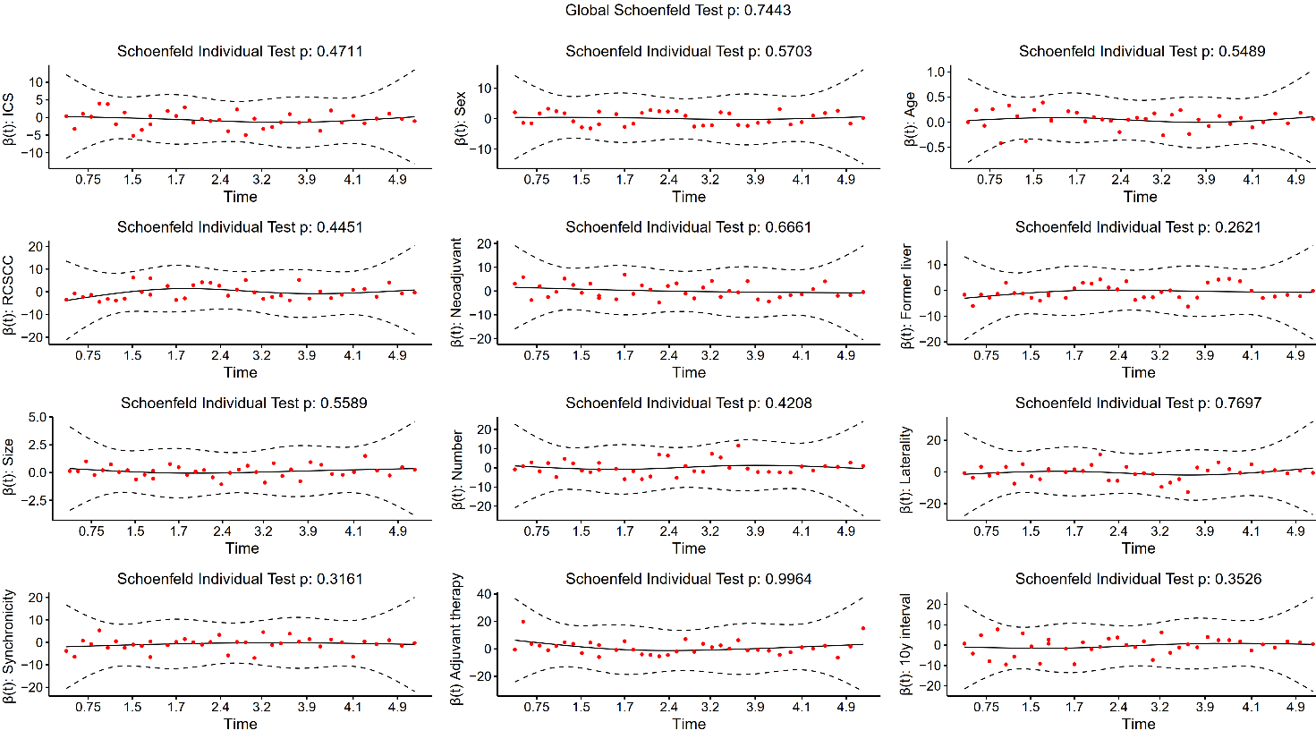
Figure S2. Schoenfeld residuals for adjusted covariables used in cox multivariable modelling.
Figure S3. Boxplots comparing monocytic cell, granulocyte, and mast cell densities between resected pulmonary metastases and corresponding primary tumours. Wilcoxon summed rank tests were applied.
Figure S4. Correlation matrix of myeloid cell densities in the tumour centre of the first resected pulmonary metastases and corresponding primary tumours. Spearman correlation coefficients were used. Statistically significant correlations are presented with asterisks. * p<0.05 ** p<0.01 *** p<0.001

Figure S5. Correlation matrix of myeloid cell densities in the invasive margin of the first resected pulmonary metastases and corresponding primary tumours. Spearman correlation coefficients were used. Statistically significant correlations are presented with asterisks. * p<0.05 ** p<0.01 *** p<0.001

Figure S6. Box plots of cell density ranges of (A) HLA-DR, FCGR3 and IDO expression in monocytic cells, and (B) IDO⁺ HLA-DR^{+/−} and FCGR3^{+/−} monocytic cell subtypes.

Figure S7. Correlation matrix of myeloid cell densities in the tumour centre (TC) and invasive margin (IM) of first resected pulmonary metastases. Spearman correlation coefficients were used. Statistically significant correlations are presented with asterisks. * p<0.05 ** p<0.01 *** p<0.001

Figure S8. Box plots cell density ranges of (A) FCGR3 and ARG1 expression in CEACAM8⁺ granulocytes and (B) ARG1⁺ FCGR3^{+/−} granulocyte subtypes.

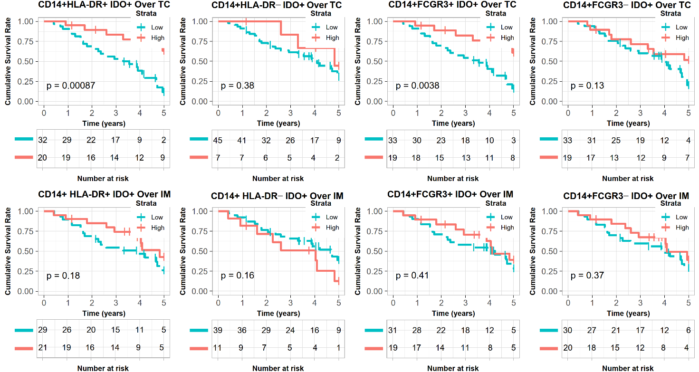
Figure S9. Kaplan–Meier overall survival curves after pulmonary metastasectomy stratified by the HLA-DR and FCGR3 expression in IDO⁺ monocytic cells. Log rank tests were applied.

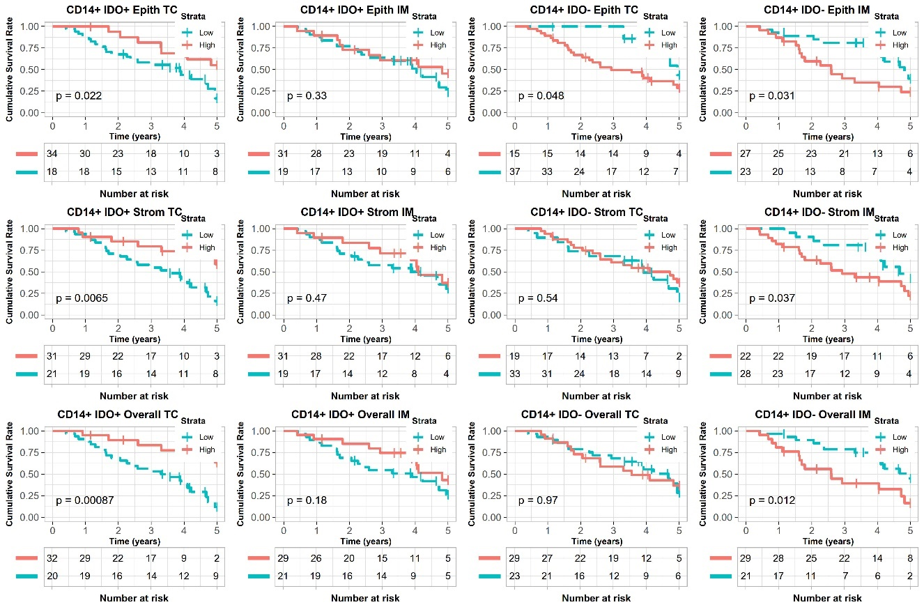
Figure S10. Kaplan–Meier survival curves of pulmonary metastasectomy patients stratified by intraepithelial, stromal and overall (intraepithelial+stromal) CD14⁺IDO⁺ and CD14⁺IDO– monocytic cell densities in the invasive margin (IM) and centre (TC) of pulmonary metastases. Log rank tests were applied.

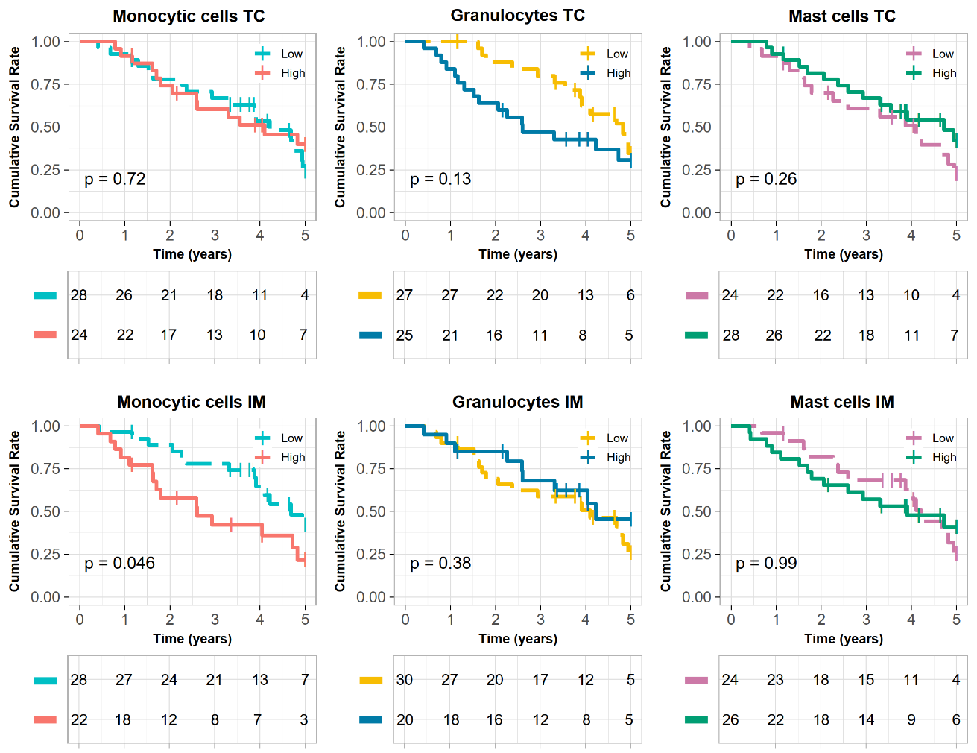
Figure S11. Kaplan–Meier 5–year overall survival curves of pulmonary metastasectomy patients stratified by overall (intraepithelial + stromal) densities of CD14⁺ monocytic cells, CEACAM8⁺ granulocyte cell densities, and mast cell densities in the invasive margin (IM) and the tumour centre (TC) of the pulmonary metastases. Log rank tests were applied.

