Supplementary material
e-Table 1 Catalogue of radiomic features
 | Shape | First-order | GLCM | GLRLM | GLSZM | GLDM
1 | Volume | 10Percentile | Autocorrelation | GrayLevelNonUniformity | GrayLevelNonUniformity | DependenceEntropy
2 | SurfaceArea | 90Percentile | ClusterProminence | GrayLevelNonUniformityNormalized | GrayLevelNonUniformityNormalized | DependenceNonUniformity
3 | SurfaceVolumeRatio | Energy | ClusterShade | GrayLevelVariance | GrayLevelVariance | DependenceNonUniformityNormalized
4 | Compactness1 | Entropy | ClusterTendency | HighGrayLevelRunEmphasis | HighGrayLevelZoneEmphasis | DependenceVariance
5 | Compactness2 | InterquartileRange | Contrast | LongRunEmphasis | LargeAreaEmphasis | GrayLevelNonUniformity
6 | Sphericity | Kurtosis | Correlation | LongRunHighGrayLevelEmphasis | LargeAreaHighGrayLevelEmphasis | GrayLevelVariance
7 | SphericalDisproportion | Maximum | DifferenceAverage | LongRunLowGrayLevelEmphasis | LargeAreaLowGrayLevelEmphasis | HighGrayLevelEmphasis
8 | Maximum3DDiameter | MAD | DifferenceEntropy | LowGrayLevelRunEmphasis | LowGrayLevelZoneEmphasis | LargeDependenceEmphasis
9 | Maximum2DDiameterSlice | Mean | DifferenceVariance | RunEntropy | SizeZoneNonUniformity | LargeDependenceHighGrayLevelEmphasis
10 | Maximum2DDiameterColumn | Median | Id | RunLengthNonUniformity | SizeZoneNonUniformityNormalized | LargeDependenceLowGrayLevelEmphasis
11 | Maximum2DDiameterRow | Minimum | Idm | RunLengthNonUniformityNormalized | SmallAreaEmphasis | LowGrayLevelEmphasis
12 | MajorAxis | Range | Idmn | RunPercentage | SmallAreaHighGrayLevelEmphasis | SmallDependenceEmphasis
13 | MinorAxis | RMAD | Idn | RunVariance | SmallAreaLowGrayLevelEmphasis | SmallDependenceHighGrayLevelEmphasis
14 | LeastAxis | RootMeanSquared | Imc1 | ShortRunEmphasis | ZoneEntropy | SmallDependenceLowGrayLevelEmphasis
15 | Elongation | Skewness | Imc2 | ShortRunHighGrayLevelEmphasis | ZonePercentage
16 | Flatness | TotalEnergy | InverseVariance | ShortRunLowGrayLevelEmphasis | ZoneVariance
17 |  | Uniformity | JointAverage
18 |  | Variance | JointEnergy
19 |  |  | JointEntropy
20 |  |  | MaximumProbability
21 |  |  | SumAverage
22 |  |  | SumEntropy
23 |  |  | SumSquares
Abbreviations: GLCM, gray level co-occurrence matrix; GLRLM, gray level run length matrix; GLSZM gray level size zone matrix; GLDM gray level dependence matrix

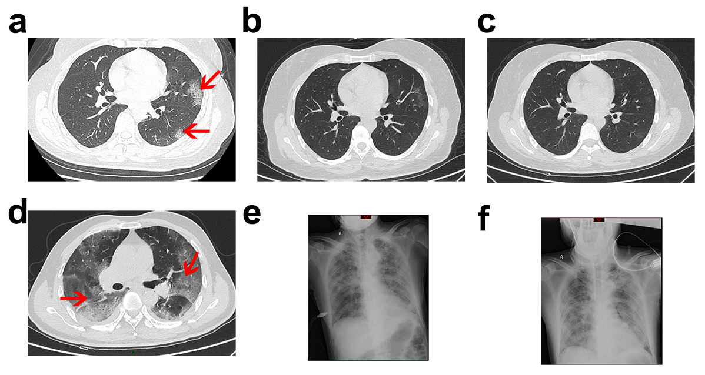
e-Figure 1. Lesion location in CT images. (a, b, c) Serial CT images of a 63-year-old man without chronic underlying disease that initially presented with fever and cough and was later confirmed to have COVID-19. CT images on day 6 after the symptoms onset showed multifocal peripheral lesions (a). Laboratory tests showed a relative low level of CRP concentration at 3·68 mg/L after treatment, and the patient showed significant relief of symptoms and lesion absorption on subsequent follow-up, representative CT image showed above on day 14 (b) and day 18(c). This patient tested negative in two successive tests for 2019-CoV RNA and discharged from hospital on day 22 (after symptom onset). (d, e, f) Serial radiographs of a 56-year-old man diagnosed as COVID-19 with fever, cough, fatigue and myalgia. This patient had no chronic underlying diseases. Representative CT image on day 7 after symptom onset showed lesions located in both internal and peripheral lung field (d). Laboratory tests revealed extremely high level of CRP concentration (128·15 mg/L). Despite intensive treatment, including ventilation support, dyspnea and pulmonary lesions aggravated on subsequent follow-up radiograph on day 14(e) and day 20(f). This patient died of sudden respiratory and cardiac arrest in hospital.

e-Figure 2. Flowchart of CT radiomic feature extraction. The process of radiomic feature extraction includes data acquisition, lesion segmentation and computer-aided automatic radiomic feature extraction.

