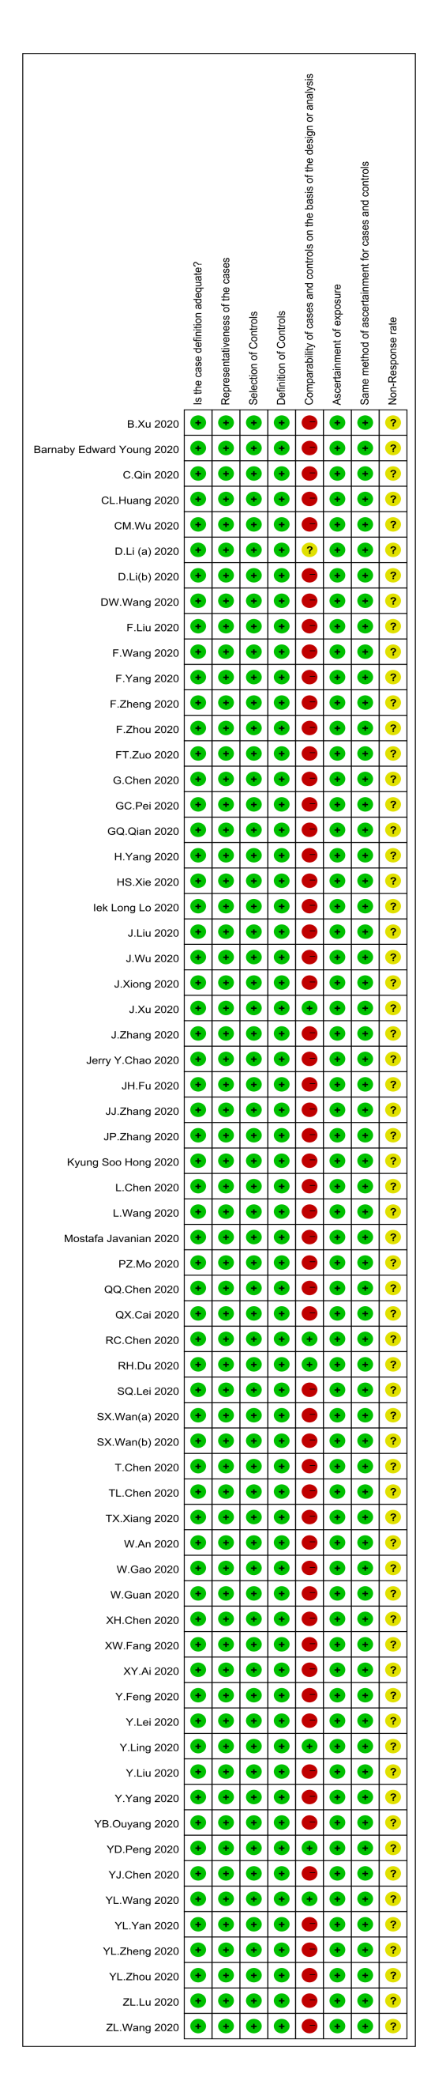
Appendix S1 Quality assessment of included studies (Newcastle–Ottawa Scale). +: high quality; −: low quality; ?: unclear quality.

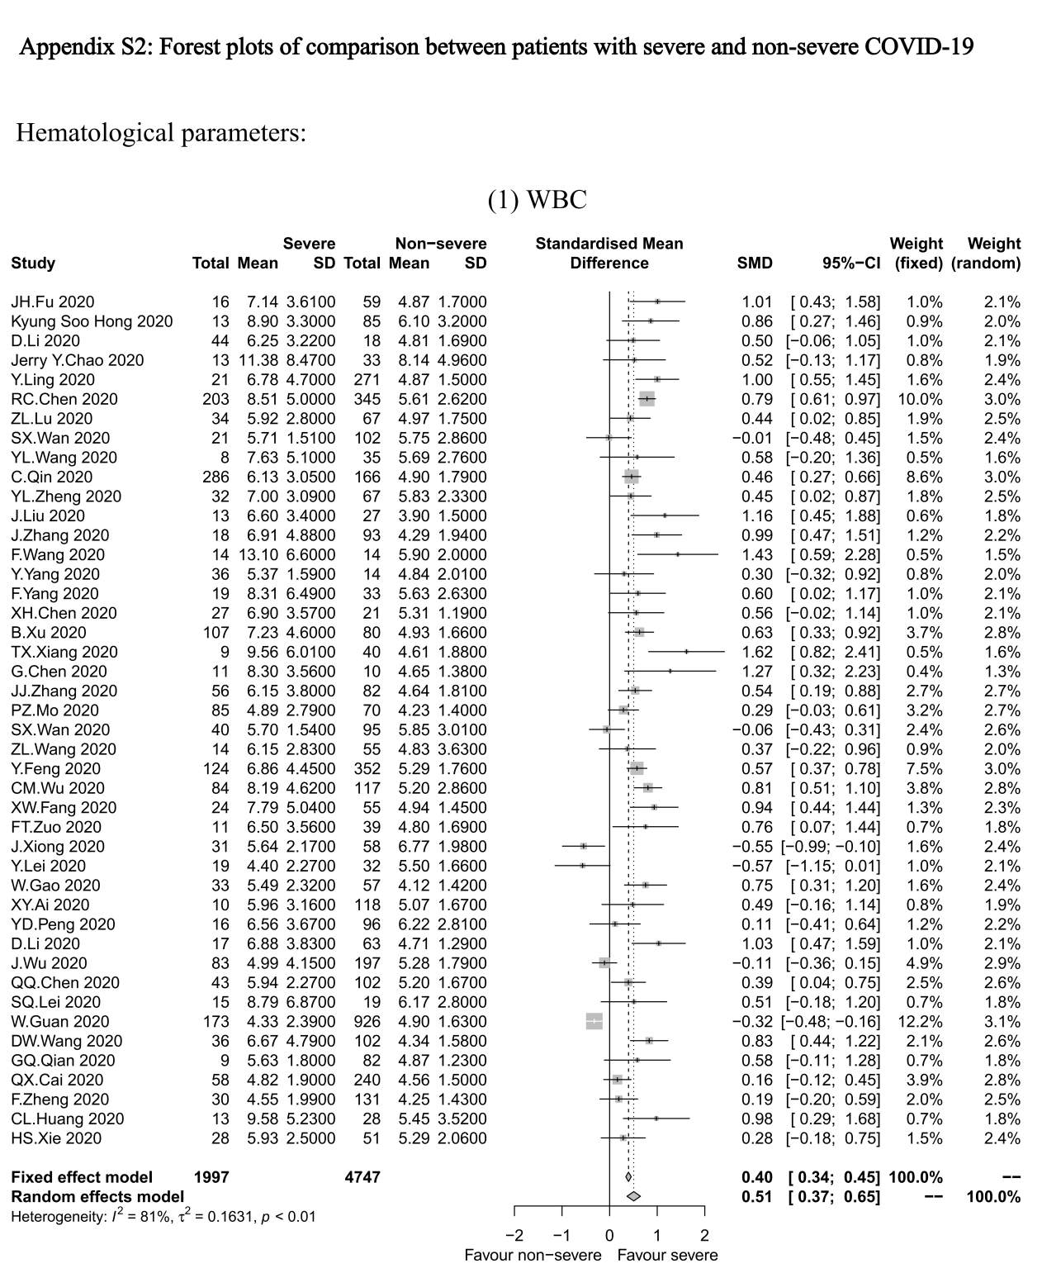
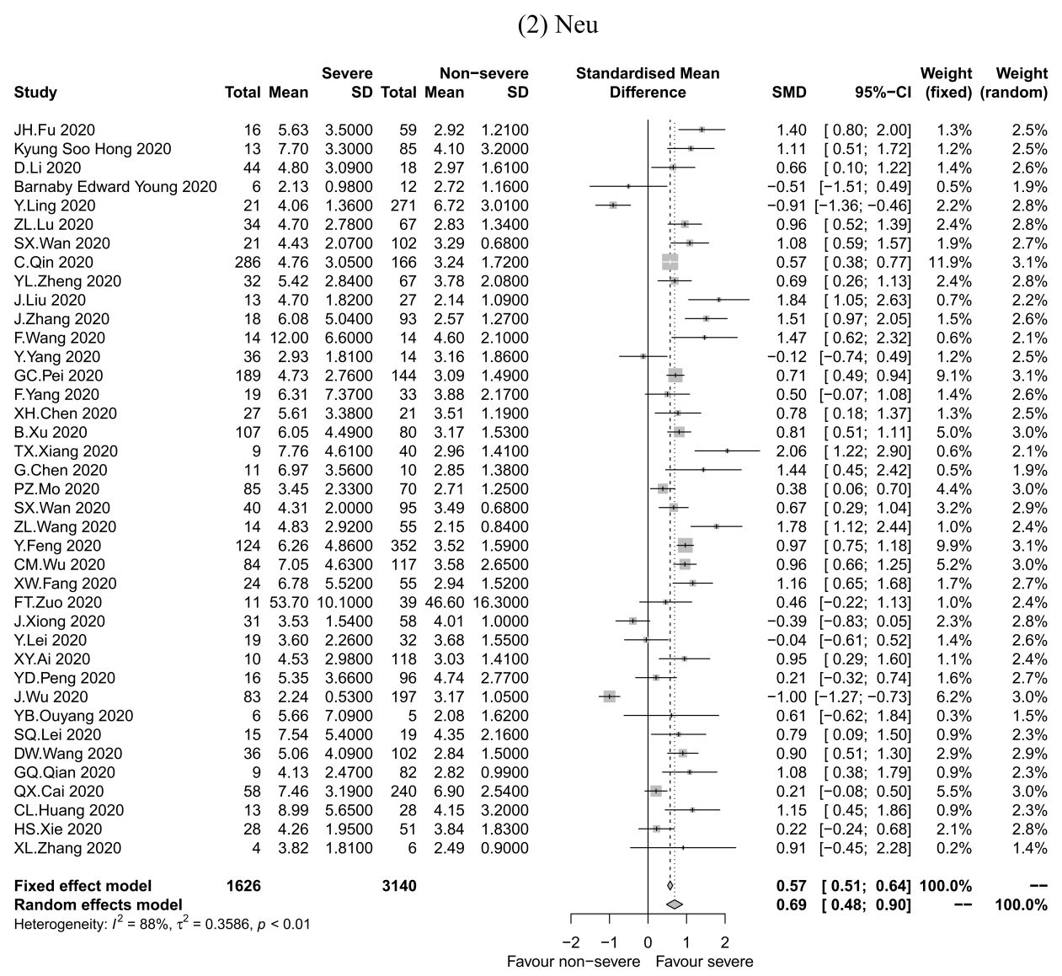
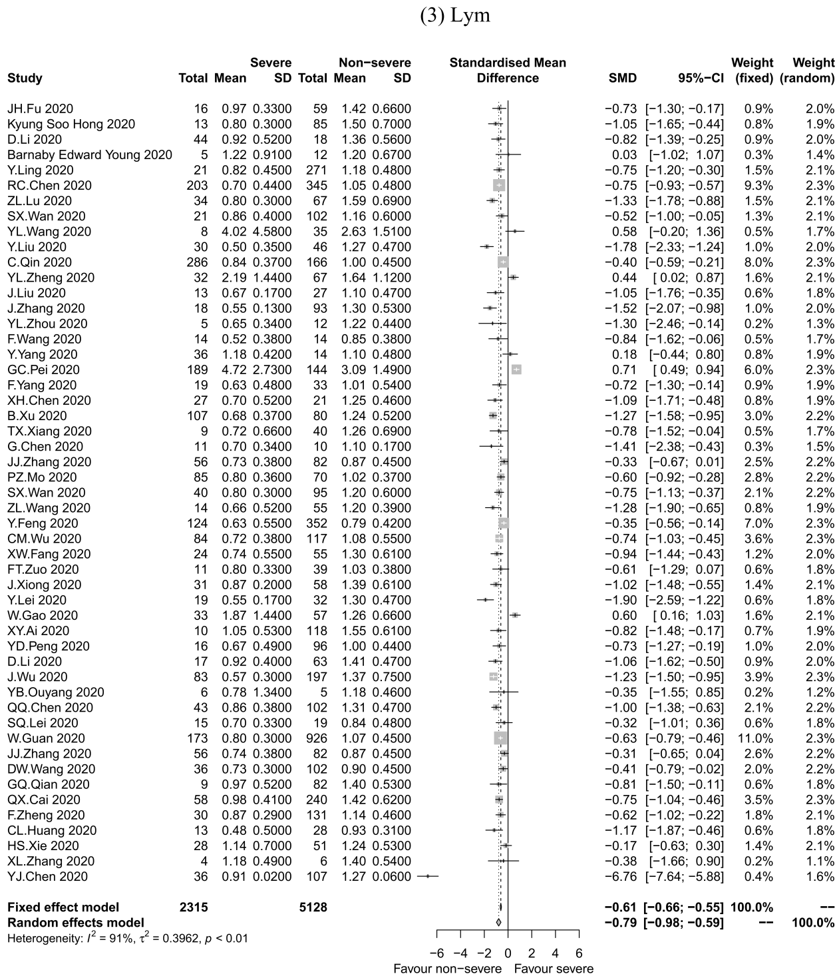

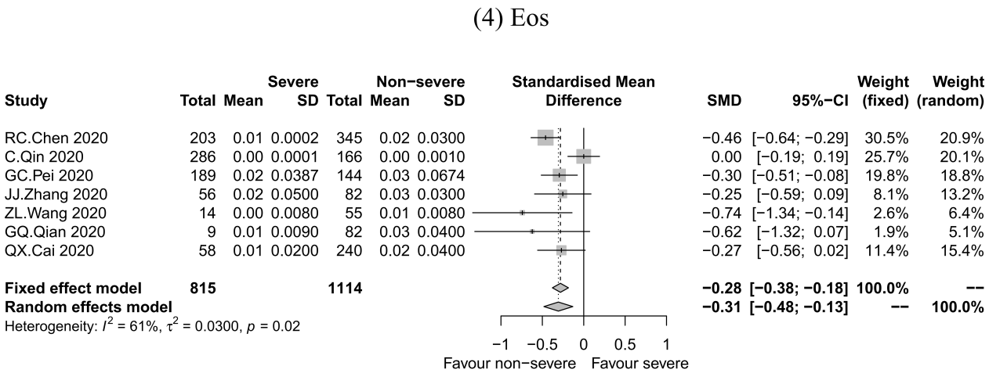

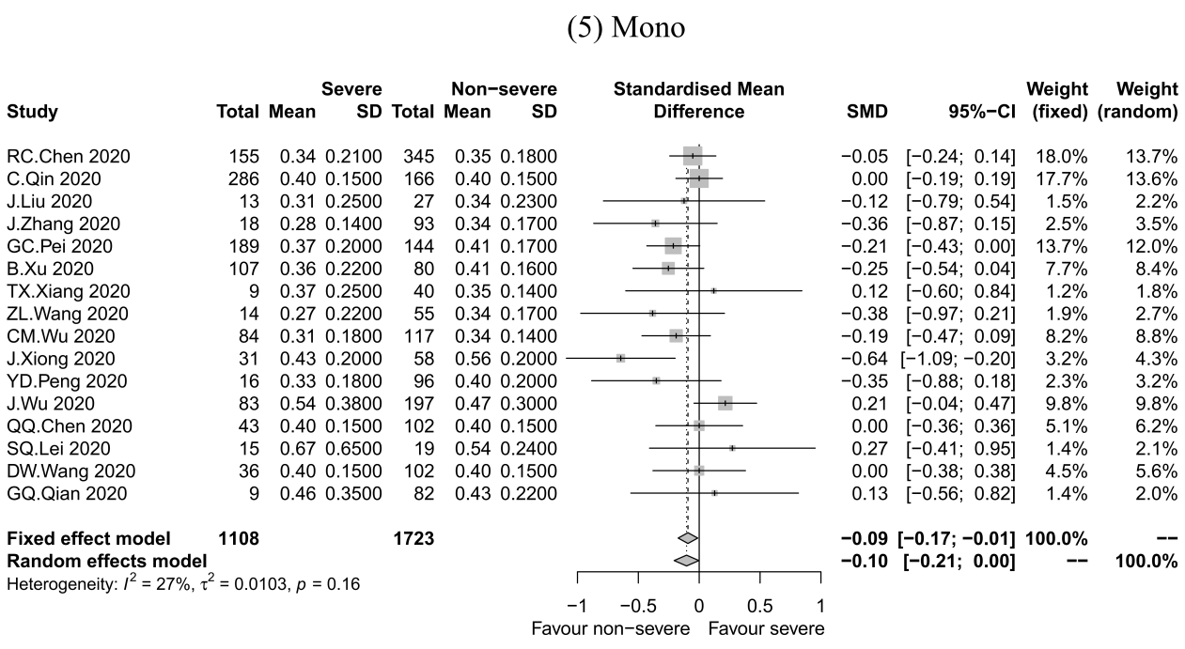

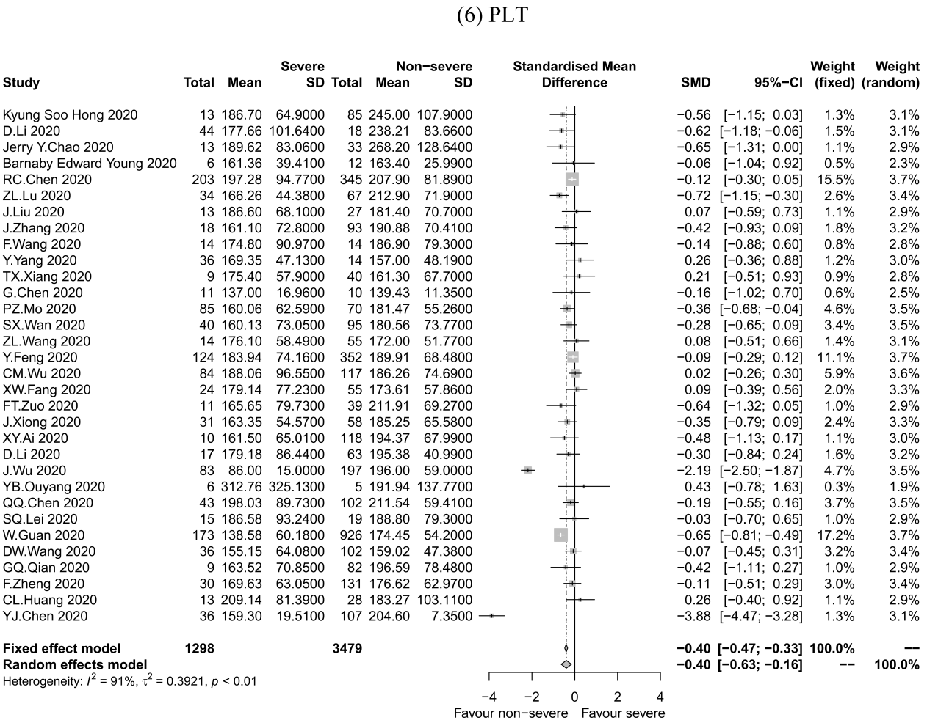

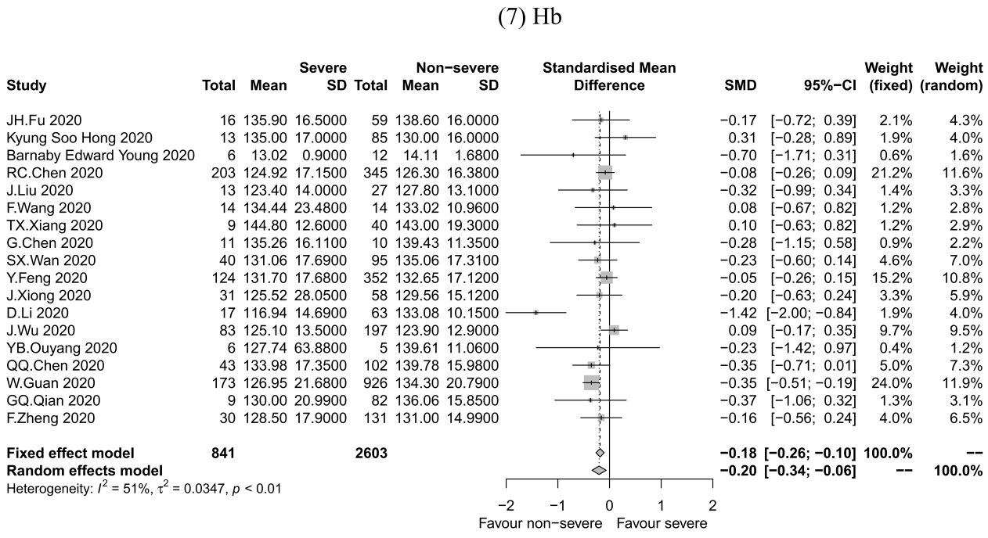

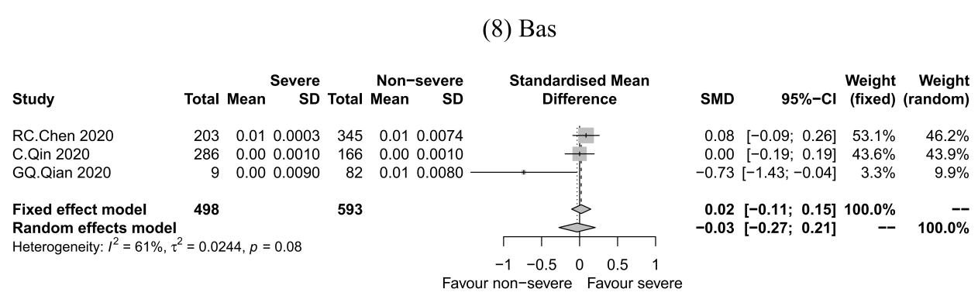

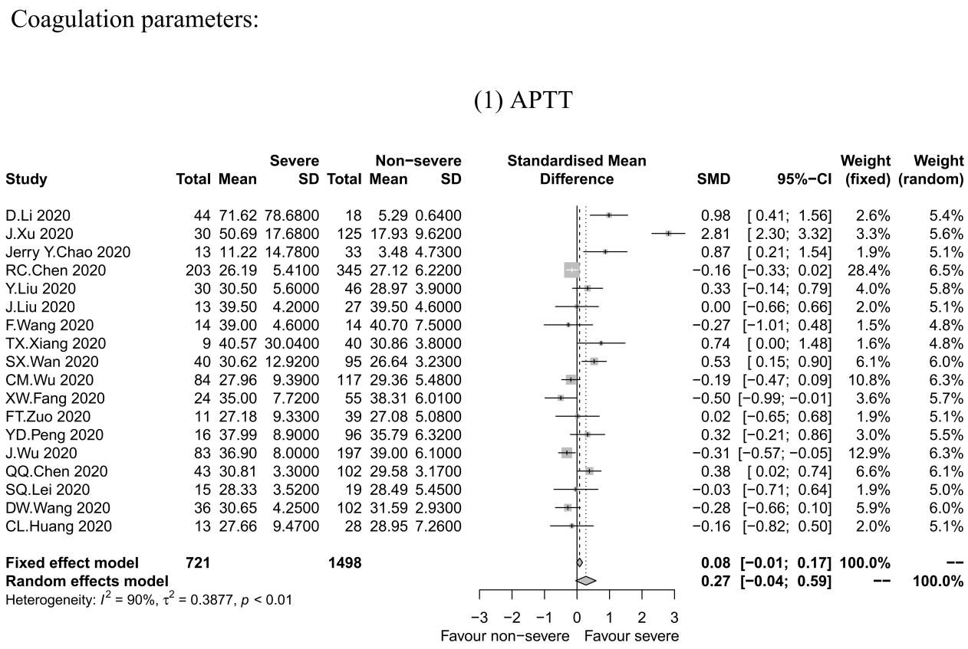

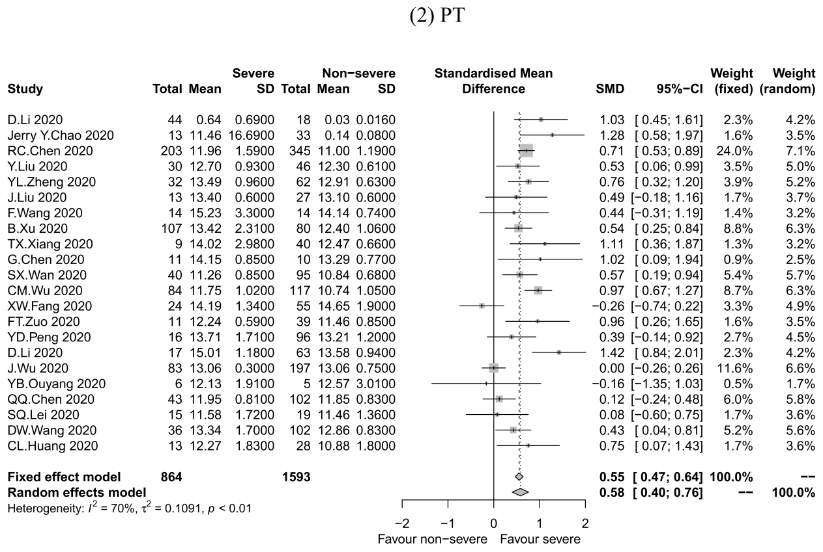

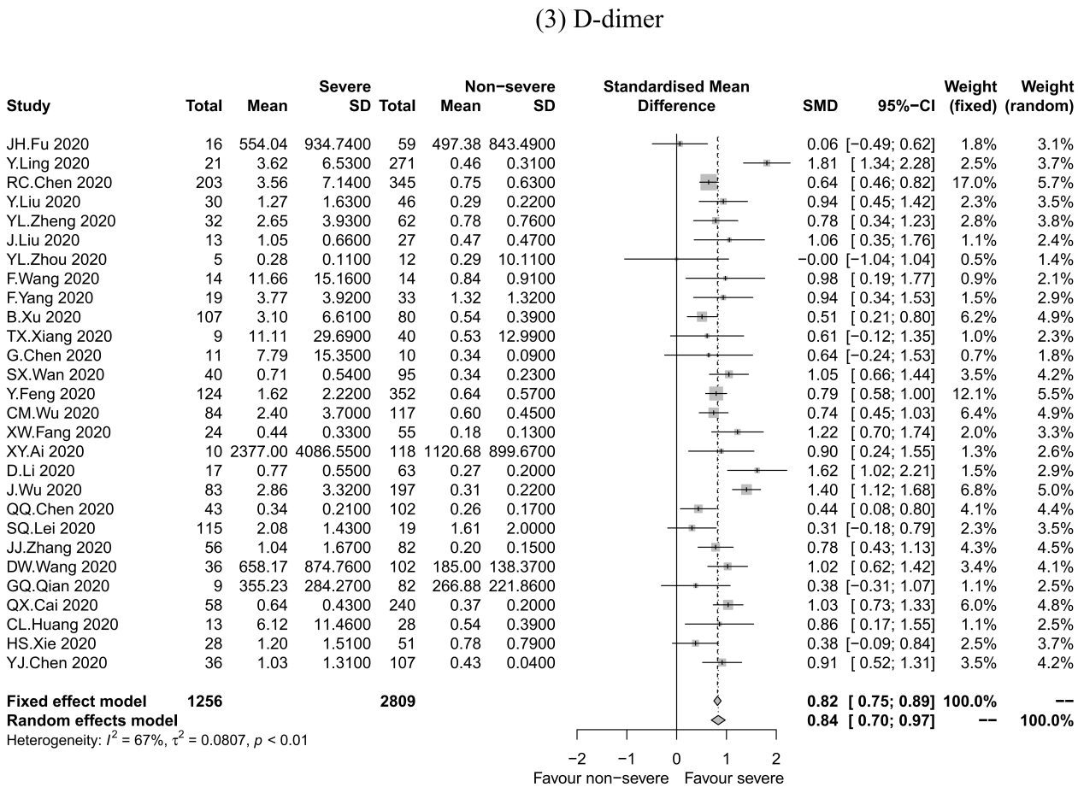

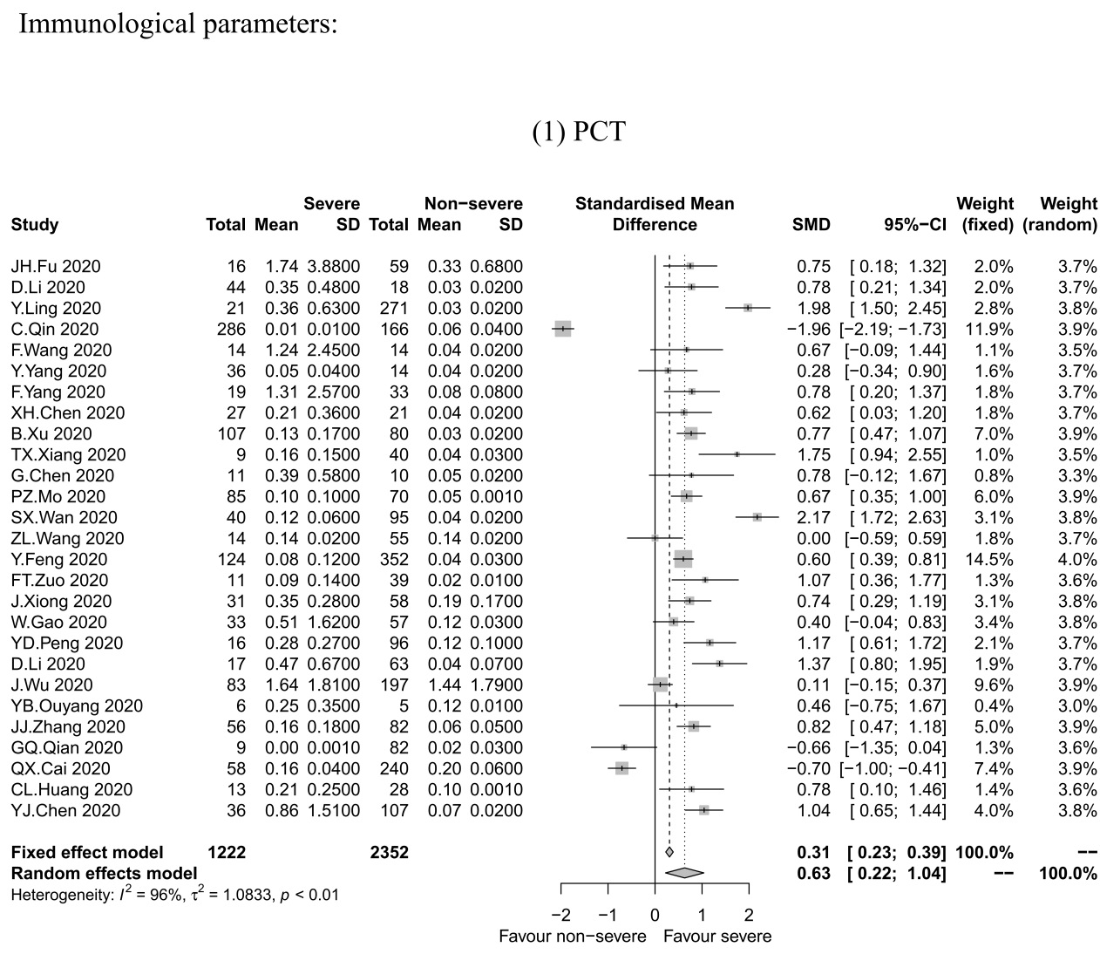

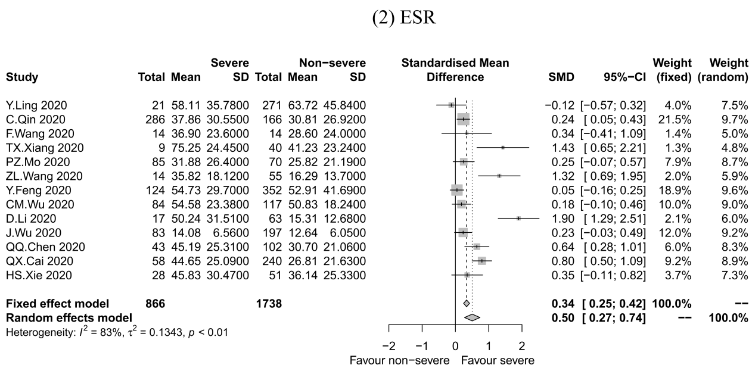

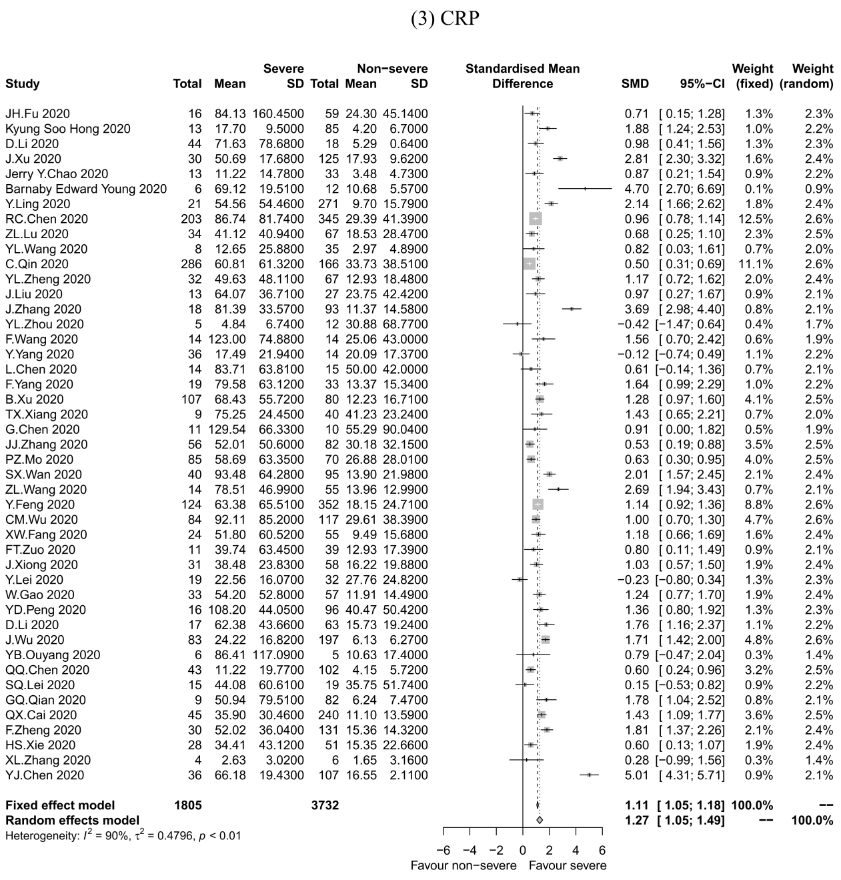

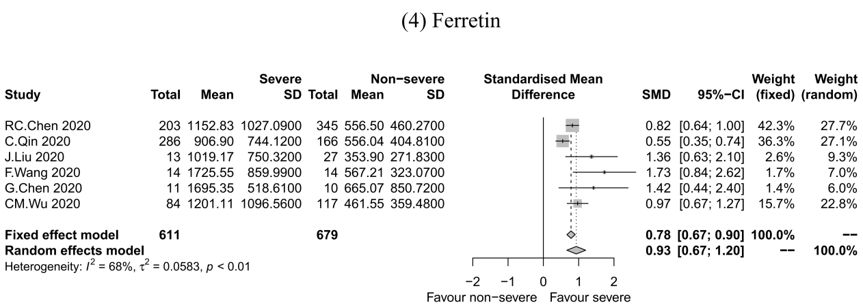

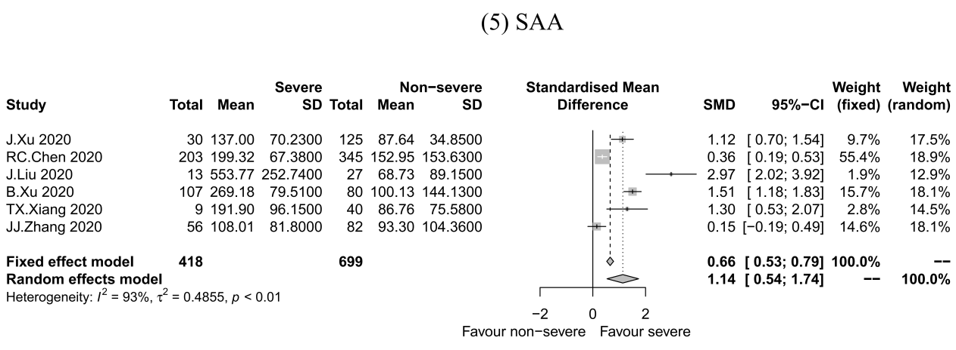

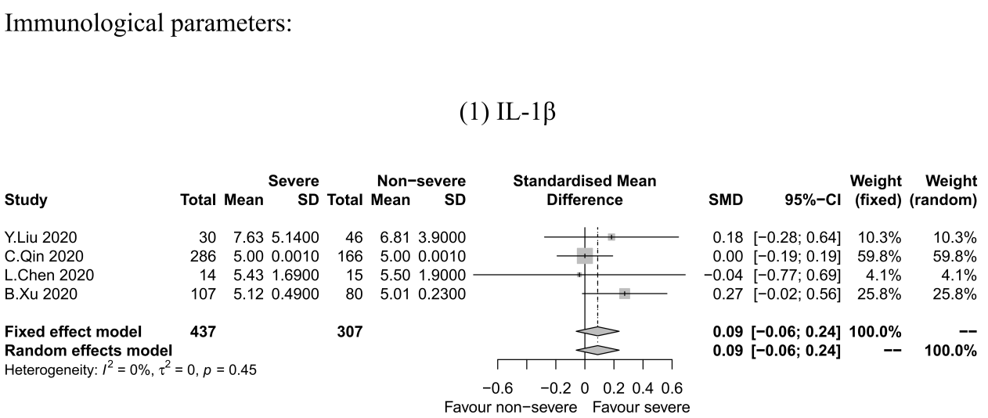

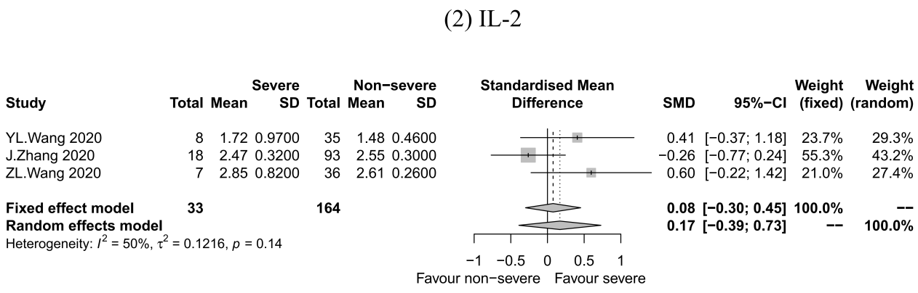

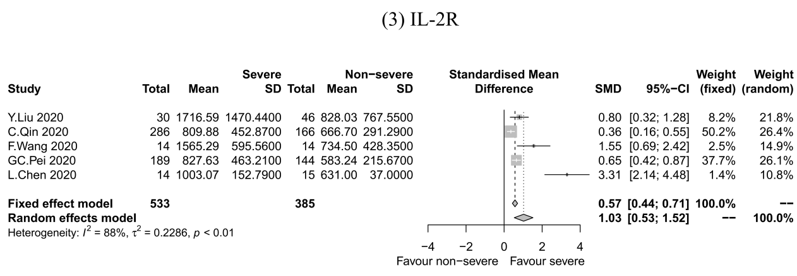

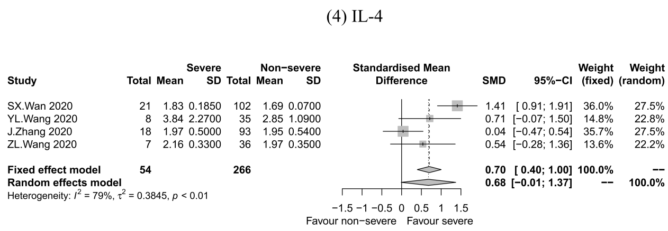

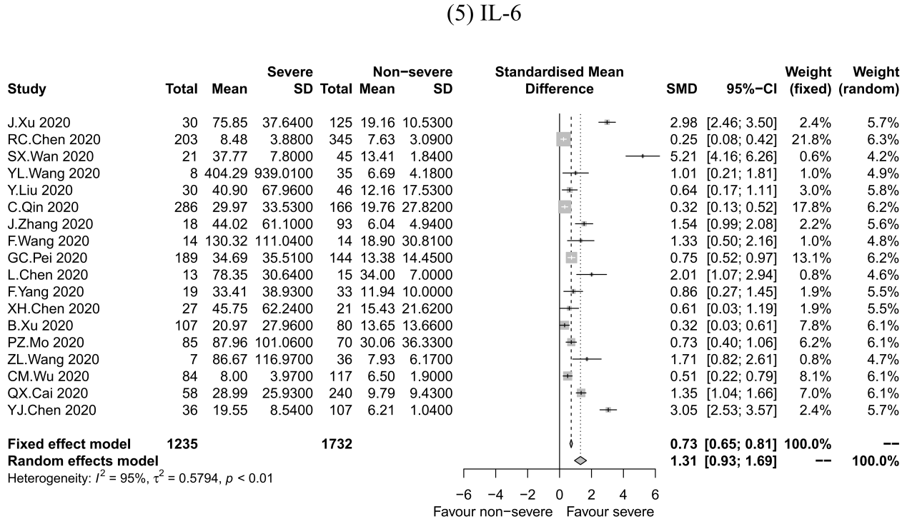

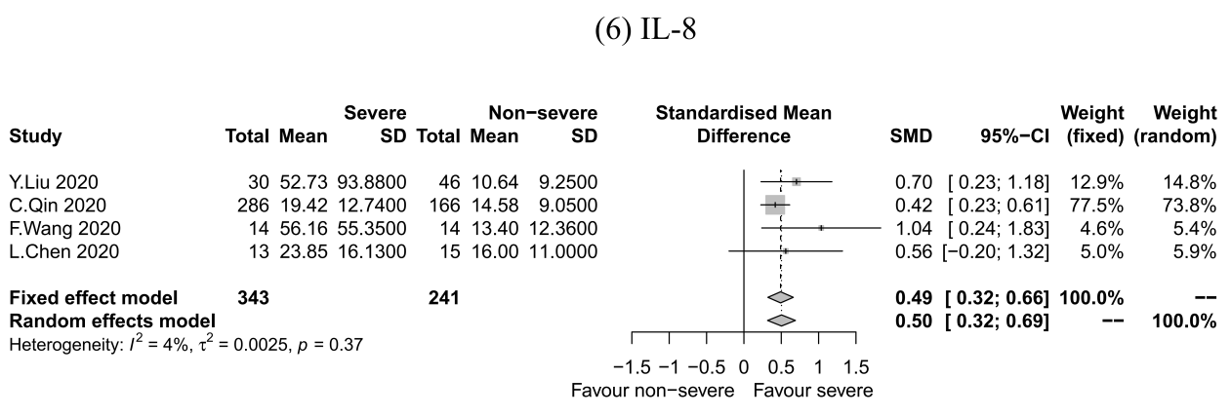

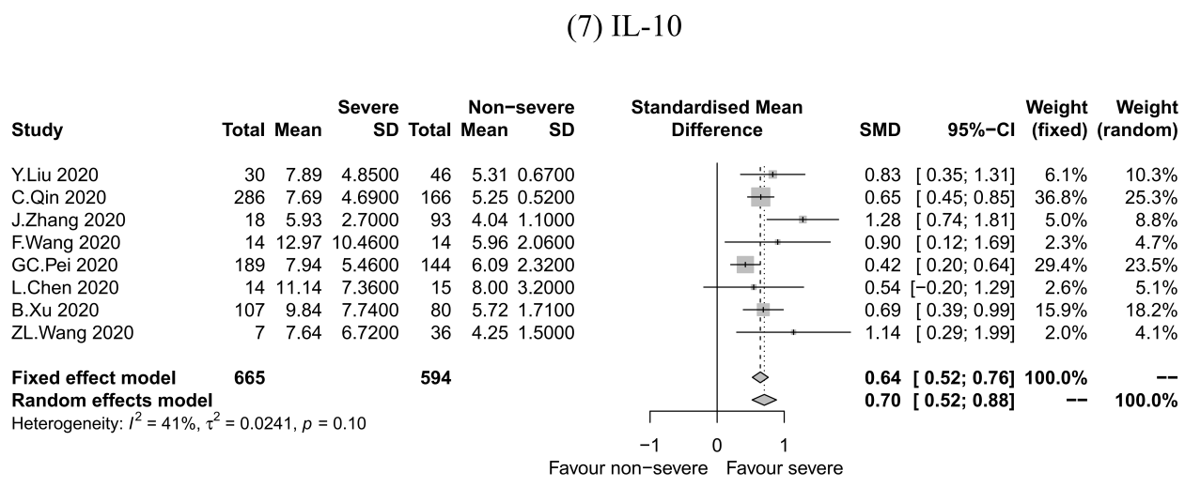

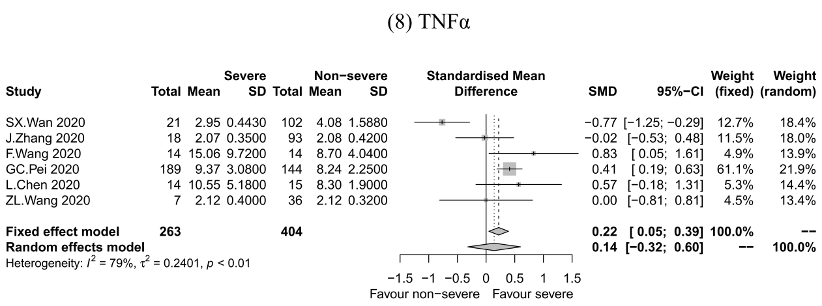

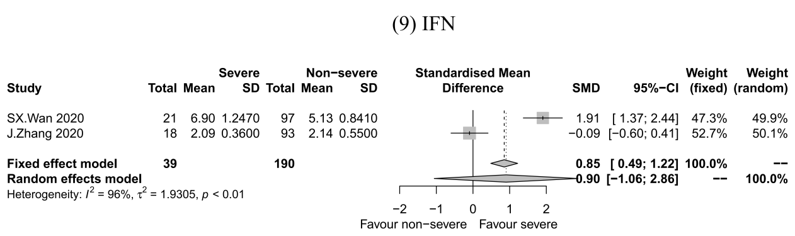

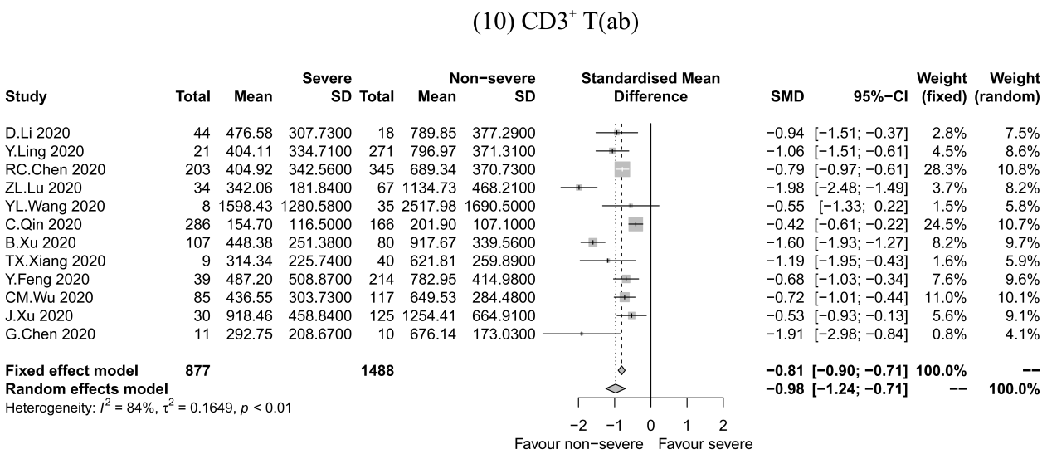

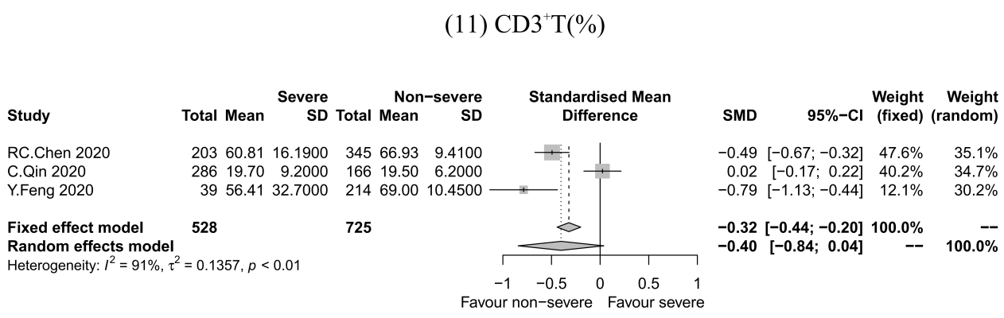

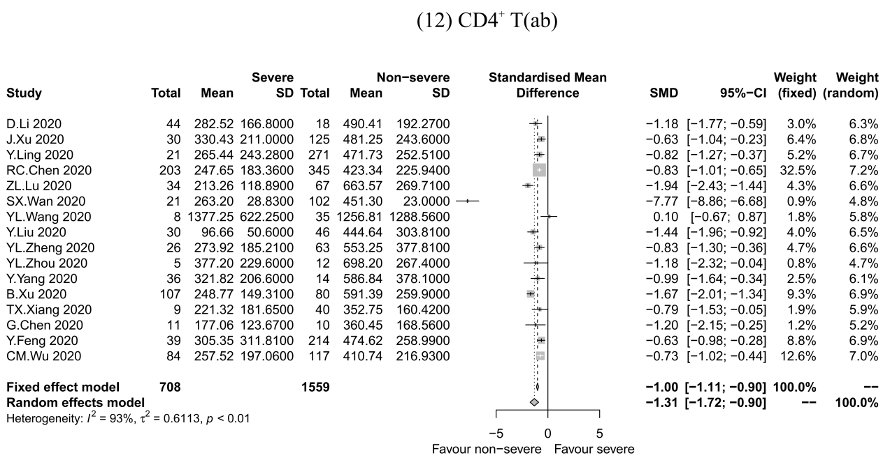

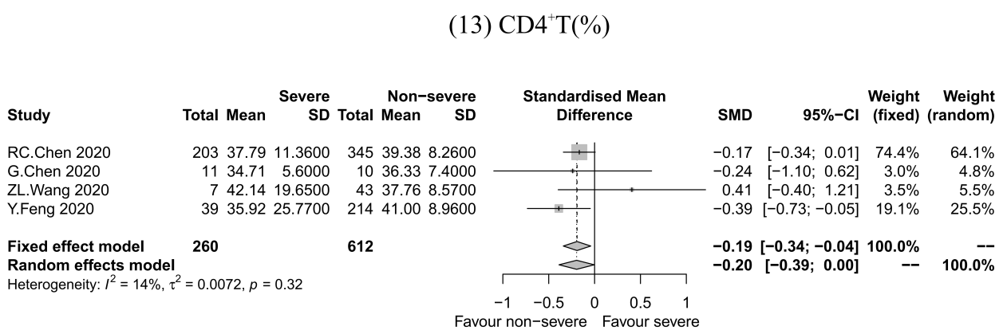

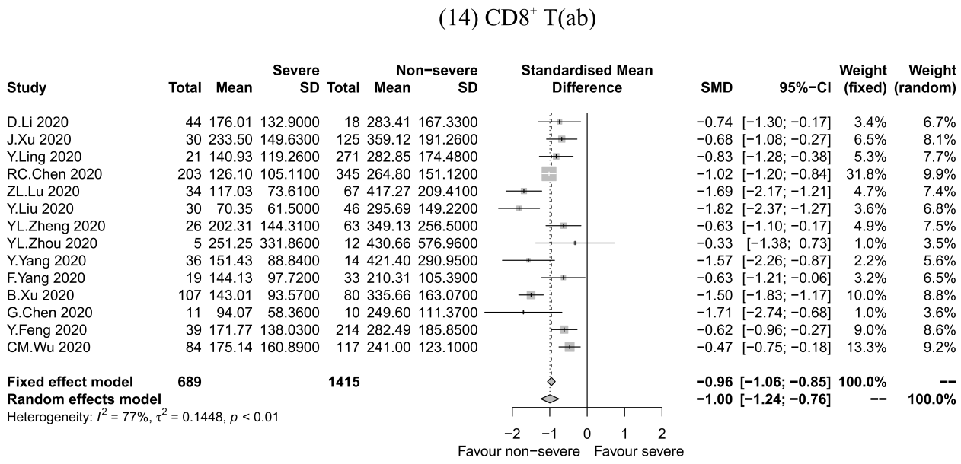

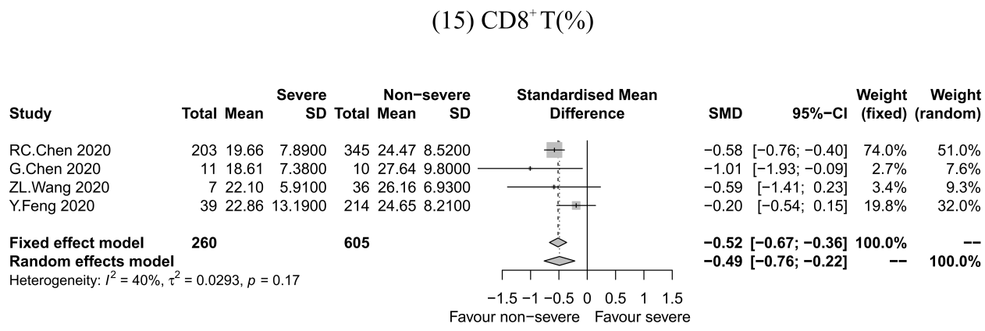

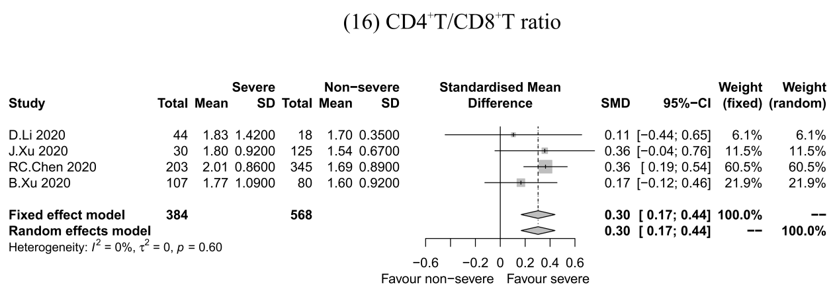

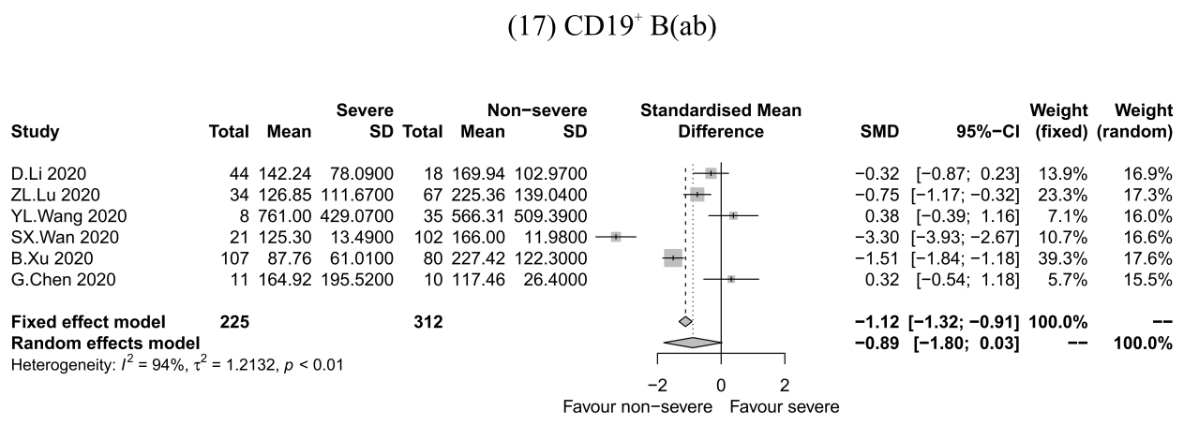

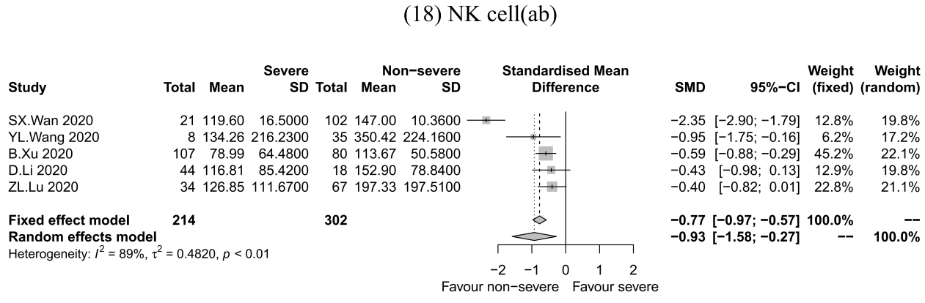

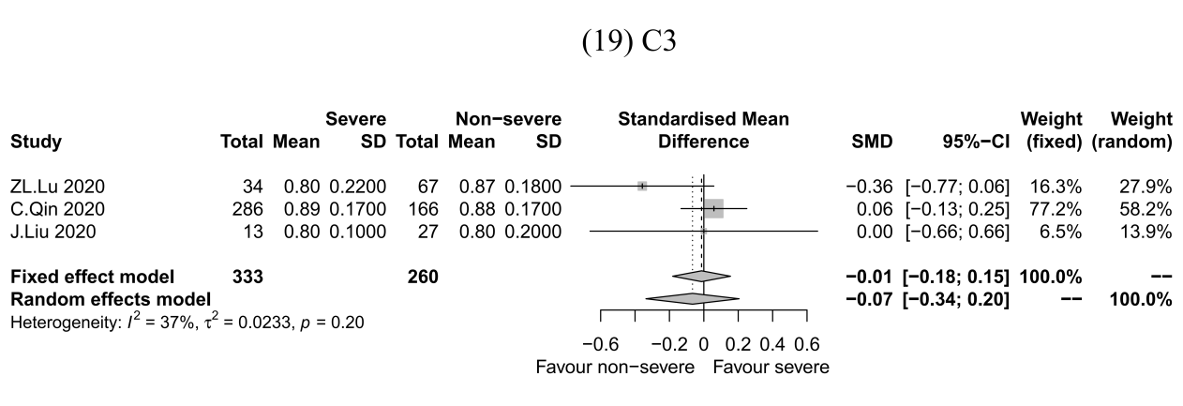

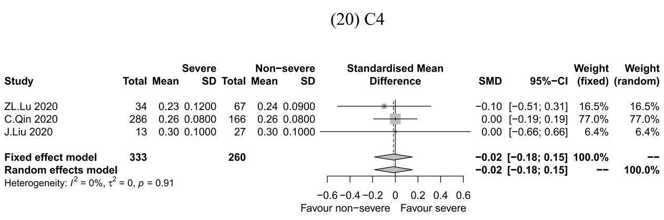

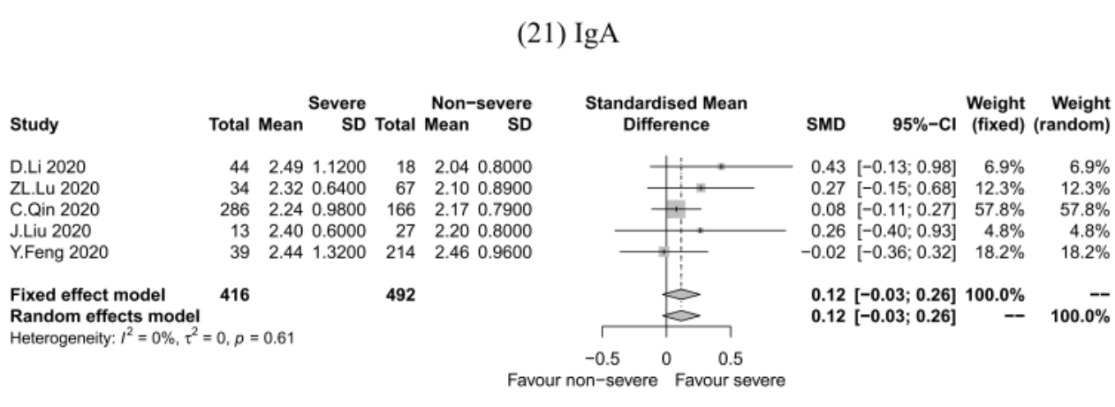

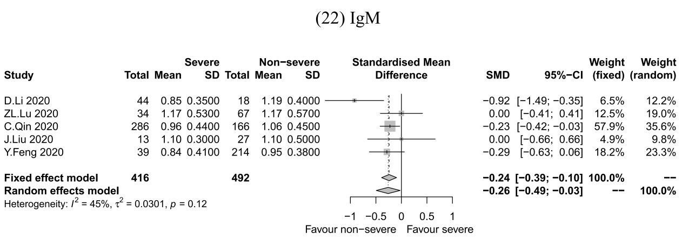

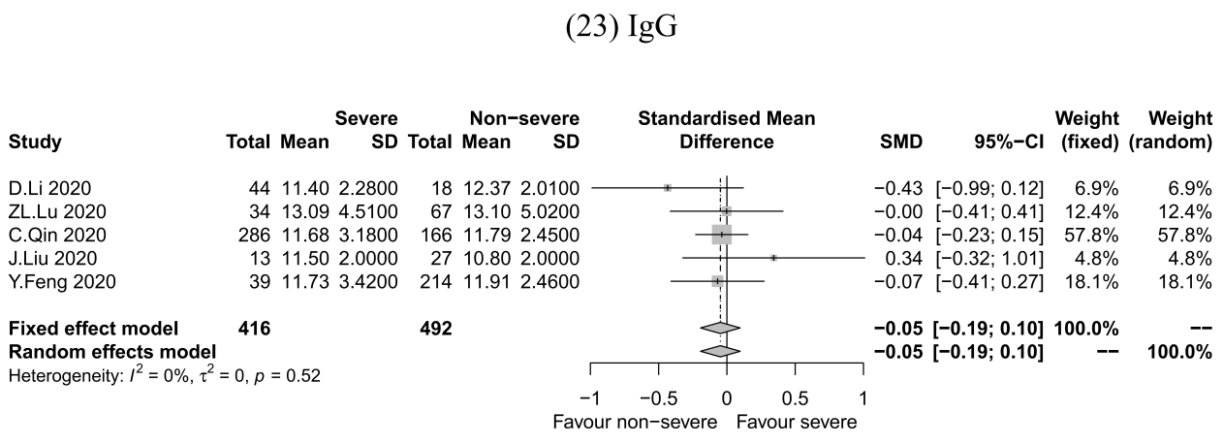

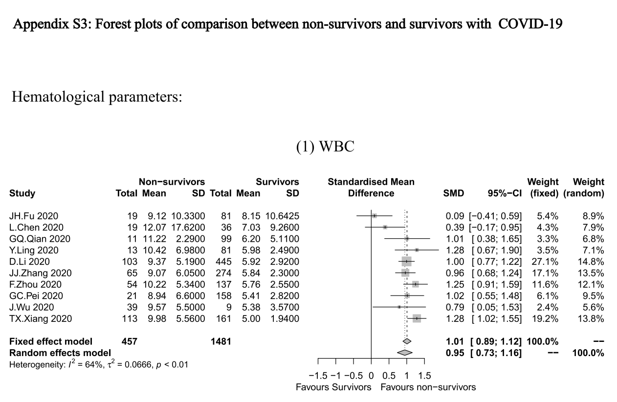

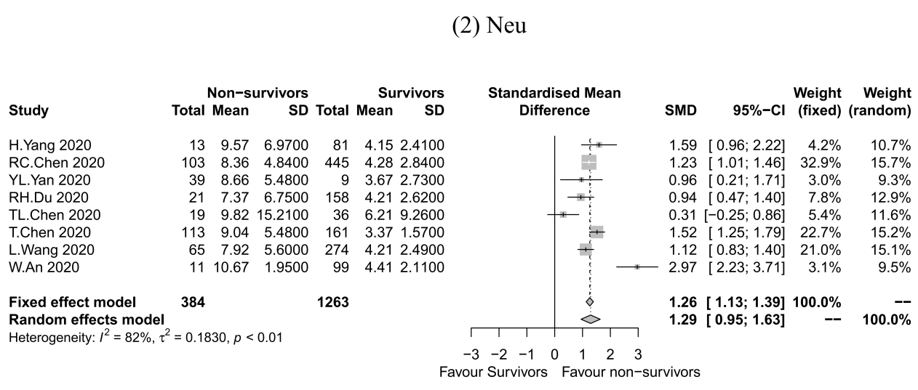

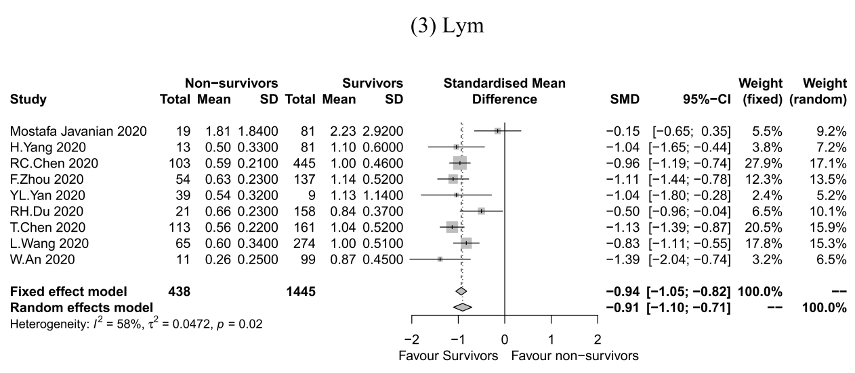

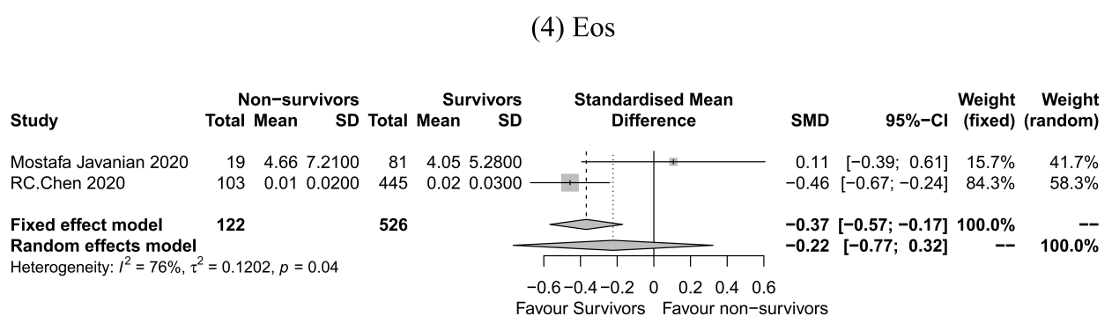

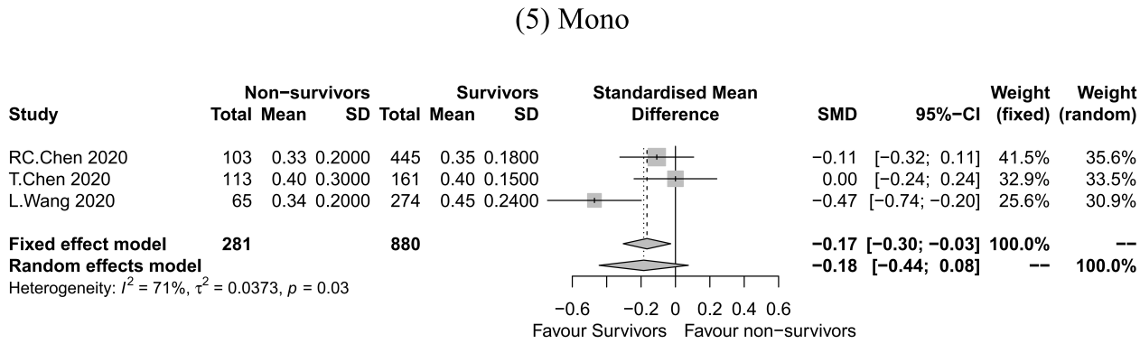

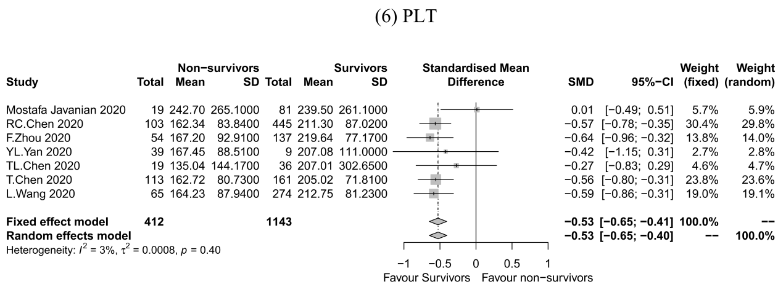

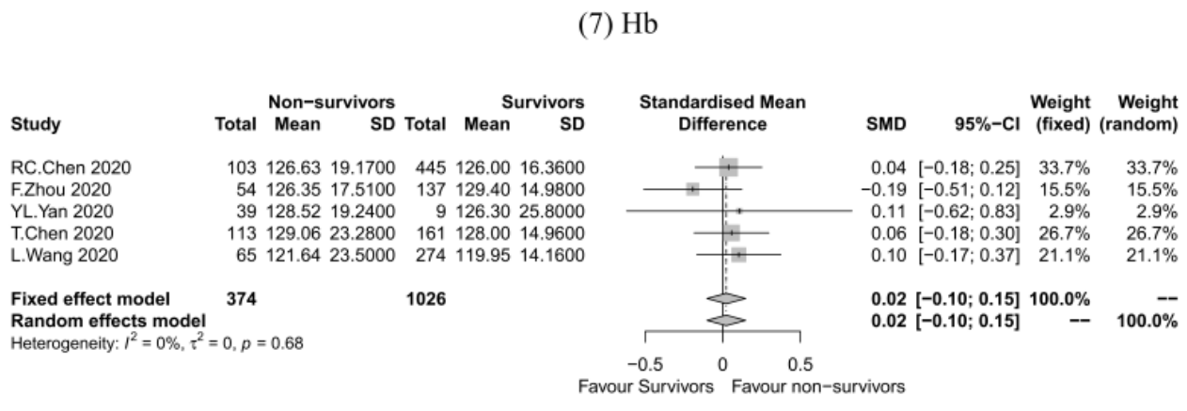

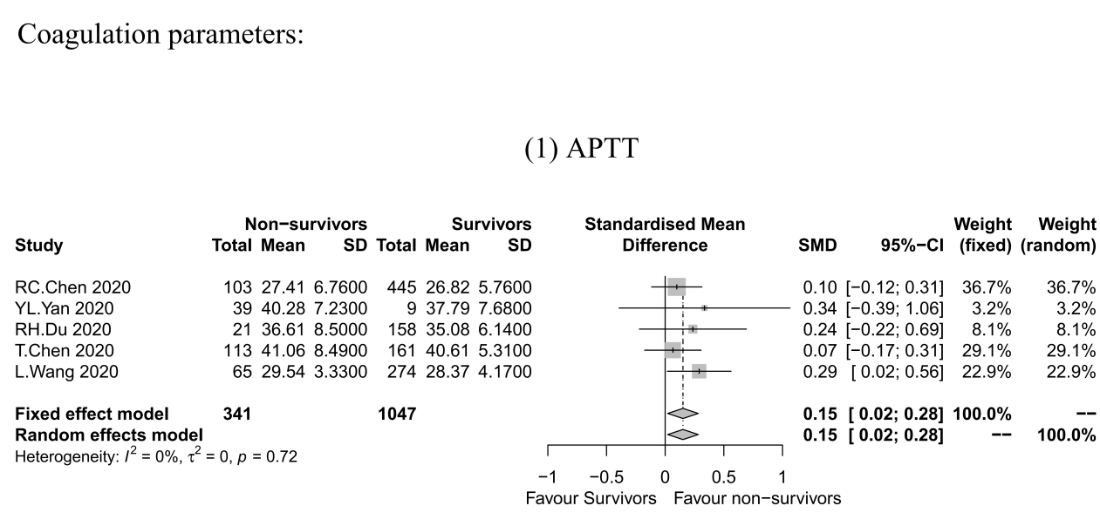

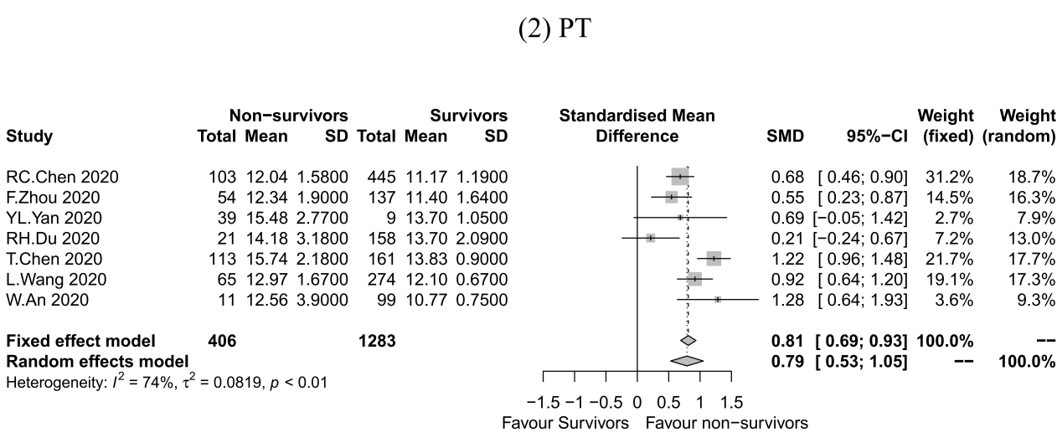

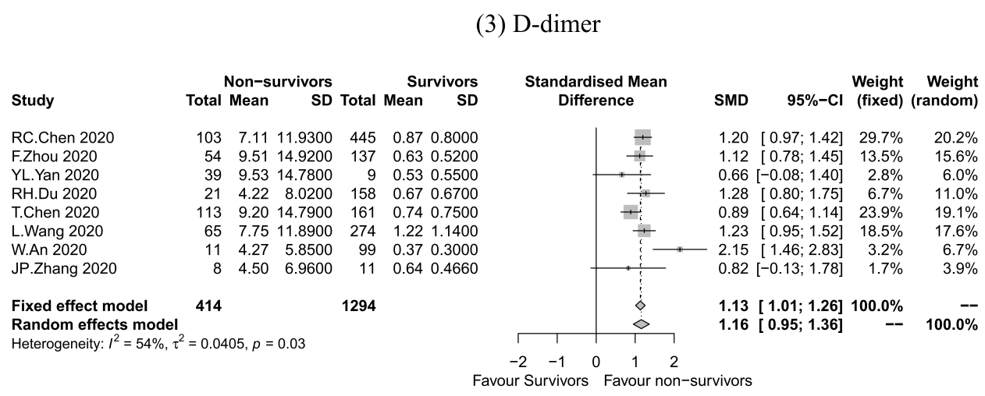

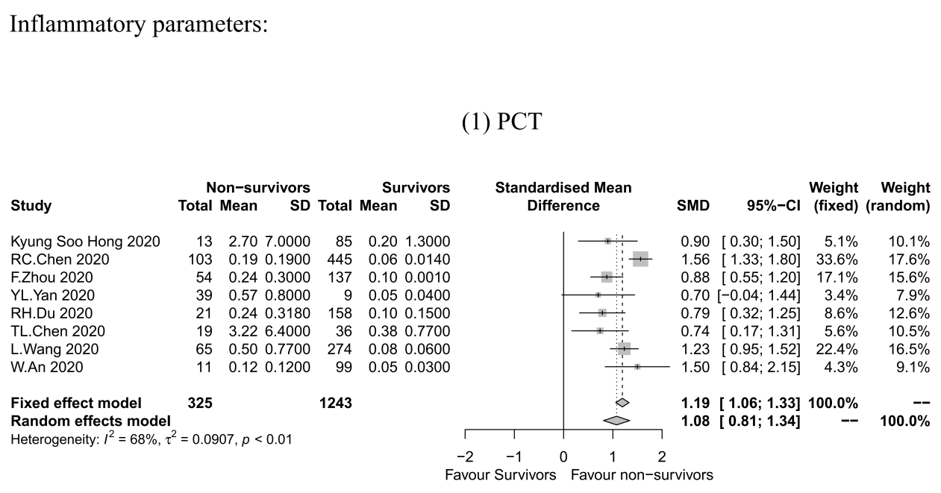
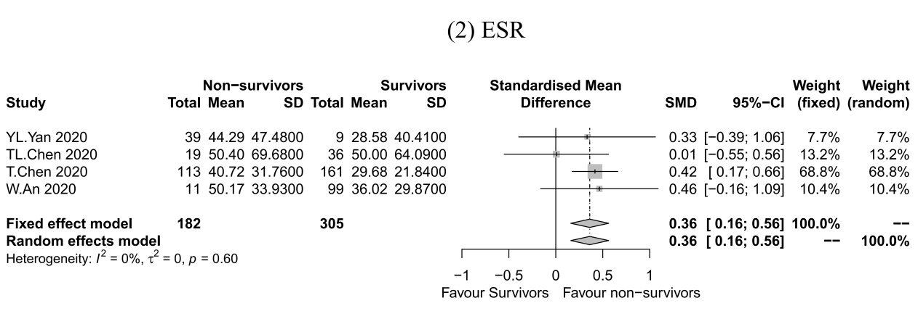

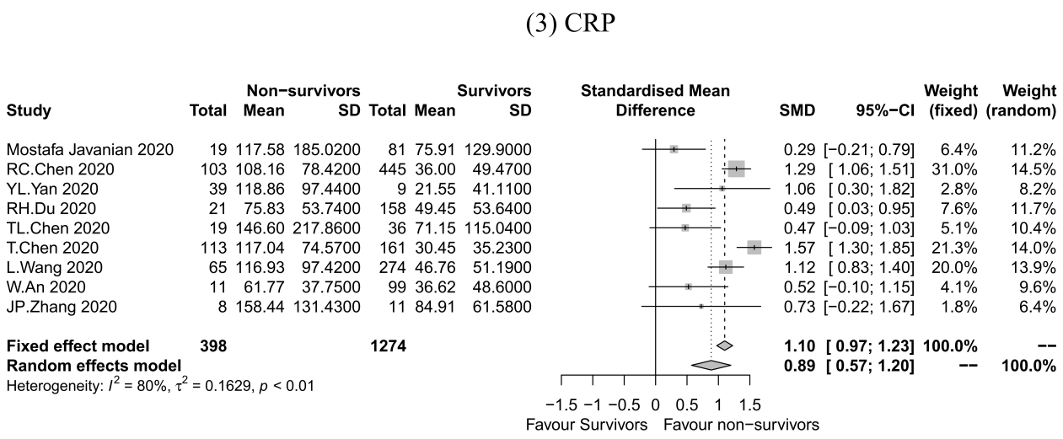

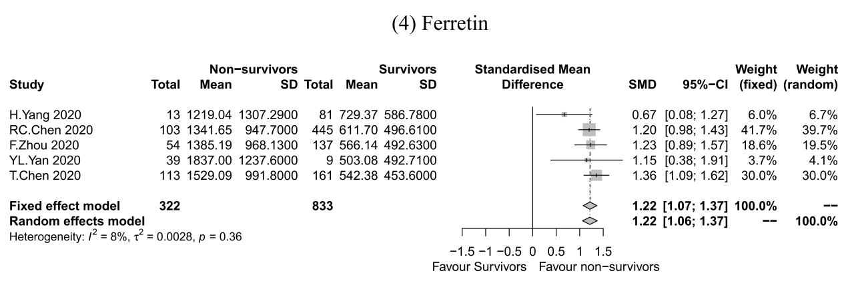

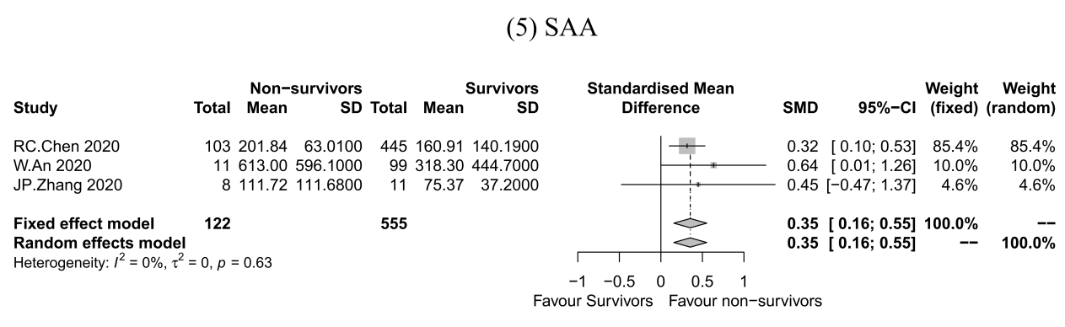

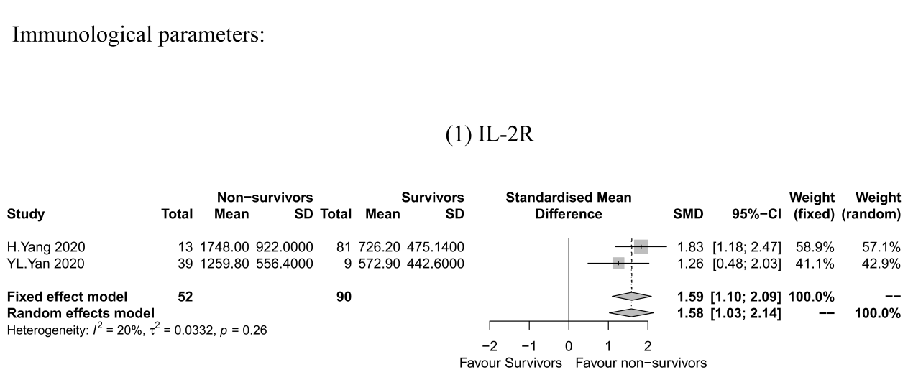

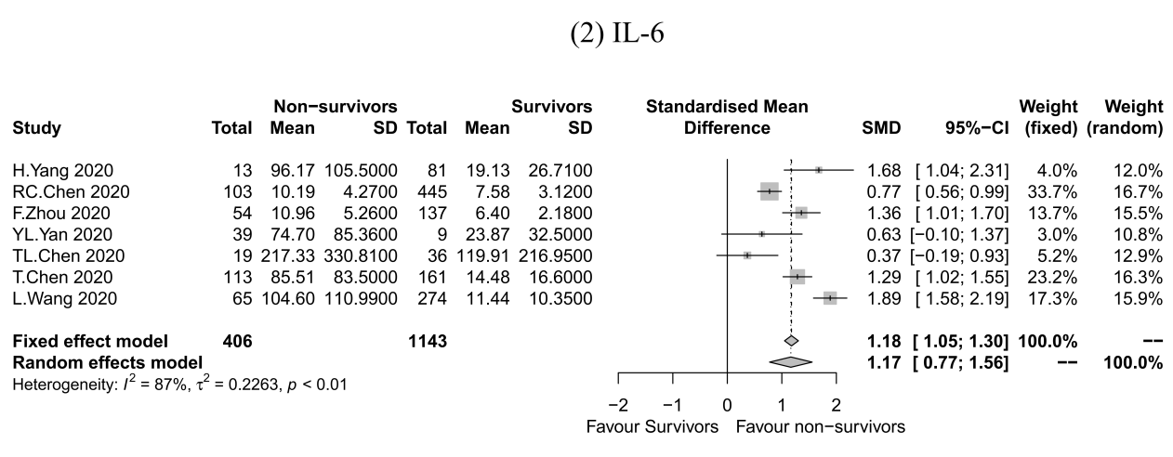
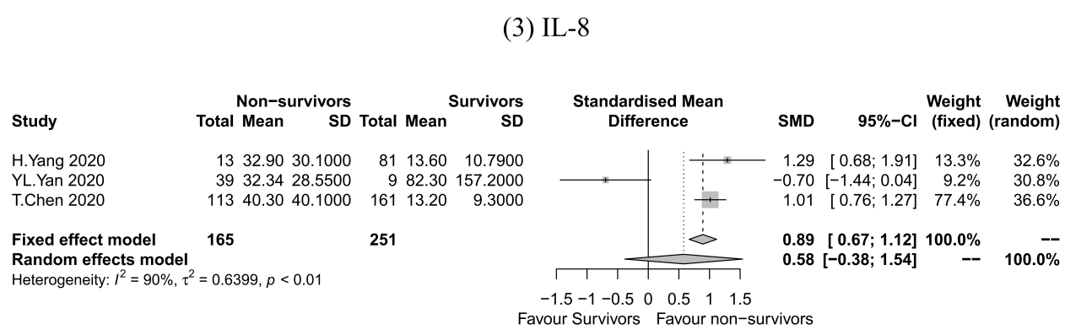

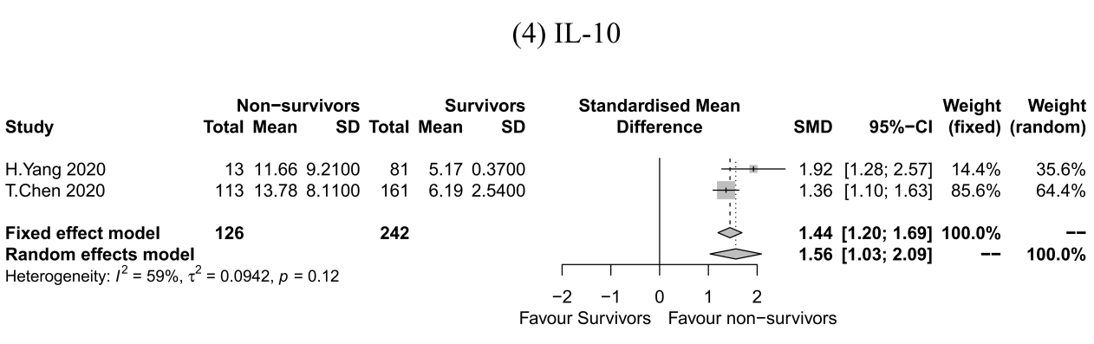

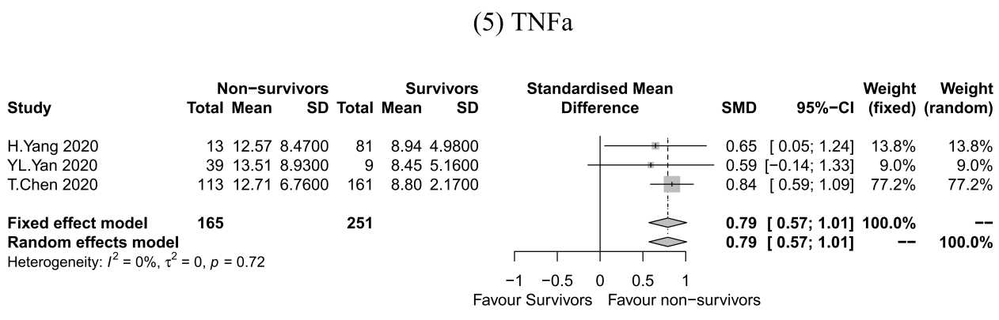

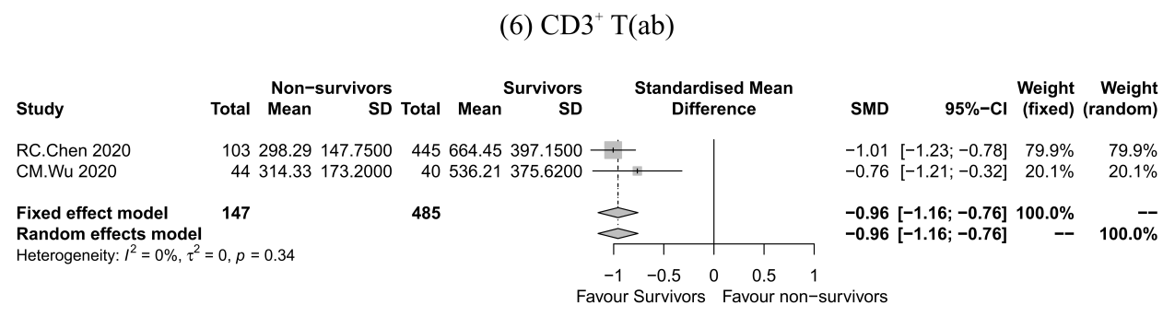
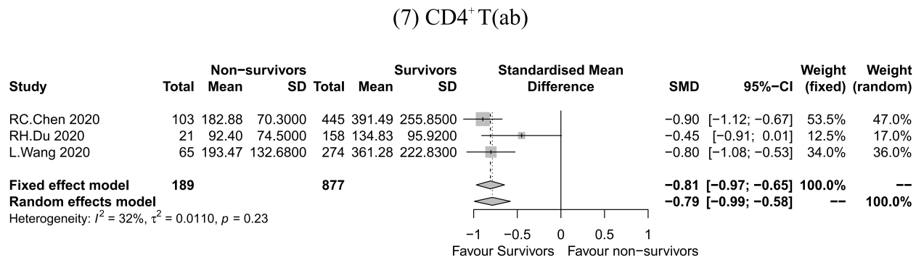

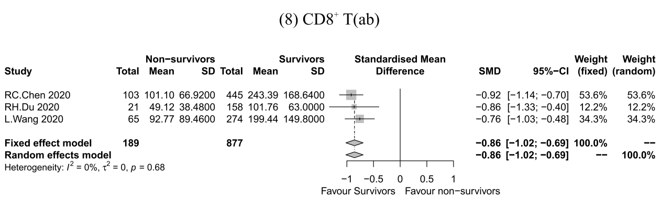

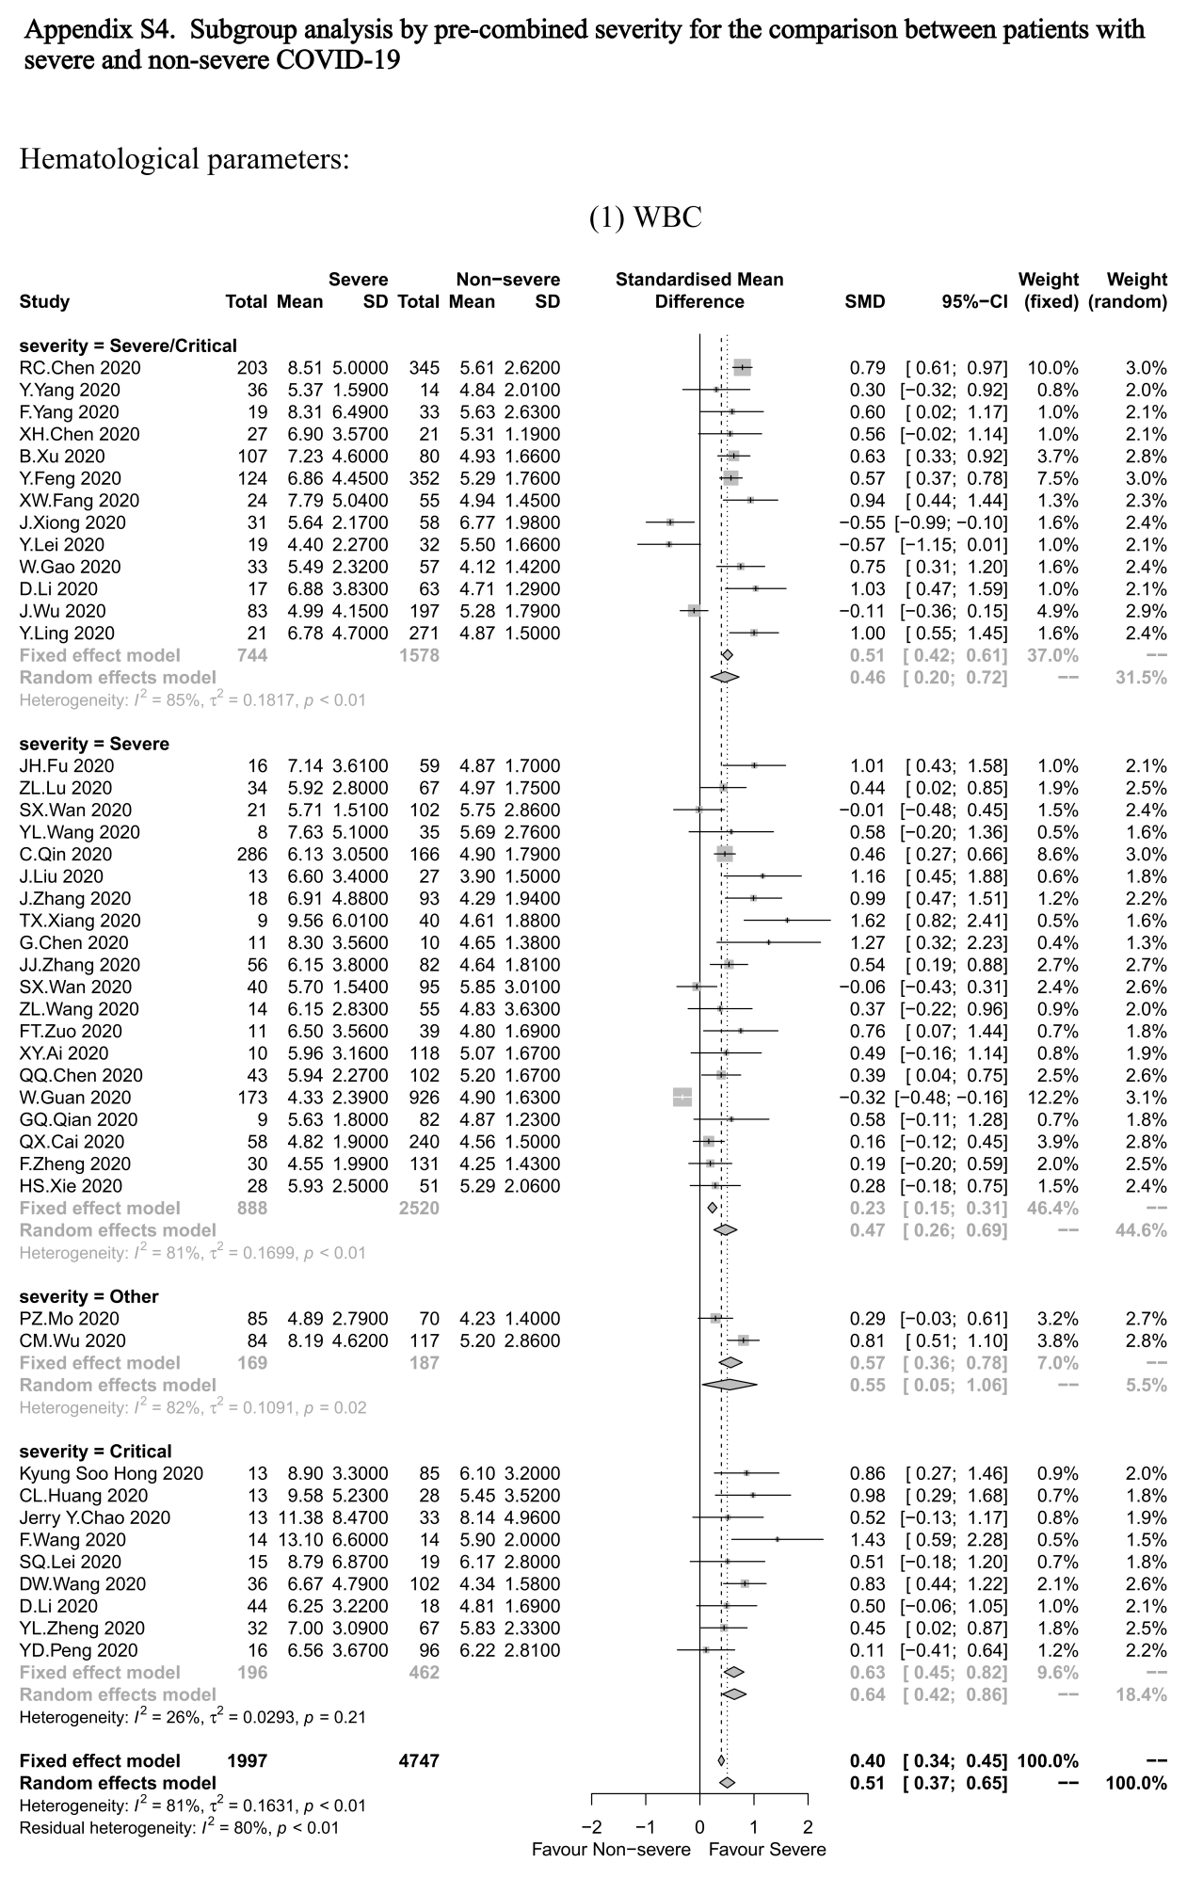
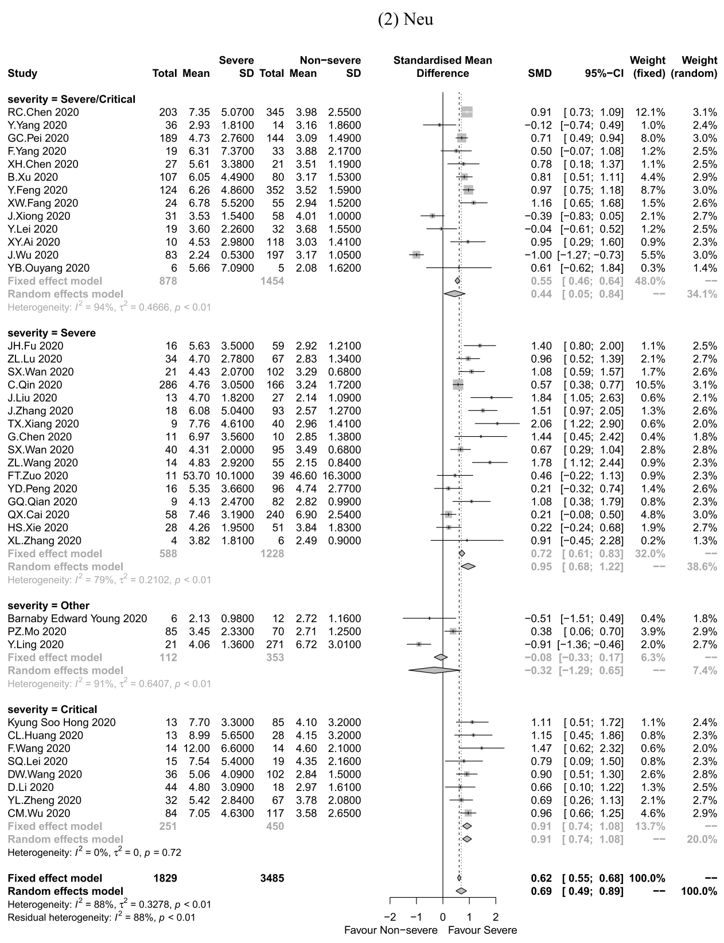
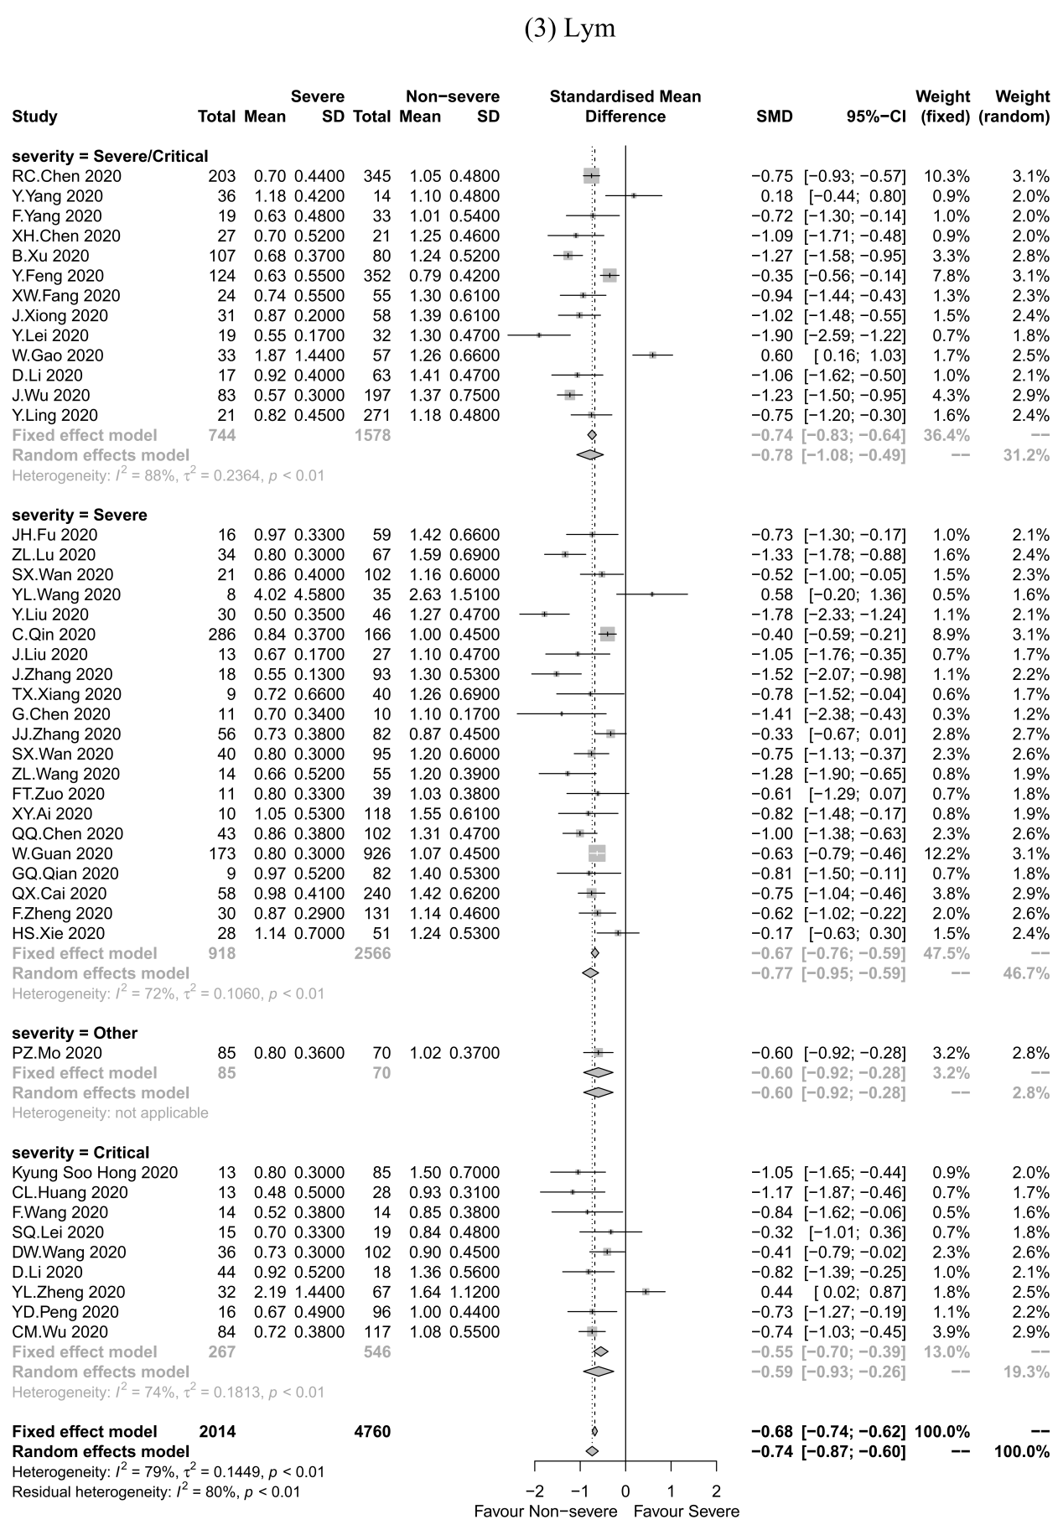
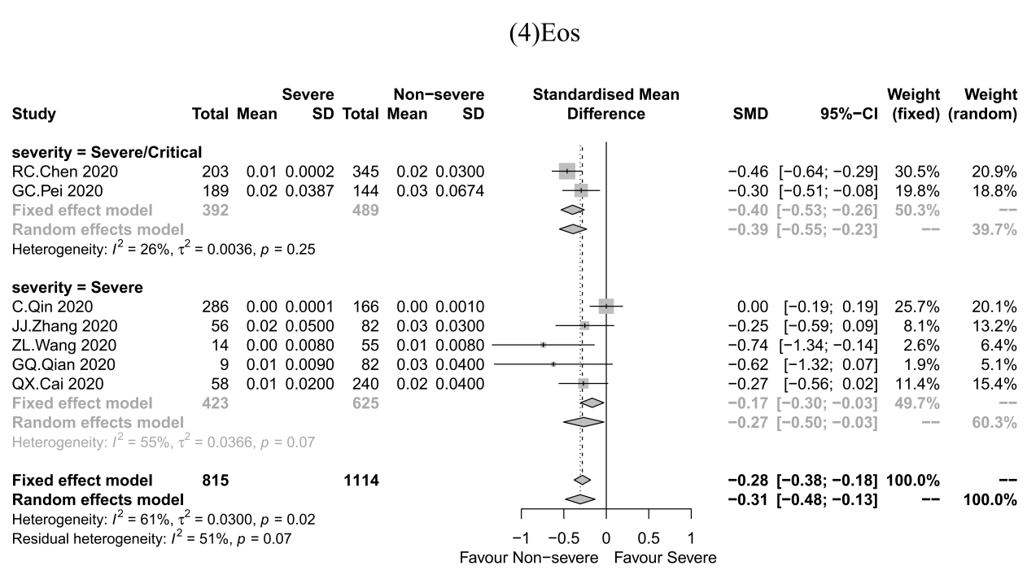

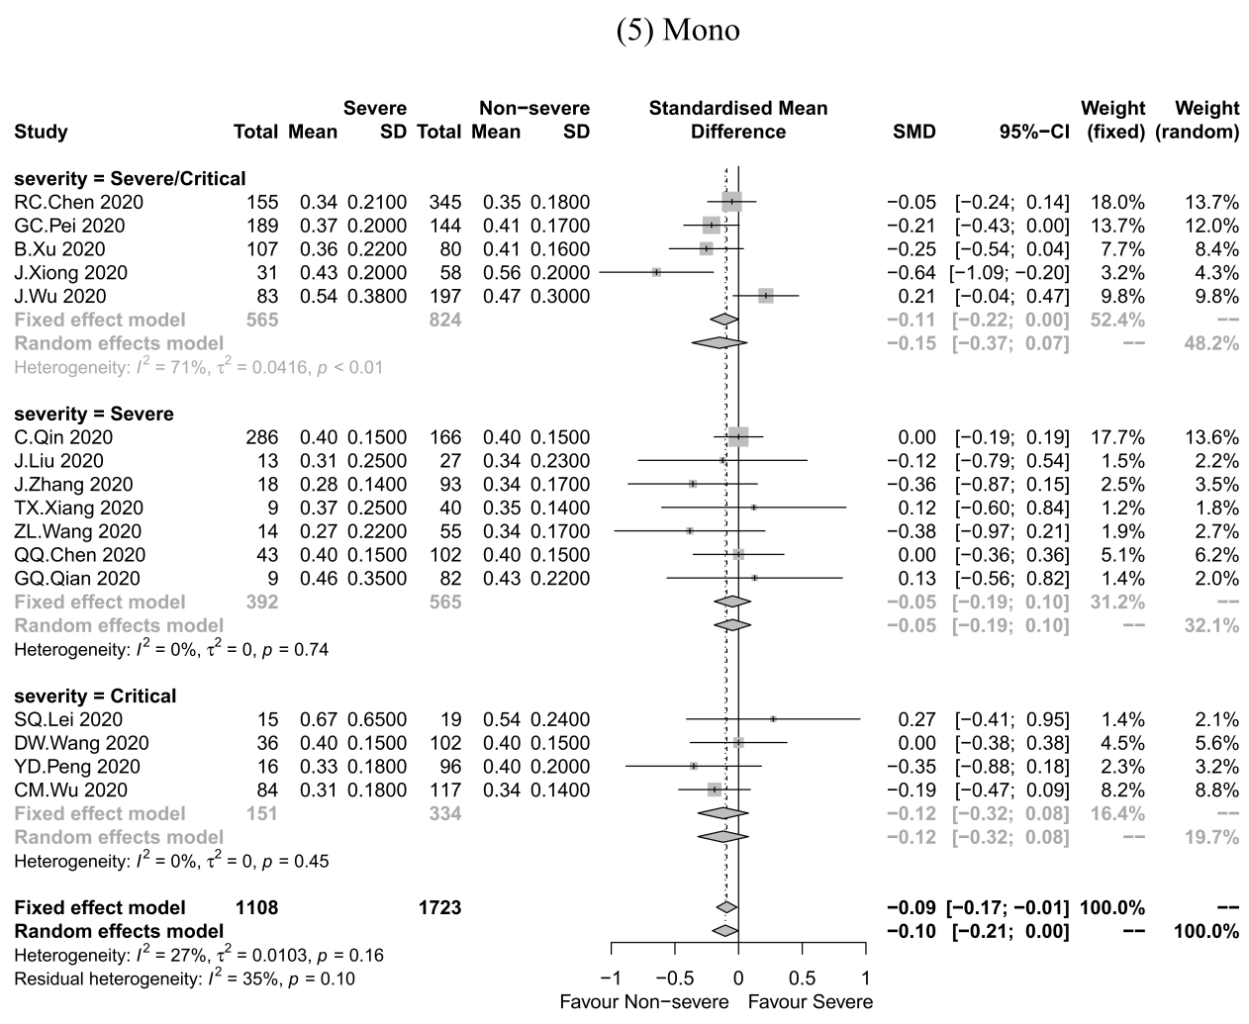
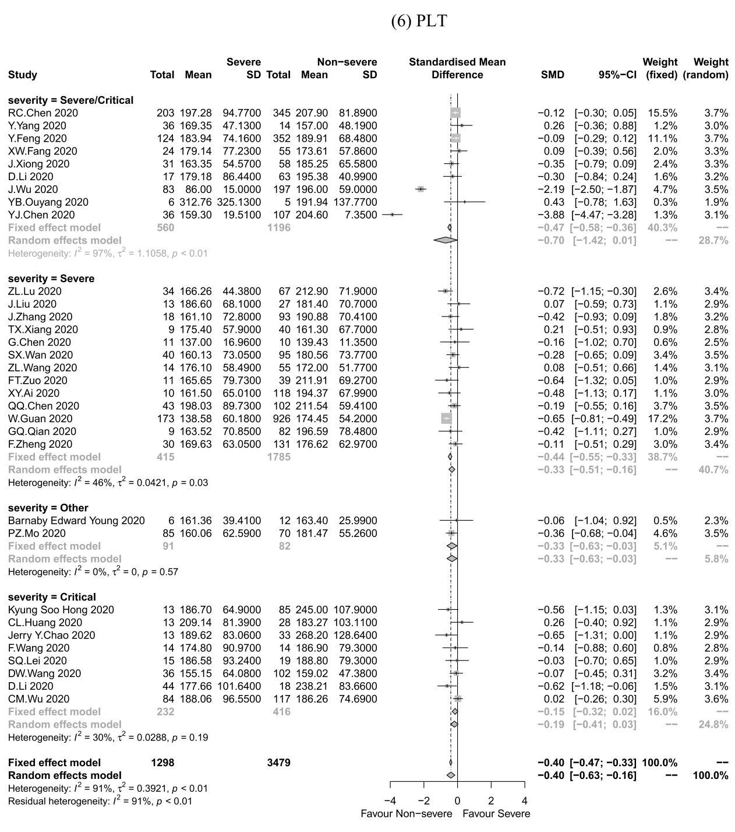
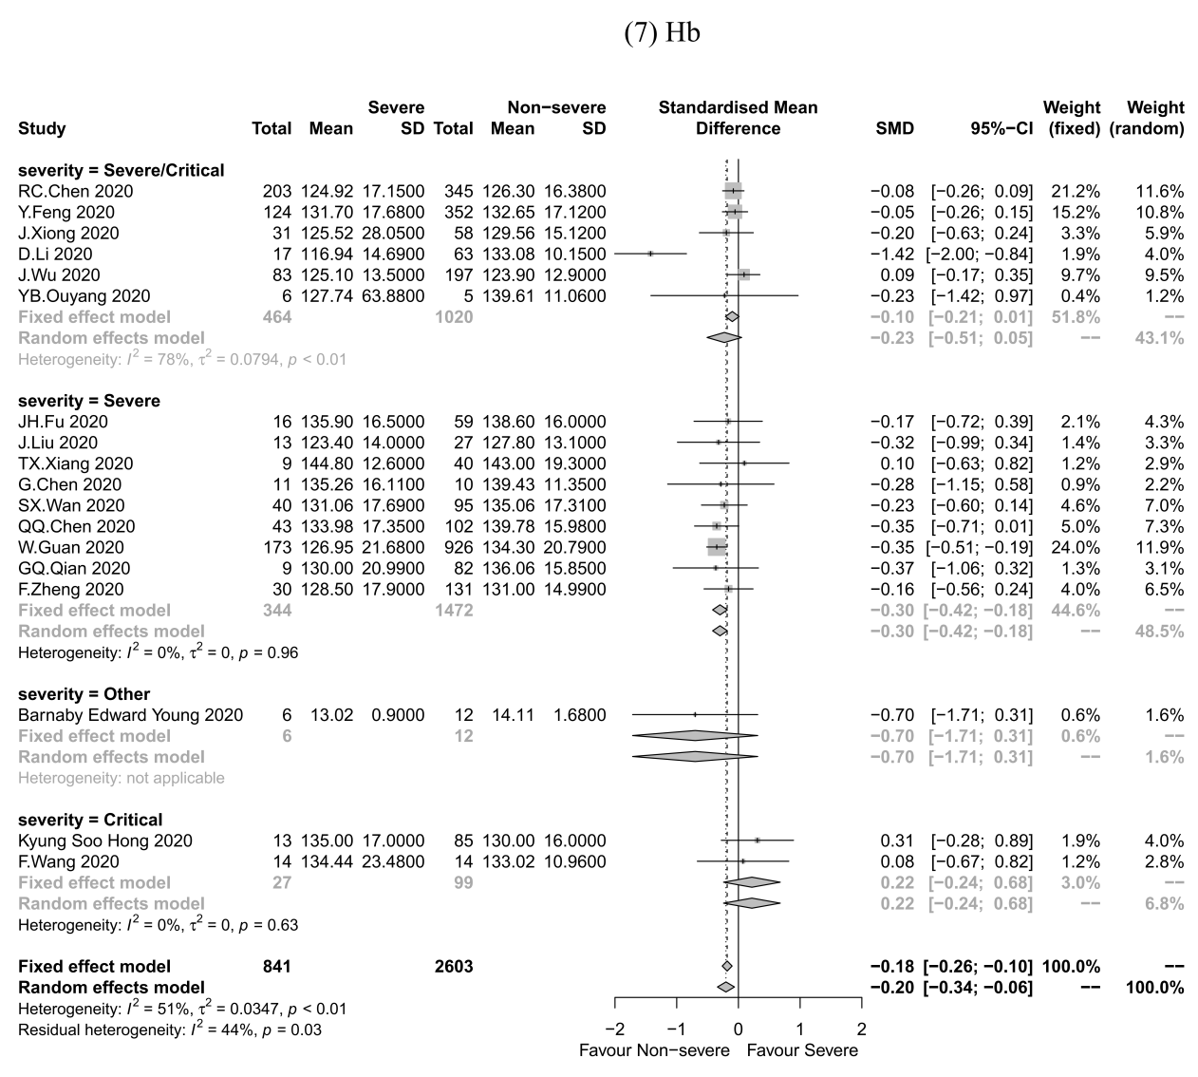

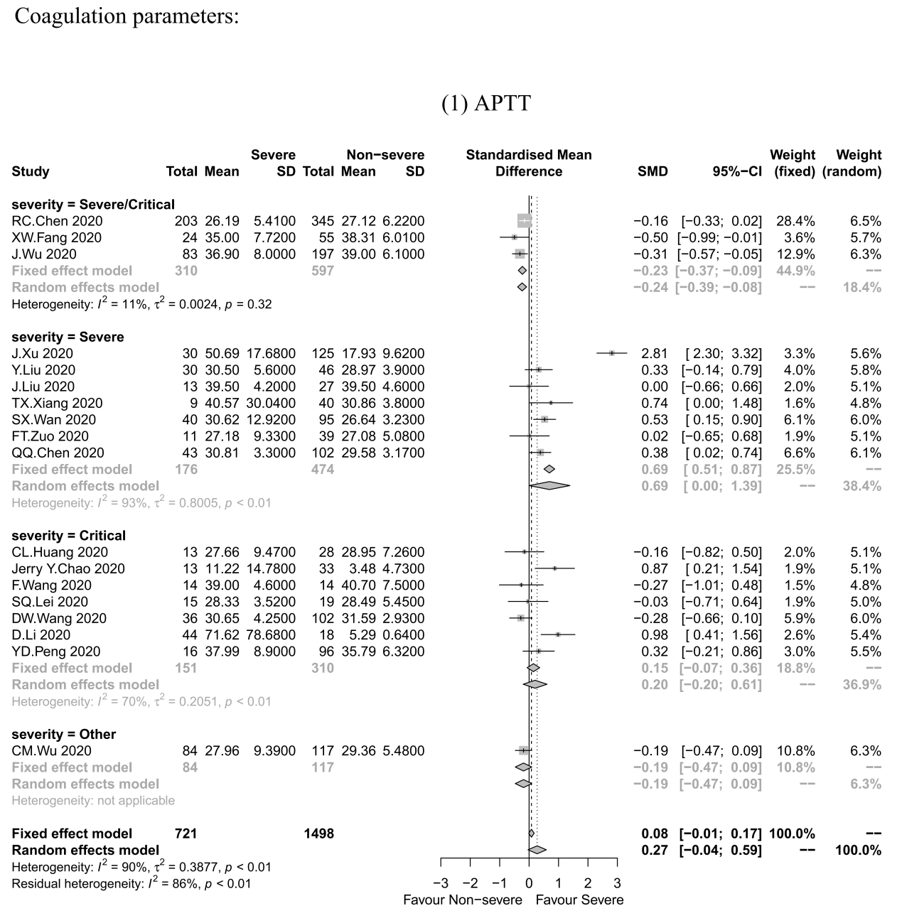
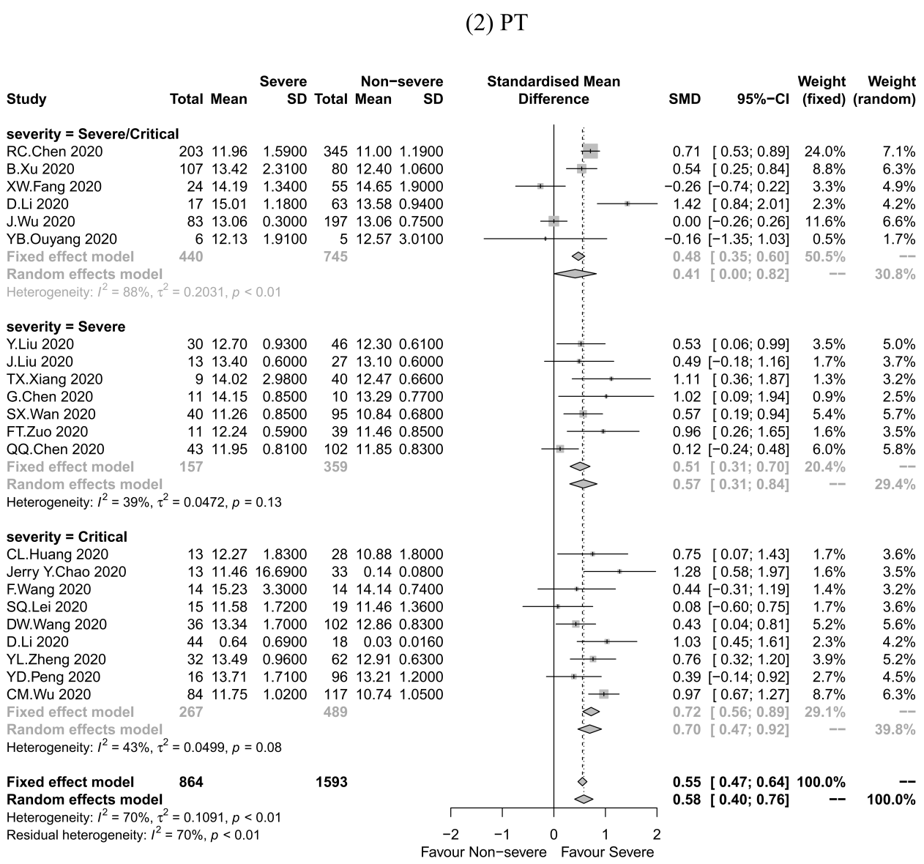

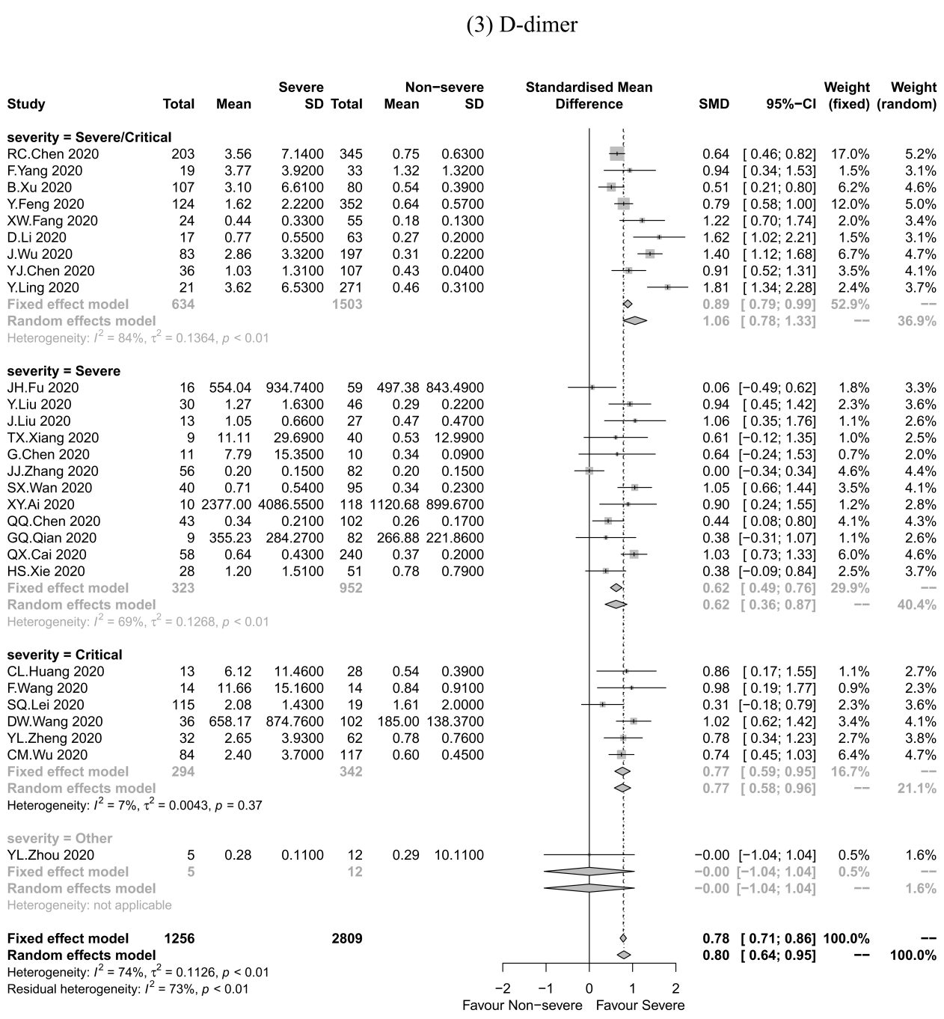

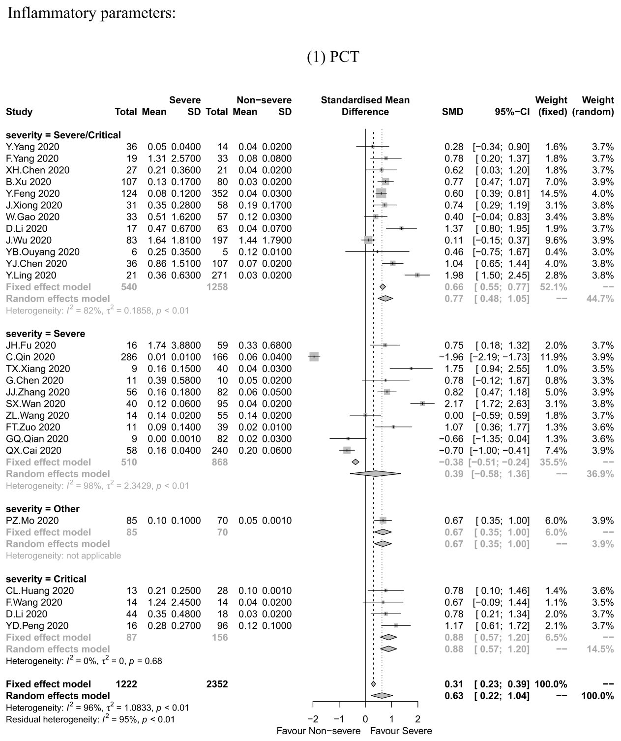

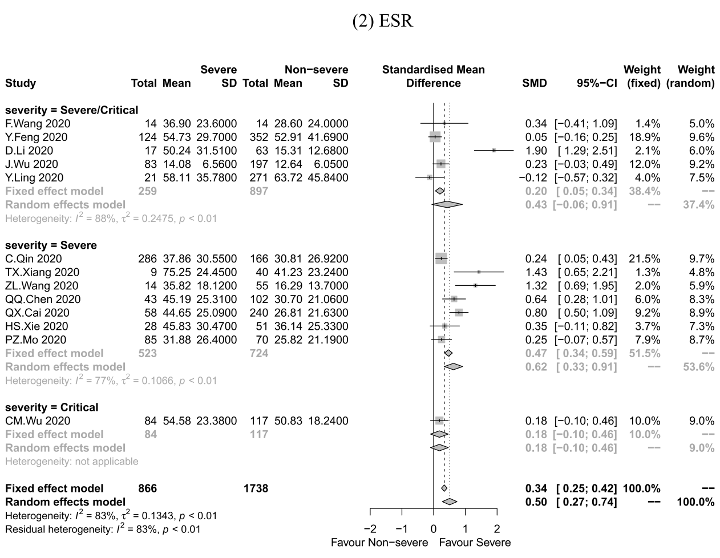

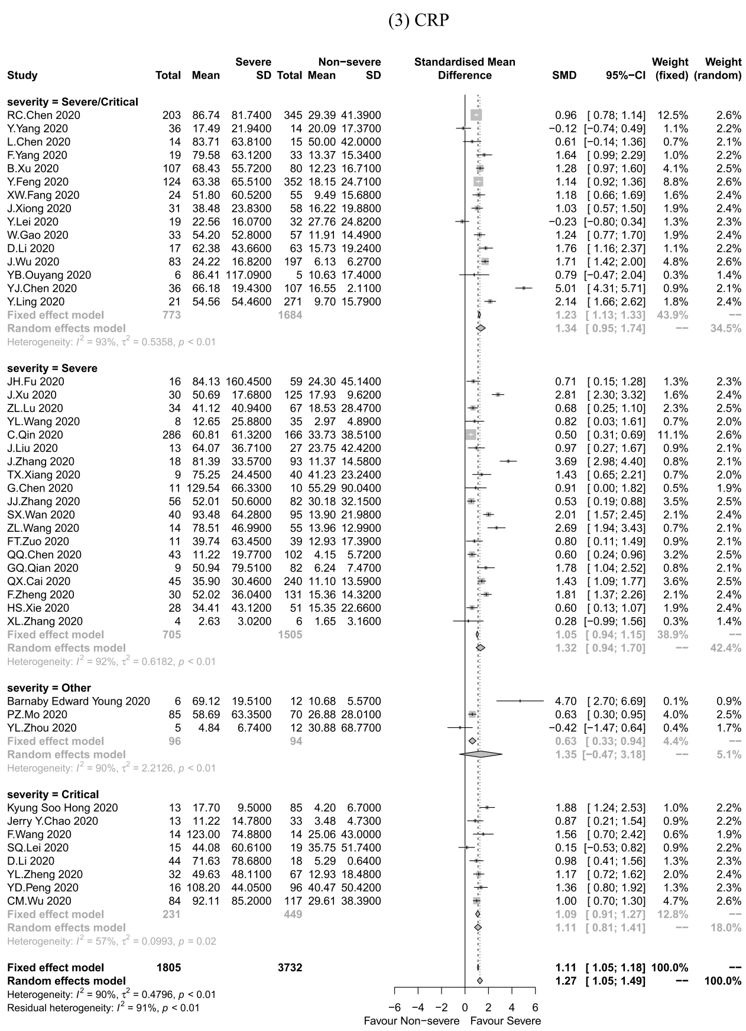
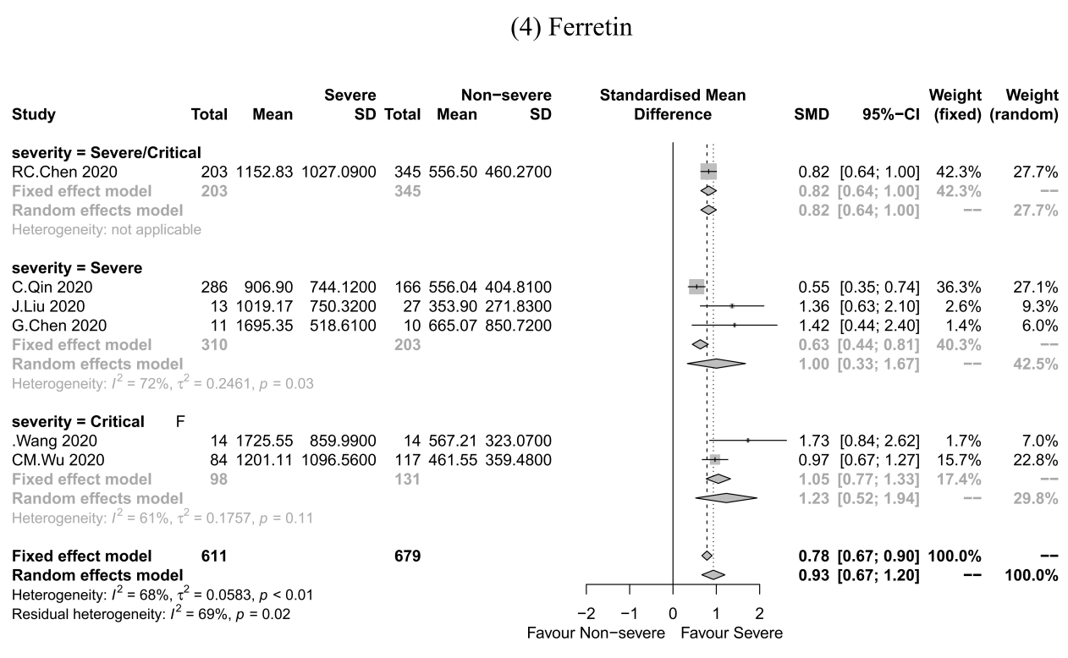

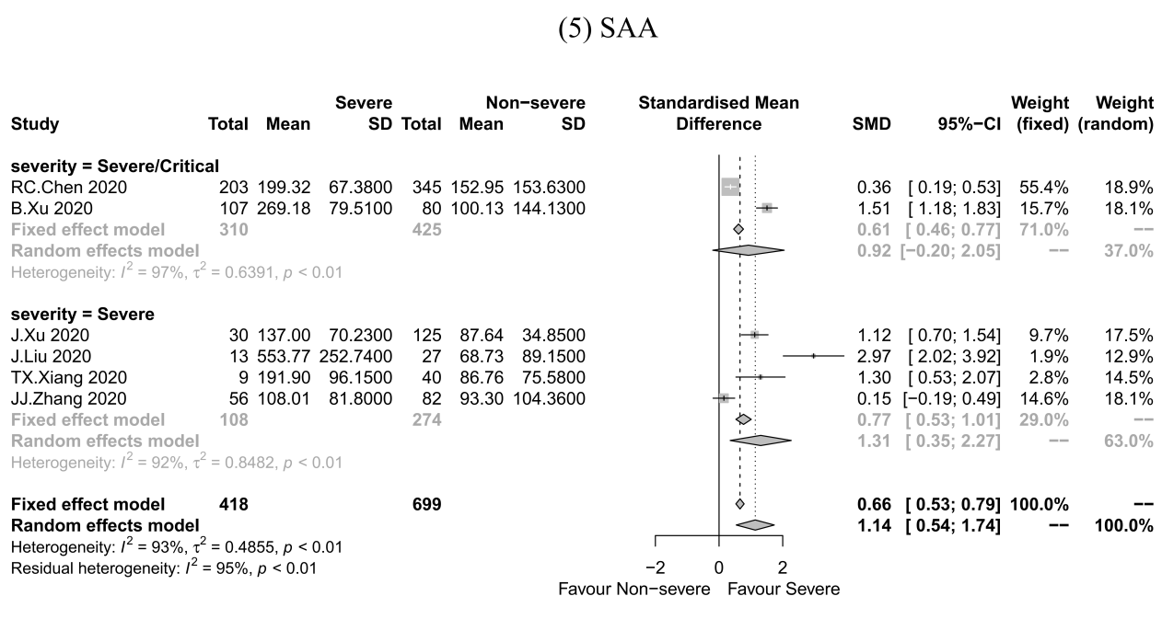

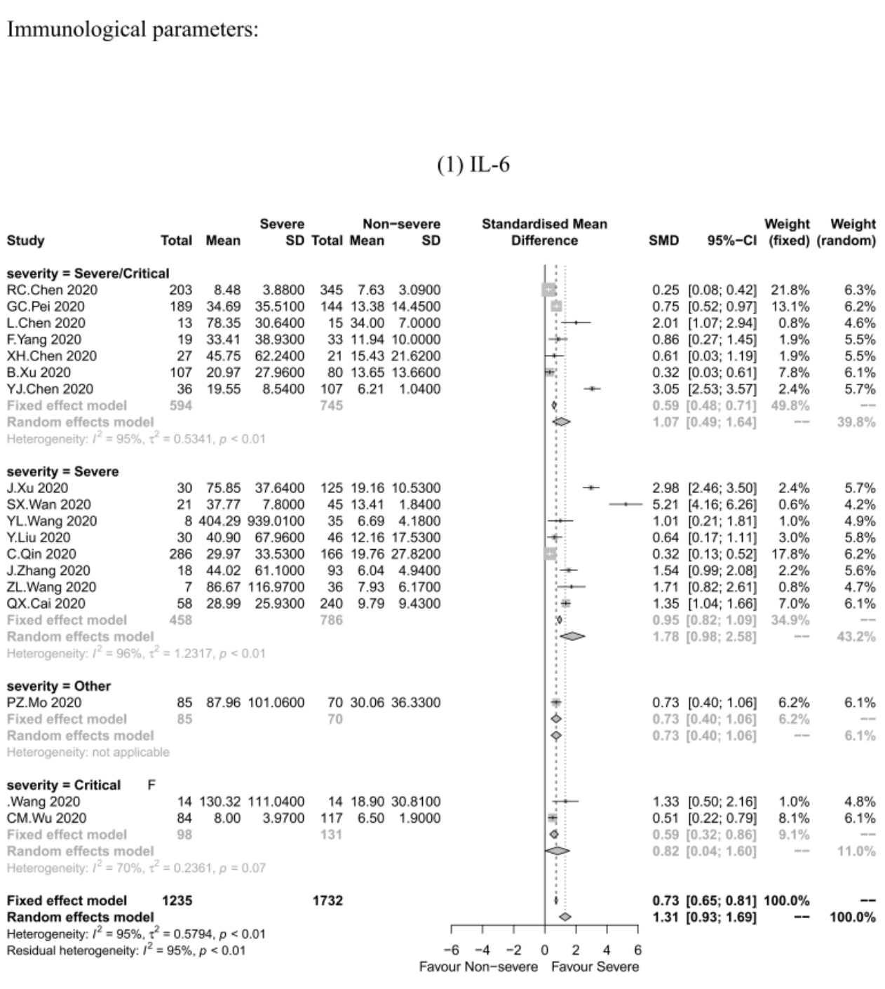

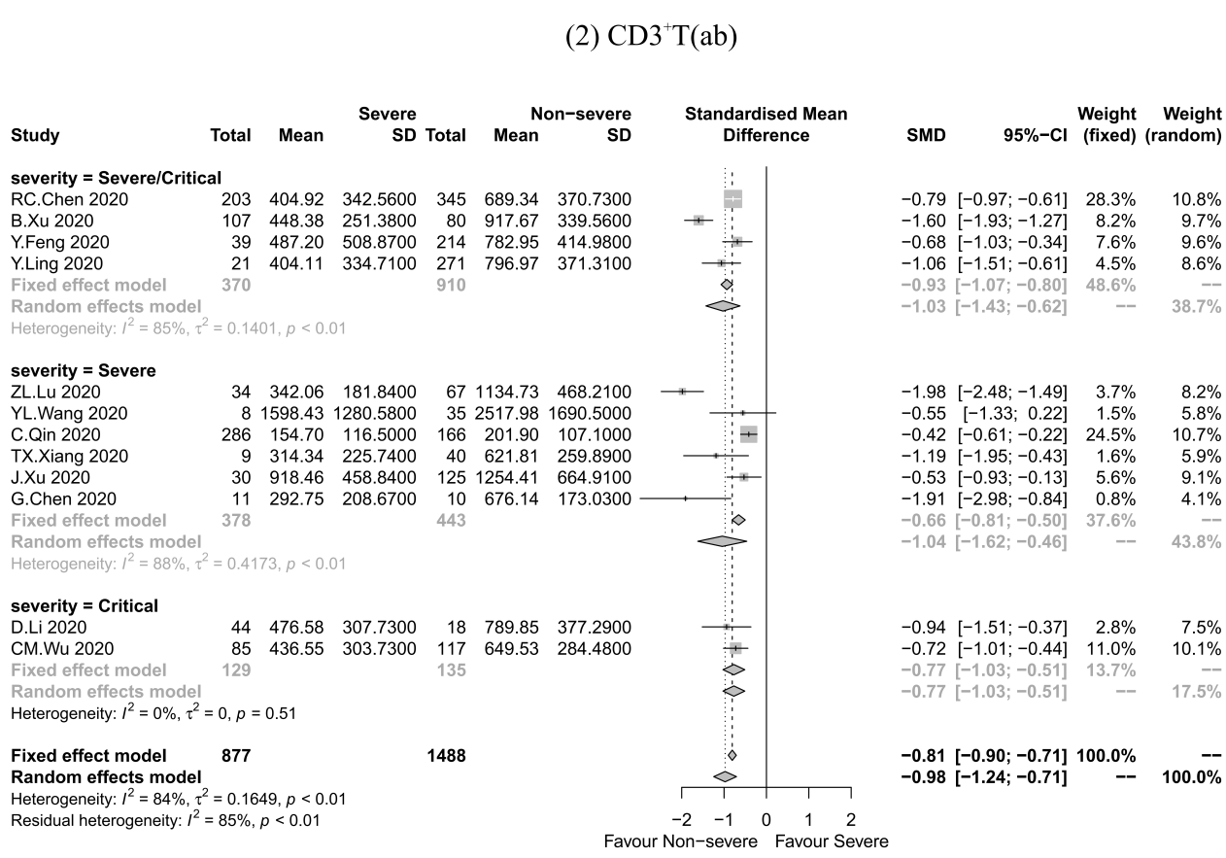

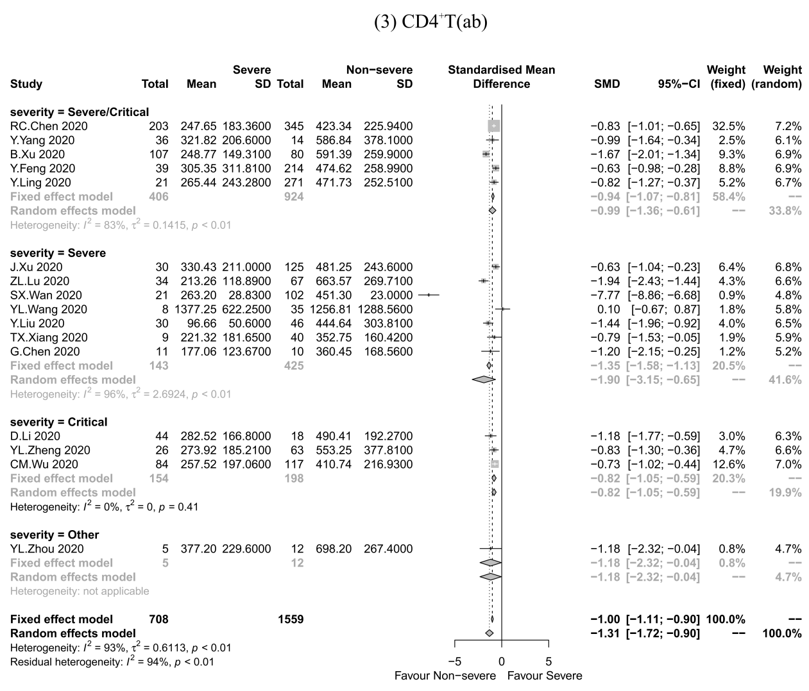

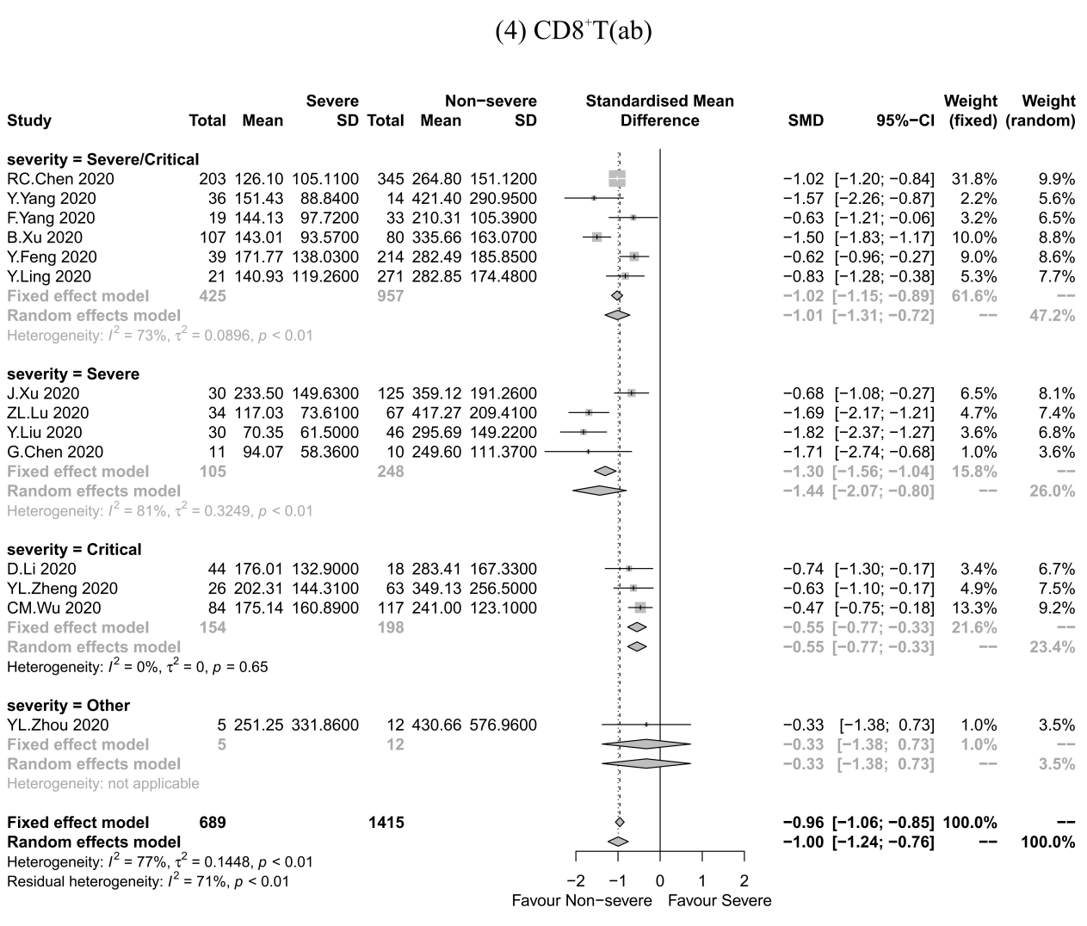

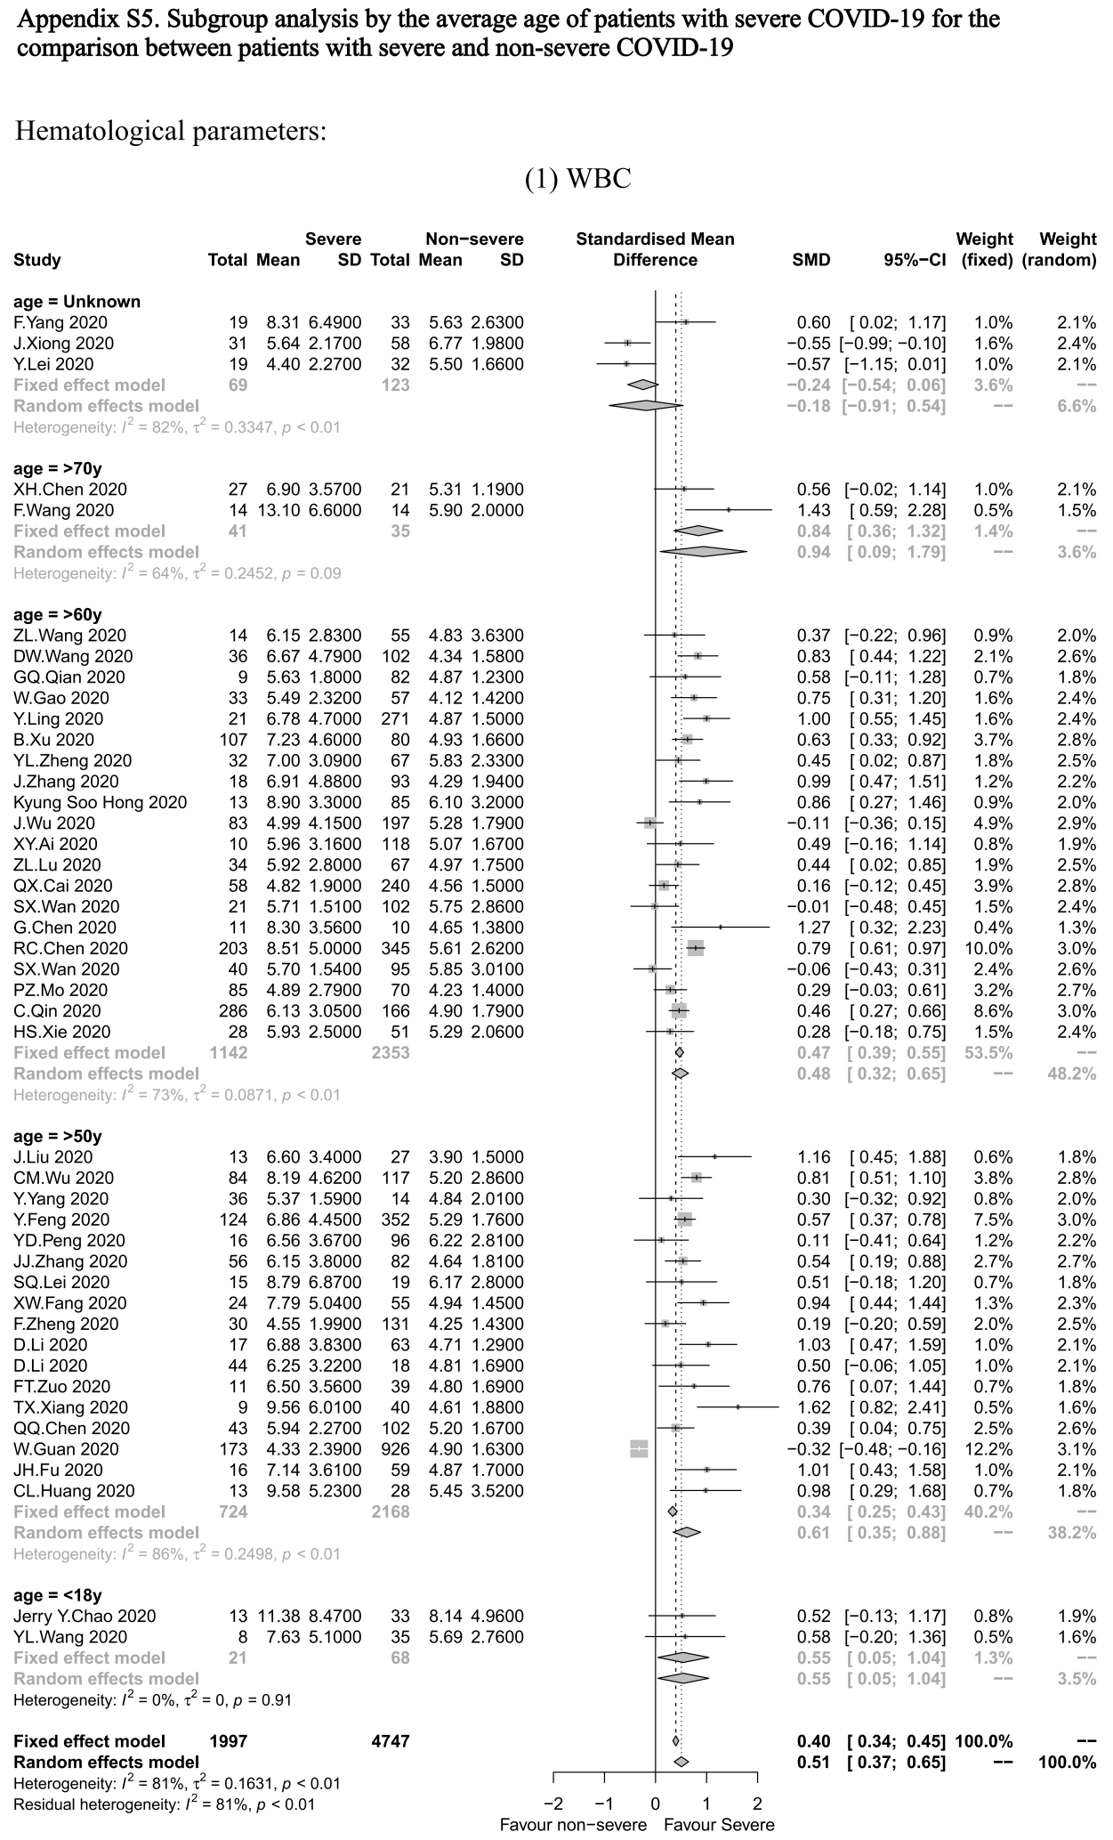

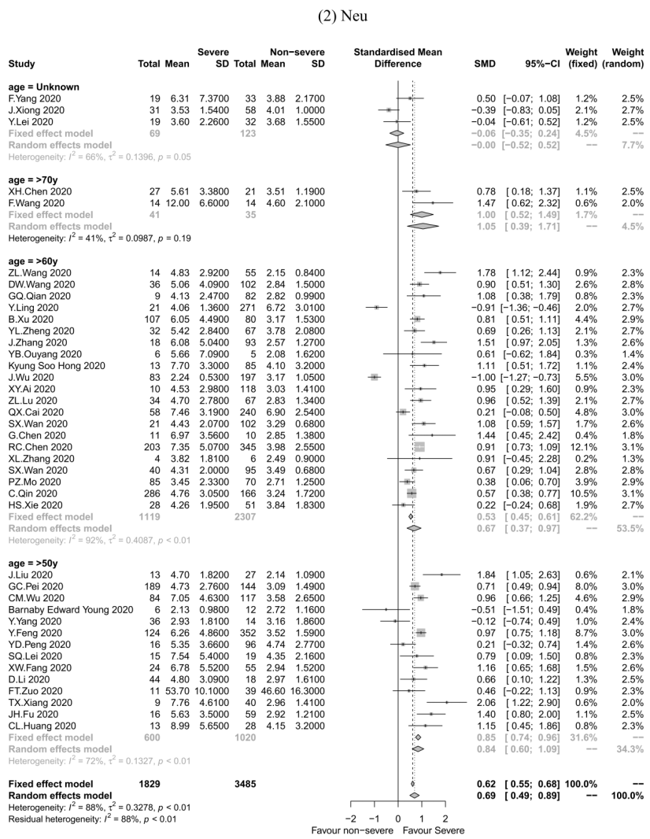
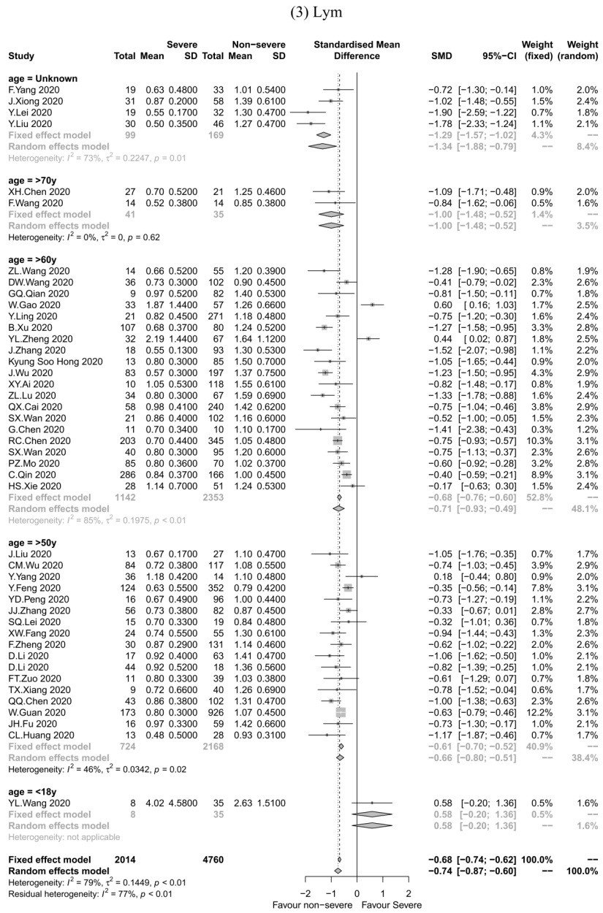
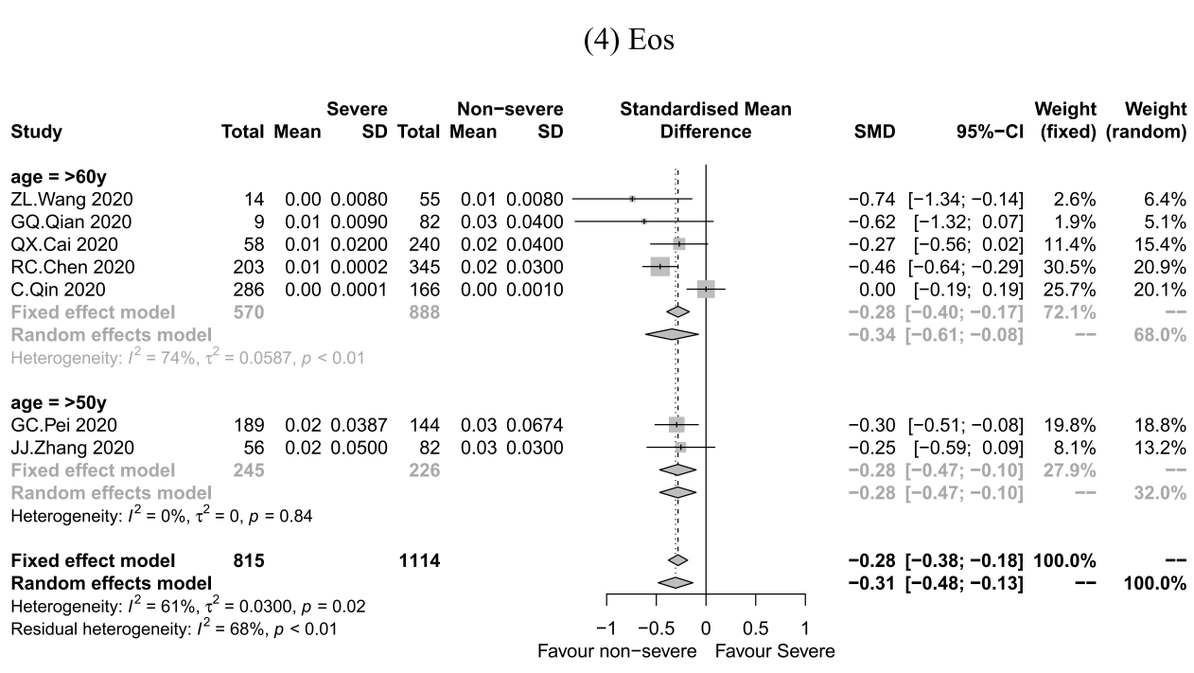
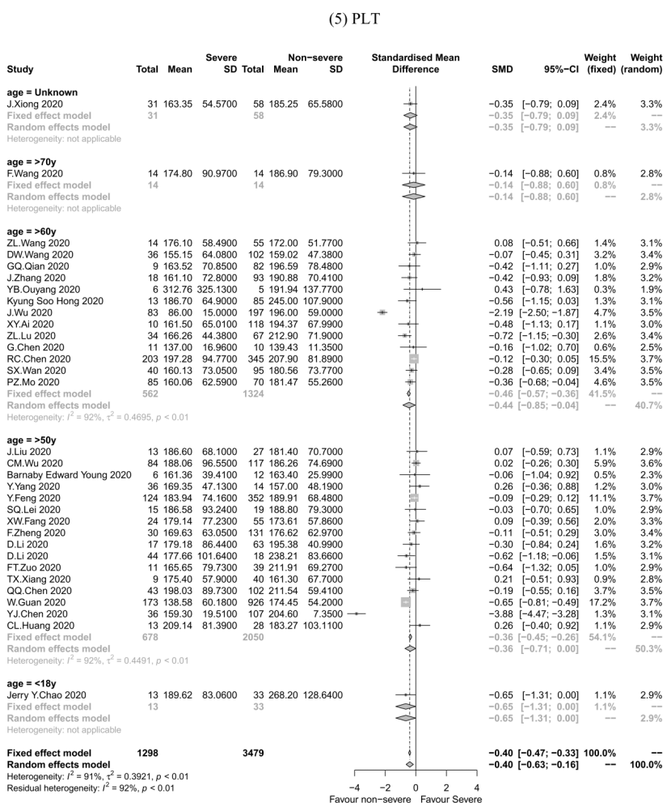
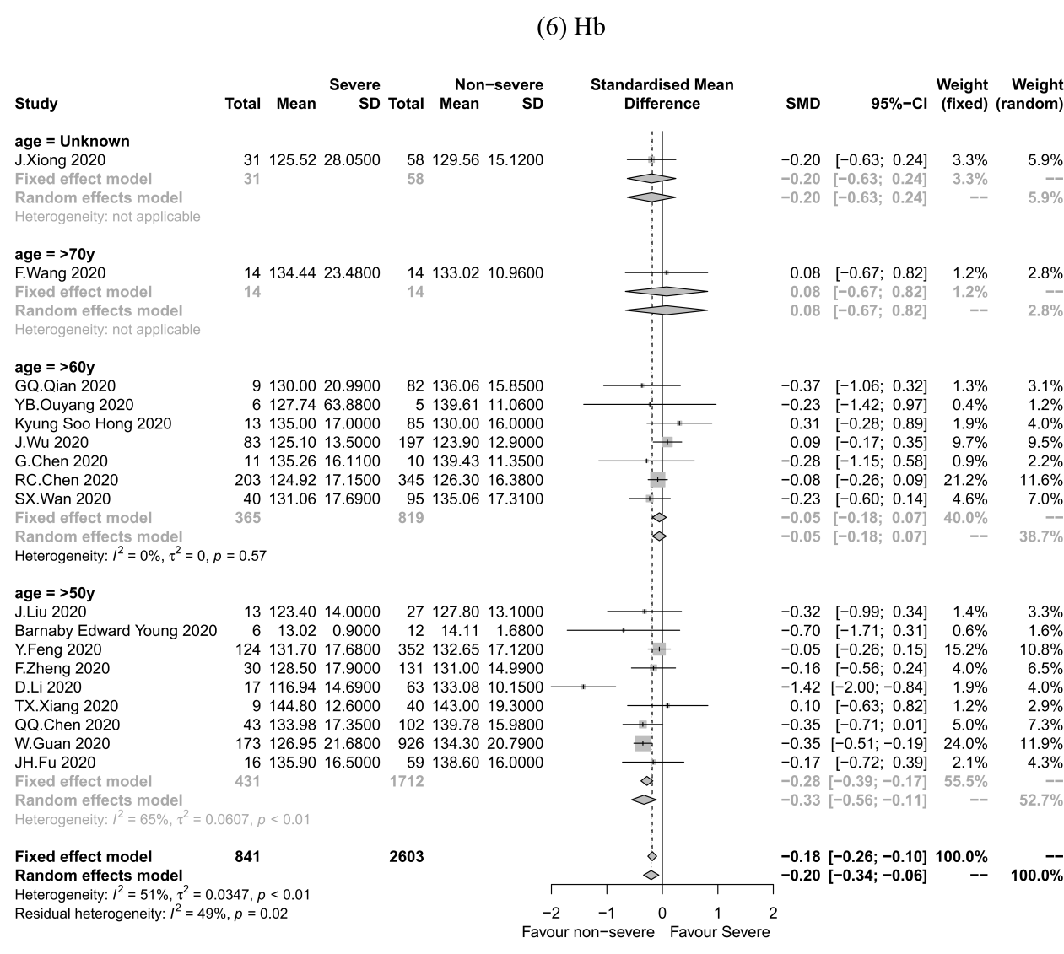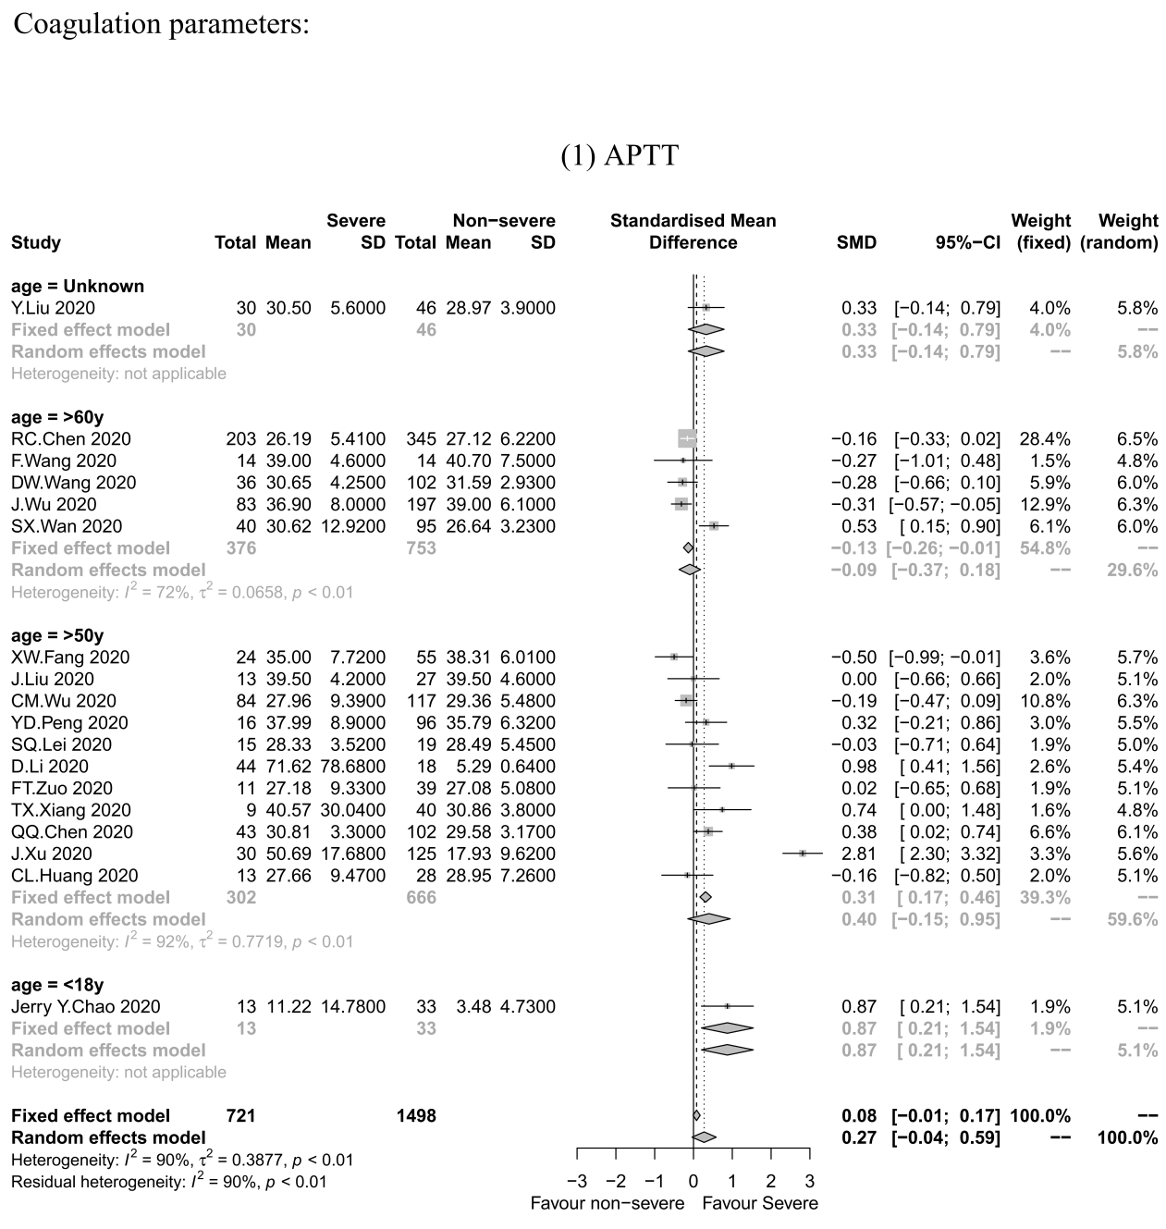
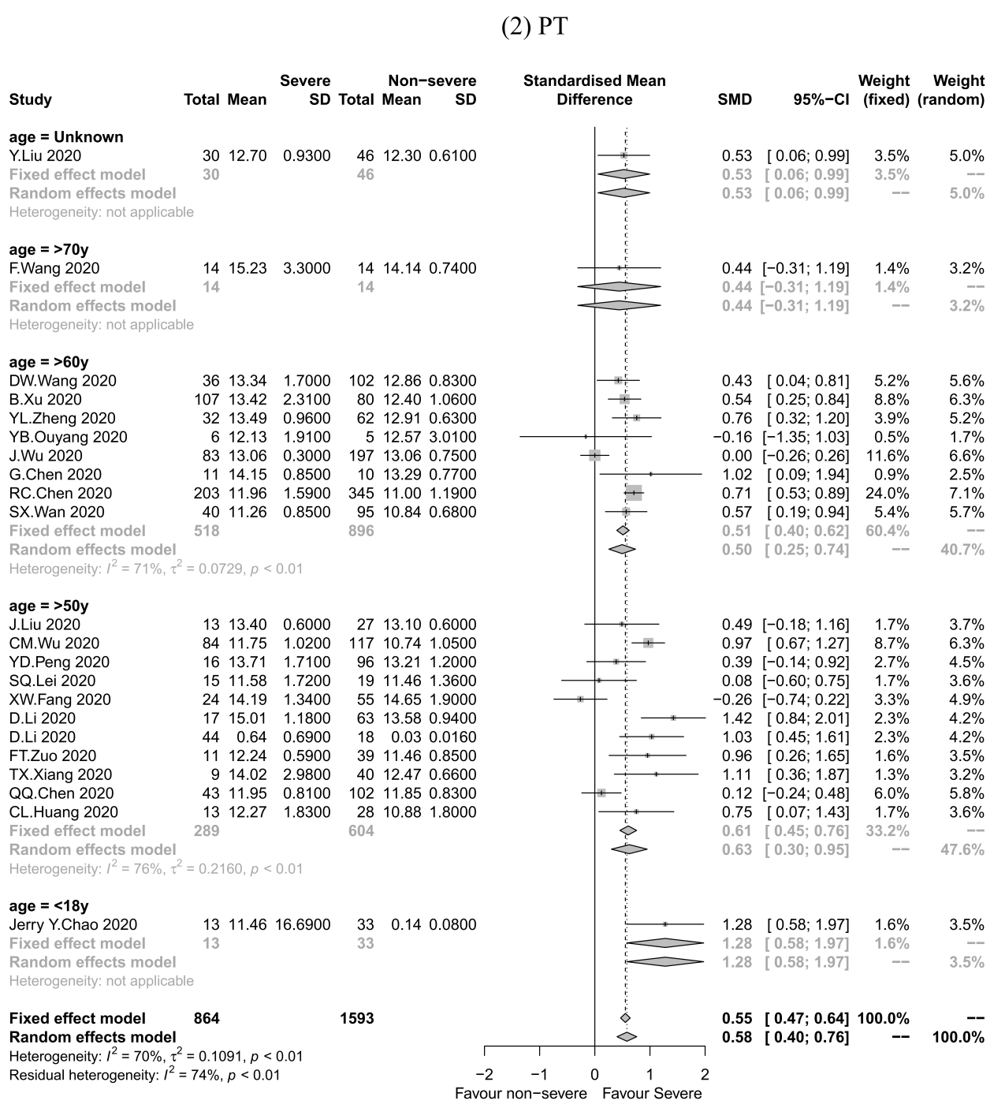
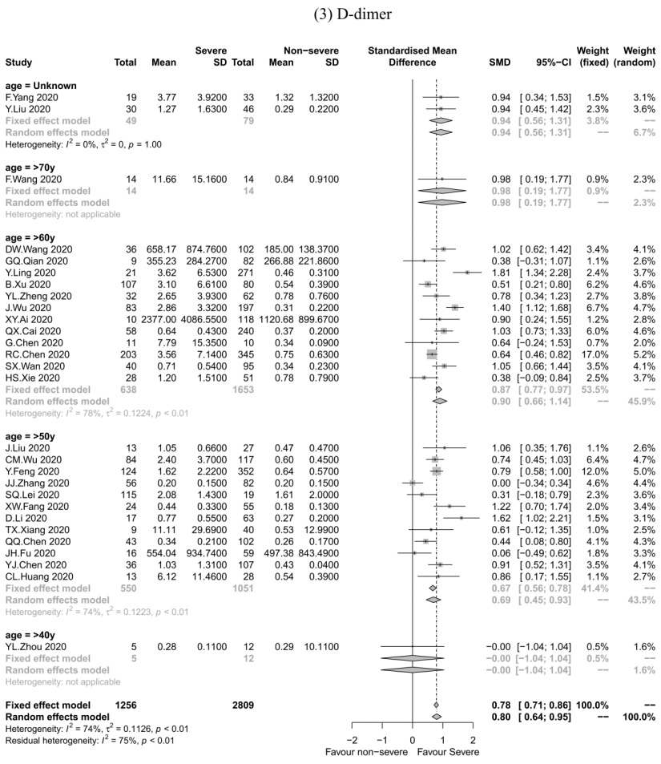
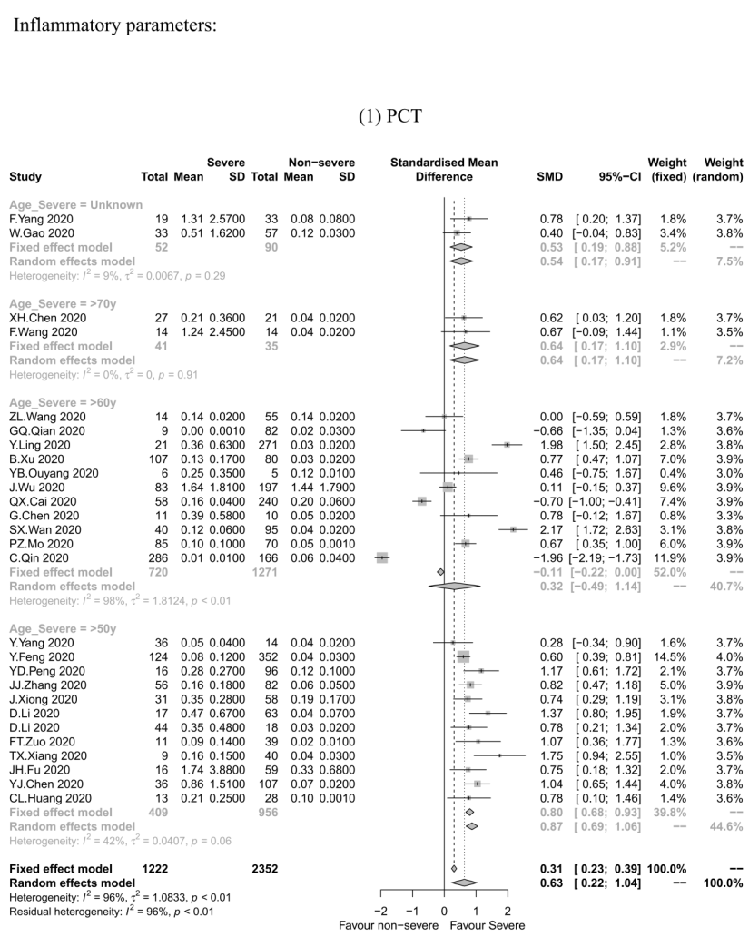
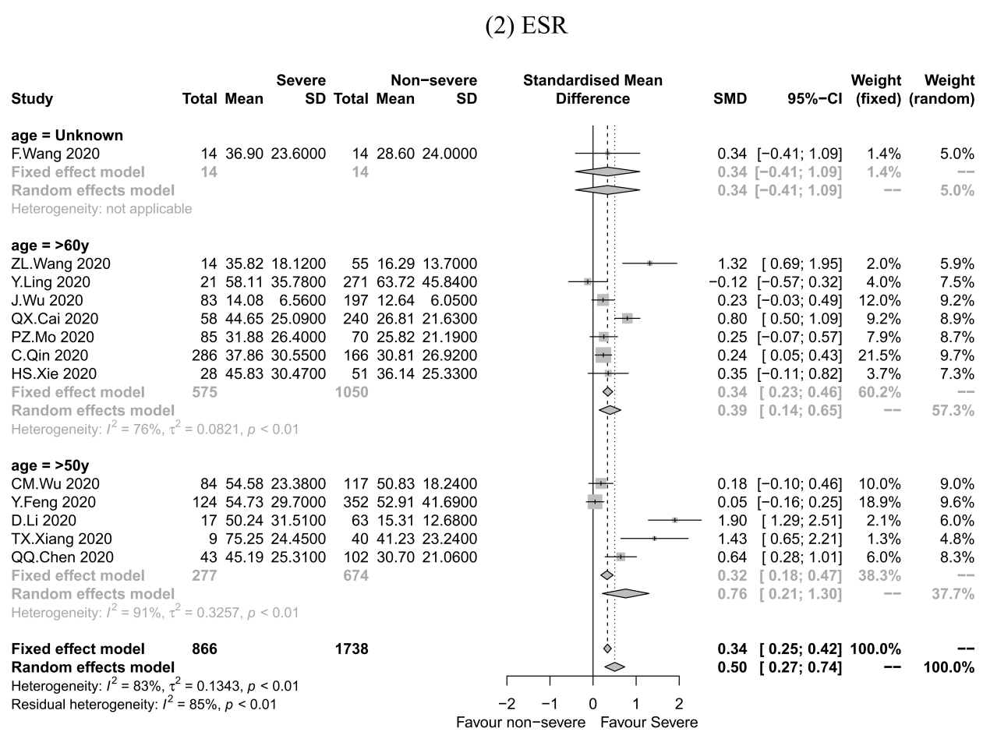
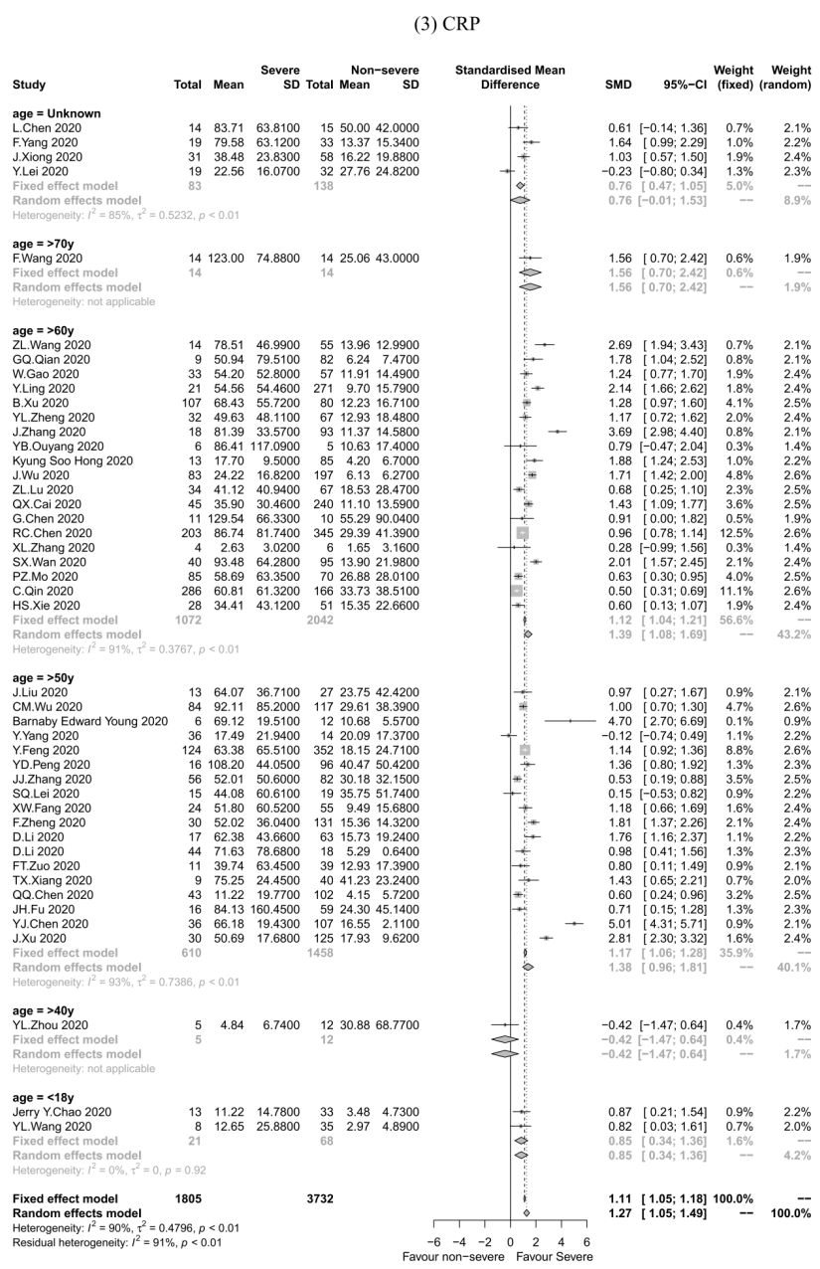

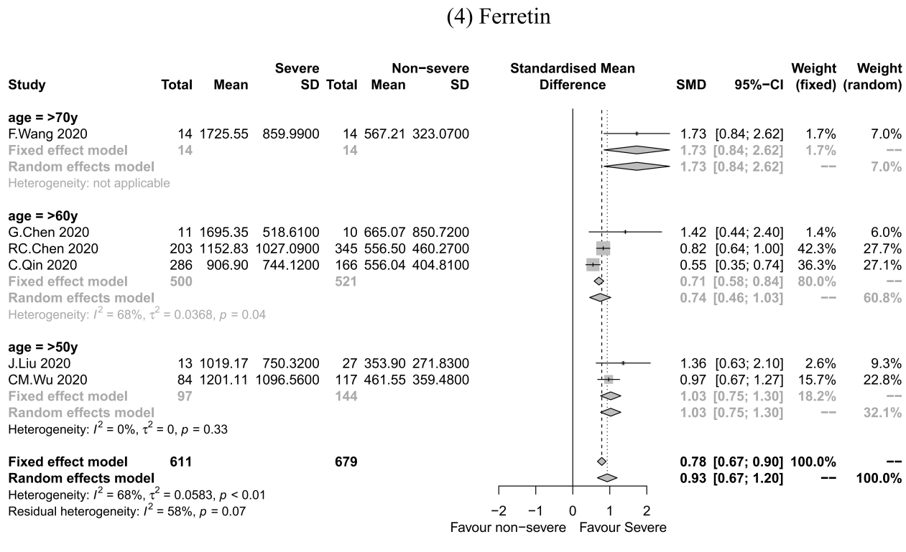

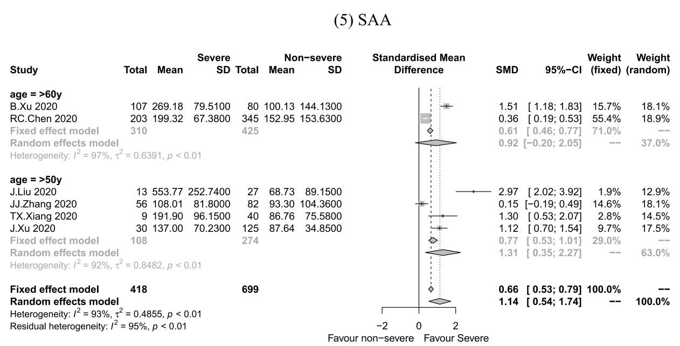
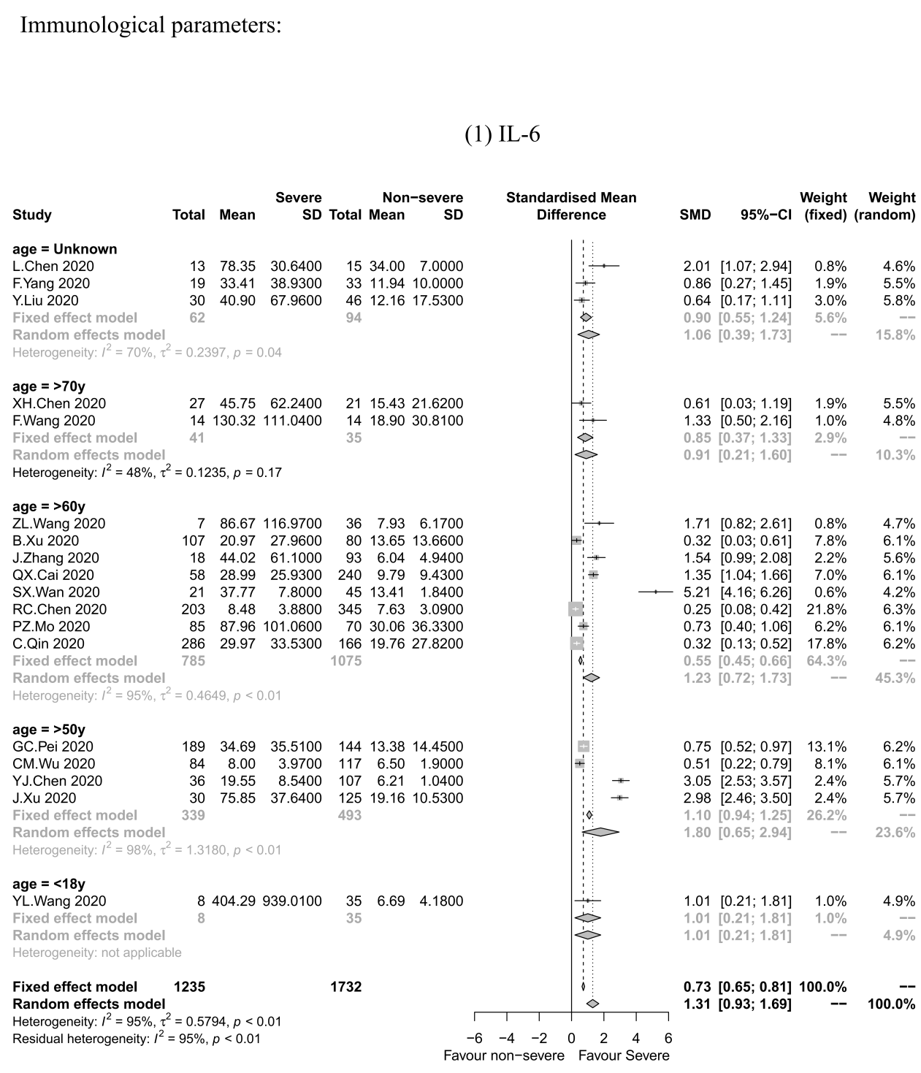
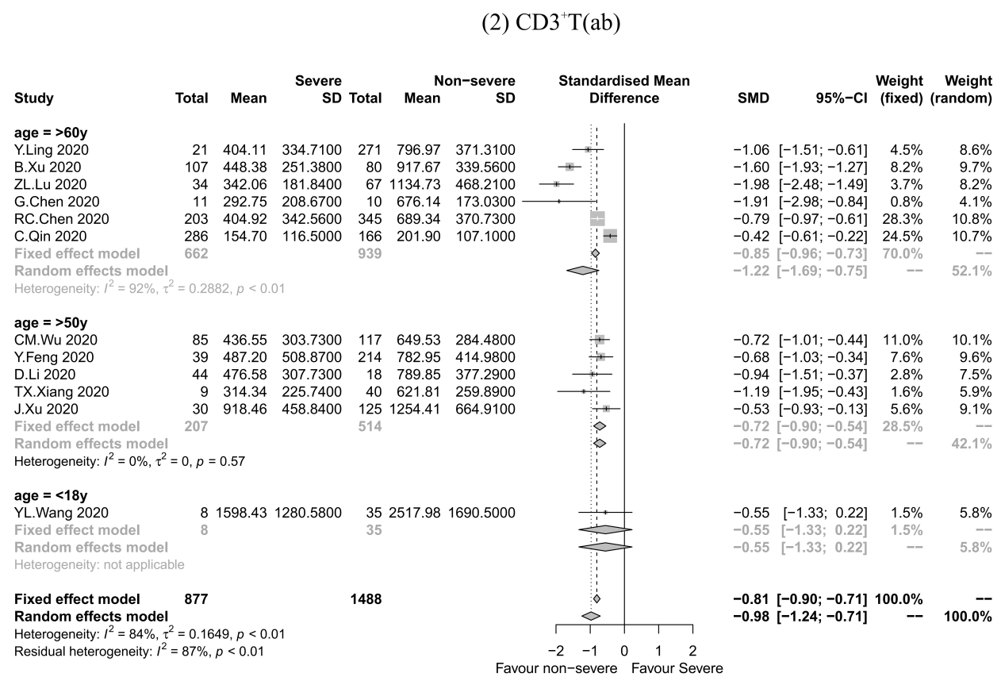

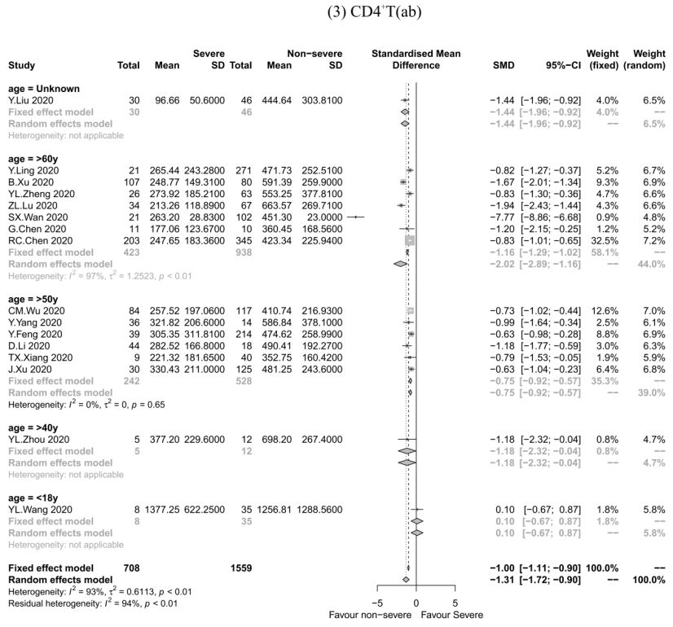
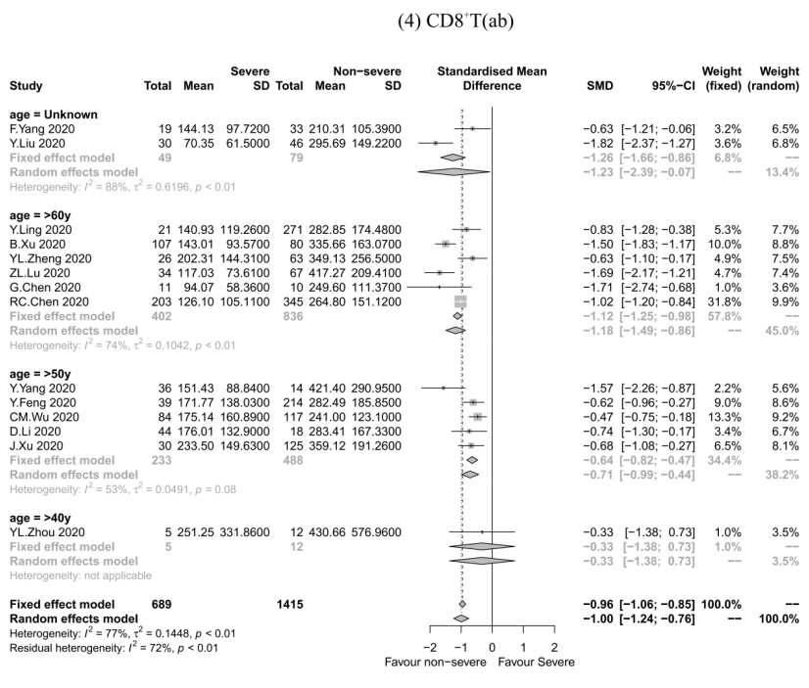

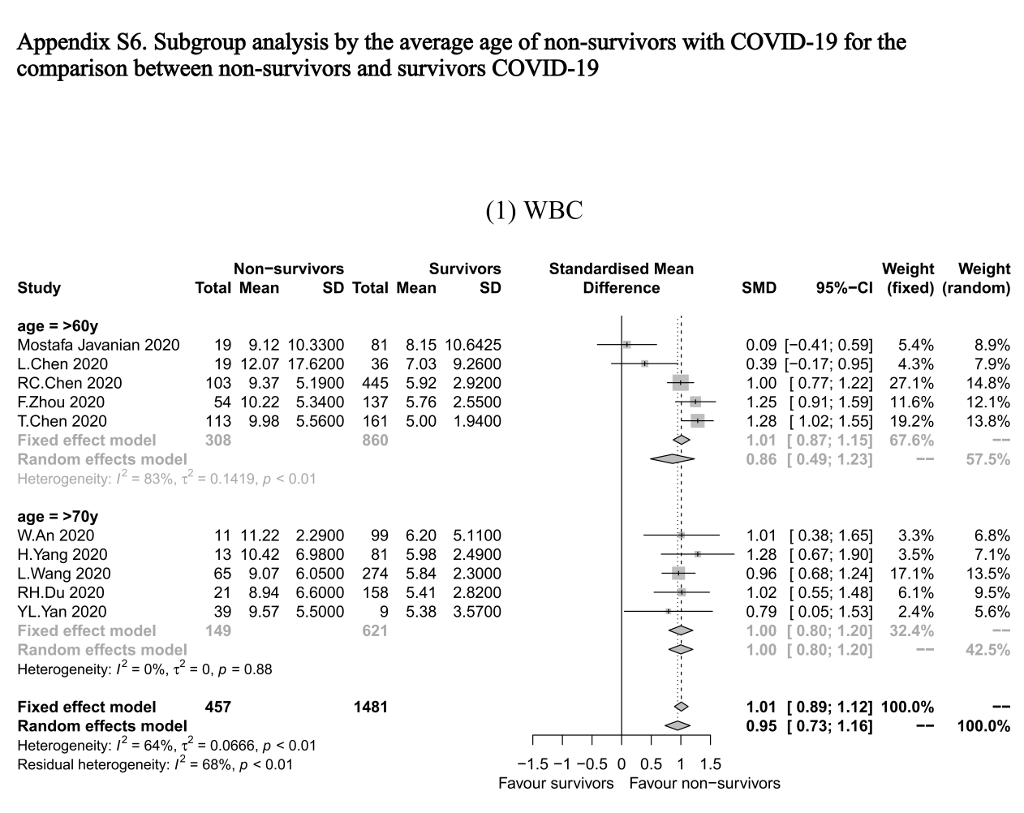

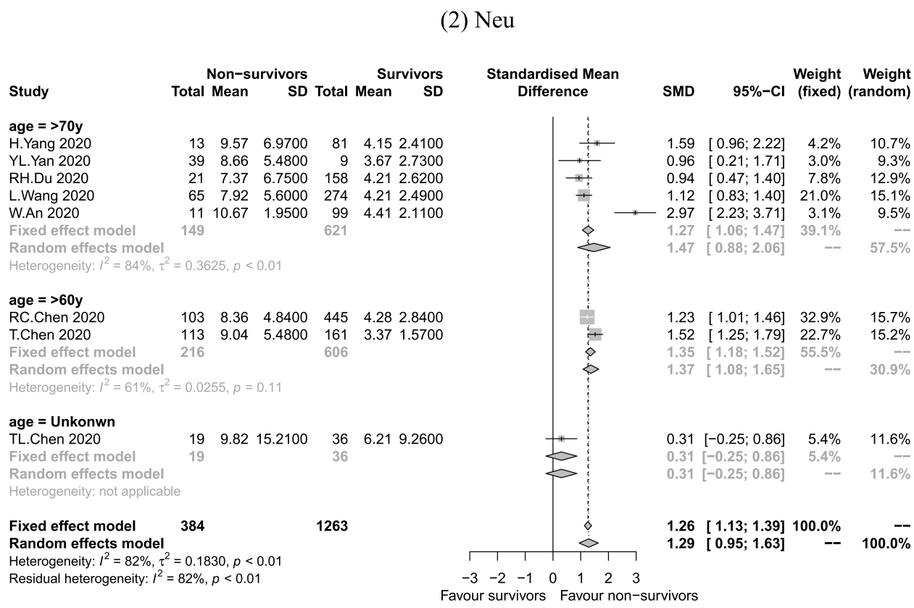
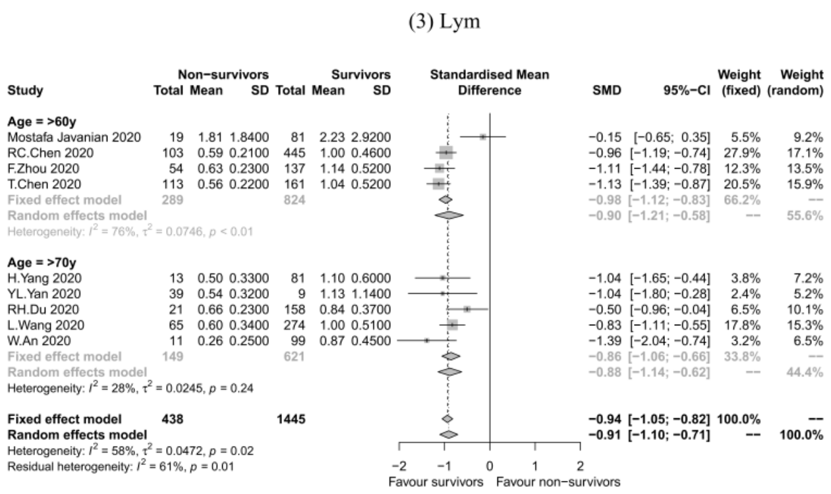

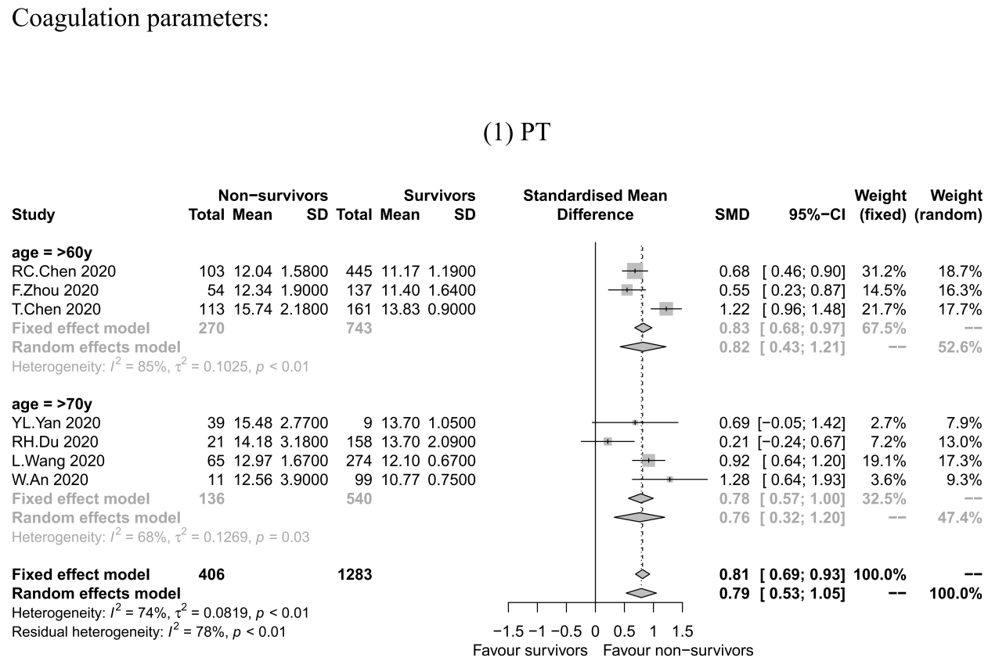
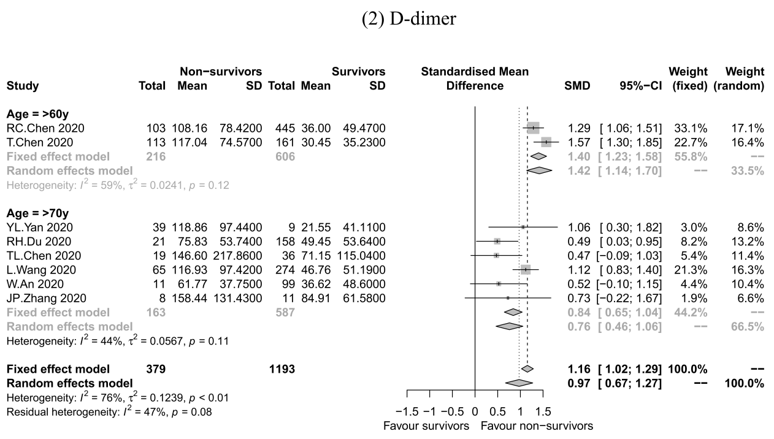

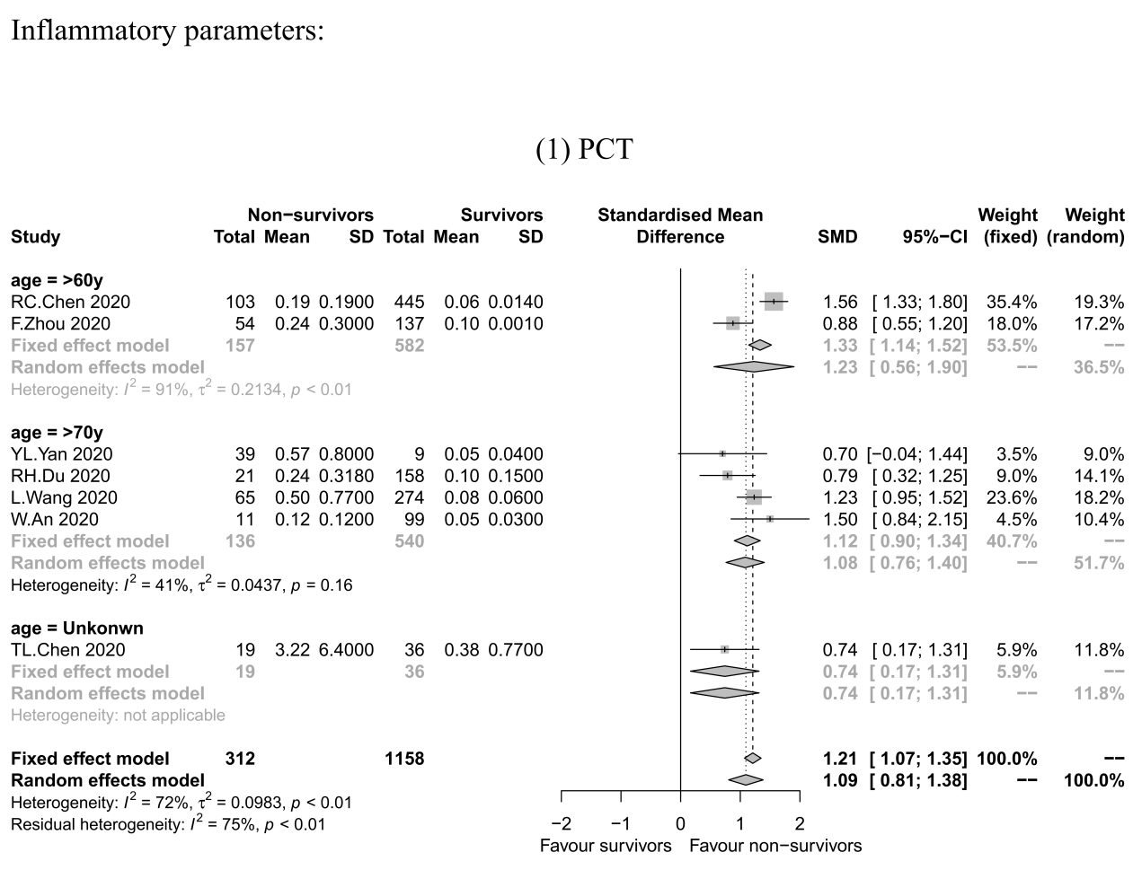
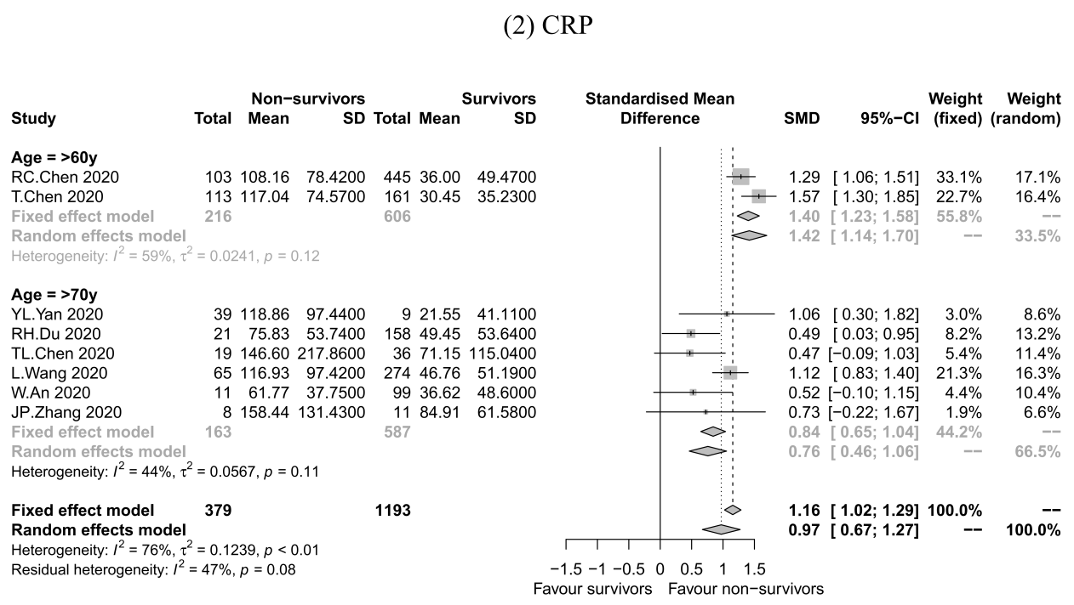

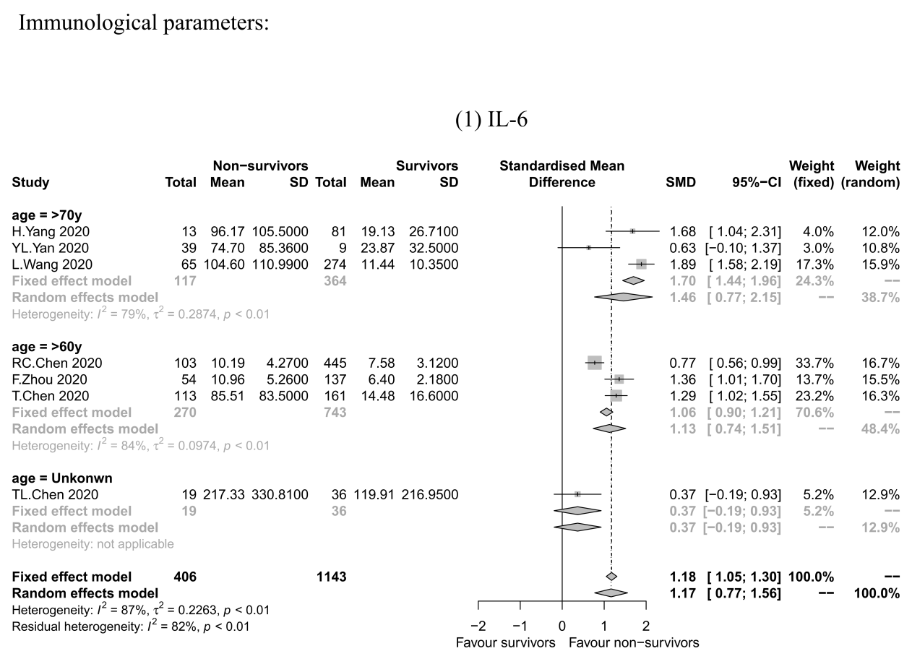

Appendix S7 Funnel plots of variables included in meta-analysis for patients with severe and non-severe COVID-19.
(A₁-A₆) funnel plots of hematological variables; (B₁-B₃) funnel plots of coagulation variables; (C₁-C₃) funnel plots of inflammatory variables; (D₁-D₄) funnel plots of immunological variables. Note: only variables with at least ten reported articles were applied for the publication bias analysis. Abbreviations: WBC, peripheral white blood cell count; Neu, peripheral neutrophil absolute count; Lym, peripheral lymphocyte absolute count; Hb, hemoglobin; PLT, platelet; APTT, activated partial thromboplastin time; PT, prothrombin time; CRP, c-reactive protein; ESR, erythrocyte sedimentation rate; PCT, procalcitonin; IL-6, interleukin-6; CD3+T, CD3 positive T lymphocyte; CD4+T, CD4 positive T lymphocyte; CD8+T, CD8 positive T lymphocyte; ab, absolute count.

Appendix Table S1 Meta-regression for pre-combined severity of patients with severe COVID-19

Disease severity | WBC | Neu*** | Lym | Mono | Hb | PLT
Critical (Reference) | 1 | 1 | 1 | 1 | 1 | 1
Severe | −0.211 | 0.024 | −0.188 | 0.040 | −0.477 | −0.074
Severe/Critical | −0.215 | −0.505 | −0.187 | −0.023 | −0.383 | −0.496
Other | −0.129 | −1.251** | −0.009 | NA | −0.914 | −0.018
Disease severity | aPTT | PT | D-dimer | CRP | ESR | Ferretin
Critical (Reference) | 1 | 1 | 1 | 1 | 1 | 1
Severe | 0.626 | −0.078 | −0.153 | 0.203 | 0.463 | −0.253
Severe/Critical | −0.096 | −0.272 | 0.279 | 0.227 | 0.223 | −0.426
Other | −0.261 | NA | −0.772 | −0.125 | NA | NA
Disease severity | PCT | IL-6 | CD3⁺ T (ab) | CD4⁺ T (ab) | CD8⁺ T (ab)
Critical (Reference) | 1 | 1 | 1 | 1 | 1
Severe | −0.479 | −0.868 | −0.289 | −1.028 | −0.861
Severe/Critical | −0.086 | 0.202 | −0.289 | −0.239 | −0.441
Other | −0.181 | −0.150 | NA | −0.403 | 0.215
Disease severity | SAA | EOS
Severe (Reference) | 1 | 1
Severe/Critical | 1.122 | −0.140

Data expressed as estimates of meta-regression model. Statistical significance is marked in bold. ***, ** indicates P<0.001 and <0.01, respectively. Only the variables with large heterogeneity (I²>50%) and greater than five reported articles were applied for the meta-regression. Abbreviations: WBC, peripheral white blood cell count; Neu, peripheral neutrophil absolute count; Lym, peripheral lymphocyte absolute count; Mono, peripheral monocyte absolute count; Hb, hemoglobin; PLT, platelet; APTT, activated partial thromboplastin time; PT, prothrombin time; CRP, c-reactive protein; ESR, erythrocyte sedimentation rate; PCT, procalcitonin; IL-6, interleukin-6; CD3+T, CD3 positive T lymphocyte; CD4+T, CD4 positive T lymphocyte; CD8+T, CD8 positive T lymphocyte; ab, absolute count; SAA, serum amyloid A; EOS, eosinophil; NA, not applicable.

Appendix Table S2 Meta-regression for average age of patients with severe COVID-19

Age groups | WBC | Lym*** | PLT | aPTT | PT | D-dimer
<18y | 1 | 1 | 1 | 1 | 1 | 1
>50y | 0.051 | −1.258* | 0.299 | −0.474 | −0.658 | 0.693
>60y | −0.054 | −1.289* | 0.212 | −0.967 | −0.778 | 0.902
>70y | 0.376 | −1.566* | 0.517 | NA | −0.834 | 0.979
Age groups | CRP | IL-6 | CD3⁺ T(ab) | CD4⁺ T(ab) | CD8⁺ T(ab)
<18y | 1 | 1 | 1 | 1 | 1
>50y | 0.515 | 0.770 | −0.227 | −0.916 | −0.419
>60y | 0.545 | 0.264 | −0.640 | −2.052* | −0.851
>70y | 0.710 | −0.058 | NA | NA | NA
Age groups | Neu | EOS | Hb | Mono* | ESR | Ferretin
>50y | 1 | 1 | 1 | 1 | 1 | 1
>60y | −0.178 | −0.055 | 0.253 | 0.112* | −0.294 | −0.329
>70y | 0.243 | NA | 0.392 | NA | NA | 0.665
Age groups | PCT | SAA
>50y | 1 | 1
>60y | −0.605 | −0.373
>70y | −0.278 | NA

Data expressed as estimates of meta-regression model. Statistical significance is marked in bold. ***, **, * indicates P<0.001, <0.01, <0.05, respectively. Only the variables with large heterogeneity (I²>50%) and greater than five reported articles were applied for the meta-regression. Abbreviations: WBC, peripheral white blood cell count; Neu, peripheral neutrophil absolute count; Lym, peripheral lymphocyte absolute count; Mono, peripheral monocyte absolute count; Hb, hemoglobin; PLT, platelet; APTT, activated partial thromboplastin time; PT, prothrombin time; CRP, c-reactive protein; ESR, erythrocyte sedimentation rate; PCT, procalcitonin; IL-6, interleukin-6; CD3+T, CD3 positive T lymphocyte; CD4+T, CD4 positive T lymphocyte; CD8+T, CD8 positive T lymphocyte; ab, absolute count; SAA, serum amyloid A; EOS, eosinophil; NA, not applicable.

Appendix Table S3 Meta-regression for average age of non-survivors of COVID-19

Age groups | WBC | Neu | Lym | PCT
>60y (Reference) | 1 | 1 | 1 | 1
>70y | 0.131 | 0.072 | 0.005 | −0.167
Age groups | PT | D-dimer | CRP*** | IL-6
>60y (Reference) | 1 | 1 | 1 | 1
>70y | −0.061 | 0.197 | −0.653** | 0.374

Data expressed as estimates of meta-regression model. Statistical significance is marked in bold. ***, ** indicates P<0.001 and <0.01, respectively. Only the variables with large heterogeneity (I²>50%) and greater than five reported articles were applied for the meta-regression. Abbreviations: WBC, peripheral white blood cell count; Neu, peripheral neutrophil absolute count; Lym, peripheral lymphocyte absolute count; PT, prothrombin time; CRP, c-reactive protein; PCT, procalcitonin; IL-6, interleukin-6; NA, not applicable.

