Supplementary files

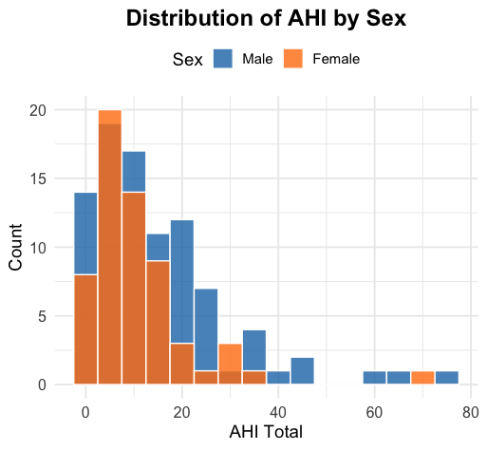
Supplementary Figure 1: Apnea-Hypopnea Index (AHI) distribution shows higher Obstructive Sleep Apnea (OSA) severity in males, aligning with Total Abdominal Adipose Tissue (TAAT) as significant predictors in males.

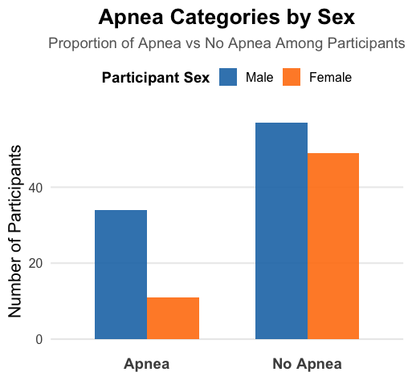
Supplementary Figure 2 Males show higher Obstructive Sleep Apnea (OSA) prevalence, while females dominate the no-OSA group.

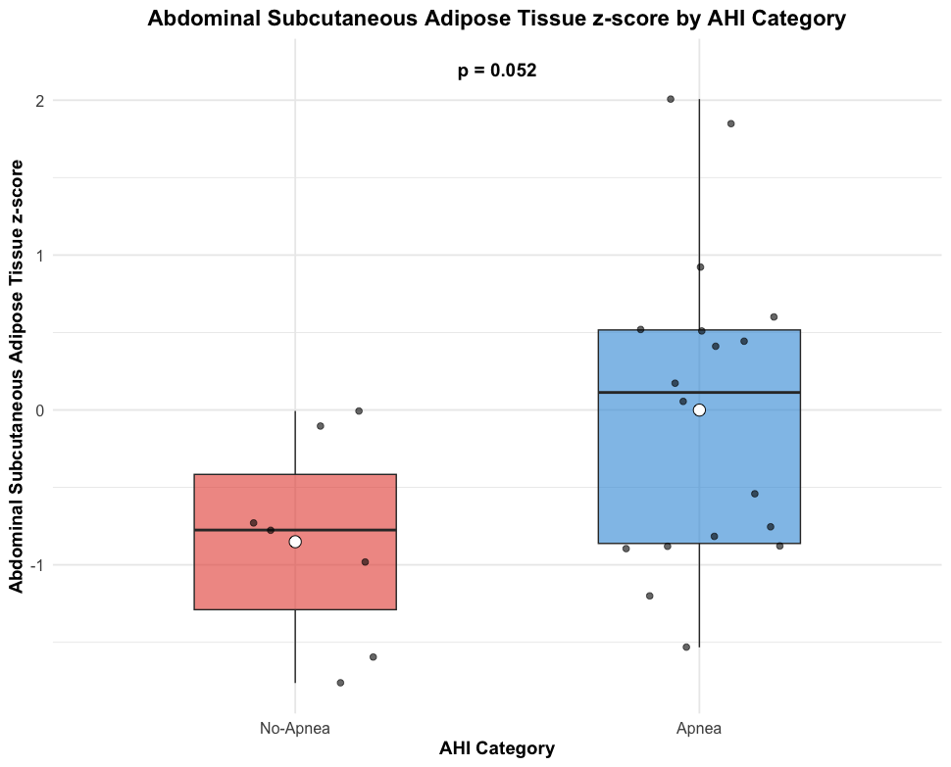

Supplementary Figure 3 The No-Apnea group had a mean ASAT-z of -0.85, while the Apnea group had -0.0007. A t-test showed t = -2.05, p = 0.052, with a 95% confidence interval ranging from -1.71 to 0.01. Although the Apnea group tended to have a higher ASAT-z, the difference was not statistically significant. This suggests a possible trend but does not provide strong evidence of a link between abdominal subcutaneous fat and apnea

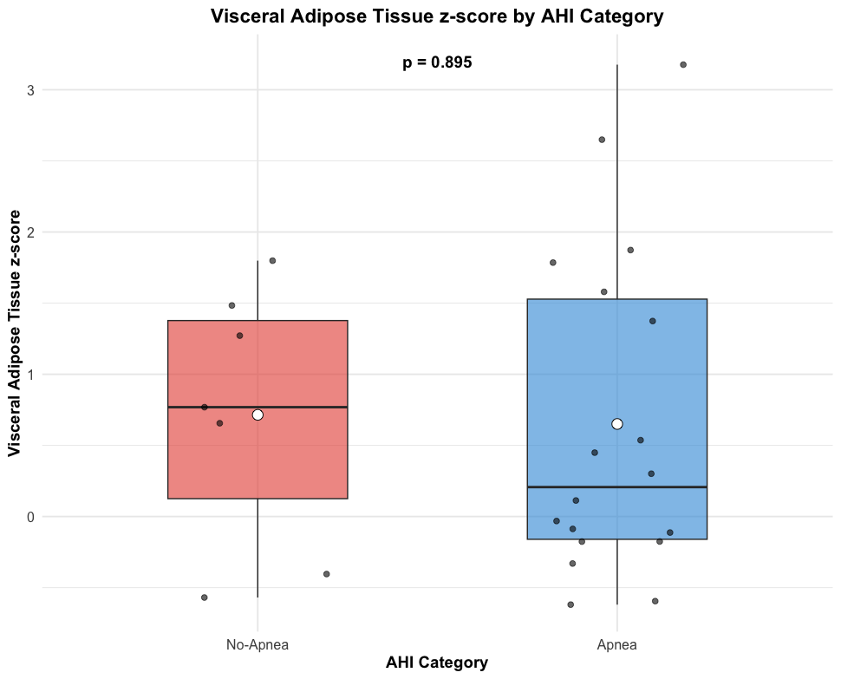

Supplementary Figure 4: The No-Apnea group had a mean Visceral Adipose Tissue z-score (VAT-z) of 0.71, while the Apnea group had 0.65. A t-test showed t = 0.13, p = 0.895, with a 95% confidence interval ranging from -0.94 to 1.06. There was no significant difference in VAT-z between the groups, suggesting no clear association between Visceral Adipose Tissue and apnea.
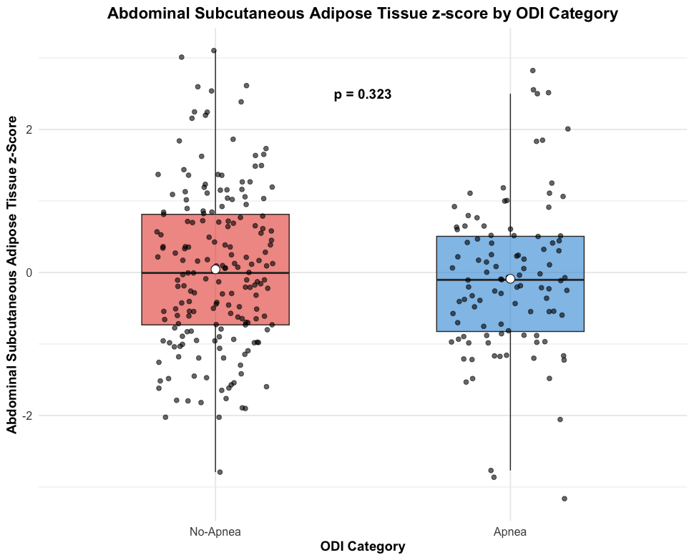
Supplementary Figure 5 The No-Apnea group had a mean abdominal subcutaneous fat Z-score (AZ) of 0.043, while the Apnea group had -0.088. A t-test showed t = -0.99, p = 0.323, with a 95% confidence interval ranging from -0.39 to 0.13. The difference between the groups was not statistically significant, indicating no clear association between abdominal subcutaneous fat and Oxygen Desaturation Index(ODI)-defined apnea. ODI-defined apnea was set at >5%, thus using similar cutoff level as AHI-based apnea classification

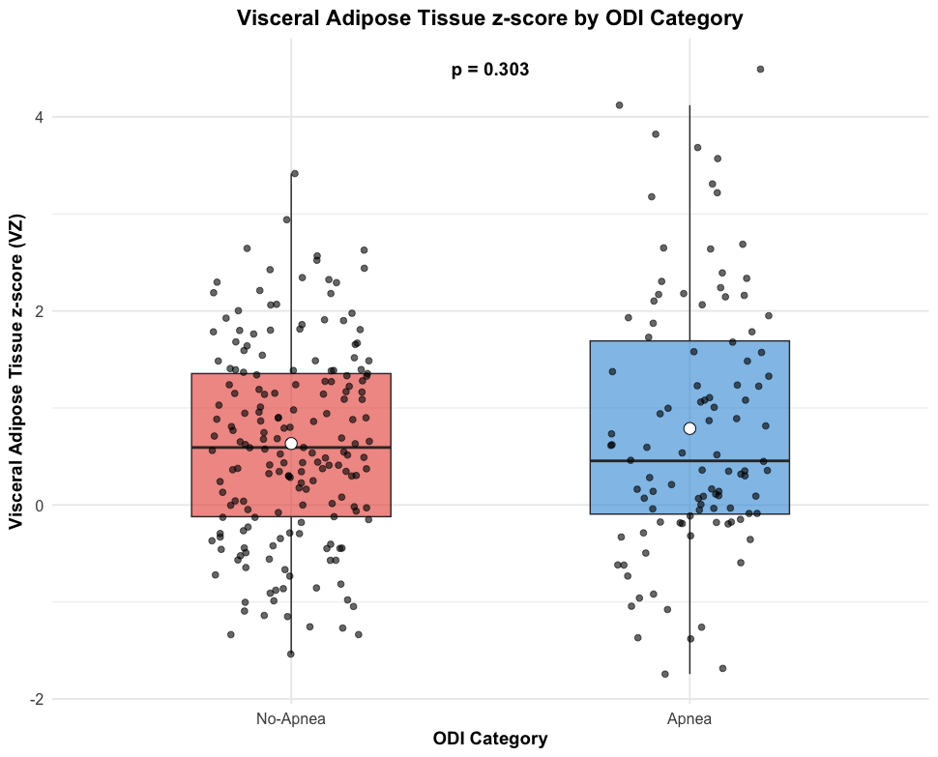
Supplementary Figure 6 The No-Apnea group had a mean visceral fat Z-score (VZ) of 0.63, while the Apnea group had 0.79. A t-test showed t = 1.03, p = 0.303, with a 95% confidence interval ranging from -0.14 to 0.45. The difference between the groups was not statistically significant, indicating no clear association between visceral fat and Oxygenn Desaturation Index-defined apnea. ODI-defined apnea was set at >5, using the same cutoff level as AHI-based apnea classification.
apnea classification.

Supplementary Table 1: Supplementary Apnea category
Summary Statistics by Variable and AHI Category
Variable | AHI Category | Count | Mean | Standard Deviation | Median | Minimum | Maximum
BMI | No Apnea | 37 | 28.39 | 4.74 | 27.10 | 22.76 | 44.04
BMI | Mild | 65 | 29.41 | 4.54 | 29.27 | 20.55 | 41.14
BMI | Moderate | 30 | 29.50 | 4.09 | 29.77 | 22.09 | 41.51
BMI | Severe | 14 | 29.66 | 4.19 | 30.55 | 22.41 | 35.67
ASAT-z | No Apnea | 37 | 0.01 | 1.07 | -0.01 | -1.89 | 2.25
ASAT-z | Mild | 65 | -0.15 | 1.20 | -0.21 | -3.16 | 2.82
ASAT-z | Moderate | 30 | 0.05 | 0.87 | 0.10 | -1.53 | 2.51
ASAT-z | Severe | 14 | -0.10 | 0.56 | -0.19 | -0.93 | 1.11
VAT-z | No Apnea | 37 | 0.59 | 0.94 | 0.53 | -1.34 | 2.64
VAT-z | Mild | 65 | 0.80 | 1.33 | 0.59 | -1.74 | 4.12
VAT-z | Moderate | 30 | 0.79 | 1.25 | 0.42 | -1.68 | 3.68
VAT-z | Severe | 14 | 0.73 | 1.50 | 0.04 | -0.62 | 4.49
TAAT | No Apnea | 37 | 13.34 | 4.87 | 12.40 | 5.31 | 25.18
TAAT | Mild | 65 | 14.40 | 5.18 | 14.27 | 3.70 | 28.71
TAAT | Moderate | 30 | 15.34 | 4.74 | 14.98 | 7.05 | 30.79
TAAT | Severe | 14 | 14.70 | 4.06 | 15.58 | 6.81 | 21.20

Supplementary Table 2: Fat distribution and its correlation with Time under 90 % oxygen (T90) and Average saturation (Av Sat), unadjusted and adjusted for BMI
Sex | Distribution | Variable | β unadj | P unadj | β adj | p adj
Male | VAT | T90 | 1.7 | 0.0021 | 2.0 | 0.0082
Female | VAT | T90 | 1.8 | 0.079 | 1.2 | 0.32
Male | ASAT | T90 | 0.50 | 0.35 | -0.67 | 0.45
Female | ASAT | T90 | 0.68 | 0.20 | -0.80 | 0.52
Male | TAAT | T90 | 0.66 | 0.028 | 0.79 | 0.17
Female | TAAT | T90 | 0.69 | 0.093 | 0.29 | 0.77
Male | VAT | AvSat | -0.20 | 0.0020 | -0.28 | 0.0029
Female | VAT | AvSat | -0.28 | 0.0076 | -0.30 | 0.018
Male | ASAT | AvSat | -0.023 | 0.72 | 0.15 | 0.18
Female | ASAT | AvSat | -0.046 | 0.41 | 0.079 | 0.55
Male | TAAT | AvSat | -0.068 | 0.063 | -0.086 | 0.22
Female | TAAT | AvSat | -0.072 | 0.092 | -0.14 | 0.17

Supplementary Table 3 Medication Used by Study Participants

Category | Drug/Treatment Name | Total Patients | Males | Females
 |  | 164 (100%) | 97 (59.1%) | 67 (40.9%)
Glucose Lowering Medications
 | Metformin | 119 (73.0%) | 75 (77.0%) | 44 (66.0%)
 | GLP-1 analogue | 9 (5.5%) | 3 (3.1%) | 6 (9.0%)
 | Sulfonylurea | 11 (6.7%) | 6 (6.2%) | 5 (7.5%)
 | SGLT2-inhibitor | 43 (26.2%) | 26 (26.8%) | 17 (25.4%)
 | DPP-4 inhibitor | 2 (1.2%) | 1 (1.0%) | 1 (1.5%)
 | Insulin | 29 (17.7%) | 20 (20.6%) | 9 (13.4%)
Antihyperlipidemic Medications
 | Atorvastatin | 29 (17.7%) | 20 (20.6%) | 9 (13.4%)
 | Rosuvastatin | 31 (18.9%) | 13 (13.4%) | 18 (26.9%)
 | Simvastatin | 54 (32.9%) | 36 (37.1%) | 18 (26.9%)
 | Ezetimibe | 8 (4.9%) | 5 (5.2%) | 3 (4.5%)
Antihypertensive Medications
 | ACE inhibitor | 22 (13.4%) | 15 (15.5%) | 7 (10.4%)
 | Angiotensin receptor blocker | 67 (40.9%) | 45 (46.4%) | 22 (32.8%)
 | Calcium channel blocker | 30 (18.3%) | 21 (21.6%) | 9 (13.4%)
 | Thiazide diuretic | 31 (18.9%) | 18 (18.6%) | 13 (19.4%)
 | Loop diuretic | 7 (4.3%) | 5 (5.2%) | 2 (3.0%)
 | Beta blocker | 33 (20.1%) | 23 (23.7%) | 10 (14.9%)
 | No antihypertensive drug | 42 (25.6%) | 23 (23.7%) | 19 (28.4%)

Category | Drug/Treatment Name | Total Patients | Males | Females
 |  | 164 (100%) | 97 (59.1%) | 67 (40.9%)
Glucose Lowering Medications
 | Metformin | 119 (73.0%) | 75 (77.0%) | 44 (66.0%)
 | GLP-1 analogue | 9 (5.5%) | 3 (3.1%) | 6 (9.0%)
 | Sulfonylurea | 11 (6.7%) | 6 (6.2%) | 5 (7.5%)
 | SGLT2-inhibitor | 43 (26.2%) | 26 (26.8%) | 17 (25.4%)
 | DPP-4 inhibitor | 2 (1.2%) | 1 (1.0%) | 1 (1.5%)
 | Insulin | 29 (17.7%) | 20 (20.6%) | 9 (13.4%)
Antihyperlipidemic Medications
 | Atorvastatin | 29 (17.7%) | 20 (20.6%) | 9 (13.4%)
 | Rosuvastatin | 31 (18.9%) | 13 (13.4%) | 18 (26.9%)
 | Simvastatin | 54 (32.9%) | 36 (37.1%) | 18 (26.9%)
 | Ezetimibe | 8 (4.9%) | 5 (5.2%) | 3 (4.5%)
Antihypertensive Medications
 | ACE inhibitor | 22 (13.4%) | 15 (15.5%) | 7 (10.4%)
 | Angiotensin receptor blocker | 67 (40.9%) | 45 (46.4%) | 22 (32.8%)
 | Calcium channel blocker | 30 (18.3%) | 21 (21.6%) | 9 (13.4%)
 | Thiazide diuretic | 31 (18.9%) | 18 (18.6%) | 13 (19.4%)
 | Loop diuretic | 7 (4.3%) | 5 (5.2%) | 2 (3.0%)
 | Beta blocker | 33 (20.1%) | 23 (23.7%) | 10 (14.9%)
 | No antihypertensive drug | 42 (25.6%) | 23 (23.7%) | 19 (28.4%)

