Supplementary Materials
Table S1. Effect of Psychedelic Compound (psilocybin vs. LSD vs. ayahuasca) on Positive Emotions (Study 1)
 | Psilocybin Mean (SE) | LSD  Mean (SE) | Ayahuasca  Mean (SE) | F | p | p_{fdr} | ηp²
Self-Compassion | 65.13 (3.33)# | 55.04 (2.57) | 65.70 (5.34) | 3.52 | .031 | .054 | .021
Compassion toward others | 67.86 (3.22)# | 56.88 (2.49) | 66.81 (5.17) | 4.09 | .018 | .042* | .024
Gratitude | 66.27 (3.25)# | 54.22 (2.51) | 71.74 (5.21)# | 6.86 | .001 | .007* | .040
Love | 65.31 (3.32)# | 56.73 (2.57) | 71.90 (5.33)# | 4.19 | .016 | .042* | .025
Ecstasy | 53.79 (2.81) | 59.79 (2.17) | 51.90 (4.51) | 2.09 | .126 | .176 | .012
Awe | 56.12 (3.31) | 61.77 (2.56) | 56.90 (5.31) | 1.01 | .367 | .428 | .006
Peace | 61.62 (3.23) | 58.65 (2.50) | 62.90 (5.18) | 0.39 | .673 | .673 | .002
Note. Estimated marginal means and standard error (SE) by psychedelic compound and positive experience. * = significant simple effect of psychedelic substance (p_{fdr}<0.05); # = significant pairwise comparison, indicating greater effect relative to LSD (uncorrected, p<0.05)

Exlcusion Criteria (Study 2)
Exclusion criteria were: 1) immediate family or personal history of psychosis; 2) contraindicated medically significant health conditions (as assessed by a physician); 3) history of serious suicide attempts; 4) positive pregnancy test; 5) contraindications to taking selective serotonin-reuptake inhibitors or undergoing magnetic resonance imaging (MRI); 6) previous use of escitalopram (although previous use of psilocybin was allowed); or 7) suspected or known presence of a preexisting psychiatric condition that could jeopardize rapport between the patient and mental health caregivers within the trial (e.g., borderline personality disorder).

Experiences of Specific Positive Emotions (25mg vs. 1mg Psilocybin) in Each Dosing Session (Study 2)
There was a significant effect of condition on positive emotion scores for both the first (Pillai's Trace=0.76, F(7,51)=23.07, p<.001, ηp²=.760) and second dosing session (Pillai's Trace=0.75, F(7,48)=21.01, p<.001, ηp²=.754). For the first dosing session, 25mg psilocybin was associated with significantly greater maximum scores for all positive emotions with medium (love and peace) to large (self-compassion, compassion toward others, gratitude, awe, and ecstasy) effect sizes. For the second dosing session, 25mg psilocybin was associated with significantly greater maximum scores for all positive emotions except for awe and peace. See Supplementary Materials, Table S2 and Figure S1.

Table S2. Scores for Experiences of Specific Positive Emotions in Both Dosing Sessions (25mg vs. 1mg Psilocybin; Study 2)
Variable | Score | 25mg Psilocybin Mean (SD) | 1mg Psilocybin Mean (SD) | F | p | p_{fdr} | ηp²
Self-Compassion | Dosing session #1 | 64.30 (40.08) | 29.97 (35.46) | 12.11 | <.001 | .003 | .175
Self-Compassion | Dosing session #2 | 65.25 (35.56) | 34.18 (40.34) | 9.35 | .003 | .005 | .148
Compassion toward others | Dosing session #1 | 72.03 (36.67) | 25.52 (34.59) | 25.09 | <.001 | <.001 | .306
Compassion toward others | Dosing session #2 | 64.36 (36.04) | 33.18 (38.90) | 9.68 | .003 | .005 | .152
Gratitude | Dosing session #1 | 58.43 (41.54) | 27.10 (30.14) | 10.93 | .002 | .003 | .161
Gratitude | Dosing session #2 | 57.93 (40.32) | 27.39 (34.34) | 9.31 | .004 | .005 | .147
Love | Dosing session #1 | 58.60 (40.34) | 28.83 (34.90) | 9.17 | .004 | .005 | .139
 | Dosing session #2 | 56.11 (38.80) | 29.04 (37.00) | 7.14 | .010 | .012 | .117
Ecstasy | Dosing session #1 | 59.33 (36.57) | 12.41 (18.83) | 37.98 | <.001 | <.001 | .400
 | Dosing session #2 | 52.14 (37.05) | 11.43 (19.95) | 26.21 | <.001 | <.001 | .327
Awe | Dosing session #1 | 58.67 (40.80) | 17.28 (26.64) | 21.13 | <.001 | <.001 | .270
 | Dosing session #2 | 39.04 (40.35) | 26.82 (36.62) | 1.44 | .235 | .235 | .026
Peace | Dosing session #1 | 57.97 (36.84) | 27.59 (32.62) | 11.22 | .001 | .003 | .164
 | Dosing session #2 | 44.54 (41.32) | 31.25 (36.14) | 1.64 | .206 | .222 | .029
Note. p_{fdr} correction applied across all post-hoc contrasts (inclusive of both dosing sessions).
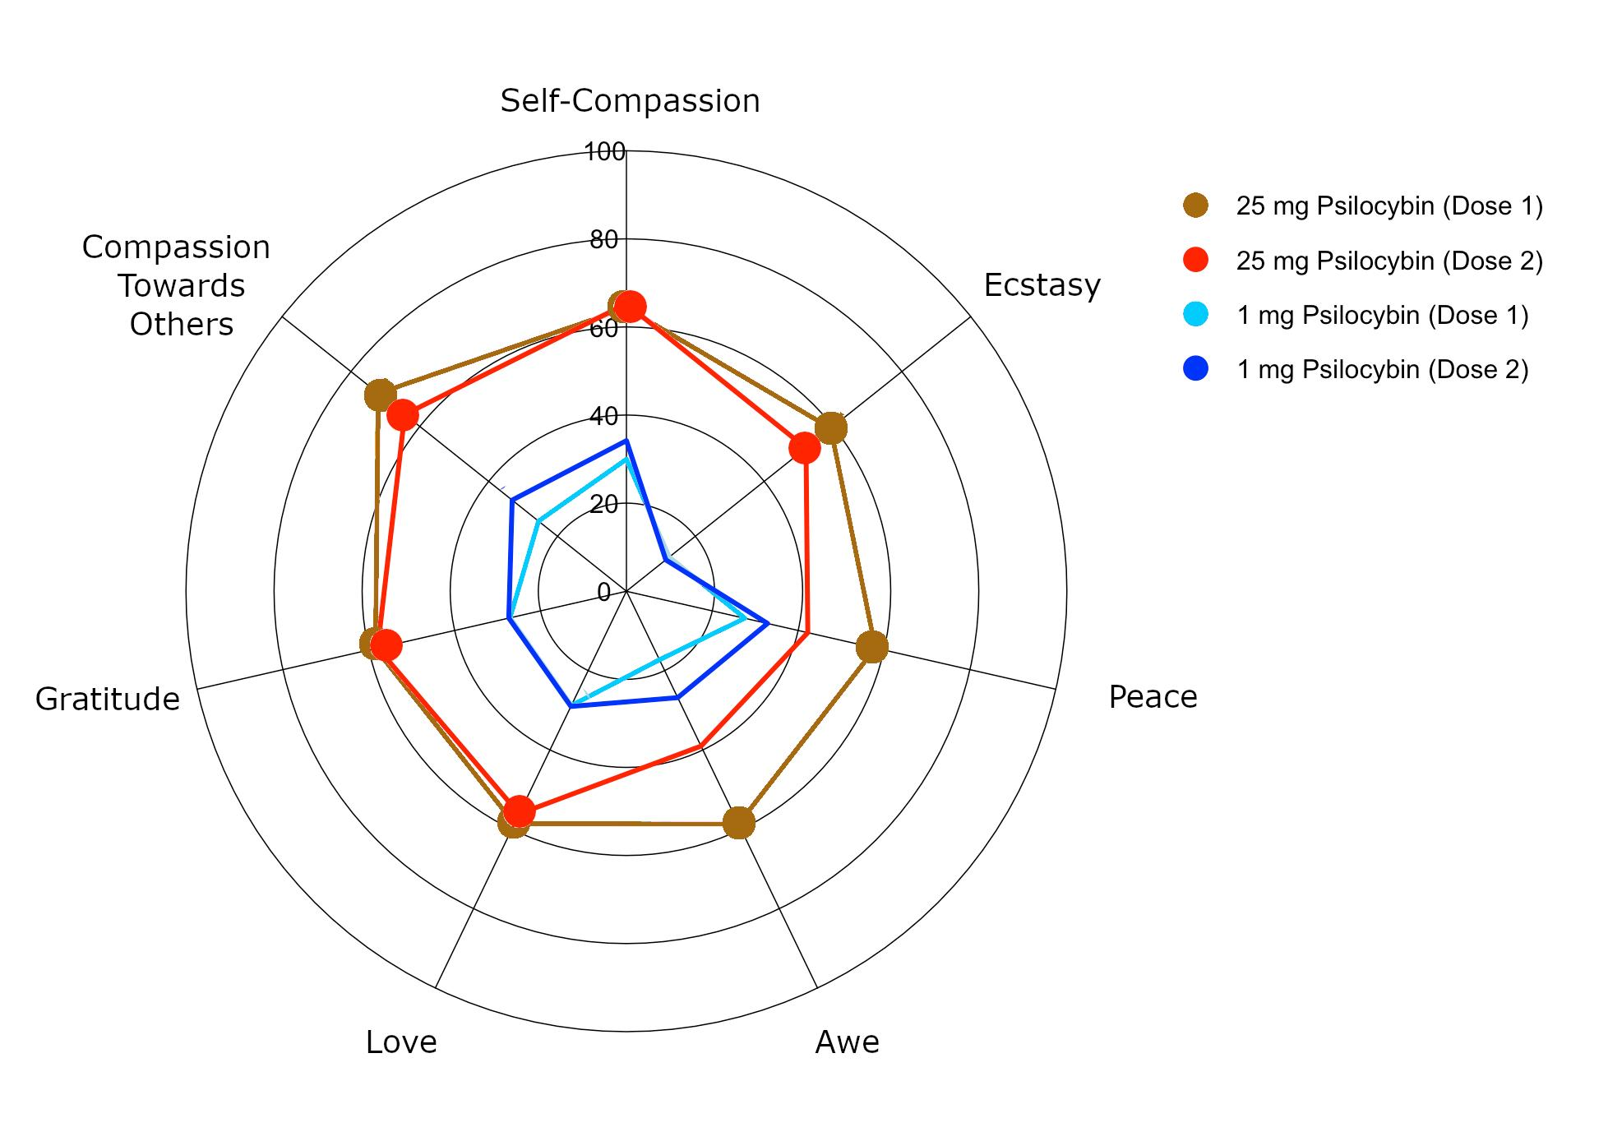
Figure S1. Spider plot demonstrating ratings for each positive emotion during dosing sessions # and 2 (Study 2). Brown lines indicate the first 25mg dose and red lines indicate the second 25mg dose. Light blue lines indicate the first 1mg dose and dark blue lines indicate the second 1mg dose. Where ratings for the first 25mg dose differ significantly (p<.05) from the first 1mg dose, 25mg dose scores are marked with a filled in circle. Where ratings for the second 25mg dose differ significantly (p<.05) from the second 1mg dose, 25mg dose scores are marked with a filled in circle.

