Supplementary Data

Predicting the ligand-binding affinity based on Simple Protein-Ligand Interaction Metrics

Figure S1: KNIME workflow for processing of protein file from PDBbind (Release 2015) dataset.

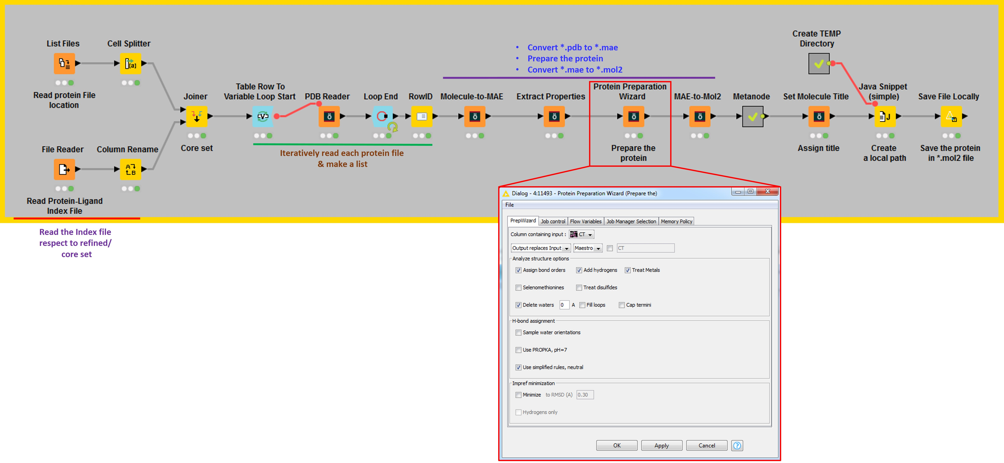

The workflow read the protein in *.pdb format and also the respective index file (which stores protein-ligand binding strength data, resolution, binding strength unit). After reading the input files, a loop was introduced, which iteratively read all the *.pdb file and store in each row. After the loop node, the nodes from Schrodinger was added, which convert the *pdb into *.mae format and then prepare the protein. The protein preparation steps include the addition of H-atoms, assign bond order, treat mental, remove all water molecules, and assign simplified rules for the protonation state of each amino acid. Once the preparation completes, the *.mae format converted into *.mol2 file and each protein was assigned with PDB-ID. To save each protein files into individual *.mol2 file format, a temporary directory was created and all the protein files saved in the local directory of the system.

Figure S2: PDBbind (Release 2015) dataset characterization. Resolution range for refined set (n = 3481) (a) and core set (n = 180) (b); Experimentally measured binding strength distribution in Refined set (c) and Core set (d); Ligand length (Å) distribution for refined and core set (e).

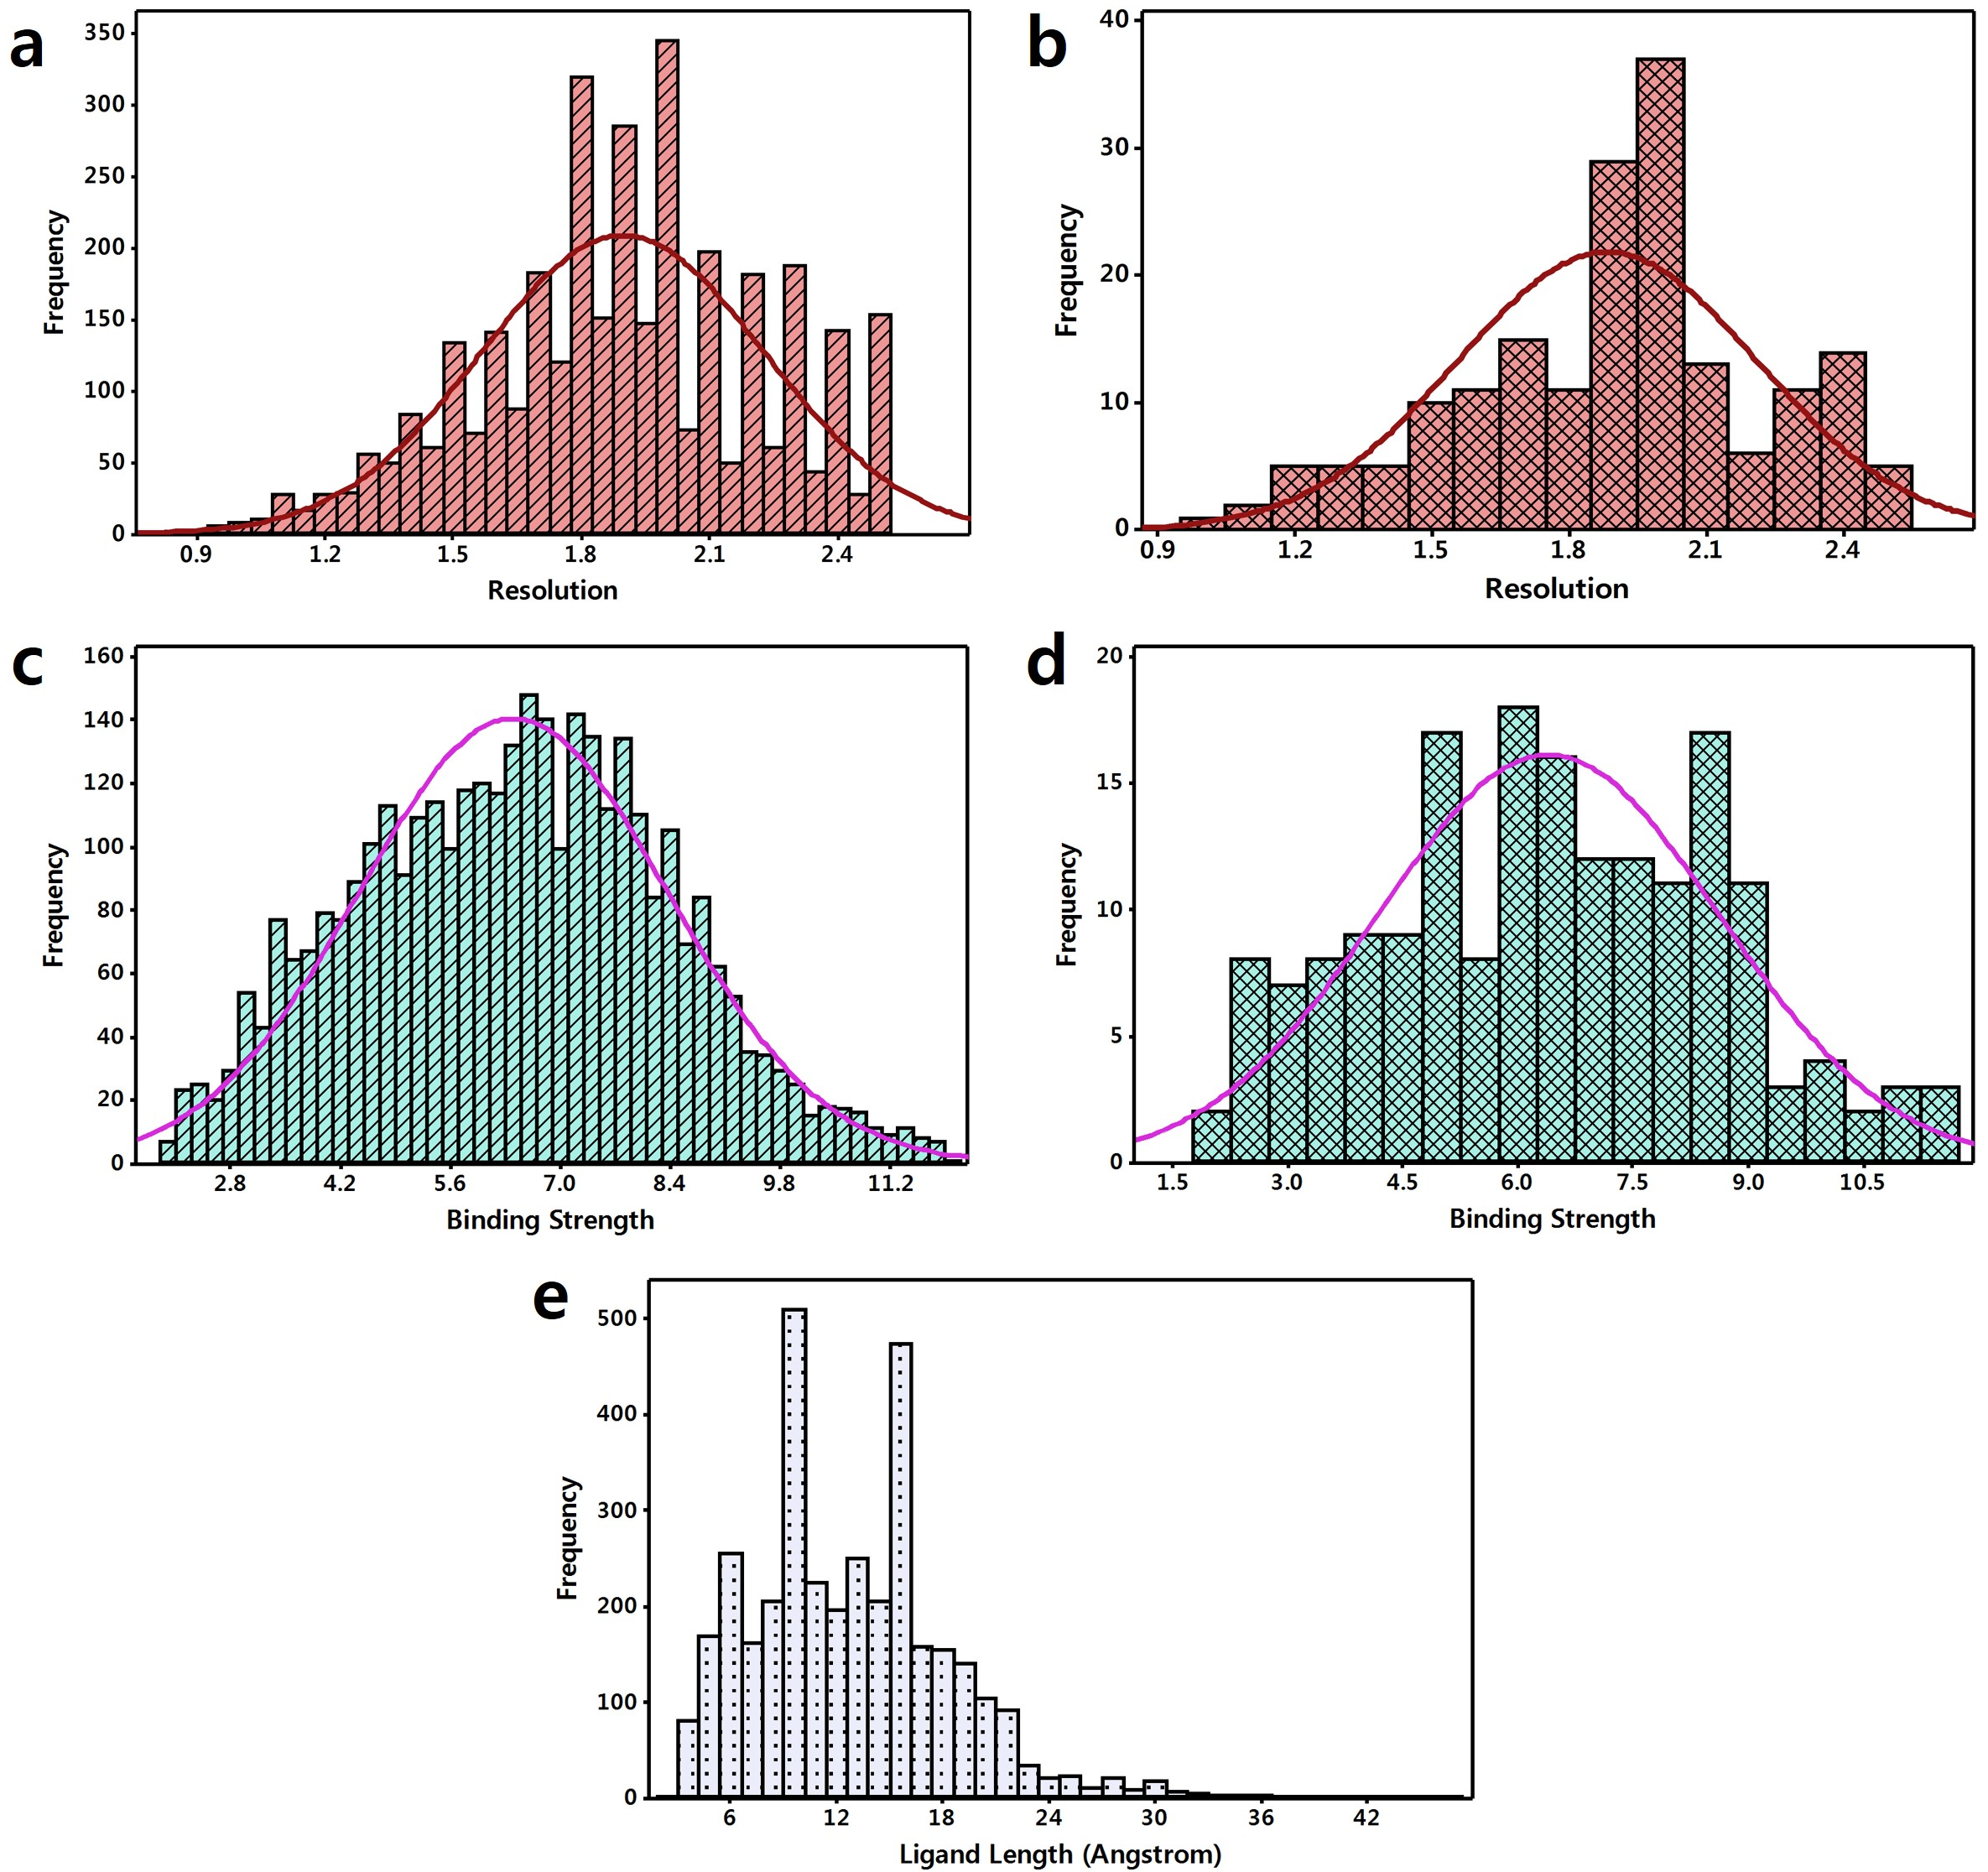

Table S1: The Result of statistical performance on PDBbind (Release 2015) using the Random Forest model. The Refined set (n =3481) used for training and validation, and core set (n=180) as a test set. The valid represent 20% of the refined set. The boldface represents the model with good statistics in each category.
Features | Random Forest parameters |  | SETS | Train |  |  |  | Valid |  |  |  | Test
Features | max_  features | n_  estimators | SETS | RMSE | MAE | PCC | p-value | RMSE | MAE | PCC | p-value | RMSE | MAE | PCC | p_value
IFP | auto | 500 | SET01 | 0.534 | 0.416 | 0.975 | 0 | 1.467 | 1.153 | 0.677 | 1.26E-94 | 1.700 | 1.376 | 0.667 | 1.62E-24
IFP | auto | 200 | SET02 | 0.540 | 0.415 | 0.974 | 0 | 1.424 | 1.113 | 0.677 | 1.80E-94 | 1.734 | 1.394 | 0.648 | 7.68E-23
IFP | auto | 300 | SET03 | 0.531 | 0.414 | 0.975 | 0 | 1.474 | 1.122 | 0.665 | 5.26E-90 | 1.758 | 1.406 | 0.629 | 3.17E-21
IFP | auto | 100 | SET04 | 0.545 | 0.424 | 0.973 | 0 | 1.423 | 1.098 | 0.696 | 3.88E-102 | 1.696 | 1.374 | 0.670 | 8.18E-25
IFP | auto | 100 | SET05 | 0.543 | 0.422 | 0.974 | 0 | 1.401 | 1.062 | 0.707 | 1.70E-106 | 1.667 | 1.343 | 0.686 | 2.20E-26
IFP | auto | 200 | SET06 | 0.532 | 0.415 | 0.975 | 0 | 1.454 | 1.136 | 0.705 | 9.45E-106 | 1.686 | 1.361 | 0.676 | 2.26E-25
IFP | sqrt | 100 | SET01 | 0.534 | 0.414 | 0.977 | 0 | 1.459 | 1.151 | 0.686 | 6.89E-98 | 1.683 | 1.362 | 0.707 | 1.50E-28
IFP | sqrt | 100 | SET02 | 0.535 | 0.416 | 0.978 | 0 | 1.381 | 1.089 | 0.706 | 2.39E-106 | 1.729 | 1.400 | 0.676 | 2.04E-25
IFP | sqrt | 300 | SET03 | 0.521 | 0.411 | 0.979 | 0 | 1.448 | 1.121 | 0.682 | 1.48E-96 | 1.741 | 1.409 | 0.666 | 1.81E-24
IFP | sqrt | 200 | SET04 | 0.529 | 0.414 | 0.979 | 0 | 1.389 | 1.090 | 0.718 | 2.44E-111 | 1.700 | 1.372 | 0.697 | 1.68E-27
IFP | sqrt | 100 | SET05 | 0.537 | 0.420 | 0.977 | 0 | 1.372 | 1.066 | 0.726 | 4.17E-115 | 1.656 | 1.349 | 0.716 | 1.49E-29
IFP | sqrt | 300 | SET06 | 0.523 | 0.411 | 0.979 | 0 | 1.447 | 1.143 | 0.717 | 7.76E-111 | 1.696 | 1.364 | 0.698 | 1.37E-27
IFP +  Int_Dist | auto | 100 | SET01 | 0.558 | 0.434 | 0.973 | 0 | 1.528 | 1.216 | 0.642 | 3.50E-82 | 1.738 | 1.426 | 0.659 | 9.40E-24
IFP +  Int_Dist | auto | 100 | SET02 | 0.567 | 0.440 | 0.974 | 0 | 1.458 | 1.161 | 0.659 | 6.31E-88 | 1.769 | 1.453 | 0.636 | 8.50E-22
IFP +  Int_Dist | auto | 500 | SET03 | 0.546 | 0.432 | 0.977 | 0 | 1.529 | 1.175 | 0.632 | 5.46E-79 | 1.783 | 1.453 | 0.632 | 1.71E-21
IFP +  Int_Dist | auto | 500 | SET04 | 0.550 | 0.435 | 0.977 | 0 | 1.456 | 1.148 | 0.681 | 3.91E-96 | 1.750 | 1.439 | 0.661 | 5.14E-24
IFP +  Int_Dist | auto | 200 | SET05 | 0.549 | 0.432 | 0.976 | 0 | 1.447 | 1.131 | 0.682 | 1.21E-96 | 1.711 | 1.410 | 0.677 | 1.91E-25
IFP +  Int_Dist | auto | 500 | SET06 | 0.541 | 0.427 | 0.977 | 0 | 1.503 | 1.190 | 0.682 | 1.55E-96 | 1.765 | 1.439 | 0.642 | 2.54E-22
IFP +  Int_Dist | sqrt | 400 | SET01 | 0.530 | 0.417 | 0.980 | 0 | 1.478 | 1.173 | 0.678 | 7.55E-95 | 1.712 | 1.407 | 0.696 | 2.37E-27
IFP +  Int_Dist | sqrt | 100 | SET02 | 0.548 | 0.428 | 0.978 | 0 | 1.398 | 1.104 | 0.699 | 1.72E-103 | 1.749 | 1.425 | 0.675 | 2.52E-25
IFP +  Int_Dist | sqrt | 400 | SET03 | 0.529 | 0.418 | 0.980 | 0 | 1.472 | 1.146 | 0.669 | 1.07E-91 | 1.766 | 1.444 | 0.665 | 2.58E-24
IFP +  Int_Dist | sqrt | 400 | SET04 | 0.533 | 0.420 | 0.980 | 0 | 1.421 | 1.126 | 0.704 | 2.67E-105 | 1.715 | 1.406 | 0.700 | 7.69E-28
IFP +  Int_Dist | sqrt | 300 | SET05 | 0.536 | 0.422 | 0.980 | 0 | 1.387 | 1.093 | 0.720 | 2.08E-112 | 1.692 | 1.388 | 0.711 | 5.15E-29
IFP +  Int_Dist | sqrt | 200 | SET06 | 0.531 | 0.417 | 0.980 | 0 | 1.481 | 1.180 | 0.700 | 1.12E-103 | 1.732 | 1.402 | 0.684 | 3.92E-26
IFP + Frag | auto | 100 | SET01 | 0.496 | 0.381 | 0.977 | 0 | 1.327 | 1.035 | 0.747 | 2.62E-125 | 1.489 | 1.227 | 0.771 | 8.71E-37
IFP + Frag | auto | 100 | SET02 | 0.503 | 0.383 | 0.976 | 0 | 1.329 | 1.023 | 0.727 | 2.36E-115 | 1.555 | 1.270 | 0.739 | 2.55E-32
IFP + Frag | auto | 200 | SET03 | 0.493 | 0.380 | 0.978 | 0 | 1.296 | 0.991 | 0.755 | 1.78E-129 | 1.552 | 1.266 | 0.747 | 2.02E-33
IFP + Frag | auto | 100 | SET04 | 0.502 | 0.382 | 0.976 | 0 | 1.296 | 1.009 | 0.758 | 4.45E-131 | 1.547 | 1.257 | 0.743 | 6.76E-33
IFP + Frag | auto | 300 | SET05 | 0.494 | 0.383 | 0.978 | 0 | 1.310 | 0.992 | 0.751 | 2.87E-127 | 1.547 | 1.274 | 0.748 | 1.83E-33
IFP + Frag | auto | 200 | SET06 | 0.487 | 0.374 | 0.978 | 0 | 1.330 | 1.049 | 0.764 | 4.02E-134 | 1.568 | 1.286 | 0.732 | 1.63E-31
IFP + Frag | sqrt | 100 | SET01 | 0.503 | 0.389 | 0.977 | 0 | 1.362 | 1.065 | 0.731 | 1.54E-117 | 1.519 | 1.252 | 0.761 | 2.36E-35
IFP + Frag | sqrt | 400 | SET02 | 0.497 | 0.384 | 0.979 | 0 | 1.331 | 1.027 | 0.727 | 9.85E-116 | 1.589 | 1.314 | 0.731 | 2.61E-31
IFP + Frag | sqrt | 500 | SET03 | 0.500 | 0.388 | 0.979 | 0 | 1.317 | 1.014 | 0.747 | 3.43E-125 | 1.594 | 1.317 | 0.730 | 2.80E-31
IFP + Frag | sqrt | 400 | SET04 | 0.499 | 0.386 | 0.979 | 0 | 1.327 | 1.051 | 0.745 | 3.19E-124 | 1.580 | 1.292 | 0.733 | 1.52E-31
IFP + Frag | sqrt | 100 | SET05 | 0.512 | 0.393 | 0.976 | 0 | 1.340 | 1.027 | 0.739 | 3.64E-121 | 1.561 | 1.287 | 0.751 | 6.54E-34
IFP + Frag | sqrt | 100 | SET06 | 0.506 | 0.387 | 0.977 | 0 | 1.349 | 1.071 | 0.758 | 7.74E-131 | 1.598 | 1.300 | 0.730 | 2.96E-31
IFP +  Int_Dist +  Frag | auto | 100 | SET01 | 0.498 | 0.381 | 0.976 | 0 | 1.332 | 1.037 | 0.745 | 3.06E-124 | 1.503 | 1.235 | 0.766 | 5.57E-36
IFP +  Int_Dist +  Frag | auto | 200 | SET02 | 0.491 | 0.377 | 0.978 | 0 | 1.318 | 1.016 | 0.732 | 4.56E-118 | 1.553 | 1.287 | 0.740 | 1.55E-32
IFP +  Int_Dist +  Frag | auto | 100 | SET03 | 0.498 | 0.382 | 0.977 | 0 | 1.310 | 0.995 | 0.749 | 3.21E-126 | 1.556 | 1.274 | 0.744 | 5.17E-33
IFP +  Int_Dist +  Frag | auto | 100 | SET04 | 0.499 | 0.382 | 0.977 | 0 | 1.308 | 1.024 | 0.753 | 2.20E-128 | 1.551 | 1.267 | 0.741 | 1.14E-32
IFP +  Int_Dist +  Frag | auto | 100 | SET05 | 0.494 | 0.382 | 0.977 | 0 | 1.316 | 1.004 | 0.748 | 9.09E-126 | 1.549 | 1.272 | 0.746 | 2.83E-33
IFP +  Int_Dist +  Frag | auto | 100 | SET06 | 0.496 | 0.377 | 0.977 | 0 | 1.336 | 1.053 | 0.760 | 2.46E-132 | 1.564 | 1.287 | 0.734 | 1.13E-31
IFP +  Int_Dist +  Frag | sqrt | 100 | SET01 | 0.494 | 0.382 | 0.978 | 0 | 1.346 | 1.054 | 0.740 | 8.07E-122 | 1.512 | 1.244 | 0.770 | 1.43E-36
IFP +  Int_Dist +  Frag | sqrt | 400 | SET02 | 0.494 | 0.382 | 0.980 | 0 | 1.314 | 1.013 | 0.736 | 4.20E-120 | 1.587 | 1.313 | 0.738 | 3.32E-32
IFP +  Int_Dist +  Frag | sqrt | 100 | SET03 | 0.506 | 0.390 | 0.978 | 0 | 1.307 | 1.004 | 0.752 | 3.54E-128 | 1.564 | 1.290 | 0.751 | 5.70E-34
IFP +  Int_Dist +  Frag | sqrt | 100 | SET04 | 0.505 | 0.389 | 0.978 | 0 | 1.314 | 1.040 | 0.751 | 1.29E-127 | 1.574 | 1.289 | 0.744 | 5.65E-33
IFP +  Int_Dist +  Frag | sqrt | 300 | SET05 | 0.499 | 0.387 | 0.979 | 0 | 1.319 | 1.018 | 0.751 | 3.74E-127 | 1.561 | 1.290 | 0.758 | 7.87E-35
IFP +  Int_Dist +  Frag | sqrt | 300 | SET06 | 0.490 | 0.379 | 0.980 | 0 | 1.343 | 1.069 | 0.762 | 2.38E-133 | 1.587 | 1.307 | 0.739 | 2.57E-32
Note: Random_State values assigned for different Sets are as SET01: 123456; SET02: 42; SET03: 56789; SET04: 98765; SET05: 4321; SET06: 1234 to reproduce the same statistical result for training and validation data. RMSE: Root-Mean-Square-Error; MAE: Mean Absolute Error; PCC: Pearson Correlation Coefficient; p_value: p_value for statistical significance.

Description: A total of six different sets were created by assigning different random seed. Each set of model was trained with different options of max_feature (‘auto’, or ‘sqrt’) and n_estimators (100, 200, 300, 400, 500). From all the models for each set, best model from each ‘auto’ and ‘sqrt’ options was selected based on lowest RMSE for test set.
Figure S3: Statistical comparison of PCC (Person-Correlation-Coefficient) and RMSE (Root-Mean-Square-Error) between different SETS for Train, Valid and Test data based on Interaction Fingerprint Pattern (IFP) as features (RF parameters: max_features = 'auto'). The statistics shown in red color are better among other SETS.
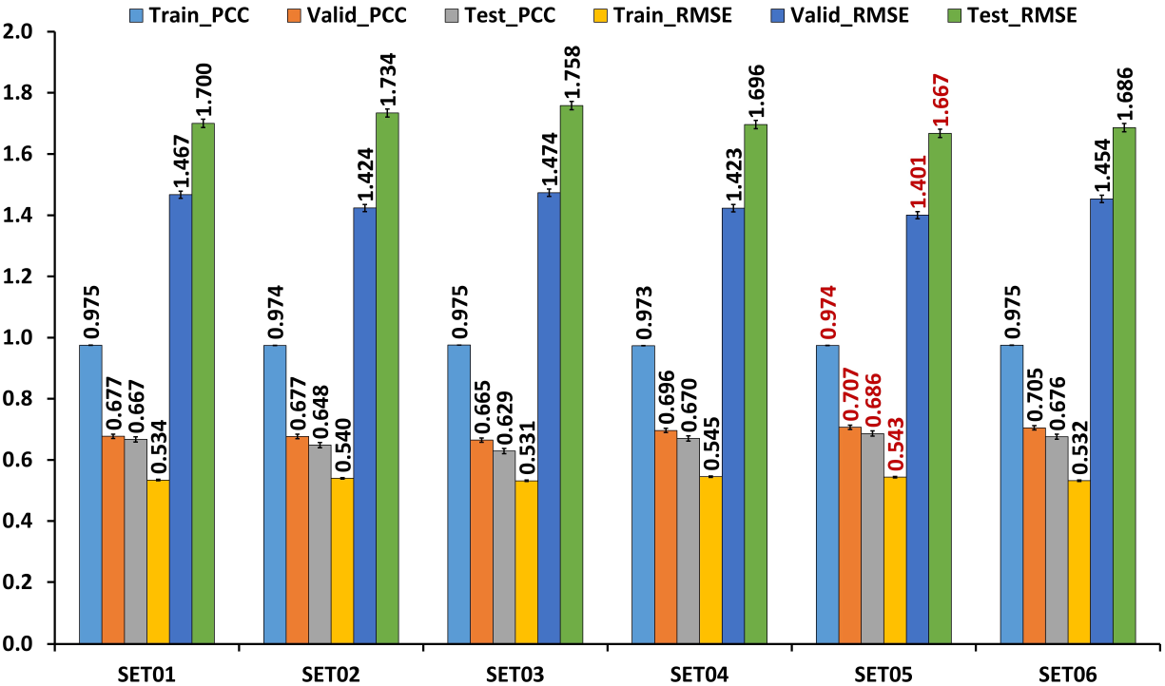

Figure S4: Statistical comparison of PCC (Person-Correlation-Coefficient) and RMSE (Root-Mean-Square-Error) between different SETS for Train, Valid and Test data based on Interaction Fingerprint Pattern (IFP) as features (RF parameters: max_features = 'sqrt'). The statistics shown in red color are better among other SETS.
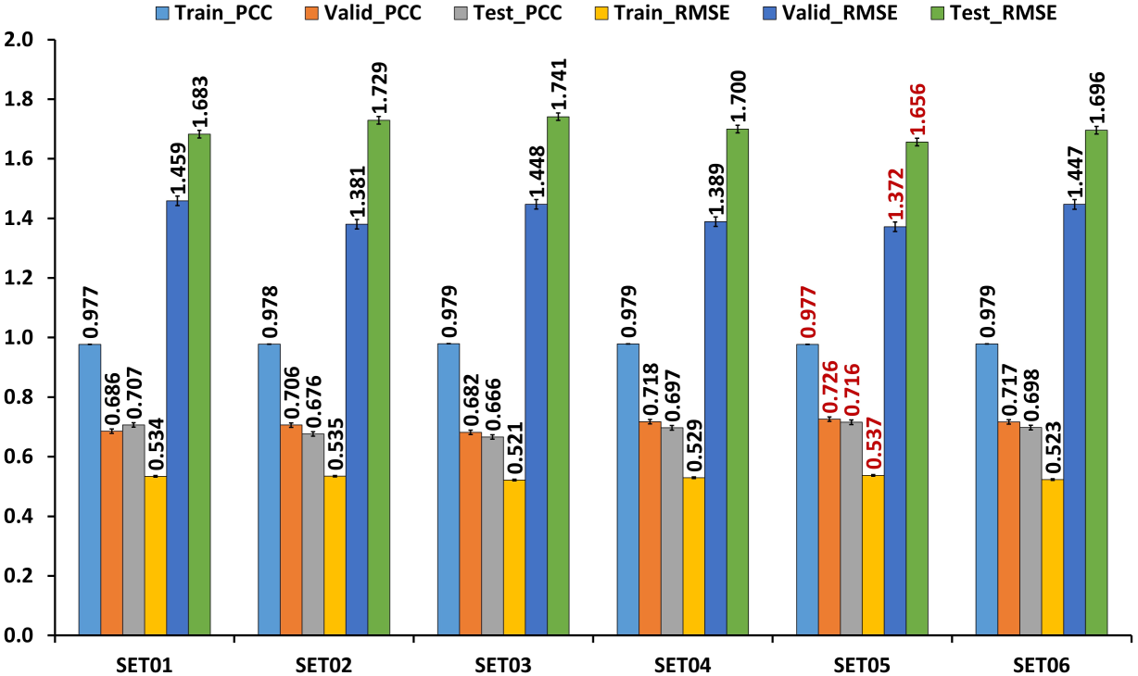
Figure S5: Statistical comparison of PCC (Person-Correlation-Coefficient) and RMSE (Root-Mean-Square-Error) between different SETS for Train, Valid and Test data based on Interaction Fingerprint Pattern (IFP) and Interaction Distances (IFP+Int-Dist) as features (RF parameters: max_features = 'auto'). The statistics shown in red color are better among other SETS.

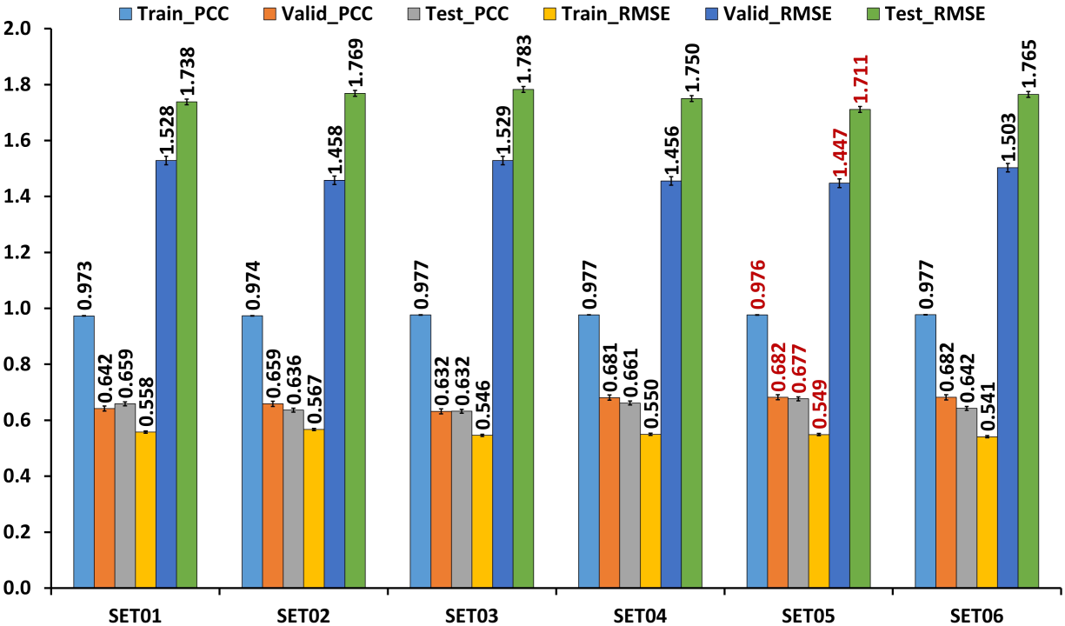

Figure S6: Statistical comparison of PCC (Person-Correlation-Coefficient) and RMSE (Root-Mean-Square-Error) between different SETS for Train, Valid and Test data based on Interaction Fingerprint Pattern (IFP) and Interaction Distances (IFP+Int-Dist) as features (RF parameters: max_features = 'sqrt'). The statistics shown in red color are better among other SETS.
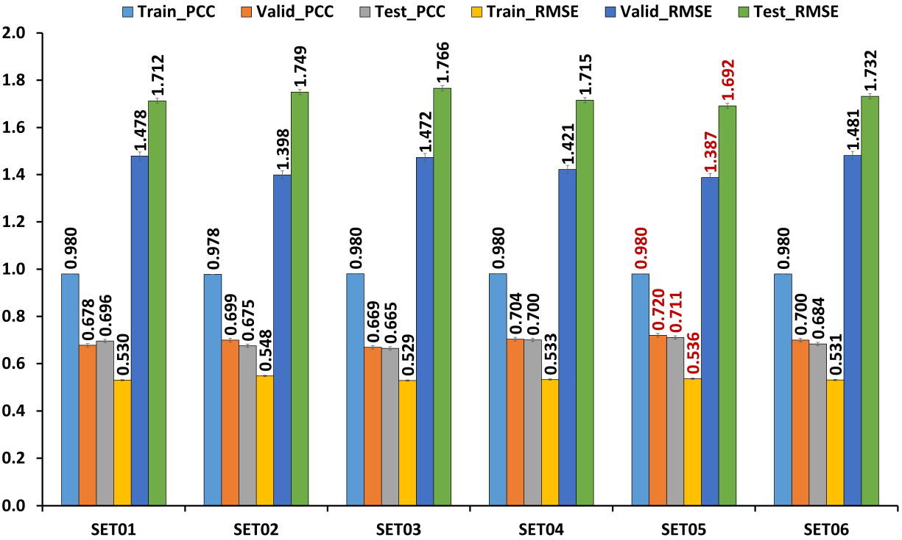
Figure S7: Statistical comparison of PCC (Person-Correlation-Coefficient) and RMSE (Root-Mean-Square-Error) between different SETS for Train, Valid and Test data based on Interaction Fingerprint Pattern (IFP) and Ligand Fragments (IFP+Frag) as features (RF parameters: max_features = 'auto'). The statistics shown in red color are better among other SETS.
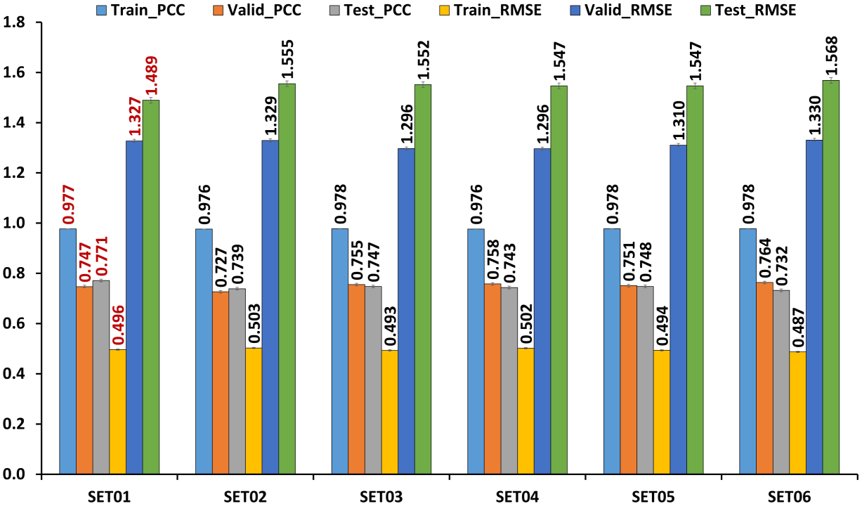

Figure S8: Statistical comparison of PCC (Person-Correlation-Coefficient) and RMSE (Root-Mean-Square-Error) between different SETS for Train, Valid and Test data based on Interaction Fingerprint Pattern (IFP) and Ligand Fragments (IFP+Frag) as features (RF parameters: max_features = 'sqrt'). The statistics shown in red color are better among other SETS.
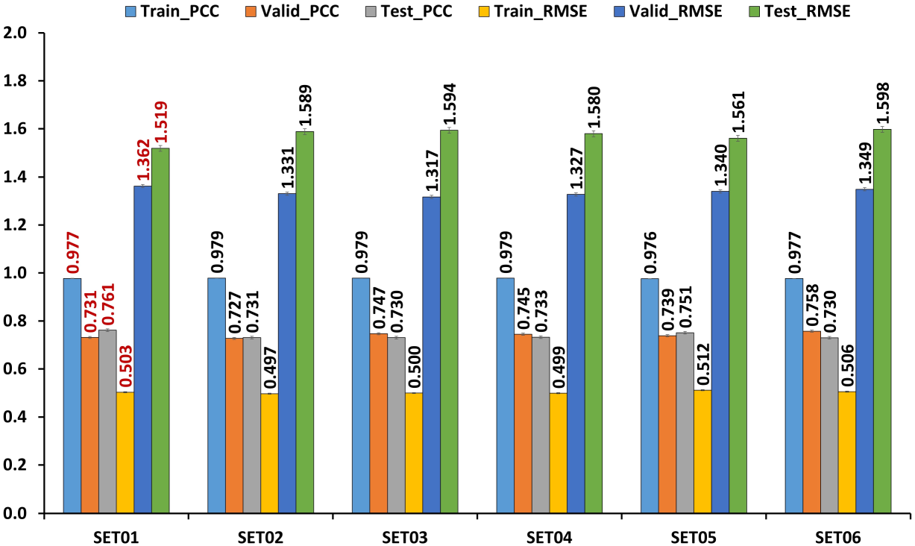
Figure S9: Statistical comparison of PCC (Person-Correlation-Coefficient) and RMSE (Root-Mean-Square-Error) between different SETS for Train, Valid and Test data based on Interaction Fingerprint Pattern (IFP), Interaction Distances and Ligand Fragments (IFP+Int-Dist+Frag) as features (RF parameters: max_features = 'auto'). The statistics shown in red color are better among other SETS.
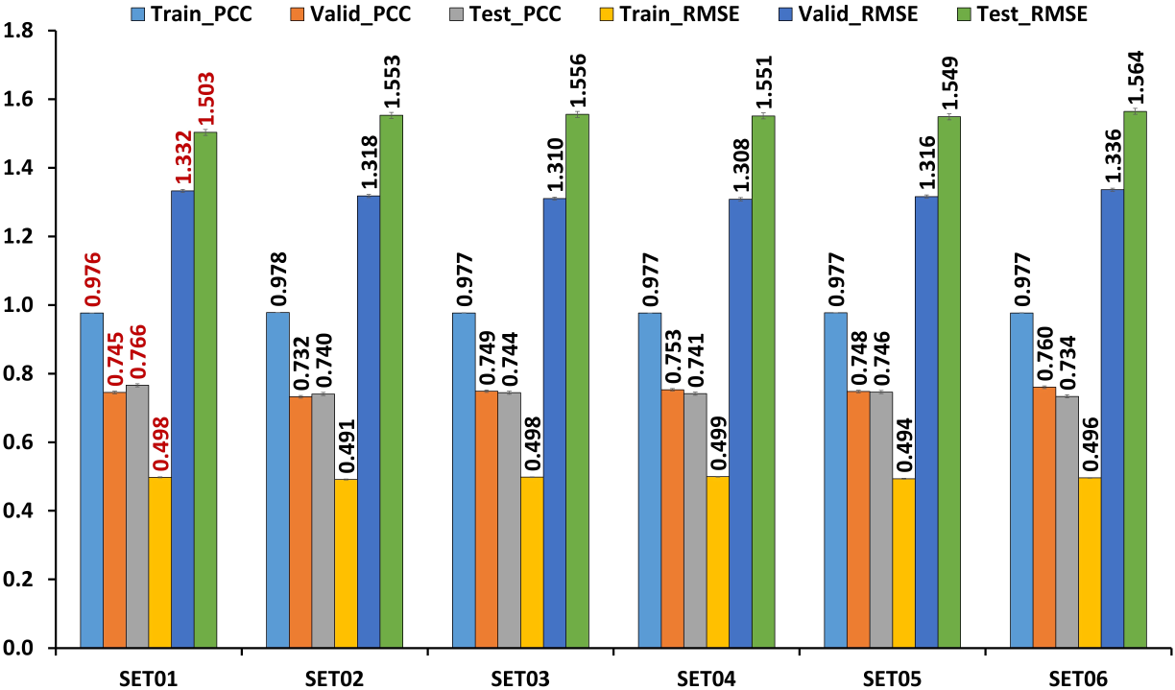
Figure S10: Statistical comparison of PCC (Person-Correlation-Coefficient) and RMSE (Root-Mean-Square-Error) between different SETS for Train, Valid and Test data based on Interaction Fingerprint Pattern (IFP), Interaction Distances and Ligand Fragments (IFP+Int-Dist+Frag) as features (RF parameters: max_features = 'sqrt'). The statistics shown in red color are better among other SETS.
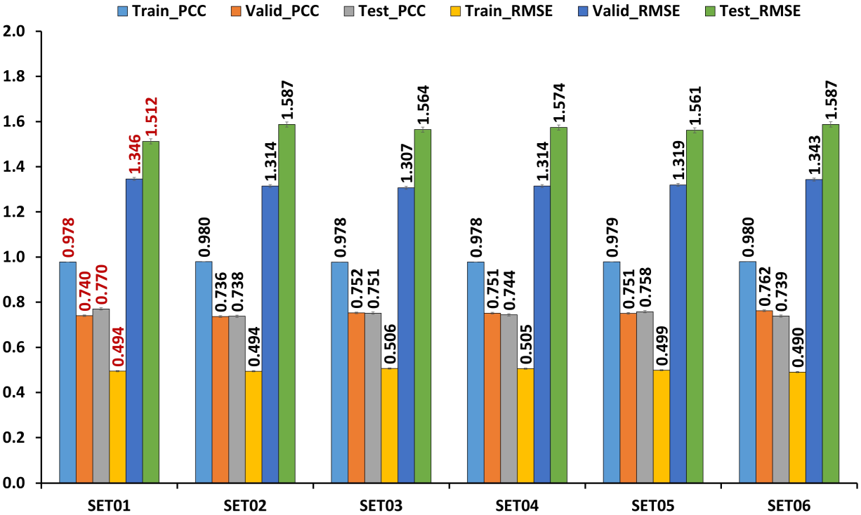
Table S2: The Result of statistical performance on PDBbind (Release 2015) using the DNN model. The Refined set (n =3481) used for training and validation, and core set (n=180) as a test set. The valid represent 20% of the refined set. The boldface represents the model with good statistics in each category.

Features | SETS | Model Parameters | Best Model  at Epochs | Train |  |  | Valid |  |  | Test
 |  |  |  | LOSS | RMSE | PCC | LOSS | RMSE | PCC | LOSS | RMSE | PCC
IFP | SET01 | 64_0.3_0.6 | 140 | 0.359 | 0.779 | 0.920 | 0.810 | 1.529 | 0.668 | 0.805 | 1.574 | 0.708
IFP | SET02 | 128_0.5_0.6 | 212 | 0.554 | 1.133 | 0.832 | 0.790 | 1.481 | 0.670 | 0.839 | 1.644 | 0.697
IFP | SET03 | 256_0.3_0.4 | 263 | 0.689 | 1.048 | 0.849 | 1.060 | 1.530 | 0.645 | 1.099 | 1.626 | 0.691
IFP | SET04 | 64_0.1_0.1 | 75 | 0.630 | 0.693 | 0.938 | 1.343 | 1.458 | 0.693 | 1.493 | 1.624 | 0.691
IFP | SET05 | 128_0.3_0.4 | 209 | 0.563 | 0.871 | 0.899 | 1.019 | 1.483 | 0.678 | 1.032 | 1.538 | 0.726
IFP | SET06 | 64_0.1_0.2 | 102 | 0.540 | 0.661 | 0.943 | 1.259 | 1.495 | 0.686 | 1.341 | 1.600 | 0.694
IFP + Int-Dist | SET01 | 128_0.4_0.4 | 156 | 0.703 | 1.070 | 0.849 | 1.065 | 1.541 | 0.650 | 1.079 | 1.606 | 0.712
IFP + Int-Dist | SET02 | 64_0.2_0.4 | 79 | 0.561 | 0.871 | 0.904 | 0.964 | 1.401 | 0.692 | 1.088 | 1.613 | 0.698
IFP + Int-Dist | SET03 | 128_0.3_0.1 | 120 | 0.931 | 1.019 | 0.867 | 1.342 | 1.455 | 0.675 | 1.507 | 1.641 | 0.692
IFP + Int-Dist | SET04 | 64_0.5_0.4 | 103 | 0.758 | 1.147 | 0.826 | 0.997 | 1.453 | 0.686 | 1.100 | 1.638 | 0.707
IFP + Int-Dist | SET05 | 128_0.5_0.6 | 261 | 0.472 | 0.990 | 0.873 | 0.775 | 1.468 | 0.687 | 0.805 | 1.582 | 0.713
IFP + Int-Dist | SET06 | 128_0.3_0.1 | 127 | 0.932 | 1.020 | 0.860 | 1.383 | 1.501 | 0.681 | 1.530 | 1.664 | 0.680
IFP+ Frag | SET01 | 128_0.5_0.2 | 143 | 0.764 | 0.929 | 0.895 | 1.235 | 1.464 | 0.679 | 1.333 | 1.593 | 0.709
IFP+ Frag | SET02 | 64_0.1_0.7 | 129 | 0.209 | 0.595 | 0.956 | 0.631 | 1.402 | 0.699 | 0.646 | 1.530 | 0.733
IFP+ Frag | SET03 | 64_0.2_0.1 | 66 | 0.762 | 0.837 | 0.910 | 1.279 | 1.389 | 0.712 | 1.423 | 1.551 | 0.727
IFP+ Frag | SET04 | 64_0.2_0.5 | 129 | 0.392 | 0.718 | 0.934 | 0.872 | 1.436 | 0.693 | 0.918 | 1.557 | 0.720
IFP+ Frag | SET05 | 128_0.2_0.1 | 269 | 0.486 | 0.536 | 0.964 | 1.216 | 1.323 | 0.747 | 1.432 | 1.560 | 0.716
IFP+ Frag | SET06 | 64_0.3_0.4 | 111 | 0.492 | 0.769 | 0.924 | 0.963 | 1.424 | 0.727 | 1.079 | 1.598 | 0.701
IFP + Frag + Int-Dist | SET01 | 128_0.4_0.4 | 156 | 0.703 | 1.070 | 0.849 | 1.065 | 1.541 | 0.650 | 1.079 | 1.606 | 0.712
IFP + Frag + Int-Dist | SET02 | 64_0.2_0.4 | 79 | 0.561 | 0.871 | 0.904 | 0.964 | 1.401 | 0.692 | 1.088 | 1.613 | 0.698
IFP + Frag + Int-Dist | SET03 | 128_0.3_0.1 | 120 | 0.931 | 1.019 | 0.867 | 1.342 | 1.455 | 0.675 | 1.507 | 1.641 | 0.692
IFP + Frag + Int-Dist | SET04 | 64_0.5_0.4 | 103 | 0.758 | 1.147 | 0.826 | 0.997 | 1.453 | 0.686 | 1.100 | 1.638 | 0.707
IFP + Frag + Int-Dist | SET05 | 128_0.5_0.6 | 261 | 0.472 | 0.990 | 0.873 | 0.775 | 1.468 | 0.687 | 0.805 | 1.582 | 0.713
IFP + Frag + Int-Dist | SET06 | 128_0.1_0.5 | 265 | 0.212 | 0.403 | 0.979 | 0.834 | 1.400 | 0.733 | 0.923 | 1.559 | 0.714
Note: Random_State assigned for different Sets are as SET01: 123456; SET02: 42; SET03: 56789; SET04: 98765; SET05: 4321; SET06: 1234 to reproduce the same statistical result for training and validation data. LOSS: Loss function is defined as: LOSS = α (1-PCC) + (1- α) RMSE; RMSE: Root-Mean-Square-Error; PCC: Pearson Correlation Coefficient; Model Parameters: each value represent the following order: batchsize_dropout_alpha; Best Model at Epochs: During training, best model is obtained at the Epochs, when the validation loss improves from the previous epochs. To avoid biasness, the same train, valid, and test set were used for DNN modeling.

Figure S11: Statistical comparison of PCC (Person-Correlation-Coefficient) and RMSE (Root-Mean-Square-Error) between different SETS for Train, Valid, and Test data based on Interaction Fingerprint Pattern (IFP) as features. The statistics shown in red color are better among other SETS.

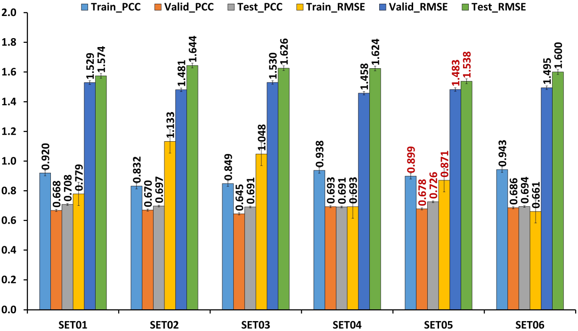

Figure S12: Statistical comparison of PCC (Person-Correlation-Coefficient) and RMSE (Root-Mean-Square-Error) between different SETS for Train, Valid and Test data based on Interaction Fingerprint Pattern (IFP) and Interaction-Distance (IFP+Int-Dist) as features. The statistics shown in red color are better among other SETS.

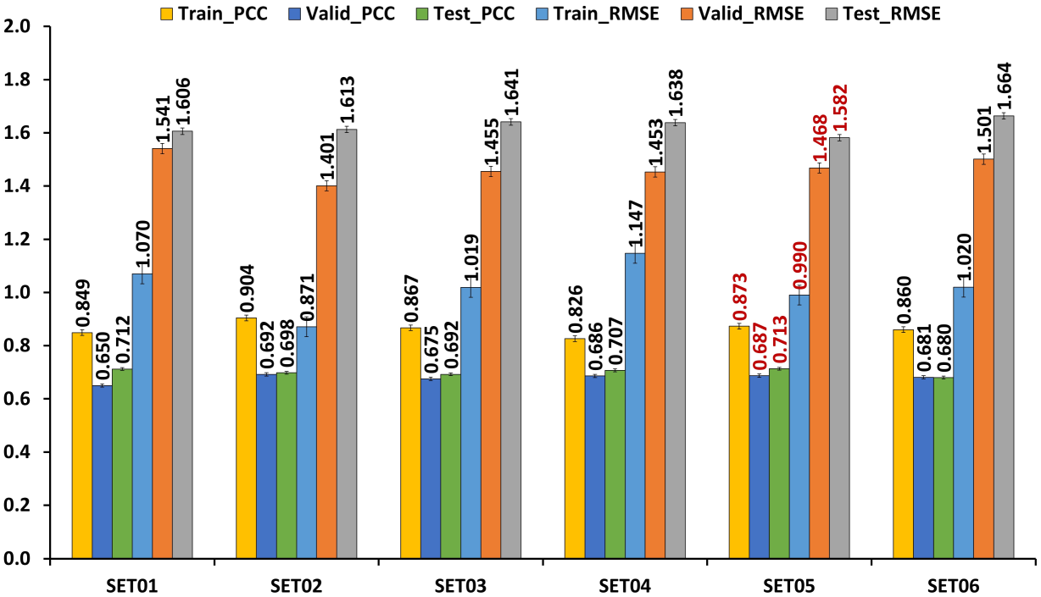
Figure S13: Statistical comparison of PCC (Person-Correlation-Coefficient) and RMSE (Root-Mean-Square-Error) between different SETS for Train, Valid and Test data based on Interaction Fingerprint Pattern (IFP) and Ligand fragments (IFP+Frag) as features. The statistics shown in red color are better among other SETS.
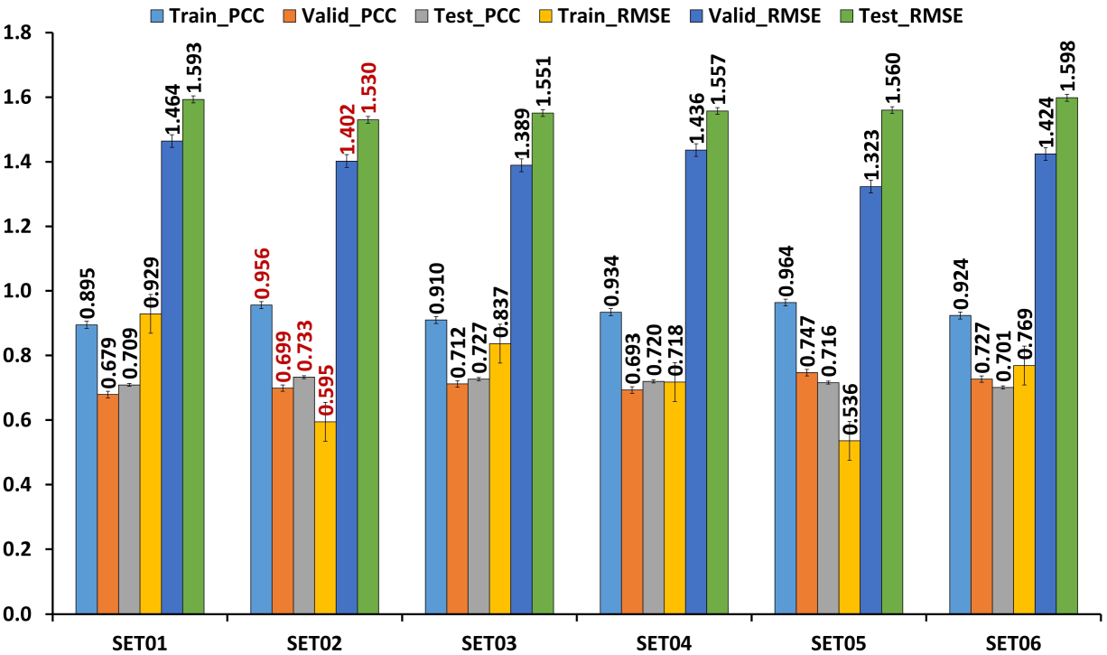

Figure S14: Statistical comparison of PCC (Person-Correlation-Coefficient) and RMSE (Root-Mean-Square-Error) between different SETS for Train, Valid and Test data based on Interaction Fingerprint Pattern (IFP), Interaction Distances and Ligand fragments (IFP+Int-Dist_Frag) as features. The statistics shown in red color are better among other SETS.
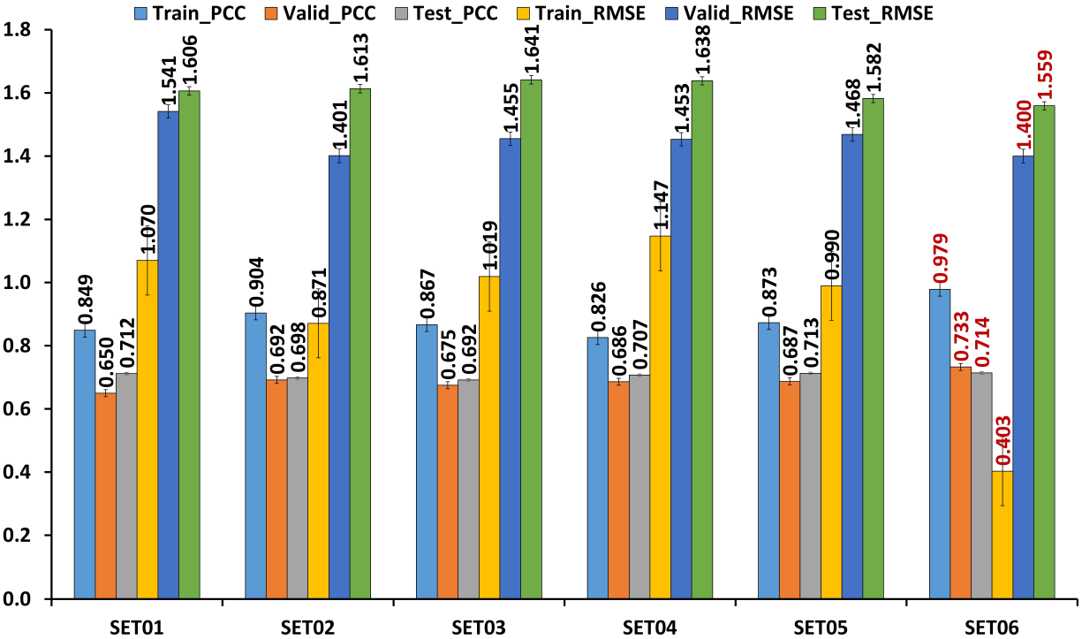
Figure S15: Statistical performance of PCC (Person-Correlation-Coefficient) and RMSE (Root-Mean-Square-Error) for Train and Valid data as a function of Epochs based on Interaction Fingerprint Pattern and Ligand fragments (IFP+Frag) as features. (The result shown here is based on selected best Hyperparameter option (Batch_Size: 64; dropout: 0.1; Alpha: 0.7)

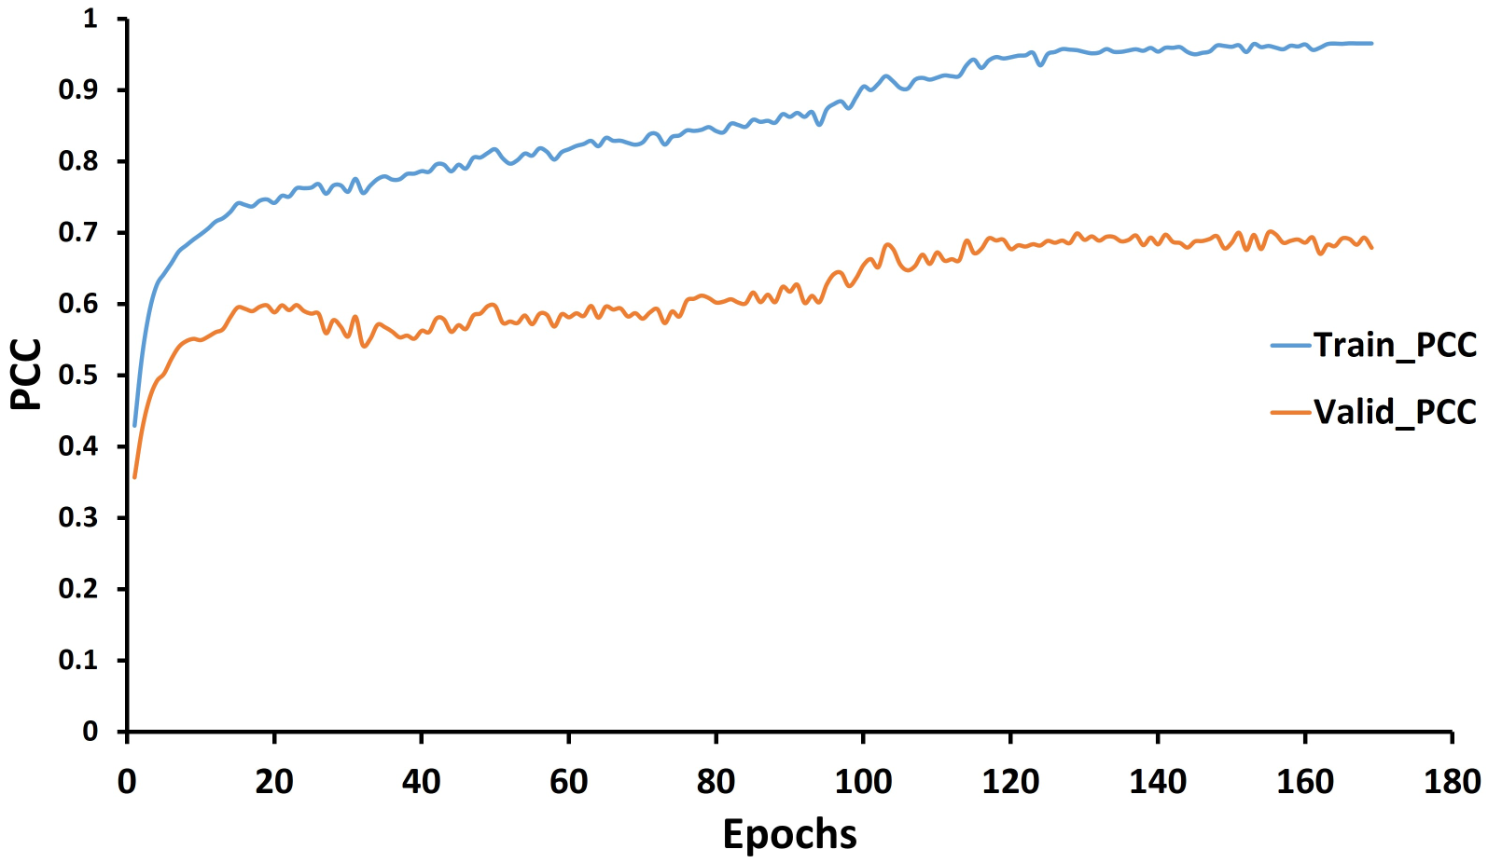
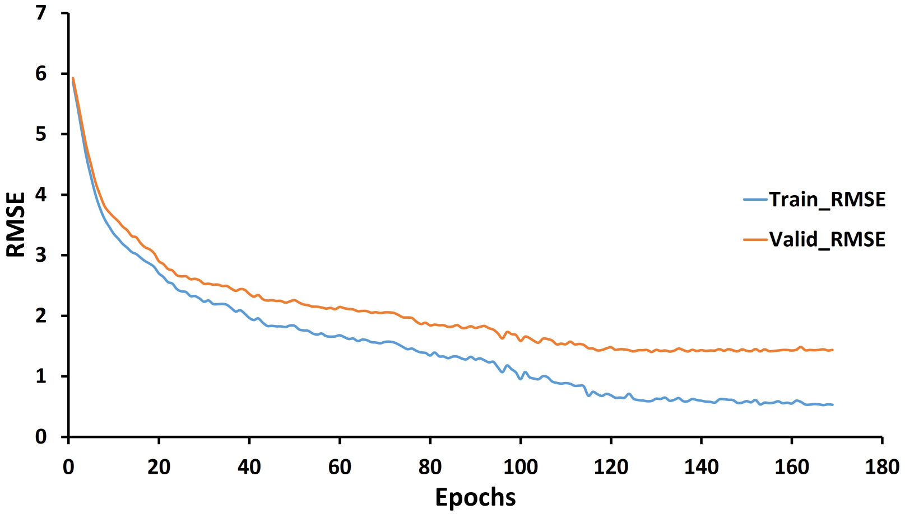

Table S3: The variance analysis of the Random Forest (RF) and Deep Neural Network (DNN) models. The results were based on the six best models from test set.

Features | Methods | Parameters | RMSE |  | PCC
Features | Methods | Parameters | Average | Std. | Average | Std.
IFP | RF | n_estimators = 500 max_features = 'auto' | 1.707 | 0.033 | 0.663 | 0.021
IFP | RF | n_estimators = 500 max_features = 'sqrt' | 1.701 | 0.031 | 0.693 | 0.019
IFP + Int_Dist | RF | n_estimators = 500 max_features = 'auto' | 1.753 | 0.026 | 0.651 | 0.017
IFP + Int_Dist | RF | n_estimators = 500 max_features = 'sqrt' | 1.728 | 0.027 | 0.689 | 0.017
IFP + Frag | RF | n_estimators = 500 max_features = 'auto' | 1.543 | 0.028 | 0.747 | 0.013
IFP + Frag | RF | n_estimators = 500 max_features = 'sqrt' | 1.574 | 0.030 | 0.739 | 0.013
IFP + Int_Dist + Frag | RF | n_estimators = 500 max_features = 'auto' | 1.546 | 0.022 | 0.745 | 0.011
IFP + Int_Dist + Frag | RF | n_estimators = 500 max_features = 'sqrt' | 1.564 | 0.028 | 0.750 | 0.012
IFP | DNN | - | 1.601 | 0.039 | 0.701 | 0.014
IFP + Int_Dist | DNN | - | 1.624 | 0.029 | 0.700 | 0.013
IFP + Frag | DNN | - | 1.565 | 0.026 | 0.718 | 0.012
IFP + Int_Dist + Frag | DNN | - | 1.607 | 0.032 | 0.706 | 0.009
Abbreviations: RMSE: Root-Mean-Square-Error; PCC: Pearson Correlation Coefficient; RF: Random Forest; DNN: Deep Neural Network

Figure S16: The binding affinity predictions for the Five benchmark dataset with IFP+Frag features using Random Forest Model. a) Astex Diverse Set; b) CASR NRC HiQ Set01; c) CASR NRC HiQ Set02; d) CSAF-2016; e) PDBbind NMR; and FEP dataset f) BACE; g) MCL1; h) PTP1B; i) Thrombin; j) Tyk2

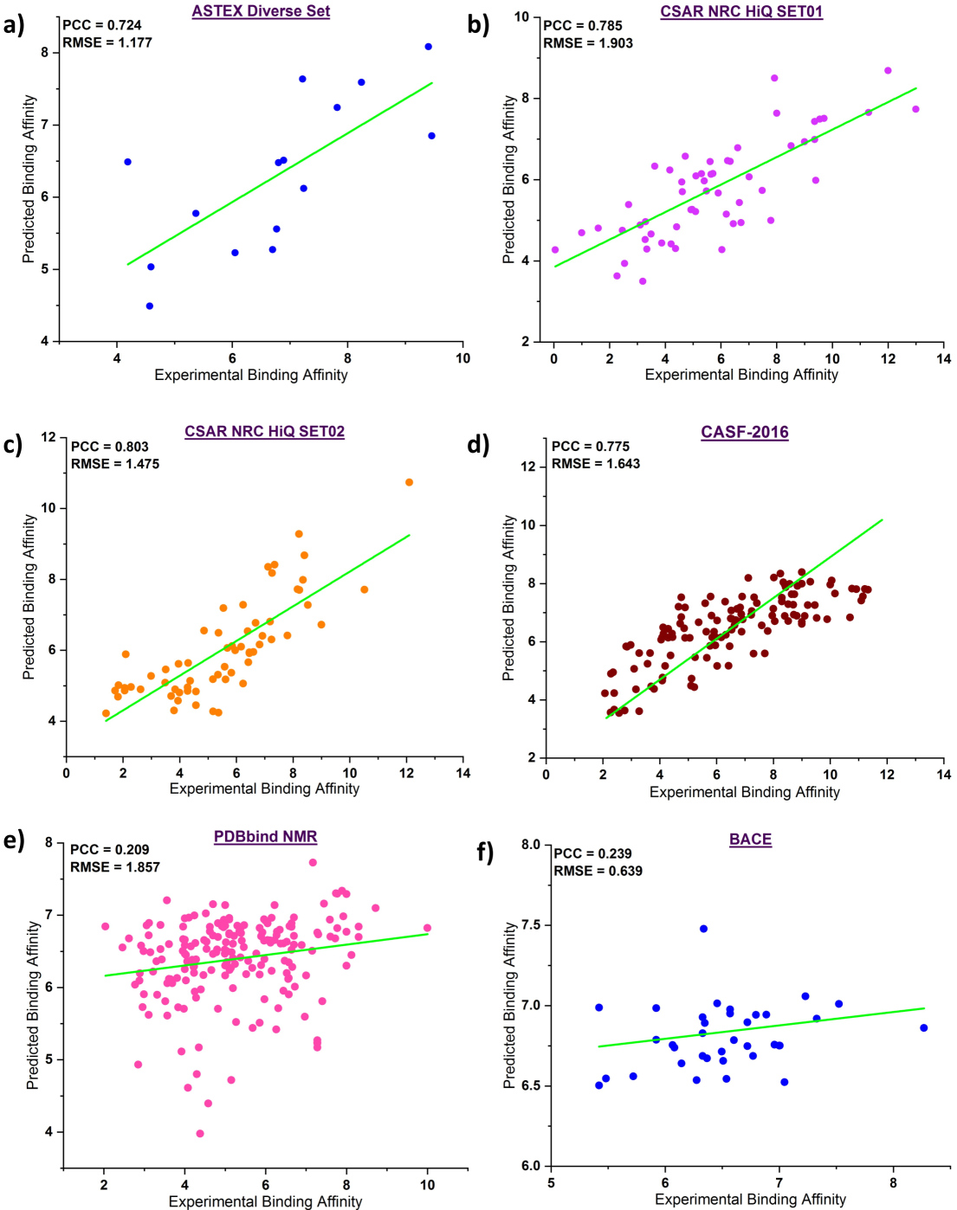
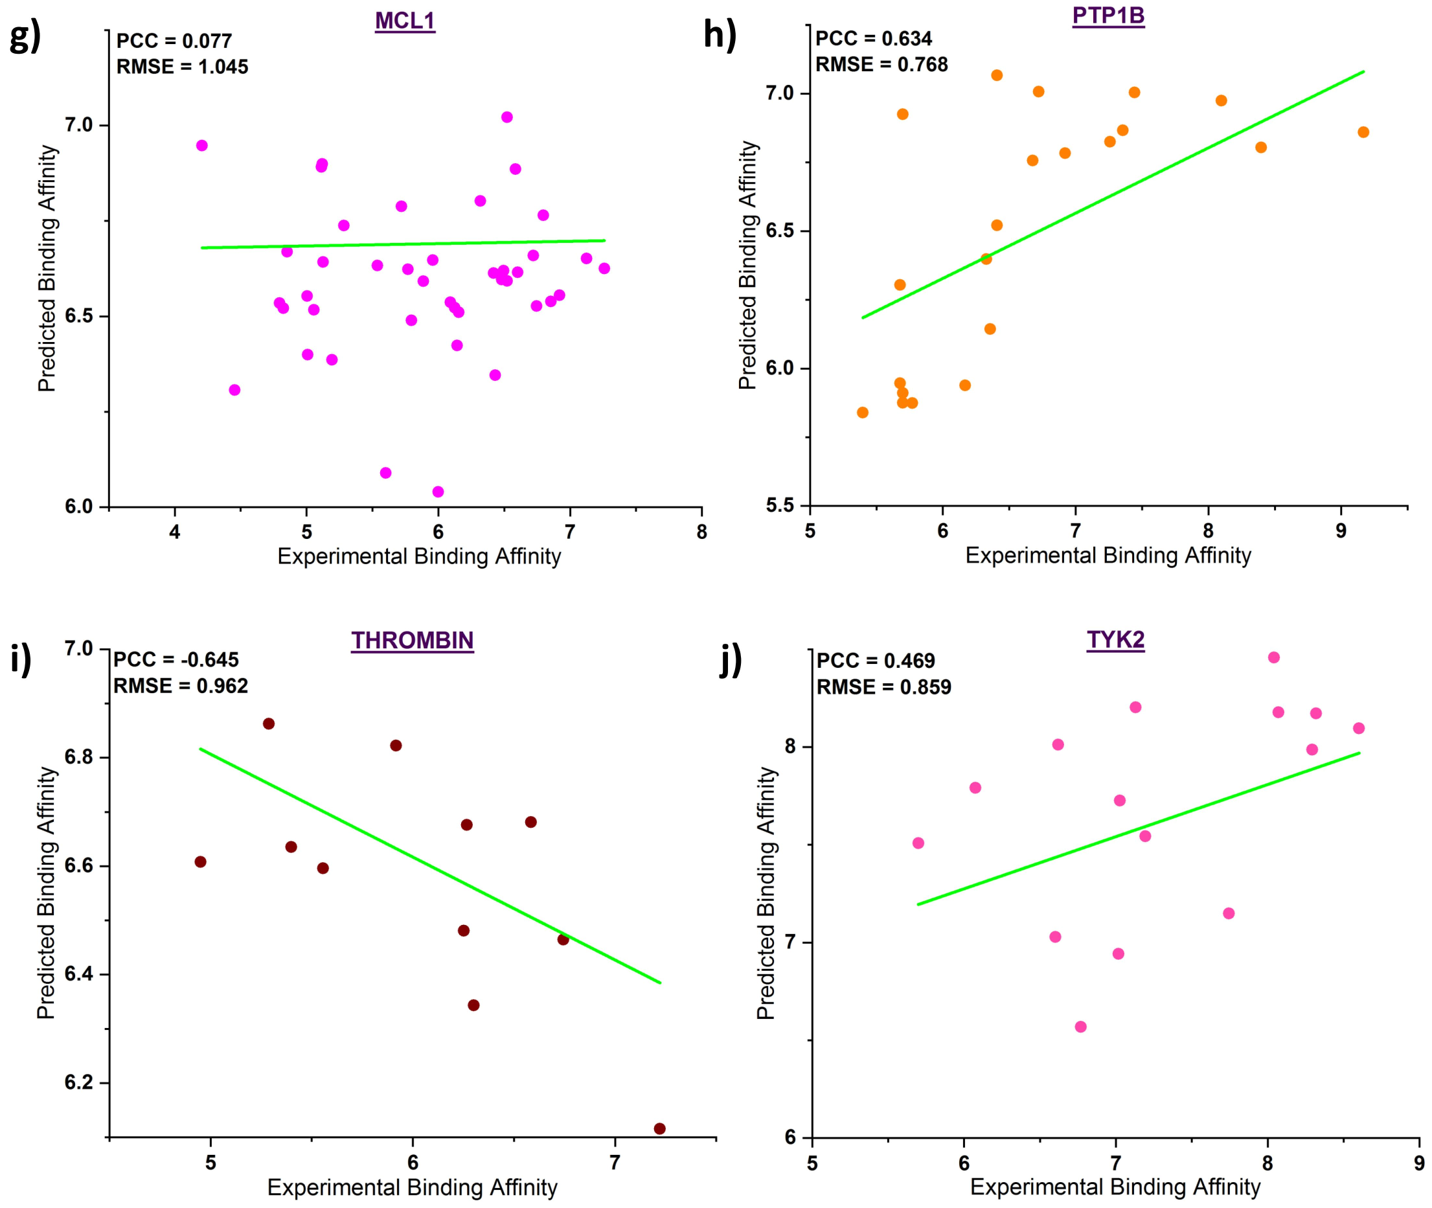

Figure S17: The superimposition of docked pose (magenta color) over the crystal pose (green color) for a) PDB ID: 2JDM; b) PDB ID: 3VH9 from PDBbind Core Set. The nitrogen atoms are in blue, oxygen in red, and hydrogen in white color.

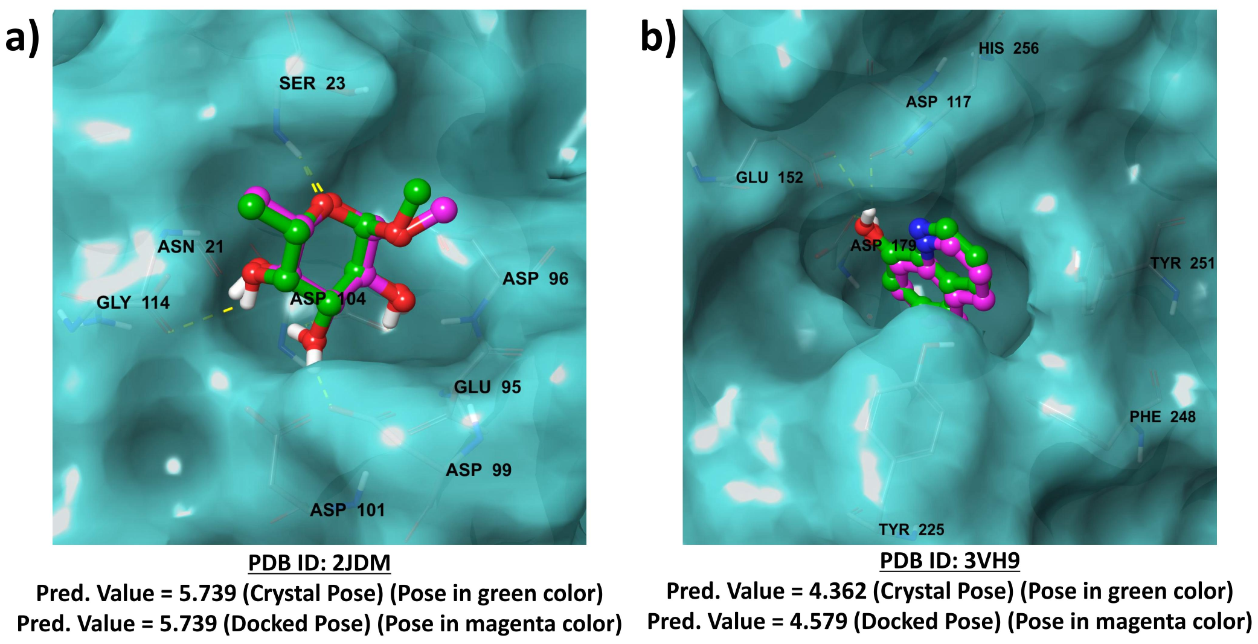

Table S4: Interaction Fingerprint Pattern (IFP) calculated for Crystal pose and Docked pose for PDB (2JDM).

Interaction Fingerprint Pattern
Crystal Pose |  |  |  | Docked Pose
Hydrophobic | CB | ALA₂₂ |  | Hydrophobic | CB | ALA₂₂
Hydrophobic | CB | SER₂₃ |  | Hydrophobic | CB | SER₂₃
Hydrophobic | CG2 | THR₄₅ |  | Hydrophobic | CG2 | THR₄₅
HBond_LIG | OD1 | ASP₁₀₄ |  | HBond_LIG | OD1 | ASP₁₀₄
HBond_LIG | OD2 | ASP₁₀₄ |  | HBond_LIG | OD2 | ASP₁₀₄
HBond_LIG | OD1 | ASP₁₀₄ |  | HBond_LIG | OD1 | ASP₁₀₄
HBond_LIG | O | GLY₁₁₄ |  | HBond_LIG | O | GLY₁₁₄
HBond_PROT | N | SER₂₃ |  | HBond_PROT | N | SER₂₃
Note: Boldface represents the common interaction found in Crystal Pose and Docked Pose.

Table S5: Interaction Fingerprint Pattern (IFP) calculated for Crystal pose and Docked pose for PDB (3VH9).

Interaction Fingerprint Pattern
Crystal Pose |  |  |  | Docked Pose
Hydrophobic | CB | ASP₁₇₉ |  | Hydrophobic | CB | ASP₁₇₉
Hydrophobic | SD | MET₁₈₀ |  | Hydrophobic | SD | MET₁₈₀
Hydrophobic | CB | CYS₂₂₇ |  | Hydrophobic | SG | CYS₂₂₃
Hydrophobic | CE | MET₂₄₂ |  | Hydrophobic | SG | CYS₂₂₇
Hydrophobic | CD1 | ILE₂₅₅ |  | Hydrophobic | CB | CYS₂₂₇
HBond_LIG | OE2 | GLU₁₅₂ |  | Hydrophobic | CE | MET₂₄₂
 |  |  |  | Hydrophobic | CD1 | ILE₂₅₅
 |  |  |  | HBond_LIG | OD1 | ASP₁₁₇
 |  |  |  | HBond_LIG | OD1 | ASP₁₇₉
Note: Boldface represents the common interaction found in Crystal Pose and Docked Pose.

Figure S18: The superimposition of docked pose (magenta color) over the crystal pose (green color) for a) PDB ID: 1TT1; b) PDB ID: 1SQN from Astex Diverse Set. The nitrogen atoms are in blue, oxygen in red, and hydrogen in white color.

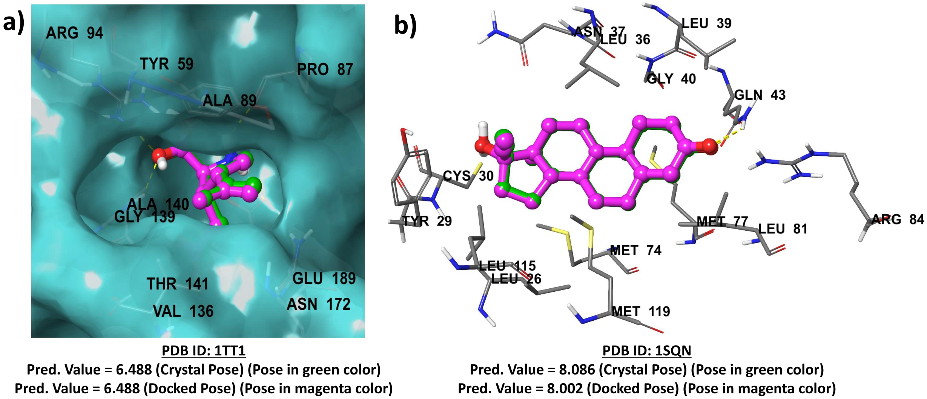

Table S6: Interaction Fingerprint Pattern (IFP) calculated for Crystal pose and Docked pose for PDB (1TT1).

Interaction Fingerprint Pattern
Crystal Pose |  |  |  | Docked Pose
Hydrophobic | CZ | TYR₆₁ |  | Hydrophobic | CE1 | TYR₆₁
Hydrophobic | CE1 | TYR₆₁ |  | Hydrophobic | CE1 | TYR₆₁
Hydrophobic | CG1 | VAL₁₃₈ |  | Hydrophobic | CG1 | VAL₁₃₈
Hydrophobic | CG | GLU₁₉₁ |  | Hydrophobic | CG | GLU₁₉₁
HBond_LIG | O | PRO₈₉ |  | HBond_LIG | O | PRO₈₉
HBond_LIG | OE1 | GLU₁₉₁ |  | HBond_LIG | OE1 | GLU₁₉₁
HBond_LIG | OE2 | GLU₁₉₁ |  | HBond_LIG | OE2 | GLU₁₉₁
HBond_PROT | N | ALA₉₁ |  | HBond_PROT | N | ALA₉₁
HBond_PROT | NH1 | ARG₉₆ |  | HBond_PROT | NH1 | ARG₉₆
HBond_PROT | NH2 | ARG₉₆ |  | HBond_PROT | NH2 | ARG₉₆
HBond_PROT | N | ALA₁₄₂ |  | HBond_PROT | N | ALA₁₄₂
HBond_PROT | N | THR₁₄₃ |  | HBond_PROT | N | THR₁₄₃
Ionic_LIG | OE1 | GLU₁₉₁ |  | Ionic_LIG | OE1 | GLU₁₉₁
Ionic_LIG | OE2 | GLU₁₉₁ |  | Ionic_LIG | OE2 | GLU₁₉₁
Note: Boldface represents the common interaction found in Crystal Pose and Docked Pose.
Table S7: Interaction Fingerprint Pattern (IFP) calculated for Crystal pose and Docked pose for PDB (1SQN).

Interaction Fingerprint Pattern
Crystal Pose |  |  |  | Docked Pose
Hydrophobic | CD2 | LEU₇₁₅ |  | Hydrophobic | CD2 | LEU₇₁₅
Hydrophobic | CD2 | LEU₇₁₈ |  | Hydrophobic | CD1 | LEU₇₁₈
Hydrophobic | CD1 | LEU₇₁₈ |  | Hydrophobic | CD2 | LEU₇₁₈
Hydrophobic | CB | LEU₇₁₈ |  | Hydrophobic | CB | LEU₇₁₈
Hydrophobic | CD2 | LEU₇₂₁ |  | Hydrophobic | CD2 | LEU₇₂₁
Hydrophobic | CE | MET₇₅₆ |  | Hydrophobic | CE | MET₇₅₆
Hydrophobic | SD | MET₇₅₆ |  | Hydrophobic | SD | MET₇₅₆
Hydrophobic | SD | MET₇₅₉ |  | Hydrophobic | CB | MET₇₅₉
Hydrophobic | CB | MET₇₅₉ |  | Hydrophobic | SD | MET₇₅₉
Hydrophobic | SD | MET₇₅₉ |  | Hydrophobic | CB | VAL₇₆₀
Hydrophobic | CB | VAL₇₆₀ |  | Hydrophobic | CD2 | LEU₇₆₃
Hydrophobic | CE2 | PHE₇₉₄ |  | Hydrophobic | CD2 | PHE₇₇₈
Hydrophobic | CD2 | LEU₇₉₇ |  | Hydrophobic | CE2 | PHE₇₉₄
Hydrophobic | CD2 | LEU₇₉₇ |  | Hydrophobic | CD2 | LEU₇₉₇
Hydrophobic | SD | MET₈₀₁ |  | Hydrophobic | CD2 | LEU₇₉₇
Hydrophobic | CD1 | LEU₈₈₇ |  | Hydrophobic | SD | MET₈₀₁
Hydrophobic | CB | LEU₈₈₇ |  | Hydrophobic | CB | LEU₈₈₇
Hydrophobic | CD1 | TYR₈₉₀ |  | Hydrophobic | CD1 | LEU₈₈₇
Hydrophobic | CE1 | TYR₈₉₀ |  | Hydrophobic | CE1 | TYR₈₉₀
Hydrophobic | CB | CYS₈₉₁ |  | Hydrophobic | CD1 | TYR₈₉₀
Hydrophobic | SG | CYS₈₉₁ |  | Hydrophobic | SG | CYS₈₉₁
Hydrophobic | CE | MET₉₀₉ |  | Hydrophobic | CB | CYS₈₉₁
HBond_PROT | NE2 | GLN₇₂₅ |  | Hydrophobic | CE | MET₉₀₉
 |  |  |  | HBond_PROT | NE2 | GLN₇₂₅
Note: Bold face represents the common interaction found in Crystal Pose and Docked Pose.

Figure S19: The superimposition of docked pose (magenta color) over the crystal pose (green color) for a) PDB ID: 2Y5H; b) PDB ID: 1W4O from CASF-2016 Set. The nitrogen atoms are in blue, oxygen in red, and hydrogen in white color.

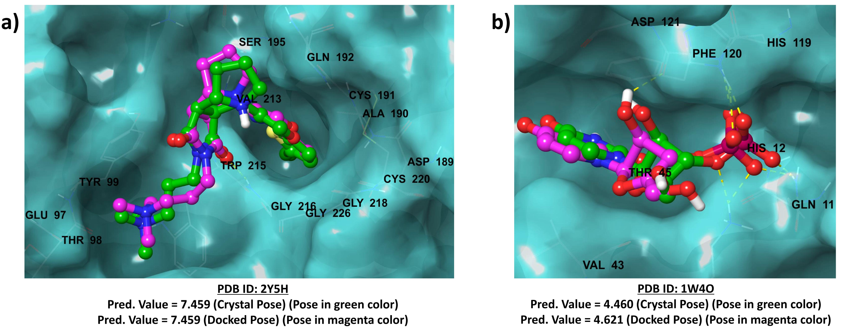

Table S8: Interaction Fingerprint Pattern (IFP) calculated for Crystal pose and Docked pose for PDB (2Y5H).

Interaction Fingerprint Pattern
Crystal Pose |  |  |  | Docked Pose
Hydrophobic | CZ | TYR₉₉ |  | Hydrophobic | CZ | TYR₉₉
Hydrophobic | CZ | TYR₉₉ |  | Hydrophobic | CE2 | TYR₉₉
Hydrophobic | CB | ALA₁₉₀ |  | Hydrophobic | CB | ALA₁₉₀
Hydrophobic | CG | GLN₁₉₂ |  | Hydrophobic | CG | GLN₁₉₂
Hydrophobic | CG1 | VAL₂₁₃ |  | Hydrophobic | CG1 | VAL₂₁₃
Hydrophobic | CG1 | VAL₂₁₃ |  | Hydrophobic | CG1 | VAL₂₁₃
Hydrophobic | CB | TRP₂₁₅ |  | Hydrophobic | CE3 | TRP₂₁₅
Hydrophobic | CZ | TYR₂₂₈ |  | Hydrophobic | CZ | TYR₂₂₈
HBond_PROT | N | GLY₂₁₆ |  | HBond_PROT | N | GLY₂₁₆
Note: Boldface represents the common interaction found in Crystal Pose and Docked Pose.

Table S9: Interaction Fingerprint Pattern (IFP) calculated for Crystal pose and Docked pose for PDB (1W4O).

Interaction Fingerprint Pattern
Crystal Pose |  |  |  | Docked Pose
HBond_LIG | OG1 | THR₄₅ |  | HBond_LIG | OG1 | THR₄₅
HBond_PROT | NE2 | GLN₁₁ |  | HBond_LIG | O | PHE₁₂₀
HBond_PROT | NZ | LYS₄₁ |  | HBond_PROT | NE2 | GLN₁₁
HBond_PROT | N | THR₄₅ |  | HBond_PROT | NZ | LYS₄₁
HBond_PROT | ND1 | HIS₁₁₉ |  | HBond_PROT | ND1 | HIS₁₁₉
HBond_PROT | N | PHE₁₂₀ |  | HBond_PROT | ND1 | HIS₁₁₉
Ionic_PROT | NZ | LYS₄₁ |  | HBond_PROT | N | PHE₁₂₀
 |  |  |  | HBond_PROT | NZ | LYS₄₁
Note: Boldface represents the common interaction found in Crystal Pose and Docked Pose.

