Fight club, or the story of the invasion of two marine blue crab species in the Mediterranean Sea
Guillaume Marchessaux^{1*}, Vojsava Gjoni^{2,3}, Raouia Ghanem^{4,5}, Wafa Rjiba Bahri⁵, Jamila Ben Souissi^{4,5}, Marina Chiappi^{6,7}, and Gianluca Sarà^{2,3}

¹ Aix Marseille Univ, Université de Toulon, CNRS, IRD, MIO, Marseille, France
² Department of Earth and Marine Science (DiSTeM), University of Palermo, Palermo, Italy
³ NBFC, National Biodiversity Future Center, Palermo, Piazza Marina 61, 90133 Palermo, Italy
⁴ National Institute of Agronomy of Tunisia (INAT), University of Carthage, Tunis, Tunisia
⁵ Laboratory of Biodiversity, Biotechnology and Climate Change (LR11ES09), University Tunis El Manar, Tunis, Tunisia
⁶ Department of Biological, Geological and Environmental Sciences (BIGEA), University of Bologna (UNIBO), Bologna, Italy
⁷ National Research Council (CNR), Institute for Biological Resources and Marine Biotechnologies (IRBIM), Ancona, Italy

Running title: Invasion of two blue crabs in Mediterranean
Keywords: Callinectes sapidus, Portunus segnis, Invasive species management, Climate change.

Corresponding authors: Guillaume Marchessaux, Guillaume.marchessaux@ird.fr

Supplementary materials

Supplementary Figure 1. Results of the GAM model fitting.
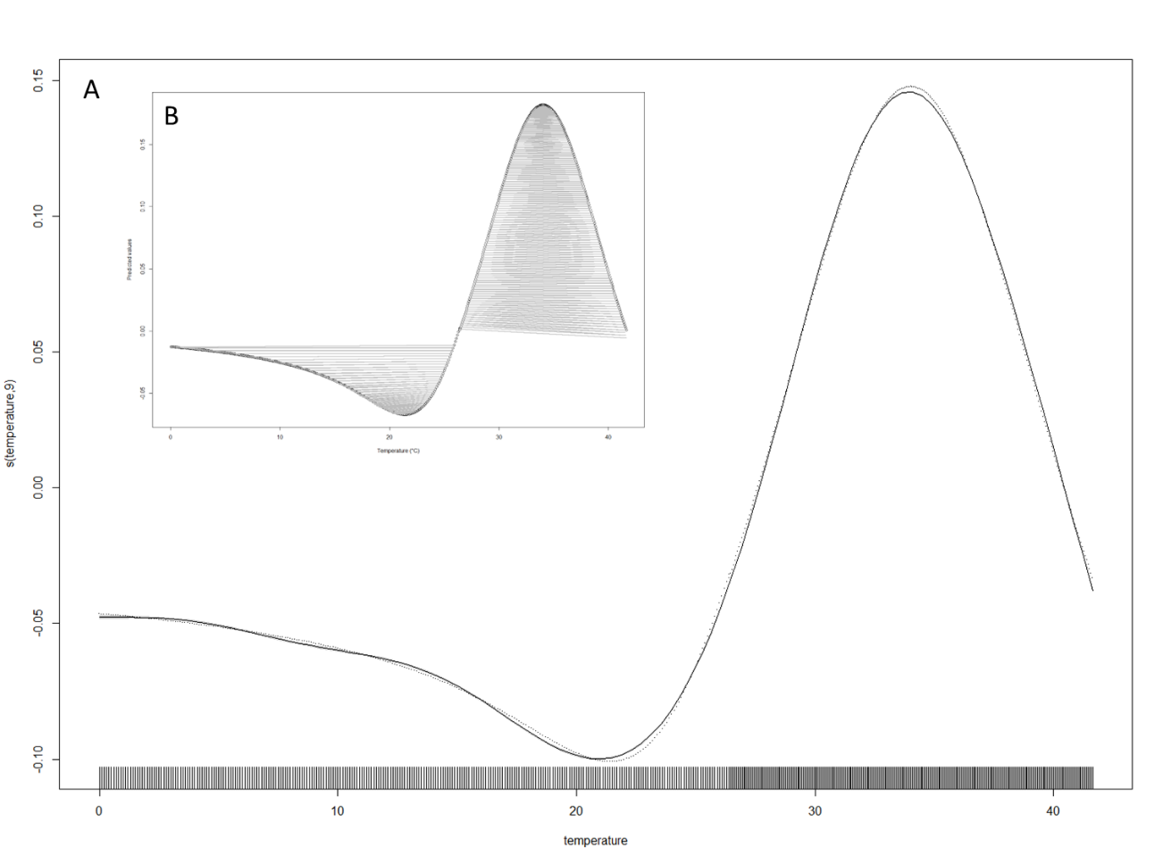

Supplementary Table 1. Percentages of change in probability of presence of C. sapidus, P. segnis and co-occurrence between 2050 and 2023.
