Supplementary File
Linear complexions enable unprecedented ductility retention in neutron irradiated ferritic steel
Arya Chatterjee, Soumita Mondal, Yu Lu, Yaqiao Wu, Janelle P Wharry

Fabrication | C | Si | Mn | P | S | Cr | Ni | Mo | Al | V | Fe
Cast | 0.10 | 0.24 | 0.48 | 0.004 | 0.008 | 8.40 | 0.009 | 0.86 | 0.05 | 0.27 | Bal.
PM-HIP | 0.12 | 0.47 | 0.62 | 0.004 | 0.003 | 8.78 | 0.08 | 0.92 | 0.12 | 0.20 | Bal.
Table S1. Chemical compositions (in wt.%) of the investigated Grade 91 specimens.

Table S2. Details of irradiation conditions for all the investigated specimens.
Fabrication | Specimen type | Target dose (dpa) | Actual dose (dpa) | Target temperature (°C) | Actual temperature (°C)
Cast | Disc | 1 | 0.99 ± 0.00 | 400 | 389.0 ± 0.00
Cast | Tensile | 1 | 1.00 ± 0.01 | 400 | 381.0 ± 7.07
Cast | Disc | 3 | 3.97 ± 0.00 | 400 | 397.0 ± 0.00
Cast | Tensile | 3 | 3.63 ± 0.12 | 400 | 362.5 ± 0.71
PM-HIP | Disc | 1 | 0.99 ± 0.00 | 400 | 389.0 ± 0.00
PM-HIP | Tensile | 1 | 1.02 ± 0.01 | 400 | 362.5 ± 6.36
PM-HIP | Disc | 3 | 3.74 ± 0.00 | 400 | 397.0 ± 0.00
PM-HIP | Tensile | 3 | 3.54 ± 0.19 | 400 | 356.5 ± 7.78

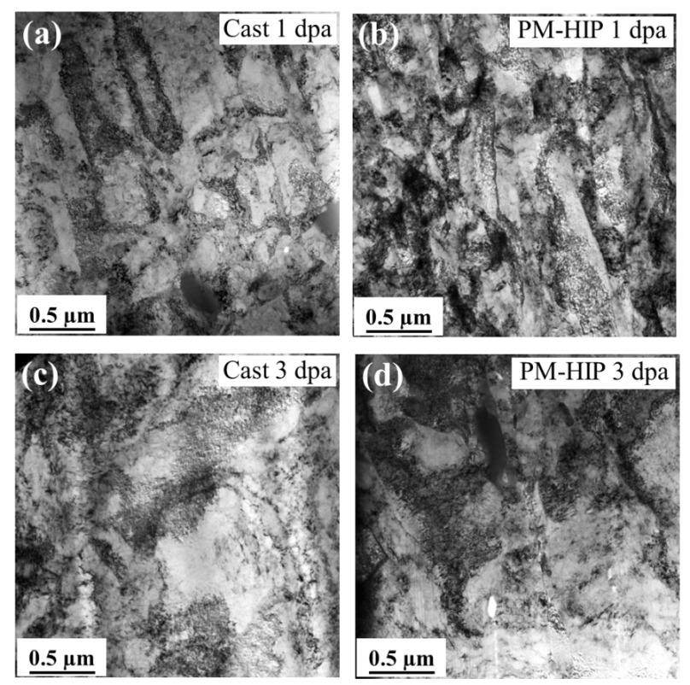
Figure S1: TEM micrographs taken from fracture surfaces after tensile testing of cast and PM-HIP G91 irradiated to (a-b) 1 dpa and (c-d) 3 dpa, confirming absence of dislocation channels.

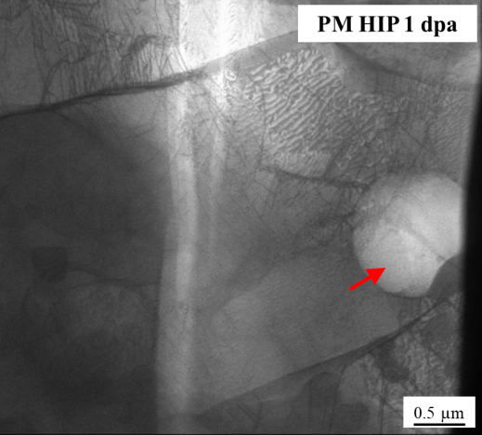
Figure S2: TEM micrograph of 1 dpa irradiated PM-HIP specimen revealing presence of residual porosity (red arrow) in the microstructure.

