Supplementary data for:
Evidence of a Bulk Interlayer Excitonic Insulator Phase in the Oxypnictide CeMnAsO_{1-x}F_{x}
S. Simpson ^{1, 2}, G. B. Lawrence ¹, C. Ritter ³, E. J. Wildman ¹, A. M. Arevalo-Lopez ⁴, K. Morita ⁵, Q. D. Gibson ¹ and A. C. Mclaughlin ^{1*}

¹ Department of Chemistry, University of Aberdeen, Meston Walk, Aberdeen, AB24 3UE, U.K.
² Department of Chemistry, University of Warwick, Gibbet Hill, CV4 7AL, Coventry, U.K
³ Institut Laue Langevin, 71 Avenue des Martyrs, BP 156, F-38042 Grenoble Cedex 9, France.
⁴ Université de Lille, CNRS, Centrale Lille, ENSCL, Université d’Artois, UMR 8181-UCCS-Unitéde Catalyse et Chimie du Solide, F-59000 Lille, France.
⁵ Department of Chemistry, University of Pennsylvania, Philadelphia, Pennsylvania 19104-6323, United States

Section 1 Electronic Properties
For the CeMnAsO_{1-x}F_{x} phases, below ∼ 100 K variable range hopping of the charge carriers is observed ¹. Hence the electrons are localised and electron transport is only possible by phonon assisted tunnelling between localised states.
The Hall coefficient in the presence of both electrons and holes can be written as Equation S1:
$$R_{H}=\frac{{μ_{h}}^{2}p-{μ_{n}}^{2}n}{e{(μ_{h}p+μ_{n}n)}^{2}}$$
Where $μ_{h}$and $μ_{n}$ are the hole and electron mobilities, and p and n are the hole and electron concentrations. In the event of roughly equal hole and electron concentrations, the sign of the Hall coefficient will be dominated by the carrier type that has the larger mobility. In this case, the negative Hall coefficient above T_{C} and positive coefficient below T_{C} is consistent with a scenario of heavy, immobile holes, and lighter, more mobile electrons above T_{C}, with both carriers freezing out at T_{C.} As T_{C} is approached, the excitons condense, lowering the carrier concentration and increasing the magnitude of the Hall coefficient. Well below T_{C} when the electrons and holes are fully condensed into bound excitons, the Hall coefficient will then be sensitive to any small imbalance in hole and electron concentration arising from defects and small changes to the chemical potential.
The very large Seebeck effect previously reported below T_{C} ¹ is also consistent with this picture. The Seebeck effect is largest at very low carrier concentrations of non-compensated carriers. Thus, if the electrons and holes freeze at T_{C}, the remaining carriers simply represent a small number of whatever electrons and holes are left over due to small imbalances of the chemical potential. The Seebeck coefficient will then be very large and either positive or negative, depending on details of the defect chemistry, consistent with what has been observed. The Seebeck coefficient of a semiconductor can be written as in Equation S2 below:

$$S_{total}= \frac{σ_{h}S_{h}+σ_{e}S_{e}}{σ_{h}+σ_{e}}$$

Therefore, above T_{C} the sign of the overall Seebeck coefficient will be dominated by the carrier that has the largest magnitude of the product of conductivity and Seebeck coefficient. In the event of very heavy, essentially immobile ($σ_{h}≈0)$ holes and mobile, conducting electrons, this would be electron dominated (negative) above T_{C}, consistent with experiment ¹.
Section 2 The Crystal and Magnetic Structure of the CeMnAsO_{1-x}F_{x} phases
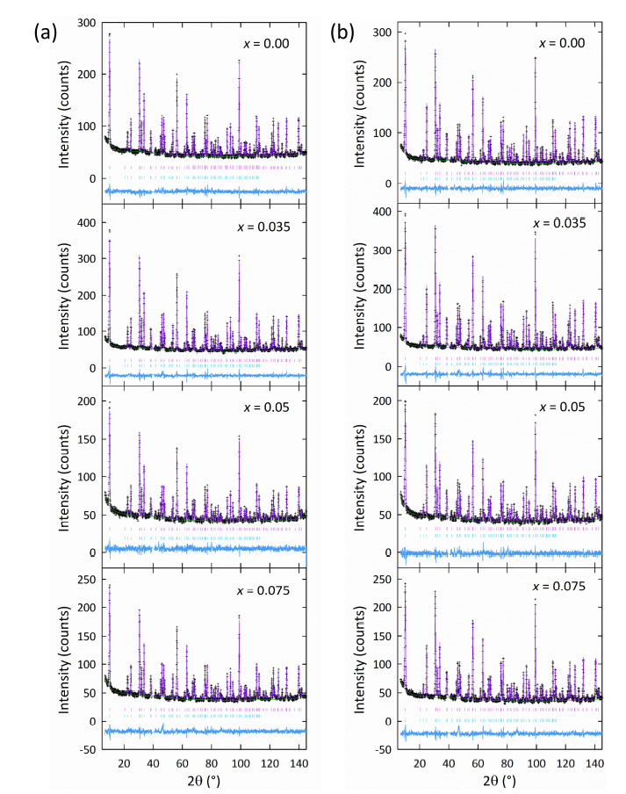
The same samples reported in reference 1 were used in the high-resolution neutron powder diffraction experiments described here. For the CeMnAsO_{1-x}F_{x} phases, all atomic occupancies could be refined to within ±1% of their nominal values, so these were fixed for the remainder of the refinements.

Supplementary Figure 1 Rietveld fits with the P4/nmm structural model for the CeMnAsO_{1-x}F_{x} series based on NPD data collected on D2B at (a) 300 K and (b) 10 K. The upper and lower tick marks in each plot correspond to the nuclear and magnetic phases, respectively.
Atom |  | CeMnAsO_{1-x}F_{x}
 | x | 0.000 | 0.035 | 0.050 | 0.075
Ce | z | 0.1319(2) | 0.1320(2) | 0.1326(3) | 0.1328(3)
 | U_{iso} (Å²) | 0.0043(6) | 0.0048(6) | 0.0038(9) | 0.0043(7)
Mn | U_{iso} (Å²) | 0.0050(6) | 0.0070(5) | 0.0064(8) | 0.0064(6)
 | μ_{B}(z) | 2.59(3) | 2.49(3) | 2.52(3) | 2.46(3)
As | z | 0.6713(2) | 0.6713(2) | 0.6716(3) | 0.6714(2)
 | U_{iso} (Å²) | 0.0067(5) | 0.0065(4) | 0.0062(7) | 0.0069(5)
O/F | U_{iso} (Å²) | 0.0051(5) | 0.0052(4) | 0.0048(7) | 0.0051(5)
 | a (Å) | 4.09196(1) | 4.09068(4) | 4.09012(6) | 4.09111(5)
 | c (Å) | 8.9717(1) | 8.9674(1) | 8.9644(2) | 8.9679(2)
 | χ² | 1.22 | 1.70 | 1.10 | 1.32
 | R_{P} (%) | 3.24 | 3.39 | 3.24 | 3.60
 | R_{WP} (%) | 4.09 | 4.44 | 4.09 | 4.67
 | V (Å³) | 150.223(2) | 150.057(5) | 149.966(8) | 150.097(7)
Supplementary Table 1. Refined cell parameters, agreement factors, and atomic parameters obtained for CeMnAsO_{1-x}F_{x} from Rietveld fits to the P4/nmm structural model from D2B neutron powder diffraction data at 300 K (origin choice no. 2). Ce and As are located at the 2c site (¼, ¼, z), Mn at 2b (¾, ¼, ½), and O/F at 2a (¼, ¾, 0). All samples were phase-pure with the exception of CeMnAsO_{0.925}F_{0.075}, which contained a small amount of CeOF (~1.5% by volume).

Supplementary Table 2. Selected bond lengths and angles for CeMnAsO_{1-x}F_{x} obtained from Rietveld fits to the P4/nmm structural model from D2B neutron diffraction data at 300 K.
x | 0 | 0.035 | 0.05 | 0.075
Bond length (Å)
Ce‒O/F | 2.3636(10) | 2.3633(9) | 2.3653(14) | 2.3670(12)
Mn‒As | 2.5589(10) | 2.5577(9) | 2.5590(14) | 2.5588(12)
Ce‒As | 3.3896(14) | 3.3879(13) | 3.3833(20) | 3.3840(17)
Mn‒Mn | 2.89345(1) | 2.89255(3) | 2.89215(4) | 2.89285(4)
Bond angles (°)
α₁ Ce‒O/F‒Ce | 119.91(8) | 119.87(7) | 119.68(12) | 119.58(10)
α₂ Ce‒O/F‒Ce | 104.52(4) | 104.54(3) | 104.62(5) | 104.67(4)
α₁ As‒Mn‒As | 111.14(3) | 111.13(3) | 111.18(4) | 111.16(4)
α₂ As‒Mn‒As | 106.17(6) | 106.20(6) | 106.10(9) | 106.15(7)

There is no clear change in the Mn–As bond length or As–Mn–As angles upon increasing x. The Ce–(O/F)–Ce α₁ bond angle decreases from 119.91(8)° to 119.58(10)° as x increases from 0 to 0.075. At the same time the Ce–(O/F)–Ce α₂ bond angle increases from 104.52(4)° to 104.67(4)° (Supplementary Figure 2). These values both tend slightly closer towards the ideal tetrahedral angle (109.47°) with increasing x.

Supplementary Figure 2. The variation of the Ce-As distance with F⁻ doping concentration, x, which shows the effect of F⁻ doping is to move the Ce-O/F layer and the As-Mn-As block closer together.

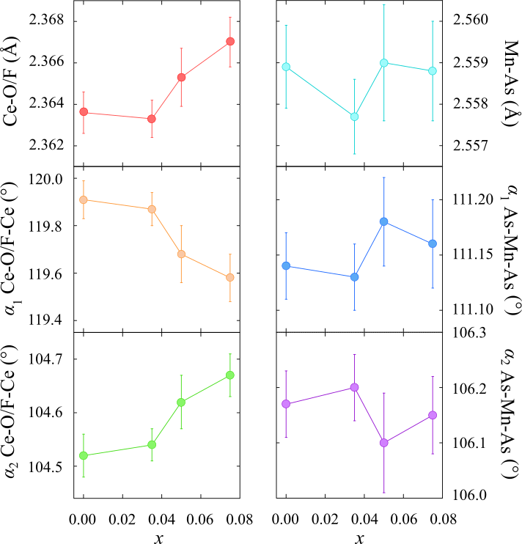
Supplementary Figure 3. Structural trends observed in the Ce(O/F) and MnAs tetrahedral layers across the CeMnAsO_{1-x}F_{x} series at 300 K. Bond angles are labelled according to the inset in Figure 3b.

At ∼ 10 K, the Ce-As distance reduces from 3.3779(13) Å for x = 0 to 3.3753(15) Å for x = 0.075 (Supplementary Table 4). The MnAs layers do not display any clear trends upon varying x.

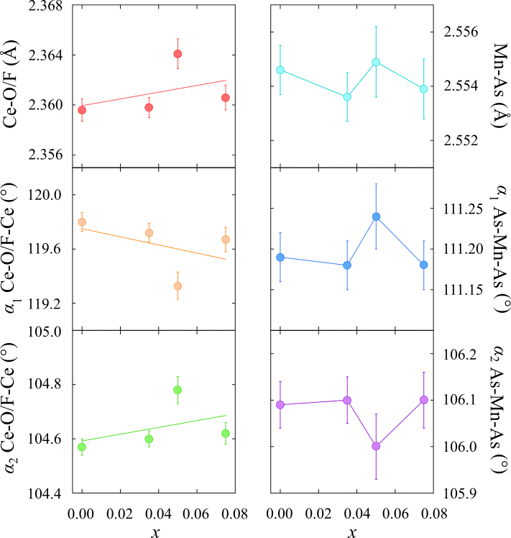
Supplementary Figure 4. Structural trends observed in the Ce(O/F) and MnAs tetrahedral layers across the CeMnAsO_{1-x}F_{x} series at temperatures < 10 K. Bond angles are labelled according to Figure 3b.

Supplementary Table 3. Refined cell parameters, agreement factors, and atomic parameters obtained for CeMnAsO_{1-x}F_{x} from Rietveld fits to the P4/nmm structural model from D2B neutron powder diffraction data at T < 10 K (origin choice no. 2). Ce and As are located at the 2c site (¼, ¼, z), Mn at 2b (¾, ¼, ½), and O/F at 2a (¼, ¾, 0).

Atom |  | CeMnAsO_{1-x}F_{x}
 | x | 0.000 | 0.035 | 0.050 | 0.075
Ce | z | 0.1323(2) | 0.1325(2) | 0.1336(3) | 0.1326(2)
 | U_{iso} (Å²) | 0.0006(6) | 0.0028(5) | 0.0011(8) | 0.0008(7)
 | moment | 1.16(4) | 1.06(3) | 0.97(5) | 0.99(5)
Mn | U_{iso} (Å²) | 0.0011(5) | 0.0020(4) | 0.0007(7) | 0.0012(6)
 | moment | 3.65(3) | 3.65(3) | 3.66(4) | 3.64(4)
As | z | 0.6717(2) | 0.6717(2) | 0.6720(2) | 0.6717(2)
 | U_{iso} (Å²) | 0.0011(4) | 0.0014(4) | 0.0006(6) | 0.0008(5)
O/F | U_{iso} (Å²) | 0.0021(4) | 0.0021(4) | 0.0019(6) | 0.0019(5)
 | a (Å) | 4.08280(5) | 4.08154(4) | 4.08079(5) | 4.08190(5)
 | c (Å) | 8.9459(1) | 8.9418(1) | 8.9378(2) | 8.9420(2)
 | χ² (%) | 1.33 | 1.84 | 1.16 | 1.38
 | R_{P} (%) | 3.33 | 3.60 | 3.34 | 3.76
 | R_{WP} (%) | 4.34 | 4.70 | 4.28 | 4.91
 | V (Å³) | 149.122(5) | 148.961(5) | 148.840(7) | 148.932(7)

Supplementary Table 4. Selected bond lengths and angles for CeMnAsO_{1-x}F_{x} obtained from Rietveld fits to the P4/nmm structural model from D2B neutron diffraction data at low temperature (1.5 – 10 K).
x | 0.000 | 0.035 | 0.050 | 0.075
Bond Length (Å)
Ce-O/F | 2.3596(9) | 2.3598(8) | 2.3641(12) | 2.3606(10)
Mn-As | 2.5546(9) | 2.5536(9) | 2.5549(13) | 2.5539(11)
Ce-As | 3.3779(13) | 3.3758(12) | 3.3681(17) | 3.3753(15)
Mn-Mn | 2.88697(3) | 2.88608(3) | 2.88555(4) | 2.88634(3)
Bond Angles (°)
α₁ Ce-O/F-Ce | 119.80(7) | 119.72(7) | 119.33(10) | 119.67(9)
α₂ Ce-O/F-Ce | 104.57(3) | 104.60(3) | 104.78(5) | 104.62(4)
α₁ As-Mn-As | 111.19(3) | 111.18(3) | 111.24(4) | 111.18(3)
α₂ As-Mn-As | 106.09(5) | 106.10(5) | 106.00(7) | 106.10(6)

Supplementary Table 5. All possible Γ-point symmetry-breaking distortions which can occur in CeMnAsO_{1–x}F_{x}. The symmetry analysis has been performed using ISODISTORT ^{2, 3}. The distortions have been labelled in terms of how they transform as irreducible representations (irreps) of the aristotype P4/nmm structure. In each case, the secondary irrep describing the transformation of any additional ferroelastic strain modes has been specified to clarify the change in crystal (metric) symmetry which should be resolvable by powder diffraction for each distortion. The corresponding order parameter directions (OPDs) for each mode have been specified in parentheses after each irrep.
Primary irrep | Strain mode(s) | Crystal symmetry | Space group
${\text{Γ}}_{\text{1}}^{\text{+}}$(a) | ${\text{Γ}}_{\text{1}}^{\text{+}}$(a) | Tetragonal | P4/nmm
${\text{Γ}}_{\text{2}}^{\text{+}}$(a) | ${\text{Γ}}_{\text{2}}^{\text{+}}$(a) | Orthorhombic | Pmmn
${\text{Γ}}_{\text{4}}^{\text{+}}$(a) | ${\text{Γ}}_{\text{4}}^{\text{+}}$(a) | Orthorhombic | Cmma
${\text{Γ}}_{\text{5}}^{\text{+}}$(a,0) | ${\text{Γ}}_{\text{2}}^{\text{+}}$(a), ${\text{Γ}}_{\text{5}}^{\text{+}}$(a,0) | Monoclinic | P2₁/m
${\text{Γ}}_{\text{5}}^{\text{+}}$(a,a) | ${\text{Γ}}_{\text{4}}^{\text{+}}$(a), ${\text{Γ}}_{\text{5}}^{\text{+}}$(a,a) | Monoclinic | C2/m
${\text{Γ}}_{\text{5}}^{\text{+}}$(a,b) | ${\text{Γ}}_{\text{2}}^{\text{+}}$(a), ${\text{Γ}}_{\text{4}}^{\text{+}}$(a), ${\text{Γ}}_{\text{5}}^{\text{+}}$(a,b) | Triclinic | P$\overline{1}$
${\text{Γ}}_{\text{3}}^{ \text{–}}$(a) | None | Tetragonal | P4nmm
${\text{Γ}}_{\text{5}}^{ \text{–}}$(a,0) | ${\text{Γ}}_{\text{2}}^{\text{+}}$(a) | Orthorhombic | Pmn2₁
${\text{Γ}}_{\text{5}}^{ \text{–}}$(a,a) | ${\text{Γ}}_{\text{4}}^{\text{+}}$(a) | Orthorhombic | Abm2
${\text{Γ}}_{\text{5}}^{ \text{–}}$(a,b) | ${\text{Γ}}_{\text{2}}^{\text{+}}$(a), ${\text{Γ}}_{\text{4}}^{\text{+}}$(a) | Monoclinic | Pc

All distorted structures feature an additional strain component transforming as the totally symmetric representation (${\text{Γ}}_{\text{1}}^{\text{+}}$) corresponding to the (non-symmetry-breaking) strain associated with thermal expansion. The only hypothetical Γ-point distortion which would not be accompanied by any symmetry-breaking strain is a polar mode transforming as the ${\text{Γ}}_{\text{3}}^{ \text{–}}$(a) irrep, but no macroscopic polarization has been observed experimentally which rules out the presence of this mode. We also observe no superstructure reflections to suggest there is any change in crystal symmetry associated with an alternative point in reciprocal space, so we limit our analysis of possible symmetry-breaking strains to distortions at the Γ point.
Supplementary Table 6. Microstrain (e₀) across the CeMnAsO_{1–x}F_{x} series estimated from Rietveld fits against high-resolution NPD data (D2B). The low-temperature data were collected at different temperatures (T < 10 K) for each member of the series, hence the low-temperature e₀ values have been reported with respect to “base” temperature.

 | e₀ (%)
x | 0 | 3.5 | 5 | 7.5
300 K | 0.023(15) | 0.029(1) | 0.026(1) | 0.027(2)
“Base” | 0.028(1) | 0.029(1) | 0.029(1) | 0.029(2)

The microstrain (e₀) is calculated based on a convolution of Gaussian and Lorentzian strain broadening terms to the peak profiles. In the absence of an appropriate instrumental standard, this analysis has been performed by including the profile parameters with the rest of the structural model for the undoped sample at 300 K before fixing these for subsequent refinements at base temperature as well as the rest of the series. Any additional strain broadening due to microstrain should hence be apparent as an increase in the magnitude of the e₀ terms, but Supplementary Table 6 shows that there is no significant increase in microstrain both across the series as well as upon cooling below T_{C} in each sample. Any attempts to include anisotropic strain broadening terms in the refinements produced physically unfeasible values, so we have also excluded this possibility. This shows there is no significant deviation from the tetragonal symmetry across the low-temperature electronic transition, demonstrating that the exciton condensation is not strongly coupled to any change in crystal symmetry as otherwise observed in other excitonic insulating candidate materials.

Section 3 Magnetic Properties and Thermal Expansion
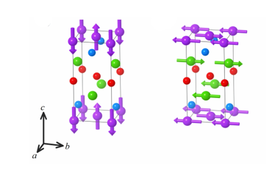
In CeMnAsO, the Mn²⁺ moments align antiferromagnetically below 367 K (Supplementary Figure 4) ¹⁹. Below 34 K (T_{SR}) the Ce spins align antiferromagnetically with spins aligned parallel to the basal plane. This results in a spin reorientation of the Mn²⁺ moments from aligning parallel to c to orienting parallel to the basal plane (Supplementary Figure 4). Variable temperature neutron diffraction patterns of CeMnAsO_{1-x}F_{x}, recorded on the high intensity D20 diffractometer show that there are no significant changes in the magnetic structure at T_{C} (Supplementary Figure 5) so that magnetic ordering is also not responsible for the electronic transition at T_{C}. Only a small reduction in the Mn magnetic transition temperature, T_{Mn}, is observed from 367 K to 359 K upon F⁻ doping (Supplementary Figure 6).

Supplementary Figure 5. The magnetic structure of CeMnAsO_{1-x}F_{x} at 300 K (left) and at T ≤ 34 K (right). The purple arrows relate the antiferromagnetic order of the Mn²⁺ moments below 360 K and the green spins relate to the antiferromagnetic order of the Ce^{3+/4+} moments below 34 K.

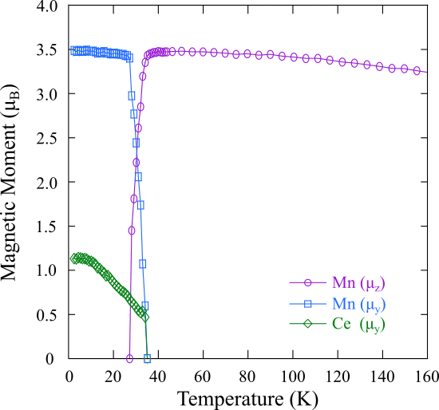
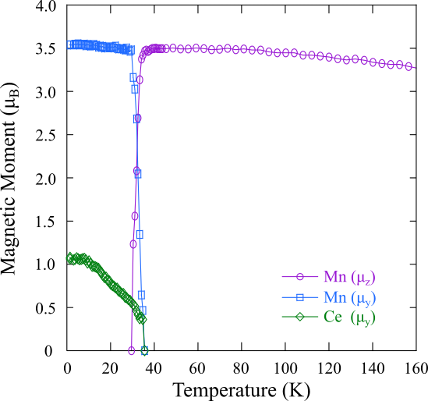
T_{C}
T_{C}
Supplementary Figure 6. Temperature variation of the refined Ce^{3+/4+} and Mn²⁺ moments for CeMnAsO_{0.925}F_{0.075} (left) and CeMnAsO_{0.965}F_{0.035} (right) using neutron diffraction patterns from the high intensity D20 diffractometer. The arrow highlights T_{C} = 82 K and 18 K respectively. There is no significant change in the Ce magnetic transition (T_{Ce}) or the spin reorientation temperature (T_{SR}) upon increasing x from 0 – 0.075 in CeMnAsO_{1-x}F_{x} within error of the neutron diffraction data.

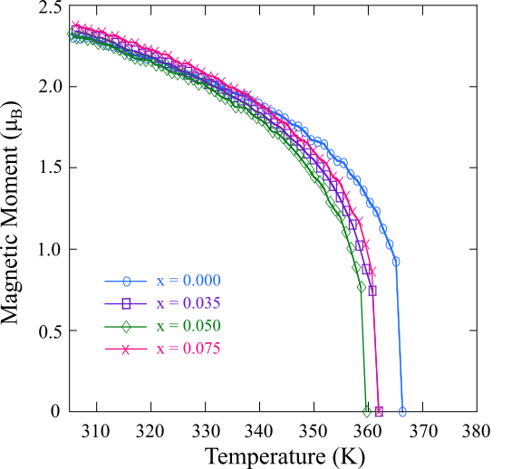

Supplementary Figure 7. Temperature variation of the refined Mn²⁺ magnetic moments for the CeMnAsO_{1-x}F_{x} series.
Thermal Expansion
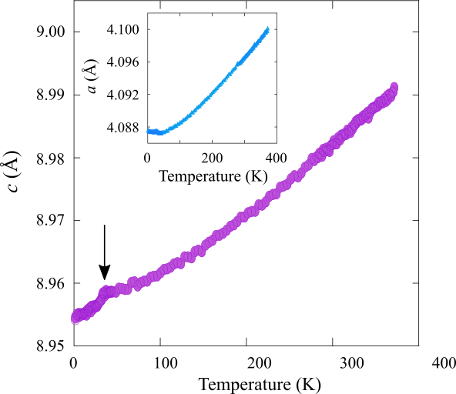
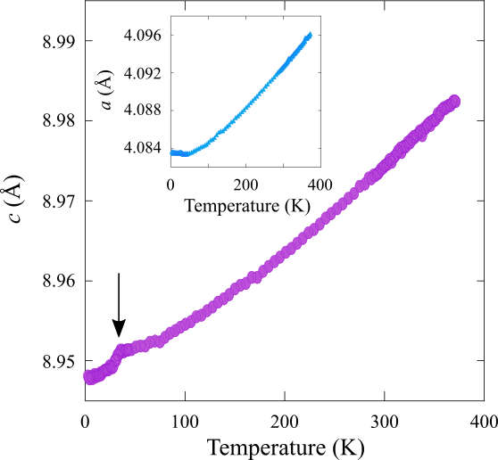

Supplementary Figure 8. Variable temperature plot of the c lattice parameter determined from Rietveld fits to the P4/nmm structural model from D20 neutron diffraction data for CeMnAsO_{0.965}F_{0.035} (left) and CeMnAsO_{0.925}F_{0.075} (right). The variation of the a lattice parameter is shown in the inset. The arrow highlights the magnetostriction observed at T_{SR}.
Data were collected on the high intensity D20 diffractometer at the ILL between 1.5 K and 380 K for x = 0.035 and 0.075 and between 300 – 380 K for x = 0.00 and 0.05 due to time constraints. The linear coefficients of thermal expansion were calculated by fitting the temperature dependence of the lattice parameters to a third order polynomial, separately from 50 K - 300 K and 10 K - 30 K (above and below T_{SR}). The coefficients of thermal expansion all begin to plateau above 200 K, consistent with the Debye temperature of 230(10) K. Above T_{SR}, the elastic properties remain anisotropic, such that there is larger thermal expansion along c. The anisotropy ratio above T_{SR}, α(c)/α(a), = 1.08(3) 1.11(2), 1.18(3), 1.20(3) and 1.25(5) for x = 0.00, 0.035, 0.05, 0.075 and Ce_{0.96}MnAsO_{0.95}F_{0.05} respectively.
The thermal anisotropy ratio is shown to increase with both x in CeMnAsO_{1-x}F_{x} and y in Ce_{y}MnAsO_{0.95}F_{0.05}. We hypothesise that this is a result of enhanced interlayer electronic coupling as the Ce-As the inter-layer distance reduces. In further corroboration, changes to the single ion anisotropy of Mn can be ruled out, as the amount of localised charge on the Mn (as determined by the low temperature ordered moment from the neutron diffraction refinements) is, within error, unchanged by F⁻ content ¹. Changes to the single ion anisotropy of Ce can also be ruled out. A combination of density functional theory (DFT) calculations and neutron diffraction results on the CeMnAsO_{1-x}F_{x} series have previously shown that upon doping by substitution of F⁻ for O²⁻, the Ce 4f band is destabilised and Ce³⁺ is partially oxidised to isotropic Ce⁴⁺ ¹ which should hence decrease the anisotropy.

References
1. Wildman, E. J. et. al. Observation of an Exotic Insulator to Insulator Transition upon Electron Doping the Mott Insulator CeMnAsO. Nature Commun. 14, 7037 (2023).
2. Stokes, H. T., Hatch, D. M. & Campbell, B. J. ISODISTORT, ISOTROPY Software Suite, iso.byu.edu.
3. Campbell, B. J., Stokes, H. T., Tanner, D. E. & Hatch, D. M. "ISODISPLACE: An Internet Tool for Exploring Structural Distortions." J. Appl. Cryst. 39, 607-614 (2006).

