Supplement:

Supplemental Table 1. Used primers.

gene | sense/forward  5’→3’ orientation | antisense/reverse  5’→3’ orientation | amplicon | reference
Nphs2^{tm3.1Antc} | CCA GCA TCC CAT TAG ATA GAT GAG G | GCA TCC AAA TGA TCA GAG TTC CCA GG | 236 / 286 bp (wt / floxed allele) | [24]
Tg(Nphs1-rtTA*3G)^{8Jhm} | GAA GCA GCA GAA TGA GTT CAC ACT GGG TCC | ACT TTG CTC TTG TCC AGT CTA GAC ATG GTG | 400 bp | [20]
Tg(tetO-cre) ^{1Jaw} | GCA TAA CCA GTG AAA CAG CAT TGC TG | GGA CAT GTT CAG GGA TCG CCA GGC G | 280 bp | [27]
C3-wt | gat ccc cag agc taa tg | agg gac cag ccc agg ttc ag | 373 bp | [9]
C3-ko | tcg tcc tgc agt tca ttc ag | agg gac cag ccc agg ttc ag | 504 bp | [9]
CFB-wt | ccg aag cat tcc tat cct cc | gta gtc ttg tct gct ttc tcc | 751 bp | [23]
CFB-ko | cga atg ggt gac cgc ttc c | gta gtc ttg tct gct ttc tcc | 600 bp | [23]
CFD-wt | GCG ATG GTA TGA TGT GCA G | GGT TGC TCT CTG CAC ACA T | 464 bp | [39]
CFD-ko | GGC CGA TCC CAT ATT GGC | GGT TGC TCT CTG CAC ACA T | 320 bp | [39]

Supplemental Table 2: Primary antibodies

antibody | host | source | reference
Anti-α-ENaC | rabbit | Pineda antibody service | [22]
Anti-β-ENaC | rabbit | Pineda antibody service | [22]
Anti-γ-ENaC | rabbit | Stressmarq SPC-405 | [22]
Anti-C3 | rabbit | Abcam EPR19394 | [35]
Anti-FB | goat | Complement Tech | [28]
Anti-FD | sheep | R&D Systems | [33]

Supplemental Figure 1: Structure of C3 and its degradation products according to [31]
The used antibody binds to the C-terminus of C3 detecting α-chain and its degradation products.
The disulfide bonds lead to different band sizes in reducing or non-reducing conditions.

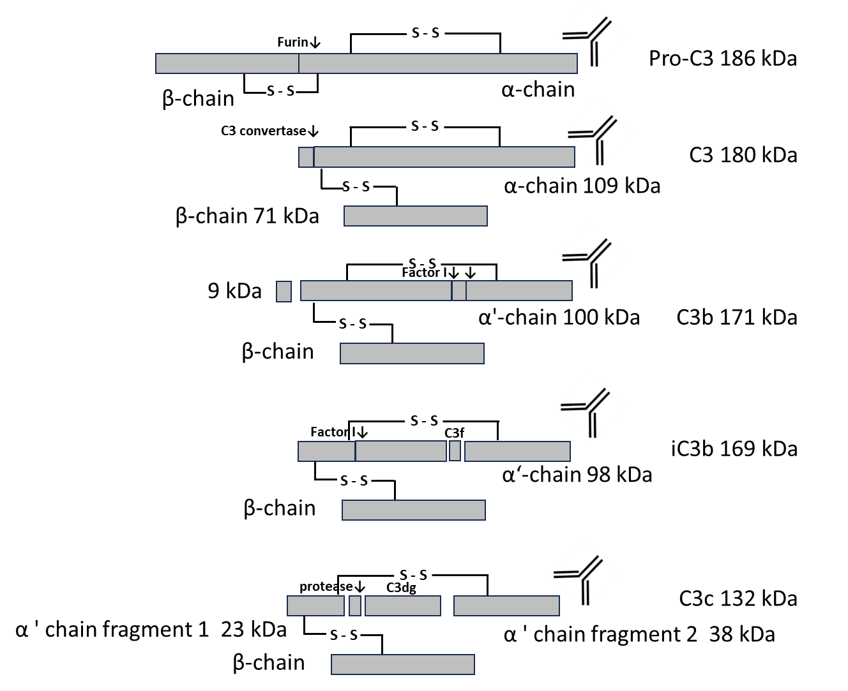

Supplemental Figure 2. Food and fluid intake in Nphs2^{Δipod}, Nphs2^{Δipod}*Cfb^{-/-}, Nphs2^{Δipod}*Cfd^{-/-} and Nphs2^{Δipod}*C3^{-/-} mice before and after induction of nephrotic syndrome
a,b,c Course of food intake over 24h
d,e,f Course of fluid intake over 24h

# significant difference (p<0,05) between uninduced healthy and nephrotic mice of the same genotype, * significant difference (p<0,05) between genotypes and wild-type

