Supplementary Information
Upcycling of Waste Sodium Sulfate to Sodium Carbonate and Sulfur
Hongya Wang¹, Shiyu Wang¹, Fengyin Zhou¹, Muya Cai¹, Jingjing Zhao¹, Danfeng Wang¹, Zhan Shi⁴, Xiang Chen¹, Dihua Wang^{1,2,3}, Huayi Yin^{1,2,3}*
- School of Resource and Environmental Science, Wuhan University, 299 Bayi Road, Wuchang District, Wuhan 430072, P. R. China.
- Hubei International Scientific and Technological Cooperation Base of Sustainable Resource and Energy, Wuhan University, Wuhan 430072, China
- Joint Center of Green Manufacturing of Energy Storage Materials of Wuhan University and Chilwee, Wuhan 430072, P. R. China
- Department of Land, Environment, Agriculture and Forestry, University of Padova, Legnaro (PD) 35020, Italy.
* Corresponding author. Email: yinhuayi@whu.edu.cn (Huayi Yin)

This PDF file includes:
Supporting Information Fig. S1 to Fig. S28;
Supporting Information Tab. S1 toTab. S13.

Supplementary Table
Tab. S1. The amount of waste Na₂SO₄ generated in different industrial processes.
Industry | Product & Consumption | Production (kg-Na₂SO₄/t)
Chemical Industry | Lithium carbonate | ~2000
Chemical Industry | Sodium hydroxide | 5~10
Chemical Industry | Ammonium sulfate | 1~2
Chemical Industry | Oxalic acid | 500~800
Chemical Industry | Penicillin | 300~500
Chemical Industry | Formic acid | 400~600
Coal Chemical Industry | Coal (Burning) | 30~120
Paper Industry | Pulp | 200~400
Glass Industry | Glass | ~30
The widespread use of H₂SO₄ and Na-based compounds has resulted in the generation of large amounts of waste Na₂SO₄. Taking lithium carbonate production as an example, the Li extraction process requires a significant amount of Na₂CO₃ to produce Li₂CO₃, generating at least three tons of waste Na₂SO₄ for every ton of Li₂CO₃ produced.¹ In the coal chemical industry, sulfur combines with carbon to form a CO₂ and SO₂ mixture. Since SO₂ emissions are strictly regulated in most countries and regions, alkaline solutions are used to absorb SO₂ to meet emission standards. While Ca-based alkaline compounds are commonly used for SO₂ removal, Na-based compounds are still employed in some cases where high removal efficiency is required, as Na-based compounds offer superior SO₂ removal performance.²

Tab. S2. The amount of Na₂CO₃ used in the production of various products.
Industry | Product | Amount (kg-Na₂CO₃/t)
Metallurgical Industry | Steel | 15~20
Metallurgical Industry | Al | ~410
Metallurgical Industry | Hard metal | ~1350
Metallurgical Industry | Au | 27000
Metallurgical Industry | Electrolytic Mg | 0.5
Metallurgical Industry | Electrolytic Bi | ~150
Metallurgical Industry | Electrolytic Ni | ~80
Metallurgical Industry | Refined Sb | 42
Metallurgical Industry | Cryolite | ~620
Metallurgical Industry | CoCO₃ | 3
Chemical Industry | Synthetic ammonia | 11.3
Chemical Industry | Sulfur blue | 767
Chemical Industry | Epoxy resin | ~400
Chemical Industry | Polyvinyl chloride | 4
Chemical Industry | Naphthol | ~230
Chemical Industry | Chrome yellow | ~700
Pharmaceutical Industry | Sulfathiazole | 1120
Pharmaceutical Industry | Sulphaguanidine | 550
Pharmaceutical Industry | Aminopyrine | 1260
Pharmaceutical Industry | Aureomycin | 11400
Pharmaceutical Industry | Tetracycline | 25000
Pharmaceutical Industry | Streptomycin | 21000
Food Industry | Soy sauce | ~80
Food Industry | Monosodium glutamate | 120
Glass Industry | Glass | ~200
Dyeing and Finishing Industry | Cloth | 30~50
Tab. S3. Life cycle inventory (LCI) of producing soda ash using this process.
Inputs/outputs | Unit | Quantity | Comments
Step 1: Dehydration and reduction of sodium sulfate
Inputs
Waste Na₂SO₄·10H₂O | kg | 3.04 | Recycling of waste sodium sulfate
Transportation | tkm | 0.30 | 100 km transportation
Electricity | kWh | 0.08 | Dehydration energy consumption
Charcoal | kg | 0.45 | Carbon source
CO | kg | 0.26 | CO reuse (from Step 2)
Electricity | kWh | 0.54 | Heating energy consumption (750 °C-4h)
Outputs
Na₂S | kg | 0.74 | For Step 2
CO₂ | kg | 1.04 | Partial emissions, partially used for Step 2
Charcoal | kg | 0.28 | Excessive charcoal
Water | kg | 1.70 | Removed water
Step 2: From sodium sulfide to sodium carbonate
Inputs
Na₂S | kg | 0.74 | From Step 1
CO₂ | kg | 0.83 | From Step 1
Charcoal | kg | 0.28 | Excessive charcoal (not involved in Step 2)
Electricity | kWh | 0.24 | Heating energy consumption (300 °C-4h)
Outputs
Na₂CO₃ | kg | 1.00 | Product (mixed with charcoal)
Charcoal | kg | 0.28 | Excessive charcoal (not involved in Step 2)
S | kg | 0.30 | By-product (volatile product)
CO | kg | 0.26 | Reuse to Step 1
Step 3: Purification of Sodium Carbonate
Inputs
Na₂CO₃ | kg | 1.00 | Product (mixed with charcoal)
Charcoal | kg | 0.28 | Excessive charcoal (not involved in Step 2)
Water | kg | 3.33 | Solubility: 0.45 kg/L (35 °C), margin: 1.5
Electricity | kWh | 0.15 | Evaporation energy consumption (45 kWh/t-H₂O)
Outputs
Na₂CO₃ | kg | 1.00 | Product
Charcoal | kg | 0.28 | Reuse to Step 1
Water | kg | 3.33 | Evaporative water cycle
Overall
Inputs
Waste Na₂SO₄·10H₂O | kg | 3.04 | Recycling of waste sodium sulfate
Transportation | tkm | 0.30 | 100 km transportation
Charcoal | kg | 0.17 | Net input carbon source
Electricity | kWh | 1.01 | Used for heating and dehydration
Water | kg | 3.33 | Dissolve and separate sodium carbonate
Outputs
Na₂CO₃ | kg | 1.00 | Product
S | kg | 0.30 | By-product
CO₂ | kg | 0.21 | Emissions into the atmosphere
Water | kg | 5.03 | Evaporative water cycle

Tab. S4. XRF results of purified Na₂CO₃ product in scale-up production.
Components | Atomic weight (%)
Na | 43.6152
O | 42.8332
C | 13.0906
S | 0.2532
Si | 0.1656
K | 0.0310
Ca | 0.0112
Total | 1

Tab. S5. XRF results for desulfurization waste.²
Components | Atomic weight (%)
C | 1.29 | Fe₂O₃ | 1.04
F | 0.443 | CuO | 0.0108
Na₂O | 46.9 | ZnO | 0.0236
MgO | 0.051 | SeO₂ | 0.0147
Al₂O₃ | 0.033 | Br | 0.0447
SiO₂ | 0.090 | Rb₂O | 0.0094
P₂O₅ | 0.0100 | I | 0.0696
SO₃ | 39.3 | PbO | 0.0818
Cl | 7.15 | Others | 0.0384
K₂O | 1.26 | Total | 1
CaO | 2.14

Life cycle assessment
This study conducted a life cycle assessment (LCA) to assess the environmental impacts and cumulative energy demands of the current sodium carbonate production process compared to the method in this work. The analysis followed the ISO 14040 and 14044 standards and was conducted using SimaPro software.³
In this study, the LCA was developed for the production of 1 kg of Na₂CO₃ (functional unit). The system boundary includes inputs (energy and materials) and outputs (wastewater, waste gases, and waste) during the Na₂CO₃ production process, while the production and maintenance of equipment were excluded. The LCI for the Na₂CO₃ process in this study is presented in Tab. S3. Allocation in multifunctional systems was carried out using the economic allocation method and system expansion method in LCA, where products with higher economic value were allocated a greater share of environmental and resource burdens. The LCI for the compared Na₂CO₃ production process is based on the global production modeling of the improved Solvay process (Soda Ash process) in the Ecoinvent database.⁴ The geographic location for electricity and fuel was set to China. Upstream background data for materials were sourced from the Ecoinvent 3.5 database, specifically data representing the Chinese (China, CN) market. When data for the CN region was unavailable, global average (GLO) or other world (ROW) production data were used as substitutes. The electricity data for China in the Ecoinvent database were adjusted. Hydropower, coal-fired power, nuclear power, wind power, solar power, and natural gas power account for 15.4%, 63.1%, 4.8%, 8.7%, 4.9%, and 3.1%, respectively. Additionally, it was assumed that the transportation of Na₂SO₄·10H₂O would be 100 km. Transport was carried out using a truck meeting the EURO6 standard (>32 t).
The energy consumption calculations for different stages in Tab. S3 are as follows (Based on 1000 kg of Na₂SO₄):
Step 1:
Heating Energy Consumption
Specific heat capacity of Na₂SO₄: 898.3 J/(kg·°C)
Specific heat capacity of industrial charcoal: 0.8-1.0 kJ/(kg·°C), with an average value of 900.0 J/(kg·°C).
Specific heat capacity of CO: 1040.4 J/(kg·°C)
Thus, the total energy required to heat the materials to 750°C is 1020689 kJ.
Considering an energy efficiency of 0.75, the calculated total energy required is:
1360918.7 kJ or 378.0 kWh.
Constant Temperature Energy Consumption
The density of Na₂SO₄ is 2.67 t/m³, and the density of charcoal is approximately 0.4 t/m³. The recycled CO is uniformly input as a gas at a rate of 50 kg per h.
The volume of 1000 kg of Na₂SO₄ and 338.2 kg of charcoal is calculated as follows:
1000.0 kg Na₂SO₄ gives a volume of 374.4 L, 338.2 kg charcoal gives a volume of 845.5 L.
Thus, the total volume is approximately: 1219.9 L.
Using a 3000 L furnace for the calculation (Tab. S6), with a porosity of 59.3%.
Tab. S6. Design parameters of enlarged furnace in LCA calculation of Na₂CO₃ production.⁵
Physical entity | Symbol | Unit | 3000 L
Reaction mixture volume | V_{(mix)} | m³ | 3
Height of reactor | L | m | 1.614
Diameter of reactor | D | m | 1.614
Surface area | A | m² | 12.275
Reactor volume | V_{(reactor)} | m³ | 3.3
Insulation material |  |  | Glass fiber
Thermal conductivity of insulation | k_{a} | W/m·°C | 0.042
Insulation thickness | s | m | 0.075
Heat transfer coefficient of insulation | k_{a}/s | W/m²·°C | 0.56
Efficiency of heating element | η_{heat} | % | 75%
Rate of heat loss | Ak_{a}/s | W/°C | 6.874
Starting and outside temperature | T₀ = T_{out} | °C | 25
Q_{loss} = 6.874 W/°C × (750-25) °C × 4h/0.75 = 26.6 kWh.
Therefore, the total energy consumption for Step 1 is 404.6 kWh.
During the reaction process, heat is continuously released (this energy also contributes to maintaining the reactor’s temperature).
Step 2:
Cooling of solid products from 750 °C and CO₂ stored at ambient temperature with subsequent heating.
Specific Heat Capacities
Specific heat capacity of CO: 843.7 J/(kg·°C).
Na₂S is cooled from 750 °C to 300 °C for the reaction, with no additional heating energy required.
With an energy efficiency of 0.75, the total energy consumption for this process is:
191708.3 kJ or 53.3 kWh.
Sublimation Heat of Sulfur
Heat of vaporization for sulfur: 45 kJ/kg.
225.7 kg S × 1403.6 kJ/kg = 316792.5 kJ.
With an energy efficiency of 0.75, the total energy consumption for sulfur sublimation is:
422390.0 kJ or 117.3 kWh.
Constant Temperature Energy Consumption
Q_{loss} = 6.874 W/°C × (300-25) °C × 4h/0.75 = 10.1 kWh.
Therefore, the total energy consumption for Step 2 is 180.7 kWh.
Considering the by-products (sulfur and distilled water) produced in this process, this study employed both economic allocation and system expansion methods to allocate environmental burdens and credits. The economic allocation method assigns environmental impacts of a multi-product system based on the economic value of the products (e.g., market prices). Products with higher economic values bear a greater share of the environmental burden. The average prices for Na₂CO₃, S_{x} powder, and industrial water over the past five years were $270/t, $140/t, and $1/t, respectively. Based on the production quantities shown in Tab. S3, Na₂CO₃ bears 85% of the total environmental burden of the entire production process. The system expansion method extends the system boundary to include the environmental impact of by-products within the life cycle of the substitute products, thus avoiding allocation issues. Consequently, the additional products are treated as environmental benefits.
This study used the ReCiPe 2016 method to assess the environmental impacts of the Na₂CO₃ production process, including both mid-point and end-point impact categories. The mid-point impact categories include global warming potential (GWP), stratospheric ozone depletion (ODP), ionizing radiation (IRP), ozone formation, human health (OFHH), fine particulate matter formation (PMFP), terrestrial ecosystems (OFTE), terrestrial acidification potential (TAP), freshwater eutrophication (FEP), marine eutrophication (MEP), terrestrial ecotoxicity (TEP), freshwater ecotoxicity (FETP), marine ecotoxicity (METP), human carcinogenic toxicity (HTPc), human non-carcinogenic toxicity (HTPcn), land use potential (LUP), mineral resource scarcity (SOP), fossil resource scarcity (FFP), and water consumption (WCP). The end-point categories include human health, ecosystems, and resources. The mid-point characterization and normalized environmental impact results for the Na₂CO₃ production process are shown in Tab.s S7 and S8, respectively. The end-point environmental impact categories and cumulative energy demand are presented in Tab.s S9 and S10. Tab.s S11 and S12 provide an analysis of the environmental impact contributions under different allocation methods.
Monte Carlo simulations were used to evaluate the potential uncertainties in the public database. A total of 1000 Monte Carlo iterations were conducted to represent uncertainty propagation results. Tab. S13 summarizes the uncertainty analysis results for all environmental impact indicators of the sodium carbonate production process, including probabilistic mean, standard deviation, coefficient of variation, and the maximum and minimum values within the 95% confidence interval. The coefficient of variation is used to measure the degree of dispersion around the mean.

Tab. S7. Environmental impact assessment results of the Na₂CO₃ production process.
Impact category | Unit | Economic Allocation Method  This Work | System Expansion Method  This Work | SSA-Process
Global warming | kg CO₂ eq | 1.217612133 | 1.302289566 | 1.650355233
Stratospheric ozone depletion | kg CFC11 eq | 8.60775E-07 | 9.50051E-07 | 2.59394E-07
Ionizing radiation | kBq Co-60 eq | 0.031414655 | 0.034994802 | 0.057701281
Ozone formation, Human health | kg NO_{x} eq | 0.002465418 | 0.002517315 | 0.003526596
Fine particulate matter formation | kg PM2.5 eq | 0.001234235 | 0.001261897 | 0.002171117
Ozone formation, Terrestrial ecosystems | kg NO_{x} eq | 0.002581762 | 0.002647441 | 0.003613473
Terrestrial acidification | kg SO₂ eq | 0.002550906 | 0.002623516 | 0.005247758
Freshwater eutrophication | kg P eq | 0.000156881 | 0.000111107 | 0.000417475
Marine eutrophication | kg N eq | 1.63336E-05 | 8.62999E-06 | 0.000885225
Terrestrial ecotoxicity | kg 1,4-DCB | 1.289957376 | 1.067983422 | 7.040595213
Freshwater ecotoxicity | kg 1,4-DCB | 0.013052977 | -0.016941482 | 0.077201833
Marine ecotoxicity | kg 1,4-DCB | 0.017680269 | -0.020203873 | 0.100735199
Human carcinogenic toxicity | kg 1,4-DCB | 0.026803055 | 0.021127847 | 0.086623752
Human non-carcinogenic toxicity | kg 1,4-DCB | 0.393070899 | -0.788867381 | 1.503783927
Land use | m²a crop eq | 0.173932174 | 0.200900427 | 0.030743635
Mineral resource scarcity | kg Cu eq | 0.000508222 | 0.000144101 | 0.005776491
Fossil resource scarcity | kg oil eq | 0.170485394 | 0.17720585 | 0.357981689
Water consumption | m³ | 0.007798293 | 0.004107667 | 0.020978793
Tab. S8. Normalized environmental impact assessment results of the Na₂CO₃ production process.
Impact category | Economic Allocation Method  This Work | System Expansion Method  This Work | SSA-Process
Global warming | 0.000152202 | 0.000162786 | 0.000206294
Stratospheric ozone depletion | 1.4375E-05 | 1.58658E-05 | 4.33188E-06
Ionizing radiation | 6.53425E-05 | 7.27892E-05 | 0.000120019
Ozone formation, Human health | 0.000119819 | 0.000122341 | 0.000171393
Fine particulate matter formation | 4.82586E-05 | 4.93402E-05 | 8.48907E-05
Ozone formation, Terrestrial ecosystems | 0.000145353 | 0.000149051 | 0.000203439
Terrestrial acidification | 6.22421E-05 | 6.40138E-05 | 0.000128045
Freshwater eutrophication | 0.000241596 | 0.000171105 | 0.000642912
Marine eutrophication | 3.54439E-06 | 1.87271E-06 | 0.000192094
Terrestrial ecotoxicity | 8.48792E-05 | 7.02733E-05 | 0.000463271
Freshwater ecotoxicity | 0.000518203 | -0.000672577 | 0.003064913
Marine ecotoxicity | 0.000406646 | -0.000464689 | 0.00231691
Human carcinogenic toxicity | 0.002602577 | 0.002051514 | 0.008411166
Human non-carcinogenic toxicity | 1.25783E-05 | -2.52438E-05 | 4.81211E-05
Land use | 2.8177E-05 | 3.25459E-05 | 4.98047E-06
Mineral resource scarcity | 4.23349E-09 | 1.20036E-09 | 4.81182E-08
Fossil resource scarcity | 0.000173895 | 0.00018075 | 0.000365141
Water consumption | 2.92436E-05 | 1.54038E-05 | 7.86705E-05
Tab. S9. End-point environmental impact assessment results of the Na₂CO₃ production process.
Damage category | Unit | Economic Allocation Method  This Work | System Expansion Method  This Work | SSA-Process
Total | mPt | 28.11264711 | 25.81085264 | 47.33817152
Human health | mPt | 26.23981098 | 23.82884518 | 44.63262909
Ecosystems | mPt | 1.627619517 | 1.745965691 | 1.92861167
Resources | mPt | 0.245216606 | 0.236041772 | 0.776930757

Tab. S10. Cumulative energy demand of the Na₂CO₃ production process.
Impact category | Unit | Economic Allocation Method  This Work | System Expansion Method  This Work | SSA-Process
Total | MJ | 16.88149282 | 18.560987 | 19.22227223
Non-renewable, fossil | MJ | 7.909572677 | 8.226185668 | 16.50128896
Non-renewable, nuclear | MJ | 0.590009113 | 0.657169616 | 1.083165866
Non-renewable, biomass | MJ | 0.001387016 | 0.001392645 | 0.000548442
Renewable, biomass | MJ | 7.382461759 | 8.59669966 | 0.354598213
Renewable, wind, solar, geothemal | MJ | 0.461787431 | 0.534685022 | 0.523001072
Renewable, water | MJ | 0.536274823 | 0.544854392 | 0.759669675

Tab. S11. Environmental impact contribution analysis of this work (Based on economic allocation method).
Impact category | Unit | Total | Direct emission | Transportation | Charcoal | Electricity | Water
Global warming | % | 100 | 14.5 | 2.2 | 20.8 | 62.5 | 0.0
Stratospheric ozone depletion | % | 100 | 0.0 | 1.4 | 85.1 | 13.5 | 0.0
Ionizing radiation | % | 100 | 0.0 | 0.9 | 3.8 | 95.2 | 0.0
Ozone formation, Human health | % | 100 | 0.0 | 2.2 | 12.6 | 85.2 | 0.0
Fine particulate matter formation | % | 100 | 0.0 | 2.0 | 10.6 | 87.4 | 0.0
Ozone formation, Terrestrial ecosystems | % | 100 | 0.0 | 2.3 | 15.9 | 81.7 | 0.0
Terrestrial acidification | % | 100 | 0.0 | 1.8 | 6.4 | 91.7 | 0.1
Freshwater eutrophication | % | 100 | 0.0 | 1.5 | 9.7 | 88.4 | 0.3
Marine eutrophication | % | 100 | 0.0 | 4.1 | 33.8 | 58.5 | 3.5
Terrestrial ecotoxicity | % | 100 | 0.0 | 41.1 | 13.1 | 45.8 | 0.0
Freshwater ecotoxicity | % | 100 | 0.0 | 4.9 | 5.8 | 89.2 | 0.1
Marine ecotoxicity | % | 100 | 0.0 | 6.4 | 6.2 | 87.3 | 0.1
Human carcinogenic toxicity | % | 100 | 0.0 | 5.0 | 6.7 | 87.9 | 0.4
Human non-carcinogenic toxicity | % | 100 | 0.0 | 5.5 | 6.3 | 87.9 | 0.3
Land use | % | 100 | 0.0 | 1.1 | 93.1 | 5.8 | 0.0
Mineral resource scarcity | % | 100 | 0.0 | 13.4 | 13.7 | 72.8 | 0.1
Fossil resource scarcity | % | 100 | 0.0 | 5.3 | 5.9 | 88.8 | 0.1
Water consumption | % | 100 | 0.0 | 0.8 | 37.6 | 25.9 | 35.7
Total environmental impact | % | 100 | 7.8 | 2.5 | 17.3 | 72.3 | 0.2
Human health | % | 100 | 7.8 | 2.4 | 16.0 | 73.6 | 0.2
Ecosystems | % | 100 | 8.2 | 2.0 | 38.0 | 51.6 | 0.2
Resources | % | 100 | 0.0 | 16.7 | 13.2 | 70.1 | 0.1
Cumulative energy demand | % | 100 | 0.0 | 2.5 | 46.1 | 51.3 | 0.0

Tab. S12. Environmental impact contribution analysis of this work (Based on system expansion method).
Impact category | Unit | Total | Direct emission | Transportation | Charcoal | Electricity | Water | Sulfur | Cycled water
Global warming | % | 100 | 15.9 | 2.4 | 22.9 | 68.7 | 0.0 | -9.9 | -0.1
Stratospheric ozone depletion | % | 100 | 0.0 | 1.5 | 90.7 | 14.4 | 0.0 | -6.6 | 0.0
Ionizing radiation | % | 100 | 0.0 | 1.0 | 4.0 | 100.5 | 0.0 | -5.5 | -0.1
Ozone formation, Human health | % | 100 | 0.0 | 2.5 | 14.5 | 98.1 | 0.1 | -15.1 | -0.1
Fine particulate matter formation | % | 100 | 0.0 | 2.3 | 12.2 | 100.5 | 0.1 | -15.0 | -0.1
Ozone formation, Terrestrial ecosystems | % | 100 | 0.0 | 2.7 | 18.3 | 93.7 | 0.1 | -14.6 | -0.1
Terrestrial acidification | % | 100 | 0.0 | 2.0 | 7.4 | 104.9 | 0.1 | -14.3 | -0.1
Freshwater eutrophication | % | 100 | 0.0 | 2.5 | 16.2 | 146.8 | 0.6 | -65.2 | -0.9
Marine eutrophication | % | 100 | 0.0 | 9.2 | 75.4 | 130.3 | 7.9 | -110.7 | -11.9
Terrestrial ecotoxicity | % | 100 | 0.0 | 58.4 | 18.6 | 65.1 | 0.1 | -42.0 | -0.1
Freshwater ecotoxicity | % | 100 | 0.0 | 4.5 | 5.3 | 80.8 | 0.1 | -190.6 | -0.1
Marine ecotoxicity | % | 100 | 0.0 | 6.6 | 6.3 | 89.9 | 0.1 | -202.8 | -0.1
Human carcinogenic toxicity | % | 100 | 0.0 | 7.4 | 10.0 | 131.3 | 0.6 | -48.3 | -0.9
Human non-carcinogenic toxicity | % | 100 | 0.0 | 3.2 | 3.7 | 51.5 | 0.2 | -158.4 | -0.2
Land use | % | 100 | 0.0 | 1.1 | 94.9 | 5.9 | 0.0 | -1.8 | 0.0
Mineral resource scarcity | % | 100 | 0.0 | 55.7 | 56.7 | 302.2 | 0.3 | -314.4 | -0.5
Fossil resource scarcity | % | 100 | 0.0 | 6.0 | 6.6 | 100.5 | 0.1 | -13.1 | -0.1
Water consumption | % | 100 | 0.0 | 1.8 | 84.0 | 57.8 | 79.7 | -2.9 | -120.4
Total environmental impact | % | 100 | 9.9 | 3.2 | 22.1 | 92.7 | 0.2 | -27.8 | -0.3
Human health | % | 100 | 10.1 | 3.1 | 20.8 | 95.4 | 0.2 | -29.2 | -0.3
Ecosystems | % | 100 | 9.0 | 2.1 | 41.6 | 56.6 | 0.2 | -9.3 | -0.4
Resources | % | 100 | 0.0 | 20.4 | 16.1 | 85.6 | 0.1 | -22.1 | -0.1
Cumulative energy demand | % | 100 | 0.0 | 2.7 | 49.4 | 54.9 | 0.0 | -7.0 | 0.0

Tab. S13. Summary of uncertainty analysis for this Work and SSA-Process.
Economic Allocation Method-This Work
Impact category | Unit | Mean | Median | Standard deviation | coefficient of variation (%) | 2.5% | 97.5%
Fine particulate matter formation | kg PM2.5 eq | 0.001238664 | 0.001199705 | 0.000242326 | 19.56347611 | 0.000869145 | 0.001848554
Fossil resource scarcity | kg oil eq | 0.172919083 | 0.158613458 | 0.073824338 | 42.6929962 | 0.077914462 | 0.356901644
Freshwater ecotoxicity | kg 1,4-DCB | 0.013074473 | 0.011766179 | 0.005720672 | 43.75451609 | 0.007187579 | 0.026630195
Freshwater eutrophication | kg P eq | 0.000155955 | 0.000118125 | 0.00012981 | 83.235123 | 4.4764E-05 | 0.000492288
Global warming | kg CO₂ eq | 1.216781983 | 1.202279982 | 0.1571253 | 12.91318432 | 0.944264087 | 1.570138374
Human carcinogenic toxicity | kg 1,4-DCB | 0.025511905 | 0.020280184 | 0.029826851 | 116.9134634 | 0.00831062 | 0.067385174
Human non-carcinogenic toxicity | kg 1,4-DCB | 0.34000223 | 0.341287138 | 2.50801608 | 737.6469492 | -4.63647497 | 5.277793974
Ionizing radiation | kBq Co-60 eq | 0.033820887 | 0.016966521 | 0.053118272 | 157.0575947 | 0.00326743 | 0.16482552
Land use | m²a crop eq | 0.169094575 | 0.160410897 | 0.143259481 | 84.72151262 | -0.08609479 | 0.468961817
Marine ecotoxicity | kg 1,4-DCB | 0.017685407 | 0.015811011 | 0.007962759 | 45.02445813 | 0.009818683 | 0.036822273
Marine eutrophication | kg N eq | 1.62183E-05 | 1.54504E-05 | 4.53136E-06 | 27.93980905 | 9.67614E-06 | 2.72095E-05
Mineral resource scarcity | kg Cu eq | 0.000506536 | 0.000497303 | 9.82143E-05 | 19.38941564 | 0.000354519 | 0.000738925
Ozone formation, Human health | kg NO_{x} eq | 0.002485638 | 0.002407987 | 0.000586181 | 23.58272828 | 0.001556305 | 0.003832289
Ozone formation, Terrestrial ecosystems | kg NO_{x} eq | 0.002602437 | 0.002519908 | 0.00059784 | 22.97230586 | 0.001647734 | 0.003978454
Stratospheric ozone depletion | kg CFC11 eq | 8.53356E-07 | 7.94284E-07 | 3.03724E-07 | 35.59165459 | 4.24386E-07 | 1.57026E-06
Terrestrial acidification | kg SO₂ eq | 0.002552242 | 0.002496476 | 0.000456729 | 17.89519282 | 0.001805638 | 0.003572871
Terrestrial ecotoxicity | kg 1,4-DCB | 1.300542535 | 1.270158378 | 0.201356921 | 15.4825325 | 0.976924273 | 1.791177688
Water consumption | m³ | 0.054123139 | 0.25116357 | 2.568556045 | 4745.763218 | -6.05716465 | 4.349317091
Ecosystems | Pt | 0.001642149 | 0.001879709 | 0.003045449 | 185.4550867 | -0.00474798 | 0.006993773
Human health | Pt | 0.026544231 | 0.028356378 | 0.024816518 | 93.49118912 | -0.0264979 | 0.071038949
Resources | Pt | 0.000242191 | 0.000228417 | 6.85069E-05 | 28.28630044 | 0.000153751 | 0.000423318
Total environmental impact | Pt | 0.028428571 | 0.030915413 | 0.027717088 | 97.49729488 | -0.0301099 | 0.079537853
Cumulative energy demand | MJ | 16.8544446 | 16.1357124 | 4.026352469 | 97.49729488 | 10.9473297 | 26.7923368
System Expansion Method-This Work
Impact category | Unit | Mean | Median | Standard deviation | coefficient of variation (%) | 2.5% | 97.5%
Fine particulate matter formation | kg PM2.5 eq | 0.001264108 | 0.001229675 | 0.000285336 | 22.57213066 | 0.000842357 | 0.001940208
Fossil resource scarcity | kg oil eq | 0.175186588 | 0.158578247 | 0.07919214 | 45.20445387 | 0.069301759 | 0.381391245
Freshwater ecotoxicity | kg 1,4-DCB | -0.017303389 | -0.01673116 | 0.011018526 | -63.67842425 | -0.04123254 | 0.002816448
Freshwater eutrophication | kg P eq | 0.000106571 | 6.81189E-05 | 0.000225551 | 211.6441749 | -2.791E-05 | 0.00043617
Global warming | kg CO₂ eq | 1.299913262 | 1.282883155 | 0.19060527 | 14.66292216 | 0.969504683 | 1.744388321
Human carcinogenic toxicity | kg 1,4-DCB | 0.020712076 | 0.014509368 | 0.031252913 | 150.8922298 | 0.000927014 | 0.073993716
Human non-carcinogenic toxicity | kg 1,4-DCB | -0.755618096 | -0.793067442 | 1.919059047 | -253.9720869 | -4.61650894 | 3.053536971
Ionizing radiation | kBq Co-60 eq | 0.032467795 | 0.016789887 | 0.050710722 | 156.1877634 | 0.003739499 | 0.154053648
Land use | m²a crop eq | 0.192379183 | 0.179904586 | 0.152547125 | 79.29502686 | -0.07947687 | 0.539620668
Marine ecotoxicity | kg 1,4-DCB | -0.02066044 | -0.020004247 | 0.014145831 | -68.46820079 | -0.05114541 | 0.00689522
Marine eutrophication | kg N eq | 8.53047E-06 | 7.70675E-06 | 4.93734E-06 | 57.87886329 | 1.42765E-06 | 2.05968E-05
Mineral resource scarcity | kg Cu eq | 0.000146757 | 0.000169867 | 0.000199628 | 136.0262975 | -0.00030801 | 0.000481
Ozone formation, Human health | kg NO_{x} eq | 0.002522371 | 0.002446933 | 0.000718356 | 28.47940515 | 0.001377686 | 0.004149106
Ozone formation, Terrestrial ecosystems | kg NO_{x} eq | 0.002651823 | 0.00258055 | 0.000731898 | 27.59981188 | 0.00147803 | 0.004311486
Stratospheric ozone depletion | kg CFC11 eq | 9.37544E-07 | 8.51857E-07 | 3.69139E-07 | 39.37300677 | 4.7117E-07 | 1.88614E-06
Terrestrial acidification | kg SO₂ eq | 0.00261791 | 0.002540702 | 0.000541441 | 20.68217705 | 0.001781741 | 0.003837363
Terrestrial ecotoxicity | kg 1,4-DCB | 1.062089063 | 1.061839955 | 0.275528171 | 25.94209665 | 0.527088243 | 1.603808574
Water consumption | m³ | 0.159307446 | 0.326705668 | 2.815354507 | 1767.246028 | -6.34506624 | 4.978228211
Ecosystems | Pt | 0.001637014 | 0.001868488 | 0.003851329 | 235.2654683 | -0.00659229 | 0.008580917
Human health | Pt | 0.023089183 | 0.024434928 | 0.030245492 | 130.9942109 | -0.04067691 | 0.076547785
Resources | Pt | 0.000234005 | 0.000219404 | 7.71571E-05 | 32.97248128 | 0.000131703 | 0.000439181
Total environmental impact | Pt | 0.024960201 | 0.02638138 | 0.034007264 | 136.2459505 | -0.04618321 | 0.084859001
Cumulative energy demand | MJ | 18.70230182 | 18.02703596 | 4.681195082 | 25.03004778 | 11.92357032 | 29.48944675
SSA-Process
Impact category | Unit | Mean | Median | Standard deviation | coefficient of variation (%) | 2.5% | 97.5%
Fine particulate matter formation | kg PM2.5 eq | 0.002143312 | 0.002061419 | 0.000481376 | 22.45942703 | 0.001414424 | 0.003280092
Fossil resource scarcity | kg oil eq | 0.354947934 | 0.336215651 | 0.104763031 | 29.51504168 | 0.214895609 | 0.633675809
Freshwater ecotoxicity | kg 1,4-DCB | 0.076411204 | 0.067792435 | 0.039709009 | 51.96752102 | 0.029560571 | 0.169675826
Freshwater eutrophication | kg P eq | 0.000415545 | 0.000359056 | 0.000228178 | 54.91037875 | 0.000159003 | 0.001034904
Global warming | kg CO₂ eq | 1.64180507 | 1.603656823 | 0.311125876 | 18.95023239 | 1.161947558 | 2.354363945
Human carcinogenic toxicity | kg 1,4-DCB | 0.087378179 | 0.073907798 | 0.081559105 | 93.34035806 | 0.003828981 | 0.233477206
Human non-carcinogenic toxicity | kg 1,4-DCB | 1.206668073 | 0.628289236 | 23.84432932 | 1976.047087 | -45.5161096 | 48.32584343
Ionizing radiation | kBq Co-60 eq | 0.055155834 | 0.030771799 | 0.079697235 | 144.494659 | 0.006082637 | 0.258016573
Land use | m²a crop eq | 0.030337265 | 0.02754805 | 0.013679726 | 45.09215201 | 0.014089926 | 0.06529831
Marine ecotoxicity | kg 1,4-DCB | 0.099754797 | 0.088816174 | 0.051544212 | 51.67091052 | 0.038945296 | 0.219817075
Marine eutrophication | kg N eq | 0.00089269 | 0.000800289 | 0.00039886 | 44.68069439 | 0.000385283 | 0.001904614
Mineral resource scarcity | kg Cu eq | 0.005731373 | 0.005009896 | 0.002975787 | 51.92101132 | 0.002316258 | 0.013723874
Ozone formation, Human health | kg NO_{x} eq | 0.003521729 | 0.003360727 | 0.000900043 | 25.55685158 | 0.002229697 | 0.005637031
Ozone formation, Terrestrial ecosystems | kg NO_{x} eq | 0.003608917 | 0.003442908 | 0.000908012 | 25.16022044 | 0.002287943 | 0.005720348
Stratospheric ozone depletion | kg CFC11 eq | 2.56509E-07 | 2.47017E-07 | 5.85822E-08 | 22.83828558 | 1.69507E-07 | 3.95285E-07
Terrestrial acidification | kg SO₂ eq | 0.005209581 | 0.005051999 | 0.001114528 | 21.39380702 | 0.003529713 | 0.007896624
Terrestrial ecotoxicity | kg 1,4-DCB | 6.82714549 | 5.860584297 | 3.937573854 | 57.67525915 | 2.83995455 | 17.49455633
Water consumption | m³ | 0.118194583 | 0.359397688 | 2.366364439 | 2002.092122 | -5.51128421 | 4.517781922
Ecosystems | Pt | 0.001977502 | 0.002244237 | 0.003424147 | 173.1551936 | -0.00523334 | 0.008259317
Human health | Pt | 0.044384016 | 0.043780474 | 0.076170955 | 171.6179864 | -0.10859347 | 0.195344977
Resources | Pt | 0.000771906 | 0.000754956 | 0.000143502 | 18.59063245 | 0.000551205 | 0.001091141
Total environmental impact | Pt | 0.047133424 | 0.046014896 | 0.077533285 | 164.4974589 | -0.10910475 | 0.201149641
Cumulative energy demand | MJ | 19.2629722 | 18.30341143 | 5.173226022 | 26.85580381 | 12.24848586 | 32.23856761

Supplementary Figures
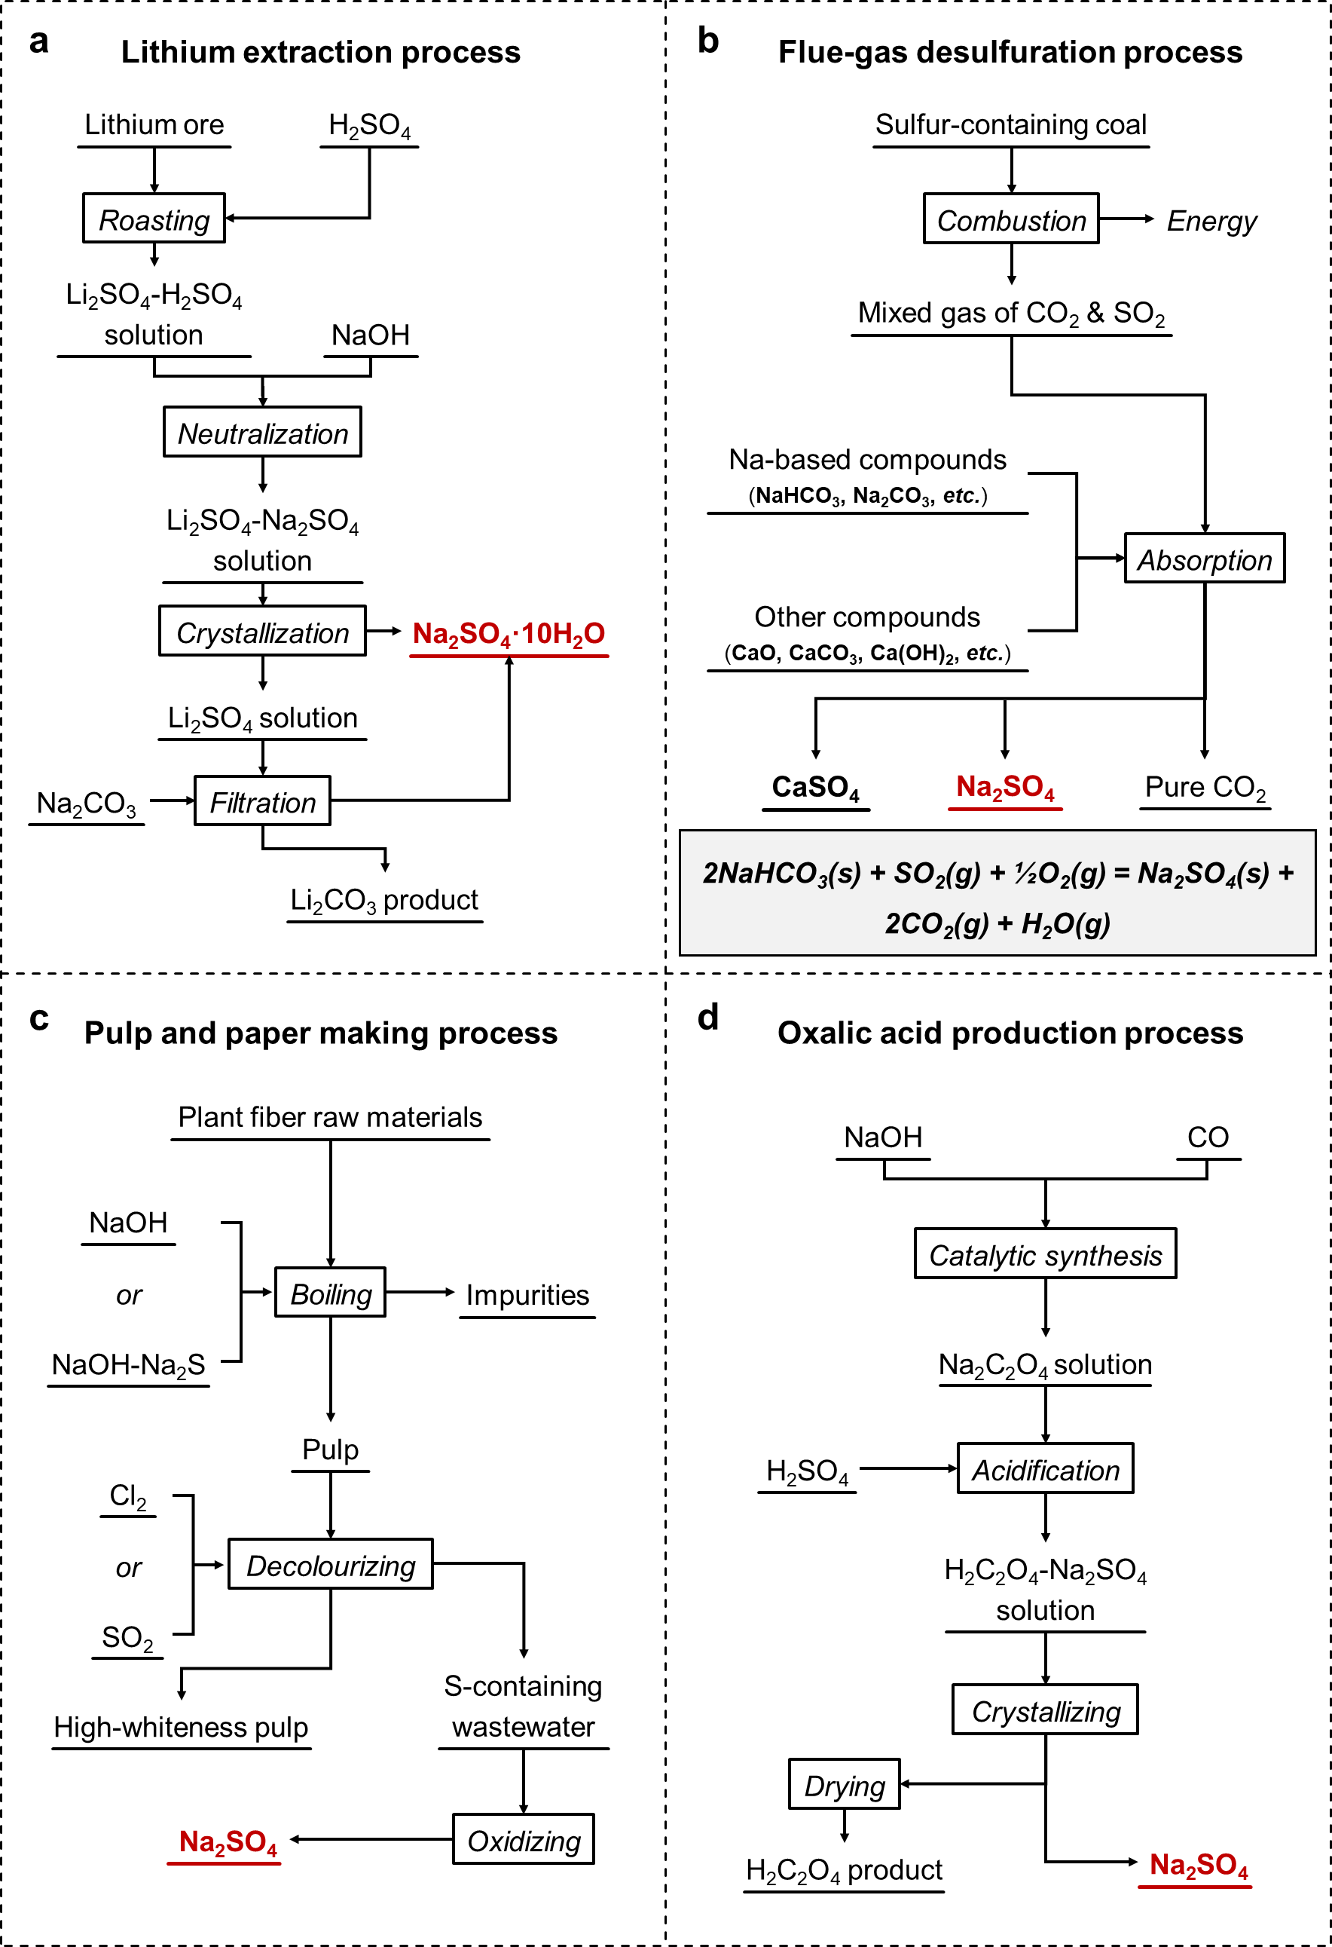
Fig. S1. Processes leading to the generation of waste Na₂SO₄: (a) lithium extraction process, (b) flue-gas desulfurization, (c) pulp and paper production, and (d) oxalic acid production.

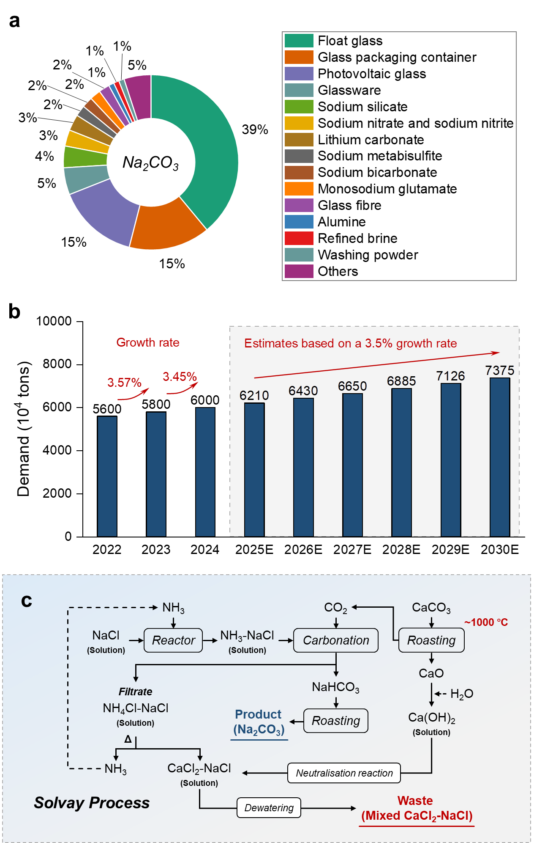
Fig. S2. (a) Downstream market structure of Na₂CO₃ in China in 2023. (b) Analysis of global Na₂CO₃ demand from 2022 to 2030. (c) Flowchart of the Solvay process.
As shown in Fig. S2a, in 2023, 39% of Na₂CO₃ consumption in China was for float glass production, followed by glass packaging container and photovoltaic glass. With both the global shift towards renewable photovoltaic energy and the rapid expansion of the electric vehicle market in recent years, the demand for Na₂CO₃ has continued to rise (Fig. S2b). Traditional Na₂CO₃ production relies on the Solvay process, which faces multiple challenges related to high energy consumption and waste generation. Consequently, the SSA-Process encounters similar issues to those faced by this conventional method (Fig. S2c).
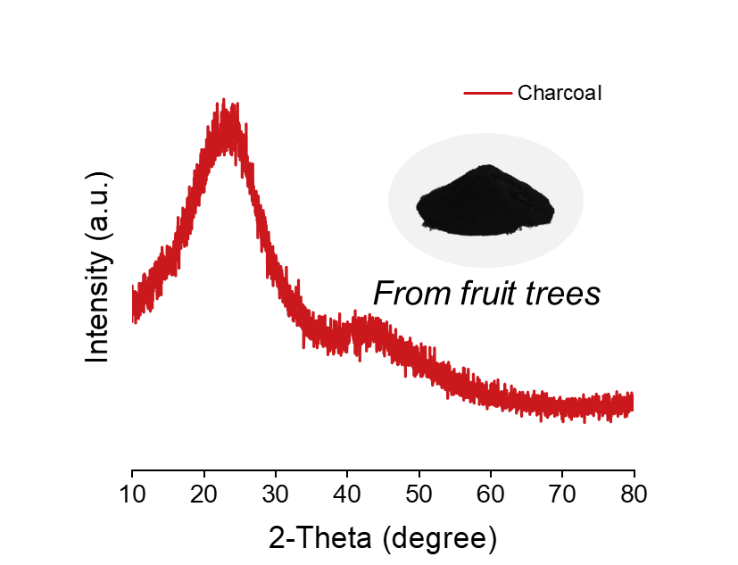
Fig. S3. XRD pattern of charcoal derived from the carbonization of cherry wood.

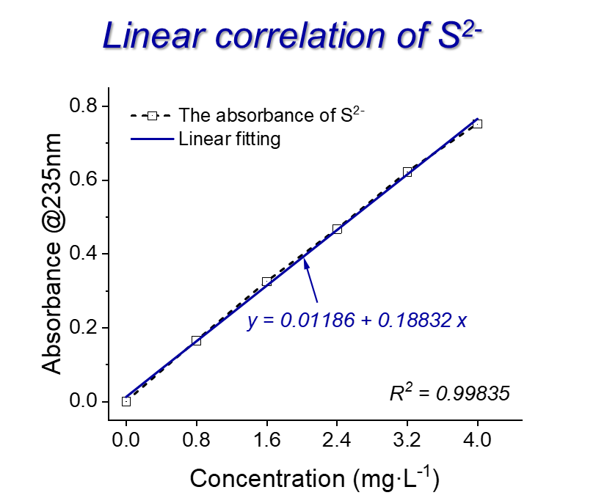
Fig. S4. Linear correlation between sulfur ion (S²⁻) concentration and absorbance at a wavelength of 235 nm.

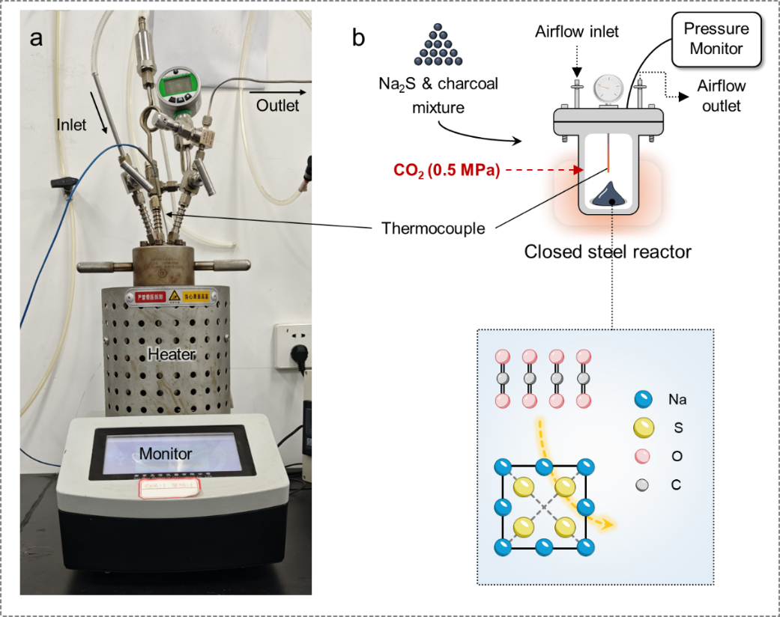
Fig. S5. (a) Photograph of the closed steel reactor. (b) Schematic diagram of the Na₂S-CO₂ reaction system and process.

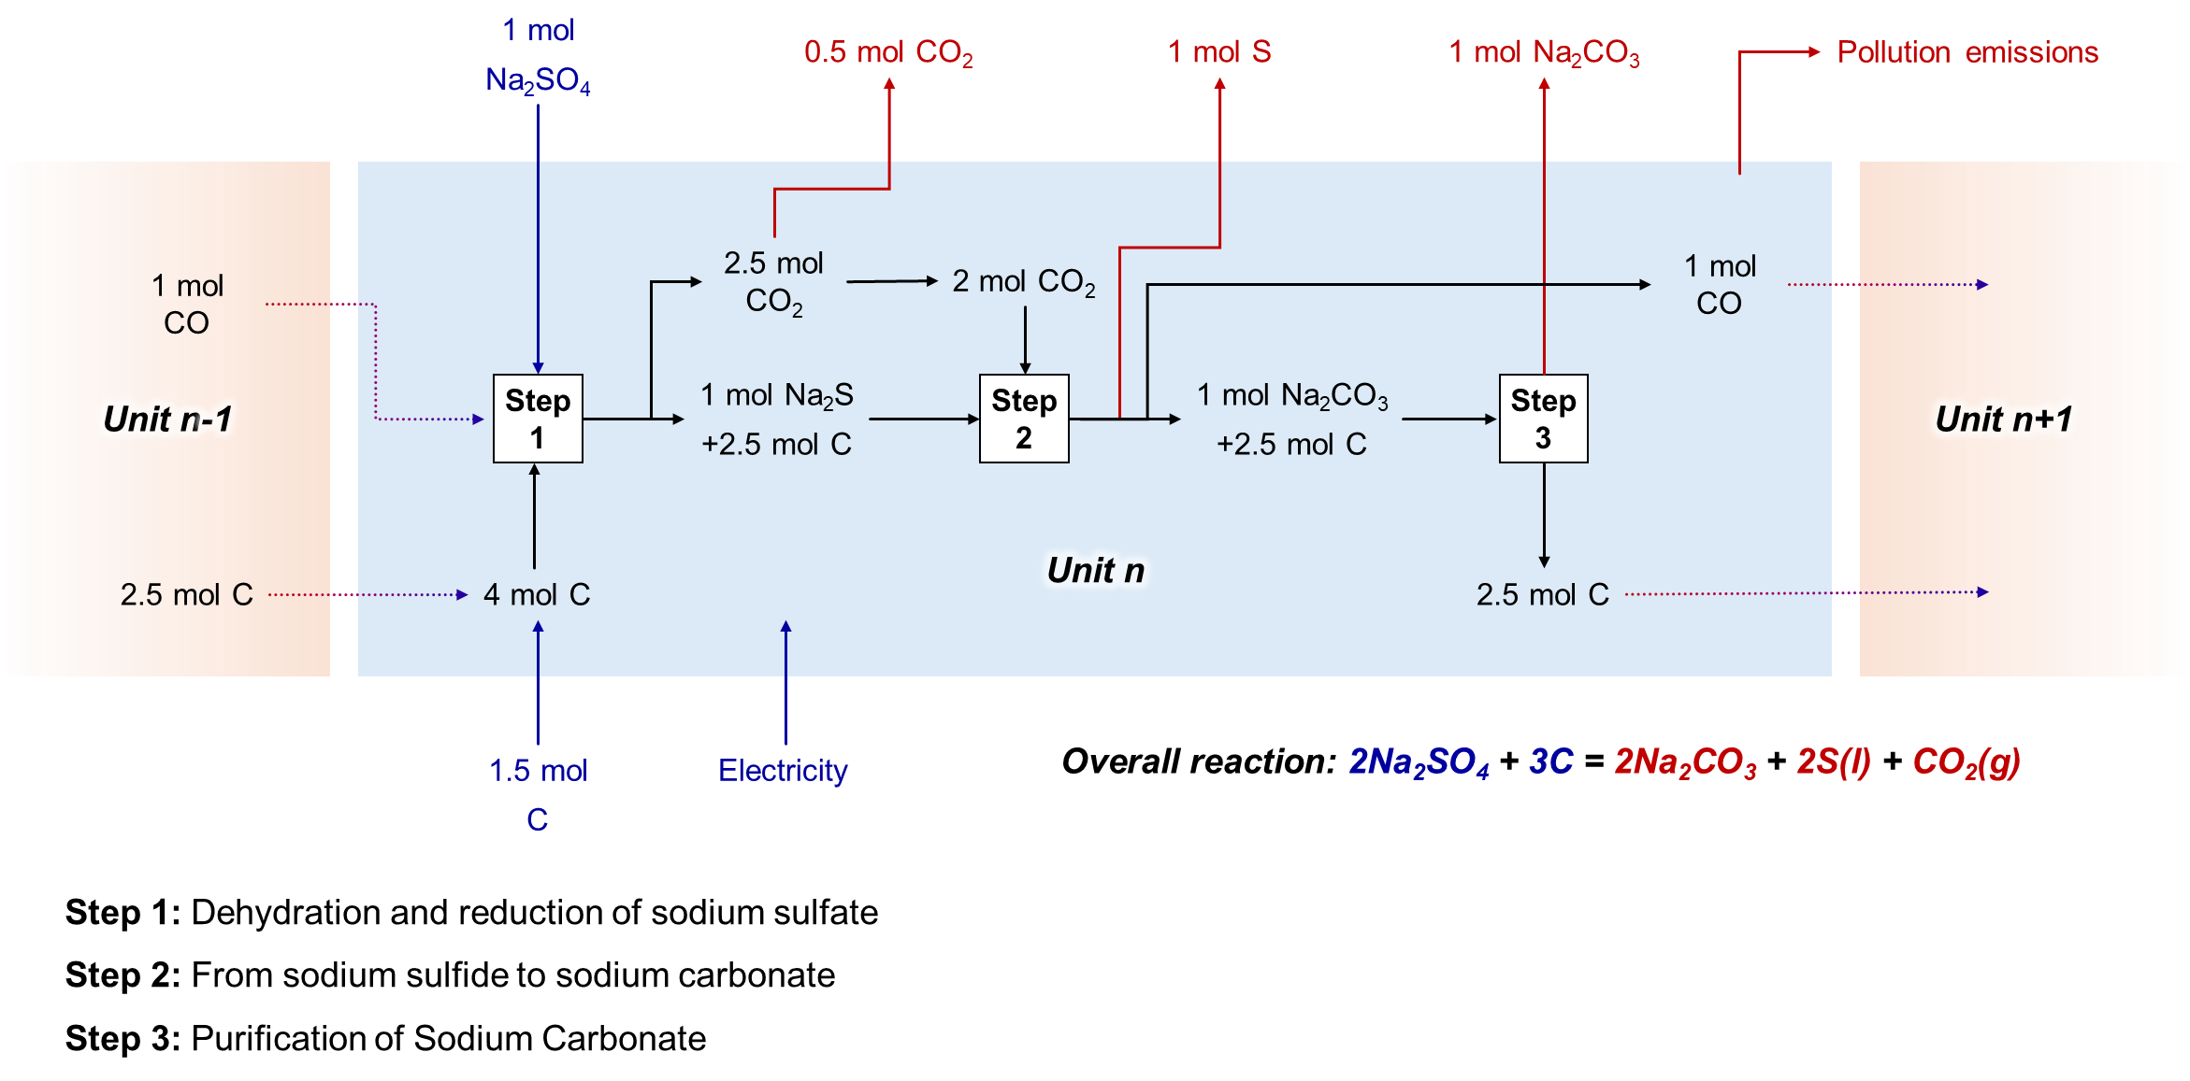
Fig. S6. System boundary diagram for the thermochemical production of Na₂CO₃ from waste Na₂SO₄ (this study).

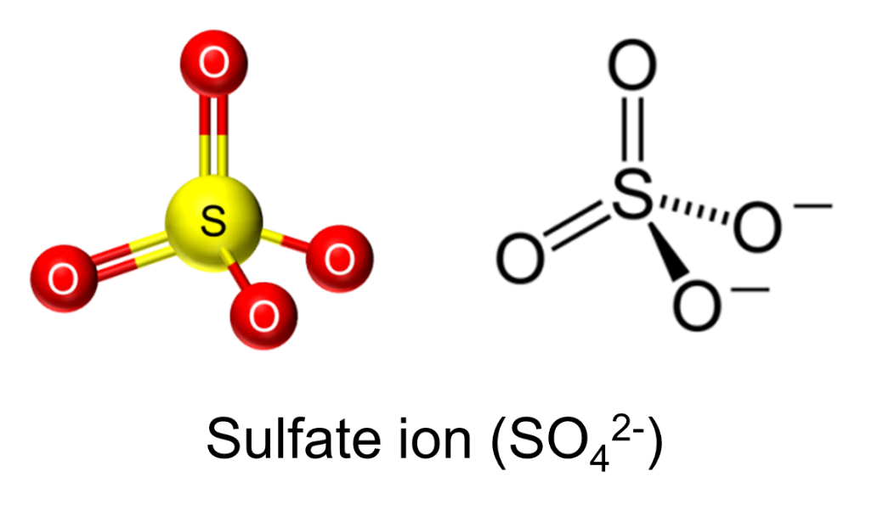
Fig. S7. Tetrahedral ball-and-stick model of SO₄²⁻ and its molecular structure diagram.

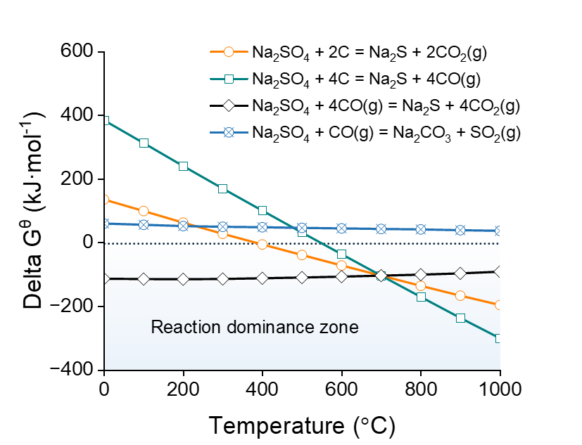
Fig. S8. The standard Gibbs free energy (∆G^{θ}) plotted against temperature for carbothermal deoxygenation reactions of Na₂SO₄ (date source: HSC Chemistry 9.0).
As the temperature increases, the formation reaction of Na₂S shifts in the negative direction, simultaneously producing CO₂ or CO. On the other hand, the reaction where Na₂SO₄ and CO simultaneously produce sodium carbonate and release SO₂ cannot occur, as there is no thermodynamic driving force for this process. Therefore, the deoxygenation of Na₂SO₄ to form Na₂S is fully feasible within the temperature range of 600-800 °C.

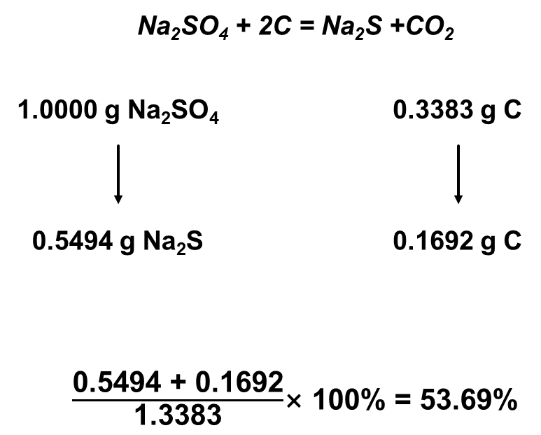
Fig. S9. Theoretical mass percentage of Na₂SO₄ thermal deoxygenation.

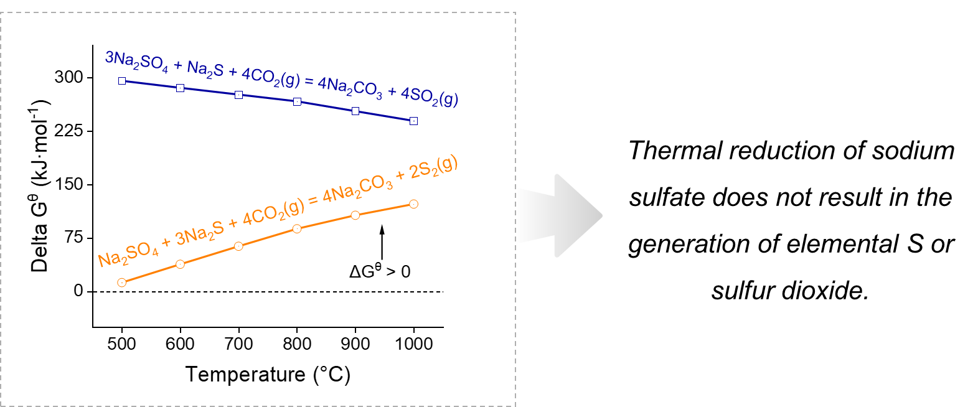
Fig. S10. The standard Gibbs free energy (∆G^{θ}) plotted against temperature for the release of S₂ or SO₂ from Na₂SO₄-Na₂S mixture.

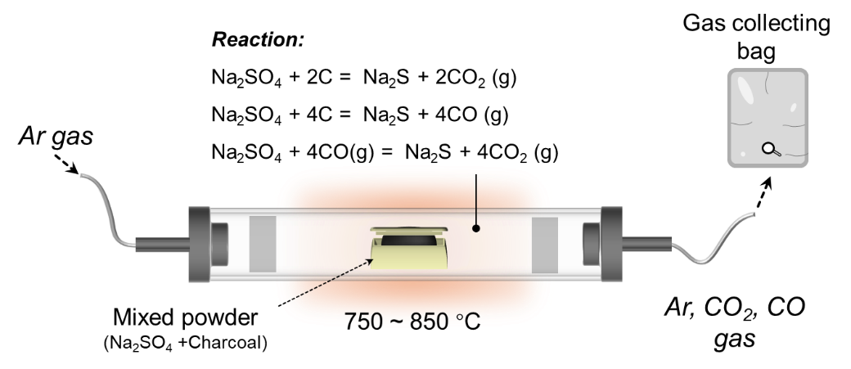
Fig. S11. Schematic diagram of the device for thermal deoxygenation of Na₂SO₄.

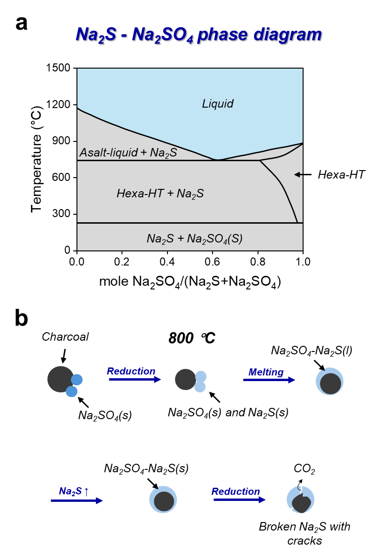
Fig. S12. (a) Phase diagram of the molten Na₂S-Na₂SO₄ mixture. (b) Schematic diagram of the thermochemical deoxygenation process of Na₂SO₄.

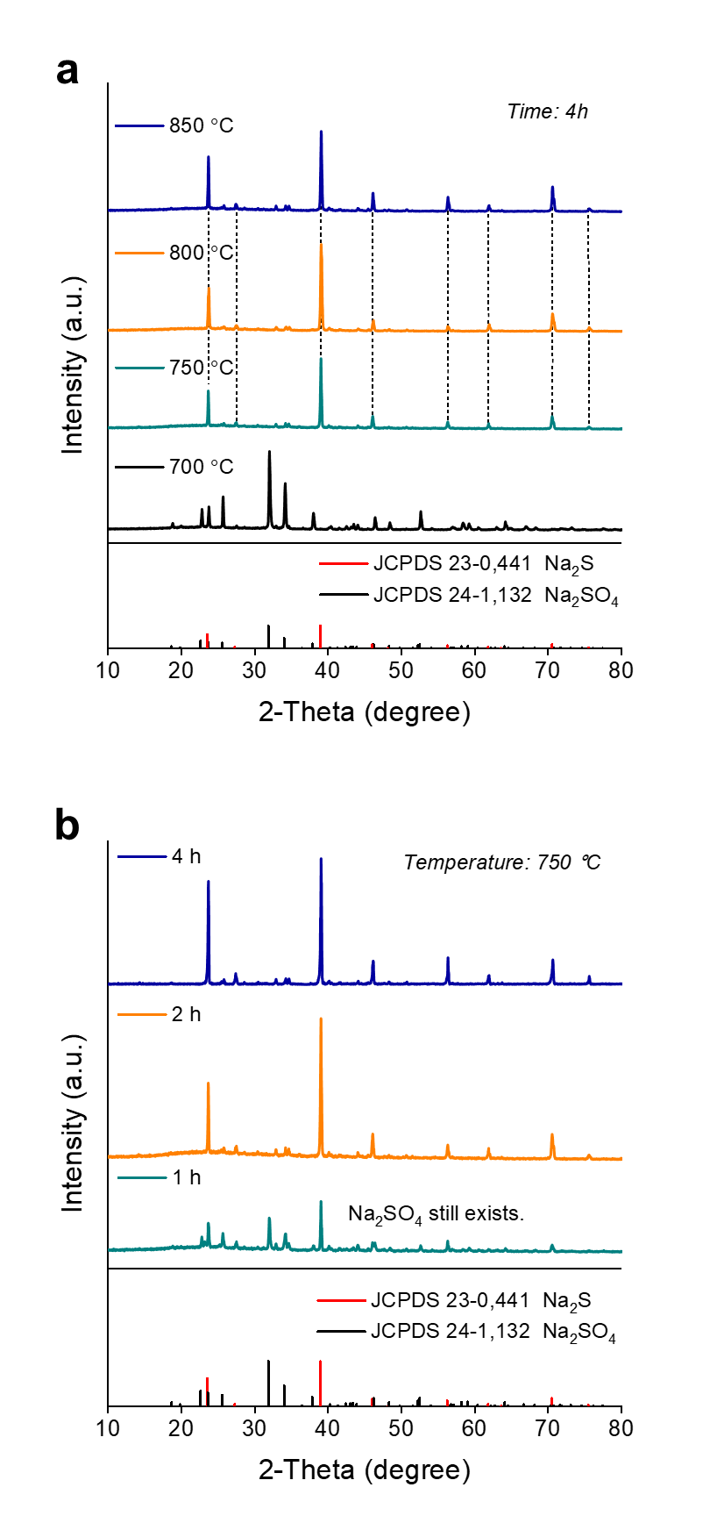
Fig. S13. XRD patterns of the products after thermochemical deoxygenation at (a) different temperatures (4 h) and (b) 750 °C for different times.

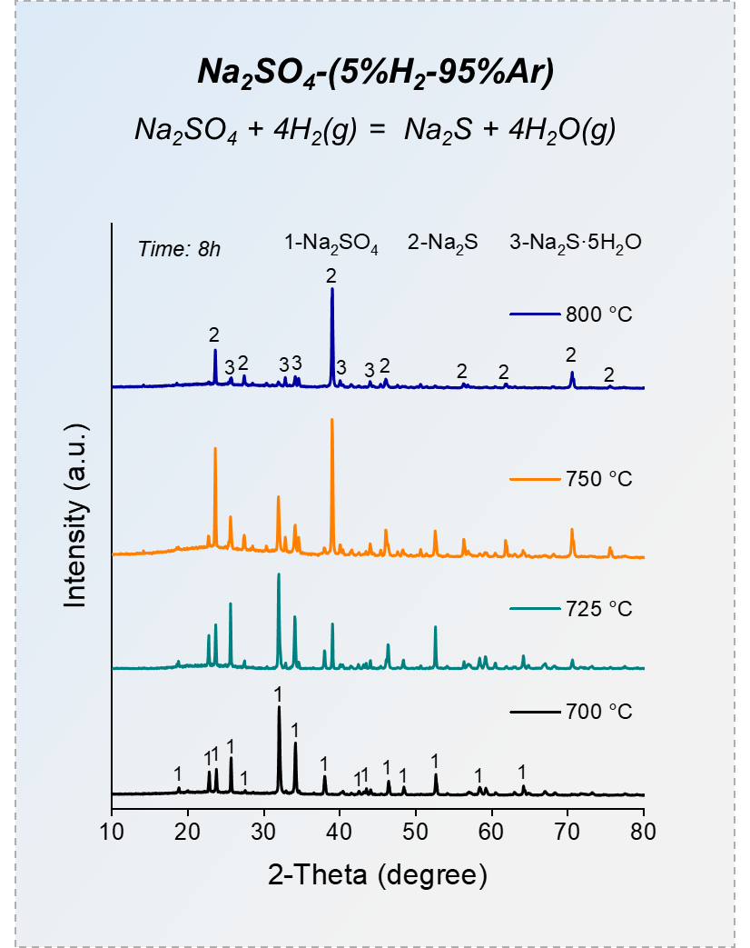
Fig. S14. XRD patterns of sodium sulfate by hydrogen thermochemical reduction as a function of temperature (isothermal time: 8 h).

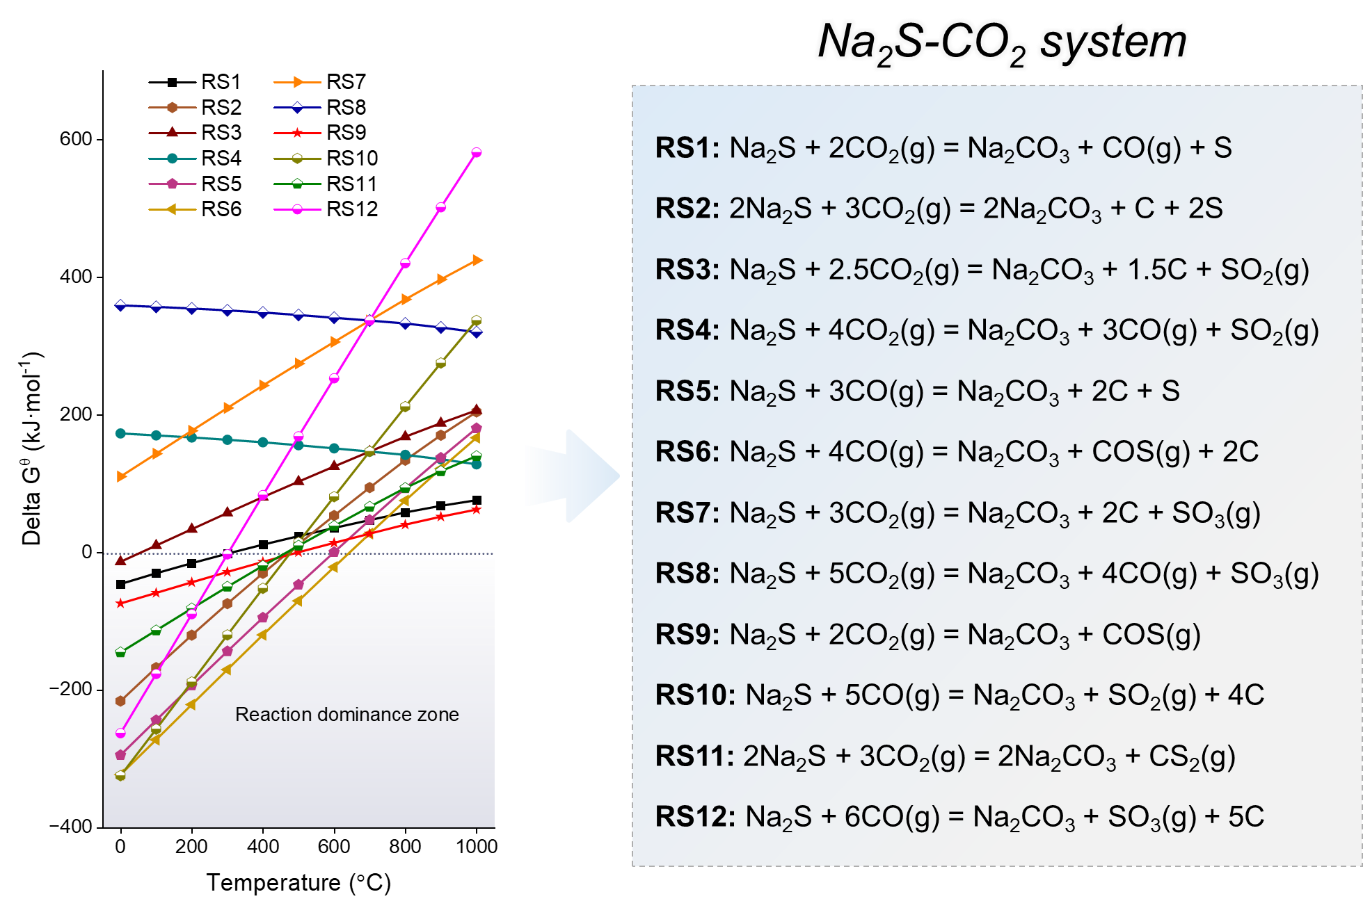
Fig. S15. The standard Gibbs free energy (∆G^{θ}) plotted against temperature for the carbonation of Na₂S in a CO₂ atmosphere (date source: HSC Chemistry 9.0).

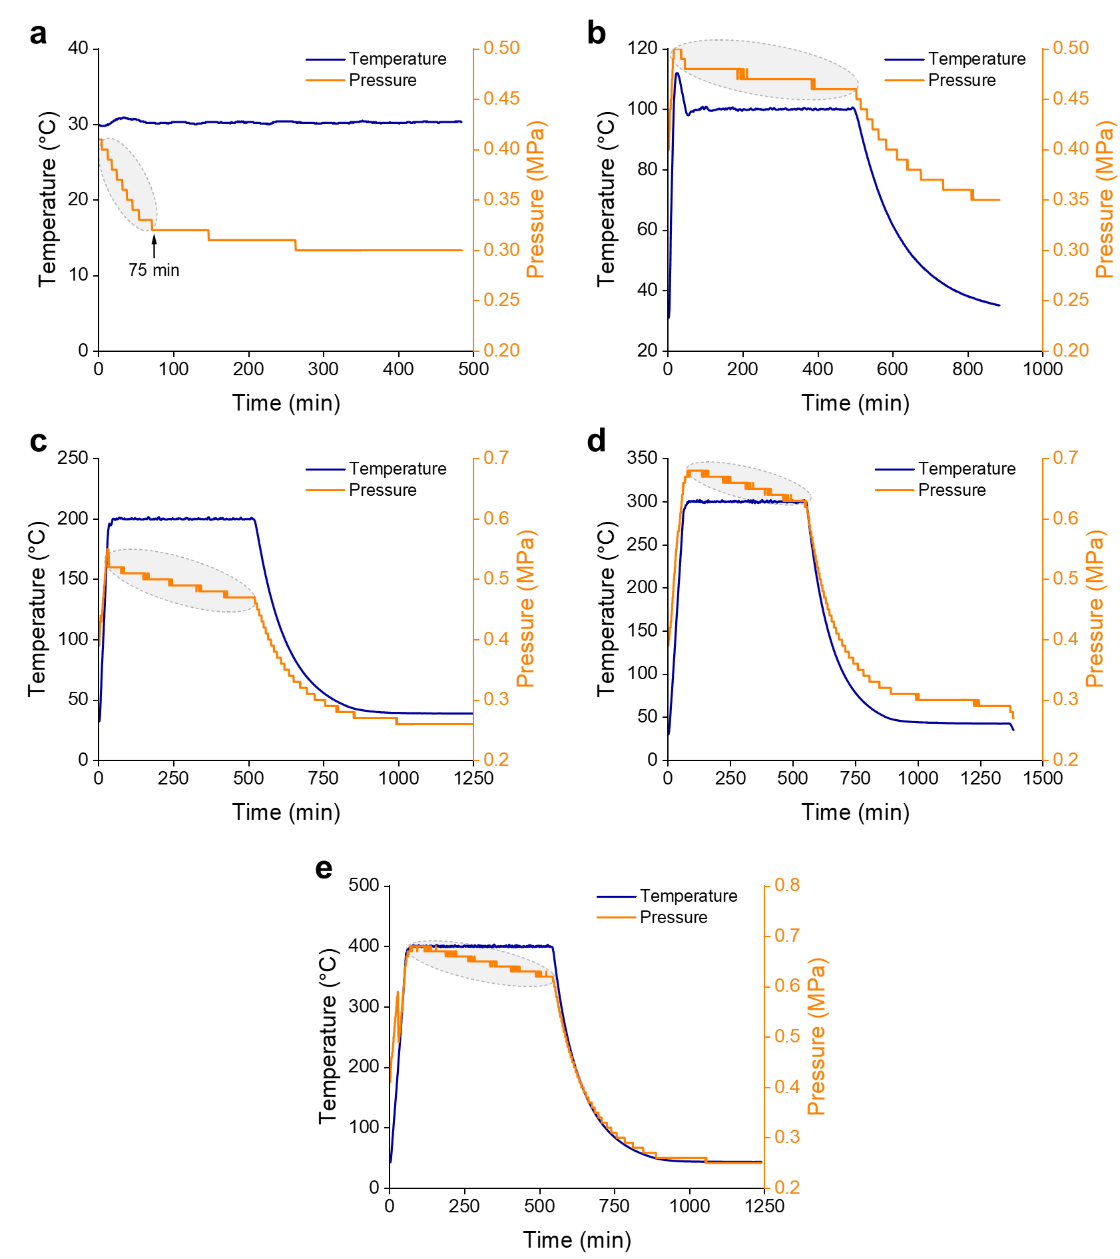
Fig. S16. The temperature and pressure curves in a closed steel reactor as a function of time: (a) room temperature, (b) 100 °C, (c) 200 °C, (d) 300 °C, and (e) 400 °C.

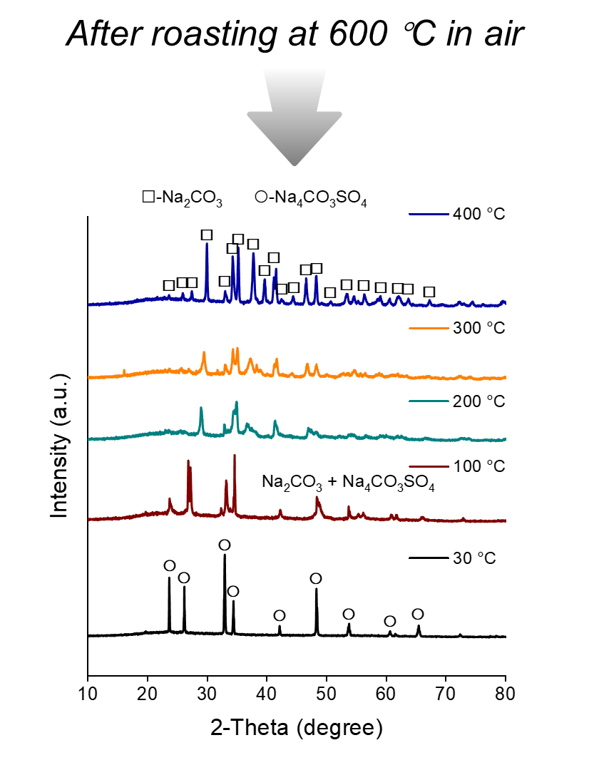
Fig. S17. XRD patterns of solid reaction products at different temperatures in the closed steel reactor after further 600 °C roasting in air.

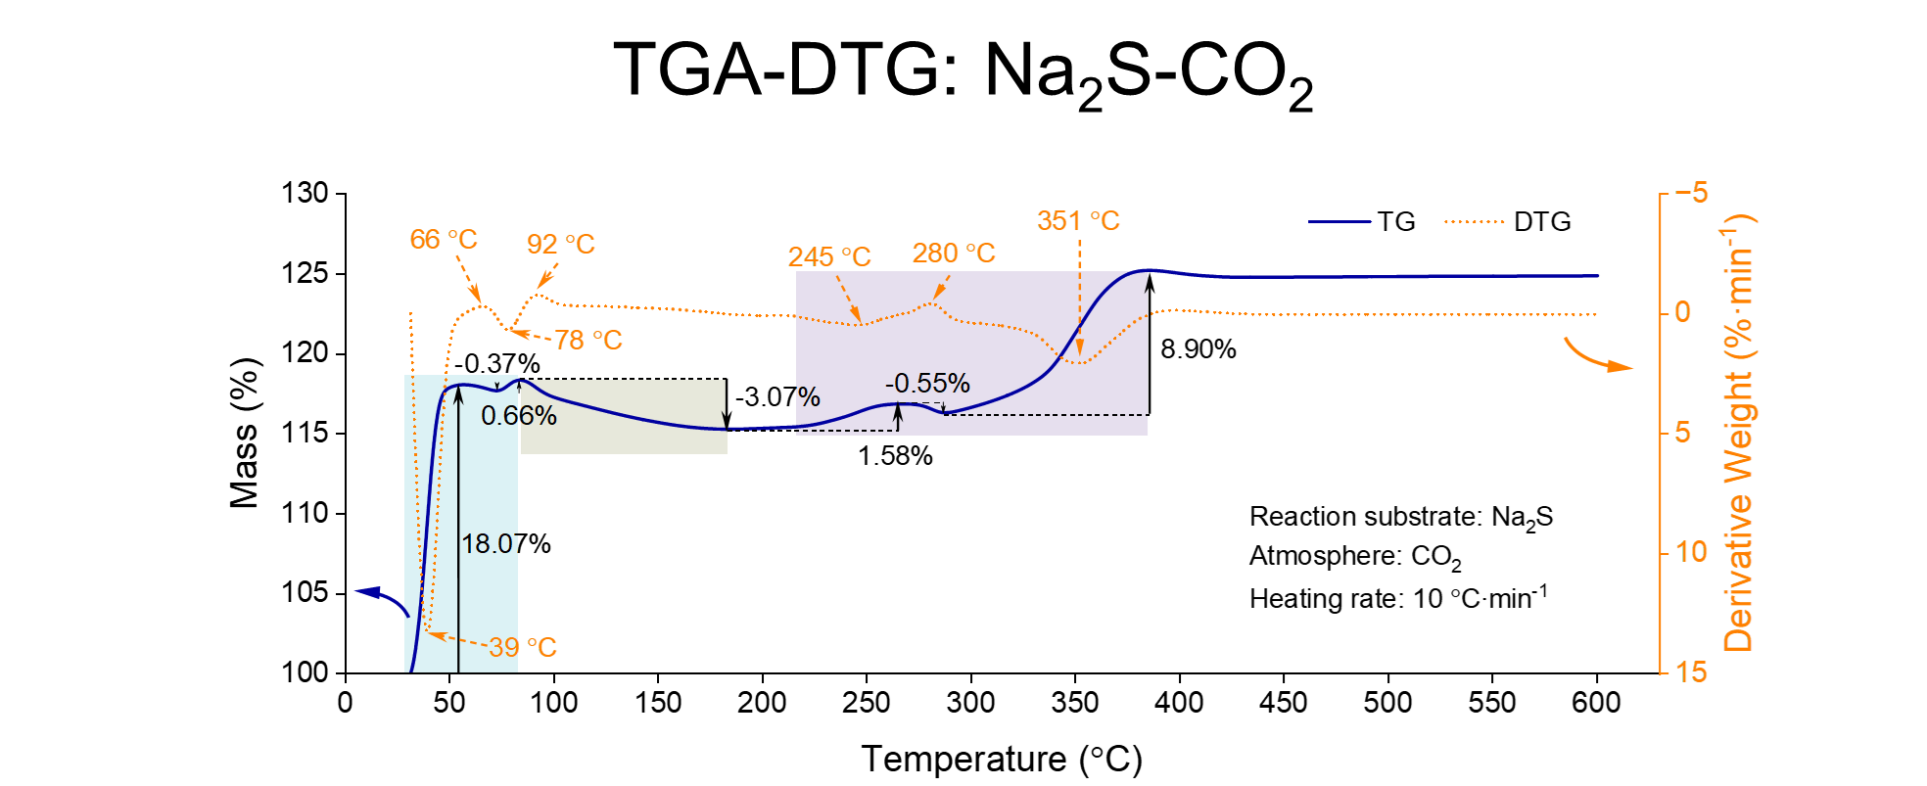
Fig. S18. TGA-DTG curves of the mixture of Na₂S and charcoal (i.e. deoxygenation product of waste Na₂SO₄) (heating rate: 10 °C·min⁻¹, atmosphere: CO₂).

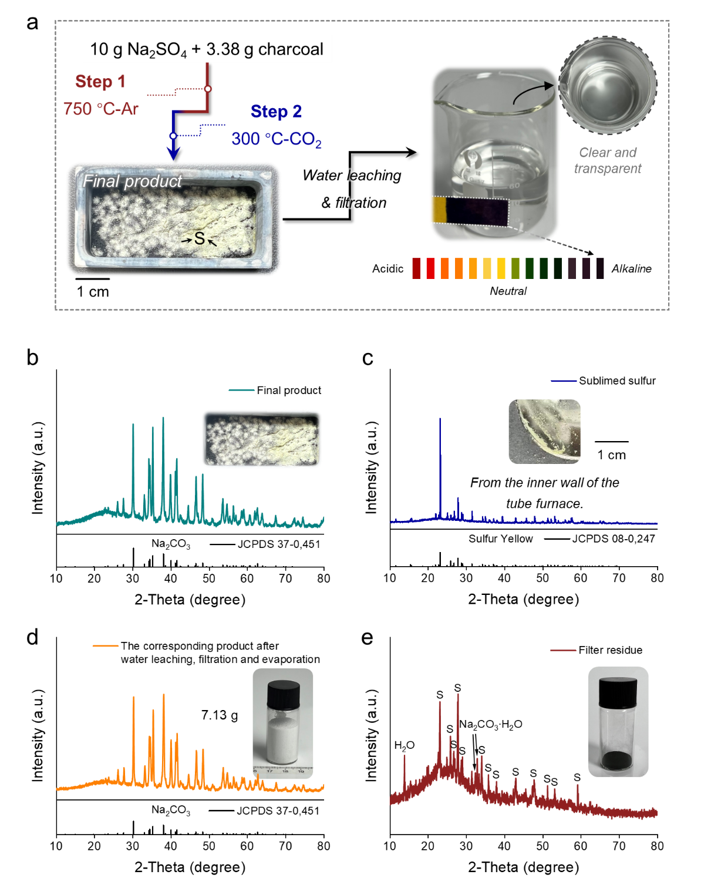
Fig. S19. (a) The conversion of Na₂SO₄ to Na₂CO₃ in a reactor with continuous gas (Ar and CO₂) flow. XRD patterns of (b) the product after the reaction, (c) the sublimed sulfur collected from the inner wall of the tube furnace, (d) Na₂CO₃ product after water leaching, filtration, and evaporation, and (e) filter residue.

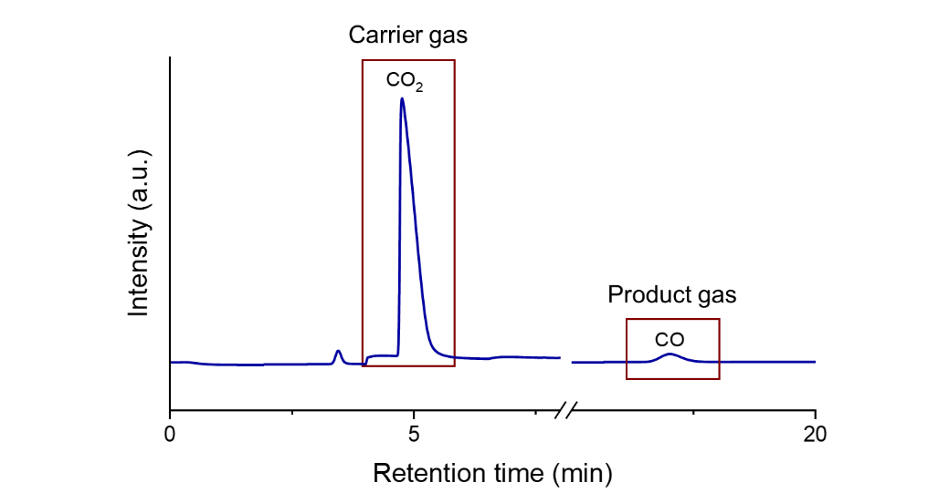
Fig. S20. Gas chromatogram for identifying product gases after switching to CO₂ gas for 20 min in a continuous flow reactor.

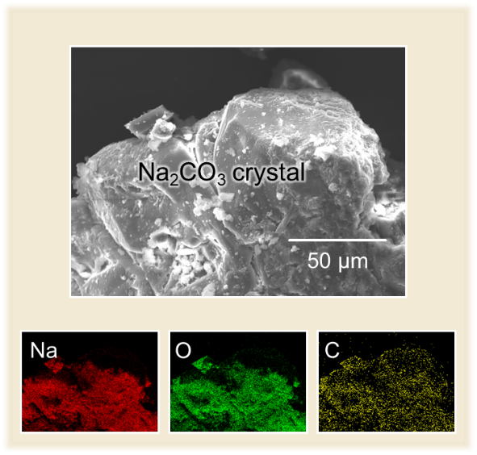
Fig. S21. Mapping images of Na, O, and C for the Na₂CO₃ crystal product.

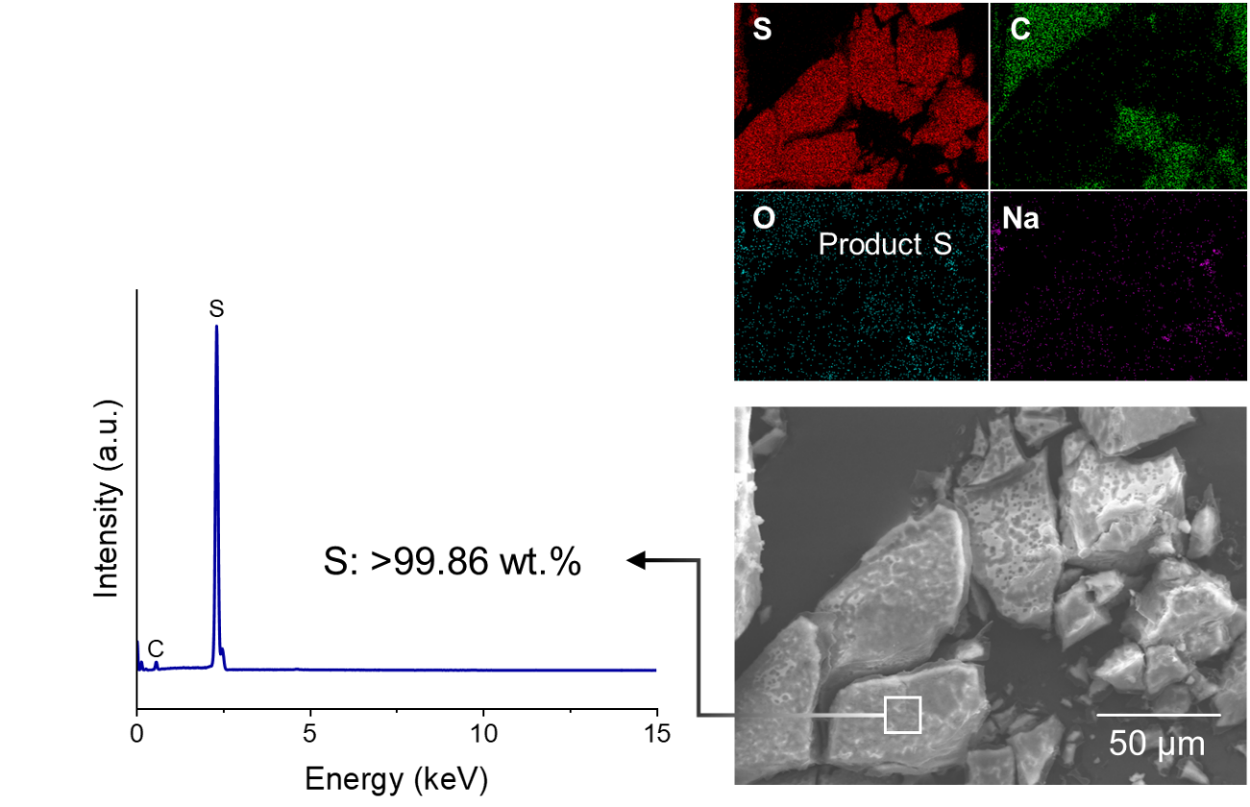
Fig. S22. Mapping images and EDS analysis of S, C, O, and Na for the sulfur product.

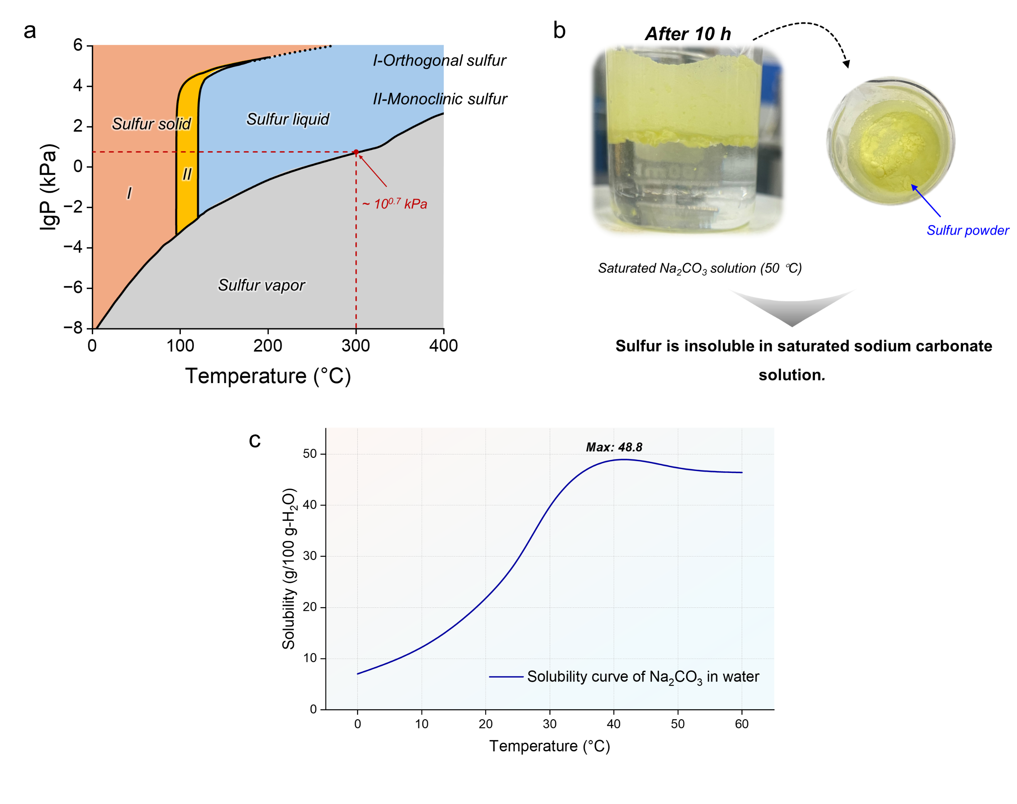
Fig. S23. (a) The relationship between the saturation vapor pressure of sulfur and temperature.⁶ (b) The state of sulfur powder dissolved in saturated Na₂CO₃ solution after 10 h. (c) The solubility curve of Na₂CO₃ in water.

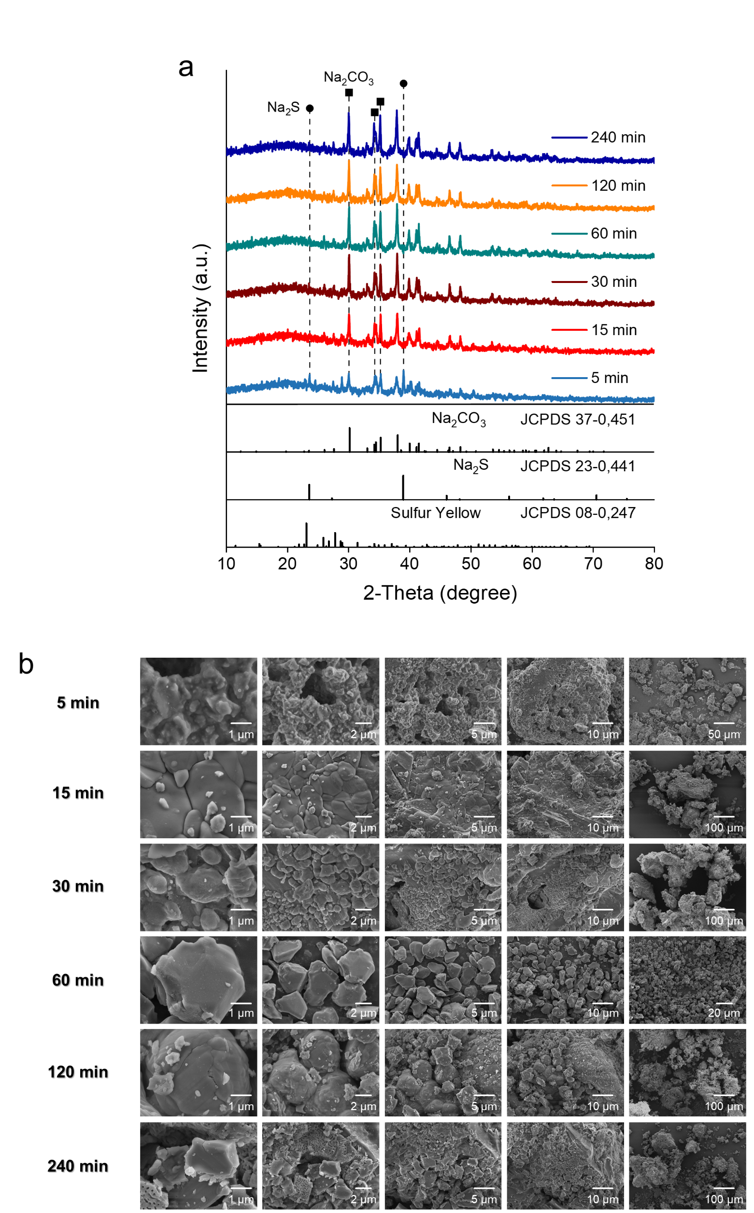
Fig. S24. (a) XRD patterns and (b) SEM images of Na₂S under different durations of CO₂ atmosphere (100 mL·min⁻¹) at 300 °C.

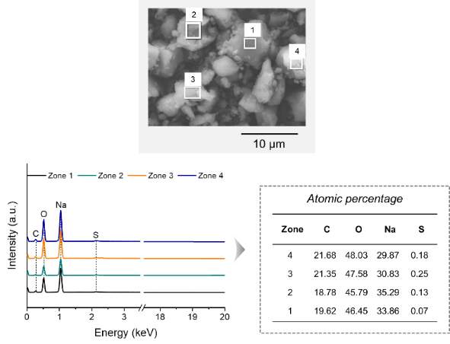
Fig. S25. Mapping images and EDS analysis of S, C, O, and Na for the final product in the scale-up production.

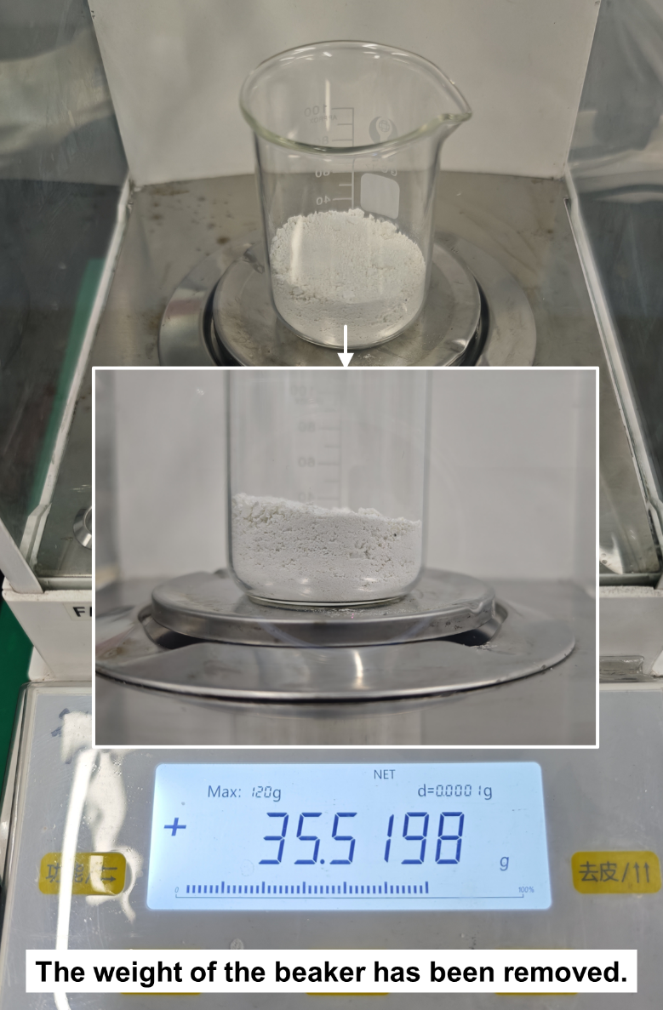
Fig. S26. Optical photograph of Na₂CO₃ upcycled from 50 g of waste Na₂SO₄ in this work.

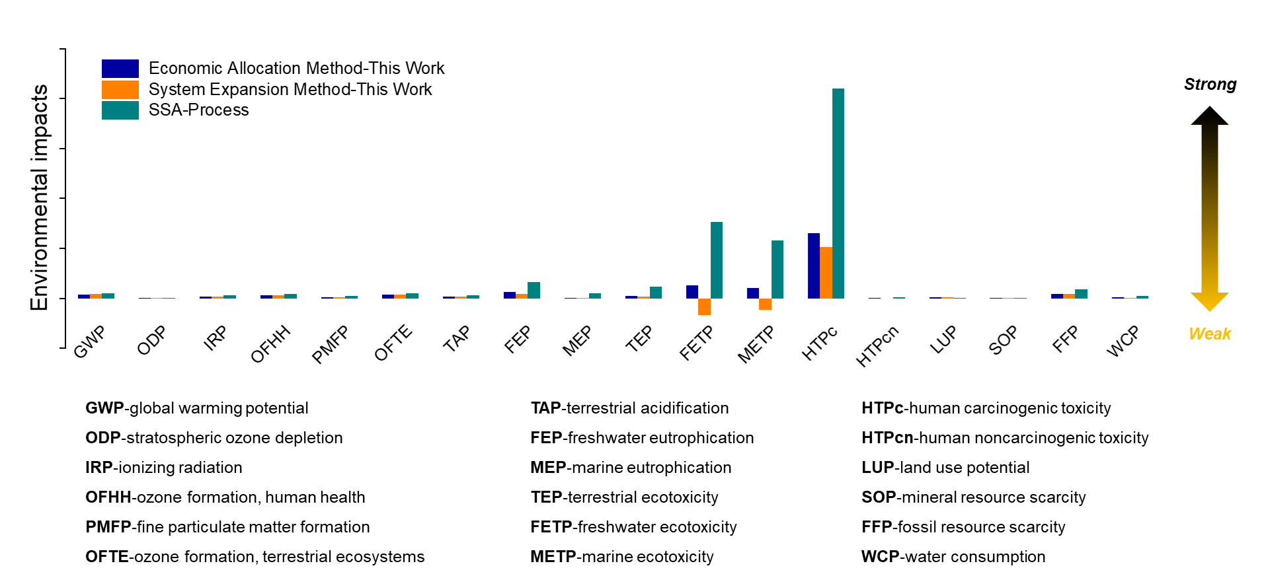
Fig. S27. The normalized environmental impact assessment results for SSA-Process and this work.

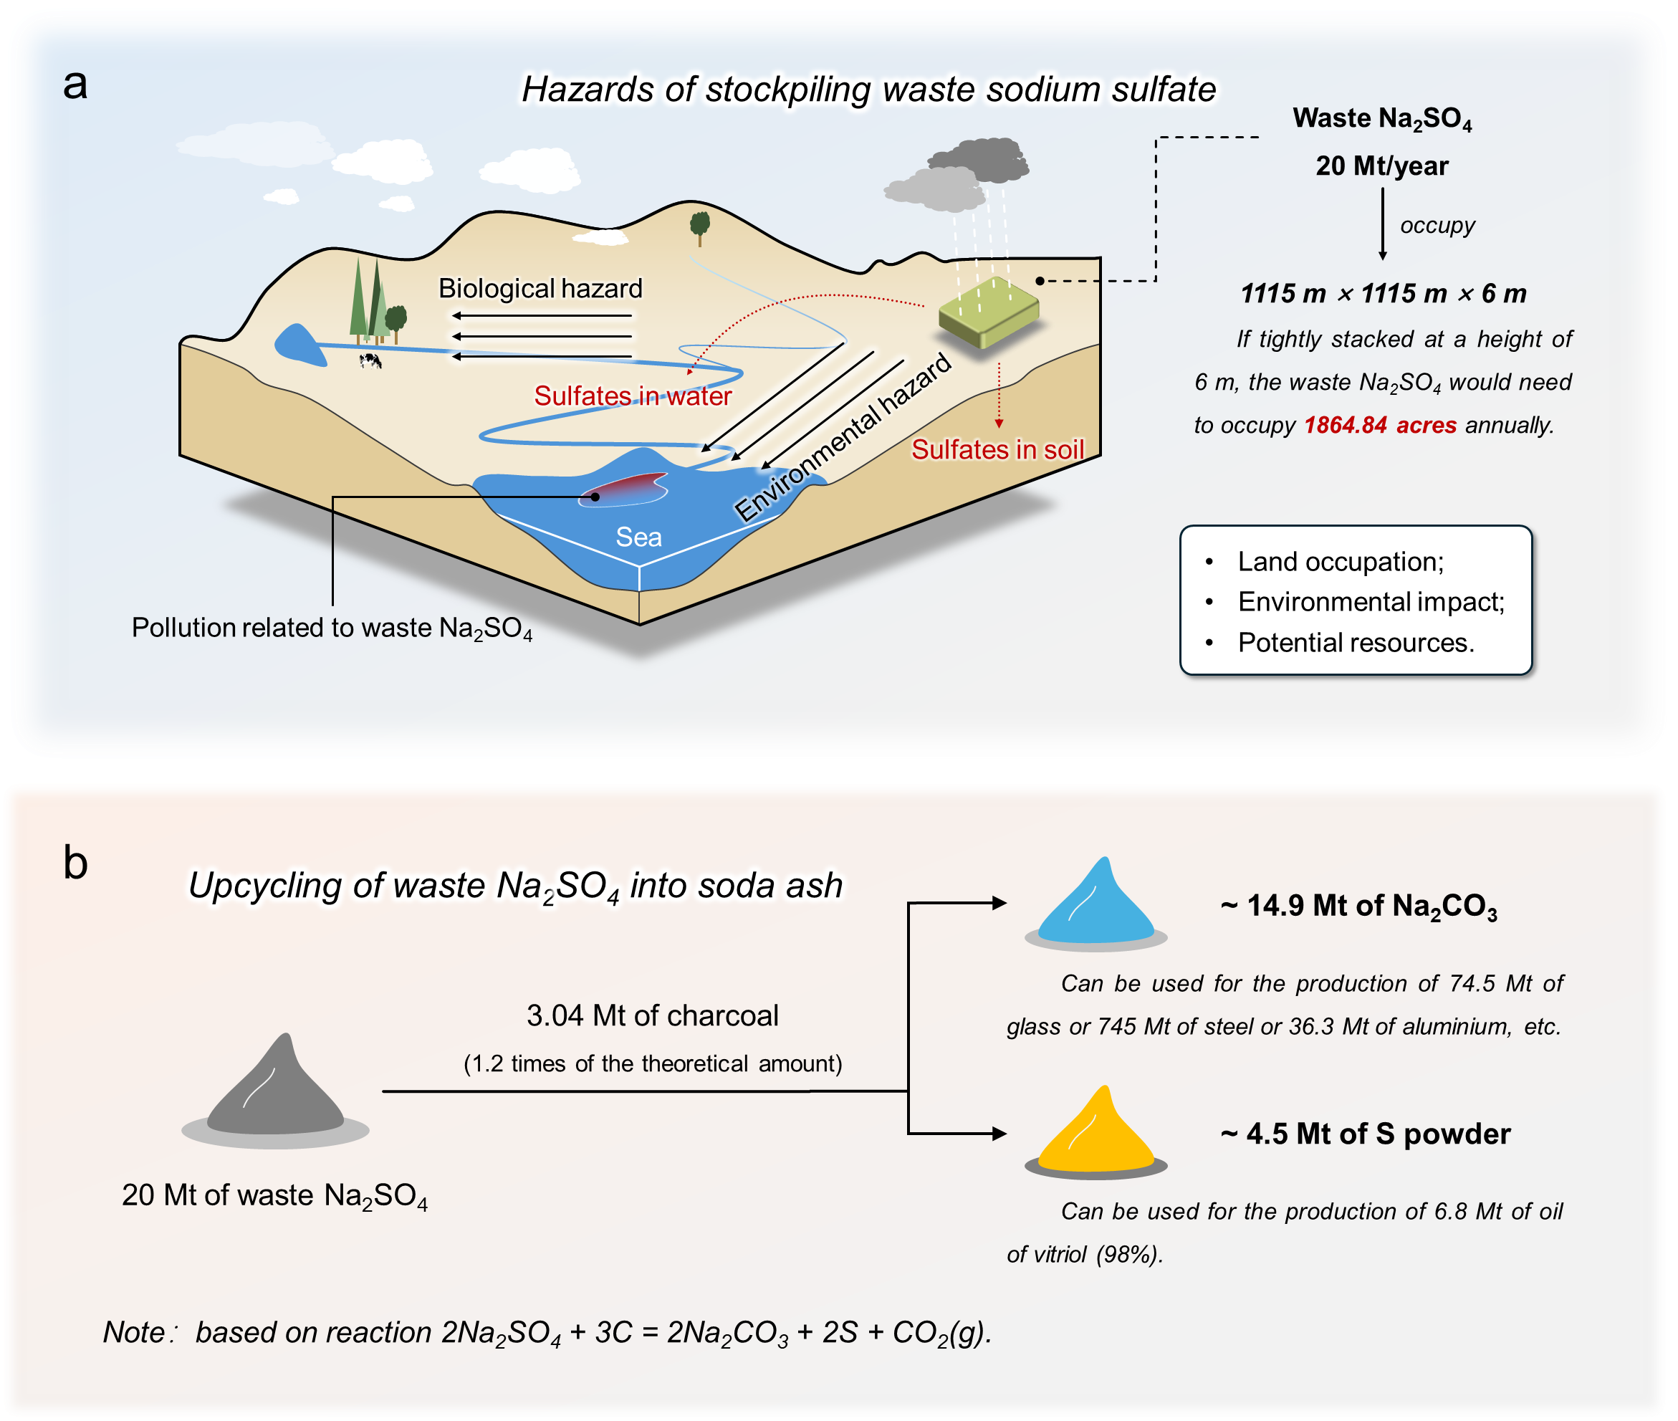
Fig. S28. (a) Hazards of stockpiling waste sodium sulfate. (b) Through this work, 20 Mt of waste Na₂SO₄ can be solved every year for the production of 14.9 Mt of Na₂CO₃ and 4.5 Mt of S powder.

References
1. Gao, W., Fang, Q., Yan, H., Wei, X. & Wu, K. Recovery of Acid and Base from Sodium Sulfate Containing Lithium Carbonate Using Bipolar Membrane Electrodialysis. Membranes 11, 152 (2021).
2. Lee, D., Ho Yun, T., Gi Min, J., Byun, Y. & Yim, C. Regeneration of sodium bicarbonate from industrial Na-based desulfurization waste using ammonium hydroxide. J. Ind. Eng. Chem. 122, 500-510 (2023).
3. Finkbeiner, M., Inaba, A., Tan, R., Christiansen, K. & Klüppel, H.-J. The New International Standards for Life Cycle Assessment: ISO 14040 and ISO 14044. Int. J. Life Cycle Assess. 11, 80-85 (2006).
4. Wernet, G. et al. The ecoinvent database version 3 (part I): overview and methodology. Int. J. Life Cycle Assess. 21, 1218-1230 (2016).
5. Piccinno, F., Hischier, R., Seeger, S. & Som, C. From laboratory to industrial scale: a scale-up framework for chemical processes in life cycle assessment studies. J. Cleaner Prod. 135, 1085-1097 (2016).
6. Ferreira, A.G.M. & Lobo, L.Q. The low-pressure phase diagram of sulfur. J. Chem. Thermodyn. 43, 95-104 (2011).

