Tables
Table 1. Pseudocode to randomly play a soundscape of interest in Max Software, triggered by OSC messages from OpenViBE.
Algorithm 1 Random playback of soundscapes
Input: Audio files at 48 kHz / 24 bits
Output: JSON file including the order in which files were played back.

START
i = audio file
For i = 1 to 8
audio file is played back
filename is saved in dictionary
next audio file is loaded randomly without duplicates
End

Table 2. Event codes written in gdf-files.
Number | Type | Description
33769 | Start experiment | Start the OpenViBE scenario programmed for recording the EEG data stage described in the experimental procedure in Figure 3.
33025 | Basal state | Recording of a resting state for 60 seconds with eyes closed.
33026 | Start reproduction of soundscape sequence by Max software | Initialization of a randomized sequence of 4 types of soundscapes (park, riverwalk, music venue, traffic) in 2 formats (stereo and binaural).
Condition 8 | Reproduction of 1:8 soundscape | Reproduction of one soundscape for 120 seconds. Refer to the excel file in the database for having the specific sequence of each participant.
33027:33029 | Questions A, B, C | Put 1 of 3 questions of the SUS questionnaire.
33041:33047 | Likert-scale answer | Answer to the previous question between 1 (the lowest presence) and 7 (the highest presence) score.
33025 | Release key button | Once the participant had released the pressed key button to answer the previous question, OpenViBE sent this event.
1010 | Stop reproduction of soundscape sequence by Max Software | Finalization of the randomized sequence of soundscapes.
32774 | Stop experiment | Stop the OpenViBE scenario programmed for recording the EEG data stage described in the experimental procedure in Figure 3.
33284 | Finalization | Finalization of the program.

Table 3. Recording conditions of soundscapes.
Soundscape | Mean A-weighted SPL (dB and absolute imprecision) | Temperature (ºC) | Latitude, Longitude (Decimal degrees) | Max-to-min level difference (dBFS)
 |  |  |  | Stereo |  | Binaural
 |  |  |  | L | R | L | R
Ecological Park | 43.5 +/- 1.5 | 21 | 25.54347, -100.27130 | 124.5 | 124.8 | 124.9 | 122.2
Riverwalk | 68.5 +/- 6.5 | 23 | 25.67280, -100.29783 | 137.3 | 133.5 | 136.2 | 131.8
Music Venue | 90.0 +/- 3.0 | 20 | 25.66640, -100.31827 | 129.0 | 127.2 | 130.2 | 127.1
Traffic | 70.0 +/- 3.0 | 18 | 25.65471, -100.29133 | 129.5 | 130.3 | 136.1 | 130.6

Figures
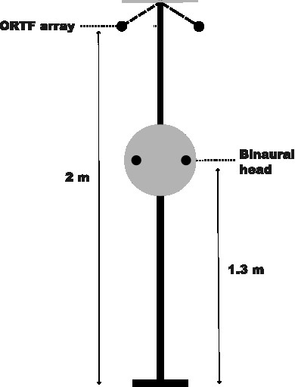 | 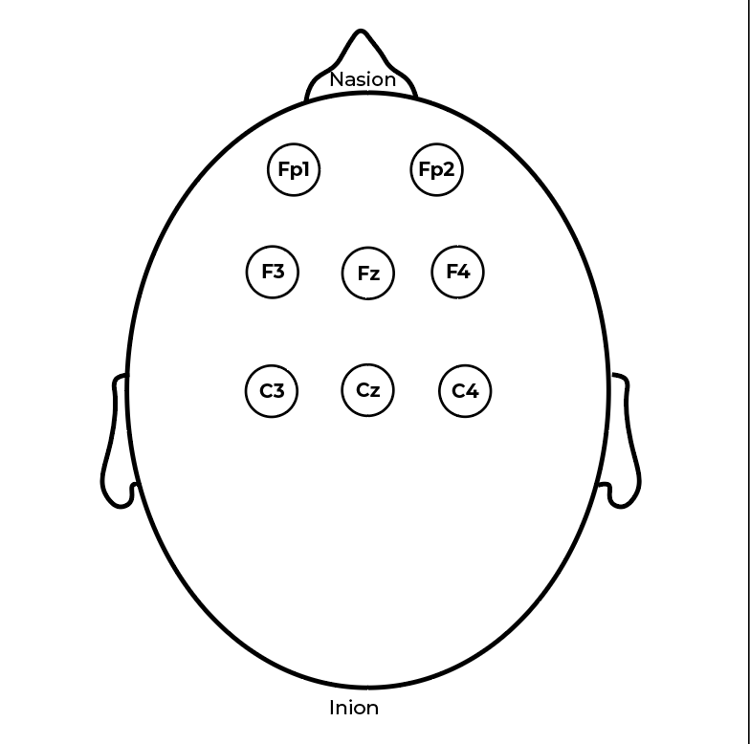
Figure 1. Experimental setup to record the soundscapes and EEG signals. In Figure 1A, the experimental setup of the binaural head to record the soundscapes is shown. In Figure 1B, the EEG channel position in line with the 10/20 system for this project is illustrated over the scalp.

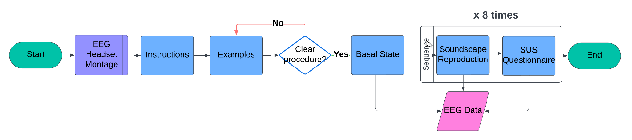
Figure 2. Experimental procedure for EEG recording. The procedure was designed in four main stages: (1) EEG montage, (2) instructions and examples, (3) basal state recording for 60 seconds, and (4) soundscape reproduction and evaluation for 135 seconds each repetition.

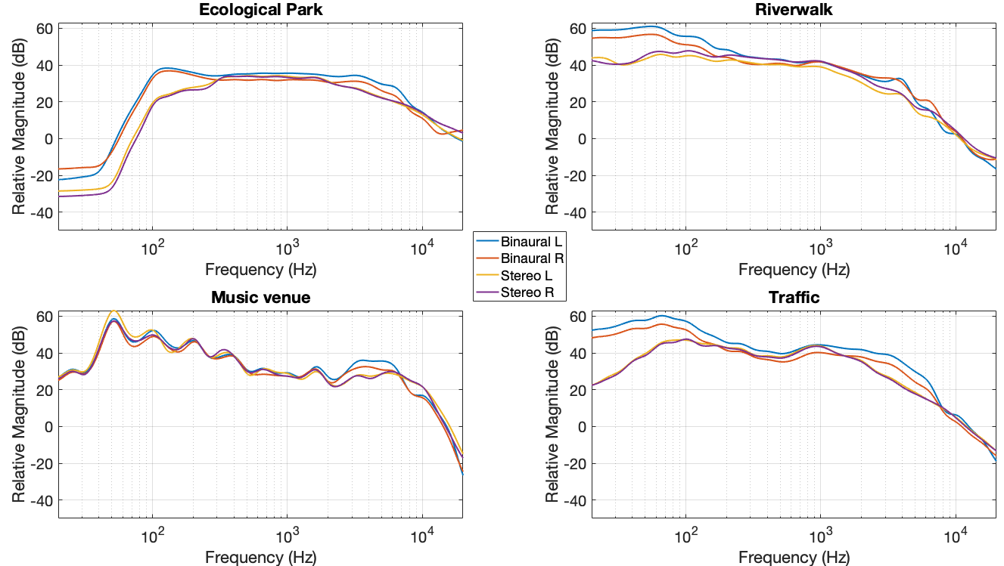
Figure 3. 1/3-octave band average frequency content of soundscapes in the range 20 – 20k Hz.
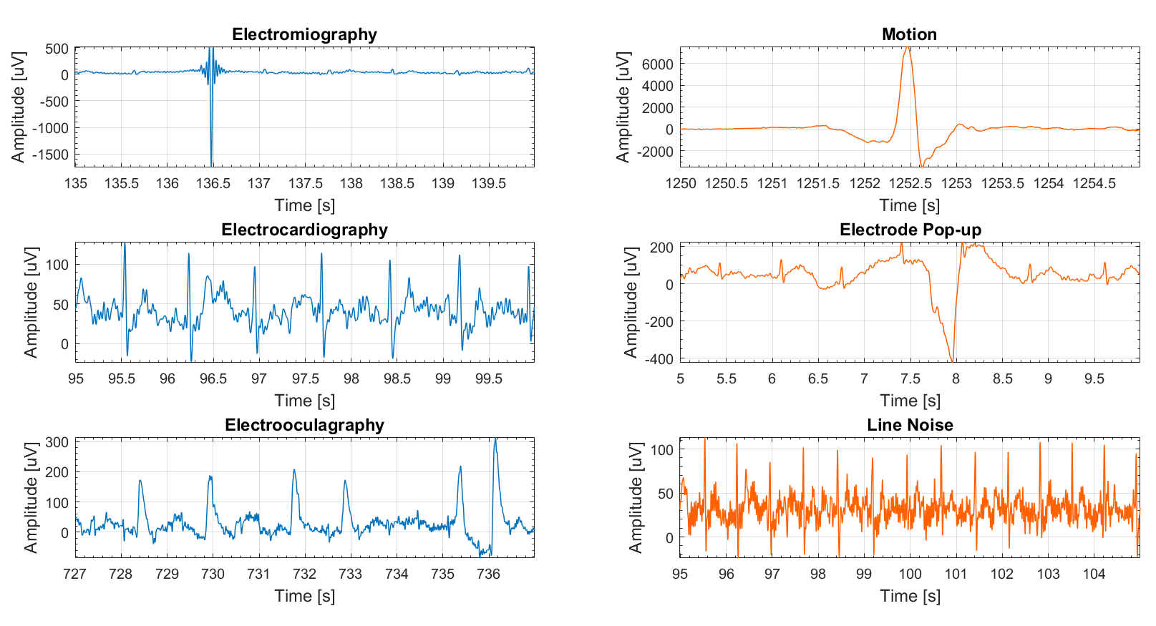
Figure 4. Endogenous (left column, blue plots) and exogenous (right column, orange plots) artefacts of EEG signals shared in this database.

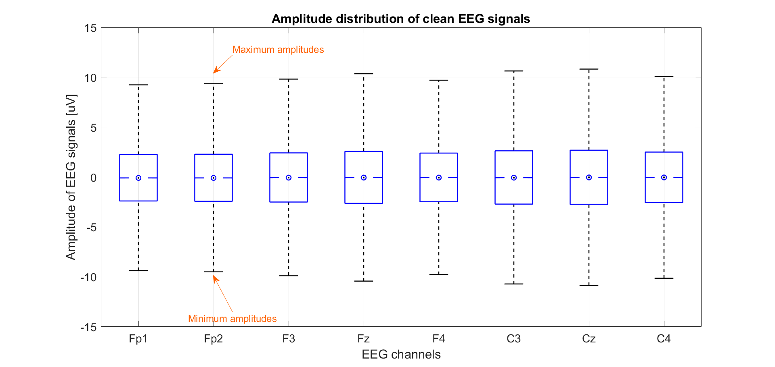
Figure 5. Distribution of signal amplitude of clean EEG data for this database. These tendencies can be used as reference to validate self-built preprocessing pipelines.

