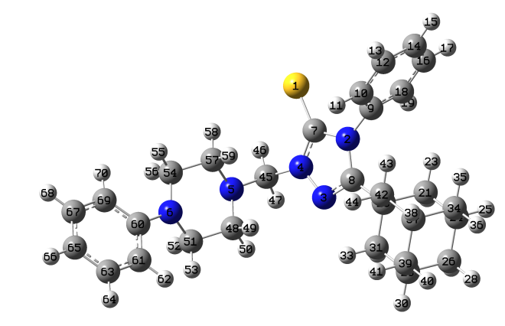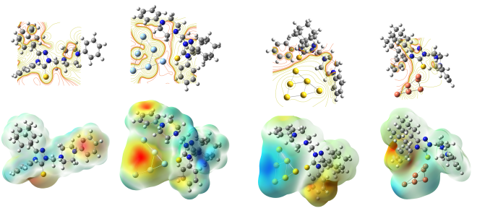
- Investigation of the adsorption properties of adamantane with metal cages
- Complexation energy is slightly more for the gold nanocluster-drug complex

