|  |  |  |  |
| --- | --- | --- | --- |
|  | **Women**  **N=121** | **Men**  **N=159** |  |
|  | **Percent difference (95% CI) in daily means of autonomic metrics per 1-log-unit increase in daily mean negative mood score** | | **P for sex interaction\*** |
| Ln HF | -2.5 (-5.0, -0.03) | 0.6 (-1.2, 2.5) | 0.047 |
| Ln LF | -2.9 (-5.1, -0.6) | -0.01 (-1.6, 1.6) | 0.045 |
| Ln VLF | -1.6 (-3.0, -0.15) | 0.10 (-0.9, 1.1) | 0.065 |
| Ln SDNN | -1.9 (-3.4, -0.47) | 0.02 (-1.0, 1.1) | 0.036 |

**Supplementary Table 1. Unadjusted sex differences in associations of daily average negative mood (in log units) with daily average ambulatory heart rate variability metrics.**

CI: confidence interval; DC: deceleration capacity; HF: high-frequency heart rate variability; LF: low- frequency heart rate variability; VLF: very-low frequency heart rate variability; SDNN: standard deviation of NN intervals.

**Supplementary Table 2. Unadjusted sex differences in associations of daily average negative mood (in original units) with daily average ambulatory autonomic function metrics.**

|  |  |  |  |
| --- | --- | --- | --- |
|  | **Women**  **N=121** | **Men**  **N=159** |  |
|  | **Percent difference (95% CI) in daily means of autonomic metrics per 20 units increase in daily mean negative mood score** | | **P for sex interaction\*** |
| Ln DC | -11.9 (-18.9, -4.8) | 0.9 (-4.5, 6.4) | 0.005 |
| Ln HF | -6.1 (-11.4, -0.8) | 1.0 (-3.1, 5.1) | 0.038 |
| Ln LF | -7.6 (-12.3, -2.9) | -0.3 (-3.8, 3.2) | 0.02 |
| Ln VLF | -4.7 (-7.6, -1.7) | 0.04 (-0.1, 0.2) | 0.005 |
| Ln SDNN | -5.0 (-8.1, -1.9) | 0.2 (-2.1, 2.6) | 0.01 |

CI: confidence interval; DC: deceleration capacity; HF: high-frequency heart rate variability; LF: low- frequency heart rate variability; VLF: very-low frequency heart rate variability; SDNN: standard deviation of NN intervals.

|  |  |  |  |
| --- | --- | --- | --- |
|  | **Women** | **Men** |  |
|  | **Percent difference (95% CI) in daily means of deceleration capacity per 20 units increase in daily mean negative mood score** | | **P for sex interaction\*** |
| Adjusted for sociodemographic factors* | -9.7 (-16.1, -3.3) | 1.1 (-3.9, 6.1) | 0.009 |
| Adjusted for the above plus CAD risk factors† | -8.0 (-13.6, -2.4) | 1.8 (-2.6, 6.1) | 0.007 |
| Adjusted for the above plus psychosocial scales‡ and antidepressant medication use | -7.3 (-13.3, -1.2) | 2.7 (-2.0, 7.4) | 0.006 |
| Adjusted for the above plus CAD severity¶ | -8.7 (-15.5, -2.0) | 2.6 (-2.6, 7.8) | 0.005 |
| Adjusted for the above plus cardiovascular medications ǁ | -8.5 (-15.2, -1.7) | 2.5 (-2.9, 7.8) | 0.006 |

**Supplementary Table 3. Adjusted sex differences in associations of daily average negative mood (in original units) with daily average ambulatory autonomic function as indexed by deceleration capacity of heart rate.**

CI: confidence interval; CAD: coronary artery disease.

*Age, race (black versus non-black), married, education >12 years.

† Ever smoking, BMI, history of hypertension and diabetes mellitus.

‡ Beck Depression Inventory score, and PTSD Symptom Checklist score.

¶ Left ventricular ejection fraction, Gensini CAD severity score, ST-segment elevation MI.

ǁ Beta-blockers, angiotensin-converting enzyme inhibitors, angiotensin receptor blockers, and statins.

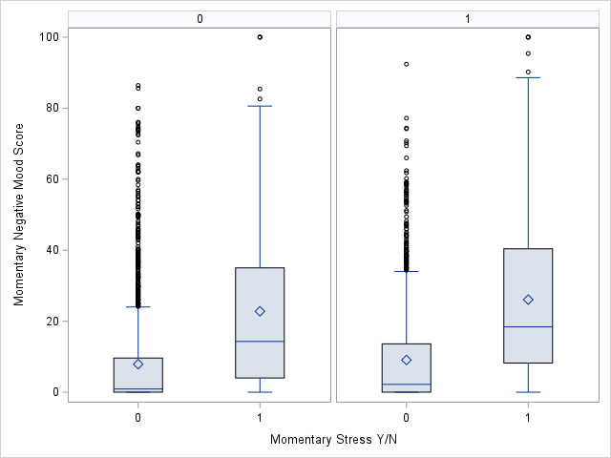

*P<0.001*

*P<0.001*

**MEN**

**WOMEN**

**Supplementary Figure 1. Difference in negative mood score between moments with perceived stress and moments with no perceived stress by sex. Momentary stress is related to momentary negative mood in both men and women.**