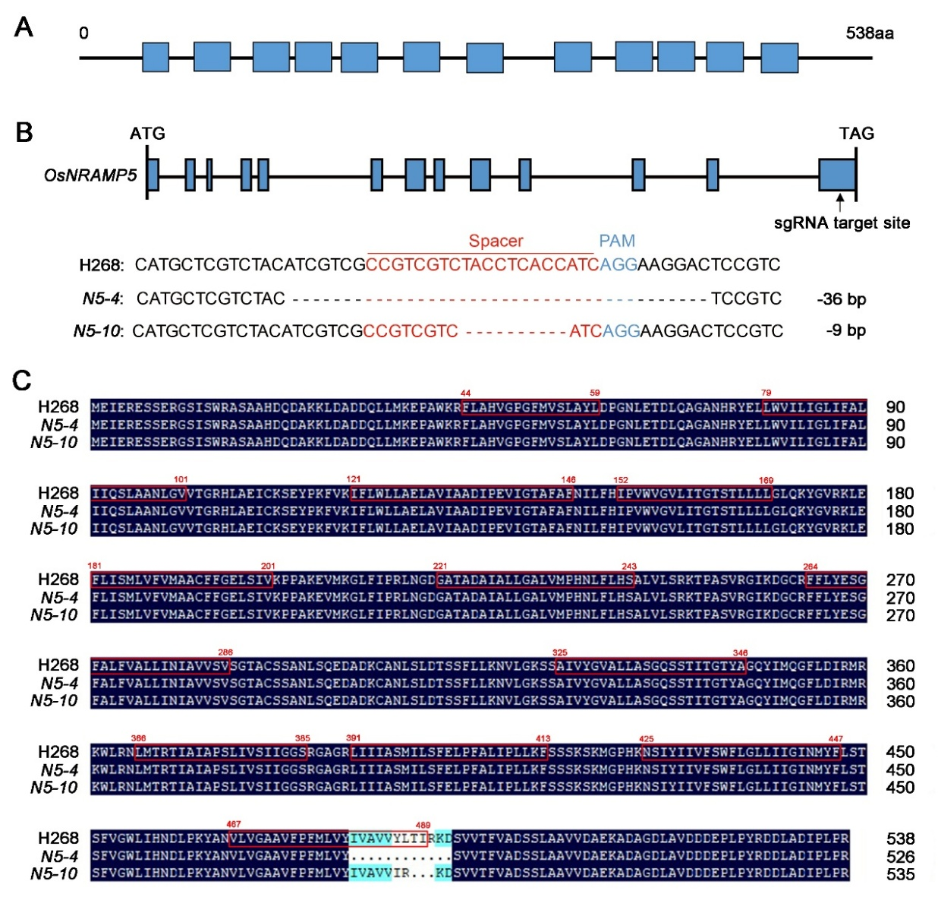
Fig. S1 CRISPR/Cas9-mediated mutagenesis of OsNRAMP5 in H268. A OsNRAMP5 protein structure pattern, where the blue boxes refer to the transmembrane domains. B Diagram of the OsNRAMP5 locus and CRISPR/Cas9 target sites. Exons and introns are indicated with blue rectangles and black lines, respectively. The spacer and protospacer adjacent motif (PAM) sequences were marked in red and blue. Homozygous mutations identified at the target site of osnramp5 mutants in the T₁ generation. C Alignment of the amino acid sequence of OsNRAMP5 between H268 and osnramp5 mutant lines. The red box indicates the amino acids of the OsNRAMP5 transmembrane domain. The dark blue and light blue shading indicate 100% and ≥50% similarity, respectively.
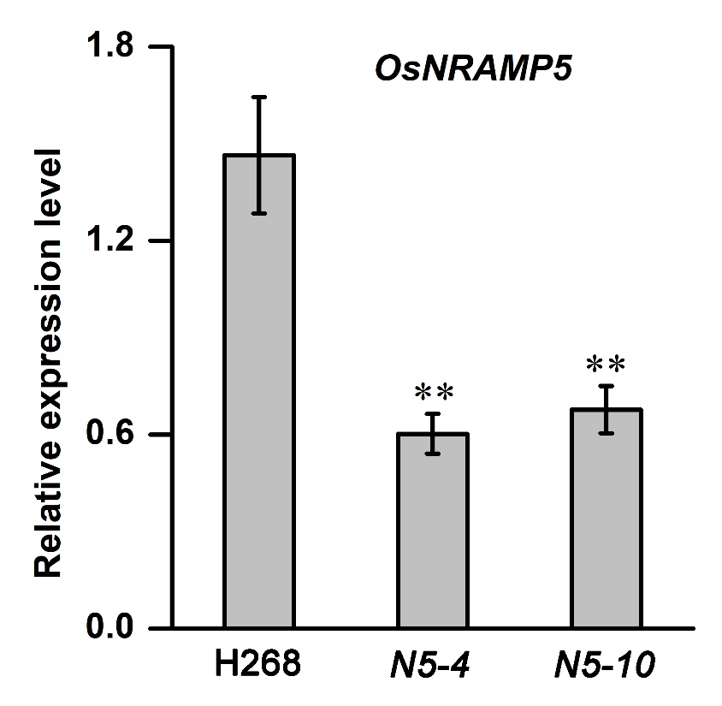
Fig. S2 Expression of OsNRAMP5 in H268 and osnramp5 mutants by RT-qPCR. Values and error bars represent the mean and standard deviation of three independent biological replicates. ** indicates a significant difference (P ≤ 0.01 from Student’s t-test).

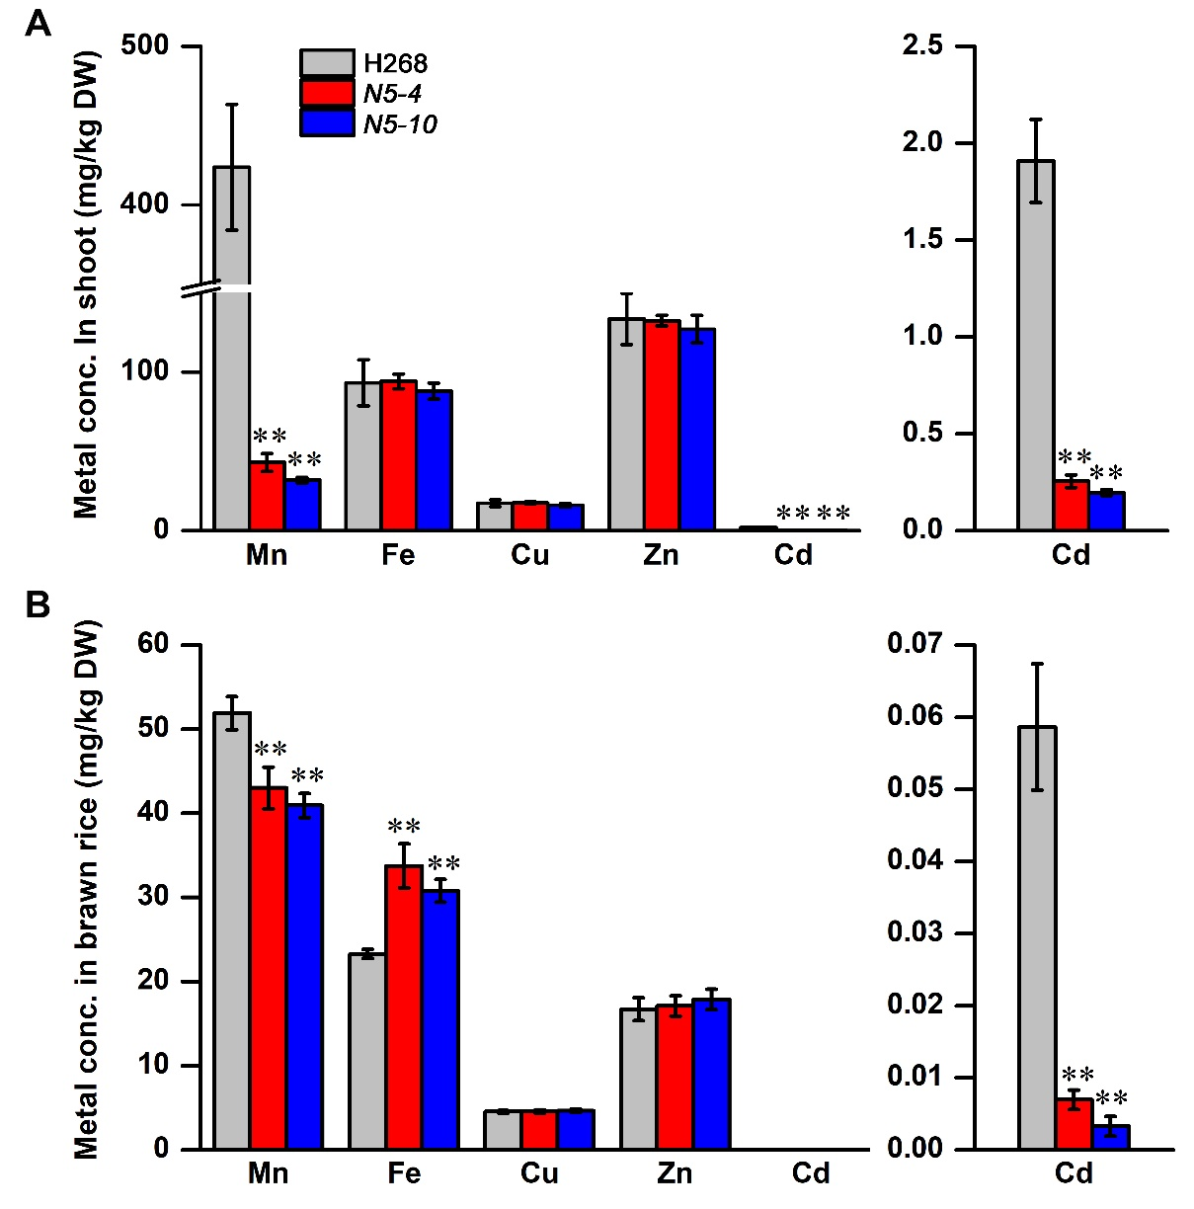
Fig. S3 Analysis of metal concentration in H268 and osnramp5 mutants. A Concentrations of metal in the shoot. H268 and the osnramp5 mutants were grown in soil to three-leaf-stage seedlings. The shoots were harvested and subjected to metal analysis by inductively coupled plasma-mass spectrometer. B Concentrations of metal in the brown rice. H268 and the osnramp5 mutants were grown in soil to maturation period. Values and error bars represent the mean and standard deviation of three independent biological replicates. ** indicates a significant difference (P ≤ 0.01 from Student’s t-test).

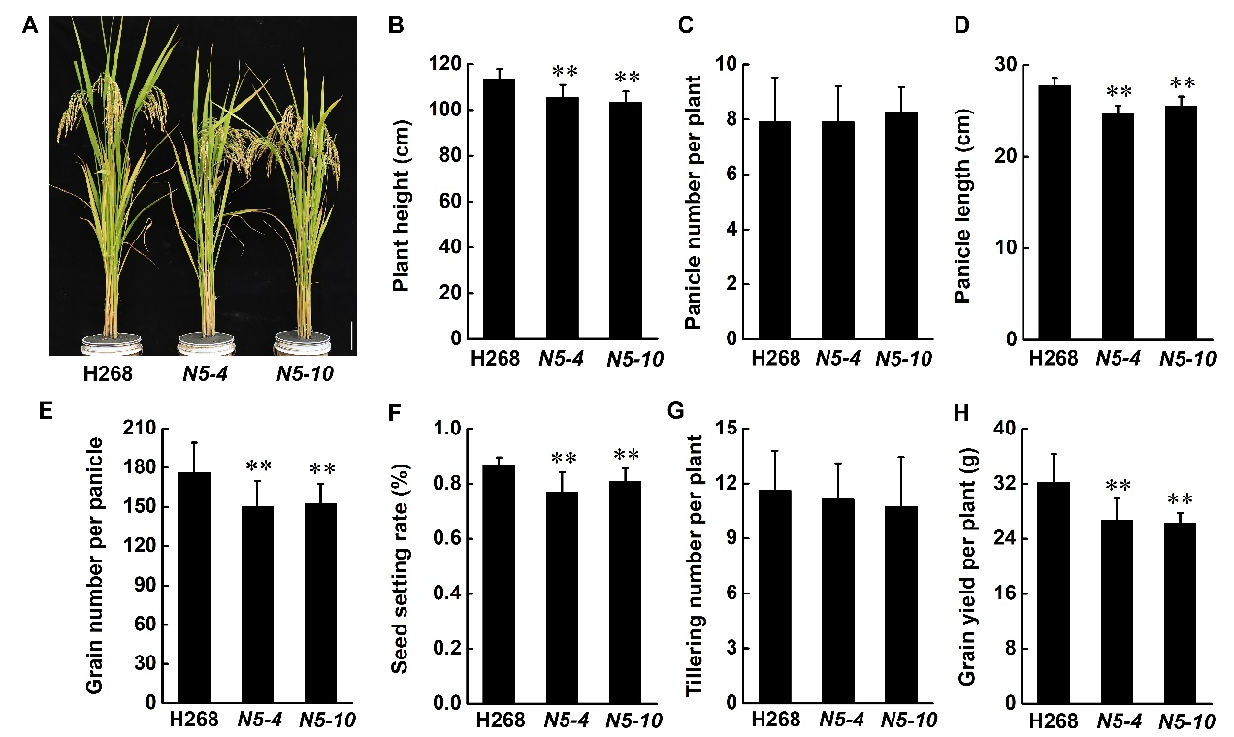
Fig. S4. Phenotypic assessment of H268 and osnramp5 mutants in the paddy field. A Phenotypes of H268 and the osnramp5 mutants at the heading stage. Scale bar = 10 cm. B-H the major traits including plant height (B), panicle number per plant (C), panicle length (D), grain number per panicle (E), seed setting rate (F), tillering number per plant (G) and grain yield per plant (H) were displayed in histograms. Agronomic traits were investigated in paddy filed located at Guanshan village (28°19’32’’N, 112°40’38’’E), Changsha, in 2023. Data are presented as mean ± SD (n = 20). ** indicates a significant difference (P ≤ 0.01 from Student’s t-test).

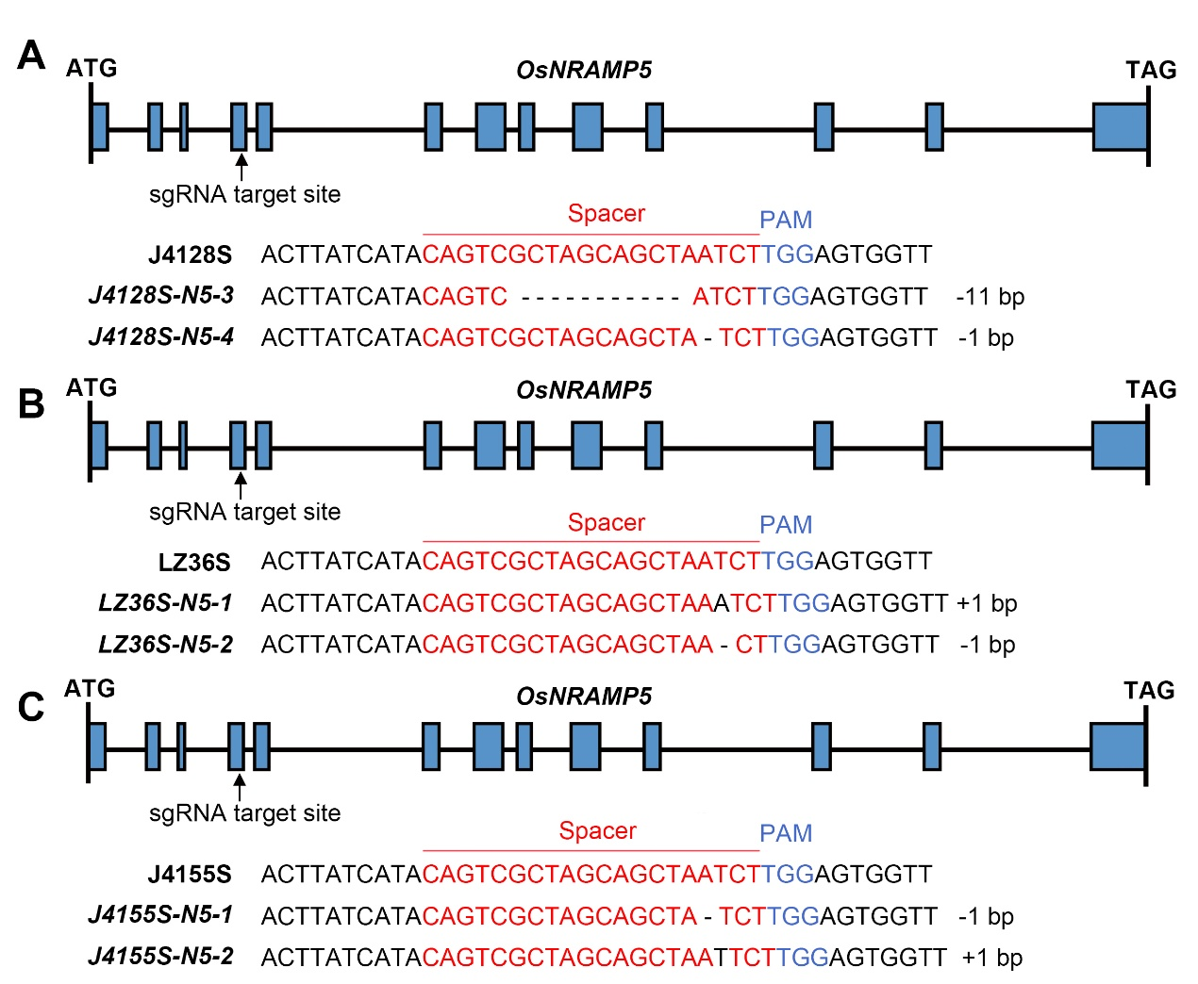
Fig. S5. CRISPR/Cas9-mediated mutagenesis of OsNRAMP5 in three TGMS lines. A-C Homozygous mutations identified at the target sites of OsNRAMP5 in J4128S (A), LZ36S (B) and J4155S (C) in the T₁ generation. The diagrams show the OsNRAMP5 locus and CRISPR/Cas9 target sites. Exons and introns are indicated with blue rectangles and black lines, respectively. The spacer and PAM sequences were marked in red and blue.

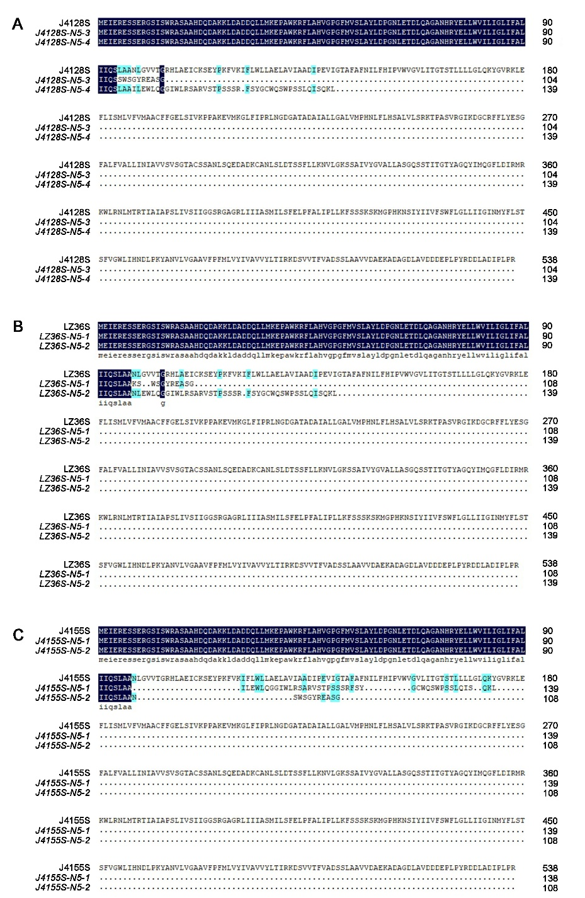
Fig. S6 Amino acid alignment of OsNRAMP5. A-C Alignment of the amino acid sequence of OsNRAMP5 between J4128S (A) or LZ36S (B) or J4155S (C) and their osnramp5 mutants, respectively. The dark blue and light blue shading indicate 100% and ≥50% similarity, respectively.
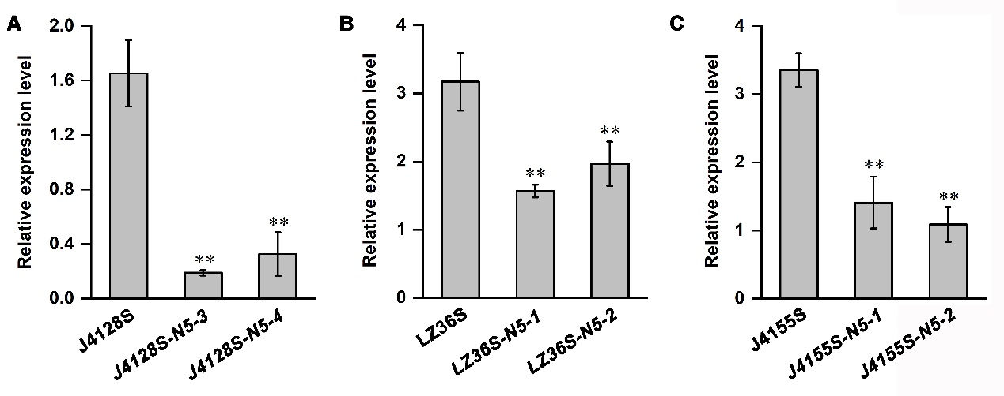
Fig. S7 Expression of OsNRAMP5 in osnramp5 mutants by RT-qPCR. A-C Relative expression of OsNRAMP5 in J4128S (A) or LZ36S (B) or J4155S (C) and their osnramp5 mutants by RT-qPCR. Data are presented as mean ± SD (n=3, *P ≤ 0.05, **P ≤ 0.01, Student’s t-test).

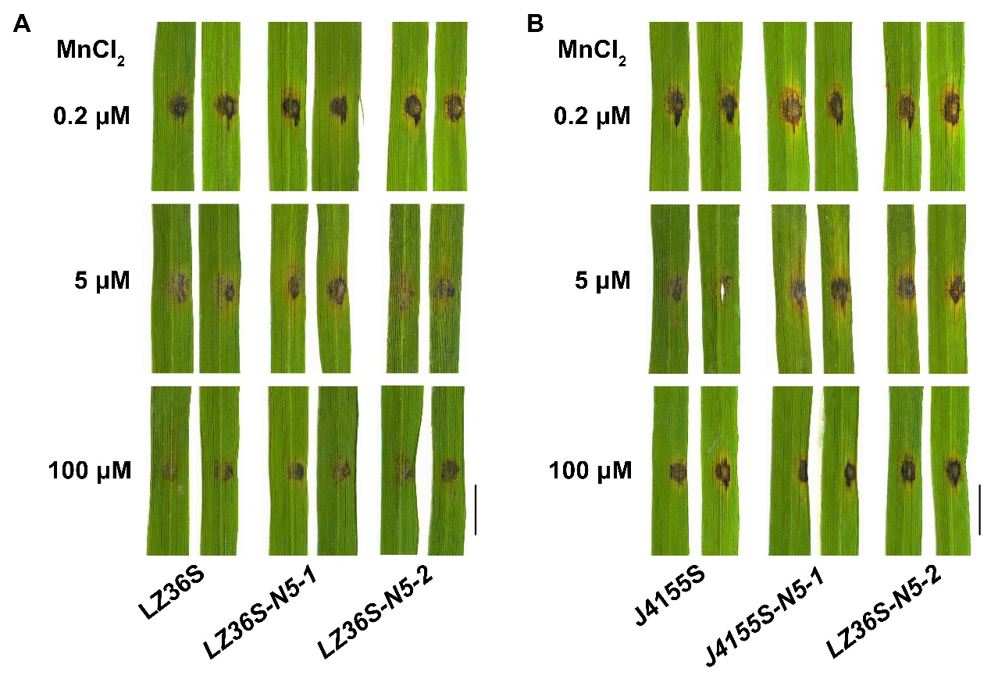
Fig. S8. Evaluation of rice blast resistance in osnramp5 mutants carrying major blast resistance gene under various Mn concentrations. Plants were grown in hydroponic cultures treated with different Mn concentrations (0.2, 5 and 100 μM) for three weeks and then the leaves were punch-inoculated with the M. oryzae strain 110-2. Disease symptoms at 10 dpi are shown. Scale bar = 5 mm.

