Supporting Information
In Situ Ozone Generated on the Surface of Water Microdroplets Mediates Selective Aromatic Oxidation
Lian Xue,^{1, #} Boyu Zhu,^{1, #} Peng Zheng,¹ Kaiyu Geng,^{1, *}Jiao Geng,^{1, *} Xingbang Hu,^{1, *}
¹ State Key Laboratory of Coordination Chemistry, School of Chemistry and Chemical Engineering, Nanjing University, Nanjing 210093, PR China
*Corresponding author E-mail: kaiy.geng@gmail.com; gengjiao@nju.edu.cn; huxb@nju.edu.cn
#Lian Xue and Boyu Zhu share the first authorship.

List of Contents
- Chemicals
- General procedures
- Measure the size of microdroplets
- Product detection
- O₃ Detection Method
- Radical Detection
- Calculation methods
- Figure S1. (a) Liquid mixtures used for microdroplets reaction and (b) Ultrasonic atomization device for synthesizing dimethyl phthalate microdroplets.
- Figure S2. ¹³C NMR spectrum of naphthalene.
- Figure S3. ¹³C NMR spectrum of dimethyl phthalate.
- Figure S4. ¹³C NMR spectra of naphthalene oxidation to dimethyl phthalate in cyclic microdroplets reaction.
- Figure S5. ¹H NMR spectrum of naphthalene.
- Figure S6. ¹H NMR spectrum of dimethyl phthalate.
- Figure S7. ¹H NMR spectra of naphthalene oxidation to dimethyl phthalate in cyclic microdroplets reaction.
- Figure S8. (a) Gas chromatogram and (b) mass spectrum of spontaneous oxidation of naphthalene droplets in an inverted device.
- Figure S9. UV visible absorption spectra of (a) IDS-O₃, (b) IDS-O₂ and (c) IDS-H₂O₂ at different reaction times. Δh represents the absorbance change at 610 nm, defined as Δh=A_{t}-A_{0,} t (t =0.1, 0.25 h, 0.5 h, 0.75 h, 1 h, 1.25 h, 4 h, 8 h, 10 h), A₀ is the absorbance at 0 h.
- Figure S10. High resolution mass spectrometry of IDS before and after oxidation reaction in microdroplets.
- Figure S11. Ultrasonic + non spray, non ultrasonic + spray and ultrasonic + spray were used for the microdroplets reaction of naphthalene oxidation to dimethyl phthalate in air atmosphere.
- Figure S12. High resolution mass spectrometry of DMPO capturing ·CH₃ before and after microdroplet reaction.
- Figure S13. EPR spectrum of pure CH₃OH-DMPO.
- Figure S14. The calibration curves of dimethyl phthalate with 5 concentrations (2 mM, 4 mM, 6 mM, 8 mM, and 10 mM) using a gas chromatography.
- Figure S15. The optimized structures of transition states
- Figure S16. The optimized structures without microdroplets.
- Figure S17. The optimized structures in microdroplets.
- Figure S18. Total Energy along IRC path: TS7 and TS8 without microdroplets (a) and (b); in microdroplets (c) and (d).
- Table S1 A series of microdroplet reactions of naphthalene oxidation carried out under different conditions.
- References
1. Chemicals
Naphthalene (NA) and methanol (CH₃OH, AR) were obtained from Nanjing Juyou Scientific Equipment Co., Ltd., dimethyl phthalate (DP), phosphpric acid (H₃PO₄) and ethyl acetate (EA) were purchased from Nanjing Shoude Biotechnology Co., Ltd., 5-dimethyl-1-pyrroline N-oxide (97%, DMPO) was purchased from Meili (Shanghai) Chemical Technology Co., Ltd., and indigo disulfonate sodium (IDS) was purchased from Nanjing Wanqing Glass Instrument Co., Ltd. Disodium hydrogen phosphate (Na₂HPO₄) was purchased from Shanghai Bide Pharmaceutical Technology Co., Ltd. Deionized water is provided by Milli-Q from Nanjing University. All chemicals are used as is without further purification.
2. General procedures
Droplets are generated by atomizers (ultrasonic power). Firstly, dissolve naphthalene in a 1:5.5 methanol water mixed solution to form a homogeneous solution. Then, inject the solution into the reactor equipped with an atomizer, ensuring that the atomizer is completely submerged in the solution. At room temperature and in an air atmosphere, droplets are sprayed from bottom to top and then fall back to the surface of the solution under the action of gravity, forming a cycle. This process lasts for 4 hours to prepare dimethyl phthalate.
To comprehensively explore the factors influencing the reaction, a series of microdroplet experiments were conducted under different conditions. To assess the roles of O₂ and H₂O₂, reactions were performed using N₂, O₂, and H₂O₂ as comparative systems, with the N₂ + H₂O₂ setup specifically designed to eliminate the possible interference of O₃, which could form from O₂ via microdroplet reactions in an air atmosphere. Additionally, the impact of temperature was examined by varying it across 30 ℃, 40 ℃, 50 ℃, and 60 ℃. The effect of atomization power was evaluated by adjusting it to 10W, 20W, and 30W. Furthermore, to determine the influence of ultrasound, three different conditions were compared: ultrasound + non-spray, non-ultrasound + spray, and ultrasound + spray. To enhance the reliability of the results, all experiments were conducted in triplicate.
3. Measure the size of microdroplets
We used a high-speed camera equipped with a high-magnification lens (Phato, USA) to capture the microdroplets (Figure 1a). Since the high-speed camera could not clearly capture the microdroplets in a single frame, we attempted to observe and measure them using a microscope. Specifically, the microdroplets floating in the air were encapsulated in an immiscible oil phase, and the system was then observed under the microscope (Figure 1b).
4. Product detection
Product analysis was performed using a Shimadzu GC-MS-QP2202NX. The concentration of DP was determined using a Shimadzu GC-2014C gas chromatograph. NMR spectra were recorded using a Bruker DPX 400 MHz spectrometer with DMSO-d6 as the solvent. The structures of NA and DP were determined by ¹H and ¹³C NMR. Isopropanol was used as the internal standard, and the yield of DP was calculated based on ¹H NMR (Figure S7).
5. O₃ Detection Method
Ozone (O₃) reacts rapidly with indigo disulfonate sodium (IDS), causing decolorization under acidic conditions. The absorbance change at 610 nm is linearly correlated with O₃ concentration, making it suitable for rapid detection. In contrast, hydrogen peroxide (H₂O₂) can also induce IDS decolorization, but at a much slower rate. If measurements are conducted within 6h of reagent addition, H₂O₂ interference can be neglected¹.
In this experiment, IDS was first added in a phosphoric acid-disodium hydrogen phosphate (H₃PO₄-Na₂HPO₄)solution. The prepared solution was then introduced into the reaction chamber and subjected to ultrasonic nebulization for approximately 1h in a recirculating spray system. Subsequently, UV-Vis spectroscopy (Shimadzu UV-2600i) and electrospray ionization mass spectrometry (ESI-MS, Thermo Fisher) were performed, with all analyses completed within 2h. UV-Vis spectroscopy showed a significant decrease in absorbance at 610 nm, accompanied by a color change from blue to colorless, confirming the in-situ generation of O₃ in microdroplets. Additionally, ESI-MS detected a characteristic oxidation product of IDS by O₃ at m/z = 226.0 (Figure 4c), further providing direct evidence of O₃ presence.

6. Radical Detection
The methyl radical (•CH₃) was trapped by DMPO and detected using a Bruker A300 electron spin resonance (EPR) spectrometer and Thermo Fisher electrospray ionization mass spectrometry (ESI-MS).
7. Calculation methods
The Density Function Theory (DFT) calculations were conducted using the Gaussian16 and Gaussian09 software package employing the B3LYP hybrid functional for electron exchange and correlation with Empirical Dispersion = GD3BJ keyword, and utilizing the 6-311+G(d, p) basis set for all atoms [abbr: B3LYP/6-311+G(d, p)]. The impact of an oriented external electric field (OEEF) was initially investigated in Gaussian 16, defining the EEF axis, direction, and magnitude with the “Field = M ± N” keyword. Energy calculations and Zero-point energy (ZPE) correction have been done by using the same level of theory².

Figure S1. (a) Liquid mixtures used for microdroplets reaction and (b) Ultrasonic atomization device for synthesizing dimethyl phthalate microdroplets.

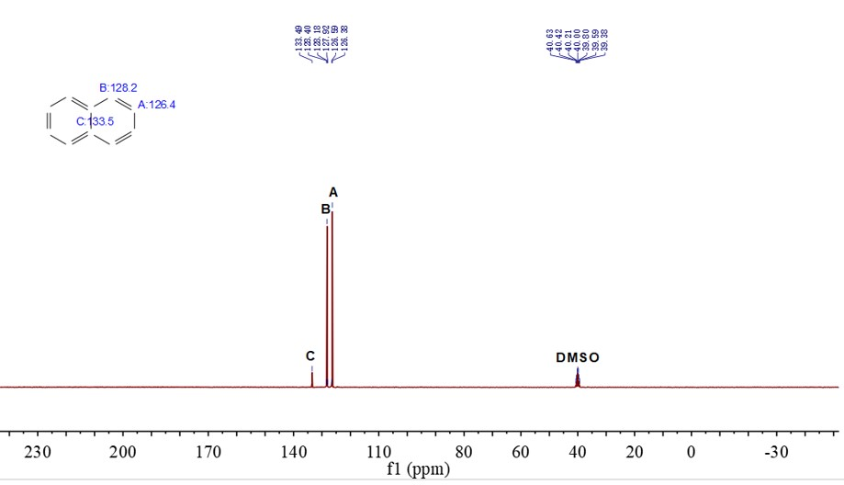
Figure S2. ¹³C NMR spectrum of naphthalene.

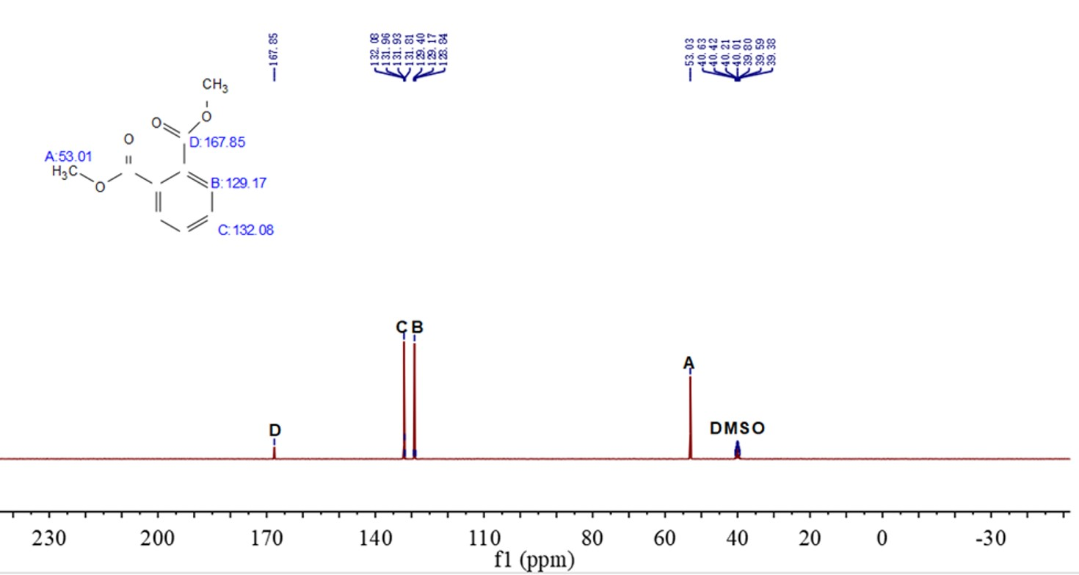
Figure S3. ¹³C NMR spectrum of dimethyl phthalate.

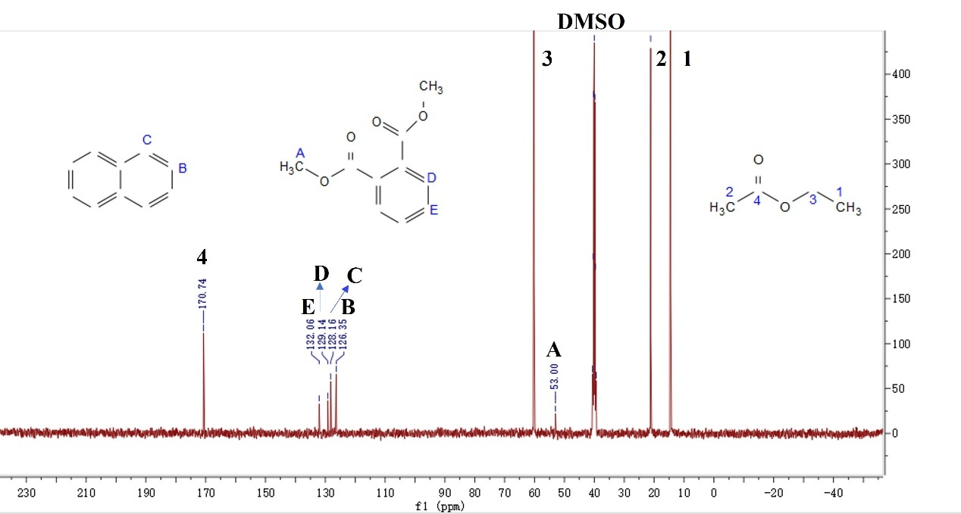
Figure S4. ¹³C NMR spectra of naphthalene oxidation to dimethyl phthalate in cyclic microdroplets reaction.

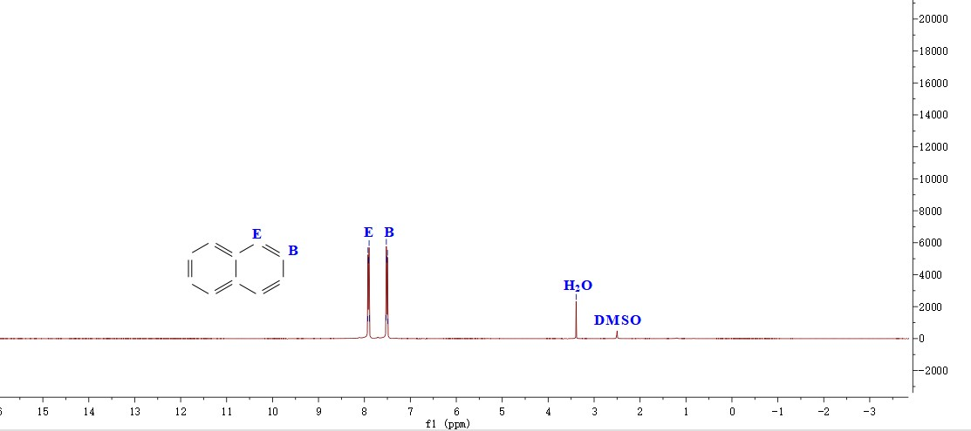
Figure S5. ¹H NMR spectrum of naphthalene.

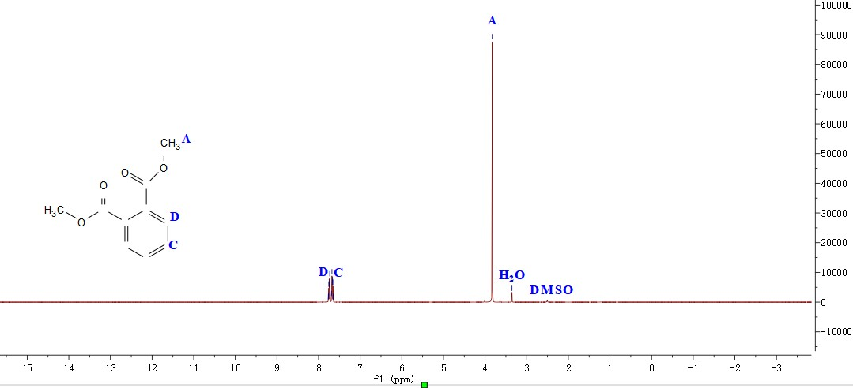
Figure S6. ¹H NMR spectrum of dimethyl phthalate.

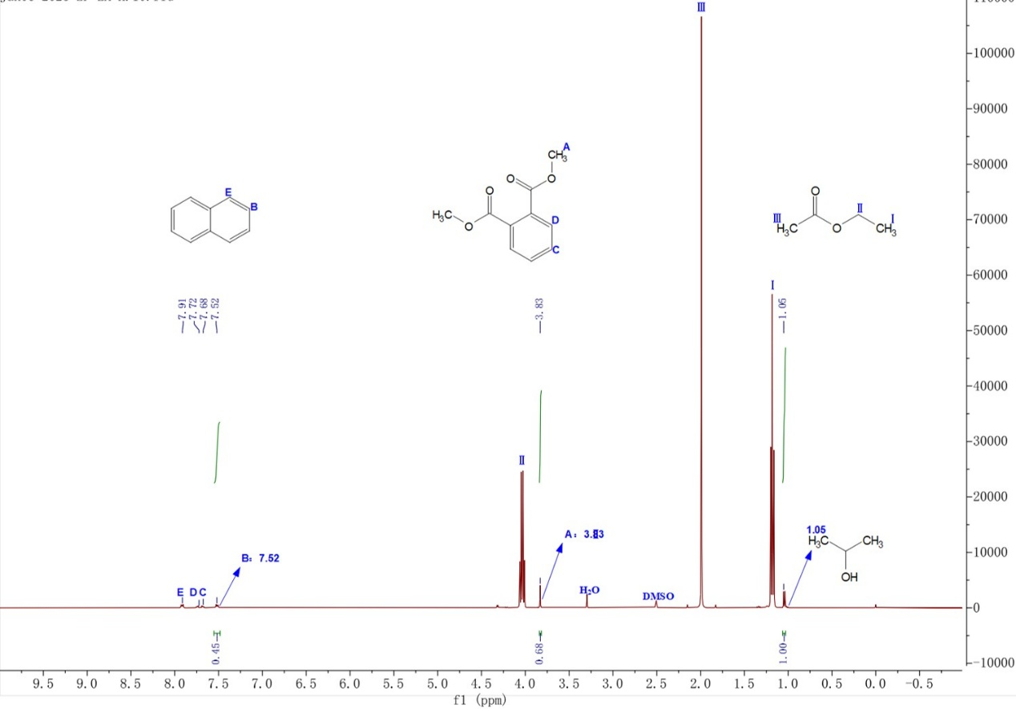
Figure S7. ¹H NMR spectra of naphthalene oxidation to dimethyl phthalate in cyclic microdroplets reaction.

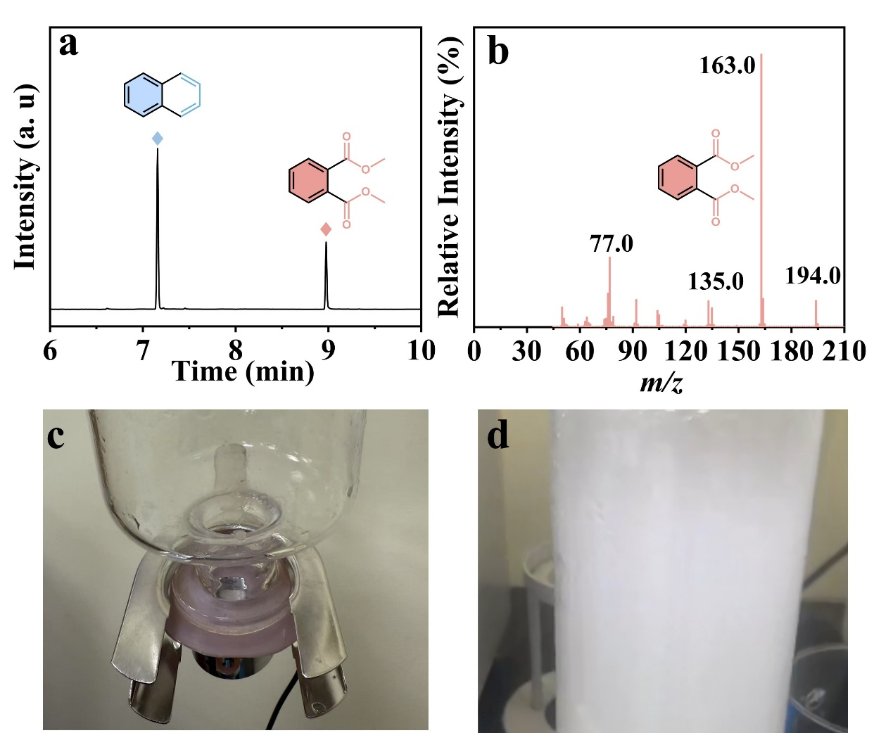Figure S8. (a) Gas chromatogram and (b) mass spectrum of spontaneous oxidation of naphthalene droplets produced in an inverted spray device (c) and (d).

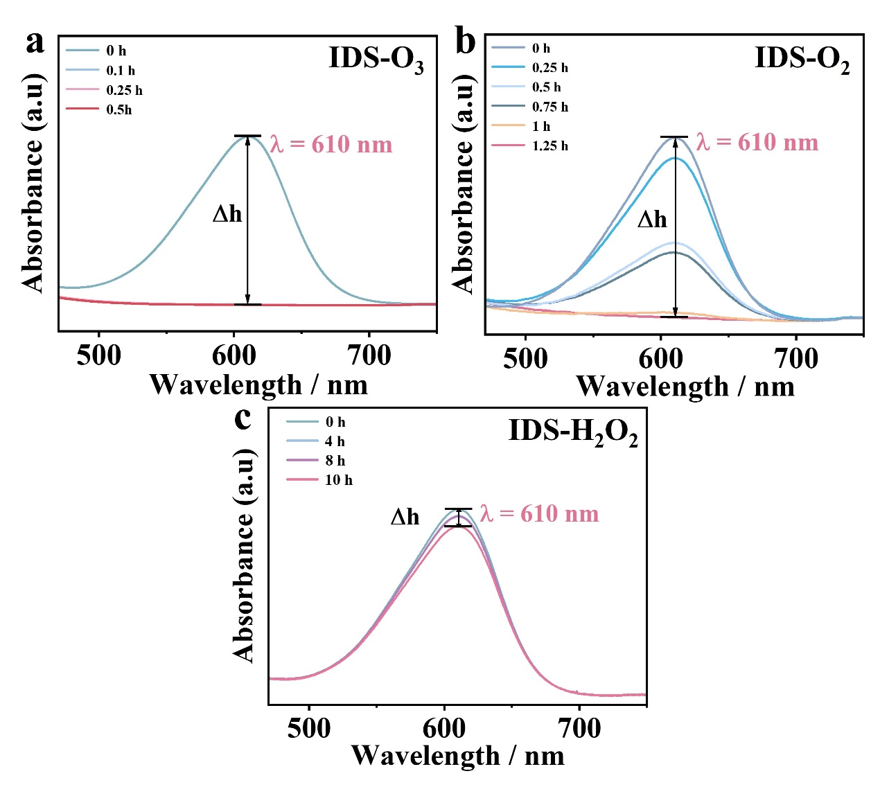
Figure S9. UV visible absorption spectra of (a) IDS-O₃, (b) IDS-O₂ and (c) IDS-H₂O₂ at different reaction times. Δh represents the absorbance change at 610 nm, defined as Δh=A_{t}-A_{0,} t (t =0.1, 0.25 h, 0.5 h, 0.75 h, 1 h, 1.25 h, 4 h, 8 h, 10 h), A₀ is the absorbance at 0 h.

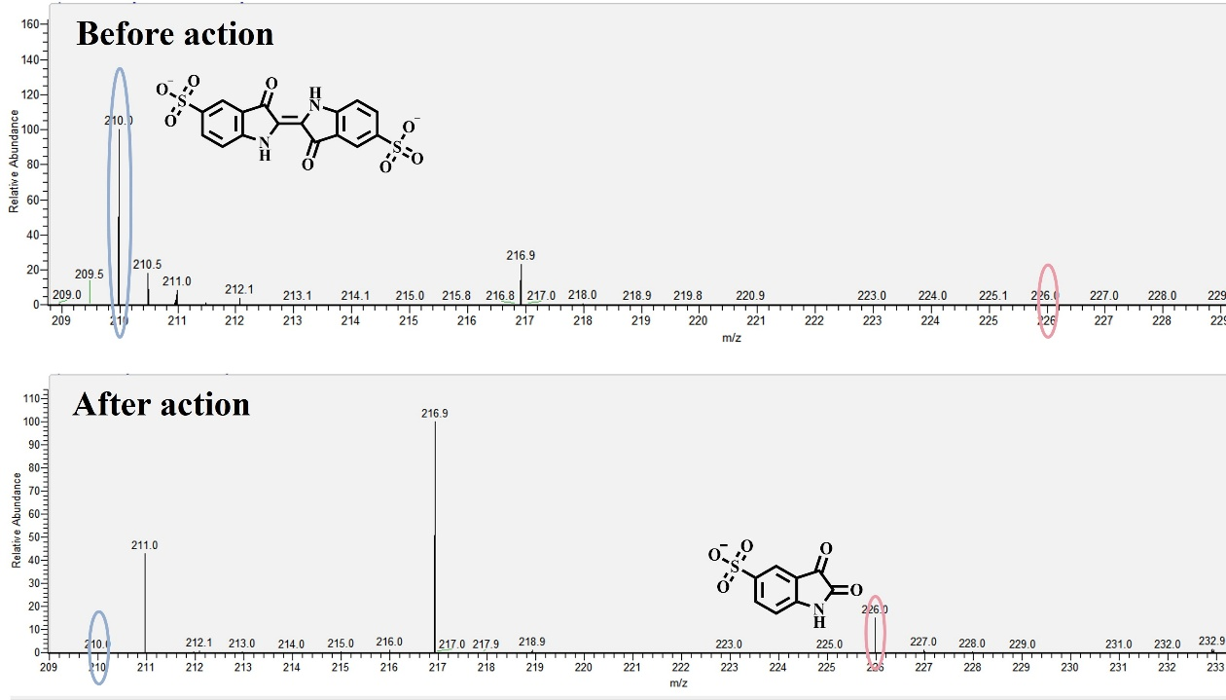
Figure S10. High resolution mass spectrometry of IDS before and after oxidation reaction in microdroplets.

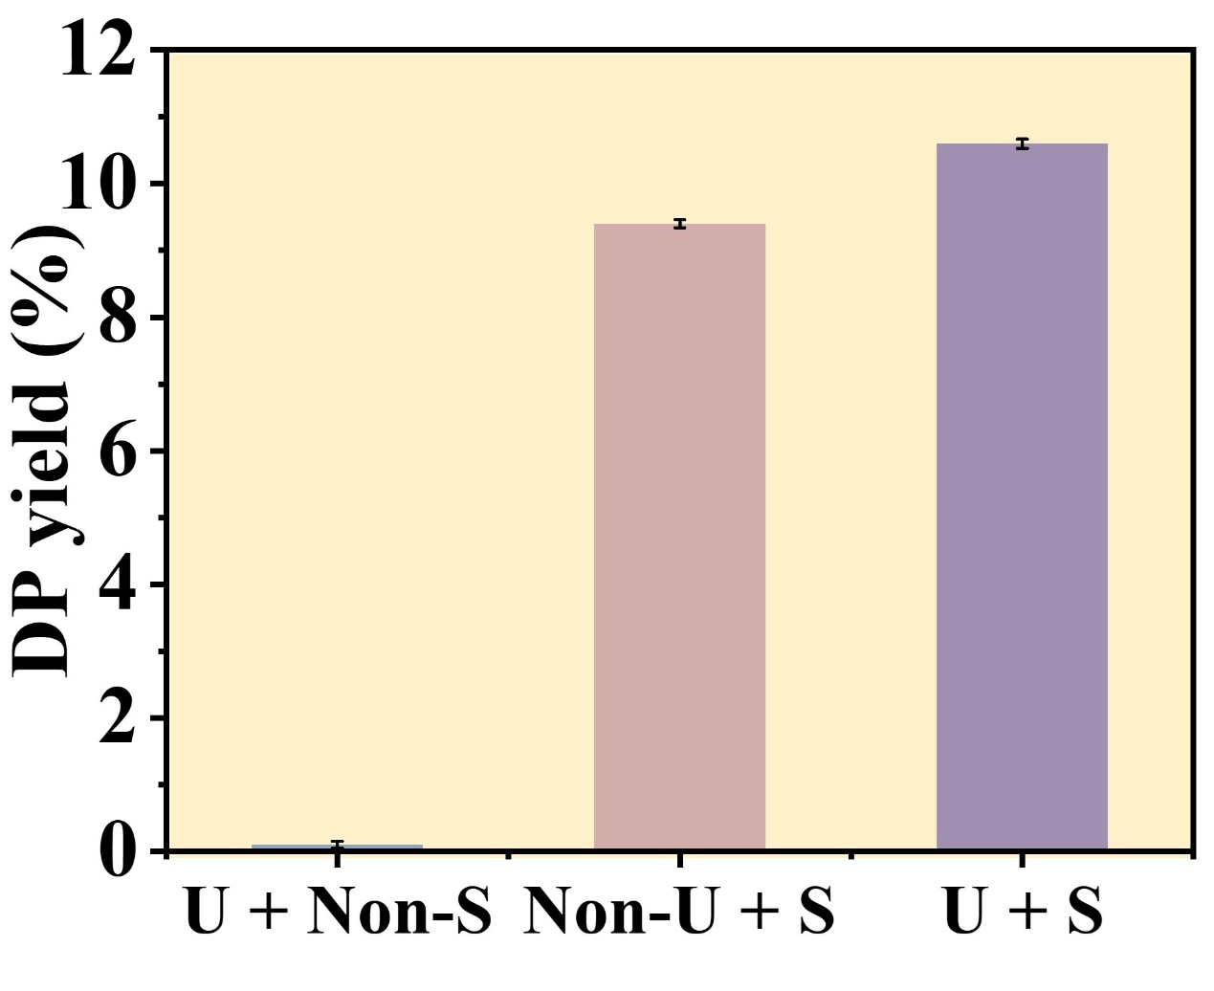
Figure S11. Ultrasonic + non spray, non ultrasonic + spray and ultrasonic + spray were used for the microdroplets reaction of naphthalene oxidation to dimethyl phthalate in air atmosphere.

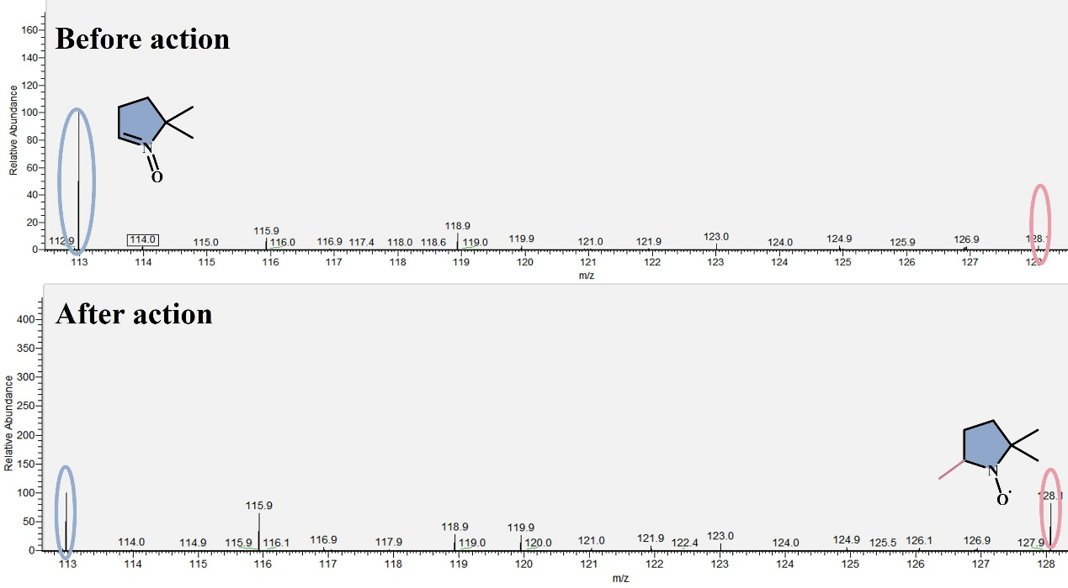
Figure S12. High resolution mass spectrometry of DMPO capturing ·CH₃ before and after microdroplet reaction.

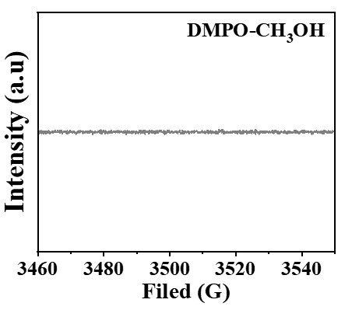
Figure S13. EPR spectrum of pure CH₃OH-DMPO.

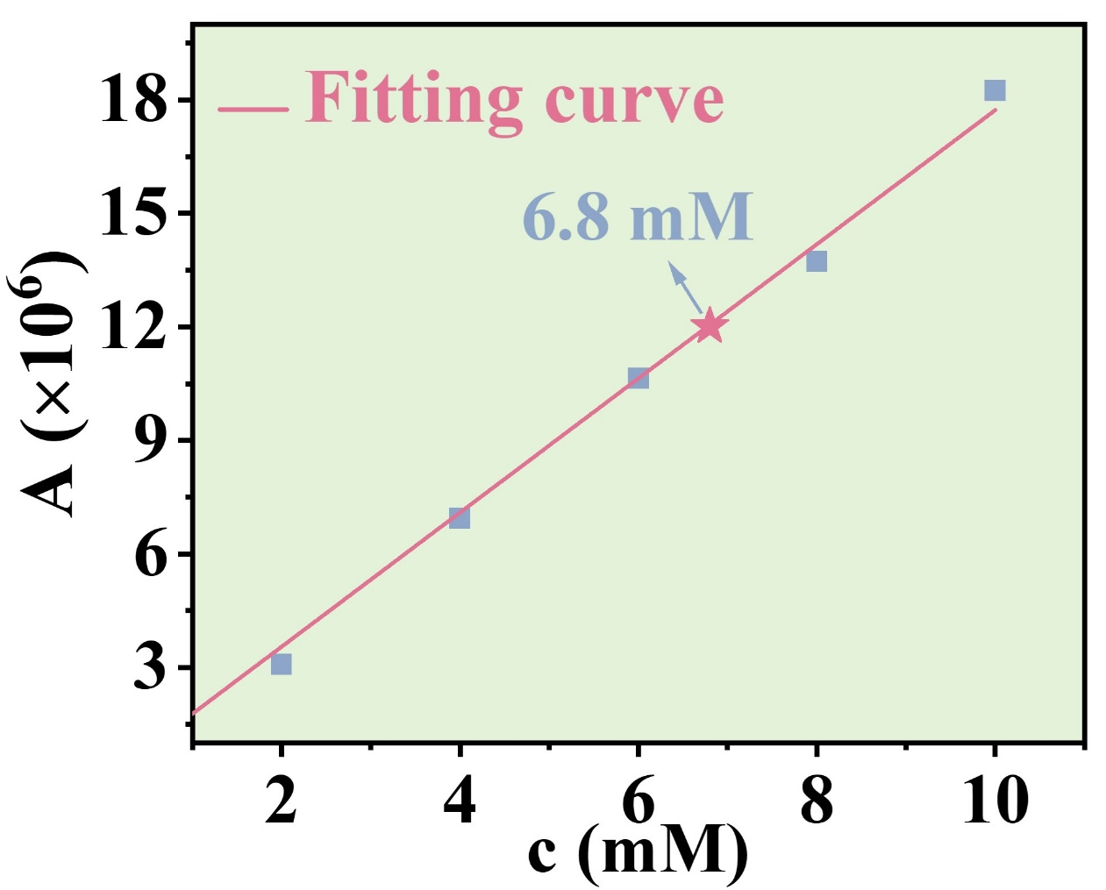
Figure S14. The calibration curves of dimethyl phthalate with 5 concentrations (2 mM, 4 mM, 6 mM, 8 mM, and 10 mM) using a gas chromatography.

Figure S15. The optimized structures of transition states

Figure S16. The optimized structures without microdroplets.

Figure S17. The optimized structures in microdroplets.

Figure S18. Total Energy along IRC path: TS7 and TS8 without microdroplets (a) and (b); in microdroplets (c) and (d).

Table S1. A series of microdroplet reactions of naphthalene oxidation carried out under different conditions.
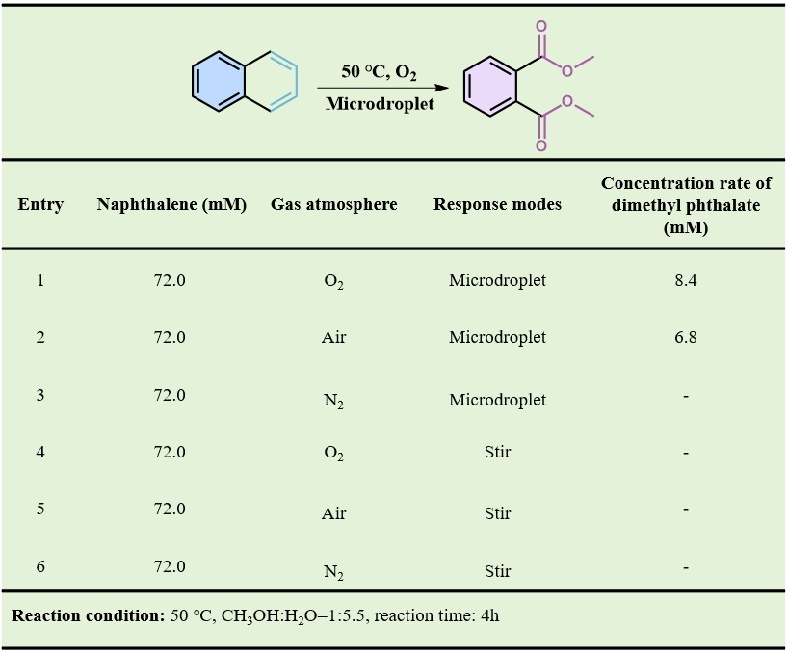

The coordinates of the optimized structures

Int1-N
C | 2.428023 | 0.707201 | 0.000117
C | 1.242005 | 1.400055 | 0.00003
C | 0.000002 | 0.71518 | -0.000021
C | -0.000002 | -0.715179 | 0.00002
C | 1.242006 | -1.400055 | 0.000112
C | 2.428022 | -0.707201 | 0.000158
H | -1.239362 | 2.48476 | -0.000143
H | 3.370321 | 1.24257 | 0.000155
H | 1.23936 | 2.484759 | -0.000002
C | -1.242008 | 1.400056 | -0.000112
C | -1.242006 | -1.400057 | -0.00003
H | 1.239362 | -2.484759 | 0.000143
H | 3.370321 | -1.24257 | 0.000227
C | -2.428021 | -0.707202 | -0.000116
C | -2.428021 | 0.707201 | -0.000159
H | -1.239355 | -2.48476 | 0.000002
H | -3.370323 | -1.242566 | -0.000153
H | -3.370322 | 1.242567 | -0.000228

O₃-N
O | 0 | 0.428312 | 0
O | 1.0793 | -0.214289 | 0
O | -1.0793 | -0.214024 | 0

Int2-N
C | -0.967247 | 1.99597 | 0.347252
C | 0.231663 | 1.968311 | -0.321472
C | 1.123404 | 0.870372 | -0.184993
C | 0.752169 | -0.218987 | 0.659255
C | -0.504495 | -0.173186 | 1.320142
C | -1.341145 | 0.919017 | 1.178691
H | 2.649875 | 1.651027 | -1.497964
H | -1.637088 | 2.839145 | 0.231625
H | 0.51743 | 2.792217 | -0.966513
C | 2.36952 | 0.823315 | -0.855634
C | 1.638091 | -1.31299 | 0.799644
H | -0.782227 | -0.99523 | 1.970014
H | -2.28208 | 0.955408 | 1.713351
C | 2.843738 | -1.330432 | 0.136196
C | 3.212339 | -0.253098 | -0.698565
H | 1.349556 | -2.14202 | 1.436487
H | 3.514543 | -2.17374 | 0.251024
H | 4.163306 | -0.278494 | -1.217654
O | -2.897435 | -1.28654 | -0.575652
O | -3.410428 | -0.128174 | -0.691901
O | -1.647328 | -1.382543 | -0.757881

TS1-N
C | -1.11404 | 1.924278 | 0.393146
C | 0.139925 | 2.010347 | -0.123523
C | 1.050116 | 0.897946 | -0.090696
C | 0.626903 | -0.324707 | 0.48913
C | -0.738358 | -0.453572 | 0.935286
C | -1.602283 | 0.686368 | 0.909105
H | 2.691084 | 1.938201 | -1.020304
H | -1.771268 | 2.784591 | 0.394706
H | 0.492211 | 2.945504 | -0.545253
C | 2.367159 | 1.004167 | -0.57467
C | 1.529115 | -1.397203 | 0.577825
H | -0.976569 | -1.269864 | 1.603634
H | -2.489231 | 0.684604 | 1.526074
C | 2.821528 | -1.270525 | 0.099625
C | 3.240446 | -0.064773 | -0.482757
H | 1.195935 | -2.331848 | 1.014598
H | 3.5101 | -2.103881 | 0.171319
H | 4.252363 | 0.029064 | -0.858833
O | -2.750087 | -1.185401 | -0.562671
O | -2.875956 | 0.115554 | -0.698295
O | -1.477419 | -1.523944 | -0.624131

In3-N
C | -1.192981 | 1.86349 | 0.219303
C | 0.098836 | 1.994173 | -0.094675
C | 1.049526 | 0.885464 | -0.052564
C | 0.61443 | -0.406775 | 0.286168
C | -0.840175 | -0.680273 | 0.541655
C | -1.788614 | 0.556006 | 0.630982
H | 2.747115 | 2.090217 | -0.582588
H | -1.864896 | 2.713136 | 0.185733
H | 0.486531 | 2.965289 | -0.384837
C | 2.407221 | 1.09381 | -0.322315
C | 1.529218 | -1.453696 | 0.356421
H | -0.97297 | -1.303506 | 1.430231
H | -2.22791 | 0.613277 | 1.632433
C | 2.877804 | -1.235971 | 0.08162
C | 3.315036 | 0.041954 | -0.26079
H | 1.182406 | -2.446344 | 0.621322
H | 3.581442 | -2.057809 | 0.136772
H | 4.362536 | 0.219161 | -0.474354
O | -2.768684 | -1.190523 | -0.445549
O | -2.838757 | 0.247683 | -0.318759
O | -1.357066 | -1.399974 | -0.595635

In4-N
C | 3.395286 | 1.207079 | -0.129212
C | 2.20138 | 1.547698 | 0.496882
C | 1.173486 | 0.608349 | 0.633304
C | 1.356509 | -0.688195 | 0.126466
C | 2.557672 | -1.024452 | -0.491835
C | 3.576736 | -0.083211 | -0.62363
H | 4.183339 | 1.944018 | -0.229106
H | 2.055708 | 2.549816 | 0.884581
H | 2.695167 | -2.02787 | -0.880095
H | 4.506662 | -0.356442 | -1.107658
C | 0.254238 | -1.712703 | 0.196877
H | 0.663382 | -2.691312 | 0.452698
C | -0.069833 | 0.955293 | 1.314733
H | -0.182658 | 1.97677 | 1.658457
C | -0.950756 | -1.370347 | 1.123155
H | -0.996793 | -2.047384 | 1.97999
C | -1.035985 | 0.059325 | 1.562377
H | -1.927445 | 0.335526 | 2.11098
O | -1.663407 | -1.287195 | -0.975454
O | -2.082792 | -1.744186 | 0.316618
O | -0.368591 | -1.91655 | -1.102827
O | -2.290153 | 1.583704 | -1.044324
O | -3.033126 | 1.447716 | -0.036293
O | -1.28065 | 2.331995 | -0.923288

TS2-N
C | 3.379796 | 0.835191 | -0.191962
C | 2.235859 | 1.394833 | 0.355969
C | 1.09148 | 0.612849 | 0.576796
C | 1.117628 | -0.752189 | 0.252423
C | 2.270844 | -1.306131 | -0.299536
C | 3.395504 | -0.519677 | -0.528388
H | 4.254767 | 1.449781 | -0.365986
H | 2.203862 | 2.451752 | 0.594082
H | 2.284041 | -2.359265 | -0.555546
H | 4.283848 | -0.962112 | -0.963136
C | -0.049194 | -1.661522 | 0.553812
H | 0.259079 | -2.418103 | 1.278906
C | -0.120935 | 1.227123 | 1.086919
H | -0.041207 | 2.211892 | 1.527219
C | -1.365827 | -0.969082 | 1.032245
H | -1.679179 | -1.387224 | 1.992293
C | -1.312786 | 0.532485 | 1.179371
H | -2.139581 | 0.970475 | 1.722283
O | -1.573593 | -1.645998 | -1.092778
O | -2.346951 | -1.449178 | 0.105116
O | -0.475288 | -2.426926 | -0.58604
O | -1.892891 | 2.368049 | -0.68932
O | -2.269097 | 1.129891 | -0.628833
O | -0.602162 | 2.484103 | -0.775145

Int5-N
C | -3.197961 | -1.389903 | -0.266744
C | -1.873037 | -1.789463 | -0.164139
C | -0.873858 | -0.868285 | 0.167349
C | -1.211596 | 0.465956 | 0.40606
C | -2.552164 | 0.855414 | 0.322124
C | -3.53928 | -0.060241 | -0.015682
H | -3.963199 | -2.109619 | -0.531127
H | -1.599207 | -2.822997 | -0.343664
H | -2.814441 | 1.891616 | 0.503219
H | -4.572386 | 0.259152 | -0.083239
C | -0.188047 | 1.538273 | 0.700172
H | -0.45377 | 2.106327 | 1.593168
C | 0.532336 | -1.358494 | 0.311619
H | 0.554221 | -2.340665 | 0.793824
C | 1.294163 | 1.073588 | 0.737762
H | 1.854833 | 1.660354 | 1.468045
C | 1.49566 | -0.418065 | 1.040769
H | 1.432725 | -0.582337 | 2.121915
O | -0.157112 | 2.509191 | -0.355236
O | 1.811179 | 1.460351 | -0.542488
O | 0.638793 | 1.815316 | -1.322356
O | 2.778847 | -0.832801 | 0.600484
O | 1.195261 | -1.471223 | -0.955869
O | 2.513524 | -1.775147 | -0.544271

TS3-N
C | -2.512395 | -2.202278 | -0.270621
C | -1.138808 | -2.206046 | -0.076363
C | -0.467172 | -1.033357 | 0.28327
C | -1.187515 | 0.148255 | 0.457425
C | -2.575175 | 0.145123 | 0.266858
C | -3.233452 | -1.021508 | -0.091869
H | -3.02085 | -3.114308 | -0.558696
H | -0.56985 | -3.117717 | -0.213968
H | -3.132969 | 1.065119 | 0.387616
H | -4.306949 | -1.009282 | -0.236458
C | -0.552059 | 1.43455 | 0.873704
H | -0.432383 | 1.635194 | 1.937853
C | 1.013533 | -1.102034 | 0.495894
H | 1.250902 | -1.795115 | 1.310986
C | 1.169102 | 1.498372 | 0.108759
H | 1.57233 | 2.404842 | 0.594539
C | 1.756493 | 0.216937 | 0.759434
H | 1.867151 | 0.391811 | 1.835206
O | -0.963603 | 2.556996 | 0.260128
O | 0.923708 | 1.541555 | -1.128873
O | -1.059954 | 2.383272 | -1.046685
O | 3.048077 | 0.009017 | 0.193367
O | 1.669715 | -1.57463 | -0.686548
O | 3.024219 | -1.382287 | -0.328393

Int6-N
C | -0.768631 | 2.679207 | -0.329953
C | 0.211341 | 1.708776 | -0.538281
C | -0.110611 | 0.357658 | -0.522984
C | -1.456935 | -0.039219 | -0.265905
C | -2.433796 | 0.960922 | -0.050525
C | -2.085597 | 2.303687 | -0.089635
H | -0.49308 | 3.7268 | -0.351398
H | 1.235506 | 2.00323 | -0.721208
H | -3.444123 | 0.64135 | 0.147575
H | -2.847066 | 3.055949 | 0.075513
C | -1.773034 | -1.437333 | -0.217809
H | -1.023188 | -2.186832 | -0.436774
C | 1.006963 | -0.641461 | -0.710969
H | 0.664395 | -1.594403 | -1.111802
C | 1.432196 | -0.150125 | 1.814536
H | 0.441902 | -0.476303 | 2.194055
C | 1.883835 | -0.924768 | 0.583792
H | 1.841894 | -1.997977 | 0.813149
O | -2.874468 | -2.020939 | 0.063277
O | 2.064668 | 0.714551 | 2.351586
O | -3.997614 | -1.32147 | 0.387908
O | 3.18736 | -0.533291 | 0.203154
O | 1.966488 | -0.090756 | -1.611928
O | 3.177238 | -0.75758 | -1.224338

TS4-N
C | -0.710763 | 2.913953 | -0.265823
C | 0.221658 | 1.919606 | -0.524535
C | -0.150951 | 0.570724 | -0.506116
C | -1.491603 | 0.223756 | -0.195484
C | -2.419767 | 1.249837 | 0.073725
C | -2.033761 | 2.577223 | 0.035966
H | -0.405353 | 3.952637 | -0.290038
H | 1.249969 | 2.179868 | -0.734345
H | -3.441293 | 0.981876 | 0.308851
H | -2.758934 | 3.354223 | 0.243918
C | -1.905824 | -1.152716 | -0.139809
H | -1.270565 | -2.001257 | -0.372927
C | 0.867712 | -0.466032 | -0.752219
H | 0.557879 | -1.43662 | -1.124678
C | 1.711916 | 0.117316 | 1.709083
H | 0.858773 | 0.140175 | 2.422441
C | 1.721247 | -1.11036 | 0.801051
H | 0.970757 | -1.870393 | 1.081639
O | -3.093429 | -1.442059 | 0.204724
O | 2.528954 | 0.993383 | 1.666366
O | -3.451034 | -2.756142 | 0.240786
O | 2.855587 | -1.533588 | 0.372163
O | 1.987813 | -0.023624 | -1.361629
O | 2.844559 | -1.033012 | -1.491148

Int7-N
C | 0.694644 | 2.401682 | -0.006475
C | 1.402008 | 1.202156 | -0.005082
C | 0.723333 | -0.02917 | 0.011835
C | -0.723333 | -0.029176 | -0.011823
C | -1.402018 | 1.202144 | 0.005088
C | -0.694665 | 2.401676 | 0.006481
H | 1.241306 | 3.337 | -0.010558
H | 2.479934 | 1.18374 | -0.004032
H | -2.479944 | 1.18372 | 0.004033
H | -1.241335 | 3.33699 | 0.010563
C | -1.430349 | -1.269508 | -0.141574
H | -0.910317 | -2.19681 | -0.343249
C | 1.430359 | -1.269496 | 0.141602
H | 0.910337 | -2.196794 | 0.343314
O | -2.688024 | -1.501288 | -0.10089
O | -3.597352 | -0.518076 | 0.127001
O | 2.688034 | -1.501274 | 0.100892
O | 3.597359 | -0.518072 | -0.127051

Int8-N
C | -0.920223 | 2.427276 | 0.06138
C | -1.599414 | 1.210832 | 0.021487
C | -0.896443 | 0.002812 | 0.153509
C | 0.526294 | 0.045461 | 0.367528
C | 1.183803 | 1.286884 | 0.372356
C | 0.458043 | 2.466387 | 0.232408
H | -1.480004 | 3.347427 | -0.054873
H | -2.665989 | 1.165343 | -0.128589
H | 2.253302 | 1.304034 | 0.512
H | 0.979828 | 3.415125 | 0.255506
C | 1.218148 | -1.160813 | 0.734332
H | 0.682541 | -2.000856 | 1.16326
C | -1.520178 | -1.272474 | -0.047812
H | -0.926372 | -2.165709 | -0.198773
O | 2.463224 | -1.420064 | 0.680964
O | 3.336441 | -0.519465 | 0.112229
O | -2.762009 | -1.560793 | -0.142253
O | -3.725322 | -0.614276 | -0.012423
O | 1.676609 | -0.231423 | -2.054085
H | 2.544969 | -0.335376 | -1.595115

TS5-N
C | 0.790198 | 2.985294 | -0.000005
C | -0.362073 | 2.222867 | -0.000002
C | -0.28911 | 0.814908 | 0.000001
C | 0.983312 | 0.17436 | 0.000001
C | 2.139899 | 0.978181 | -0.000003
C | 2.043697 | 2.35777 | -0.000006
H | -1.335614 | 2.695323 | -0.000003
H | 3.109564 | 0.499164 | -0.000003
H | 2.946735 | 2.955909 | -0.000008
H | 0.722317 | 4.066062 | -0.000008
C | 1.102098 | -1.262878 | 0.000004
H | 0.2745 | -1.966679 | 0.000005
C | -1.49106 | 0.029319 | 0.000004
H | -1.621712 | -1.258744 | -0.000007
O | 2.272585 | -1.76322 | 0.000005
O | -2.626238 | 0.570456 | 0.000014
O | -2.086791 | -2.35821 | -0.000026
H | -3.047402 | -2.199396 | -0.000019
O | -3.786007 | -0.163714 | 0.000009
O | 2.407681 | -3.109133 | 0.000008

Int9-N
C | 0.071126 | 2.649639 | -0.000462
C | 1.040221 | 1.655403 | -0.001533
C | 0.662779 | 0.304968 | -0.001333
C | -0.722766 | -0.051332 | -0.000756
C | -1.684205 | 0.978257 | 0.000561
C | -1.281872 | 2.309002 | 0.00064
H | 2.092529 | 1.908543 | -0.002498
H | -2.725498 | 0.699101 | 0.001397
H | -2.034289 | 3.088185 | 0.001369
H | 0.371924 | 3.69043 | -0.000505
C | -1.048565 | -1.449214 | -0.001689
H | -0.254537 | -2.188626 | -0.00386
C | 1.663063 | -0.732718 | -0.00339
O | -2.194096 | -2.008991 | -0.000554
O | 2.876135 | -0.505327 | 0.006211
O | 3.955179 | -1.350719 | -0.001266
O | -3.34332 | -1.282673 | 0.002093

Int10-N
C | -0.509167 | -2.907037 | 0.002039
C | 0.541876 | -1.997473 | 0.000909
C | 0.279987 | -0.613339 | -0.002179
C | -1.08054 | -0.172273 | -0.003083
C | -2.121248 | -1.111576 | -0.002545
C | -1.834075 | -2.470229 | 0.000306
H | -0.29054 | -3.967867 | 0.004123
H | 1.570869 | -2.319458 | 0.002185
H | -3.145958 | -0.763266 | -0.004259
H | -2.64522 | -3.188431 | 0.000999
C | -1.371367 | 1.240726 | -0.008044
C | 1.302543 | 0.392716 | -0.004517
H | 1.044441 | 1.446238 | -0.009101
O | -2.52148 | 1.688721 | 0.012354
O | -2.994637 | 2.972569 | -0.002573
O | 2.568287 | 0.242219 | -0.002386
O | 3.157719 | -0.983025 | 0.003571
O | 3.294211 | 2.628038 | 0.002522
H | 4.185555 | 2.23551 | 0.000831

TS6-N
C | 2.055597 | 2.349972 | 0.092585
C | 2.158223 | 0.968448 | 0.072358
C | 0.99857 | 0.174727 | 0.019329
C | -0.274925 | 0.799206 | -0.002997
C | -0.355331 | 2.20291 | 0.019022
C | 0.799138 | 2.966868 | 0.064506
H | 3.126135 | 0.48492 | 0.094983
H | -1.328871 | 2.674957 | 0.005272
H | 0.726606 | 4.047352 | 0.083063
H | 2.954117 | 2.953693 | 0.131961
C | -1.466879 | -0.013417 | -0.033991
H | -1.574741 | -1.295384 | 0.189677
C | 1.080924 | -1.267377 | 0.005117
O | -2.5847 | 0.525638 | -0.23445
O | 2.156279 | -1.85114 | -0.170725
O | -2.154503 | -2.310232 | 0.419332
H | -3.091244 | -2.065026 | 0.290233
O | 2.492442 | -3.16923 | -0.115055
O | -3.757506 | -0.181102 | -0.175448

Int11-N
C | 0.700044 | 2.686663 | -0.024944
C | 1.403903 | 1.493291 | 0.021868
C | 0.708132 | 0.272931 | 0.069387
C | -0.708113 | 0.272732 | 0.069084
C | -1.404174 | 1.492952 | 0.021047
C | -0.700607 | 2.686491 | -0.025419
H | 1.23893 | 3.625638 | -0.061948
H | 2.486213 | 1.486272 | 0.024799
H | -2.486485 | 1.485634 | 0.023362
H | -1.239706 | 3.625328 | -0.062812
C | -1.393863 | -0.99208 | 0.163005
C | 1.394016 | -0.991882 | 0.162955
O | -2.573801 | -1.114186 | -0.194624
O | -3.466869 | -2.120493 | 0.028236
O | 2.574116 | -1.113755 | -0.194125
O | 3.467182 | -2.120248 | 0.027351

Int12-N
C | 2.650899 | -0.695943 | 0.000507
C | 1.4456 | -1.393439 | 0.008683
C | 0.23241 | -0.703358 | 0.009255
C | 0.232371 | 0.703363 | -0.009269
C | 1.445523 | 1.393513 | -0.00869
C | 2.65086 | 0.696083 | -0.000502
H | 3.587002 | -1.240686 | 0.003129
H | 1.434834 | -2.475851 | 0.03367
H | 1.434696 | 2.475924 | -0.033668
H | 3.586933 | 1.240878 | -0.003113
C | -1.003284 | 1.514714 | -0.117441
C | -1.003213 | -1.514759 | 0.117424
O | -1.124303 | 2.639732 | 0.431675
O | -1.12414 | -2.639829 | -0.431612
O | -1.997662 | -1.20274 | 0.815559
O | -1.997702 | 1.202674 | -0.815599

Int13-N
C | 2.661111 | -1.44739 | 0.098154
C | 1.304563 | -1.745982 | 0.00287
C | 0.355936 | -0.72614 | -0.040357
C | 0.784754 | 0.613369 | -0.014383
C | 2.14873 | 0.907049 | 0.088452
C | 3.083574 | -0.120605 | 0.148746
H | 3.386962 | -2.250631 | 0.137217
H | 0.959852 | -2.771672 | -0.028644
H | 2.466718 | 1.942177 | 0.104298
H | 4.138188 | 0.1142 | 0.225886
C | -0.134441 | 1.765525 | -0.181948
C | -1.084206 | -1.126366 | -0.070339
O | -0.173063 | 2.722268 | 0.630027
O | -1.487063 | -2.172499 | -0.519043
O | -0.863692 | 1.926237 | -1.190706
O | -1.862978 | -0.19643 | 0.500327
C | -3.283515 | -0.428467 | 0.448097
H | -3.732178 | 0.429137 | 0.942257
H | -3.611669 | -0.492034 | -0.589621
H | -3.532535 | -1.353745 | 0.968016

TS7-N
C | -3.112049 | -0.000987 | 0.069268
C | -2.130204 | 0.979247 | -0.003862
C | -0.773395 | 0.640456 | -0.02684
C | -0.387791 | -0.728237 | -0.0208
C | -1.401769 | -1.707238 | 0.074018
C | -2.737518 | -1.347978 | 0.125731
H | -4.157337 | 0.279325 | 0.098266
H | -2.402411 | 2.027517 | -0.009689
H | -1.119747 | -2.752645 | 0.069175
H | -3.495606 | -2.118973 | 0.194402
C | 0.956037 | -1.196652 | -0.227648
C | 0.179258 | 1.754178 | 0.050383
O | 1.334455 | -2.404361 | 0.090792
O | -0.059567 | 2.897742 | -0.44074
O | 1.275449 | 1.735934 | 0.66406
O | 1.930821 | -0.573361 | -0.770433
C | 3.484614 | -0.129952 | 0.309554
H | 3.630045 | 0.868465 | -0.073543
H | 3.090489 | -0.21564 | 1.312673
H | 4.142219 | -0.912701 | -0.039534

Int14-N
C | 3.431241 | -0.244298 | 0.225617
C | 2.348001 | -1.110193 | 0.102658
C | 1.052409 | -0.612622 | -0.02376
C | 0.851244 | 0.779468 | -0.052223
C | 1.943142 | 1.644793 | 0.079977
C | 3.228578 | 1.13418 | 0.221882
H | 4.431948 | -0.646148 | 0.328987
H | 2.487216 | -2.183633 | 0.113219
H | 1.7757 | 2.71446 | 0.055008
H | 4.069 | 1.810341 | 0.320868
C | -0.467197 | 1.412054 | -0.300866
C | -0.061955 | -1.608662 | -0.077267
O | -0.964029 | 2.258646 | 0.482748
O | 0.071579 | -2.750704 | -0.44707
O | -1.13154 | 1.240521 | -1.351023
C | -4.291007 | 1.173016 | 0.333154
H | -5.341588 | 0.924436 | 0.39297
H | -3.767312 | 1.536464 | 1.205722
H | -3.770526 | 1.130732 | -0.612717
O | -1.210076 | -1.086866 | 0.372799
C | -2.374221 | -1.934556 | 0.302798
H | -3.199742 | -1.310639 | 0.635897
H | -2.530245 | -2.267174 | -0.723478
H | -2.24332 | -2.800704 | 0.952076

TS8-N
C | -3.274432 | -0.472177 | 0.276979
C | -2.142334 | -1.262638 | 0.202253
C | -0.863024 | -0.691195 | -0.006055
C | -0.762816 | 0.722361 | -0.108327
C | -1.925233 | 1.49251 | -0.081066
C | -3.174818 | 0.91321 | 0.116965
H | -4.241641 | -0.934639 | 0.434114
H | -2.226951 | -2.340585 | 0.261453
H | -1.827719 | 2.564931 | -0.193551
H | -4.060838 | 1.534929 | 0.150412
C | 0.509479 | 1.490259 | -0.184098
C | 0.217592 | -1.60778 | -0.237544
O | 0.655277 | 2.503094 | -0.8284
O | 0.164966 | -2.852701 | 0.172943
O | 1.308663 | -1.406475 | -0.880078
C | 2.930065 | -1.587346 | 0.067436
H | 2.649196 | -1.31131 | 1.07409
H | 3.144191 | -2.630771 | -0.114259
H | 3.511556 | -0.86903 | -0.492187
O | 1.467257 | 0.990194 | 0.626011
C | 2.698325 | 1.734089 | 0.648323
H | 3.349315 | 1.202204 | 1.338201
H | 3.138141 | 1.772437 | -0.348966
H | 2.518627 | 2.751185 | 0.997688

Pro-N
C | -3.217347 | -0.686557 | 0.11487
C | -2.011781 | -1.372914 | 0.219149
C | -0.797934 | -0.695158 | 0.097668
C | -0.797737 | 0.69523 | -0.097812
C | -2.011382 | 1.373359 | -0.219135
C | -3.217148 | 0.687371 | -0.114677
H | -4.153386 | -1.224727 | 0.204732
H | -1.995041 | -2.443148 | 0.382277
H | -1.994362 | 2.443586 | -0.382284
H | -4.153032 | 1.225833 | -0.204415
C | 0.445841 | 1.522407 | -0.12435
C | 0.445365 | -1.522719 | 0.124061
O | 0.623959 | 2.465789 | -0.856473
O | 0.622853 | -2.466828 | 0.8554
O | 1.321478 | -1.13364 | -0.82251
C | 2.572469 | -1.841528 | -0.843783
H | 3.137817 | -1.406043 | -1.664273
H | 3.096812 | -1.705727 | 0.103438
H | 2.405798 | -2.905928 | -1.011656
O | 1.321329 | 1.133925 | 0.823065
C | 2.572573 | 1.841378 | 0.844356
H | 3.137369 | 1.40641 | 1.665502
H | 3.097354 | 1.704585 | -0.10248
H | 2.406209 | 2.905985 | 1.011221

Int1-M
C | 2.428441 | 0.707365 | 0.001356
C | 1.242269 | 1.400272 | 0.006632
C | 0 | 0.715174 | 0.011332
C | -0.000001 | -0.715173 | 0.011374
C | 1.242269 | -1.400271 | 0.006714
C | 2.428441 | -0.707364 | 0.001397
H | -1.23966 | 2.484991 | -0.001921
H | 3.370762 | 1.242677 | -0.011585
H | 1.239659 | 2.484991 | -0.001781
C | -1.24227 | 1.400272 | 0.006492
C | -1.242269 | -1.400272 | 0.006574
H | 1.23966 | -2.48499 | -0.001635
H | 3.370763 | -1.242676 | -0.011512
C | -2.42844 | -0.707366 | 0.001122
C | -2.42844 | 0.707365 | 0.001081
H | -1.239658 | -2.484991 | -0.001775
H | -3.370761 | -1.242676 | -0.011895
H | -3.370761 | 1.242675 | -0.011968

O₃-M
O | -0.001935 | 0.428711 | 0
O | 1.080053 | -0.215064 | 0
O | -1.078117 | -0.213648 | 0

Int2-M
C | -0.971068 | 2.003562 | 0.366257
C | 0.221937 | 1.973591 | -0.310862
C | 1.11282 | 0.874613 | -0.177043
C | 0.747808 | -0.210028 | 0.676207
C | -0.502004 | -0.159646 | 1.34928
C | -1.340019 | 0.92846 | 1.204958
H | 2.624058 | 1.642064 | -1.514465
H | -1.64382 | 2.844336 | 0.250332
H | 0.501153 | 2.793248 | -0.964159
C | 2.350972 | 0.819132 | -0.862621
C | 1.632353 | -1.306857 | 0.810179
H | -0.777197 | -0.980152 | 2.002255
H | -2.279205 | 0.966618 | 1.742742
C | 2.828824 | -1.332778 | 0.131655
C | 3.191078 | -0.259943 | -0.712735
H | 1.346053 | -2.133317 | 1.451426
H | 3.495108 | -2.181026 | 0.23845
H | 4.133459 | -0.292955 | -1.247557
O | -2.86427 | -1.282247 | -0.624117
O | -3.291478 | -0.098833 | -0.765606
O | -1.620401 | -1.468494 | -0.769123

TS1-M
C | -1.115137 | 1.920894 | 0.39628
C | 0.136683 | 2.005778 | -0.125976
C | 1.048923 | 0.895223 | -0.092088
C | 0.627745 | -0.326363 | 0.491188
C | -0.739909 | -0.45827 | 0.932546
C | -1.603257 | 0.683037 | 0.913524
H | 2.686329 | 1.933827 | -1.029965
H | -1.7737 | 2.780471 | 0.396369
H | 0.486358 | 2.939393 | -0.554026
C | 2.365217 | 1.001609 | -0.577898
C | 1.531604 | -1.396832 | 0.584217
H | -0.978837 | -1.278343 | 1.596154
H | -2.486944 | 0.68056 | 1.53512
C | 2.824154 | -1.269317 | 0.105906
C | 3.240331 | -0.065652 | -0.482446
H | 1.200908 | -2.331018 | 1.023486
H | 3.513511 | -2.101552 | 0.180238
H | 4.251319 | 0.026562 | -0.861485
O | -2.743424 | -1.175114 | -0.570946
O | -2.882284 | 0.127612 | -0.688212
O | -1.467917 | -1.497598 | -0.638673

In3-M
C | -1.192856 | 1.868929 | 0.227238
C | 0.102842 | 2.001547 | -0.068882
C | 1.050625 | 0.889855 | -0.035084
C | 0.615075 | -0.402518 | 0.301998
C | -0.838412 | -0.675875 | 0.570047
C | -1.797533 | 0.556428 | 0.607945
H | 2.745035 | 2.090541 | -0.582685
H | -1.863379 | 2.719596 | 0.194478
H | 0.495051 | 2.975677 | -0.342602
C | 2.406107 | 1.094088 | -0.320835
C | 1.527089 | -1.453049 | 0.355337
H | -0.965489 | -1.261486 | 1.484915
H | -2.28927 | 0.611351 | 1.584414
C | 2.87267 | -1.239637 | 0.063578
C | 3.310485 | 0.038543 | -0.277708
H | 1.178496 | -2.445749 | 0.61735
H | 3.5725 | -2.065926 | 0.102427
H | 4.355455 | 0.212609 | -0.507232
O | -2.754087 | -1.199084 | -0.449295
O | -2.790299 | 0.239682 | -0.395631
O | -1.340057 | -1.446734 | -0.539198

In4-M
C | 3.396803 | 1.207322 | -0.123146
C | 2.205036 | 1.545032 | 0.509061
C | 1.177517 | 0.605443 | 0.644002
C | 1.35815 | -0.688604 | 0.129992
C | 2.556758 | -1.021891 | -0.494854
C | 3.575933 | -0.080295 | -0.624848
H | 4.182706 | 1.945885 | -0.227506
H | 2.058685 | 2.547076 | 0.897042
H | 2.691 | -2.021403 | -0.893971
H | 4.501463 | -0.349554 | -1.119145
C | 0.253732 | -1.711466 | 0.195643
H | 0.662837 | -2.693225 | 0.439696
C | -0.06682 | 0.950559 | 1.325162
H | -0.184458 | 1.974471 | 1.66063
C | -0.945215 | -1.375126 | 1.131448
H | -0.983312 | -2.055016 | 1.986641
C | -1.031623 | 0.05429 | 1.571784
H | -1.930564 | 0.332285 | 2.107623
O | -1.672973 | -1.279846 | -0.959581
O | -2.081671 | -1.748468 | 0.33279
O | -0.377698 | -1.902838 | -1.100993
O | -2.293536 | 1.578033 | -1.063274
O | -3.048544 | 1.484862 | -0.059276
O | -1.266829 | 2.299917 | -0.951527

TS2-M
C | 3.377346 | 0.833408 | -0.201506
C | 2.232108 | 1.39454 | 0.341392
C | 1.09052 | 0.610495 | 0.571542
C | 1.120093 | -0.757506 | 0.258148
C | 2.276145 | -1.313501 | -0.285591
C | 3.39834 | -0.525629 | -0.521517
H | 4.250544 | 1.44849 | -0.383195
H | 2.195279 | 2.453861 | 0.568677
H | 2.294167 | -2.369248 | -0.529586
H | 4.288986 | -0.971076 | -0.948141
C | -0.047841 | -1.667351 | 0.556063
H | 0.258182 | -2.426535 | 1.279066
C | -0.118893 | 1.222149 | 1.087516
H | -0.039082 | 2.208395 | 1.524452
C | -1.36596 | -0.974283 | 1.029685
H | -1.686918 | -1.395432 | 1.985811
C | -1.309903 | 0.527266 | 1.182332
H | -2.136864 | 0.965185 | 1.725104
O | -1.557624 | -1.634688 | -1.100453
O | -2.341451 | -1.442416 | 0.092464
O | -0.469671 | -2.424784 | -0.589322
O | -1.911487 | 2.383878 | -0.672417
O | -2.266664 | 1.139917 | -0.624768
O | -0.621334 | 2.525882 | -0.764989

Int5-M
C | -3.199614 | -1.390727 | -0.260902
C | -1.87361 | -1.788936 | -0.166284
C | -0.873866 | -0.867374 | 0.162325
C | -1.212049 | 0.465954 | 0.406562
C | -2.553579 | 0.853817 | 0.330615
C | -3.541377 | -0.062255 | -0.004237
H | -3.964491 | -2.109372 | -0.52894
H | -1.599085 | -2.820653 | -0.354895
H | -2.815642 | 1.890356 | 0.510543
H | -4.574546 | 0.256992 | -0.07111
C | -0.188108 | 1.539868 | 0.692547
H | -0.456375 | 2.116104 | 1.579656
C | 0.532891 | -1.356504 | 0.304469
H | 0.554885 | -2.34162 | 0.781099
C | 1.294107 | 1.073773 | 0.739028
H | 1.85137 | 1.658971 | 1.473575
C | 1.492114 | -0.41844 | 1.042643
H | 1.418838 | -0.583659 | 2.123348
O | -0.153264 | 2.50179 | -0.369854
O | 1.819353 | 1.46158 | -0.535578
O | 0.650754 | 1.802936 | -1.3265
O | 2.776904 | -0.83562 | 0.614207
O | 1.202931 | -1.460595 | -0.958679
O | 2.51694 | -1.770088 | -0.541942

TS3-M
C | -2.519355 | -2.208322 | -0.250899
C | -1.142931 | -2.206731 | -0.07699
C | -0.468606 | -1.030538 | 0.265702
C | -1.189725 | 0.150757 | 0.442108
C | -2.580451 | 0.142127 | 0.272885
C | -3.240942 | -1.028659 | -0.068701
H | -3.030567 | -3.123724 | -0.522376
H | -0.574543 | -3.119107 | -0.213548
H | -3.140926 | 1.059519 | 0.401738
H | -4.316836 | -1.021073 | -0.192879
C | -0.562568 | 1.442501 | 0.853424
H | -0.47101 | 1.659438 | 1.917132
C | 1.012924 | -1.099719 | 0.468859
H | 1.256655 | -1.821949 | 1.256102
C | 1.186184 | 1.500273 | 0.128213
H | 1.5757 | 2.400722 | 0.6372
C | 1.750915 | 0.210265 | 0.777078
H | 1.831007 | 0.364561 | 1.858577
O | -0.955641 | 2.555785 | 0.213696
O | 0.977193 | 1.558469 | -1.114838
O | -1.018351 | 2.367724 | -1.090757
O | 3.061148 | 0.003097 | 0.252799
O | 1.675082 | -1.524296 | -0.730358
O | 3.027742 | -1.358641 | -0.357604

Int6-M
C | -0.722115 | 2.643123 | -0.305043
C | 0.231475 | 1.648433 | -0.509124
C | -0.12372 | 0.304035 | -0.502255
C | -1.482922 | -0.058763 | -0.270028
C | -2.434911 | 0.966885 | -0.059847
C | -2.051512 | 2.299806 | -0.083691
H | -0.418128 | 3.68316 | -0.314441
H | 1.265603 | 1.914778 | -0.679535
H | -3.456172 | 0.672554 | 0.120141
H | -2.796362 | 3.069607 | 0.077777
C | -1.850249 | -1.44723 | -0.259811
H | -1.131857 | -2.220352 | -0.499833
C | 0.988337 | -0.706452 | -0.672203
H | 0.637852 | -1.698547 | -0.94962
C | 1.444237 | -0.14933 | 1.833245
H | 0.511574 | -0.599835 | 2.230292
C | 1.954329 | -0.841504 | 0.580647
H | 2.101273 | -1.906199 | 0.803135
O | -2.976888 | -1.990119 | 0.000053
O | 1.981812 | 0.777803 | 2.371544
O | -4.069935 | -1.256473 | 0.342692
O | 3.157579 | -0.25141 | 0.133472
O | 1.870015 | -0.221809 | -1.690503
O | 3.176329 | -0.652487 | -1.246028

TS4-M
C | -0.716264 | 2.918374 | -0.264263
C | 0.220004 | 1.926692 | -0.519766
C | -0.149619 | 0.577159 | -0.504269
C | -1.490101 | 0.225568 | -0.197182
C | -2.42214 | 1.248708 | 0.068971
C | -2.039529 | 2.577473 | 0.031702
H | -0.415321 | 3.958352 | -0.288847
H | 1.247855 | 2.189872 | -0.728766
H | -3.444394 | 0.978979 | 0.299142
H | -2.768677 | 3.351991 | 0.234528
C | -1.895821 | -1.153177 | -0.138668
H | -1.260886 | -1.997907 | -0.385723
C | 0.869685 | -0.459776 | -0.749711
H | 0.556423 | -1.422902 | -1.138996
C | 1.716662 | 0.111722 | 1.704187
H | 0.835362 | 0.181912 | 2.378091
C | 1.700031 | -1.112401 | 0.791572
H | 0.932787 | -1.855741 | 1.070146
O | -3.074205 | -1.452712 | 0.229524
O | 2.584979 | 0.939181 | 1.703648
O | -3.416984 | -2.765896 | 0.271816
O | 2.828765 | -1.564835 | 0.37076
O | 1.997652 | -0.01758 | -1.351245
O | 2.847284 | -1.034282 | -1.484689

Int7-M
C | 0.694504 | 2.398924 | -0.002829
C | 1.400618 | 1.199392 | 0.000185
C | 0.7232 | -0.033278 | 0.010887
C | -0.723224 | -0.03327 | -0.010883
C | -1.400608 | 1.199423 | -0.000188
C | -0.694461 | 2.398938 | 0.00282
H | 1.242524 | 3.333643 | -0.003622
H | 2.478396 | 1.179521 | 0.003898
H | -2.478384 | 1.179585 | -0.003906
H | -1.242458 | 3.333671 | 0.003607
C | -1.437924 | -1.272477 | -0.12074
H | -0.925986 | -2.210496 | -0.290488
C | 1.437909 | -1.272473 | 0.120741
H | 0.926005 | -2.210513 | 0.290477
O | -2.698124 | -1.490304 | -0.087064
O | -3.601535 | -0.495432 | 0.103428
O | 2.698121 | -1.490205 | 0.087093
O | 3.601405 | -0.495207 | -0.103341

Int8-M
C | -0.932232 | 2.412355 | 0.015074
C | -1.62114 | 1.200205 | 0.009615
C | -0.92544 | -0.010412 | 0.139918
C | 0.501332 | 0.020408 | 0.332842
C | 1.165822 | 1.260161 | 0.326373
C | 0.447142 | 2.442782 | 0.172784
H | -1.486158 | 3.334206 | -0.114752
H | -2.691501 | 1.16426 | -0.11621
H | 2.233846 | 1.27176 | 0.469781
H | 0.976991 | 3.387253 | 0.173253
C | 1.178779 | -1.198914 | 0.664967
H | 0.620717 | -2.071407 | 0.98544
C | -1.580577 | -1.276107 | -0.043465
H | -1.020845 | -2.166137 | -0.304822
O | 2.426816 | -1.456833 | 0.694381
O | 3.347446 | -0.518892 | 0.289302
O | -2.827885 | -1.547822 | 0.007491
O | -3.750323 | -0.599228 | 0.311283
O | 1.962713 | -0.025745 | -2.026082
H | 2.801747 | -0.23156 | -1.554137

TS5-M
C | 2.438057 | -1.241446 | 0.026883
C | 1.107204 | -1.612997 | 0.025841
C | 0.091154 | -0.635742 | 0.013837
C | 0.440205 | 0.745184 | -0.000231
C | 1.804905 | 1.092978 | -0.001066
C | 2.784542 | 0.116714 | 0.012576
H | 0.826698 | -2.658145 | 0.031173
H | 2.077886 | 2.139374 | -0.019449
H | 3.827928 | 0.407507 | 0.005557
H | 3.210458 | -2.000396 | 0.032407
C | -0.568521 | 1.776221 | -0.00095
H | -1.64103 | 1.612966 | -0.059959
C | -1.289924 | -1.028785 | 0.025582
H | -2.347744 | -0.286519 | -0.05062
O | -0.181725 | 2.985877 | 0.082677
O | -1.624762 | -2.237562 | 0.115979
O | -3.483037 | 0.08325 | -0.068605
H | -3.993183 | -0.745801 | -0.085048
O | -2.939149 | -2.633499 | 0.118046
O | -1.110228 | 3.969868 | 0.093343

Int9-M
C | 0.07731 | 2.64129 | -0.000353
C | 1.041812 | 1.643473 | -0.001517
C | 0.661199 | 0.293669 | -0.001374
C | -0.724181 | -0.058351 | -0.000796
C | -1.682129 | 0.975523 | 0.000463
C | -1.276593 | 2.304662 | 0.000651
H | 2.095202 | 1.891869 | -0.00247
H | -2.723911 | 0.698474 | 0.001189
H | -2.027832 | 3.085198 | 0.0015
H | 0.382238 | 3.68107 | -0.000325
C | -1.059823 | -1.455222 | -0.001495
H | -0.274052 | -2.2032 | -0.003295
C | 1.664569 | -0.745446 | -0.00353
O | -2.212246 | -2.000807 | -0.000509
O | 2.873013 | -0.488454 | 0.005701
O | 3.980356 | -1.287157 | -0.001159
O | -3.351126 | -1.262661 | 0.001745

Int10-M
C | 0.769842 | 2.644617 | 0.024913
C | -0.405289 | 1.902863 | 0.059999
C | -0.355212 | 0.495915 | 0.01811
C | 0.922831 | -0.143189 | -0.038091
C | 2.092432 | 0.628814 | -0.074391
C | 2.012899 | 2.014866 | -0.044361
H | 0.713267 | 3.726057 | 0.046835
H | -1.372923 | 2.375513 | 0.113442
H | 3.051743 | 0.130629 | -0.127792
H | 2.921663 | 2.603844 | -0.07629
C | 1.000106 | -1.58291 | -0.05864
C | -1.516418 | -0.346446 | 0.00786
H | -1.425099 | -1.419834 | -0.119805
O | 2.055681 | -2.200707 | 0.109045
O | 2.337604 | -3.539245 | 0.055352
O | -2.74222 | -0.014503 | 0.123435
O | -3.130366 | 1.275941 | 0.306997
O | -3.706194 | -2.358658 | 0.026266
H | -4.442068 | -1.93229 | -0.449387

TS6-M
C | 2.442359 | -1.23671 | -0.036367
C | 1.111756 | -1.624371 | -0.014443
C | 0.094696 | -0.655234 | 0.037272
C | 0.442143 | 0.720107 | 0.058107
C | 1.798528 | 1.09107 | 0.034605
C | 2.785256 | 0.120502 | -0.010756
H | 0.841834 | -2.672263 | -0.034811
H | 2.057092 | 2.141673 | 0.047329
H | 3.827396 | 0.414947 | -0.030556
H | 3.2193 | -1.990474 | -0.074728
C | -0.597744 | 1.719187 | 0.089849
H | -1.872193 | 1.546249 | -0.121996
C | -1.30381 | -1.023722 | 0.053272
O | -0.302972 | 2.925575 | 0.284422
O | -1.647264 | -2.201542 | 0.21635
O | -2.987921 | 1.910527 | -0.338728
H | -2.923333 | 2.876956 | -0.205668
O | -2.854059 | -2.813238 | 0.177377
O | -1.246912 | 3.927505 | 0.226691

Int11-M
C | 0.70003 | 2.674954 | -0.026211
C | 1.402245 | 1.481302 | 0.020855
C | 0.70738 | 0.25992 | 0.06849
C | -0.70745 | 0.259797 | 0.068404
C | -1.402531 | 1.481053 | 0.020691
C | -0.700524 | 2.67483 | -0.02629
H | 1.240148 | 3.613383 | -0.063138
H | 2.484548 | 1.473005 | 0.023486
H | -2.484832 | 1.472563 | 0.023196
H | -1.240805 | 3.613162 | -0.063276
C | -1.40108 | -1.003978 | 0.16492
C | 1.401209 | -1.003744 | 0.165068
O | -2.58749 | -1.093348 | -0.184696
O | -3.511463 | -2.067664 | 0.019723
O | 2.58772 | -1.092885 | -0.184275
O | 3.511815 | -2.067061 | 0.020275

Int12-M
C | -3.147984 | 0.007109 | 0.050272
C | -2.153133 | 0.981153 | 0.024198
C | -0.807107 | 0.612949 | -0.00036
C | -0.459022 | -0.750103 | -0.011254
C | -1.463108 | -1.719 | 0.022423
C | -2.803125 | -1.341577 | 0.057313
H | -4.189554 | 0.303313 | 0.07032
H | -2.410426 | 2.032827 | 0.039896
H | -1.185204 | -2.765237 | 0.000157
H | -3.574935 | -2.101111 | 0.077871
C | 0.937619 | -1.232672 | -0.13347
C | 0.192464 | 1.703211 | 0.085765
O | 1.352496 | -2.258901 | 0.460657
O | 0.008345 | 2.834579 | -0.434618
O | 1.259059 | 1.638517 | 0.74201
O | 1.801166 | -0.714007 | -0.882262

Int13-M
C | 2.658739 | -1.447883 | 0.096351
C | 1.301844 | -1.743279 | 0.003259
C | 0.35427 | -0.721838 | -0.039217
C | 0.78568 | 0.615816 | -0.012915
C | 2.15046 | 0.906826 | 0.088719
C | 3.083859 | -0.12183 | 0.146605
H | 3.382523 | -2.253278 | 0.13406
H | 0.95336 | -2.767676 | -0.028868
H | 2.468562 | 1.941935 | 0.106215
H | 4.139096 | 0.11176 | 0.222046
C | -0.126142 | 1.775677 | -0.175874
C | -1.087456 | -1.125749 | -0.070262
O | -0.147567 | 2.735567 | 0.631913
O | -1.477357 | -2.180507 | -0.50942
O | -0.856563 | 1.94421 | -1.182658
O | -1.86934 | -0.193706 | 0.48458
C | -3.292188 | -0.43722 | 0.44479
H | -3.743452 | 0.426228 | 0.925397
H | -3.624111 | -0.523017 | -0.589642
H | -3.52917 | -1.354037 | 0.984226

TS7-M
C | -1 | -0.70771 | -1.210487
C | 0 | -1.391128 | -0.000565
C | 0 | -0.701378 | 1.216293
C | 0 | 0.720152 | 1.223811
C | 0 | 1.394262 | -0.017549
C | -1 | 0.69152 | -1.210487
H | 0 | -1.255724 | -2.143901
H | 0 | -2.473341 | 0.015043
H | 0 | 2.475745 | -0.025435
H | 0 | 1.232346 | -2.149049
C | 0 | 1.521292 | 2.40538
C | 0 | -1.510822 | 2.425119
O | 0 | 2.798138 | 2.427981
O | 0 | -2.684252 | 2.544816
O | 0 | -1.183609 | 3.424649
O | 0 | 1.162061 | 3.547075
C | 0 | 1.19013 | 5.053974
H | 0 | 0.249155 | 5.487489
H | 0 | 1.214186 | 4.585401
H | 0 | 2.100468 | 5.519526

Int14-M
C | -0.67565 | 0.015928 | 0.11391
C | -1.498388 | 0.911898 | -0.563067
C | -0.949918 | 1.94052 | -1.326777
C | 0.447922 | 2.046294 | -1.431656
C | 1.270073 | 1.147453 | -0.743631
C | 0.709765 | 0.137872 | 0.030887
H | -1.117114 | -0.77203 | 0.712478
H | -2.5765 | 0.837848 | -0.499283
H | 2.345087 | 1.241211 | -0.834735
H | 1.352698 | -0.553857 | 0.561642
C | 1.128932 | 3.018303 | -2.320344
C | -1.901782 | 2.911727 | -1.954585
O | 2.100906 | 3.715345 | -1.933205
O | -3.021662 | 2.621116 | -2.302604
O | 0.877656 | 3.147113 | -3.542351
C | 1.027628 | 6.818689 | -3.151657
H | 0.815752 | 7.819656 | -3.500819
H | 1.34034 | 6.656459 | -2.130149
H | 1.012817 | 5.985258 | -3.839216
O | -1.369314 | 4.133887 | -2.030798
C | -2.167658 | 5.152486 | -2.672298
H | -1.540792 | 6.040263 | -2.677737
H | -2.411932 | 4.844252 | -3.688727
H | -3.084681 | 5.316366 | -2.1063

TS8-M
C | -0.699075 | 0 | 0
C | -1.392754 | -1.196048 | -0.007343
C | -0.712101 | -2.437902 | 0.010977
C | 0.707072 | -2.429464 | 0.070926
C | 1.383934 | -1.210469 | 0.029558
C | 0.699075 | 0 | 0
H | -1.245154 | 0.936044 | -0.018924
H | -2.474008 | -1.197985 | -0.068133
H | 2.466354 | -1.231306 | 0.043723
H | 1.249023 | 0.933031 | -0.017464
C | 1.571348 | -3.631765 | 0.234658
C | -1.52145 | -3.610119 | -0.177595
O | 2.664282 | -3.750019 | -0.269554
O | -2.80961 | -3.609342 | 0.05815
O | -1.173086 | -4.753446 | -0.635969
C | -1.374244 | -6.273317 | 0.506484
H | -1.210022 | -5.844534 | 1.484805
H | -2.384269 | -6.561328 | 0.253827
H | -0.577363 | -6.871091 | 0.088782
O | 1.04776 | -4.536726 | 1.084528
C | 1.866258 | -5.697907 | 1.32706
H | 1.302568 | -6.312482 | 2.024483
H | 2.047939 | -6.234558 | 0.395578
H | 2.821025 | -5.401348 | 1.761449

Pro-M
C | -3.2031 | -0.704963 | 0.066282
C | -1.986185 | -1.366132 | 0.200446
C | -0.784741 | -0.662313 | 0.113924
C | -0.80912 | 0.728871 | -0.074642
C | -2.034438 | 1.382076 | -0.222073
C | -3.227111 | 0.670262 | -0.155012
H | -4.128606 | -1.264793 | 0.127739
H | -1.953974 | -2.436437 | 0.360863
H | -2.033411 | 2.453756 | -0.376293
H | -4.17248 | 1.187761 | -0.266521
C | 0.416228 | 1.578997 | -0.064725
C | 0.475238 | -1.466923 | 0.177982
O | 0.551111 | 2.59862 | -0.700909
O | 0.693189 | -2.324154 | 0.997208
O | 1.303127 | -1.170894 | -0.842506
C | 2.550208 | -1.889838 | -0.856717
H | 3.075338 | -1.541382 | -1.742791
H | 3.121532 | -1.668808 | 0.046169
H | 2.370293 | -2.963517 | -0.911993
O | 1.341427 | 1.110803 | 0.794675
C | 2.591915 | 1.815516 | 0.821914
H | 3.197535 | 1.301814 | 1.564806
H | 3.0672 | 1.774857 | -0.159457
H | 2.436901 | 2.857763 | 1.10352

References:
1. Bader, H. Determination of Ozone In Water By The Indigo Method: A Submitted Standard Method. Ozone Sci. Eng. 4, 169-176 (2008).
2. Frisch, M. J., Trucks, G. W., Schlegel, H. B. et al. GAUSSIAN 03, Gaussion, Inc., Pittsburgh, PA, 2009.

