De-ageing of 1-3 piezocomposites by thermal cycling and degradation due to encapsulation

R. Ramesh*, T.K. Vinod Kumar, R. Rajeswari and N.R. Manoj
Naval Physical & Oceanographic Laboratory, Kochi – 682 021, India

Supplementary data

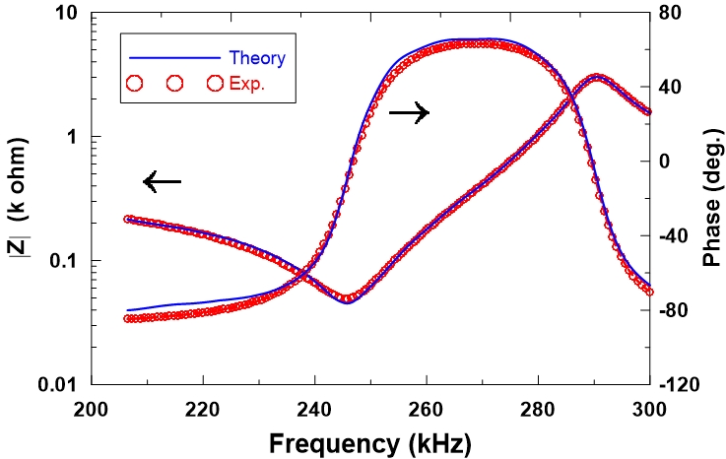
Supplementary data
Fig.S1. Magnitude (|Z|) and Phase (φ) of electrical impedance of a piezocomposite sample. Markers : Experimental data and Solid lines : Theoretical curves plotted with refined material parameters, for N = 0.
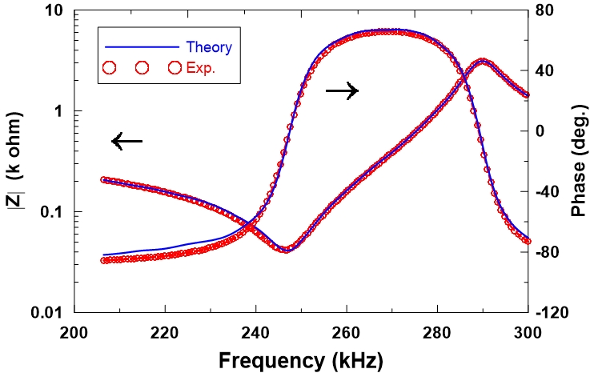
Fig.S2. Magnitude (|Z|) and Phase (φ) of electrical impedance of a piezocomposite sample. Markers : Experimental data and Solid lines : Theoretical curves plotted with refined material parameters, for N = 0.5

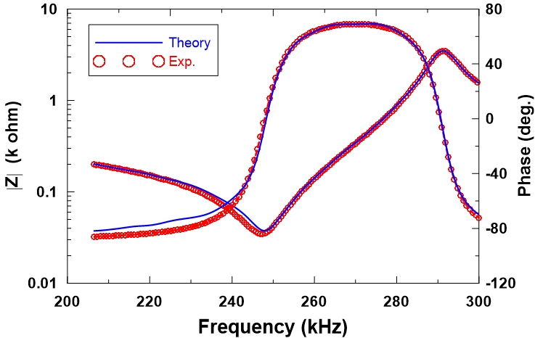
Fig.S3. Magnitude (|Z|) and Phase (φ) of electrical impedance of a piezocomposite sample. Markers : Experimental data and Solid lines : Theoretical curves plotted with refined material parameters, for N = 1.
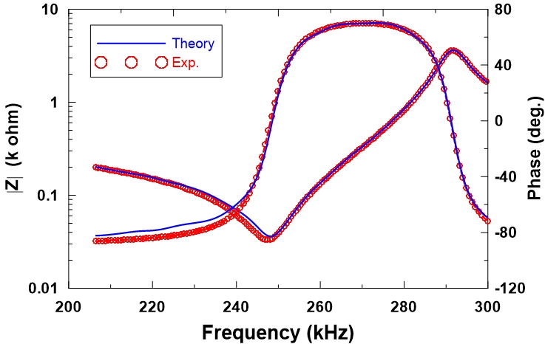
Fig.S4. Magnitude (|Z|) and Phase (φ) of electrical impedance of a piezocomposite sample. Markers : Experimental data and Solid lines : Theoretical curves plotted with refined material parameters, for N = 2.

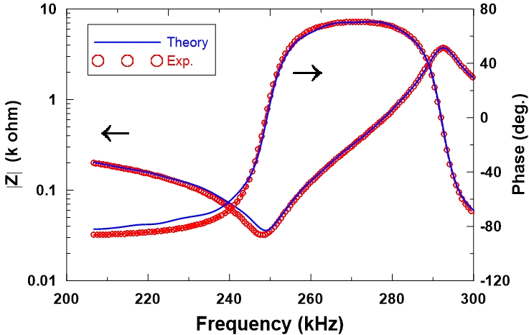
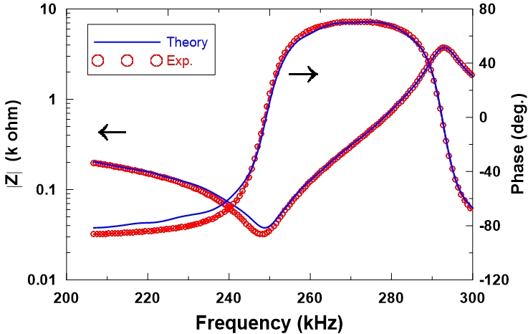
Fig.S5. Magnitude (|Z|) and Phase (φ) of electrical impedance of a piezocomposite sample. Markers : Experimental data and Solid lines : Theoretical curves plotted with refined material parameters, for N = 3.
Fig.S6. Magnitude (|Z|) and Phase (φ) of electrical impedance of a piezocomposite sample. Markers : Experimental data and Solid lines : Theoretical curves plotted with refined material parameters, for N = 4.

