Where are you from? Finding the origin of the recently observed sprat in Iceland using a panel of SNPs

FIGURES
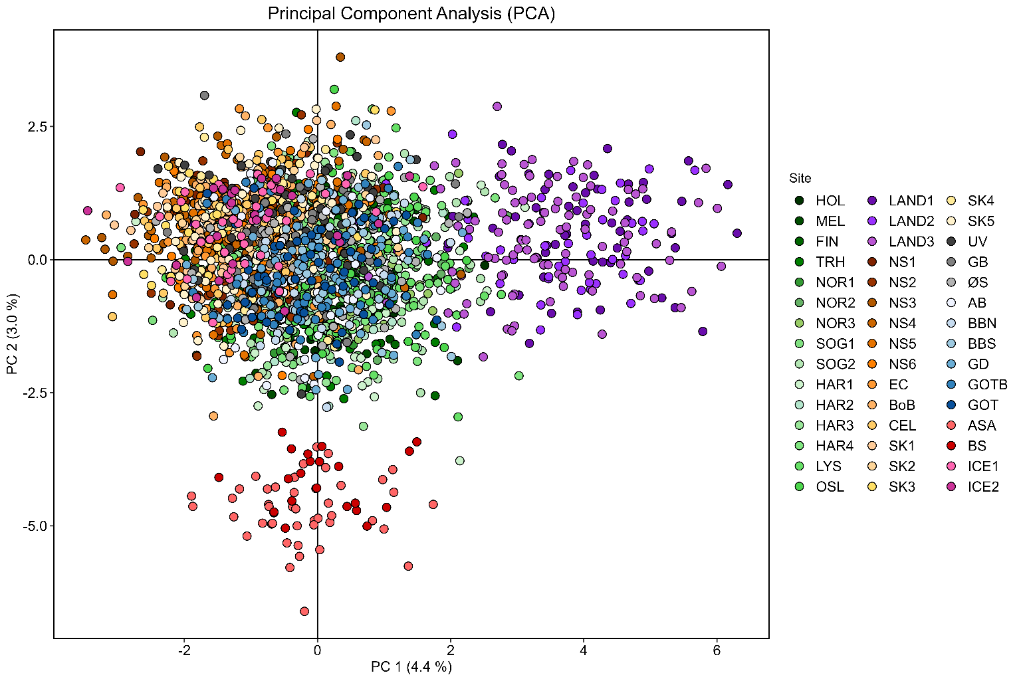
Fig S1. Principal Component Analysis biplot of the Icelandic samples (ICE 1, ICE 2) combined with the 43 reference samples genotyped at 91 SNP loci and published in Quintela et al. (2020, 2021). Individuals from different sampling sites are represented by coloured dots, and detailed information regarding sampling coordinates and sampling year can be found in the aforementioned bibliographic references.

a)
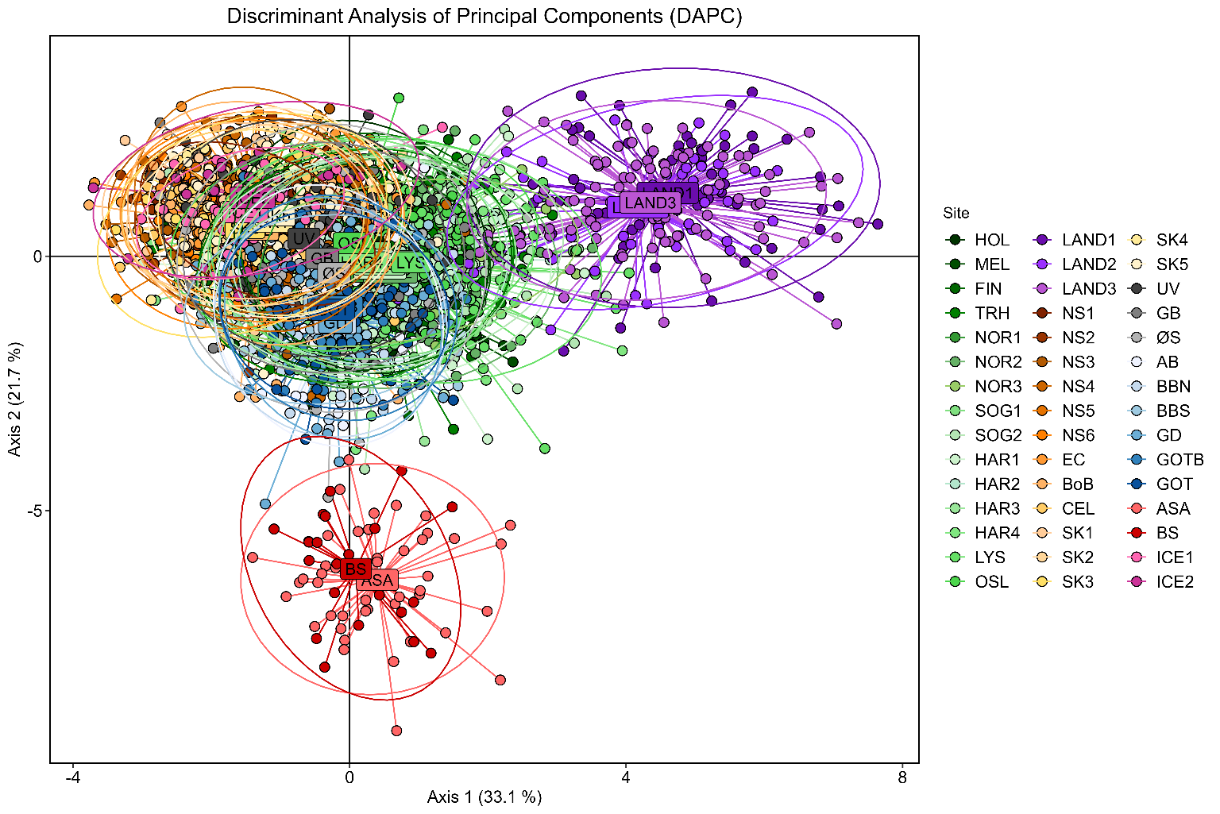
b)
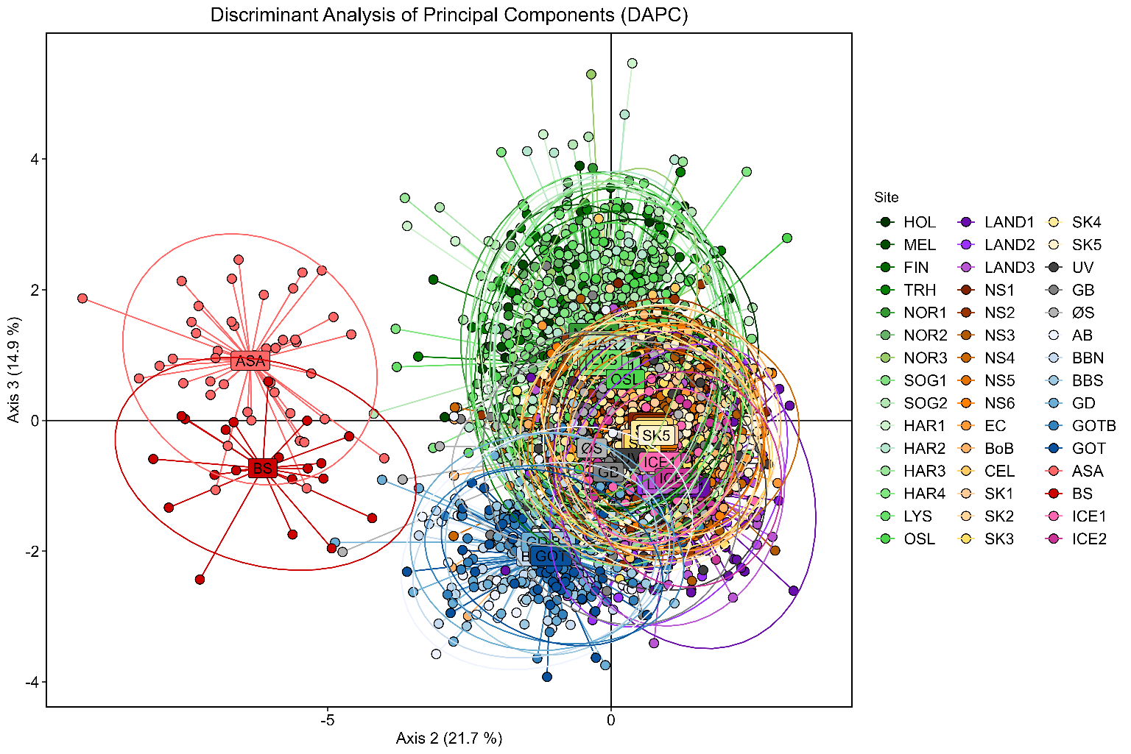

c)
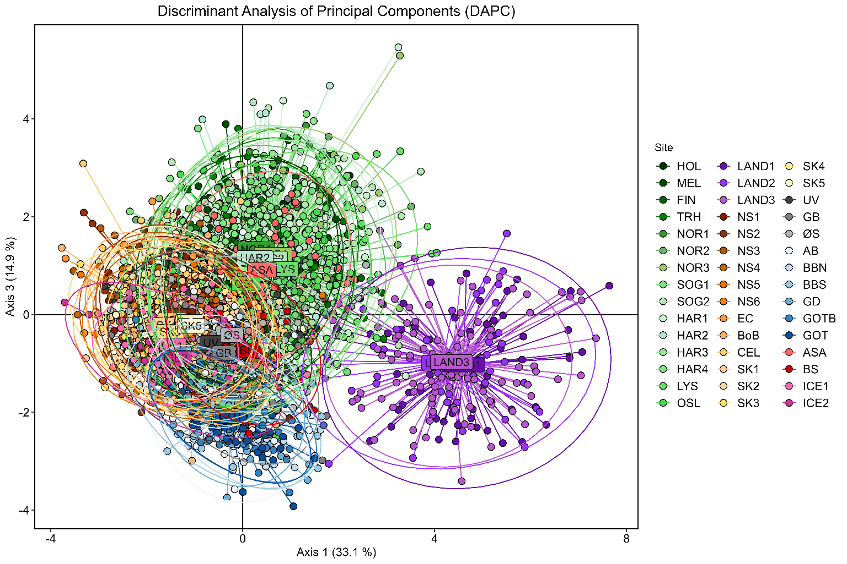
Fig S2. Genetic differentiation among sprat samples genotyped with 91 SNP loci using Discriminant Analysis of Principal Components (DAPC) after retaining 60 principal components and 3 discriminant functions: a) axis 1 and 2, b) axis 2 and 3, and c) axis 1 and 3. Individuals from different sampling sites are represented by coloured dots and detailed information regarding sampling coordinates and sampling year can be found in Quintela et al. (2020, 2021).

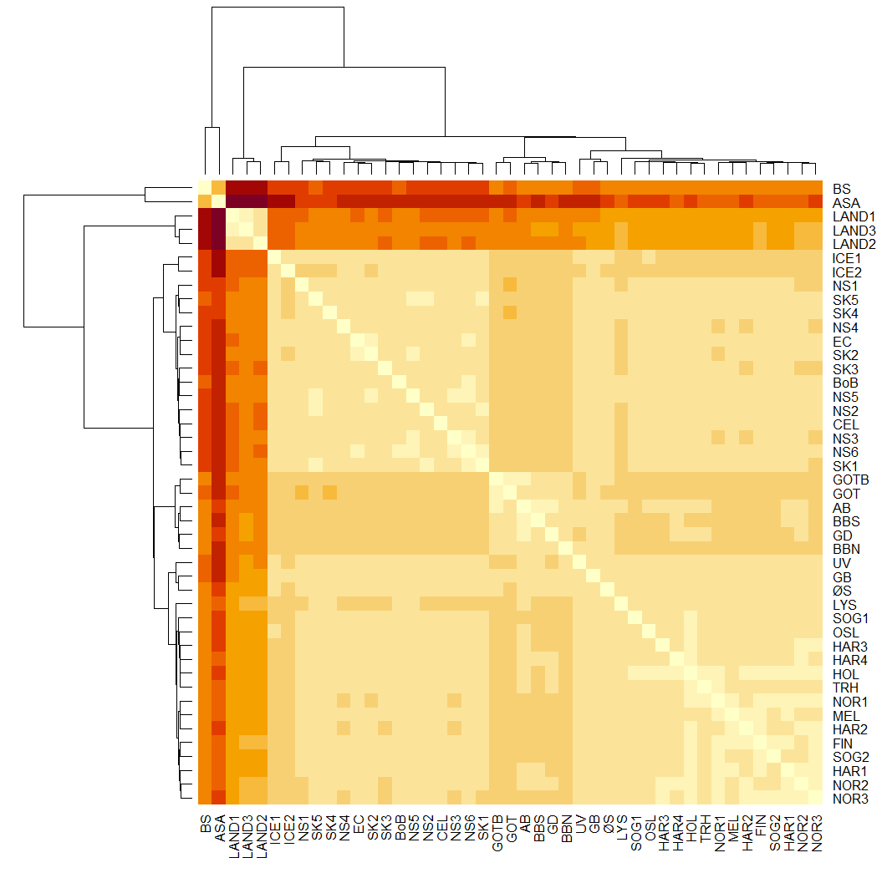
Fig S3. Heatmap F_{ST} coupled with dendrogram. Pairwise values and significance can be found in Suppl. Table S2. Colours depict the degree of differentiation: beige colours indicating low differentiation and move towards dark brown to indicate larger differentiation.

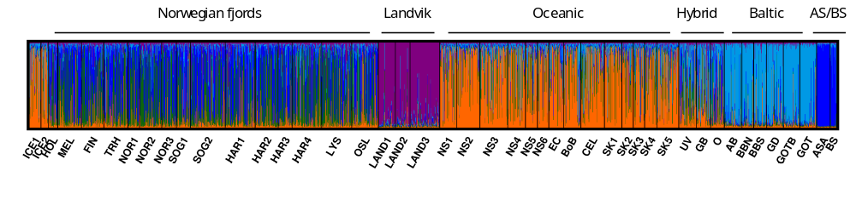
Fig S4. Proportion of individuals’ ancestry to cluster at K =5 after Bayesian cluster analyses performed in STRUCTURE assessed from the set of 91 SNP loci. “Hybrid” depicts the hybrid zone between the North Sea and the Baltic Sea. AS and BS account for the Adriatic Sea and Black Sea, respectively.

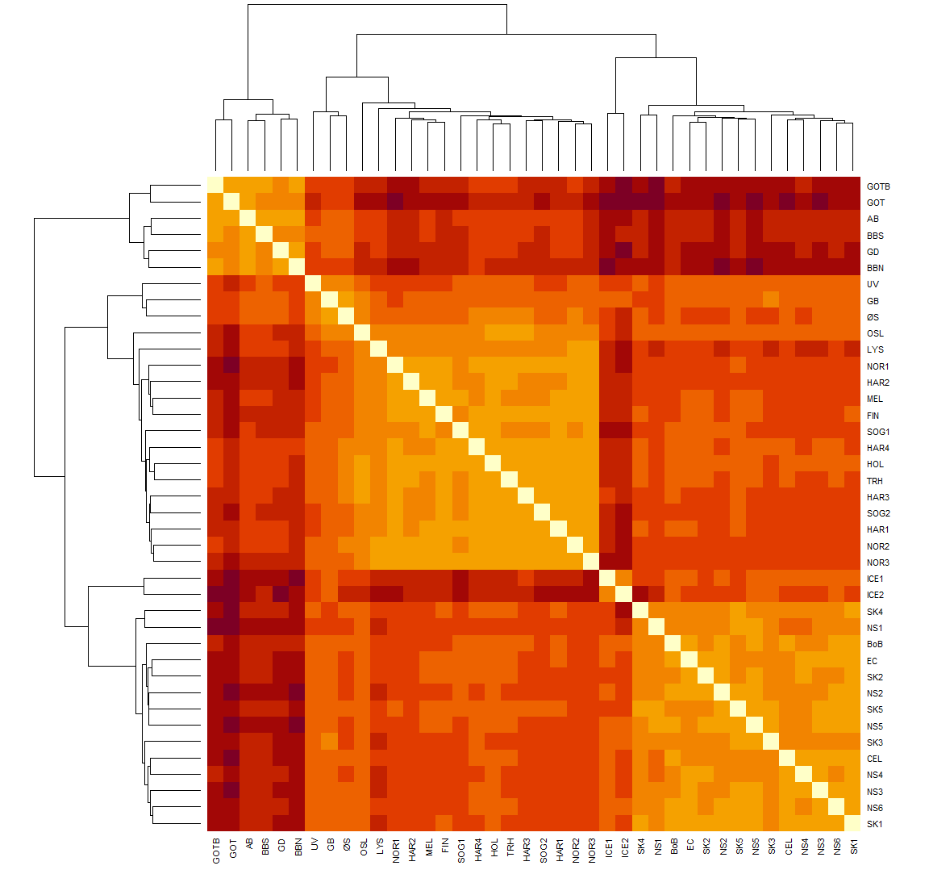
Fig S5. Heatmap F_{ST} coupled with dendrogram of the trimmed dataset. Colours depict the degree of differentiation: light orange colours indicating low differentiation and move towards dark red to indicate larger differentiation.

a)
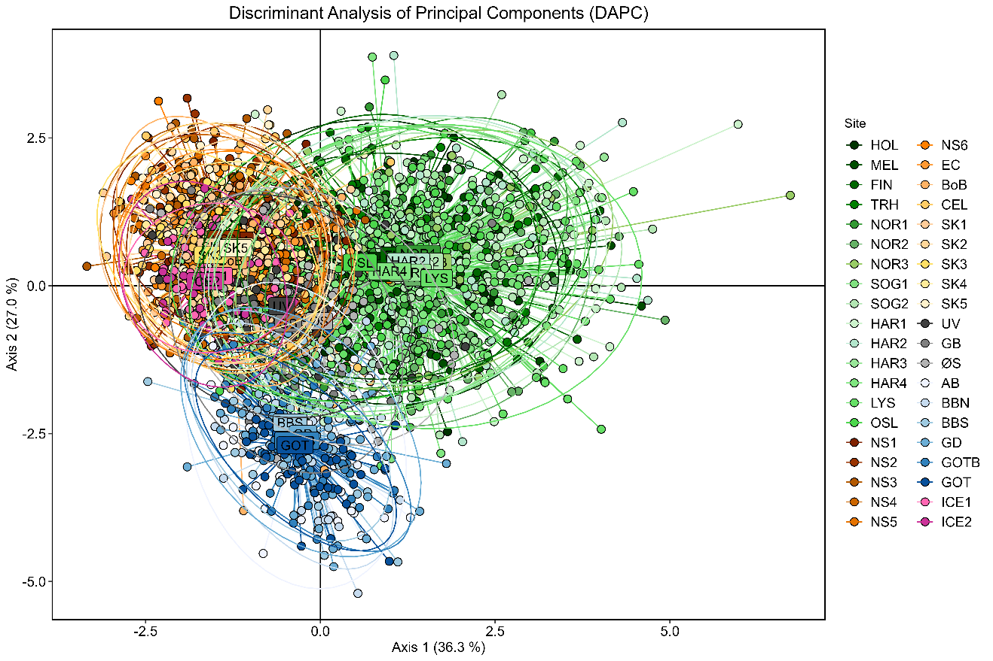
b)
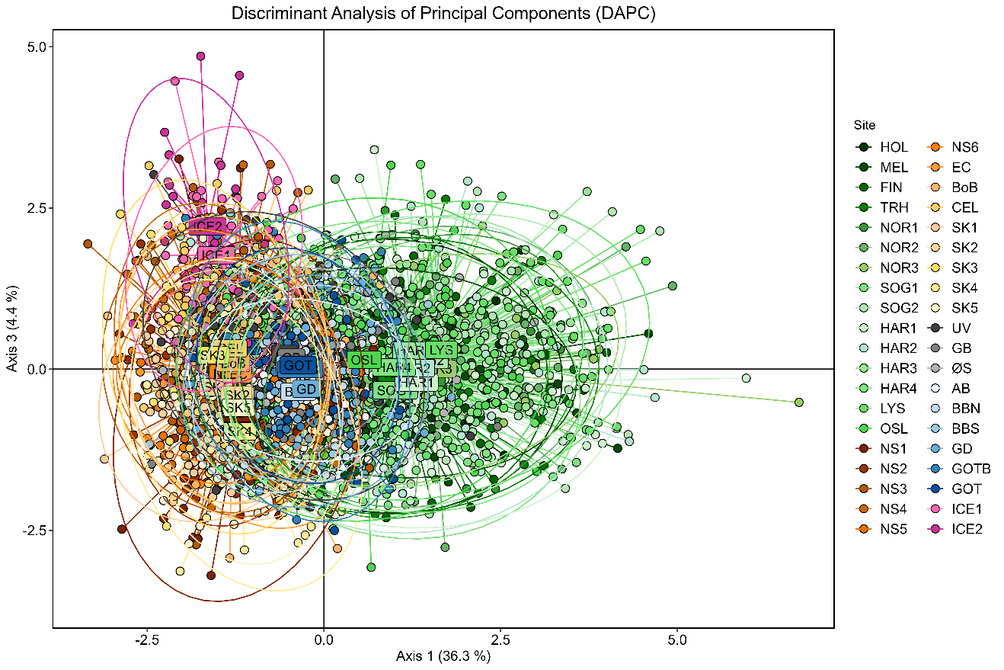
Fig S6. Discriminant Analysis of Principal Components (DAPC) along axis 1 and 2 (a) and 1 and 3 (b) of sprat collected in the Norwegian fjords, Baltic Sea and oceanic locations in the Atlantic, and genotyped with 91 SNP loci. DAPC was conducted after retaining 60 principal components and 3 discriminant functions. Colours depict different sampling sites.

TABLES
Table S1. Number of individual sprat observed in Iceland and number of samples. * Data for 2025 was retrieved in August 2025.
Year | No individuals | No samples
2017 | 1 | 1
2019 | 3 | 2
2020 | 36 | 8
2021 | 684 | 37
2022 | 1340 | 23
2023 | 26473 | 30
2024 | 11821 | 35
2025* | 9059 | 13

Table S2. Pairwise F_{ST} (excel document attached).

Table S3. Major allele frequency of the loci that displayed significant genetic differentiation in the oceanic cluster after including the Icelandic samples. Heatmap should be read per locus across samples with red colours depicting the largest values and green colours the lowest ones.
Locus | Ssp202 | Ssp210 | Ssp220 | Ssp229 | Ssp275 | Ssp276 | Ssp297
ICE1 | 0.676 | 0.949 | 0.513 | 0.778 | 0.936 | 0.910 | 0.500
ICE2 | 0.417 | 0.920 | 0.396 | 0.696 | 0.940 | 0.960 | 0.500
NS1 | 0.361 | 0.636 | 0.698 | 0.620 | 0.991 | 0.947 | 0.518
NS2 | 0.493 | 0.562 | 0.647 | 0.572 | 0.994 | 0.896 | 0.592
NS3 | 0.416 | 0.618 | 0.571 | 0.583 | 0.995 | 0.876 | 0.574
NS4 | 0.430 | 0.613 | 0.640 | 0.519 | 1.000 | 0.915 | 0.570
NS5 | 0.450 | 0.638 | 0.603 | 0.649 | 0.988 | 0.913 | 0.383
NS6 | 0.579 | 0.667 | 0.581 | 0.658 | 1.000 | 0.882 | 0.541
EC | 0.510 | 0.677 | 0.542 | 0.617 | 0.990 | 0.860 | 0.612
BoB | 0.439 | 0.670 | 0.600 | 0.583 | 1.000 | 0.891 | 0.480
CEL | 0.538 | 0.597 | 0.638 | 0.514 | 0.993 | 0.926 | 0.547
SK1 | 0.519 | 0.500 | 0.679 | 0.621 | 1.000 | 0.871 | 0.632
SK2 | 0.471 | 0.618 | 0.649 | 0.569 | 1.000 | 0.921 | 0.446
SK3 | 0.364 | 0.694 | 0.694 | 0.736 | 1.000 | 0.875 | 0.408
SK4 | 0.525 | 0.613 | 0.788 | 0.650 | 1.000 | 0.890 | 0.608
SK5 | 0.430 | 0.603 | 0.600 | 0.562 | 0.993 | 0.897 | 0.552

