Supplementary Material
Supplementary Table 1: Flow cytometry panel for phenotyping
Marker | Fluorochrome | Clone | Company
CD127 | FITC, APC | MB15-18C9 | Miltenyi Biotec
CD19 | PE-Vio® 770 | REA675 | Miltenyi Biotec
CD25 | PE | 3G10, 4E3 | Miltenyi Biotec
CD3 | APC-Vio® 770 | BW264/56 | Miltenyi Biotec
CD4 | VioBlue® | M-T466 | Miltenyi Biotec
CD45 | V500 | HI30 | BD Biosciences
CD56 | PerCP-Cy™5.5 | NCAM16.2 | BD Biosciences
CD8 | APC | BW135/80 | Miltenyi Biotec
FOXP3 | PE-Cyanine7 | PCH101 | eBioscience
5B9 monoclonal antibody | - | 5B9 | Bachmann et al. 2021 [91]
Goat anti-mouse IgG (minimal x-reactivity) | PE | Poly4053 | BioLegend
Zombie Red™ Fixable Viability Kit (BioLegend) was used to stain and gate out dead cells.

Supplementary Table 2: Mass cytometry panel for extended phenotyping
Marker | Metal Tag | Clone | Company
CD134 (OX40) | 150Nd | ACT35 | Standard BioTools
CD137 (4-1BB) | 159Tb | 4B4-1 | BioLegend
CD152 (CTLA-4) | 161Dy | 14D3 | Standard BioTools
CD161 | 156Gd | HP-3G10 | BioLegend
CD183 (CXCR3) | 163Dy | G025H7 | Standard BioTools
CD185 (CXCR5) | 153Eu | RF8B2 | Standard BioTools
CD19 | 142Nd | HIB19 | Standard BioTools
CD194 (CCR4) | 149Sm | L291H4 | Standard BioTools
CD195 (CCR5) | 171Yb | NP-6G4 | BioLegend
CD196 (CCR6) | 141Pr | G034E3 | Standard BioTools
CD197 (CCR7) | 167Er | G043H7 | Standard BioTools
CD27 | 158Gd | L128 | Standard BioTools
CD278 (ICOS) | 148Nd | C398.4A | Standard BioTools
CD28 | 160Gd | CD28.2 | Standard BioTools
CD3 | 115In | UCHT1 | BioLegend
CD31 (PECAM-1) | 145Nd | WM59 | Standard BioTools
CD4 | 174Yb | SK3 | Standard BioTools
CD44 | 170Er | BJ18 | BioLegend
CD45 (barcoding) | 89Y, 106Cd, 110Cd, 111Cd, 114Cd, 116Cd | HI30 | BioLegend
CD45RA | 155Gd | HI100 | Standard BioTools
CD45RO | 165Ho | UCHL1 | Standard BioTools
CD57 | 113In | HNK-1 | BioLegend
CD62L (L-selectin) | 166Er | DREG-56 | BioLegend
CD69 | 146Nd | FN50 | BioLegend
CD8a | 168Er | SK1 | Standard BioTools
CD95 (Fas) | 164Dy | DX2 | Standard BioTools
FOXP3 | 162Dy | PCH101 | Standard BioTools
TCRγδ | 152Sm | 11F2 | Standard BioTools
TIGIT | 154Sm | MBSA43 | Standard BioTools
The antibodies purchased from BioLegend were purified unconjugated antibodies. Based on requirement they were conjugated in-house using Maxpar® X8 Multimetal Labeling Kit.

Supplementary Table 3: Flow cytometry panel for stability assay
Marker | Fluorochrome | Clone | Company
CD127 | BV786 | HIL-7R-M21 | BD Biosciences
CD25 | BUV737 | 2A3 | BD Biosciences
CD25 | BV421 | 2A3 | BD Biosciences
CD3 | APC-Vio® 770 | BW264/56 | Miltenyi Biotec
CD4 | BUV395 | RPA-T4 | BD Biosciences
CD4 | VioGreen™ | REA623 | Miltenyi Biotec
CD8 | APC | BW135/80 | Miltenyi Biotec
FOXP3 | PE-Cyanine7 | PCH101 | eBioscience
Granzyme B | PE | GB11 | BD Biosciences
Helios | PE | 22F6 | BD Biosciences
IFN-γ | APC-R700 | B27 | BD Biosciences
IL-17A | BV421 | N49-653 | BD Biosciences
IL-2 | PE-Cy7 | MQ1-17H12 | BioLegend
TNF-α | BV711 | MAb11 | BioLegend
Zombie Red™ Fixable Viability Kit (BioLegend) was used to stain and gate out dead cells.
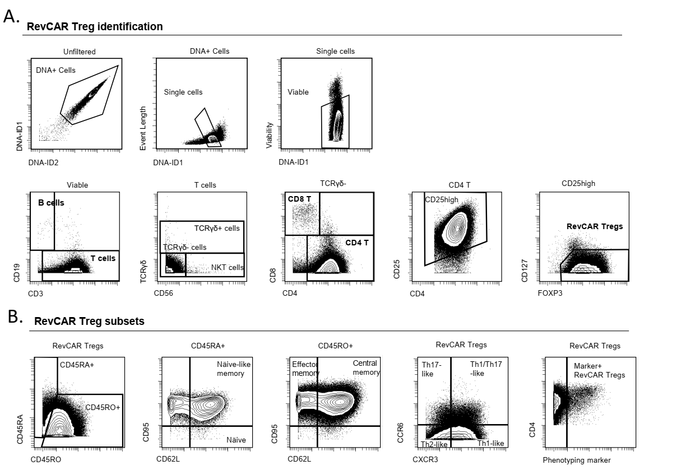
Supplementary Figure S1: Mass cytometry gating strategy for comprehensive phenotyping. Gating strategy used to identify (A) RevCAR Tregs and (B) immune subsets within RevCAR Tregs. Mass cytometry data was analyzed and visualized using the OMIQ software. Abbreviations: DNA-ID – DNA-Intercalator identification

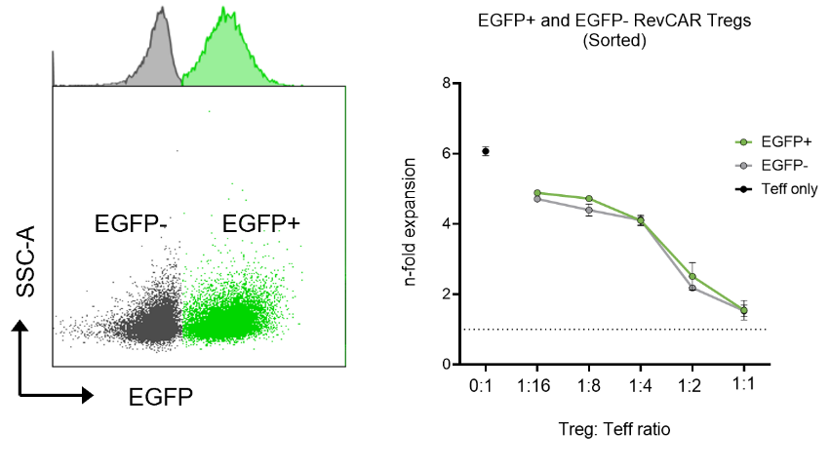
Supplementary Figure S2: Comparison of suppressive activity between EGFP⁺ and EGFP⁻ RevCAR Tregs in a polyclonal suppression assay. Left: Representative flow cytometry plot displaying EGFP⁺ cells (green) among single viable cells (gray). EGFP⁺ and EGFP⁻ RevCAR Treg sorted fractions displayed equal dose-dependent suppression of autologous Teff expansion upon polyclonal stimulation. Data are shown from triplicate wells and presented as mean ± SD.

