Supplementary information for: High-Mobility P-Type Boron Carbon Nitride with Wafer-Scale Uniformity
Chien-Chih Tseng^{1,11}, Chang-Hsun Huang^{2,11}, Jui-Cheng Kao^{3,4,11}, Aowen Li⁵, Ryo Ishikawa⁵, Seong Rae Cho¹, Chenxi Lei¹, Chih-Zong Deng⁹, Wei-Chun Chen⁶, Ming-Chung Wu^{7,8}, Fong-Zhi Chen⁶, Yu-Chieh Lo³, Ya-Lun Ho⁹, Yi-Chia Chou^{2#}, Jui-Han Fu^{1#}, Naoya Shibata⁵, Chun-Wei Pao^{4,10#}, Vincent Tung^{1,10#}

¹Department of Chemical System Engineering, School of Engineering, The University of Tokyo, Tokyo 113-8656, Japan
²Department of Materials Science and Engineering, National Taiwan University, Taipei 10617, Taiwan
³Department of Materials Science and Engineering, National Yang-Ming Chiao Tung University, Hsinchu 300092, Taiwan
⁴Research Centre for Applied Sciences, Academia Sinica, Taipei 115201, Taiwan
⁵Institute of Engineering Innovation, The University of Tokyo, Tokyo 113-8656, Japan
⁶National Center for Instrumentation Research, National Institutes of Applied Research, Hsinchu 300092, Taiwan
⁷ Department of Chemical and Materials Engineering, Chang Gung University, Taoyuan 333323, Taiwan
⁸Center for Sustainability and Energy Technologies, Chang Gung University, Taoyuan 333323, Taiwan
⁹Research Center for Electronic and Optical Materials, National Institute for Materials Science (NIMS), Ibaraki 305-0044, Japan
¹⁰Physics Division, National Centre for Theoretical Sciences, Taipei 10631, Taiwan
¹¹These authors contributed equally to this work.

#To whom correspondence should be addressed: fuj@g.ecc.u-tokyo.ac.jp, ycchou@ntu.edu.tw, cwpao@gate.sinica.edu.tw, and vincent@g.ecc.u-tokyo. ac.jp

Supplementary Methods
Formation energy, nucleation free energy, and nucleation rate
To evaluate the thermodynamic stability of the BCN flake on the Cu (111) surface, six different dimensions (L = 1 - 6) of triangular BCN models are extracted from the SQS BCN monolayer. Each size is sampled with more than 10 configurations except for L = 1. The average value of the formation energy is used to evaluate the thermodynamic stability. The formation energy (E_{f}) of the BCN flake on the Cu (111) surface is expressed as the following equation:
$E_{f}=(E_{BCN+subs}-E_{subs}-n_{N}μ_{B+N}-\left(n_{B}-n_{N}\right)μ_{B}-n_{C}μ_{C})/n_{BCN}$ (1)
$E_{BCN+subs}$ and $E_{subs}$ are the total energy of the BCN flake on the substrate and the Cu (111) substrate, respectively. $n_{N}$, $n_{B}$, and $n_{C}$ are the number of N, B, and C atoms to form the BCN flake, respectively. $n_{BCN}$ is the number of total atoms for BCN flake, which is equal to the summation of $n_{N}$, $n_{B}$, and $n_{C}$. $μ_{B}$ is the chemical potential of the B atom, referenced from an isolated B atom in the vacuum state, while $μ_{B+N}$ and $μ_{C}$ denote the chemical potentials of the B/N and C precursors, respectively. In Fig. 1b, these parameters are varied to assess the range of precursor chemical potentials stabilizing the monolayer BCN flake.
The Gibbs free energy of the BCN nucleation can be defined as eq. (2):
$G\left(N\right)=E\left(N\right)-μ_{BCN}N$ (2)
$E\left(N\right)$ is the cluster energy for a different number of atoms (N) of the BCN flake. $μ_{BCN }$is the chemical potential of the nucleating BCN precursors. The cluster energy ($E\left(N\right)$) as a function of N can be expressed as:
$E\left(N\right)=E_{BCN+subs}-E_{subs}-Nϵ_{BCN}$ (3)
$ϵ_{BCN}$ is the energy per atom of the BCN monolayer. Supplementary Fig. 3a shows the cluster energies of the BCN flakes on the Cu (111) surface. Due to the sp² network structure of the BCN flake, which can be fitted as follows:
$E\left(N\right)=1.8860×N^{\frac{1}{2}}+0.2424$ (4)
Therefore, the Gibbs free energy can be written as follows:
$G\left(N\right)=1.8860×N^{\frac{1}{2}}+0.2424-μ_{BCN}N$ (5)
Supplementary Fig. 3b displays the G(N) curve with different chemical potential conditions. The nucleation barrier (G*) can be defined as the maximum of the G(N) curve. From the classical 2D nucleation theory¹, the nucleation rate (R_{nul}) of the 2D materials can be expressed as the following equation:
$R_{nul}=R_{0}\exp\left(\frac{-G^{*}}{k_{B}T}\right)$ (6)
R₀ is the pre-factor. In our case, we chose R₀ ~10²³ cm⁻² s⁻¹, corresponding to the graphene nucleation on Cu (111). Such a value is driven by the difference in the diffusion barrier of C atom on Ni (111) surface² and Cu (111) surface. On the other hand, it can be seen as the upper limit of the BCN nucleation. k_{B} and T are the Boltzmann constant and temperature, respectively. It is noticed that for the chemical potential used in the Gibbs energy curve, we did not consider the partial pressure of the BCN, implying that the nucleation rate estimated from theory represents a lower bound relative to that of the actual CVD process.
Cu (111) on sapphire
The as-received sapphire substrates were first etched in a mixed H₂SO₄/H₃PO₄ aqueous solution at 300 °C for 20 min. The etched sapphire substrates were cleaned by immersion in ultra-pure water for 5 min. After cleaning, the sapphire substrates were loaded into a sputtering chamber for Cu deposition. The chamber was maintained at room temperature under an argon pressure of 0.3 mTorr, resulting in a Cu deposition rate of 2 nm/s.

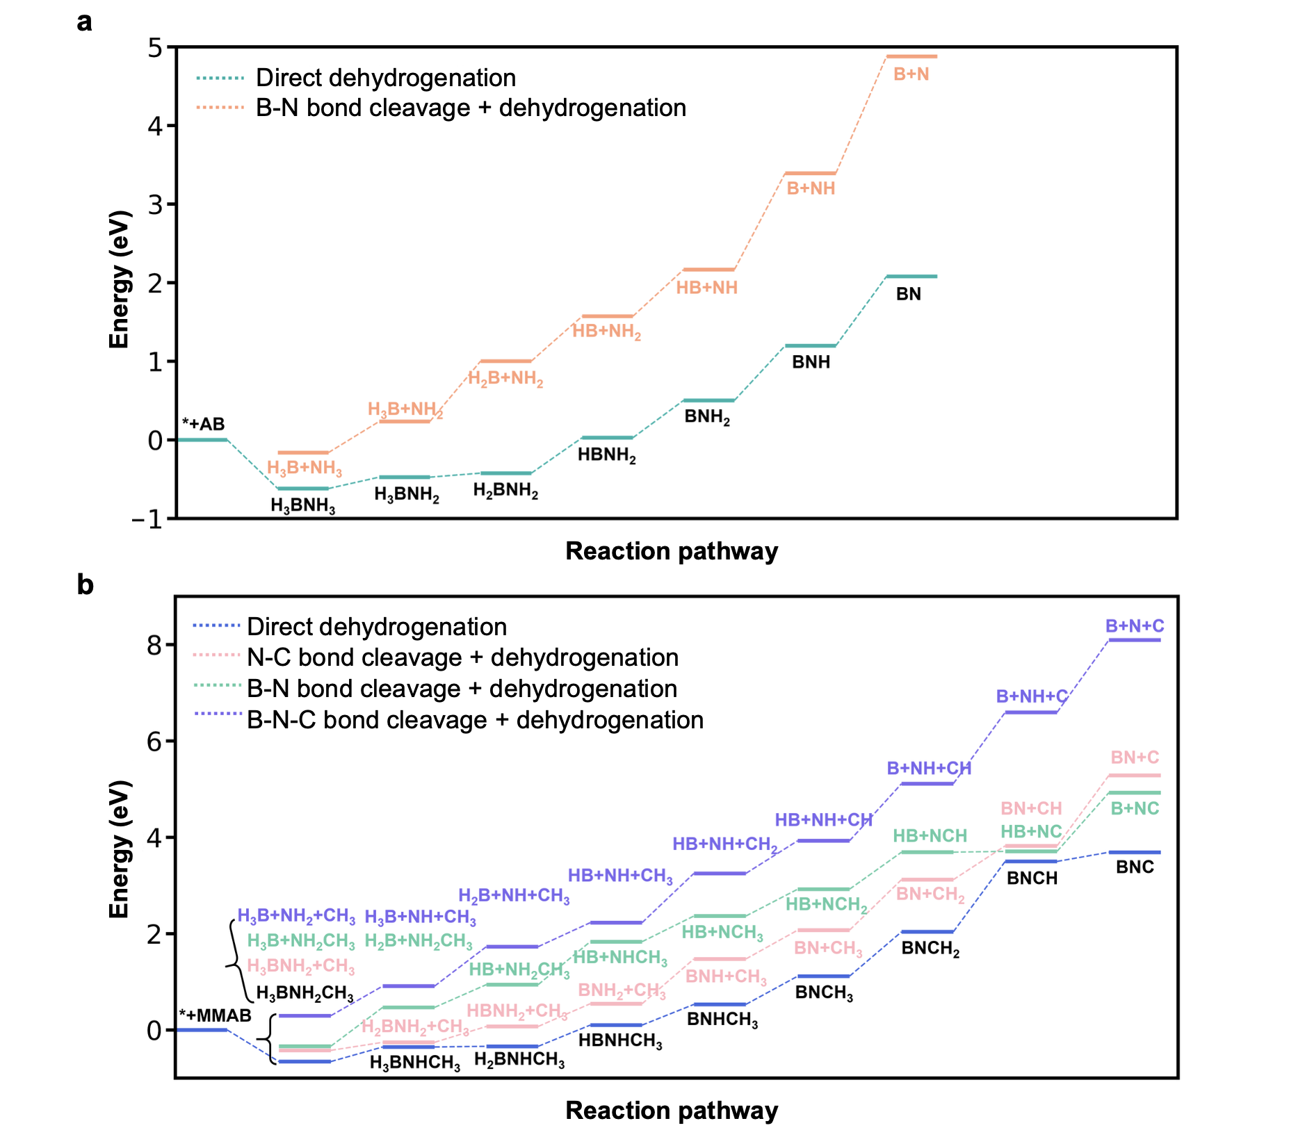
Supplementary Fig. 1 | The relative energy of the a, AB, and b, MMAB decomposition reactions on the Cu (111) surface. The cleavages of B-N, N-C, or B-N-C bonds are considered for both AB and MMAB precursors.
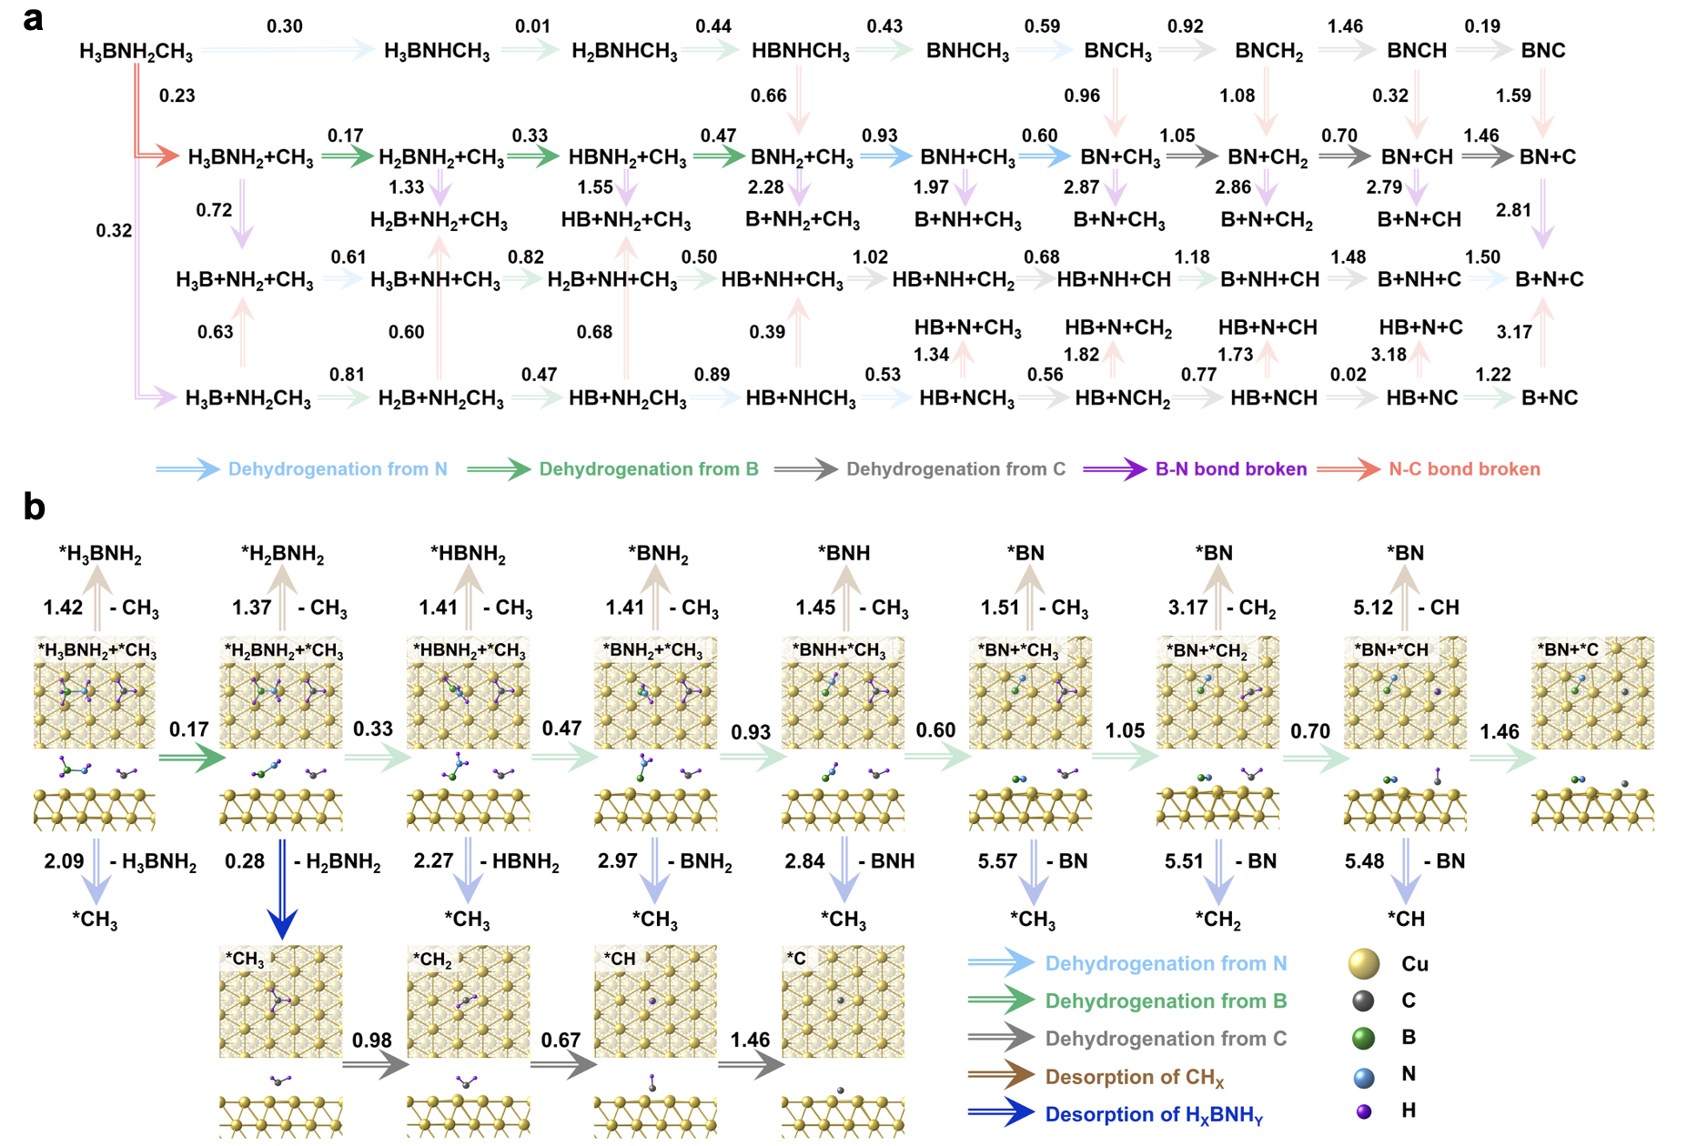

Supplementary Fig. 2 | Reaction energies of the MMAB decomposition on Cu (111) surface. a, Reaction energies as a function of the reaction pathways include the cleavage of N-C, B-N, and B-N-C bonds, respectively. b, Reaction energy landscape of the MMAB decomposition stems from the cleavage of the N-C bond and the desorption of intermediates. The result is the formation of adsorbed *C and the desorption of *H₂BNH₂.

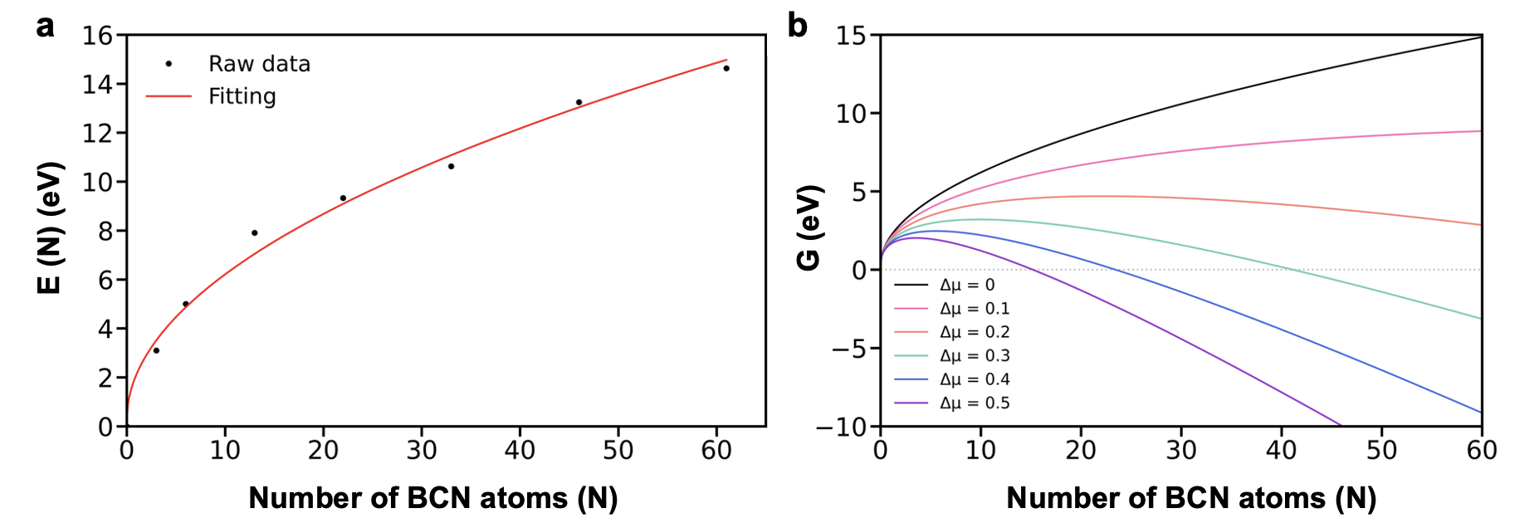
Supplementary Fig. 3 | Cluster energy variation during the nucleation of BCN flakes and their subsequent coalescence into thin films. a, Cluster energies of the nucleating BCN flakes on a Cu (111) surface with different numbers of BCN atoms. b, The Gibbs free energies as a function of the number of atoms for BCN flakes under the different chemical potential conditions.
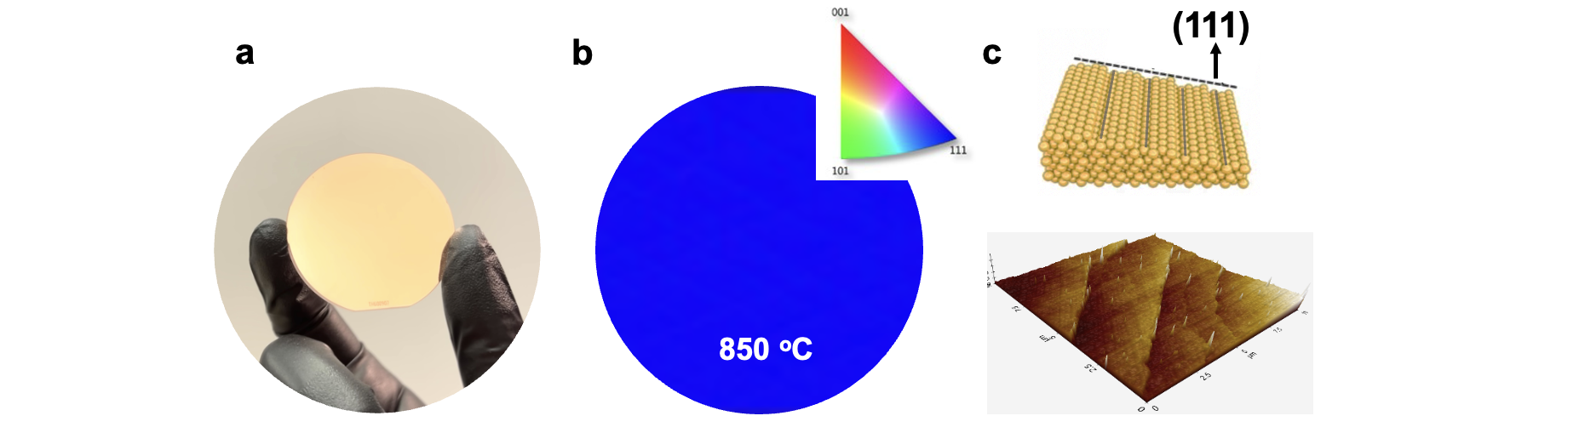

Supplementary Fig. 4 | Annealing-induced Surface reconstruction of Cu (111) on sapphire. A photograph shows a grain-boundary-free and single-crystal Cu (111) substrate after annealing at 1050 °C for 2 hours in a H₂/Ar environment. b, EBSD IPF mapping (1 x 1 mm²) of the resultant Cu thin film, where the normal direction indicates the absence of twinned Cu (111) polycrystals with misoriented angles. c, Schematic representation features the atomically well-defined steps of Cu (111) and the corresponding AFM image.

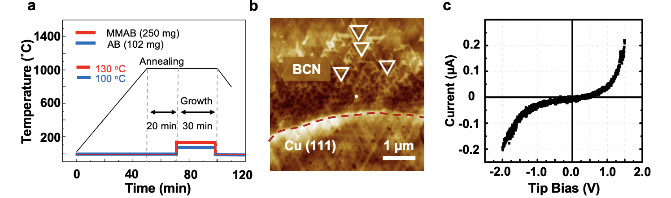Supplementary Fig. 5 | a, Growth temperature as a function of the deposition time. Note that MMAB and AB are introduced separately at annealing temperatures of 130 °C and 100 °C, respectively. b, AFM image reveals predominantly mono-oriented BCN flakes on single-crystal Cu (111) films after 5 minutes of growth. c, Conductive AFM (C-AFM) measurements taken on BCN flakes supported on Cu (111) exhibit a non-linear and asymmetric shape of the I-V curve, providing compelling evidence for the semiconducting nature of the BCN films.

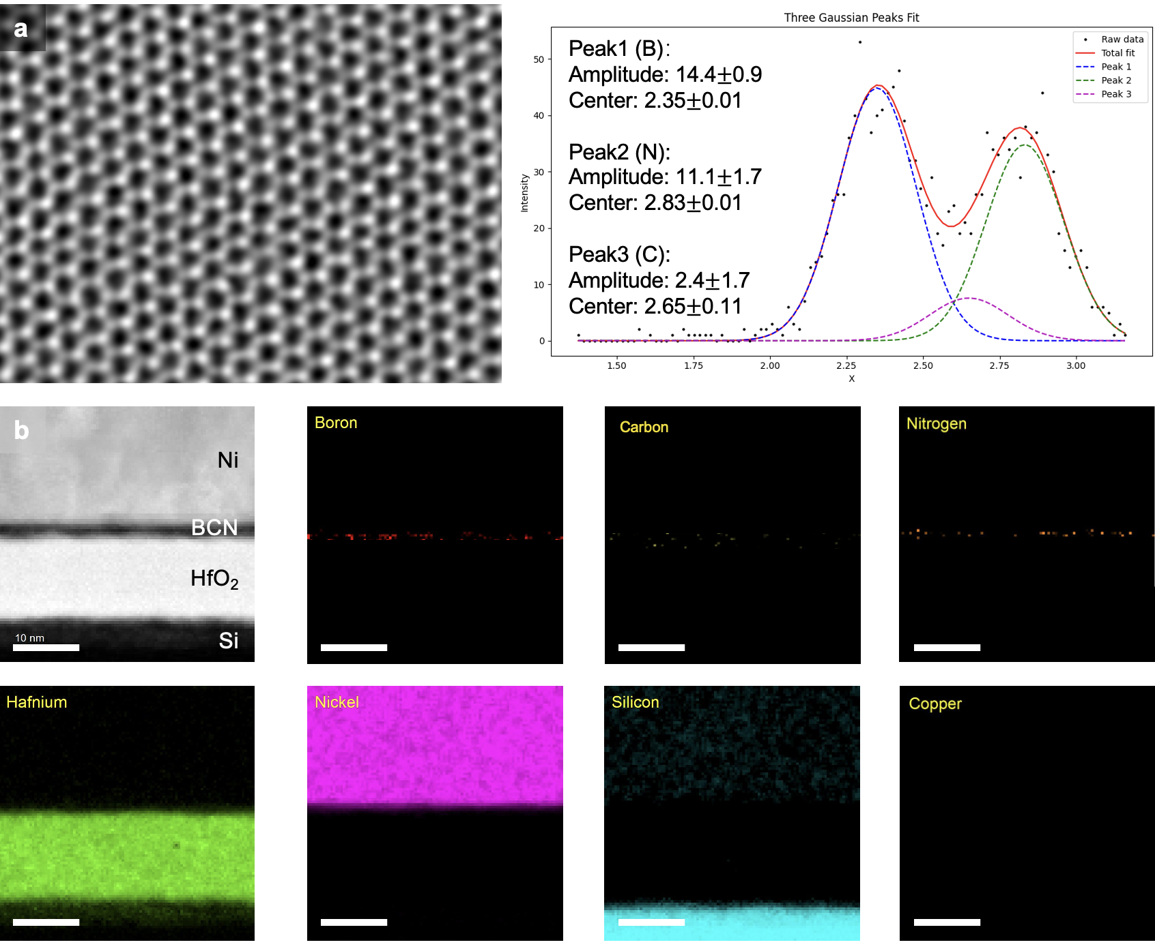
Supplementary Fig. 6 | a, HR-STEM image of ML 2D BCN film. The total atoms included in the analyses is 1563, where B: 51.6%, C: 8.6%, and N: 39.8%. b, The EELS-mapping of the Si wafer/HfO₂/BCN/Ni interface. Cu signal is notably absent from the device stack. It is noted that relatively thick BCN films were used for characterization. Scale bars are 10 nm.

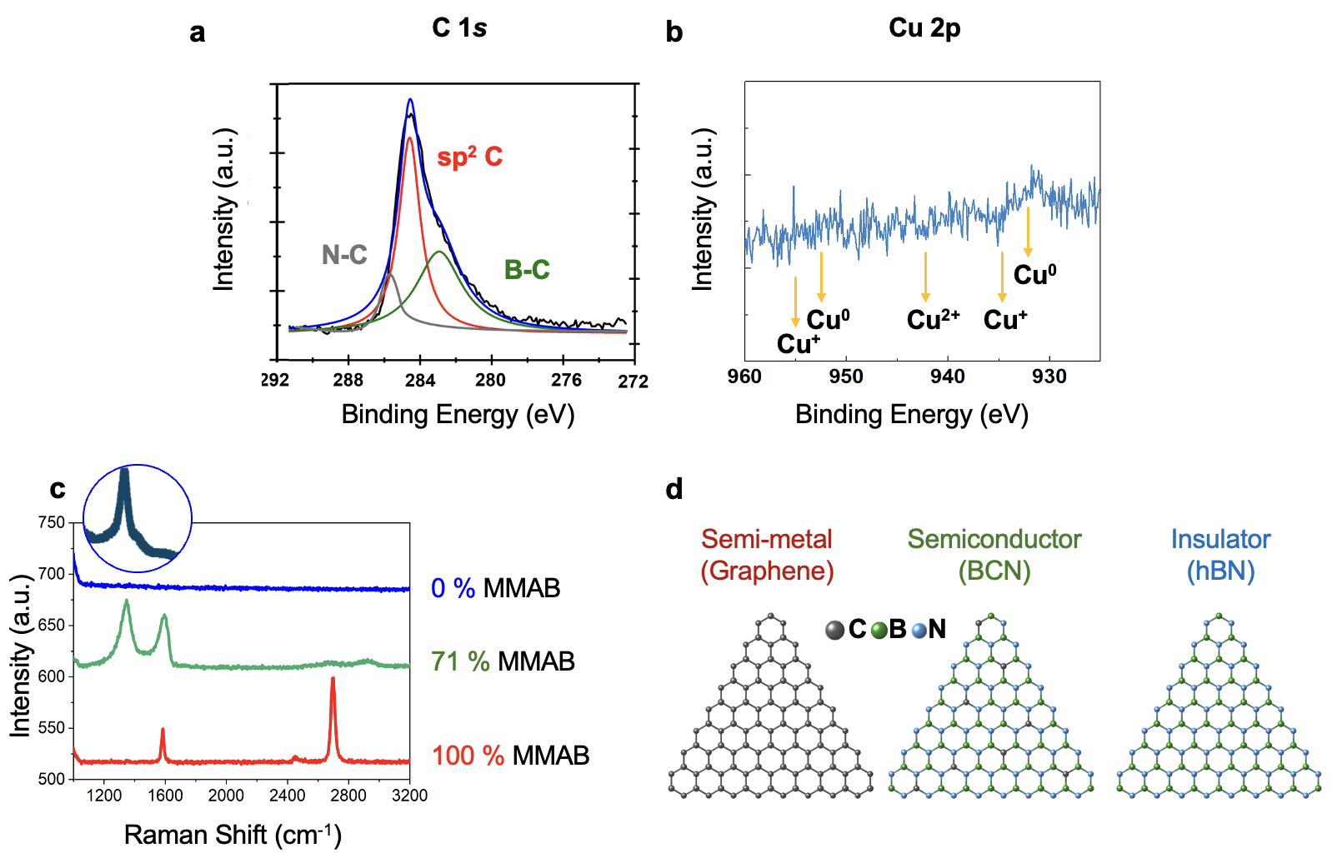Supplementary Fig. 7 | a, XPS spectra of C 1s reveal a variety of bonding environments in addition to the graphitic carbon. b, The absence of Cu 2p contribution rules out the surface contamination during the coupling reaction, thus confirming the semiconducting nature of BCN. c, Raman spectra of hBN (line in blue), BCN (line in green), and graphene (line in red) based on controlling the co-precursor ratios of AB and MMAB. d, Computer-generated models of the resulting products.

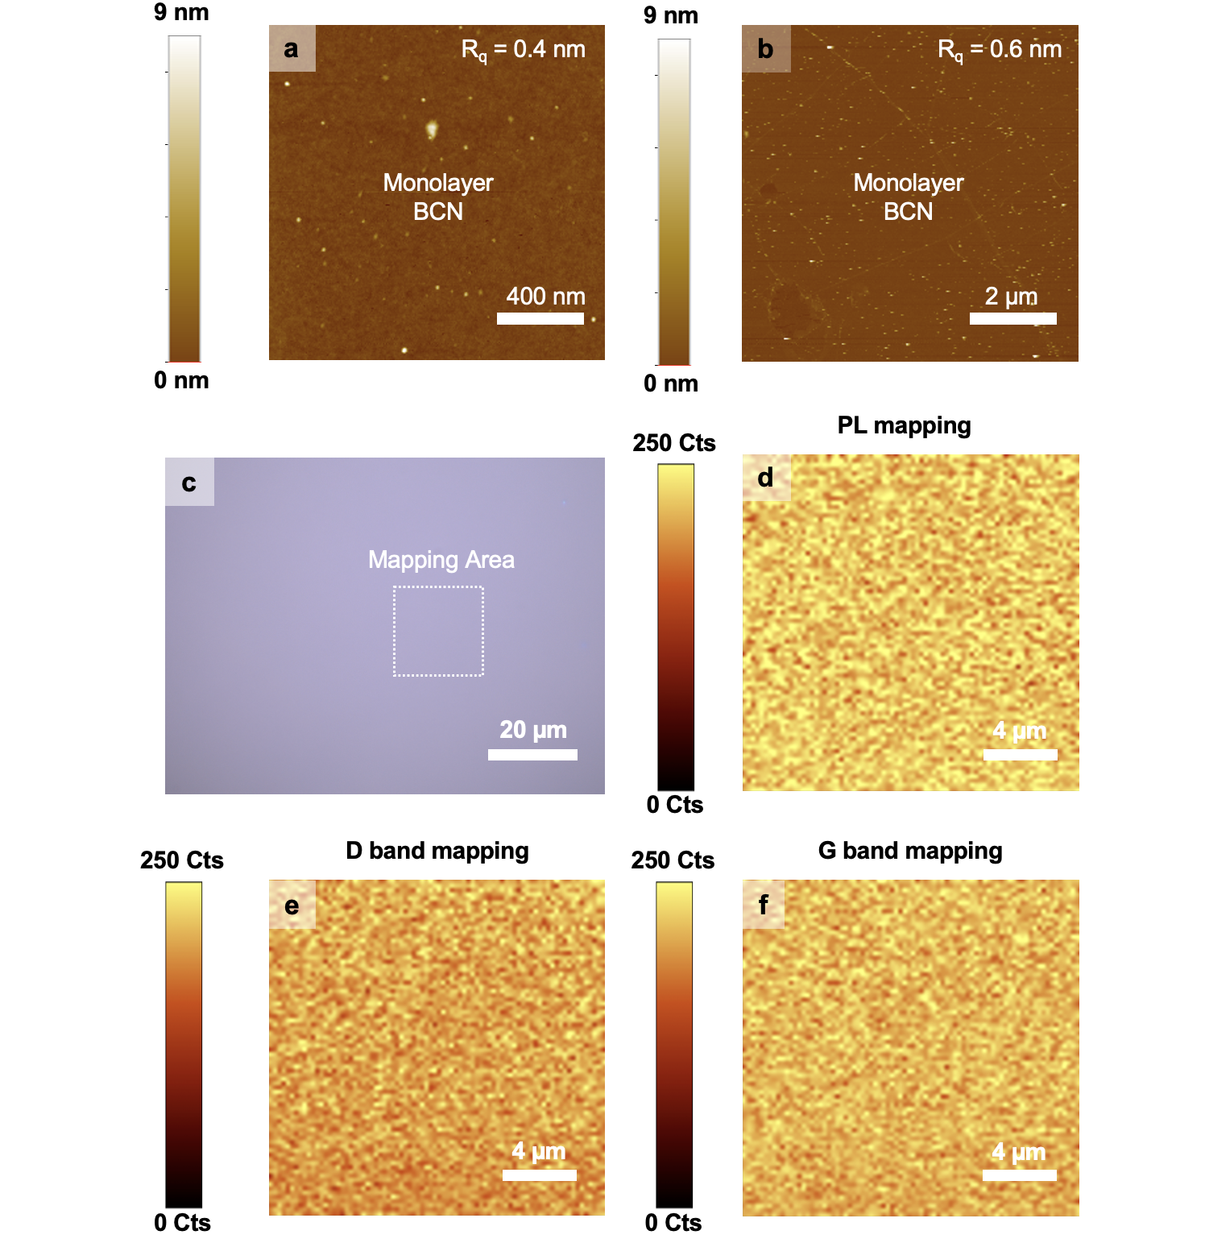
Supplementary Fig. 8 | Large-scale BCN films. Surface roughness of BCN films of a, 1.5 x 1.5 µm² and b, 8 x 8 µm² determined by AFM. c, Optical micrograph of ML BCN films deposited on a 2-inch SiO₂/Si substrate. Mappings of d, signature PL peak at 1.85 eV, and characteristic Raman spectra e, D-, and f, G bands of the resulting BCN films collectively confirm the continuous uniformity across the large area.

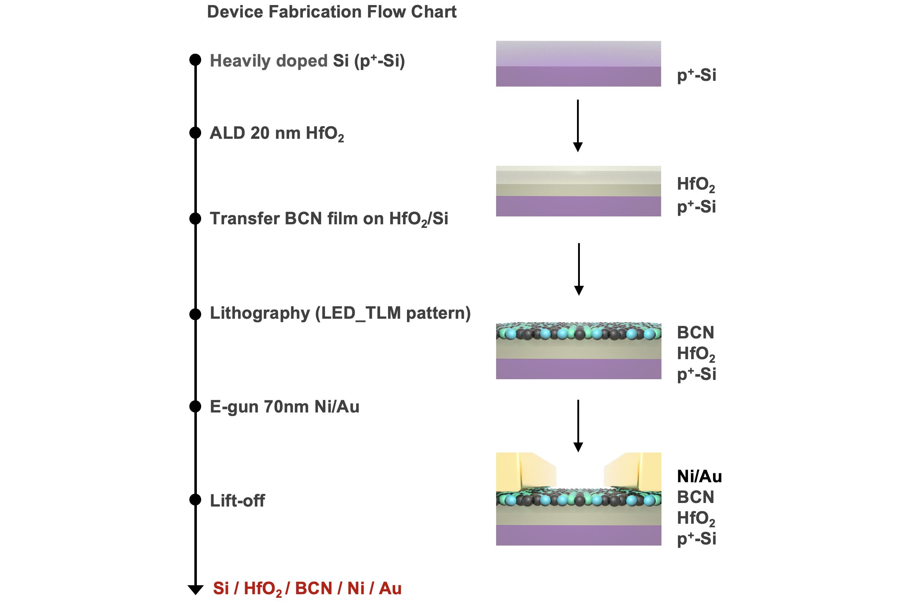

Supplementary Fig. 9 | Device fabrication flow chart of 2D BCN FET arrays. The integration of 2D BCN films is compatible with the current standard of semiconductor manufacturing processes. In this study, we fabricated back-gate and top-contact FET arrays on HfO₂-coated Si substrates.

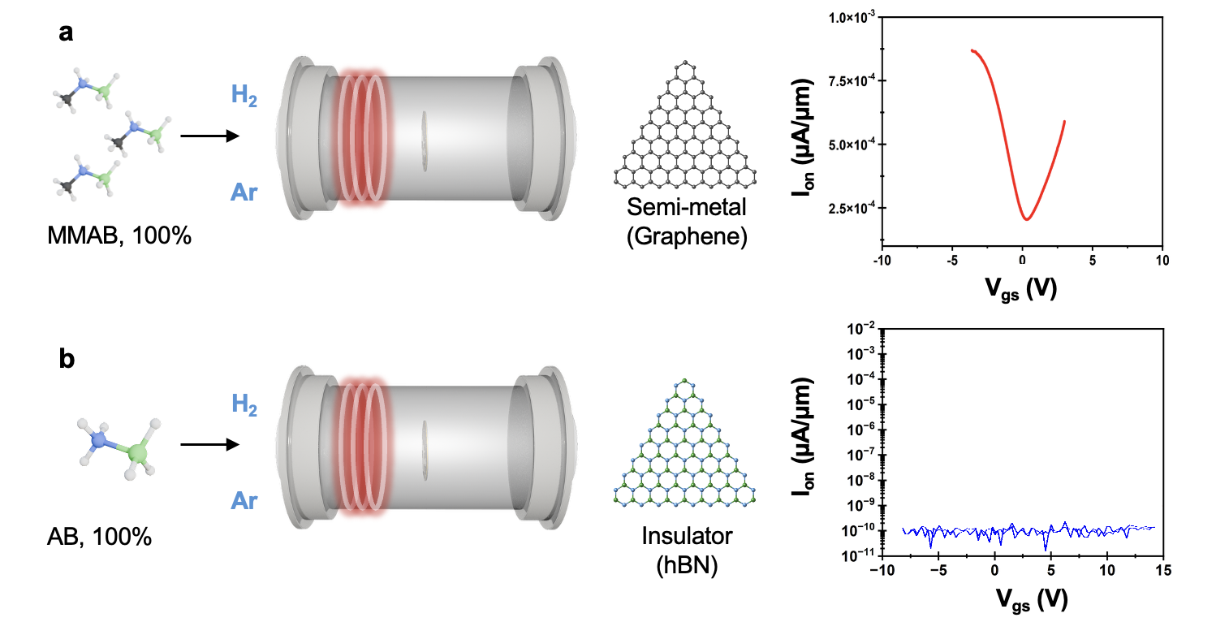
Supplementary Fig. 10 | Electrical properties of graphene-like and hBN films. Schematic illustrations (left panel) depict the synthesis procedure using a, graphene-like, and b, hBN atomic thin films as precursors, with 100% MMAB and 100% AB, respectively. These films were deposited on HfO₂-coated (20 nm) heavily doped Si, followed by the thermal evaporation of Au/Ni source-drain electrodes. The drain-source voltage is fixed to 1V.

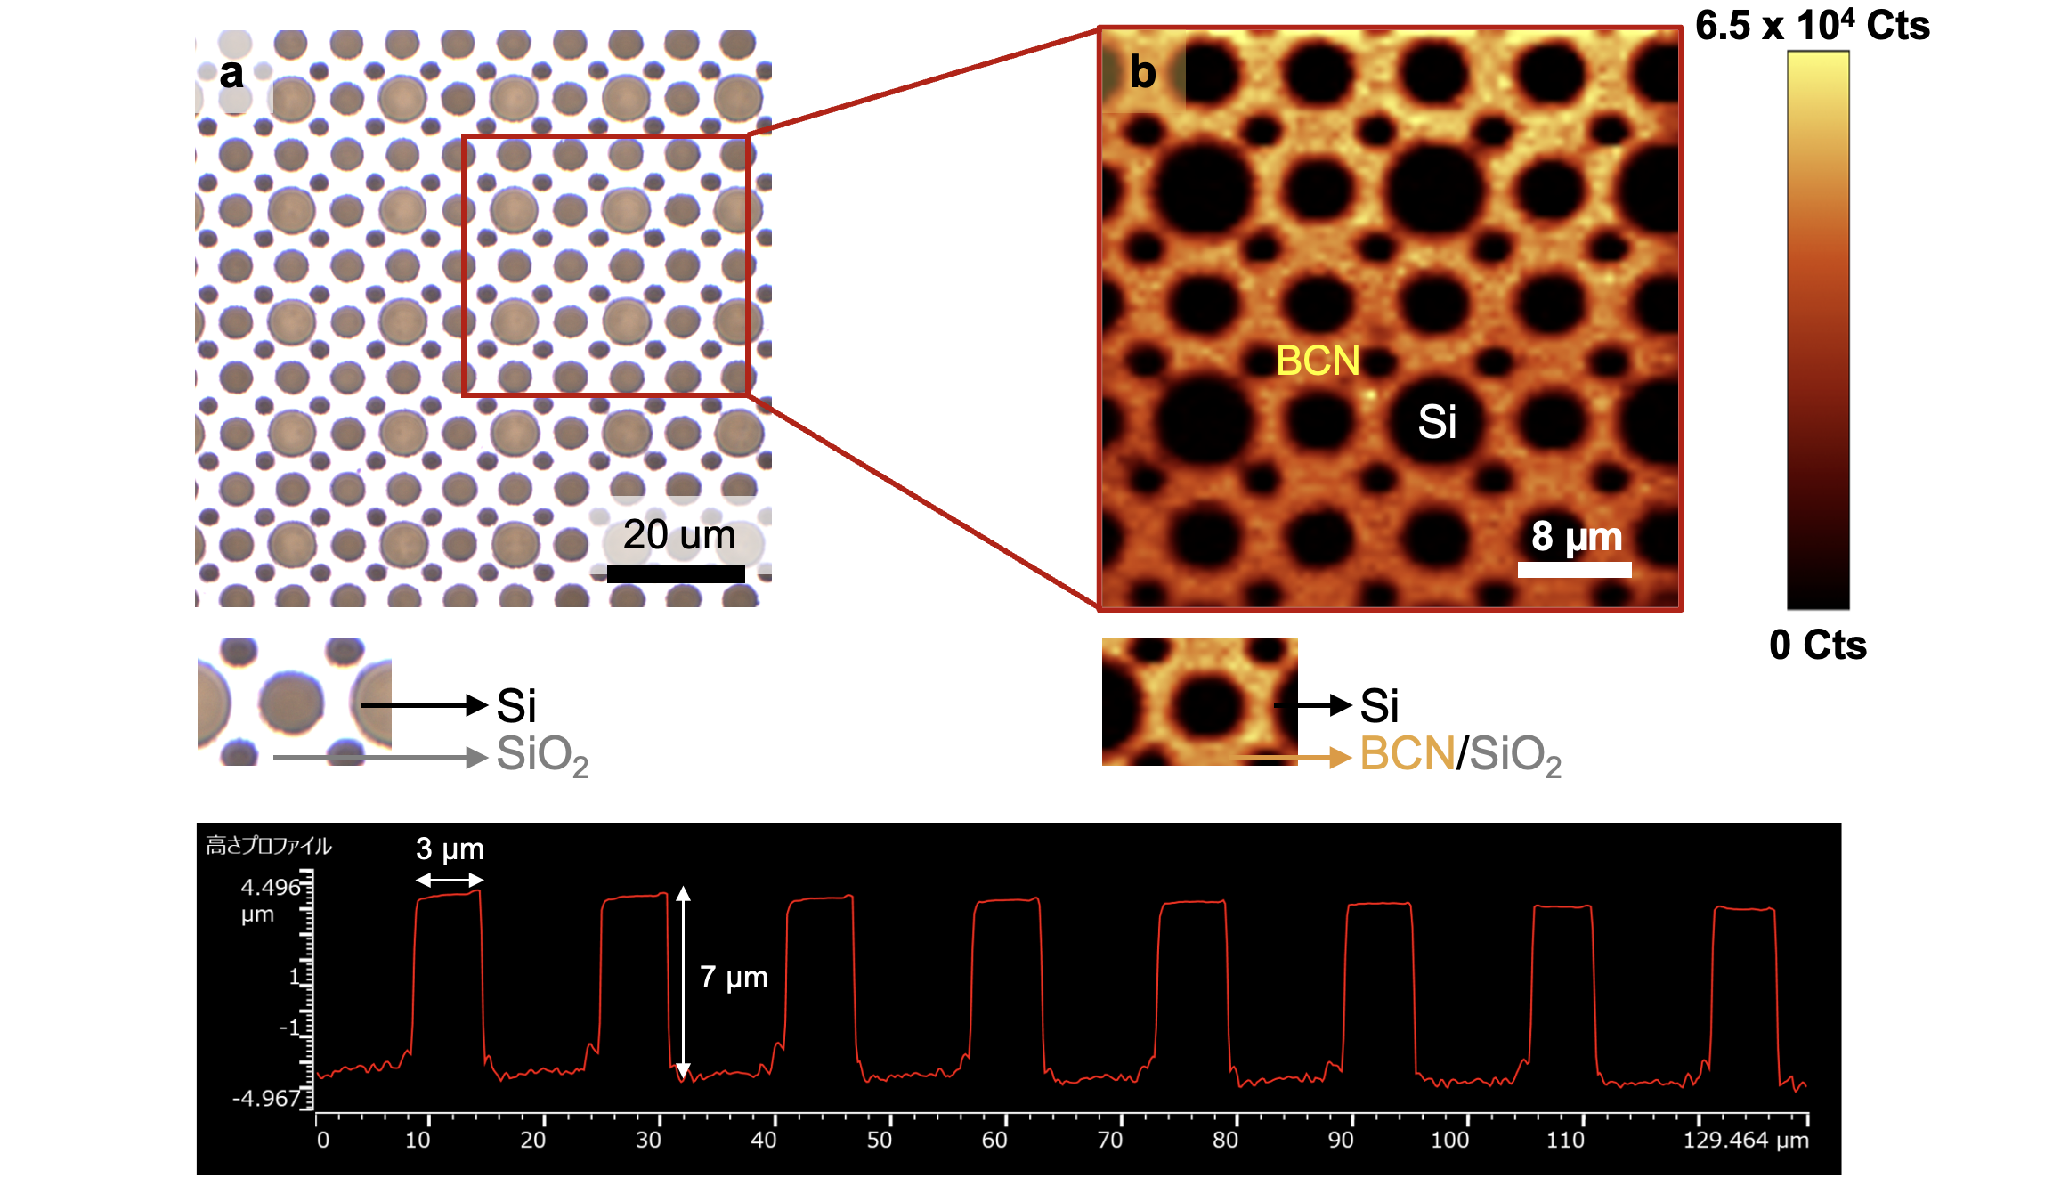
Supplementary Fig. 11 | Deposition of 2D ML BCN films on 3D patterned substrates. a, Optical micrograph shows a series of holey patterns in SiO₂ dielectrics on Si substrates. b, Corresponding PL mapping (at 1.85 eV) demonstrates the preferential growth of 2D ML BCN films only on SiO₂ dielectrics. Meanwhile, Si wells remain clean without BCN coating. Surface roughness is quantified by a profilometer.

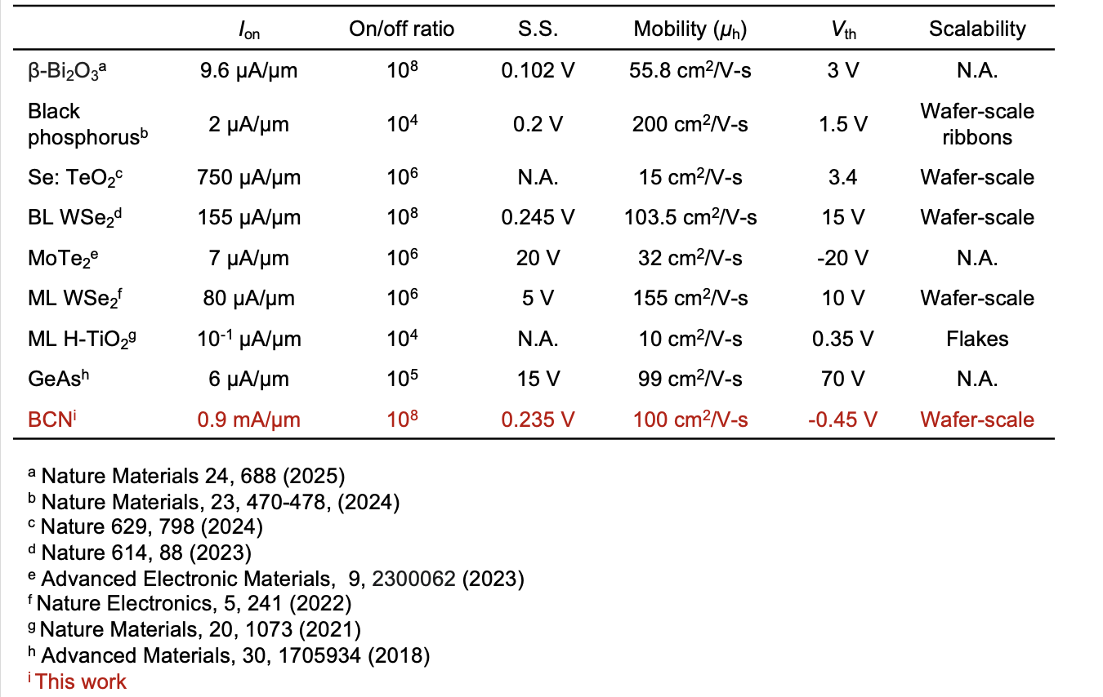
Supplementary Table 1 | Benchmark for p-type FETs fabricated with emerging 2D TMDs, non-TMDs, and amorphous oxide materials.

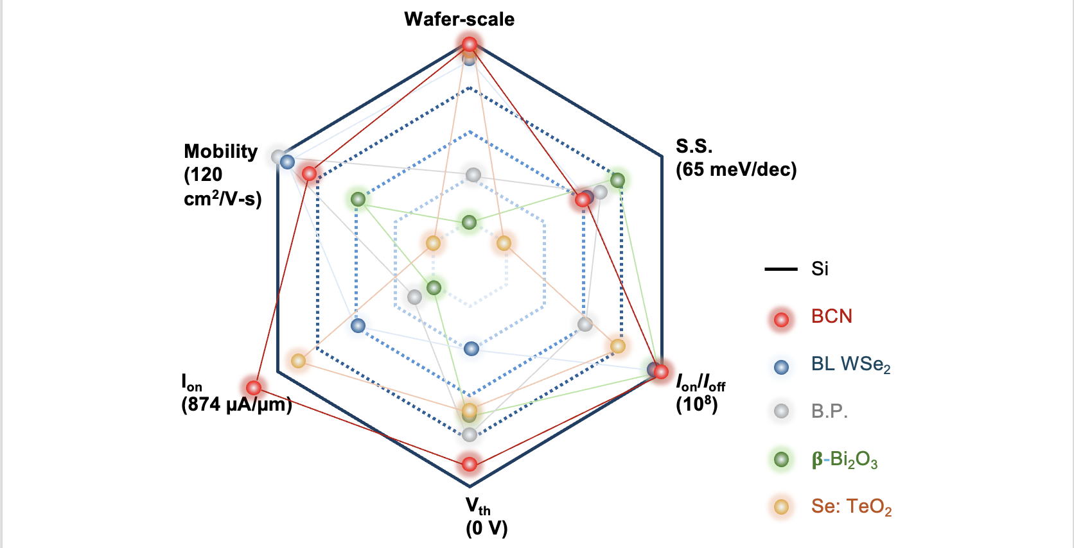
Supplementary Table 2 | The radar chart comparison of the electric performance of p-channel FETs between BCN (red dot), emerging 2D TMD (blue dot), non-TMD (gray and green dots), and amorphous oxides (orange dot) and the Si standard (black line).

Reference:
1. Markov, I. V. Crystal Growth for Beginners. (WORLD SCIENTIFIC, 2003). doi:10.1142/5172.
2. Gao, J., Yip, J., Zhao, J., Yakobson, B. I. & Ding, F. Graphene Nucleation on Transition Metal Surface: Structure Transformation and Role of the Metal Step Edge. J Am Chem Soc 133, 5009–5015 (2011).

