SUPPLEMENTARY MATERIAL
Reporting of Health Service Use
Respondents to the NHS were asked whether they had taken any of the following actions in the last 12 months (shown on a prompt card):
- Consulted a GP
- Consulted a specialist
- Consulted a dentist
- Consulted other health professional
- Admitted to hospital as an inpatient
- Visited an outpatient clinic
- Visited emergency/casualty
- Visited a day clinic.
More than one response was allowed. If the respondent indicated they had consulted an 'other health professional' in the last 12 months, they were asked (excluding any time spent in hospital) which other health professional(s) they had consulted, with a list of 24 other health professionals shown no a prompt card:
- Aboriginal Health Worker
- Accredited counsellor
- Acupuncturist
- Alcohol and drug worker
- Audiologist/Audiometrist
- Chemist/Pharmacist (for advice only)
- Chiropodist/Podiatrist
- Chiropractor
- Diabetes educator
- Dietitian/Nutritionist
- Naturopath
- Herbalist
- Hypnotherapist
- Nurse
- Occupational therapist
- Optician/Optometrist/Orthoptist
- Osteopath
- Physiotherapist/Hydrotherapist
- Psychologist
- Radiographer;
- Social worker/Welfare officer
- Sonographer
- Speech therapist/Pathologist
- Other.

More than one response was allowed.
In addition, respondents who had consulted a GP, specialist or dentist, been admitted to hospital as an inpatient, visited an outpatient or day clinic, or visited emergency/casualty in the last 12 months were asked how many times they had done so during that period.

Reporting of Medication Use
Respondents were asked for the names or brands of all medications and dietary supplements (vitamins, minerals or natural or herbal supplements) they had taken in the last 2 weeks. Respondents were encouraged to have all of their medications and supplements in front of them during the interview to assist in reporting the information. Interviewers recorded the Australian Register of Therapeutic Goods Administration (TGA) identification number of each medication taken by the respondent. The therapeutic substances people reported were coded as either ‘medications’ or as ‘dietary supplements’. Medications were coded based on their active ingredient(s) and their therapeutic application, to the World Health Organisation Anatomical Therapeutic Chemical (ATC) classification system.

Supplementary Table 1. Results of negative binomial regression model testing factors associated with the frequency of General Practitioner consultations in the past 12 months among disability benefit recipients.
 | IRR | LCI | UCI | p
Sex
Male | Ref
Female | 1.13 | 1.03 | 1.24 | 0.01
Age
18-24 | 0.81 | 0.59 | 1.11 | 0.19
25-34 | 1.10 | 0.88 | 1.36 | 0.41
35-44 | 1.06 | 0.93 | 1.21 | 0.41
45-54 | 0.95 | 0.86 | 1.06 | 0.39
55-64 | Ref
Age Started Smoking Daily
Never | Ref
<15 | 1.16 | 1.02 | 1.31 | 0.02
15-17 | 1.15 | 1.01 | 1.30 | 0.03
18-24 | 1.06 | 0.92 | 1.22 | 0.42
>24 | 1.08 | 0.81 | 1.44 | 0.60
Number of ICD-10 Categories
0-4 | Ref
5-9 | 1.29 | 1.12 | 1.47 | <0.001
10-14 | 1.35 | 1.16 | 1.56 | <0.001
15+ | 1.48 | 1.26 | 1.75 | <0.001
Pain in Past 4 Weeks
None | Ref
Mild/Very Mild | 1.14 | 0.97 | 1.35 | 0.11
Moderate | 1.15 | 0.98 | 1.35 | 0.09
Severe/Very Severe | 1.28 | 1.09 | 1.50 | 0.003
Highest Level of Education
Less than Year 12 | Ref
Year 12 | 0.96 | 0.83 | 1.11 | 0.60
Cert III/IV or Diploma | 1.06 | 0.96 | 1.18 | 0.26
Bachelor Degree | 1.05 | 0.87 | 1.27 | 0.62
Postgraduate Studies | 0.58 | 0.37 | 0.91 | 0.02
Self-Assessed Health
Excellent | 0.72 | 0.52 | 1.00 | 0.05
Very Good | 0.76 | 0.62 | 0.93 | 0.01
Good | 0.84 | 0.74 | 0.96 | 0.01
Fair | 0.89 | 0.80 | 1.00 | 0.05
Poor | Ref
Note: IRR = Incidence Rate Ratio; LCI = Lower Confidence Interval; UCI = Upper Confidence Interval; p = results of significance testing; Ref = reference category; ICD-10 = International Classification of Diseases version 10.
Supplementary Table 2. Results of negative binomial regression model testing factors associated with the frequency of hospital admission in the past 12 months among disability benefit recipients
 | IRR | LCI | UCI | p
Sex
Male | Ref
Female | 1.10 | 0.75 | 1.62 | 0.62
Age
18-24 | 4.76 | 1.80 | 12.62 | 0.002
25-34 | 0.92 | 0.34 | 2.48 | 0.87
35-44 | 1.68 | 0.96 | 2.92 | 0.07
45-54 | 0.90 | 0.59 | 1.38 | 0.63
55-64 | Ref
Self-Perceived Body Mass
Acceptable | Ref
Underweight | 3.79 | 1.91 | 7.54 | <0.001
Overweight | 1.20 | 0.79 | 1.83 | 0.40
Hypertension
No | Ref
Yes | 1.72 | 1.14 | 2.58 | 0.01
Number of ICD-10 Conditions
0-4 | Ref
5-9 | 1.74 | 0.96 | 3.18 | 0.07
10-14 | 2.26 | 1.20 | 4.26 | 0.01
15+ | 4.05 | 2.07 | 7.95 | <0.001
Self-Assessed Health
Excellent | 0.16 | 0.03 | 0.74 | 0.02
Very Good | 0.36 | 0.17 | 0.80 | 0.01
Good | 0.31 | 0.19 | 0.51 | <0.001
Fair | 0.49 | 0.32 | 0.74 | 0.001
Poor | Ref
Note: IRR = Incidence Rate Ratio; LCI = Lower Confidence Interval; UCI = Upper Confidence Interval; p = results of significance testing; Ref = reference category; ICD-10 = International Classification of Diseases version 10.
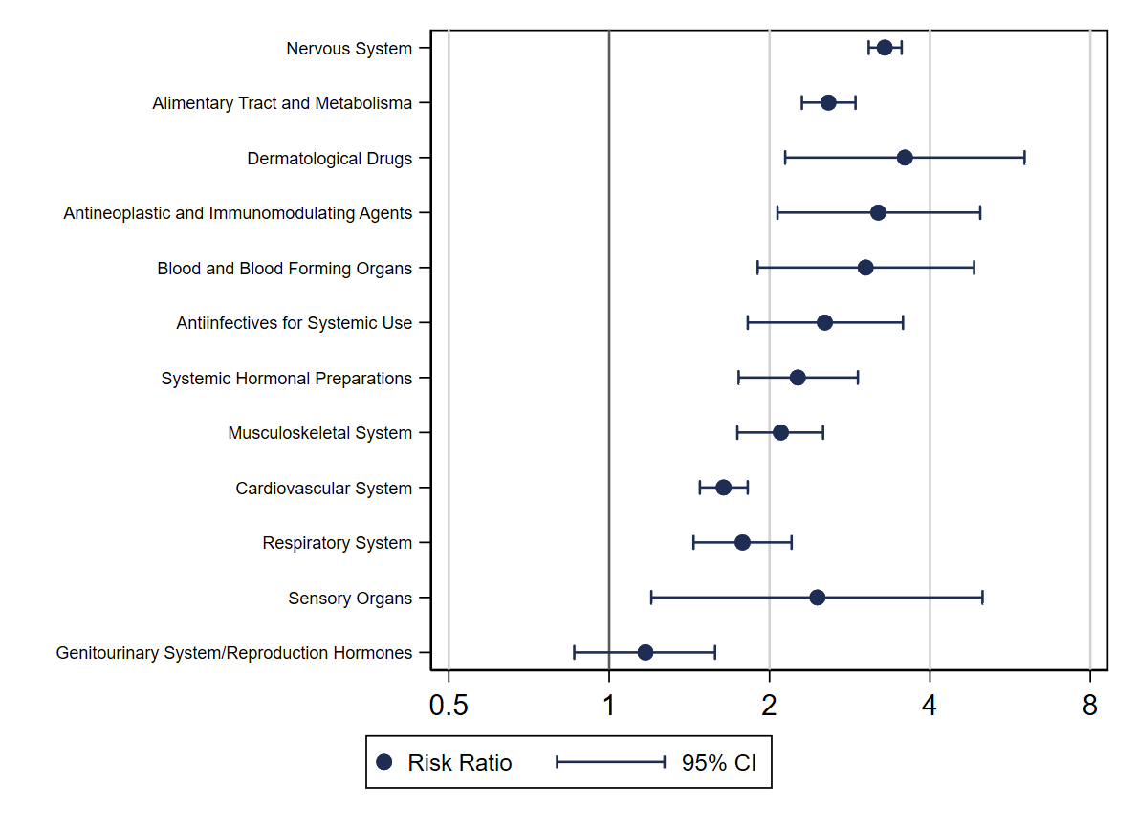
Supplementary Figure 1. Age and sex adjusted risk ratios for having used a medication from an Anatomical Therapeutic Chemical Classification System category at least once in the past 2 weeks for DSP recipients compared to the working population.
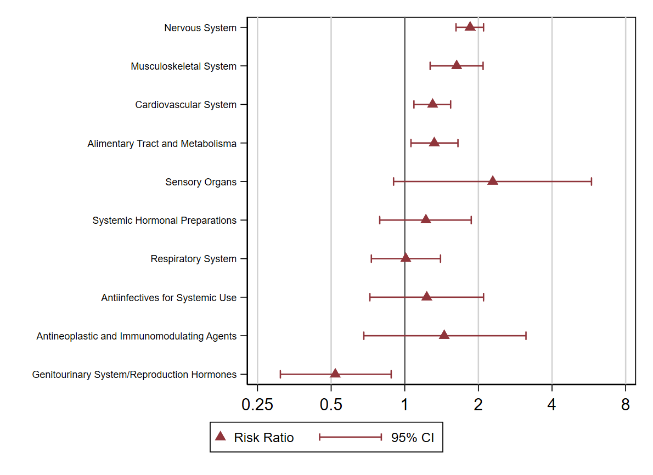
Supplementary Figure 2. Age and sex adjusted risk ratios for having used a medication from an Anatomical Therapeutic Chemical Classification System category at least once in the past 2 weeks for NSA recipients compared to the working population.

