Supporting Information
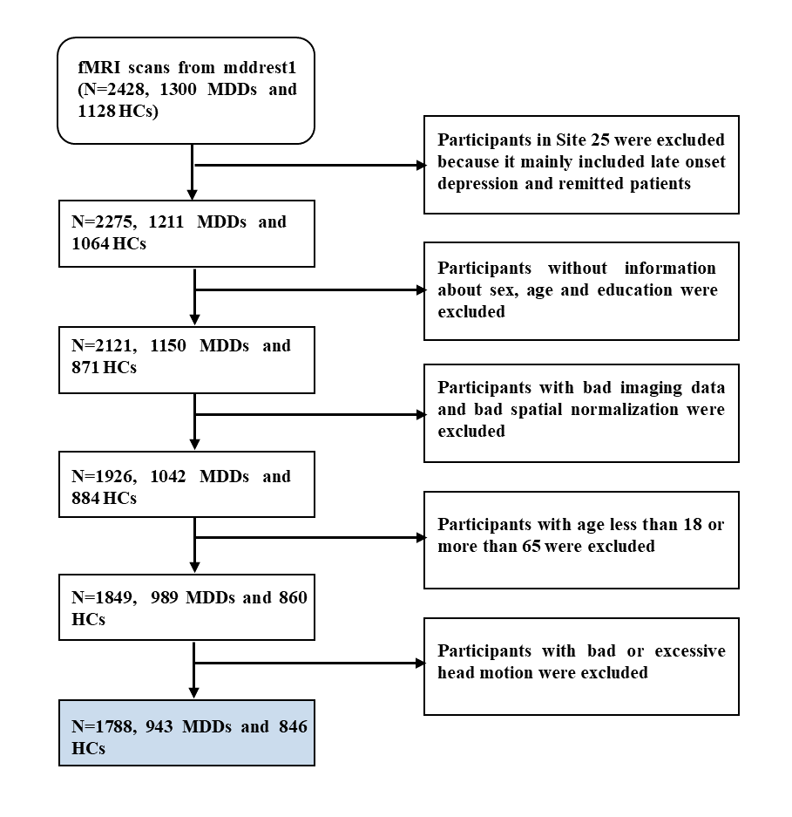
Figure S1. Sample Selection of REST-meta-MDD 1. From 2428 subjects, 1788 subjects were selected through above criteria.
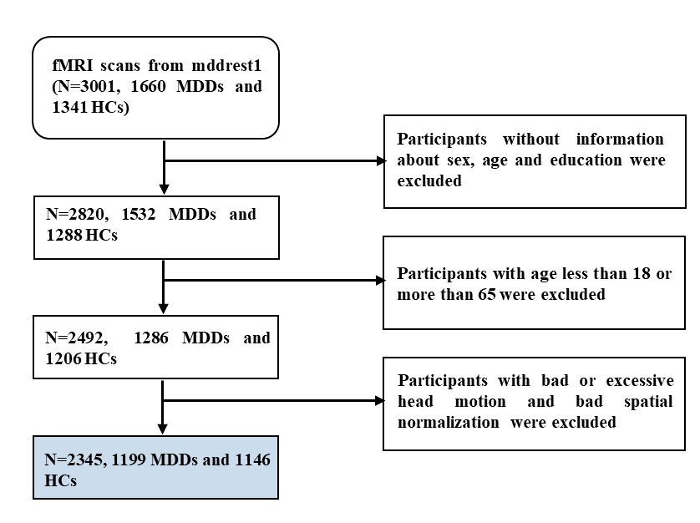
Figure S2. Sample Selection of REST-meta-MDD 2. From 3001 subjects, 2345 subjects were selected through above criteria.

Figure S3 Reduced EC from mPFC to PCC within DMN in patients with recurrent MDD. (A) Violin plots depict the distribution of mean EC from mPFC to PCC differences among various groups in REST-meta-MDD 1. B Violin plots depict the distribution of mean EC from mPFC to PCC differences among various groups in REST-meta-MDD 2. It is noteworthy that, for each comparison, only sites with a sample size larger than 10 in each group were considered. The t values represent the statistics for these comparisons in Linear Mixed-Effects Model (LMM) analyses. FEDN, First Episode Drug Naïve. *p < 0.05; **p < 0.01.

