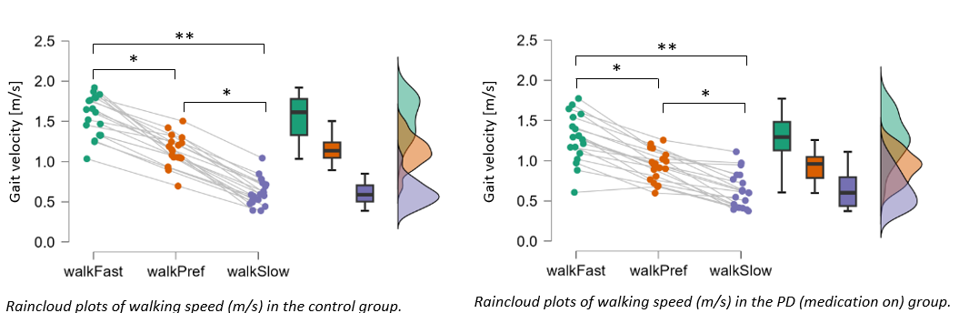
S-I. Differences in gait speed during walking trials.
Supplementary Fig. 1 Fast (green), preferred (orange), and slow (purple) gait speed of controls (left) and pwPD (right)

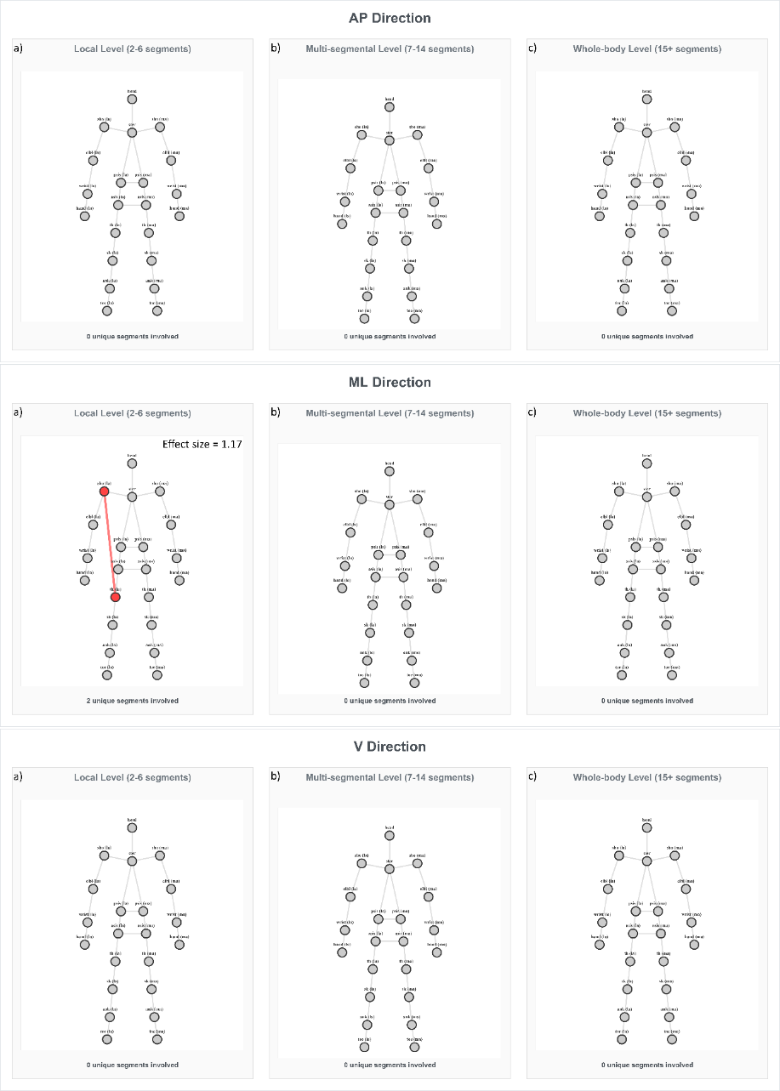
S-II. Inter-segmental coordination patterns in slow walking speed.
Supplementary Fig. 2 Significantly different coordination pattern between PD and controls at slow walking speed. Connected nodes indicate the strongest coordination deficit in pwPD. Red indicates weaker inter-segmental coordination in the PD group than in the control group. ASIS – anterior superior iliac spine; PSIS – posterior superior iliac spine
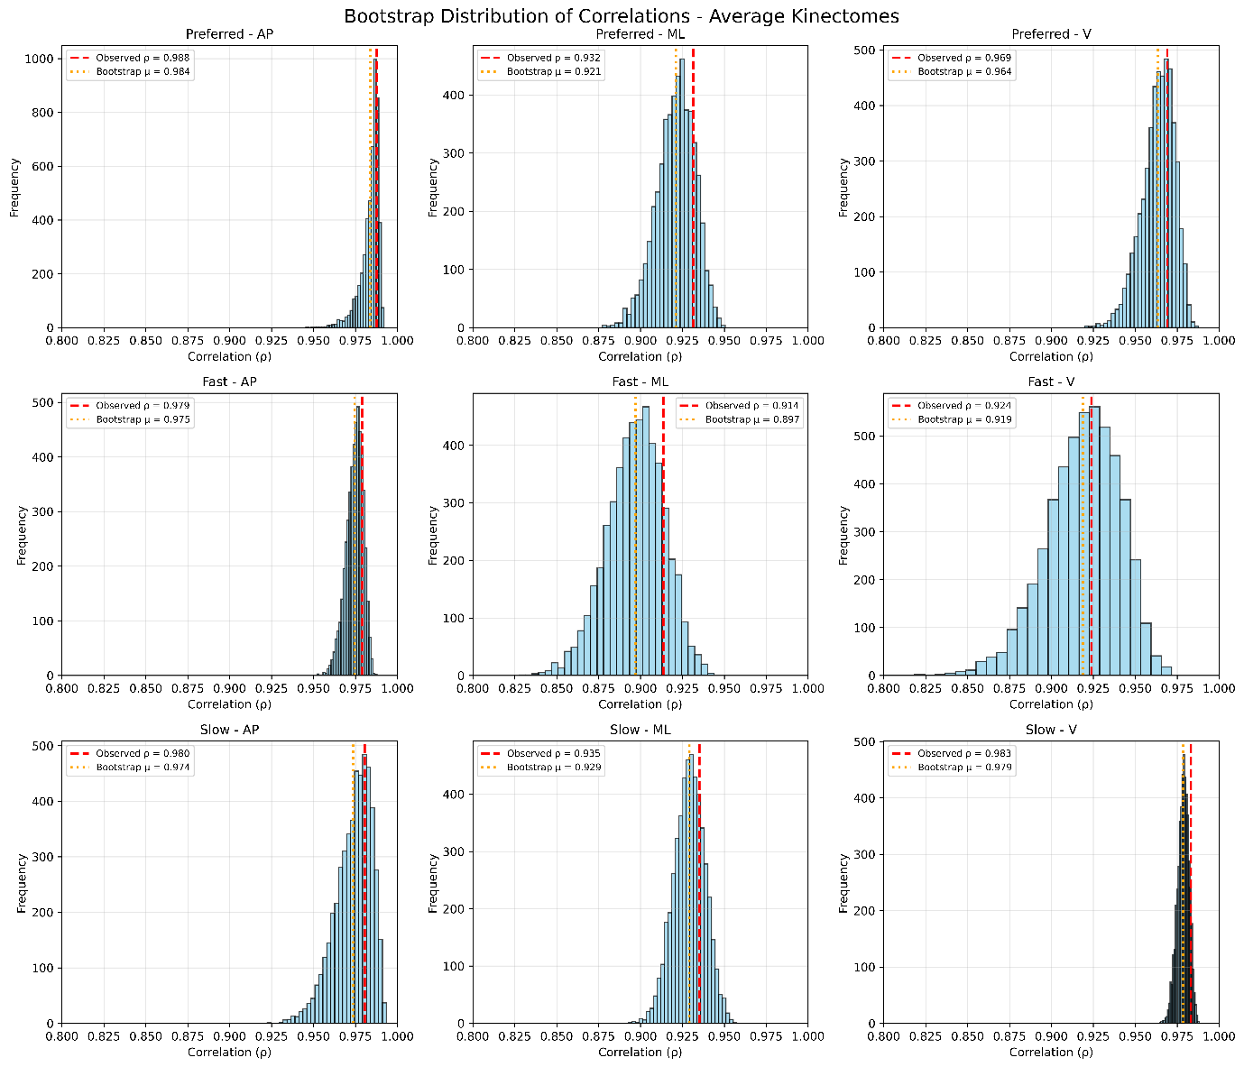
S-III. Bootstrapping of the average kinectomes
Supplementary Fig. 3 Bootstrap distribution of correlations for the average kinectomes. The orange dashed line indicates the mean of the bootstrapped rho, and the red dashed line indicates the observed rho, both from permutation testing using Spearman’s correlation to evaluate the correlation between the group-specific average kinectomes
S-IV. Bootstrapping of the standard deviation kinectomes
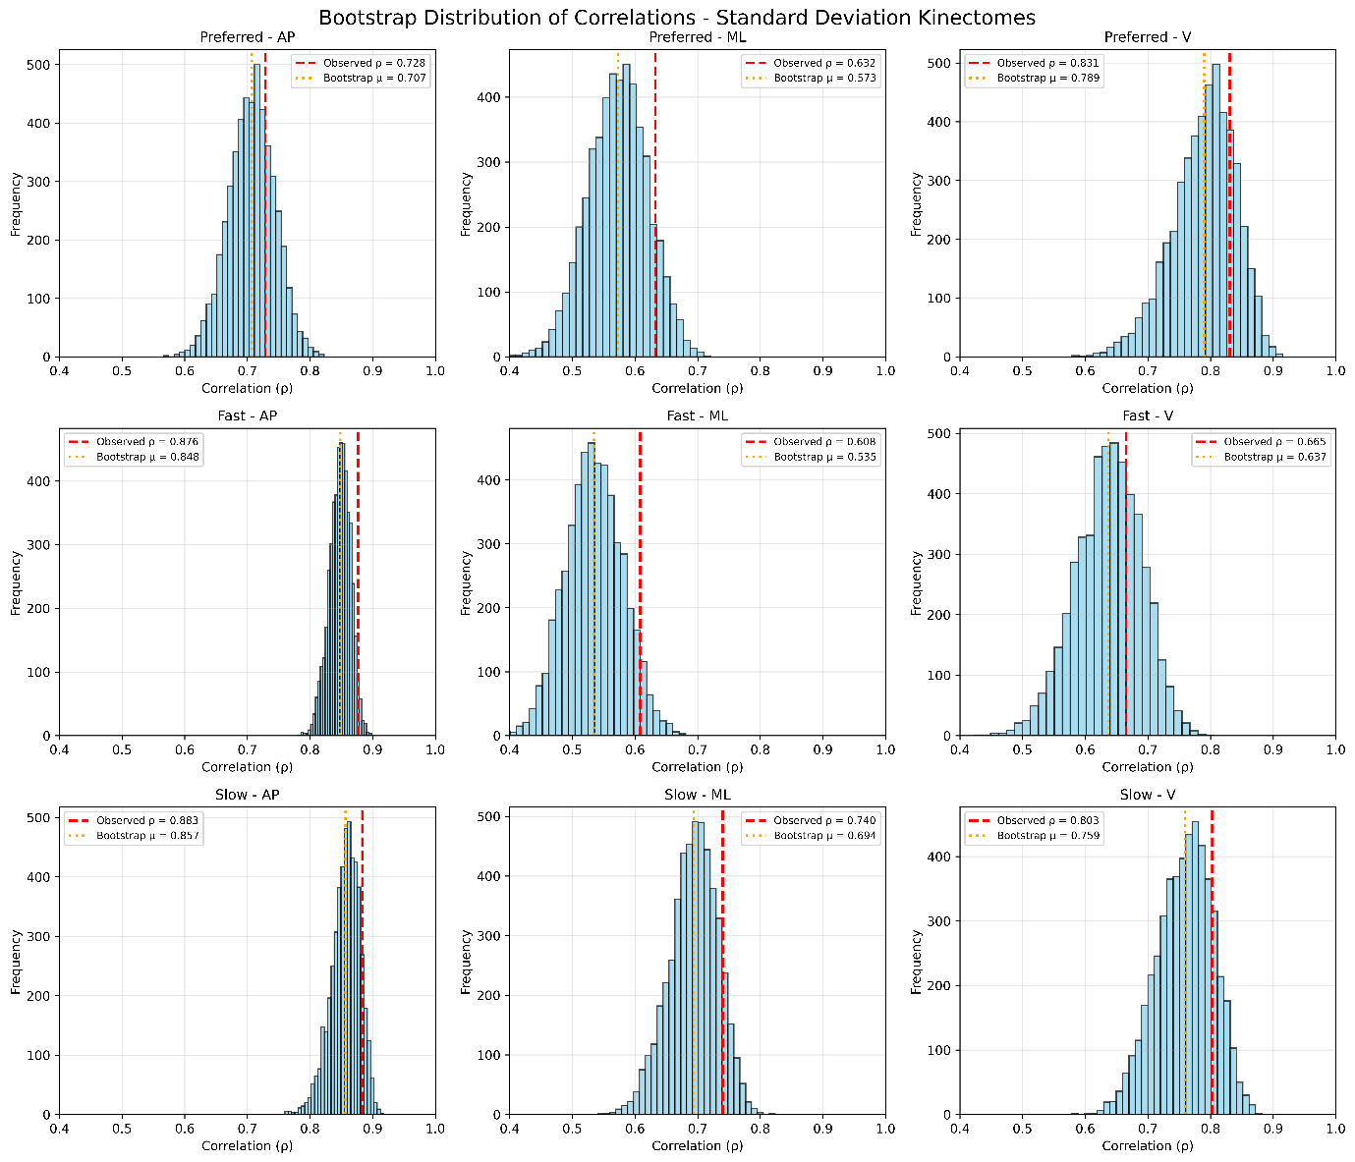
Supplementary Fig. 4 Bootstrap distribution of correlations for the standard deviation kinectomes. The orange dashed line indicates the mean of the bootstrapped rho, and the red dashed line indicates the observed rho, both from permutation testing using Spearman’s correlation to evaluate the correlation between the group-specific standard deviation kinectomes

S-V. Strongest patterns found in the PD group, and their comparison with the same patterns in the control group
Supplementary Table 1. Strongest patterns found in the PD group
Pattern | Pattern length | PD (mean ± SD) | Controls (mean ± SD) | p-value | Effect size
Fast walking speed
AP direction
ankle_mas-toe_mas-shoulder_las-head-shoulder_mas | 5 | 6.0 ± 0.4 | 5.5 ± 0.5 | <.001 | 1.1
ML direction – no significant differences
V direction
thigh_mas-shank_mas-wrist_las-hand_las-psis_las-elbow_mas-wrist_mas | 7 | 8.2 ± 1.1 | 7.2 ± 0.9 | .02 | 1
shoulder_mas-ankle_las-toe_las-shank_las-hand_mas-wrist_mas-asis_las-hand_las-shoulder_las-ankle_mas-shank_mas-wrist_las-elbow_las | 13 | 11.0 ± 1.9 | 9.2 ± 1.6 | .04 | -0.52
shoulder_mas-ankle_las-toe_las-shank_las-hand_mas-wrist_mas-asis_las-hand_las-shoulder_las-ankle_mas-shank_mas-wrist_las-elbow_las-psis_mas | 14 | 12.5 ± 2.0 | 10.7 ± 1.8 | .04 | 0.95
Preferred walking speed
AP direction
head-psis_mas | 2 | 1.3 ± 0.3 | 1.6 ± 0.3 | .04 | 0.56
sternum-psis_las | 2 | 1.7 ± 0.1 | 1.8 ± 0.1 | <.001 | 0.75
wrist_las-hand_las | 2 | 1.8 ± 0.1 | 1.9 ± 0.1 | .04 | 0.53
asis_las-psis_las | 2 | 1.8 ± 0.1 | 1.9 ± 0.1 | <.001 | 0.65
psis_mas-asis_las | 2 | 1.6 ± 0.2 | 1.8 ± 0.1 | .02 | 0.6
head-psis_mas-psis_las | 3 | 3.0 ± 0.3 | 3.4 ± 0.3 | .02 | 0.58
sternum-psis_las-psis_mas | 3 | 3.4 ± 0.3 | 3.7 ± 0.2 | <.001 | 0.69
asis_las-psis_las-asis_mas | 3 | 3.4 ± 0.3 | 3.7 ± 0.2 | <.001 | 0.66
psis_mas-asis_las-psis_las | 3 | 3.4 ± 0.3 | 3.7 ± 0.1 | <.001 | 0.64
sternum-psis_las-psis_mas-asis_las | 4 | 5.0 ± 0.4 | 5.5 ± 0.3 | <.001 | 0.68
hand_las-asis_las-psis_las-sternum | 4 | 4.0 ± 0.3 | 4.4 ± 0.3 | .04 | 1.33
asis_las-psis_las-asis_mas-psis_mas | 4 | 5.2 ± 0.3 | 5.6 ± 0.2 | <.001 | 0.69
head-psis_mas-asis_mas-psis_las-elbow_las | 5 | 5.7 ± 0.5 | 6.2 ± 0.5 | .02 | 1.0
sternum-psis_las-asis_mas-asis_las-hand_las | 5 | 5.4 ± 0.5 | 6.0 ± 0.5 | <.001 | 0.62
asis_las-psis_las-asis_mas-sternum-psis_mas | 5 | 6.7 ± 0.5 | 7.3 ± 0.3 | <.001 | 0.73
psis_mas-asis_las-psis_las-sternum-shoulder_las | 5 | 6.6 ± 0.5 | 7.2 ± 0.3 | <.001 | 1.43
head-psis_mas-asis_mas-psis_las-sternum-shoulder_mas | 6 | 8.1 ± 0.6 | 8.8 ± 0.5 | <.001 | 0.66
sternum-psis_las-asis_mas-psis_mas-asis_las-hand_las | 6 | 7.3 ± 0.6 | 7.9 ± 0.5 | .02 | 1.08
asis_las-psis_las-asis_mas-sternum-psis_mas-elbow_las | 6 | 7.7 ± 0.6 | 8.4 ± 0.3 | <.001 | 1.45
psis_mas-asis_las-psis_las-sternum-asis_mas-hand_mas | 6 | 7.6 ± 0.7 | 8.3 ± 0.4 | <.001 | 1.21
ankle_las-toe_las-shoulder_mas-asis_las-psis_las-psis_mas | 6 | 7.2 ± 0.6 | 7.9 ± 0.4 | <.001 | 0.67
head-psis_mas-asis_mas-sternum-psis_las-asis_las-shoulder_mas | 7 | 9.6 ± 0.8 | 10.6 ± 0.6 | <.001 | 1.4
sternum-psis_las-asis_mas-asis_las-hand_las-wrist_las-elbow_las | 7 | 8.9 ± 0.7 | 9.7 ± 0.6 | <.001 | 1.22
shoulder_mas-ankle_las-toe_las-shank_las-elbow_mas-head-psis_mas | 7 | 7.6 ± 0.8 | 8.3 ± 0.8 | .02 | 0.57
hand_las-asis_las-psis_las-psis_mas-sternum-shoulder_las-wrist_las | 7 | 8.3 ± 0.6 | 9.0 ± 0.6 | .04 | 1.17
hand_mas-wrist_las-hand_las-elbow_las-psis_mas-asis_las-psis_las | 7 | 8.1 ± 0.7 | 8.5 ± 0.3 | .04 | 0.54
asis_las-psis_las-asis_mas-sternum-psis_mas-elbow_las-shoulder_las | 7 | 9.1 ± 0.7 | 9.8 ± 0.4 | .02 | 1.21
asis_mas-elbow_mas-wrist_mas-hand_mas-shank_las-sternum-psis_las | 7 | 8.7 ± 0.8 | 9.5 ± 0.8 | .04 | 0.56
psis_las-asis_las-hand_las-wrist_las-thigh_las-shank_las-elbow_mas | 7 | 7.8 ± 0.5 | 8.3 ± 0.4 | .02 | 1.1
psis_mas-asis_las-psis_las-sternum-shoulder_mas-thigh_las-shank_las | 7 | 9.7 ± 0.7 | 10.6 ± 0.4 | <.001 | 1.55
ankle_las-toe_las-shoulder_mas-head-psis_mas-sternum-shoulder_las | 7 | 8.6 ± 0.6 | 9.2 ± 0.6 | <.001 | 0.65
ankle_mas-toe_mas-shoulder_las-psis_mas-psis_las-sternum-head | 7 | 8.7 ± 0.6 | 9.3 ± 0.4 | <.001 | 1.16
toe_las-ankle_las-shoulder_mas-sternum-psis_mas-elbow_mas-wrist_mas | 7 | 8.8 ± 0.5 | 9.3 ± 0.5 | .04 | 1.0
shoulder_mas-ankle_las-toe_las-shank_las-elbow_mas-head-psis_mas-asis_mas | 8 | 9.4 ± 0.8 | 10.2 ± 0.8 | .02 | 0.58
hand_las-asis_las-psis_las-psis_mas-sternum-shoulder_las-wrist_las-elbow_las | 8 | 10.0 ± 0.8 | 10.8 ± 0.7 | .04 | 1.06
asis_mas-elbow_mas-wrist_mas-hand_mas-shank_las-thigh_las-psis_mas-asis_las | 8 | 10.6 ± 0.9 | 11.5 ± 0.9 | .02 | 0.58
psis_las-asis_las-hand_las-wrist_las-thigh_las-shank_las-elbow_mas-hand_mas | 8 | 9.4 ± 0.7 | 10.0 ± 0.5 | .04 | 0.98
psis_mas-asis_las-psis_las-sternum-shoulder_mas-thigh_las-shank_las-hand_mas | 8 | 11.0 ± 1.0 | 12.1 ± 0.9 | <.001 | 0.62
shank_las-wrist_mas-hand_mas-thigh_mas-asis_mas-psis_mas-shoulder_las-psis_las | 8 | 9.6 ± 0.8 | 10.4 ± 0.6 | .02 | 1.12
ankle_las-toe_las-shoulder_mas-head-psis_las-hand_las-shank_las-elbow_mas | 8 | 7.7 ± 0.5 | 8.2 ± 0.5 | .02 | 1.0
ankle_mas-toe_mas-shoulder_las-psis_mas-head-sternum-asis_las-shoulder_mas | 8 | 9.6 ± 0.9 | 10.6 ± 0.8 | <.001 | 0.65
head-psis_mas-asis_mas-psis_las-sternum-shoulder_mas-shoulder_las-ankle_mas-toe_mas | 9 | 11.9 ± 0.8 | 12.7 ± 0.7 | .04 | 0.54
shoulder_mas-ankle_las-toe_las-shank_las-elbow_mas-head-psis_mas-asis_mas-psis_las | 9 | 11.0 ± 0.8 | 12.0 ± 0.9 | <.001 | 0.62
hand_las-asis_las-psis_las-sternum-psis_mas-asis_mas-hand_mas-wrist_mas-elbow_mas | 9 | 12.0 ± 0.8 | 12.8 ± 0.6 | .02 | 1.12
asis_mas-elbow_mas-wrist_mas-hand_mas-shank_las-thigh_las-shoulder_mas-psis_las-asis_las | 9 | 12.2 ± 1.0 | 13.3 ± 1.0 | .02 | 0.58
psis_las-asis_las-hand_las-wrist_las-thigh_las-elbow_mas-hand_mas-ankle_las-toe_las | 9 | 10.7 ± 0.8 | 11.5 ± 0.6 | .02 | 1.12
shank_las-wrist_mas-hand_mas-thigh_mas-asis_mas-psis_mas-shoulder_las-sternum-asis_las | 9 | 11.5 ± 0.8 | 12.3 ± 0.6 | <.001 | 0.61
ankle_las-toe_las-shoulder_mas-head-psis_las-hand_las-shank_las-elbow_mas-wrist_mas | 9 | 9.4 ± 0.6 | 10.0 ± 0.6 | <.001 | 1.0
toe_las-ankle_las-shoulder_mas-asis_las-psis_las-hand_las-wrist_las-shank_las-elbow_mas | 9 | 9.9 ± 0.6 | 10.7 ± 0.5 | <.001 | 1.44
toe_mas-ankle_mas-shoulder_las-psis_mas-asis_las-psis_las-sternum-shoulder_mas-head | 9 | 12.2 ± 0.8 | 13.0 ± 0.6 | .04 | 0.55
head-psis_mas-asis_mas-psis_las-sternum-shoulder_mas-shoulder_las-ankle_mas-toe_mas-hand_las | 10 | 13.2 ± 1.0 | 14.1 ± 0.9 | .04 | 0.54
shank_las-wrist_mas-hand_mas-thigh_mas-asis_mas-psis_mas-shoulder_las-psis_las-asis_las-elbow_mas | 10 | 12.7 ± 1.0 | 13.7 ± 0.8 | .02 | 1.1
ankle_las-toe_las-shoulder_mas-head-psis_las-hand_las-shank_las-elbow_mas-wrist_mas-hand_mas | 10 | 11.2 ± 0.6 | 12.0 ± 0.6 | <.001 | 1.33
ankle_mas-toe_mas-shoulder_las-psis_mas-asis_las-shoulder_mas-head-sternum-psis_las-hand_las | 10 | 12.2 ± 1.0 | 13.1 ± 0.9 | .02 | 0.94
toe_las-ankle_las-shoulder_mas-asis_las-psis_las-hand_las-wrist_las-shank_las-elbow_mas-wrist_mas | 10 | 11.6 ± 0.7 | 12.5 ± 0.5 | <.001 | 1.46
hand_las-asis_las-psis_las-asis_mas-hand_mas-wrist_mas-elbow_mas-ankle_las-shank_las-thigh_las-shoulder_las | 11 | 13.6 ± 0.9 | 14.7 ± 0.7 | <.001 | 0.64
psis_mas-asis_las-hand_las-wrist_las-thigh_las-shoulder_las-shoulder_mas-ankle_las-toe_las-elbow_mas-hand_mas | 11 | 12.0 ± 0.8 | 12.9 ± 0.6 | <.001 | 1.26
ankle_las-toe_las-shoulder_mas-head-psis_mas-asis_las-psis_las-hand_las-shank_las-elbow_mas-wrist_mas | 11 | 12.7 ± 0.8 | 13.7 ± 0.6 | <.001 | 1.4
ankle_mas-toe_mas-shoulder_las-head-sternum-psis_mas-asis_las-shoulder_mas-psis_las-hand_las-shank_mas | 11 | 13.6 ± 1.3 | 14.8 ± 1.0 | .04 | 1.03
toe_las-ankle_las-shoulder_mas-head-psis_mas-asis_las-psis_las-hand_las-sternum-shoulder_las-asis_mas | 11 | 12.9 ± 1.0 | 14.1 ± 1.0 | <.001 | 1.2
sternum-psis_las-asis_las-hand_las-wrist_las-elbow_las-head-shoulder_mas-ankle_las-toe_las-hand_mas-ankle_mas | 12 | 14.5 ± 0.8 | 15.3 ± 0.7 | <.001 | 0.65
elbow_mas-shank_las-hand_mas-ankle_mas-shoulder_las-head-psis_mas-asis_mas-psis_las-sternum-shoulder_mas-ankle_las | 12 | 14.3 ± 1.3 | 15.4 ± 1.1 | .02 | 0.57
hand_las-asis_las-psis_las-asis_mas-hand_mas-wrist_mas-elbow_mas-ankle_las-shoulder_mas-head-shoulder_las-wrist_las | 12 | 14.4 ± 1.1 | 15.4 ± 1.0 | .04 | 0.95
psis_mas-asis_las-psis_las-sternum-shoulder_mas-ankle_las-toe_las-shoulder_las-head-asis_mas-hand_mas-wrist_mas | 12 | 15.2 ± 0.7 | 16.4 ± 0.7 | <.001 | 1.71
shank_las-wrist_mas-hand_mas-ankle_mas-shoulder_las-psis_las-asis_las-thigh_las-shoulder_mas-ankle_las-toe_las-head | 12 | 13.2 ± 1.0 | 14.2 ± 0.8 | .04 | 0.55
ankle_las-toe_las-shoulder_mas-head-psis_mas-asis_las-psis_las-hand_las-shank_las-elbow_mas-wrist_mas-hand_mas | 12 | 14.6 ± 0.8 | 15.6 ± 0.7 | <.001 | 1.32
head-psis_mas-asis_mas-psis_las-sternum-shoulder_mas-shoulder_las-ankle_mas-shank_mas-wrist_las-hand_las-elbow_las-shank_las | 13 | 17.0 ± 1.1 | 18.0 ± 0.9 | .04 | 0.55
sternum-psis_las-asis_las-hand_las-wrist_las-elbow_las-head-shoulder_mas-ankle_las-toe_las-hand_mas-wrist_mas-shank_las | 13 | 17.1 ± 1.4 | 18.3 ± 1.2 | .04 | 0.55
wrist_mas-hand_mas-shank_las-hand_las-wrist_las-thigh_las-shoulder_mas-ankle_las-toe_las-elbow_las-shank_mas-thigh_mas-asis_mas | 13 | 14.6 ± 0.8 | 15.3 ± 0.6 | .02 | 0.58
hand_las-asis_las-psis_las-sternum-psis_mas-asis_mas-hand_mas-wrist_mas-elbow_mas-ankle_las-shoulder_mas-head-shoulder_las | 13 | 16.9 ± 1.1 | 18.2 ± 0.9 | <.001 | 1.28
asis_las-psis_las-asis_mas-hand_mas-ankle_las-toe_las-shoulder_mas-head-psis_mas-sternum-shoulder_las-ankle_mas-toe_mas | 13 | 16.5 ± 1.1 | 17.8 ± 1.0 | <.001 | 0.62
asis_mas-elbow_mas-hand_mas-wrist_mas-shank_las-hand_las-wrist_las-elbow_las-shank_mas-thigh_mas-head-asis_las-shoulder_mas | 13 | 16.7 ± 1.4 | 18.2 ± 1.2 | .02 | 0.6
psis_mas-asis_las-psis_las-sternum-shoulder_mas-ankle_las-toe_las-shoulder_las-head-asis_mas-hand_mas-wrist_mas-shank_las | 13 | 16.5 ± 1.0 | 18.0 ± 1.1 | <.001 | 1.43
ankle_las-toe_las-shoulder_mas-head-psis_mas-asis_las-psis_las-hand_las-shank_las-elbow_mas-hand_mas-wrist_mas-wrist_las | 13 | 14.7 ± 0.9 | 15.6 ± 0.7 | .02 | 1.11
ankle_mas-toe_mas-shoulder_las-head-sternum-psis_mas-thigh_mas-shank_mas-wrist_las-elbow_las-psis_las-asis_las-shoulder_mas | 13 | 17.3 ± 1.2 | 18.4 ± 1.0 | .04 | 0.99
toe_mas-ankle_mas-shoulder_las-head-asis_las-psis_mas-sternum-psis_las-hand_las-shank_mas-wrist_las-elbow_las-toe_las | 13 | 15.8 ± 1.4 | 17.0 ± 1.2 | .04 | 0.92
head-psis_mas-asis_mas-psis_las-asis_las-shoulder_mas-sternum-shoulder_las-ankle_mas-shank_mas-wrist_las-elbow_las-shank_las-wrist_mas | 14 | 18.2 ± 1.4 | 19.7 ± 1.2 | <.001 | 0.61
hand_las-asis_las-psis_las-sternum-psis_mas-asis_mas-hand_mas-wrist_mas-thigh_las-shank_las-head-shoulder_las-wrist_las-elbow_las | 14 | 18.5 ± 1.3 | 19.8 ± 1.0 | <.001 | 1.11
asis_mas-elbow_mas-hand_mas-wrist_mas-shank_las-hand_las-wrist_las-elbow_las-shank_mas-thigh_mas-head-asis_las-shoulder_mas-ankle_las | 14 | 17.4 ± 1.4 | 19.0 ± 1.2 | .02 | 0.61
toe_las-ankle_las-shoulder_mas-head-psis_mas-asis_las-psis_las-hand_las-sternum-shoulder_las-asis_mas-hand_mas-shank_las-elbow_mas | 14 | 16.4 ± 1.7 | 18.1 ± 1.5 | .02 | 1.06
toe_mas-ankle_mas-shoulder_las-head-asis_las-psis_mas-sternum-psis_las-hand_las-shank_mas-wrist_las-elbow_las-toe_las-ankle_las | 14 | 17.6 ± 1.4 | 18.9 ± 1.2 | .04 | 0.99
elbow_mas-shank_las-hand_mas-wrist_mas-thigh_las-shoulder_mas-ankle_las-toe_las-head-psis_mas-asis_mas-sternum-shoulder_las-hand_las-wrist_las | 15 | 19.1 ± 2.2 | 20.9 ± 2.2 | .02 | 0.58
asis_las-psis_las-asis_mas-hand_mas-wrist_mas-shank_las-hand_las-wrist_las-elbow_las-shank_mas-thigh_mas-psis_mas-sternum-shoulder_mas-head | 15 | 20.7 ± 1.2 | 21.9 ± 1.0 | .02 | 1.08
asis_mas-elbow_mas-hand_mas-wrist_mas-thigh_las-shoulder_mas-ankle_las-toe_las-shank_las-hand_las-wrist_las-elbow_las-shank_mas-thigh_mas-head | 15 | 19.0 ± 1.4 | 20.3 ± 1.2 | .04 | 0.54
shank_mas-hand_mas-wrist_mas-shank_las-elbow_mas-ankle_las-shoulder_mas-asis_mas-psis_mas-sternum-psis_las-head-shoulder_las-ankle_mas-toe_mas | 15 | 18.8 ± 1.7 | 20.4 ± 1.5 | .04 | 0.56
toe_mas-ankle_mas-shoulder_las-head-asis_las-psis_mas-sternum-psis_las-hand_las-shank_mas-wrist_las-elbow_las-toe_las-ankle_las-thigh_las | 15 | 18.5 ± 1.5 | 19.9 ± 1.2 | .04 | 1.02
elbow_mas-shank_las-hand_mas-wrist_mas-thigh_las-shoulder_mas-ankle_las-psis_las-sternum-psis_mas-asis_mas-asis_las-hand_las-ankle_mas-shoulder_las-head | 16 | 19.1 ± 2.8 | 21.1 ± 2.6 | .04 | 0.53
wrist_mas-hand_mas-shank_las-elbow_mas-shank_mas-wrist_las-hand_las-ankle_las-toe_las-shoulder_las-asis_mas-sternum-psis_mas-psis_las-asis_las-shoulder_mas | 16 | 20.6 ± 1.4 | 22.2 ± 1.1 | <.001 | 1.26
hand_mas-wrist_las-elbow_mas-shank_las-thigh_las-shoulder_mas-ankle_las-toe_las-shoulder_las-head-sternum-psis_mas-asis_mas-wrist_mas-thigh_mas-shank_mas | 16 | 17.7 ± 1.3 | 18.4 ± 1.0 | .04 | 0.55
asis_las-psis_las-asis_mas-hand_mas-wrist_mas-shank_las-hand_las-wrist_las-elbow_las-shank_mas-thigh_mas-psis_mas-sternum-shoulder_mas-head-shoulder_las | 16 | 22.3 ± 1.3 | 23.5 ± 1.1 | .04 | 0.99
asis_mas-elbow_mas-hand_mas-wrist_mas-thigh_las-shoulder_mas-ankle_las-toe_las-shank_las-hand_las-wrist_las-elbow_las-shank_mas-thigh_mas-head-asis_las | 16 | 20.2 ± 1.4 | 21.8 ± 1.3 | .02 | 0.59
shank_mas-hand_mas-wrist_mas-shank_las-elbow_mas-ankle_las-shoulder_mas-asis_mas-psis_mas-sternum-psis_las-head-shoulder_las-ankle_mas-toe_mas-thigh_las | 16 | 19.0 ± 1.7 | 20.5 ± 1.5 | .04 | 0.53
sternum-psis_las-asis_las-hand_las-wrist_las-elbow_las-shank_mas-hand_mas-wrist_mas-shank_las-head-shoulder_mas-ankle_las-elbow_mas-psis_mas-asis_mas-shoulder_las | 17 | 21.4 ± 1.7 | 23.0 ± 1.4 | .04 | 0.55
elbow_mas-shank_las-hand_mas-wrist_mas-thigh_las-shoulder_mas-ankle_las-psis_las-sternum-psis_mas-asis_mas-asis_las-hand_las-wrist_las-ankle_mas-shoulder_las-head | 17 | 21.0 ± 2.8 | 23.0 ± 2.7 | .04 | 0.54
wrist_mas-hand_mas-shank_las-hand_las-ankle_las-toe_las-shoulder_las-asis_mas-sternum-psis_mas-psis_las-asis_las-shoulder_mas-head-toe_mas-ankle_mas-shank_mas | 17 | 21.2 ± 1.2 | 22.4 ± 1.1 | .02 | 1.04
asis_mas-elbow_mas-hand_mas-wrist_mas-thigh_las-shoulder_mas-ankle_las-toe_las-shank_las-hand_las-wrist_las-elbow_las-shank_mas-thigh_mas-head-asis_las-psis_las | 17 | 22.0 ± 1.5 | 23.7 ± 1.3 | .02 | 0.6
shank_mas-hand_mas-wrist_mas-shank_las-elbow_mas-ankle_las-shoulder_mas-asis_mas-psis_mas-sternum-psis_las-head-shoulder_las-ankle_mas-toe_mas-thigh_las-asis_las | 17 | 20.5 ± 1.8 | 22.1 ± 1.6 | .04 | 0.54
asis_mas-elbow_mas-hand_mas-wrist_mas-thigh_las-shoulder_mas-ankle_las-toe_las-shank_las-hand_las-wrist_las-ankle_mas-shoulder_las-psis_mas-sternum-asis_las-psis_las-head | 18 | 22.8 ± 1.6 | 24.7 ± 1.4 | <.001 | 1.26
hand_mas-wrist_las-hand_las-elbow_las-shank_las-elbow_mas-ankle_las-psis_las-sternum-psis_mas-asis_mas-wrist_mas-thigh_mas-shoulder_las-head-shoulder_mas-asis_las-thigh_las-toe_las | 19 | 22.1 ± 1.5 | 23.5 ± 1.2 | .02 | 0.56
shank_mas-hand_mas-wrist_mas-shank_las-elbow_mas-psis_mas-sternum-psis_las-head-shoulder_mas-asis_mas-asis_las-hand_las-wrist_las-elbow_las-ankle_mas-toe_mas-shoulder_las-ankle_las | 19 | 23.7 ± 1.7 | 25.3 ± 1.5 | .04 | 0.99
shank_mas-hand_mas-wrist_mas-shank_las-elbow_mas-psis_mas-sternum-psis_las-head-shoulder_mas-asis_mas-asis_las-hand_las-wrist_las-elbow_las-ankle_mas-toe_mas-shoulder_las-ankle_las-toe_las | 20 | 25.5 ± 1.7 | 27.2 ± 1.6 | .04 | 1.03
ML direction
elbow_las-shank_mas-wrist_las-hand_las-ankle_las | 5 | 3.1 ± 0.5 | 3.7 ± 0.5 | .02 | 1.2
thigh_las-hand_mas-thigh_mas-elbow_las-shank_mas-wrist_las-hand_las-ankle_las-toe_las-head | 10 | 6.7 ± 0.9 | 7.7 ± 0.9 | .02 | 1.11
thigh_las-hand_mas-thigh_mas-elbow_las-shank_mas-wrist_las-hand_las-ankle_las-toe_las-head-shoulder_mas-asis_las | 12 | 9.1 ± 1.0 | 10.3 ± 1.0 | <.001 | 1.2
wrist_mas-hand_mas-shank_las-hand_las-wrist_las-thigh_las-shoulder_mas-ankle_las-toe_las-elbow_las-shank_mas-thigh_mas-asis_mas | 13 | 10.3 ± 0.9 | 11.3 ± 0.9 | <.001 | 1.11
wrist_mas-hand_mas-shank_las-hand_las-ankle_las-toe_las-elbow_las-shank_mas-wrist_las-thigh_las-shoulder_mas-head-toe_mas-ankle_mas | 14 | 10.5 ± 0.9 | 11.6 ± 0.9 | .02 | 1.22
asis_mas-elbow_mas-hand_mas-wrist_mas-thigh_las-shoulder_mas-ankle_las-toe_las-shank_las-hand_las-wrist_las-elbow_las-shank_mas-thigh_mas-head | 15 | 12.8 ± 0.9 | 13.9 ± 1.2 | .02 | 1.05
asis_mas-elbow_mas-hand_mas-wrist_mas-thigh_las-shoulder_mas-ankle_las-toe_las-shank_las-hand_las-wrist_las-elbow_las-shank_mas-thigh_mas-head-asis_las | 16 | 13.7 ± 1.0 | 15.0 ± 1.2 | .02 | 1.18
asis_mas-elbow_mas-hand_mas-wrist_mas-thigh_las-shoulder_mas-ankle_las-toe_las-shank_las-hand_las-wrist_las-elbow_las-shank_mas-thigh_mas-head-asis_las-psis_las | 17 | 14.6 ± 1.1 | 15.9 ± 1.5 | .04 | 1.0
V direction – no significant differences
Slow walking speed
AP direction – no significant differences
ML direction – no significant differences
V direction – no significant differences

S-VI. Strongest patterns found in the control group, and their comparison with the same patterns in the PD group.
Supplementary Table 2. Strongest patterns found in the control group
Pattern | Pattern length | PD group (mean ± SD) | Control group (mean ± SD) | p-value | Effect size
Fast walking speed
AP direction
shank_las-hand_mas-elbow_mas-ankle_las-toe_las-shoulder_mas-thigh_las-shoulder_las-asis_las-psis_mas | 10 | 12.1 ± 1.4 | 13.2 ± 1.8 | .04 | 0.51
psis_las-asis_mas-psis_mas-sternum-shoulder_mas-hand_mas-elbow_mas-ankle_las-elbow_las-hand_las-wrist_las-asis_las-shoulder_las-thigh_las | 14 | 17.7 ± 1.1 | 18.8 ± 1.1 | .02 | 1.0
ML direction – no significant differences
V direction
toe_mas-ankle_mas-elbow_las-shank_mas-hand_las-wrist_las-wrist_mas-hand_mas-sternum | 9 | 8.5 ± 1.1 | 7.6 ± 0.7 | .02 | 0.99
elbow_mas-hand_mas-shank_las-wrist_mas-ankle_las-toe_las-elbow_las-hand_las-wrist_las-asis_mas-psis_mas | 11 | 10.8 ± 1.5 | 9.5 ± 1.2 | .04 | 0.96
Preferred walking speed
AP direction
head-psis_las | 2 | 1.3 ± 0.3 | 1.6 ± 0.2 | .04 | 0.55
sternum-psis_mas | 2 | 1.7 ± 0.2 | 1.8 ± 0.1 | <.001 | 0.71
wrist_las-hand_las | 2 | 1.8 ± 0.1 | 1.9 ± 0.1 | .04 | 0.53
asis_las-psis_mas | 2 | 1.6 ± 0.2 | 1.8 ± 0.1 | .02 | 0.6
asis_mas-psis_las | 2 | 1.6 ± 0.2 | 1.8 ± 0.1 | <.001 | 0.62
psis_mas-asis_mas | 2 | 1.8 ± 0.1 | 1.9 ± 0.1 | <.001 | 0.67
head-psis_las-asis_las | 3 | 3.1 ± 0.3 | 3.5 ± 0.3 | <.001 | 0.68
sternum-psis_mas-asis_mas | 3 | 3.5 ± 0.2 | 3.7 ± 0.1 | <.001 | 0.72
asis_las-psis_mas-asis_mas | 3 | 3.4 ± 0.2 | 3.7 ± 0.1 | <.001 | 1.86
psis_las-asis_mas-psis_mas | 3 | 3.4 ± 0.2 | 3.7 ± 0.2 | <.001 | 0.65
head-psis_las-asis_las-psis_mas | 4 | 4.7 ± 0.5 | 5.2 ± 0.3 | <.001 | 1.19
psis_las-asis_mas-head-sternum | 4 | 4.5 ± 0.6 | 5.0 ± 0.5 | .02 | 0.58
psis_mas-asis_mas-sternum-psis_las | 4 | 5.1 ± 0.3 | 5.5 ± 0.2 | <.001 | 0.74
head-psis_las-asis_las-psis_mas-asis_mas | 5 | 6.5 ± 0.5 | 7.1 ± 0.4 | <.001 | 1.32
shoulder_las-thigh_las-shank_las-wrist_mas-hand_mas | 5 | 5.9 ± 0.6 | 6.5 ± 0.6 | .04 | 0.54
asis_mas-psis_las-asis_las-sternum-shoulder_mas | 5 | 6.7 ± 0.5 | 7.3 ± 0.3 | <.001 | 0.74
psis_mas-asis_mas-sternum-psis_las-asis_las | 5 | 6.9 ± 0.4 | 7.4 ± 0.3 | <.001 | 0.77
toe_las-psis_las-head-psis_mas-asis_mas | 5 | 4.9 ± 0.6 | 5.5 ± 0.5 | <.001 | 0.65
head-psis_las-asis_las-psis_mas-asis_mas-shoulder_las | 6 | 7.8 ± 0.8 | 8.7 ± 0.5 | <.001 | 0.69
sternum-psis_mas-head-shoulder_las-asis_mas-psis_las | 6 | 7.5 ± 0.9 | 8.4 ± 0.6 | <.001 | 0.61
shoulder_las-thigh_las-shank_las-wrist_mas-hand_mas-elbow_mas | 6 | 7.5 ± 0.8 | 8.2 ± 0.7 | .04 | 0.53
hand_mas-wrist_mas-ankle_las-toe_las-shoulder_mas-thigh_las | 6 | 6.7 ± 0.9 | 7.4 ± 0.9 | .02 | 0.58
psis_mas-asis_mas-sternum-psis_las-asis_las-shoulder_las | 6 | 8.2 ± 0.6 | 9.0 ± 0.3 | <.001 | 1.65
thigh_las-shoulder_las-psis_mas-asis_mas-psis_las-sternum | 6 | 7.5 ± 0.7 | 8.3 ± 0.5 | <.001 | 1.3
thigh_mas-shoulder_mas-asis_mas-psis_las-head-psis_mas | 6 | 6.7 ± 1.0 | 7.5 ± 0.9 | .02 | 0.56
toe_las-psis_las-head-psis_mas-asis_mas-asis_las | 6 | 6.4 ± 0.7 | 7.3 ± 0.5 | <.001 | 0.69
elbow_mas-hand_mas-wrist_mas-shank_las-thigh_las-shoulder_mas-asis_mas | 7 | 9.2 ± 1.0 | 10.1 ± 0.9 | .02 | 0.59
hand_mas-wrist_mas-ankle_las-toe_las-shoulder_mas-shank_las-elbow_mas | 7 | 7.9 ± 1.5 | 8.8 ± 1.5 | .04 | 0.54
asis_las-psis_mas-asis_mas-sternum-psis_las-shoulder_las-thigh_mas | 7 | 9.2 ± 0.9 | 10.3 ± 0.6 | <.001 | 0.71
psis_mas-asis_mas-psis_las-asis_las-sternum-shoulder_mas-hand_mas | 7 | 9.5 ± 0.7 | 10.4 ± 0.5 | <.001 | 1.46
thigh_mas-shoulder_mas-asis_mas-psis_las-head-psis_mas-sternum | 7 | 8.4 ± 1.1 | 9.4 ± 0.9 | .02 | 0.57
toe_las-psis_las-sternum-psis_mas-shoulder_las-head-asis_mas | 7 | 8.0 ± 0.9 | 9.0 ± 0.6 | <.001 | 0.62
head-psis_las-asis_las-shoulder_mas-shank_las-elbow_mas-ankle_las-toe_las | 8 | 9.8 ± 1.4 | 11.1 ± 1.4 | .02 | 0.58
shoulder_las-thigh_las-shank_las-wrist_mas-hand_mas-elbow_mas-ankle_las-elbow_las | 8 | 9.0 ± 0.9 | 9.8 ± 0.8 | .04 | 0.53
elbow_las-shank_mas-hand_las-shank_las-thigh_las-shoulder_las-asis_mas-psis_mas | 8 | 9.1 ± 0.7 | 9.8 ± 0.7 | .02 | 0.57
elbow_mas-hand_mas-wrist_mas-shank_las-thigh_las-shoulder_mas-asis_mas-psis_las | 8 | 10.8 ± 1.0 | 11.9 ± 0.9 | .02 | 0.61
hand_mas-wrist_mas-ankle_las-toe_las-shoulder_mas-shank_las-elbow_mas-ankle_mas | 8 | 8.3 ± 1.1 | 9.1 ± 1.1 | .04 | 0.56
asis_las-psis_mas-asis_mas-psis_las-sternum-shoulder_mas-hand_mas-wrist_mas | 8 | 11.3 ± 0.7 | 12.2 ± 0.5 | <.001 | 1.46
asis_mas-psis_las-head-shoulder_mas-hand_mas-wrist_mas-shank_las-thigh_las | 8 | 10.5 ± 1.0 | 11.5 ± 0.9 | .04 | 0.54
psis_mas-asis_mas-psis_las-asis_las-shoulder_mas-hand_mas-elbow_mas-thigh_las | 8 | 10.6 ± 1.0 | 11.6 ± 0.8 | .02 | 0.59
thigh_las-shoulder_las-asis_mas-psis_las-sternum-psis_mas-thigh_mas-shank_mas | 8 | 10.2 ± 0.9 | 11.2 ± 0.7 | <.001 | 1.23
thigh_mas-shoulder_mas-asis_mas-psis_las-head-psis_mas-shoulder_las-sternum | 8 | 9.6 ± 1.4 | 10.8 ± 1.2 | .02 | 0.61
shank_las-hand_mas-elbow_mas-ankle_las-toe_las-shoulder_mas-thigh_las-shoulder_las | 8 | 8.6 ± 1.4 | 9.7 ± 1.4 | .04 | 0.54
toe_las-psis_las-asis_las-asis_mas-psis_mas-shoulder_mas-thigh_las-shoulder_las | 8 | 9.4 ± 0.6 | 10.4 ± 0.6 | <.001 | 1.67
head-psis_las-asis_las-shoulder_mas-shank_las-elbow_mas-ankle_las-toe_las-thigh_las | 9 | 10.6 ± 1.5 | 12.0 ± 1.4 | .02 | 0.58
elbow_mas-hand_mas-wrist_mas-shank_las-thigh_las-shoulder_mas-asis_mas-psis_mas-head | 9 | 12.3 ± 1.1 | 13.5 ± 1.0 | <.001 | 0.63
wrist_las-hand_las-shank_mas-elbow_las-shank_las-thigh_las-shoulder_las-asis_mas-psis_las | 9 | 10.9 ± 0.9 | 11.8 ± 0.7 | .02 | 1.11
hand_mas-wrist_mas-ankle_las-toe_las-thigh_las-shoulder_mas-shank_las-elbow_mas-ankle_mas | 9 | 9.8 ± 1.2 | 10.8 ± 1.1 | .02 | 0.56
asis_las-psis_mas-asis_mas-psis_las-sternum-shoulder_mas-hand_mas-wrist_mas-shank_las | 9 | 12.6 ± 1.0 | 13.8 ± 0.9 | <.001 | 0.63
thigh_mas-shoulder_mas-asis_mas-psis_las-asis_las-psis_mas-head-sternum-shoulder_las | 9 | 11.9 ± 1.2 | 13.0 ± 1.1 | .02 | 0.95
shank_las-hand_mas-elbow_mas-ankle_las-toe_las-shoulder_mas-thigh_las-shoulder_las-thigh_mas | 9 | 9.8 ± 1.6 | 11.1 ± 1.5 | .04 | 0.55
toe_las-psis_las-asis_las-asis_mas-psis_mas-shoulder_las-sternum-shoulder_mas-thigh_las | 9 | 11.5 ± 0.9 | 12.6 ± 0.6 | <.001 | 1.42
head-psis_las-asis_las-shoulder_mas-shank_las-elbow_mas-ankle_las-toe_las-thigh_las-sternum | 10 | 11.9 ± 1.6 | 13.5 ± 1.5 | .02 | 0.59
wrist_las-hand_las-shank_mas-elbow_las-shank_las-thigh_las-shoulder_las-asis_mas-psis_las-asis_las | 10 | 12.6 ± 0.9 | 13.7 ± 0.8 | <.001 | 1.29
hand_las-wrist_las-ankle_mas-toe_mas-shank_mas-elbow_las-shank_las-thigh_las-shoulder_las-asis_mas | 10 | 12.2 ± 1.0 | 13.1 ± 0.9 | .04 | 0.55
asis_las-psis_mas-asis_mas-psis_las-sternum-shoulder_mas-hand_mas-wrist_mas-shank_las-wrist_las | 10 | 13.1 ± 0.8 | 14.1 ± 0.6 | <.001 | 1.4
asis_mas-psis_las-head-shoulder_mas-hand_mas-wrist_mas-shank_las-thigh_las-elbow_las-hand_las | 10 | 12.9 ± 0.9 | 13.9 ± 0.8 | .02 | 0.6
psis_las-asis_mas-psis_mas-sternum-shoulder_mas-thigh_mas-shank_mas-wrist_mas-shank_las-hand_mas | 10 | 12.6 ± 1.0 | 13.5 ± 0.7 | .04 | 0.55
psis_mas-asis_mas-psis_las-asis_las-shoulder_mas-hand_mas-elbow_mas-ankle_las-elbow_las-hand_las | 10 | 12.3 ± 1.2 | 13.5 ± 0.8 | <.001 | 1.16
thigh_las-shoulder_las-thigh_mas-psis_mas-sternum-psis_las-asis_las-wrist_las-hand_las-elbow_las | 10 | 12.6 ± 0.9 | 13.7 ± 0.9 | <.001 | 1.22
thigh_mas-shoulder_mas-asis_mas-psis_las-asis_las-shoulder_las-thigh_las-shank_las-ankle_las-wrist_mas | 10 | 12.4 ± 1.0 | 13.8 ± 0.8 | <.001 | 1.53
shank_las-hand_mas-elbow_mas-ankle_las-toe_las-shoulder_mas-thigh_las-shoulder_las-asis_las-psis_mas | 10 | 11.5 ± 1.4 | 13.1 ± 1.4 | <.001 | 0.67
ankle_las-elbow_mas-hand_mas-wrist_mas-shank_las-thigh_las-shoulder_las-psis_mas-psis_las-sternum | 10 | 13.3 ± 1.4 | 14.7 ± 1.1 | .02 | 0.6
toe_las-psis_las-asis_mas-shoulder_mas-thigh_las-shoulder_las-sternum-psis_mas-head-asis_las | 10 | 11.7 ± 1.3 | 13.2 ± 1.1 | <.001 | 0.68
head-psis_las-asis_las-shoulder_mas-shank_las-hand_mas-wrist_mas-elbow_mas-ankle_las-toe_las-thigh_las | 11 | 14.1 ± 1.7 | 15.7 ± 1.5 | .02 | 0.6
wrist_las-hand_las-shank_mas-wrist_mas-hand_mas-elbow_mas-asis_las-psis_mas-asis_mas-psis_las-sternum | 11 | 15.3 ± 1.0 | 16.1 ± 0.7 | .04 | 0.54
wrist_mas-hand_mas-shank_las-elbow_mas-ankle_las-hand_las-wrist_las-asis_las-psis_las-sternum-psis_mas | 11 | 13.7 ± 1.3 | 14.9 ± 1.1 | .02 | 0.58
hand_mas-wrist_mas-ankle_las-toe_las-shoulder_mas-shank_las-elbow_mas-ankle_mas-toe_mas-wrist_las-hand_las | 11 | 13.1 ± 1.6 | 14.2 ± 1.6 | .04 | 0.54
asis_las-psis_mas-asis_mas-sternum-shoulder_mas-hand_mas-wrist_mas-shank_las-wrist_las-hand_las-ankle_mas | 11 | 14.6 ± 1.0 | 15.7 ± 0.9 | .02 | 0.61
psis_mas-asis_mas-psis_las-asis_las-shoulder_mas-hand_mas-elbow_mas-ankle_las-elbow_las-hand_las-shank_mas | 11 | 13.7 ± 1.4 | 15.1 ± 1.1 | .02 | 0.57
thigh_mas-shoulder_mas-asis_mas-psis_las-asis_las-psis_mas-head-shoulder_las-thigh_las-elbow_las-ankle_mas | 11 | 13.2 ± 1.3 | 14.5 ± 1.0 | .02 | 1.11
shank_las-hand_mas-elbow_mas-ankle_las-toe_las-shoulder_mas-thigh_mas-psis_mas-asis_mas-psis_las-asis_las | 11 | 13.7 ± 1.4 | 14.9 ± 1.2 | .02 | 0.56
shank_mas-elbow_las-ankle_mas-toe_mas-head-psis_las-asis_las-psis_mas-asis_mas-shoulder_las-thigh_las | 11 | 13.6 ± 1.2 | 14.9 ± 1.1 | .02 | 0.61
head-psis_las-asis_las-shoulder_mas-shank_las-wrist_mas-elbow_mas-ankle_las-hand_mas-sternum-psis_mas-asis_mas | 12 | 15.3 ± 2.2 | 17.3 ± 2.1 | .02 | 0.6
wrist_las-hand_las-shank_mas-wrist_mas-hand_mas-shank_las-thigh_las-shoulder_las-sternum-psis_las-asis_las-psis_mas | 12 | 16.3 ± 1.1 | 17.5 ± 0.8 | <.001 | 0.63
wrist_mas-hand_mas-shank_las-elbow_mas-ankle_las-hand_las-wrist_las-asis_las-psis_las-sternum-psis_mas-asis_mas | 12 | 15.5 ± 1.3 | 16.8 ± 1.1 | .02 | 0.59
hand_las-wrist_las-ankle_mas-toe_mas-shank_mas-wrist_mas-sternum-psis_mas-asis_mas-psis_las-asis_las-head | 12 | 15.9 ± 1.1 | 17.0 ± 0.8 | .02 | 0.57
asis_las-psis_mas-asis_mas-psis_las-sternum-shoulder_mas-hand_mas-ankle_las-elbow_las-hand_las-wrist_las-wrist_mas | 12 | 14.8 ± 0.9 | 15.8 ± 0.7 | <.001 | 1.23
thigh_las-shoulder_las-asis_mas-psis_las-asis_las-psis_mas-sternum-shoulder_mas-thigh_mas-shank_mas-hand_las-wrist_las | 12 | 16.6 ± 1.3 | 18.0 ± 0.9 | <.001 | 1.24
thigh_mas-shoulder_mas-asis_mas-psis_las-asis_las-psis_mas-head-shoulder_las-thigh_las-wrist_mas-shank_las-hand_las | 12 | 14.3 ± 1.3 | 15.8 ± 1.0 | <.001 | 1.28
shank_las-hand_mas-elbow_mas-ankle_las-toe_las-shoulder_mas-thigh_mas-psis_mas-asis_mas-psis_las-asis_las-shoulder_las | 12 | 15.0 ± 1.3 | 16.5 ± 1.2 | <.001 | 0.66
shank_mas-elbow_las-ankle_mas-toe_mas-head-psis_las-asis_las-psis_mas-asis_mas-shoulder_las-thigh_las-shank_las | 12 | 15.3 ± 1.3 | 16.7 ± 1.2 | <.001 | 0.62
head-psis_las-asis_las-shoulder_mas-shank_las-elbow_mas-ankle_las-hand_mas-wrist_mas-sternum-psis_mas-asis_mas-shoulder_las | 13 | 16.9 ± 2.1 | 19.1 ± 2.0 | .02 | 0.6
sternum-psis_mas-thigh_mas-elbow_las-ankle_las-toe_las-shoulder_las-thigh_las-shank_las-hand_mas-wrist_mas-elbow_mas-ankle_mas | 13 | 14.8 ± 0.8 | 15.6 ± 0.8 | .02 | 1.0
shoulder_mas-thigh_mas-elbow_las-hand_las-wrist_las-psis_las-asis_las-psis_mas-asis_mas-head-shoulder_las-thigh_las-shank_las | 13 | 17.2 ± 1.3 | 18.5 ± 1.1 | .02 | 0.59
wrist_las-hand_las-shank_mas-wrist_mas-hand_mas-shank_las-thigh_las-shoulder_las-sternum-psis_las-asis_las-psis_mas-asis_mas | 13 | 18.1 ± 1.2 | 19.4 ± 0.9 | <.001 | 0.64
wrist_mas-hand_mas-shank_las-elbow_mas-ankle_las-hand_las-wrist_las-asis_las-psis_las-psis_mas-asis_mas-head-toe_mas | 13 | 15.7 ± 1.4 | 16.9 ± 1.1 | .02 | 0.57
hand_las-wrist_las-ankle_mas-toe_mas-shank_mas-wrist_mas-sternum-psis_mas-asis_mas-psis_las-asis_las-head-thigh_mas | 13 | 17.0 ± 1.3 | 18.3 ± 0.9 | .02 | 0.6
asis_las-psis_mas-asis_mas-psis_las-sternum-shoulder_mas-hand_mas-ankle_las-elbow_las-hand_las-wrist_las-wrist_mas-shank_las | 13 | 16.1 ± 1.2 | 17.3 ± 1.0 | .02 | 0.6
psis_las-asis_mas-psis_mas-sternum-shoulder_mas-hand_mas-elbow_mas-ankle_las-elbow_las-hand_las-wrist_las-asis_las-shoulder_las | 13 | 16.3 ± 1.2 | 17.8 ± 0.8 | <.001 | 1.45
psis_mas-asis_mas-psis_las-asis_las-shoulder_mas-hand_mas-elbow_mas-ankle_las-elbow_las-hand_las-shank_las-wrist_mas-head | 13 | 15.0 ± 1.5 | 16.5 ± 1.0 | .02 | 0.6
thigh_las-shoulder_las-asis_mas-psis_mas-sternum-psis_las-asis_las-shoulder_mas-thigh_mas-shank_mas-hand_las-wrist_las-elbow_las | 13 | 18.3 ± 1.4 | 19.9 ± 1.1 | <.001 | 0.65
thigh_mas-shoulder_mas-asis_mas-psis_las-asis_las-shoulder_las-thigh_las-wrist_mas-elbow_mas-shank_las-hand_las-wrist_las-elbow_las | 13 | 16.4 ± 1.1 | 17.9 ± 1.0 | <.001 | 0.71
shank_las-hand_mas-elbow_mas-ankle_las-toe_las-shoulder_mas-thigh_mas-psis_mas-asis_mas-psis_las-asis_las-sternum-shoulder_las | 13 | 16.9 ± 1.4 | 18.4 ± 1.2 | <.001 | 0.63
toe_las-psis_las-sternum-psis_mas-asis_mas-shoulder_mas-thigh_mas-shank_mas-hand_las-shank_las-thigh_las-shoulder_las-ankle_mas | 13 | 15.1 ± 0.9 | 16.0 ± 0.8 | <.001 | 0.63
sternum-psis_mas-thigh_mas-shank_mas-elbow_las-ankle_las-toe_las-shoulder_las-thigh_las-shank_las-hand_mas-wrist_mas-elbow_mas-ankle_mas | 14 | 16.6 ± 0.9 | 17.4 ± 0.9 | .02 | 0.89
shoulder_mas-thigh_mas-shank_mas-hand_las-ankle_las-toe_las-elbow_mas-hand_mas-wrist_mas-shank_las-thigh_las-psis_mas-asis_mas-psis_las | 14 | 18.5 ± 1.5 | 19.9 ± 1.2 | .02 | 0.6
elbow_mas-hand_mas-shank_las-thigh_las-shoulder_mas-asis_mas-sternum-psis_mas-head-toe_mas-ankle_mas-shank_mas-hand_las-ankle_las | 14 | 17.6 ± 1.4 | 19.1 ± 1.2 | <.001 | 0.63
wrist_mas-hand_mas-shank_las-elbow_mas-ankle_las-hand_las-wrist_las-elbow_las-toe_las-shoulder_mas-sternum-psis_mas-asis_mas-head | 14 | 17.1 ± 1.4 | 18.6 ± 1.1 | <.001 | 0.63
hand_mas-wrist_mas-ankle_las-toe_las-shoulder_mas-shank_las-elbow_mas-ankle_mas-toe_mas-hand_las-wrist_las-elbow_las-psis_las-asis_las | 14 | 17.6 ± 1.6 | 19.0 ± 1.5 | .02 | 0.59
asis_las-psis_mas-asis_mas-psis_las-shoulder_las-thigh_las-shank_las-hand_las-wrist_las-elbow_las-ankle_las-toe_las-shoulder_mas-hand_mas | 14 | 16.9 ± 1.3 | 18.2 ± 1.2 | <.001 | 0.64
psis_las-asis_mas-psis_mas-sternum-shoulder_mas-hand_mas-elbow_mas-ankle_las-elbow_las-hand_las-wrist_las-asis_las-shoulder_las-thigh_las | 14 | 17.3 ± 1.2 | 19.0 ± 0.9 | <.001 | 1.59
thigh_las-shoulder_las-asis_mas-psis_mas-sternum-psis_las-asis_las-shoulder_mas-thigh_mas-shank_mas-hand_las-wrist_las-elbow_las-ankle_las | 14 | 18.7 ± 1.4 | 20.3 ± 1.1 | <.001 | 1.26
thigh_mas-shoulder_mas-asis_mas-psis_las-asis_las-psis_mas-head-shoulder_las-thigh_las-wrist_mas-shank_las-hand_las-wrist_las-elbow_las | 14 | 17.9 ± 1.4 | 19.5 ± 1.1 | <.001 | 0.62
shank_mas-elbow_las-ankle_mas-toe_mas-elbow_mas-ankle_las-wrist_mas-shank_las-thigh_las-shoulder_las-psis_mas-asis_mas-psis_las-asis_las | 14 | 17.5 ± 2.3 | 19.4 ± 2.2 | .02 | 0.57
ankle_las-elbow_mas-hand_mas-wrist_mas-shank_las-thigh_las-shoulder_las-asis_mas-psis_mas-sternum-psis_las-asis_las-shoulder_mas-thigh_mas | 14 | 19.2 ± 1.7 | 21.2 ± 1.3 | <.001 | 0.67
head-psis_las-asis_las-shoulder_mas-shank_las-elbow_mas-ankle_las-hand_mas-wrist_mas-sternum-psis_mas-asis_mas-shoulder_las-thigh_las-elbow_las | 15 | 18.7 ± 1.9 | 20.9 ± 1.7 | <.001 | 0.65
sternum-psis_mas-head-toe_mas-ankle_mas-hand_mas-wrist_mas-elbow_mas-ankle_las-toe_las-shoulder_las-thigh_las-shank_las-wrist_las-elbow_las | 15 | 17.5 ± 1.1 | 18.5 ± 1.1 | .02 | 0.56
shoulder_las-thigh_las-shank_las-hand_mas-elbow_mas-ankle_mas-elbow_las-ankle_las-toe_las-asis_las-psis_mas-asis_mas-shoulder_mas-thigh_mas-shank_mas | 15 | 17.4 ± 1.1 | 18.7 ± 1.1 | .02 | 1.18
shoulder_mas-thigh_mas-elbow_las-ankle_las-toe_las-asis_las-psis_mas-asis_mas-psis_las-sternum-shoulder_las-thigh_las-shank_las-elbow_mas-hand_mas | 15 | 19.0 ± 1.2 | 20.4 ± 1.0 | <.001 | 0.61
elbow_mas-hand_mas-shank_las-thigh_las-shoulder_mas-asis_mas-psis_mas-head-toe_mas-ankle_mas-shank_mas-hand_las-ankle_las-toe_las-asis_las | 15 | 18.4 ± 1.5 | 19.7 ± 1.3 | .04 | 0.53
wrist_las-hand_las-shank_mas-elbow_las-shank_las-elbow_mas-ankle_las-hand_mas-wrist_mas-asis_mas-psis_mas-sternum-psis_las-asis_las-shoulder_mas | 15 | 19.9 ± 2.2 | 21.7 ± 2.3 | .04 | 0.55
wrist_mas-hand_mas-shank_las-elbow_mas-ankle_las-hand_las-wrist_las-elbow_las-shank_mas-thigh_mas-shoulder_mas-sternum-psis_mas-asis_mas-head | 15 | 20.1 ± 1.9 | 21.8 ± 1.7 | .04 | 0.54
asis_las-psis_mas-asis_mas-psis_las-shoulder_las-thigh_las-shank_las-hand_las-wrist_las-elbow_las-ankle_las-toe_las-shoulder_mas-hand_mas-wrist_mas | 15 | 18.8 ± 1.3 | 20.2 ± 1.2 | <.001 | 0.65
psis_las-asis_mas-psis_mas-sternum-shoulder_mas-hand_mas-elbow_mas-ankle_las-wrist_las-elbow_las-hand_las-shank_mas-thigh_mas-head-shoulder_las | 15 | 20.1 ± 1.7 | 21.7 ± 1.2 | .02 | 0.59
thigh_las-shoulder_las-asis_mas-psis_mas-sternum-psis_las-asis_las-shoulder_mas-thigh_mas-shank_mas-hand_las-wrist_las-elbow_las-ankle_mas-ankle_las | 15 | 19.9 ± 1.6 | 21.7 ± 1.4 | <.001 | 0.61
shank_mas-elbow_las-ankle_mas-toe_mas-elbow_mas-hand_las-wrist_las-shank_las-hand_mas-wrist_mas-psis_mas-asis_mas-psis_las-asis_las-shoulder_las | 15 | 17.8 ± 1.2 | 19.0 ± 1.0 | .04 | 0.53
ankle_mas-hand_las-wrist_las-shank_mas-elbow_las-thigh_mas-psis_mas-asis_mas-psis_las-asis_las-shoulder_las-thigh_las-shank_las-elbow_mas-ankle_las | 15 | 20.1 ± 2.8 | 22.0 ± 3.0 | .02 | 0.56
head-psis_las-asis_las-shoulder_mas-shank_las-elbow_mas-ankle_las-hand_mas-wrist_mas-sternum-psis_mas-asis_mas-shoulder_las-thigh_las-elbow_las-hand_las | 16 | 20.3 ± 1.9 | 22.7 ± 1.7 | <.001 | 0.66
shoulder_mas-thigh_mas-elbow_las-ankle_las-toe_las-asis_las-psis_mas-asis_mas-psis_las-sternum-shoulder_las-thigh_las-shank_las-hand_mas-elbow_mas-wrist_las | 16 | 19.2 ± 1.2 | 20.5 ± 1.0 | .02 | 0.58
elbow_mas-hand_mas-shank_las-thigh_las-shoulder_mas-asis_mas-psis_mas-head-toe_mas-ankle_mas-elbow_las-hand_las-ankle_las-toe_las-asis_las-psis_las | 16 | 20.1 ± 1.5 | 21.7 ± 1.3 | .02 | 0.6
wrist_las-hand_las-shank_mas-elbow_las-shank_las-hand_mas-elbow_mas-ankle_las-wrist_mas-asis_mas-psis_mas-sternum-psis_las-asis_las-shoulder_mas-thigh_mas | 16 | 20.6 ± 2.4 | 22.5 ± 2.3 | .02 | 0.56
wrist_mas-hand_mas-shank_las-elbow_mas-ankle_las-toe_las-shoulder_mas-psis_las-asis_las-shoulder_las-thigh_las-psis_mas-asis_mas-head-toe_mas-ankle_mas | 16 | 20.1 ± 1.9 | 22.3 ± 1.9 | <.001 | 0.66
hand_mas-wrist_mas-ankle_las-ankle_mas-toe_mas-shoulder_mas-shank_las-elbow_mas-shank_mas-hand_las-wrist_las-elbow_las-toe_las-head-shoulder_las-thigh_las | 16 | 17.3 ± 1.2 | 18.4 ± 1.1 | .02 | 0.59
asis_las-psis_mas-asis_mas-psis_las-shoulder_las-thigh_las-shoulder_mas-hand_mas-wrist_mas-shank_las-hand_las-wrist_las-elbow_mas-ankle_las-elbow_las-ankle_mas | 16 | 18.1 ± 1.2 | 19.7 ± 1.0 | <.001 | 0.75
psis_las-asis_mas-psis_mas-sternum-shoulder_mas-hand_mas-elbow_mas-ankle_las-wrist_las-elbow_las-hand_las-shank_mas-thigh_mas-head-shoulder_las-thigh_las | 16 | 21.1 ± 1.6 | 22.9 ± 1.3 | <.001 | 0.64
psis_mas-asis_mas-psis_las-asis_las-shoulder_mas-hand_mas-elbow_mas-ankle_las-wrist_las-elbow_las-hand_las-shank_mas-thigh_mas-head-shoulder_las-ankle_mas | 16 | 20.5 ± 1.9 | 22.3 ± 1.4 | .04 | 0.55
thigh_las-shoulder_las-asis_mas-psis_mas-sternum-psis_las-asis_las-shoulder_mas-thigh_mas-shank_mas-hand_las-wrist_las-elbow_las-ankle_mas-ankle_las-toe_las | 16 | 21.7 ± 1.7 | 23.5 ± 1.4 | .02 | 0.61
thigh_mas-shoulder_mas-asis_mas-psis_las-asis_las-shoulder_las-thigh_las-wrist_mas-shank_las-elbow_mas-ankle_las-hand_mas-ankle_mas-toe_mas-wrist_las-hand_las | 16 | 19.6 ± 2.4 | 21.9 ± 2.3 | .02 | 0.59
shank_mas-elbow_las-ankle_mas-toe_mas-elbow_mas-ankle_las-wrist_mas-shank_las-hand_mas-psis_mas-asis_mas-psis_las-asis_las-shoulder_las-thigh_las-shoulder_mas | 16 | 19.2 ± 2.9 | 21.6 ± 3.1 | .02 | 0.56
ankle_las-elbow_mas-hand_mas-wrist_mas-shank_las-thigh_las-shoulder_las-asis_mas-psis_mas-sternum-psis_las-asis_las-head-toe_mas-wrist_las-elbow_las | 16 | 21.5 ± 2.0 | 23.6 ± 1.8 | <.001 | 0.64
toe_las-psis_las-sternum-psis_mas-asis_mas-shoulder_mas-thigh_las-shoulder_las-ankle_mas-shank_mas-hand_las-shank_las-elbow_mas-hand_mas-wrist_mas-asis_las | 16 | 19.3 ± 1.5 | 20.7 ± 1.4 | .04 | 0.54
head-psis_las-asis_las-shoulder_mas-shank_las-elbow_mas-hand_mas-wrist_mas-sternum-psis_mas-asis_mas-shoulder_las-thigh_las-elbow_las-ankle_las-toe_las-hand_las | 17 | 20.9 ± 1.5 | 22.7 ± 1.2 | <.001 | 1.32
shoulder_las-thigh_las-shoulder_mas-thigh_mas-shank_mas-hand_las-wrist_las-ankle_mas-elbow_las-ankle_las-elbow_mas-shank_las-hand_mas-wrist_mas-psis_mas-asis_mas-psis_las | 17 | 21.0 ± 2.8 | 23.0 ± 2.9 | .04 | 0.54
wrist_mas-hand_mas-shank_las-elbow_mas-ankle_las-toe_las-shoulder_mas-psis_las-asis_las-shoulder_las-thigh_las-psis_mas-asis_mas-head-toe_mas-ankle_mas-shank_mas | 17 | 21.5 ± 2.0 | 23.7 ± 1.9 | <.001 | 0.62
hand_mas-wrist_mas-ankle_las-toe_las-shoulder_mas-shank_las-elbow_mas-ankle_mas-toe_mas-shank_mas-hand_las-wrist_las-elbow_las-shoulder_las-thigh_las-psis_mas-asis_mas | 17 | 21.7 ± 1.9 | 23.4 ± 1.8 | .02 | 0.59
asis_las-psis_mas-asis_mas-psis_las-shoulder_las-thigh_las-shoulder_mas-hand_mas-wrist_mas-shank_las-elbow_mas-ankle_las-wrist_las-hand_las-elbow_las-ankle_mas-toe_mas | 17 | 22.2 ± 2.1 | 24.5 ± 2.0 | <.001 | 0.62
thigh_mas-shoulder_mas-asis_mas-psis_las-asis_las-psis_mas-head-shoulder_las-thigh_las-wrist_mas-shank_las-elbow_mas-ankle_las-hand_mas-ankle_mas-toe_mas-wrist_las | 17 | 21.0 ± 2.6 | 23.4 ± 2.4 | .02 | 0.57
shank_mas-elbow_las-ankle_mas-toe_mas-elbow_mas-ankle_las-wrist_mas-shank_las-hand_mas-psis_mas-asis_mas-psis_las-asis_las-shoulder_las-thigh_las-shoulder_mas-thigh_mas | 17 | 20.2 ± 2.8 | 22.6 ± 2.9 | .02 | 0.56
ankle_las-elbow_mas-hand_mas-wrist_mas-shank_las-thigh_las-shoulder_las-asis_mas-psis_mas-sternum-psis_las-asis_las-head-toe_mas-wrist_las-hand_las-elbow_las | 17 | 23.2 ± 2.1 | 25.5 ± 1.8 | <.001 | 0.64
toe_las-psis_las-sternum-psis_mas-asis_mas-shoulder_mas-thigh_las-shoulder_las-ankle_mas-toe_mas-wrist_las-shank_las-elbow_mas-hand_mas-wrist_mas-asis_las-elbow_las | 17 | 20.4 ± 1.3 | 21.9 ± 1.2 | <.001 | 0.64
toe_mas-ankle_mas-elbow_las-shank_mas-hand_las-ankle_las-shank_las-elbow_mas-wrist_mas-hand_mas-head-shoulder_mas-psis_mas-asis_mas-psis_las-asis_las-shoulder_las | 17 | 23.0 ± 2.0 | 24.7 ± 2.0 | .04 | 0.54
head-psis_las-asis_las-shoulder_mas-shank_las-elbow_mas-hand_mas-wrist_mas-sternum-psis_mas-asis_mas-shoulder_las-thigh_las-elbow_las-ankle_las-toe_las-hand_las-wrist_las | 18 | 22.7 ± 1.5 | 24.6 ± 1.3 | <.001 | 1.35
wrist_las-hand_las-shank_mas-elbow_las-ankle_las-hand_mas-elbow_mas-ankle_mas-toe_mas-shoulder_las-sternum-psis_las-asis_las-psis_mas-asis_mas-head-shoulder_mas-thigh_mas | 18 | 22.9 ± 1.5 | 24.5 ± 1.2 | <.001 | 1.17
thigh_mas-shoulder_mas-asis_mas-psis_las-asis_las-psis_mas-head-shoulder_las-thigh_las-elbow_las-ankle_las-wrist_mas-shank_las-elbow_mas-ankle_mas-toe_mas-wrist_las-hand_las-sternum | 19 | 22.2 ± 1.7 | 24.2 ± 1.3 | <.001 | 1.31
asis_las-psis_mas-asis_mas-psis_las-shoulder_las-thigh_las-shoulder_mas-hand_mas-wrist_mas-shank_mas-hand_las-wrist_las-elbow_mas-ankle_las-elbow_las-ankle_mas-toe_mas-shank_las-sternum-head | 20 | 22.9 ± 1.5 | 24.7 ± 1.2 | <.001 | 1.32
ML direction
shoulder_las-thigh_las | 2 | 0.6 ± 0.2 | 0.9 ± 0.2 | <.001 | 1.5
shoulder_mas-thigh_mas | 2 | 0.6 ± 0.2 | 0.9 ± 0.2 | <.001 | 1.5
thigh_las-shoulder_las-sternum | 3 | 2.1 ± 0.2 | 2.5 ± 0.3 | <.001 | 1.59
thigh_mas-shoulder_mas-asis_mas | 3 | 1.5 ± 0.4 | 2.1 ± 0.4 | <.001 | 1.5
hand_mas-wrist_mas-ankle_las-toe_las-shoulder_mas-thigh_las | 6 | 4.1 ± 0.4 | 4.5 ± 0.4 | .04 | 0.54
elbow_las-shank_mas-hand_las-shank_las-thigh_las-shoulder_las-asis_mas | 7 | 4.7 ± 0.6 | 5.5 ± 0.8 | <.001 | 1.14
elbow_las-shank_mas-hand_las-shank_las-thigh_las-shoulder_las-asis_mas-psis_mas | 8 | 5.5 ± 0.7 | 6.4 ± 1.0 | .02 | 1.06
elbow_las-shank_mas-hand_las-shank_las-wrist_las-ankle_mas-toe_mas-thigh_las-shoulder_las | 9 | 5.1 ± 0.6 | 5.9 ± 0.9 | .04 | 1.06
wrist_las-hand_las-shank_mas-elbow_las-shank_las-thigh_las-shoulder_las-asis_mas-psis_las | 9 | 6.7 ± 0.8 | 7.7 ± 1.0 | <.001 | 1.11
hand_mas-wrist_mas-ankle_las-toe_las-thigh_las-shoulder_mas-shank_las-elbow_mas-ankle_mas | 9 | 5.6 ± 0.6 | 6.4 ± 0.7 | <.001 | 1.23
hand_las-wrist_las-ankle_mas-toe_mas-shank_mas-elbow_las-shank_las-thigh_las-shoulder_las-asis_mas | 10 | 7.7 ± 0.7 | 8.6 ± 1.0 | .02 | 1.06
thigh_mas-shoulder_mas-asis_mas-psis_las-asis_las-shoulder_las-thigh_las-shank_las-ankle_las-wrist_mas | 10 | 8.0 ± 1.1 | 9.1 ± 1.2 | .04 | 0.96
hand_mas-wrist_mas-ankle_las-ankle_mas-toe_mas-shoulder_mas-shank_las-elbow_mas-shank_mas-hand_las-wrist_las-elbow_las-toe_las-head-shoulder_las-thigh_las | 16 | 11.5 ± 1.2 | 12.7 ± 1.2 | .04 | 1.0
thigh_mas-shoulder_mas-asis_mas-psis_las-asis_las-shoulder_las-thigh_las-wrist_mas-shank_las-elbow_mas-ankle_las-hand_mas-ankle_mas-toe_mas-wrist_las-hand_las | 16 | 11.2 ± 1.4 | 12.9 ± 2.0 | .02 | 1.0
ankle_mas-hand_las-ankle_las-shank_las-hand_mas-wrist_mas-shank_mas-elbow_las-thigh_mas-psis_mas-asis_mas-wrist_las-psis_las-asis_las-shoulder_mas-sternum-shoulder_las-thigh_las-head | 19 | 15.9 ± 1.8 | 18.0 ± 2.3 | .02 | 1.03
shank_mas-elbow_las-ankle_las-wrist_mas-shank_las-hand_mas-elbow_mas-ankle_mas-toe_mas-wrist_las-hand_las-psis_mas-asis_mas-psis_las-asis_las-shoulder_las-thigh_las-shoulder_mas-thigh_mas-head | 20 | 13.7 ± 1.6 | 15.9 ± 2.6 | .02 | 1.04
V direction – no significant differences
Slow walking speed
AP direction – no significant differences
ML direction
shoulder_las-thigh_las | 2 | 0.6 ± 0.2 | 0.9 ± 0.3 | .02 | 1.17
V direction – no significant differences

