Supplementary Information
Supplementary information is available for this paper.

Supplementary Table 1
The "Data" sheet lists time series of all Sr/Ca values for Makai Pier and KoʻOlina corals and reconstructed SSTs, and the results of screening based on the diagenesis check. Diagenesis was assessed using SEM observations and line scans from X-ray imaging (see Methods). Based on the screening, reconstructed SSTs are shown for scenarios A, B, and C (with stricter filtering from A to C, see Methods). The "notes" sheet provides description of type of Sr/Ca outliers and footnotes explaining the symbols used in the "Data" sheet.

Supplementary Table 2
Monthly-resampled reconstructed SSTs are shown for scenarios A, B, and C, with stricter filtering from A to C (see Methods).

Extended Data Figure 1
Map of study site: Oahu Island, Hawaii, indicating the core collection: Makai Pier (21.320˚N, 157.669˚W; ~3 m depth depending on tidal height) and KoʻOlina (21.327˚N, 158.129˚W; 7 m depth).
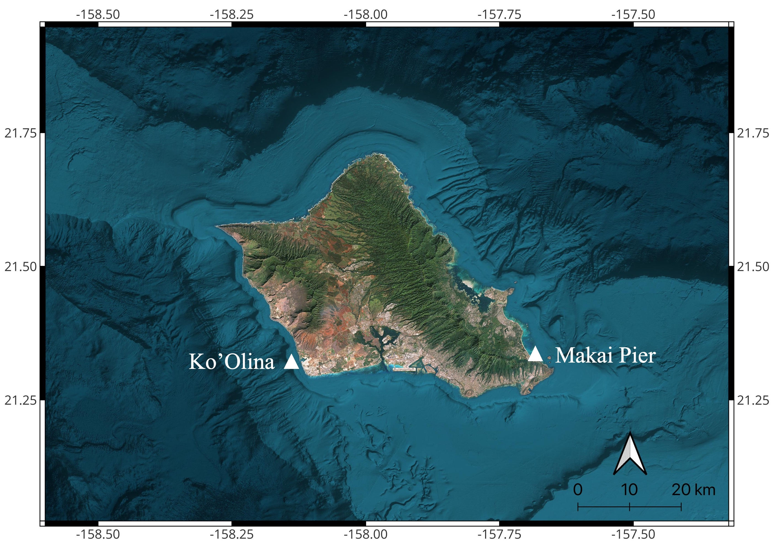

Extended Data Figure 2
SEM images of the Makai Pier coral from the winter of 1922, 1926, 1931, 1932, 1933, 1934, 1935, 1937, 1940, 1944, 1946, 1947, 1948, 1952, and 1955. Scale bars (white) represent 300 µm. The years written in red indicate when secondary aragonite (SA) or skeletal dissolution (D) was observed.
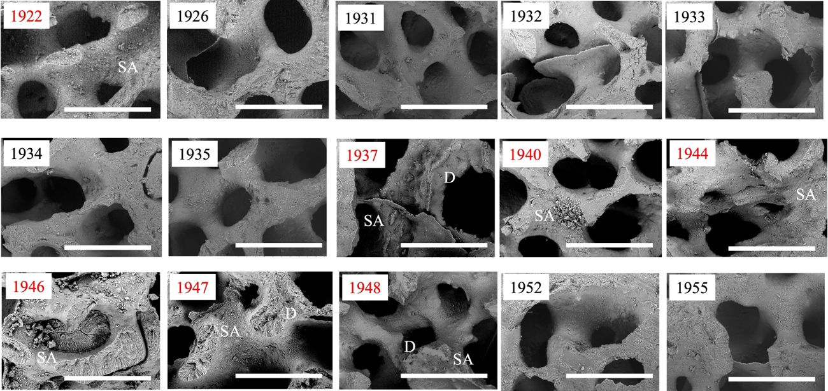

Extended Data Table 1 | List of the sites and Long-term trends in reconstructed SST (˚C per century) using coral Sr/Ca
Reconstructed SST trends derived from coral Sr/Ca ratios across various oceanic regions, including Hawaii (Makai Pier and KoʻOlina), the Atlantic, Indian Ocean, East Asia, Central-Eastern Pacific, the Indo-Pacific Warm Pool–South Pacific Convergence Zone (IPWP–SPCZ), and the Red Sea^{11,15,19,20,25,32–63}.
– SST trends (˚C per century) are based on Sr/Ca ratios measured in Porites corals.
– Our new records from Hawaii (Makai Pier and KoʻOlina) are highlighted in bold.
– Trends are calculated over the full available period for each core, and over 1850–2000 when possible.
– n values indicate the number of records per region.
– Seasonal SST ranges and analytical precision are provided.
– Trend significance is marked in bold (p < 0.05).
– Method of trend derivation: a: reported in original paper b: calculated using Sr/Ca–SST slope. c: estimated using common slope (-0.06 mmol/mol/˚C)⁶⁴
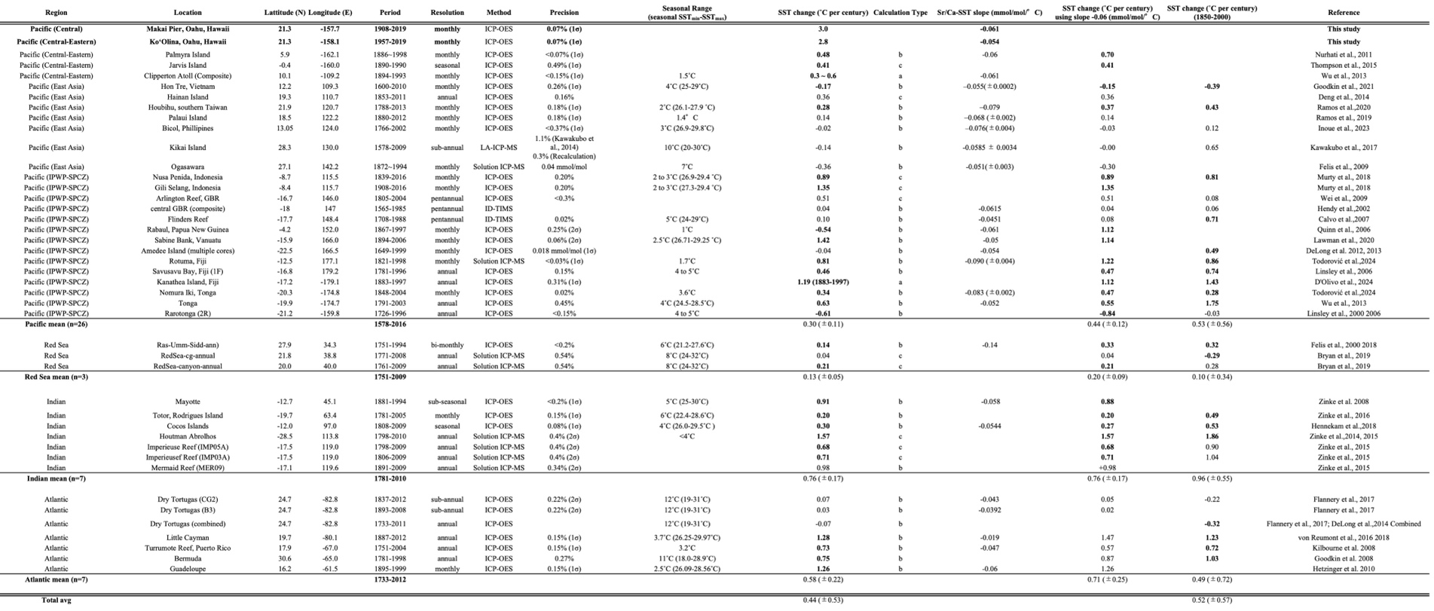

Extended Data Table 2.
Long-term trends in reconstructed sea surface temperature (SST, ˚C per century) at Makai Pier (1908–2019) and KoʻOlina (1957–2019).
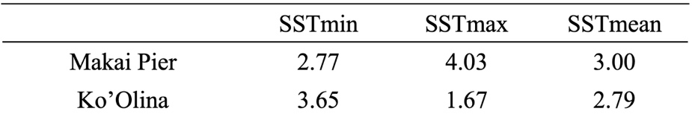
SST_{min} refers to the seasonal minimum, SST_{max} to the seasonal maximum, and SST_{mean} to the annual mean (calculated from April to March) of next year.

Extended Data Table 3. SST products and linear trends
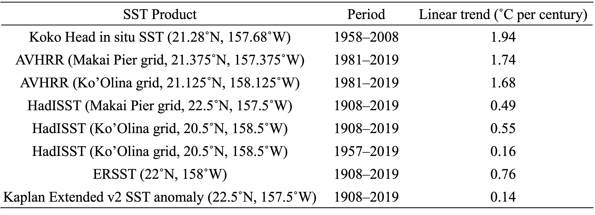
For gridded SST datasets, the coordinates represent the center of each grid cell (with spatial resolutions of 0.25˚ for AVHRR³¹, 1˚ for HadISST²⁹, 2˚ for ERSST²⁸, 5˚ for Kaplan Extended v2 SST anomaly³⁰).

Reference for Extended Data
11. DeLong, K. L., Quinn, T. M., Taylor, F. W., Shen, C. C. & Lin, K. Improving coral-base paleoclimate reconstructions by replicating 350years of coral Sr/Ca variations. Palaeogeog Palaeoclimatol Palaeoecol 373, 6–24 (2013).
15. D’Olivo, J. P. & McCulloch, M. T. Response of coral calcification and calcifying fluid composition to thermally induced bleaching stress. Sci Rep 7, (2017).
19. Lawman, A. E. et al. A Century of Reduced ENSO Variability During the Medieval Climate Anomaly. Paleoceanogr Paleoclimatol 35, (2020).
20. Zinke, J. et al. Corals record long-term Leeuwin current variability including Ningaloo Niño/Niña since 1795. Nat Commun 5, (2014).
25. Quinn, T. M. & Taylor, F. W. SST artifacts in coral proxy records produced by early marine diagenesis in a modern coral from Rabaul, Papua New Guinea. Geophys Res Lett 33, (2006).
32. Nurhati, I. S., Cobb, K. M. & Di Lorenzo, E. Decadal-scale SST and salinity variations in the central tropical pacific: Signatures of natural and anthropogenic climate change. J Clim 24, 3294–3308 (2011).
33. Thompson, D. M., Cole, J. E., Shen, G. T., Tudhope, A. W. & Meehl, G. A. Early twentieth-century warming linked to tropical Pacific wind strength. Nat Geosci 8, 117–121 (2015).
34. Wu, H. C., Linsley, B. K., Dassié, E. P., Schiraldi, B. & Demenocal, P. B. Oceanographic variability in the south pacific convergence zone region over the last 210 years from multi-site coral Sr/Ca records. Geochemistry, Geophysics, Geosystems 14, 1435–1453 (2013).
35. Goodkin, N. F. et al. Natural and Anthropogenic Forcing of Multi-Decadal to Centennial Scale Variability of Sea Surface Temperature in the South China Sea. Paleoceanogr Paleoclimatol 36, 1–15 (2021).
36. Deng, W. et al. Evaluation of annual resolution coral geochemical records as climate proxies in the Great Barrier Reef of Australia. Coral Reefs 33, 965–977 (2014).
37. Ramos, R. D., Goodkin, N. F., Siringan, F. P. & Hughen, K. A. Coral Records of Temperature and Salinity in the Tropical Western Pacific Reveal Influence of the Pacific Decadal Oscillation Since the Late Nineteenth Century. Paleoceanogr Paleoclimatol 34, 1344–1358 (2019).
38. Ramos, R. D., Goodkin, N. F. & Fan, T. ‐Y. Coral Records at the Northern Edge ofthe Western Pacific Warm Pool Reveal Multiple Drivers of Sea Surface Temperature, Salinity, and Rainfall Variability Since the End of the Little Ice Age. Preprint at (2020).
39. Inoue, M. et al. Natural and Anthropogenic Climate Variability Signals in a 237-Year-Long Coral Record From the Philippines. Paleoceanogr Paleoclimatol 38, (2023).
40. Kawakubo, Y., Alibert, C. & Yokoyama, Y. A Reconstruction of Subtropical Western North Pacific SST Variability Back to 1578, Based on a Porites Coral Sr/Ca Record from the Northern Ryukyus, Japan. Paleoceanography 32, 1352–1370 (2017).
41. Felis, T. et al. Subtropical coral reveals abrupt early-twentieth-century freshening in the western North Pacific Ocean. Geology 37, 527–530 (2009).
42. Murty, S. A., Goodkin, N. F., Wiguna, A. A. & Gordon, A. L. Variability in Coral-Reconstructed Sea Surface Salinity Between the Northern and Southern Lombok Strait Linked to East Asian Winter Monsoon Mean State Reversals. Paleoceanogr Paleoclimatol 33, 1116–1133 (2018).
43. Wei, G., McCulloch, M. T., Mortimer, G., Deng, W. & Xie, L. Evidence for ocean acidification in the Great Barrier Reef of Australia. Geochim Cosmochim Acta 73, 2332–2346 (2009).
44. Hendy et al.,2002.
45. Calvo, E. et al. Interdecadal climate variability in the Coral Sea since 1708 A.D. Palaeogeogr Palaeoclimatol Palaeoecol 248, 190–201 (2007).
46. Delong, K. L., Quinn, T. M., Taylor, F. W., Lin, K. & Shen, C. C. Sea surface temperature variability in the southwest tropical Pacific since AD 1649. Nat Clim Chang 2, 799–804 (2012).
47. Todorović, S. et al. Western Pacific Warm Pool Warming and Salinity Front Expansion Since 1821 Reconstructed From Paired Coral δ18O, Sr/Ca, and Reconstructed δ18Osw. Paleoceanogr Paleoclimatol 39, (2024).
48. Linsley, B. K. et al. Tracking the extent of the South Pacific Convergence Zone since the early 1600s. Geochemistry, Geophysics, Geosystems 7, 1–15 (2006).
49. Braddock K. Linsley, Gerard M. Wellington, D. P. S. Decadal Sea Surface Temperature Variability in the Subtropical South Pacific from 1726 to 1997 A.D. 290, 1145–1148 (2000).
50. Felis, T. et al. A coral oxygen isotope record from the northern Red Sea documenting NAO, ENSO, and North Pacific teleconnections on Middle East climate variability since the year 1750. Paleoceanography 15, 679–694 (2000).
51. Felis, T., Ionita, M., Rimbu, N., Lohmann, G. & Kölling, M. Mild and Arid Climate in the Eastern Sahara-Arabian Desert During the Late Little Ice Age. Geophys Res Lett 45, 7112–7119 (2018).
52. Bryan, S. P., Hughen, K. A., Karnauskas, K. B. & Farrar, J. T. Two Hundred Fifty Years of Reconstructed South Asian Summer Monsoon Intensity and Decadal-Scale Variability. Geophys Res Lett 46, 3927–3935 (2019).
53. Zinke, J. et al. Mayotte coral reveals hydrological changes in the western indian ocean between 1881 and 1994. Geophys Res Lett 35, (2008).
54. Zinke, J. et al. A sea surface temperature reconstruction for the southern IndianOcean trade wind belt from corals in Rodrigues Island (19◦S, 63◦E). Biogeosciences 13, 5827–5847 (2016).
55. Hennekam, R. et al. Cocos (Keeling) Corals Reveal 200 Years of Multidecadal Modulation of Southeast Indian Ocean Hydrology by Indonesian Throughflow. Paleoceanogr Paleoclimatol 33, 48–60 (2018).
56. Zinke, J. et al. Coral record of southeast Indian Ocean marine heatwaves with intensified Western Pacific temperature gradient. Nat Commun 6, (2015).
57. Flannery, J. A., Richey, J. N., Thirumalai, K., Poore, R. Z. & DeLong, K. L. Multi-species coral Sr/Ca-based sea-surface temperature reconstruction using Orbicella faveolata and Siderastrea siderea from the Florida Straits. Palaeogeogr Palaeoclimatol Palaeoecol 466, 100–109 (2017).
58. DeLong, K. L. et al. A reconstruction of sea surface temperature variability in the southeastern Gulf of Mexico from 1734 to 2008 C.E. using cross-dated Sr/Ca records from the coral Siderastrea siderea. Paleoceanography vol. 29 403–422 Preprint at https://doi.org/10.1002/2013PA002524 (2014).
59. Von Reumont, J., Hetzinger, S., Garbe-Schönberg, D., Manfrino, C. & Dullo, W. C. Impact of warming events on reef-scale temperature variability as captured in two Little Cayman coral Sr/Ca records. Geochemistry, Geophysics, Geosystems 17, 846–857 (2016).
60. von Reumont, J., Hetzinger, S., Garbe-Schönberg, D., Manfrino, C. & Dullo, C. Tracking Interannual- to Multidecadal-Scale Climate Variability in the Atlantic Warm Pool Using Central Caribbean Coral Data. Paleoceanogr Paleoclimatol 33, 395–411 (2018).
61. Kilbourne, K. H. et al. Paleoclimate proxy perspective on Caribbean climate since the year 1751: Evidence of cooler temperatures and multidecadal variability. Paleoceanography 23, 1–14 (2008).
62. Goodkin, N. F., Hughen, K. A., Curry, W. B., Doney, S. C. & Ostermann, D. R. Sea surface temperature and salinity variability at Bermuda during the end of the Little Ice Age. Paleoceanography 23, (2008).
63. Hetzinger, S., Pfeiffer, M., Dullo, W. C., Garbe-Schönberg, D. & Halfar, J. Rapid 20th century warming in the Caribbean and impact of remote forcing on climate in the northern tropical Atlantic as recorded in a Guadeloupe coral. Palaeogeogr Palaeoclimatol Palaeoecol 296, 111–124 (2010).
64. Corrège, T. Sea surface temperature and salinity reconstruction from coral geochemical tracers. Palaeogeogr Palaeoclimatol Palaeoecol 232, 408–428 (2006).

