Supplementary material

Cytidine Derivatives as SARS-CoV-2 M^{pro} Inhibitors: Antiviral Prediction, Molecular Docking and Pharmacokinetic Score Investigations

Sarkar Mohammad Abe Kawsar^{1*}, Mohammed Anowar Hosen¹, Yuki Fujii², Yasuhiro Ozeki³

¹ Laboratory of Carbohydrate and Nucleoside Chemistry (LCNC), Department of Chemistry, Faculty of Science, University of Chittagong, Chittagong-4331, Bangladesh
² School of Pharmaceutical Sciences, Nagasaki International University, 2825-7, Huis Ten Bosch-cho, Sasebo, Nagasaki 859-3298, Japan
³ School of Sciences, Yokohama City University, 22-2, Seto, Kanazawa-ku, Yokohama 236-0027, Japan

*Corresponding author: Sarkar Mohammad Abe Kawsar
akawsar@cu.ac.bd
Tel.: +88 01762717081
Fax.: +88 031 2606001

S1: Optimization of designed cytidine derivatives

Entry | Name of the chemicals | Stable optimized structure
1 | 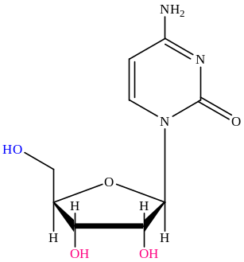 | 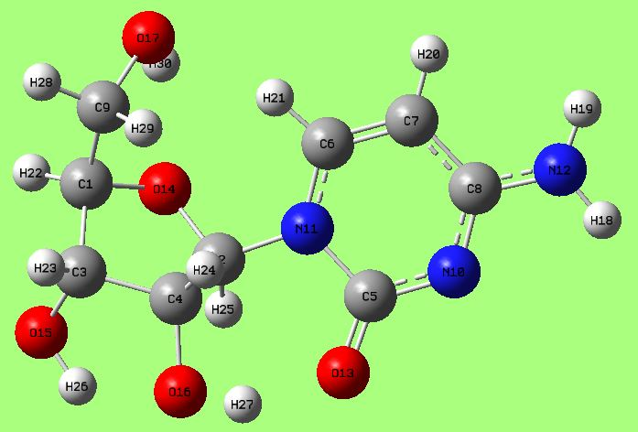
4 | 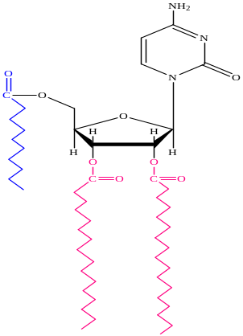 | 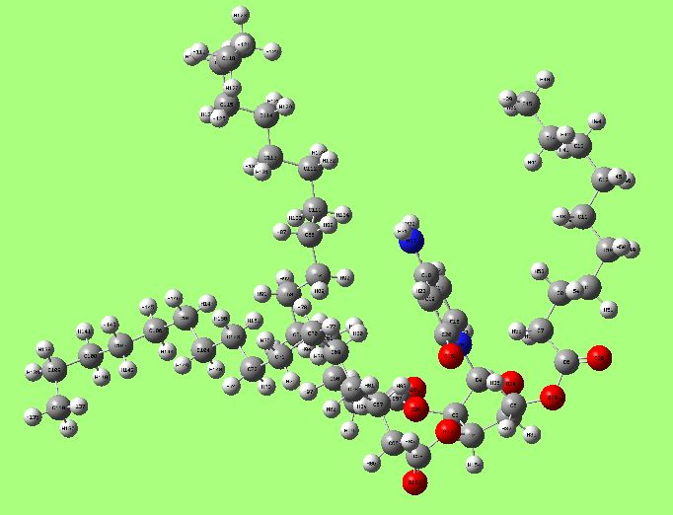
5 | 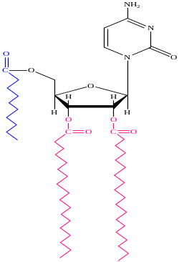 | 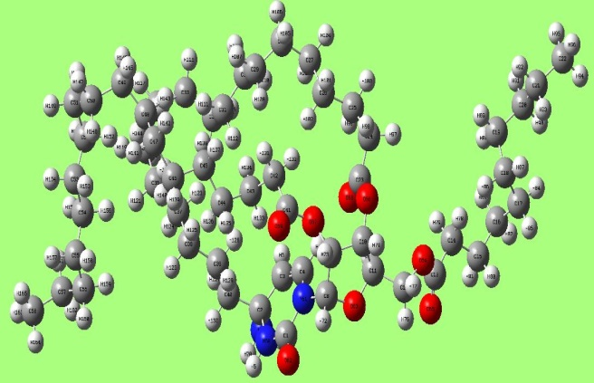
10 | 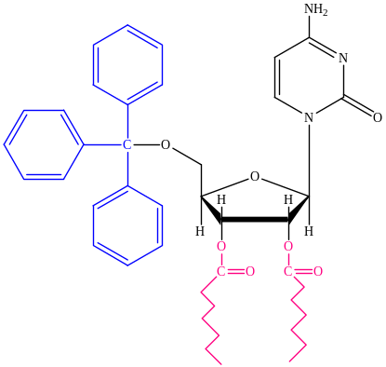 | 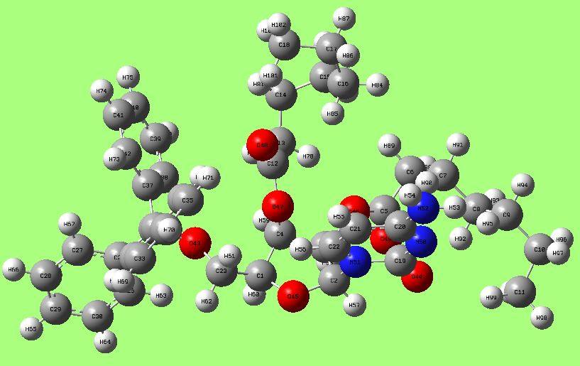
12 | 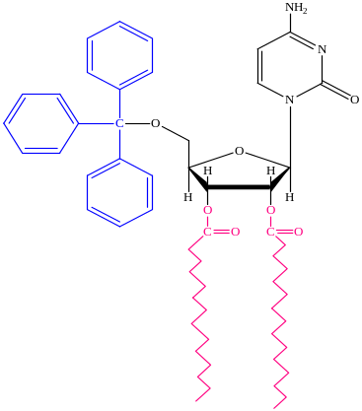 | 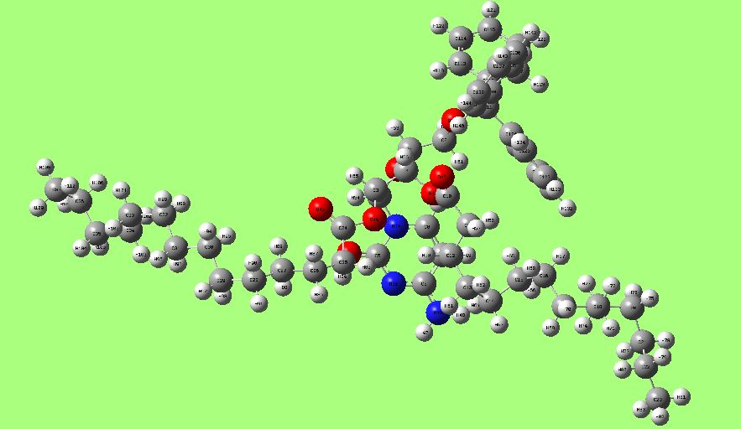
14 | 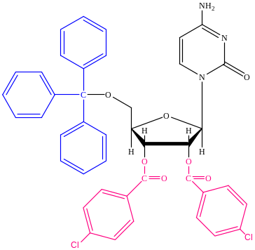 | 