Supporting Information
Vitrimer-Enabled Circularity: Upcycling Mixed Polyolefin Waste from Milk Packets into High-Value 3D Printing Feedstock
Indranil Dey^{#,a}, Ketaki Samanta^{#,a,}*, Tanay Debnath^{b}, and Suryasarathi Bose^{a,}*
ªDepartment of Materials Engineering, Indian Institute of Science, Bengaluru – 560012, India.
^{b}Department of Chemistry, School of Advanced Sciences (SAS), Vellore Institute of Technology, Vellore, TN 632014, India.
#equal contribution
* Corresponding Author Email address: sbose@iisc.ac.in, ketakisamanta123@gmail.com.

Table S1: Formulation details for maleic anhydride grafting onto post-consumer recycled polypropylene (PCR PP) using triallyl cyanurate (TAC) as a co-agent during reactive melt extrusion.
Sample Name | PCR PP  (wt%) | Maleic anhydride  (wt%) | TAC  (wt%) | DCP  (wt%) | Irganox 1010  (wt%)
PCR PP | 99.5 | - | - | - | 0.5
m"-PCR PP | 84 | 10 | 5 | 0.5 | 0.5

Table S2: Compositions of vitrimeric PCR PP systems prepared by blending m″-PCR PP with varying weight percentages (10, 15, and 20 wt%) of tetrafunctional epoxy crosslinker (TGDDM) and 1 wt% zinc acetate catalyst.
Sample  Name | m"-PCR PP  (wt%) | TGDDM  (wt%) | Zn(OAc)₂  (wt%)
X10 | 89 | 10 | 1
X15 | 84 | 15 | 1
X20 | 79 | 20 | 1

Table S3: Blend formulations of neat PCR PP and vitrimeric m″-PCR PP with post-consumer recycled polyethylene (PCR PE) at different weight ratios (70/30, 50/50, and 30/70) for compatibility and processability evaluation.
Sample Name | PCR PE  (wt%) | PCR PP  (wt%) | X15  (wt%)
PCR PE/PCR PP 70/30 | 70 | 30 | -
PCR PE /PCR PP 50/50 | 50 | 50 | -
PCR PE /PCR PP 30/70 | 30 | 70 | -
PCR PE /V" 70/30 | 70 | - | 30
PCR PE /V" 50/50 | 50 | - | 50
PCR PE /V" 30/70 | 30 | - | 70

Determination of Grafting Yield for mʺ-PCR PP:
Approximately 2–3 strands each of m-PCR PP and mʺ-PCR PP were subjected to dissolution in hot xylene under reflux at 140 °C for an extended period overnight. Following dissolution, the reaction mixtures were decanted into chilled acetone maintained in an ice bath, thereby inducing the reprecipitation of the grafted polymer. During this process, the grafted fraction precipitated out while the ungrafted constituents remained soluble in acetone. The resultant suspension was filtered to isolate the grafted mʺ-PCR PP, which was subsequently dried under vacuum at 80 °C overnight.
The transformation in the spectral intensity corresponding to the symmetric and asymmetric carbonyl (C=O) stretching vibrations of maleic anhydride (MA) was monitored via FTIR spectroscopy, both prior to and following reprecipitation (refer to Figure S1a–c).
The grafting yield for all modified samples was deduced from FTIR data using the following relation:
Grafting Yield = A₁₇₈₀ / A₁₁₆₇
Here, A₁₇₈₀ represents the integrated area under the absorbance peak at 1780 cm⁻¹, attributed to the carbonyl stretching of five-membered cyclic anhydrides. A₁₁₆₇ denotes the area under the peak at 1167 cm⁻¹, corresponding to the methyl (CH₃) rocking vibration of the polypropylene backbone, serving as an internal reference due to its proportionality to PP content.
The calculated grafting yield for the mʺ-PCR PP sample is as follows:
Grafting Yield = A₁₇₈₀ / A₁₁₆₇ = 447.89 / 55.70 = 8.04

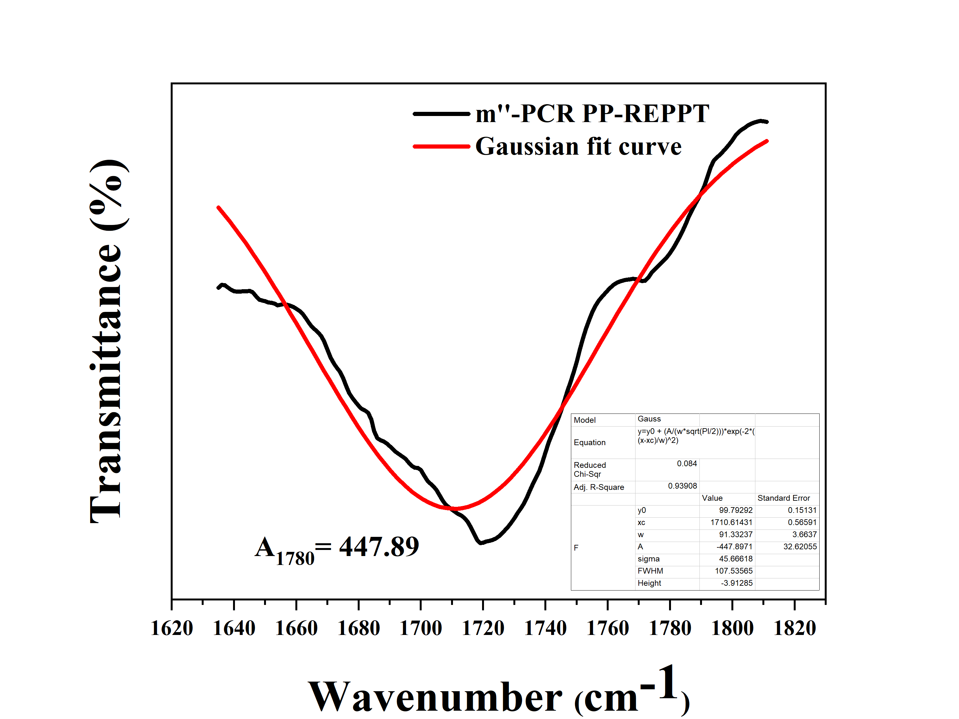
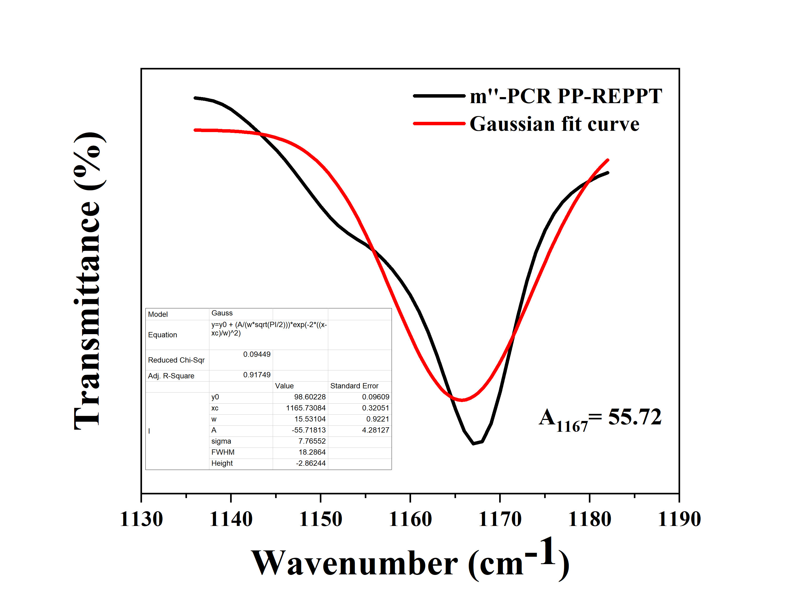
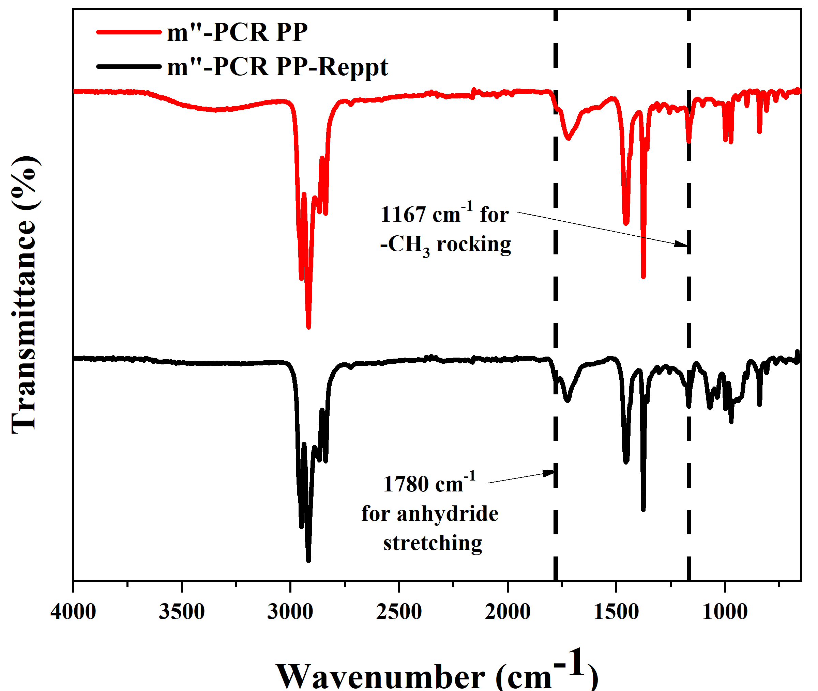
(a)
(b)
(c)

Figure S1: (a) Fourier-transform infrared (FT-IR) spectra of mʺ-PCR PP before and after purification via reprecipitation; (b) Gaussian deconvolution of the absorption band centred at 1780 cm⁻¹ in mʺ-PCR PP; (c) Gaussian deconvolution of the spectral region corresponding to 1167 cm⁻¹ in mʺ-PCR PP.

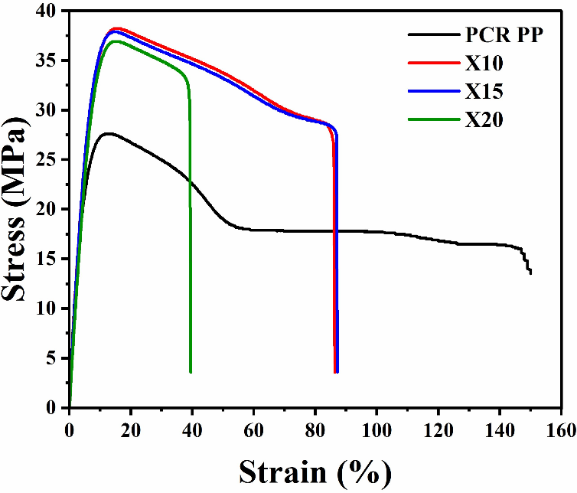
Figure S2: Stress–strain curves of unmodified PCR PP and vitrimeric PCR PP samples, showing the influence of dynamic crosslinking on yield strength, stiffness, and elongation.

Table S4: Tensile properties of PCR PE, pristine PCR PP and vitrimer samples, including yield strength (YS), elongation at yield (Ey), and Young’s modulus (YM) highlighting the effect of dynamic crosslinking on mechanical performance.
Sample Name | YS  (MPa) | YM  (MPa) | Ey  (%)
PCR PE | 12±0.46 | 72±5.61 | 20±0.69
PCR PP | 28±0.35 | 215±4.04 | 13±0.37
X10 | 38±0.61 | 250±5.33 | 15±0.41
X15 | 38±0.56 | 250±4.62 | 15±0.29
X20 | 37±0.63 | 247±5.21 | 15±0.32

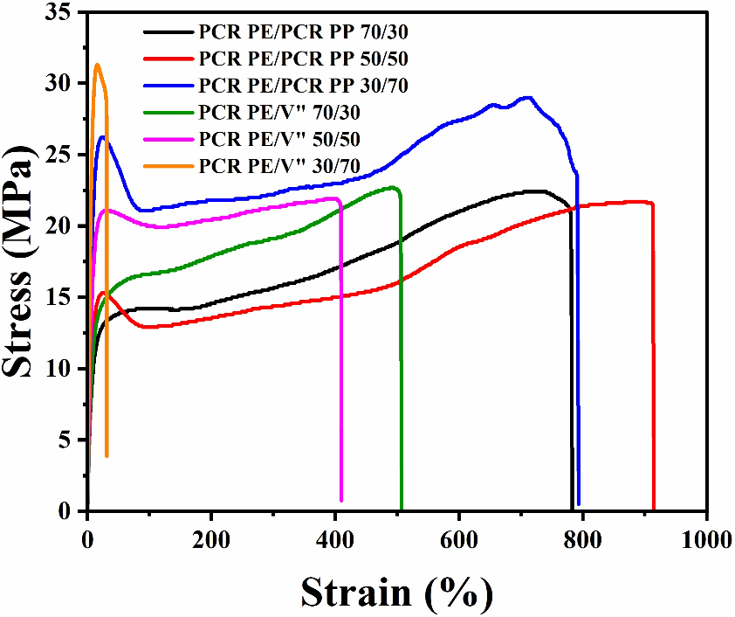

Figure S3: Stress–strain curves of PCR PE/PCR PP and PCR PE/V″ blends at various compositions (70/30, 50/50, and 30/70), demonstrating improved mechanical response and reduced elongation in vitrimer-modified systems.

Table S5: Mechanical properties of PCR PE /PCR PP and PCR PE /V″ blends at different weight ratios (70/30, 50/50, and 30/70), comparing yield strength, Young’s modulus (YM), and elongation at yield to evaluate the effect of vitrimeric compatibilization.
Sample Name | YS  (MPa) | YM  (MPa) | Ey  (%)
PCR PE /PCR PP 70/30 | 14±0.33 | 18±2.04 | 80±2.32
PCR PE /PCR PP 50/50 | 15±0.45 | 58±5.54 | 26±1.35
PCR PE /PCR PP 30/70 | 26±0.52 | 104±6.82 | 25±1.22
PCR PE /V'' 70/30 | 16±0.35 | 22±2.21 | 74±1.85
PCR PE /V'' 50/50 | 21±0.31 | 70±3.52 | 30±1.24
PCR PE /V'' 30/70 | 31±0.44 | 193±5.67 | 16±1.15

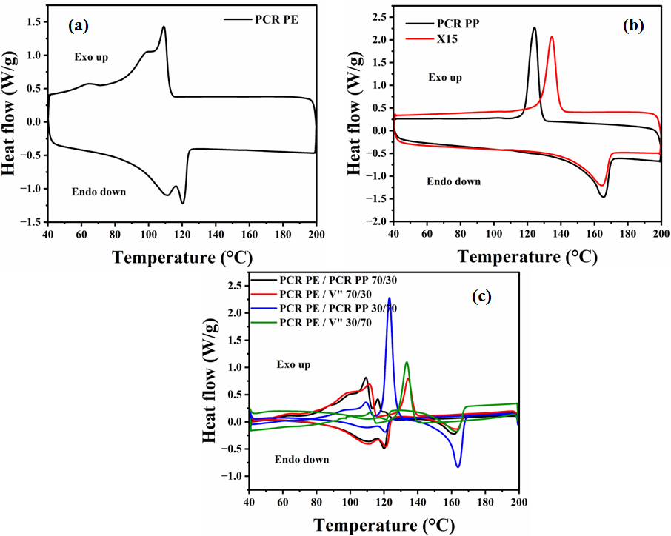Figure S4: DSC thermograms of individual components (a) PCR PE, (b) PCR PP, and vitrimer X15 (c) Comparison of melting temperatures (T_{m}), crystallization temperatures (T_{c}) between PCR PE/PCR PP and PCR PE/V″ blends at 70/30, and 30/70 ratios.
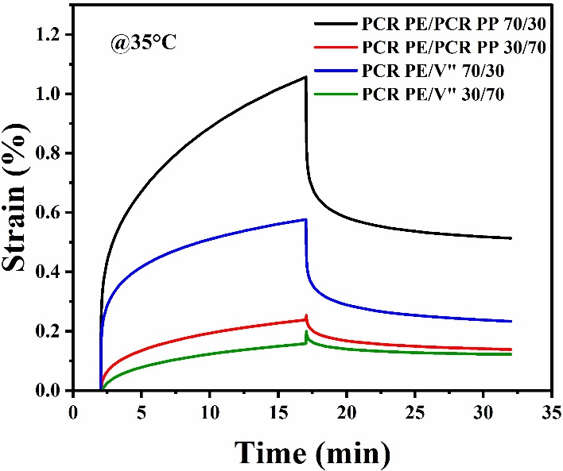

Figure S5: Creep-recovery profiles of PCR PE/PCR PP and PCR PE /V″ blends at 35 °C for 70/30 and 30/70 compositions, demonstrating enhanced resistance to deformation and improved elastic recovery with vitrimeric PP.
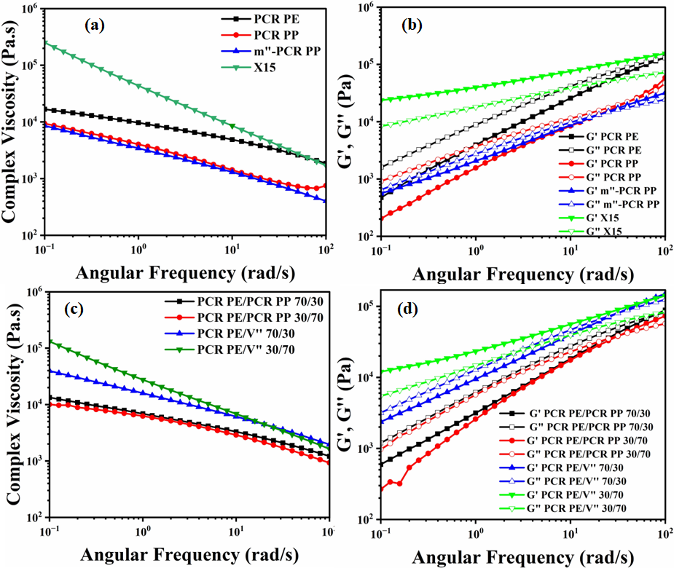
Figure S6: (a) Complex viscosity versus angular frequency profiles for neat PCR PE, PCR PP, m″-PCR PP, and vitrimeric PCR PP (X15) at 180 °C, demonstrating the progressive increase in viscosity from thermoplastic to dynamically crosslinked systems. (b) Storage modulus (G′) and loss modulus (G″) versus angular frequency for PCR PE, PCR PP, m″-PCR PP, and vitrimeric PCR PP (X15) measured at 180 °C, illustrating the enhanced melt elasticity and network formation in X15 due to the presence of transesterification-based dynamic bonds. (c) Complex viscosity plots of PCR PE /PCR PP and PCR PE /V″ blends at 70/30 and 30/70 compositions, highlighting increased viscosity in vitrimer-based systems, confirming improved network formation and compatibility. (d) Storage and loss moduli (G′, G″) versus angular frequency for PCR PE /PCR PP and PCR PE /V″ blends at 70/30 and 30/70 ratios, showing elevated moduli in vitrimer-containing blends, indicating enhanced melt strength and viscoelastic stability.

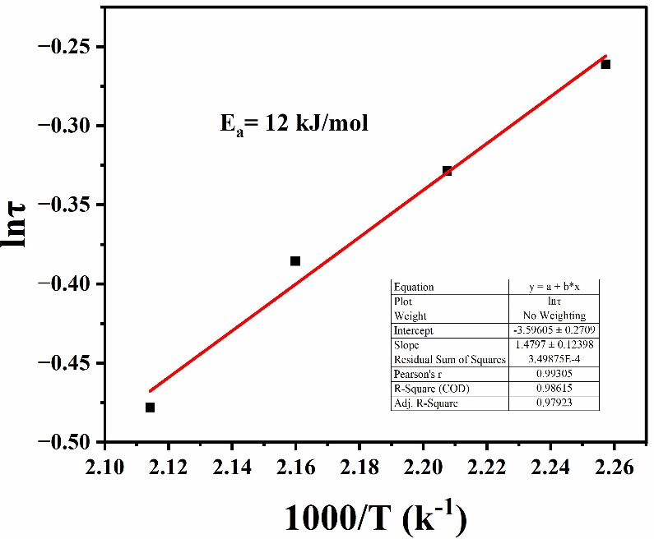
Figure S7: Arrhenius plot of relaxation time (ln τ) versus inverse temperature (1000/T) for the PCR PE /V″ 50/50 blend, obtained from stress relaxation measurements at four temperatures. The linear fit yields an activation energy of approximately 12 kJ/mol, indicating efficient dynamic bond exchange within the vitrimer network.
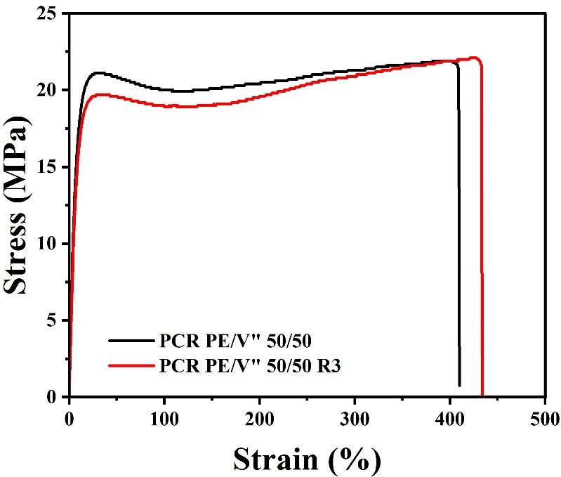
Figure S8: Representative stress–strain curves of PCR PE /V″ 50/50 before and after three recycling cycles (R3), demonstrating the retention of tensile properties such as yield strength, Young’s modulus, and elongation at break after reprocessing.

Table S6: Summary of tensile properties—yield strength (YS), Young’s modulus (YM), and elongation at yield (Ey)—for PCR PE /V″ 50/50 and PCR PE /V″ 50/50 R3 samples, confirming mechanical integrity upon recycling.
Sample Name | YS  (MPa) | Recovery of YS (%) | YM  (MPa) | Recovery of YM (%) | Ey  (%) | Recovery of Ey (%)
PCR PE /V'' 50/50 | 21±0.31 | - | 70±3.52 | - | 30±1.24 | -
PCR PE /V'' 50/50 R3 | 20±0.25 | 95 | 67±3.04 | 96 | 30±0.93 | 100

Table S7: Thermal properties derived from DSC analysis for PCR PE /V″ 50/50 and PCR PE /V″ 50/50 R3 samples, including melting temperature (T_{m}), crystallization temperature (T_{c}), and percent crystallinity (%X_{c}) of PE and PP phases, highlighting thermal stability post-recycling.
Sample Name | T_{m}  of PE (°C) |  | T_{m}  of PP (°C) | T_{c}  of PE (°C) |  | T_{c}  of PP (°C) | %X_{c}  of PE | %X_{c}  of PP
Sample Name |  |  | T_{m}  of PP (°C) | LDPE | LLDPE | T_{c}  of PP (°C) | %X_{c}  of PE | %X_{c}  of PP
Sample Name | LDPE | LLDPE
PCR PE/V" 50/50 | 108 | 122 | 164 | 96 | 112 | 133 | 14 | 14
PCR PE/V" 50/50 R3 | 108 | 121 | 163 | 97 | 112 | 134 | 16 | 15

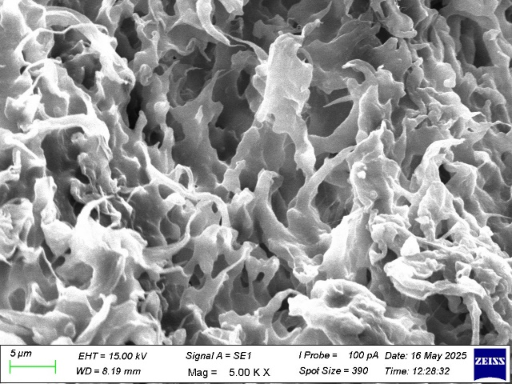
Figure S9: SEM cryo-fractured surface morphology of PCR PE /V″ 50/50 R3 sample, revealing the preserved microfibrillar structure and shear bands consistent with the original blend, indicating morphological stability after repeated processing.

