Supporting Information

Biomimetic-Voltage Nitride-Enhanced Memristor Arrays for Femtojoule In-Memory Biosignal Processing
Zijian Wang^{1,3}, Zhejia Zhang^{1,3}, Guobin Zhang^{1,2,3}, Xuemeng Fan^{1,3}, Pengtao Li^{1,2,3}, Baicheng Zhu^{1,3}, Yi Tong⁴, Panpan Zhang⁵, Dawei Gao^{1,3}, Bin Yu¹, Jiuren Zhou^{6*}, Qing Wan^{2*} and Yishu Zhang^{1,2,3*}
¹College of Integrated Circuits, Zhejiang University, ZJU-Hangzhou Global Scientific and Technological Innovation Center, Hangzhou, Zhejiang, 311200, China
²Yongjiang Laboratory, Ningbo, Zhejiang, 315202, China
³Zhejiang ICsprout Semiconductor Co., Ltd, Hangzhou, Zhejiang, 310027, China
⁴Suzhou lab, Suzhou, Jiangsu, 215123, China
⁵School of Integrated Circuits, Beijing University of Posts and Telecommunications 100876, China
⁶Hangzhou Institute of Technology, Xidian University, Hangzhou, 311231, China.
*Corresponding author: zhoujiuren@163.com; qing-wan@ylab.ac.cn; zhangyishu@zju.edu.cn

Fig. S1 The lift-off photolithography process for fabricating the integrated passive array of memristors based on this work. First, a photoresist is spin-coated on a clean SiO₂/p+Si substrate, and the bottom electrode pattern of the array is formed using photolithography. The bottom electrode is then completed through thin film deposition and develop processes. Subsequently, the functional layer, isolated layer and top electrode of the array are fabricated using the same process.

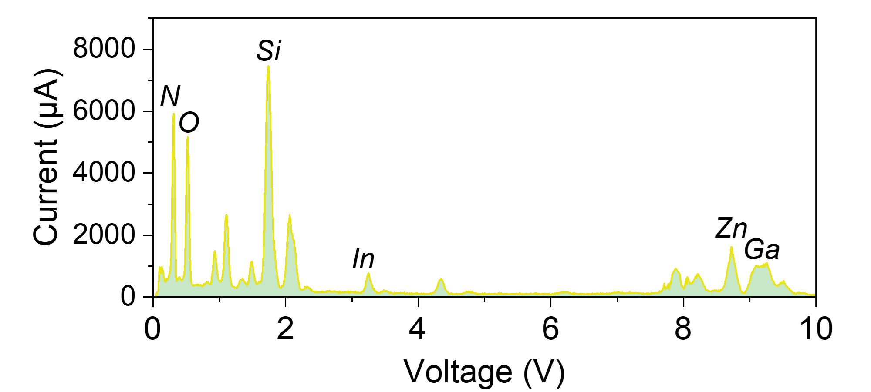
Fig. S2 The EDS spectrum of the device functional layer, showing peaks for N, Si, In, Zn, Ga, and O, confirming the composition of the SiN_{x}/IGZO functional layer.

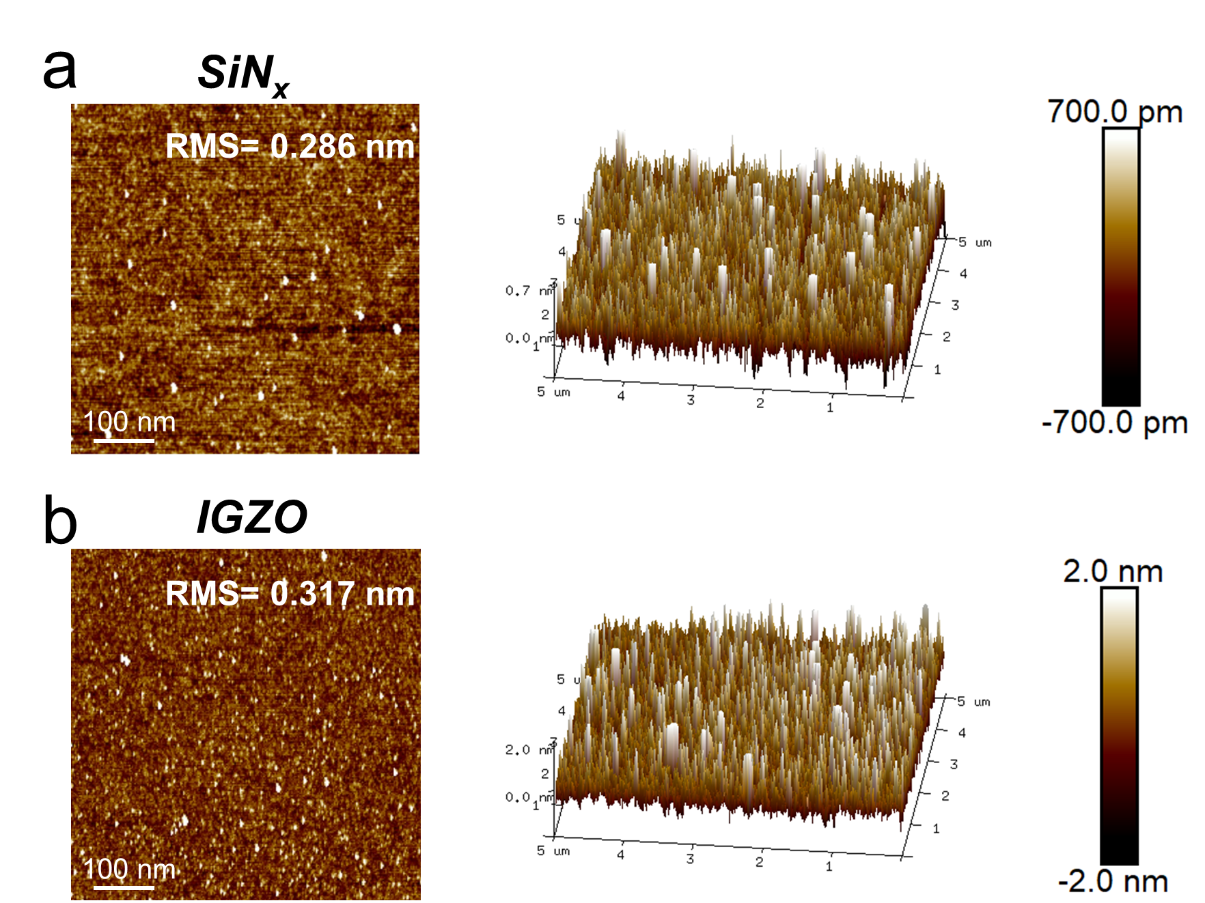
Fig. S3 a AFM characterization of SiN_{x} and b IGZO thin film surfaces, with RMS roughness of 0.286 nm and 0.317 nm, respectively, demonstrating good surface uniformity of the films.

Fig. S4 I-V curve of the device forming process, with a set voltage of 280 mV and a voltage slope of 0.47 mV/dec.

Fig. S5 The I-V cyclical curve of the device under continuous forward voltage sweep. As the applied voltage approaches the threshold, the conductivity of the device continually increases with each cycle of the applied voltage.

Fig. S6 Current variations of the device under continuous positive pulse sequences. The sequence pulse tests confirm that when pulses below the threshold voltage are applied, the device exhibits a continuous increase in conductance and ultimately successfully switches to LRS.

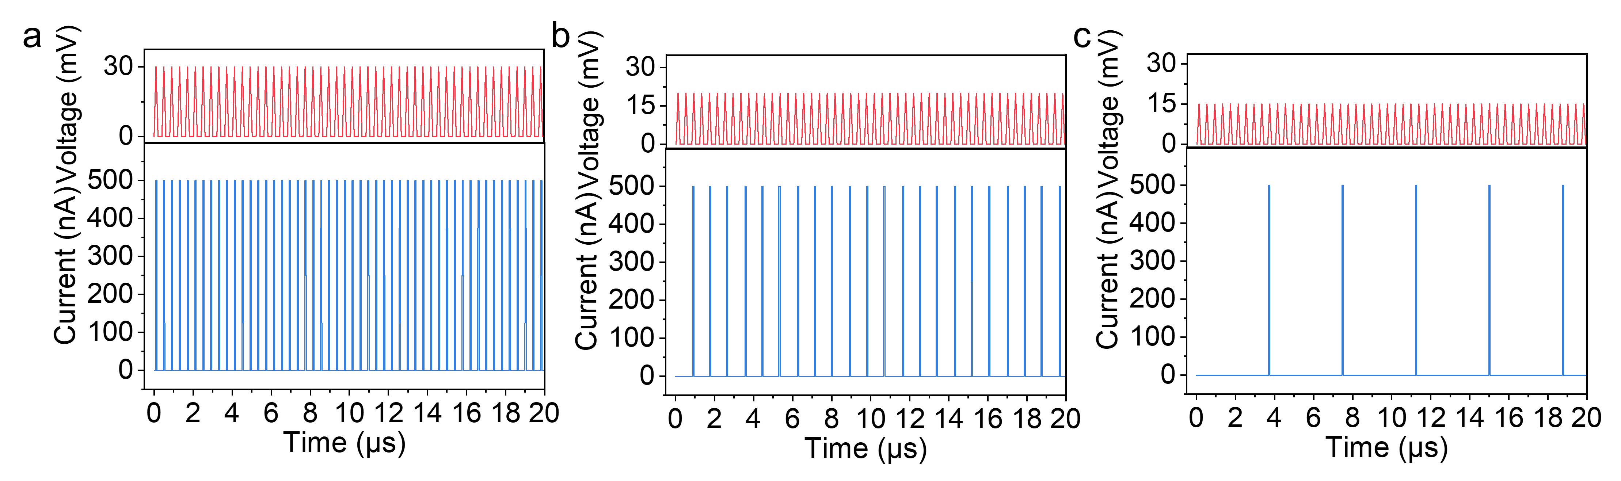

Fig. S7 With decreasing amplitude of the applied pulse train, a device activation transitions from consistent response per pulse at 30 mV, b to intermittent response (every 3–4 pulses) at 18 mV, c and finally to sparse response (every 10-12 pulses) at 15 mV, demonstrating accumulation switching behavior. CC is defined as 0.5 μA by configuring the pulse testing measurement range.
At 30 mV, the device exhibits robust volatile switching characterized by reliable pulse-to-pulse correspondence, indicative of sustained ion migration and efficient charge transfer. This behavior confirms stable conductive filament formation under repeated electrical stimulation.
When the voltage is reduced to 18 mV, activation becomes intermittent under continuous pulse sequences, accompanied by oscillatory charge transfer dynamics. This suggests the device approaches an operational threshold where cumulative pulse energy progressively modulates vacancy migration within the IGZO layer, yet remains insufficient for consistent switching.
Further reducing the voltage to 15 mV results in sparse, stochastic activation even under extended pulse sequences. Here, only high-frequency, low-amplitude stimuli can trigger limited ion rearrangement and vacancy migration, implying that minimal energy per pulse restricts conductive pathway formation to rare statistical events.

Fig. S8 Device resistance state retention under different CC. a At stage ①, 1 mV reading voltage is applied to the initial device, maintaining it in HRS. At stage ②, 40 mV reset voltage is applied to switch the device to LRS under different CC. At stage ③, a 10 mV hold voltage stabilizes the device in LRS. At stage ④, the test voltage returns to 1 mV reading voltage, where devices with CC between 100 μA and 5 μA maintain a stable LRS, demonstrating non-volatility (purple curve), while devices with CC from 1 μA to 0.5 μA switch back to HRS, showing volatility (blue curve). At stage ⑤, all devices are switched to LRS with -120 mV reset voltage. b The device's resistance state under phases ② and ③. To highlight the device's changes at the microsecond level, the y-axis has been adjusted by subtracting the initial test duration (100 s). It shows that devices switching to LRS at lower CC values will self-reset to HRS after the hold voltage is removed, because the conductive filaments generated at low CC values cannot maintain stability and spontaneously rupture upon voltage removal. Thus, by adjusting CC, we can switch the state of device between long-term non-volatile storage and volatile resistance switching.

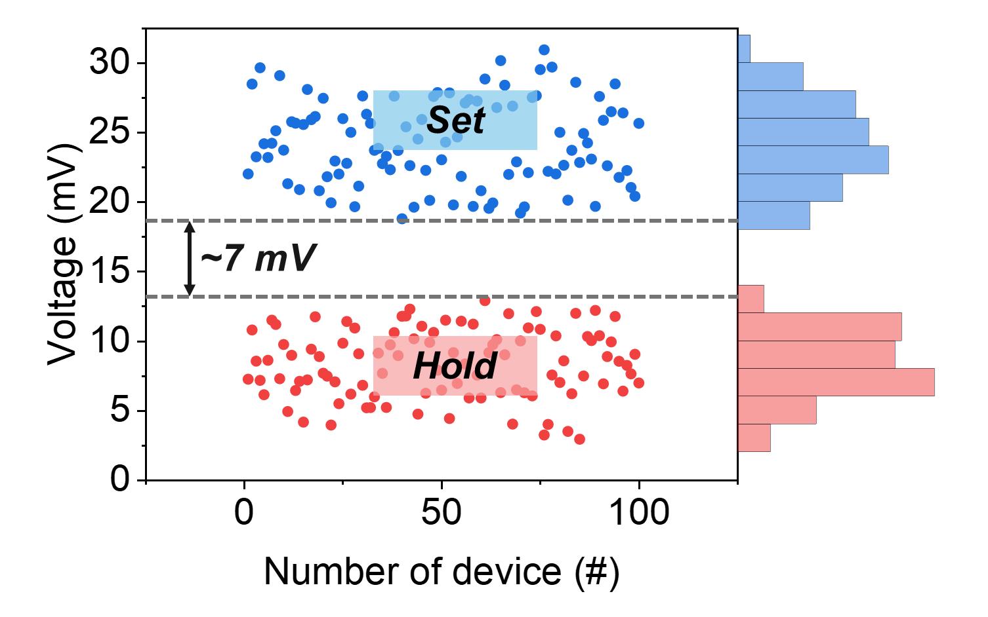
Fig. S9 Scatter distribution of hold and set voltages across 100 devices. A ∼7 mV margin between maximum hold voltage and minimum set voltage prevents unintended switching during hold-voltage application.

Fig. S10 The trend of power consumption of the device under different compliance currents and operating voltages for non-volatile switching. Lower compliance currents reduce operational power consumption; however, when combined with lower operating pulse voltages, this leads to an increase in the number of pulses required for switching, which in turn raises overall power consumption. According to the energy formula:
𝐸=𝐼_{cc}⋅𝑉⋅𝑇
Where 𝐼_{cc} is CC, V is the pulse amplitude and T is the switching speed. The device achieves a minimum operating voltage as low as 1.44 fJ for volatile switching (40 mV pulse voltage; 500 nA CC and 72 ns switching speed) and 248.2 fJ for non-volatile switching (40 mV pulse voltage; 5 μA CC and 124 ns switching speed).

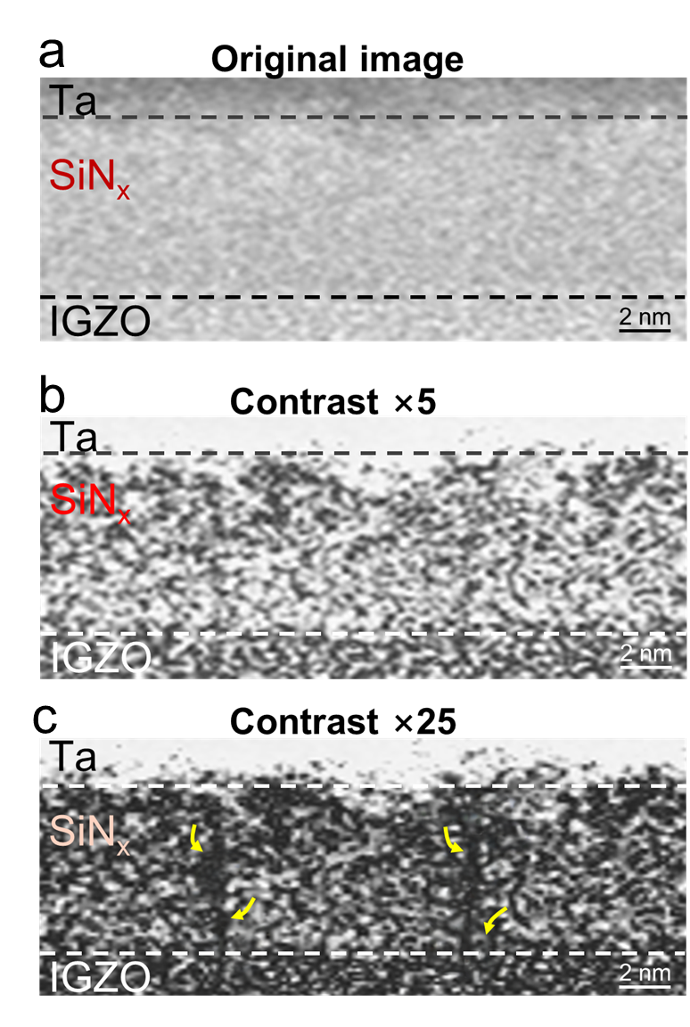
Fig. S11 TEM cross-sectional characterization of SiN_{x} layers with varying contrast. a Original TEM characterization of the thin film cross-section; b TEM characterization of the SiN_{x} thin film cross-section after a fivefold increase in contrast, revealing blurred channels; c TEM characterization of the SiN_{x} thin film cross-section after a tenfold increase in contrast, clearly illustrating distinct vacancy channels. Further comprehensive experimental validation of this conclusion is precluded at this stage by the constraints of the available characterization platform.

Fig. S12 The TCAD simulation of our Pt/IGZO/SiN_{x}/Ta memristor reveals intricate electrophysical dynamics that elucidate the fundamental switching mechanism. By computationally modeling the device's nanoscale architecture, we demonstrate that the unique vertical heterostructure induces highly localized and intensified electric field distributions. Specifically, the interfaces between dissimilar materials (Pt/IGZO, IGZO/SiN_{x}, and SiN_{x}/Ta) generate significant dielectric discontinuities, which act as electric field concentration sites. These nanoscale heterojunctions create potential barriers and charge carrier redistribution zones that are critical for resistive switching behavior.
Under modest applied voltages, intense electric field gradients within the device heterostructure drive a cascade of nanoscale processes. Specifically, these gradients initiate selective oxygen vacancy migration and dynamic ionic rearrangement within the IGZO layer, nucleating conductive filaments. Critically, the SiN_{x} layer mediates this process by concentrating and confining the electric field, thereby enabling precise electrostatic control over filament development. This field-guided mechanism orchestrates the systematic nucleation and spatially confined extension of conductive filamentary networks, transforming inherently stochastic resistive switching into a deterministic process. The vertically confined field profile ensures high spatial selectivity during filament formation, suppressing lateral dispersion and enhancing switching uniformity.

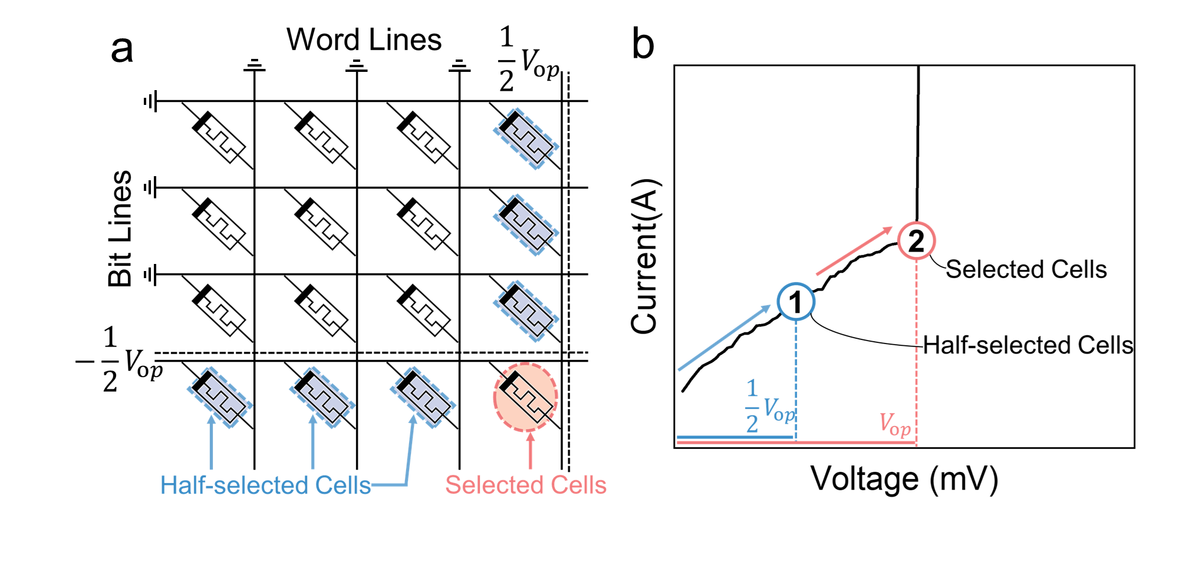
Fig. S13 1/2 V_{op} voltage distribution scheme to program target cells. a Based on this voltage distribution scheme, positions within the array are categorized into selected cells and half-selected cells. Under this scheme, selected cells receive sufficient voltage to meet the required setting criteria, while half-selected cells fail to reach this threshold and thus cannot be successfully programmed. b In the I-V graph, the voltage applied to the half-selected cells is represented at position ①, indicating that they did not reach the turn-on voltage and therefore could not be set. On the other hand, the applied voltage for the selected cells is shown at position ②, successfully reaching the turn-on voltage and thus allowing for successful programming.

Fig. S14 Distribution of set and reset voltages for 16 devices in passive array. The slight differences in resistance switching behaviors among various devices in the passive array reflect their uniformity and stability in performance.

Fig. S15 Passive array programming architecture based on DAC and MU. The information received by the sensing end is converted into a voltage signal by the DAC and then routed through the MUX to select specific channels, generating sequential input pulses. These signals interact within the array and ultimately output responses via the MUX below. The structure of the array facilitates on-chip information processing, enabling data writing and row-wise reading by controlling the rows and columns.

Fig. S16 By leveraging the resistance values at different locations in the encoding array, the information “Z J U I C 1 8 9 7” can be input into the array based on binary encoding. Specifically, each resistance value at a location represents a particular state, enabling effective encoding of letters and digits.

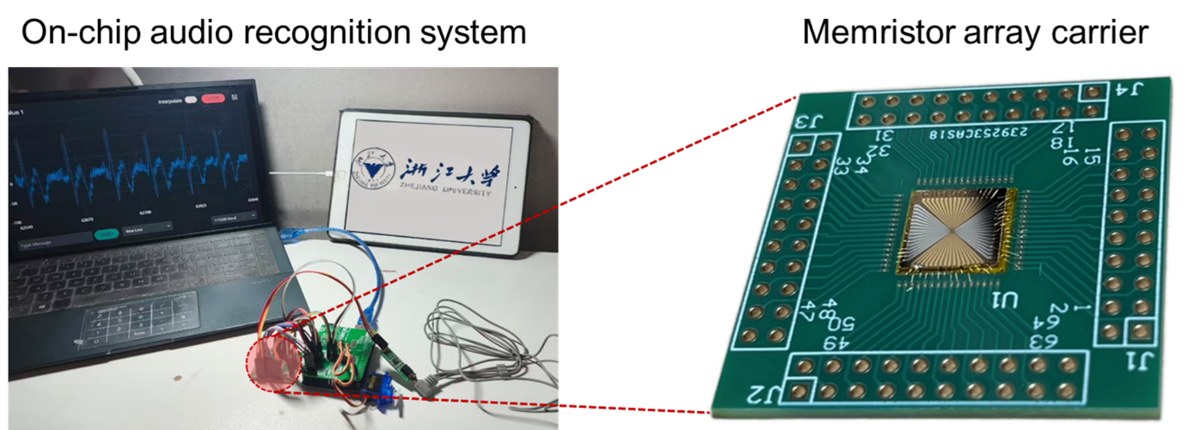
Fig. S17 On-Chip Audio Recognition System. Photograph of the on-chip audio recognition system, highlighting the memristor array fabricated in this work and subsequently bonded onto a chip carrier.
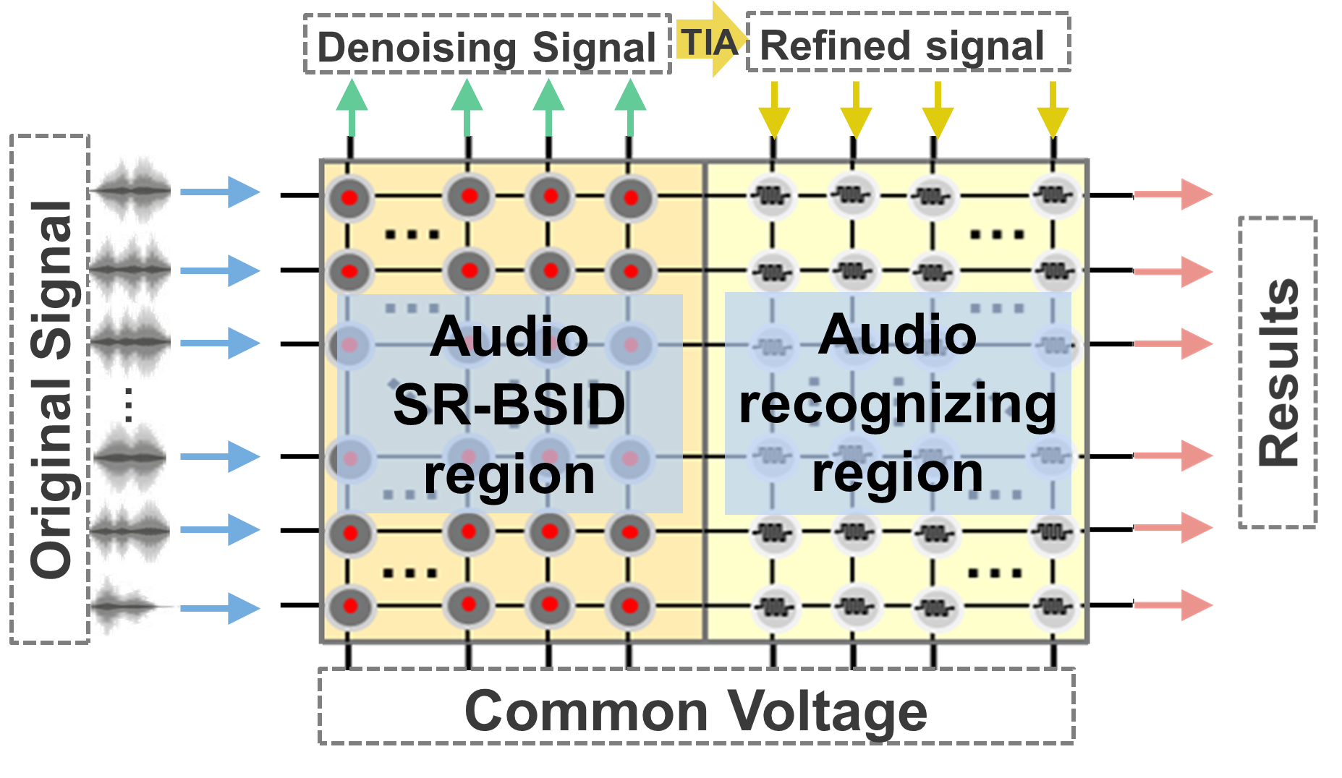
Fig. S18 Array functional area division, parameter programming, and signal path.

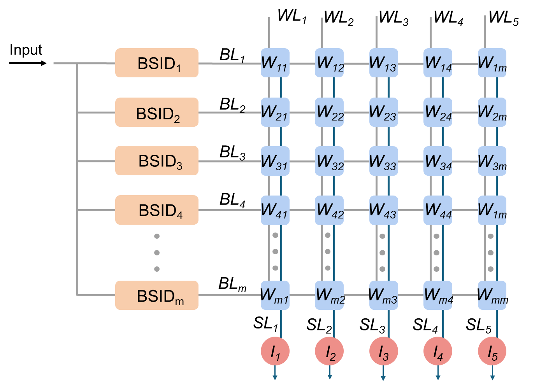
Fig. S19 Schematic diagram of signal processing flow of audio recognition system with SR-BSID method. WL, SL, and BL stand for the word line, source line, and bit line,
respectively.

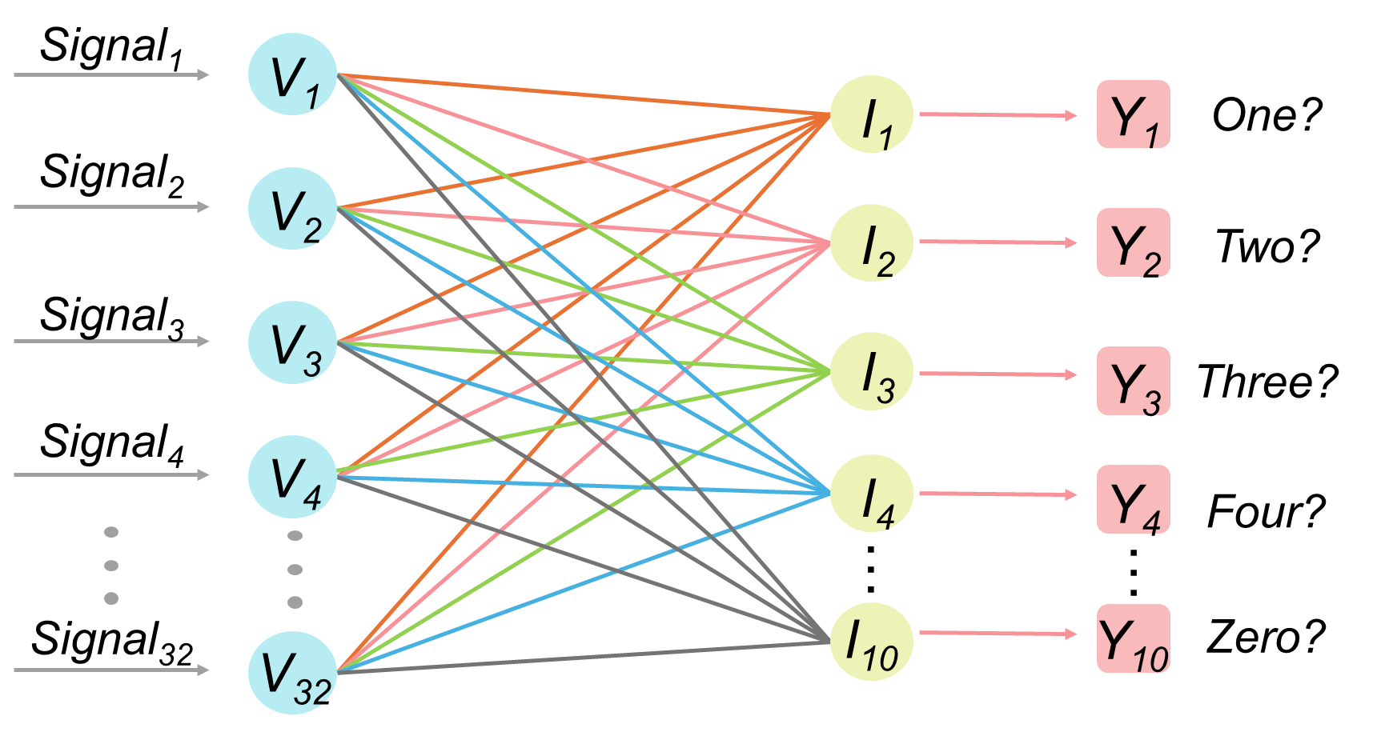
Fig. S20 Schematic diagram of the readout layer for biological audio signal classification in a single-layer CNN.

Fig. S21 Changes in activated site distribution from early training to convergence.

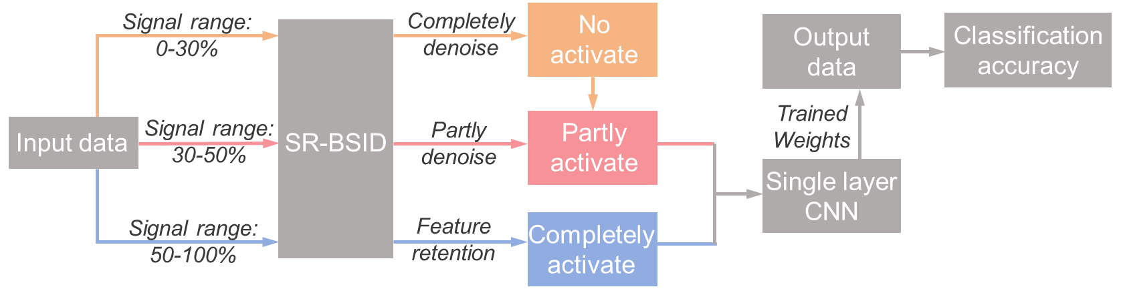
Fig. S22 The scheme of training and testing processes. Input data segmented into 0-30%, 30-50%, and 50-100% signal-intensity tiers undergoes hierarchical processing by the SR-BSID module: the weak-signal tier (0-30%) undergoes complete denoising, the mid-signal tier (30-50%) receives partial denoising with core feature retention, while the strong-signal tier (50-100%) deactivates denoising and enables feature enhancement; the processed data then trains weight parameters through a single-layer CNN, ultimately generating classification accuracy metrics.

Fig. S23 Original and Denoised Audio Signals of Digits '0' to '9'. Strong signal data is effectively retained, while noisy and chaotic interference signals are effectively suppressed.

Fig. S24 a Retention of high-intensity feature signals; b Low-intensity noise suppression effect;

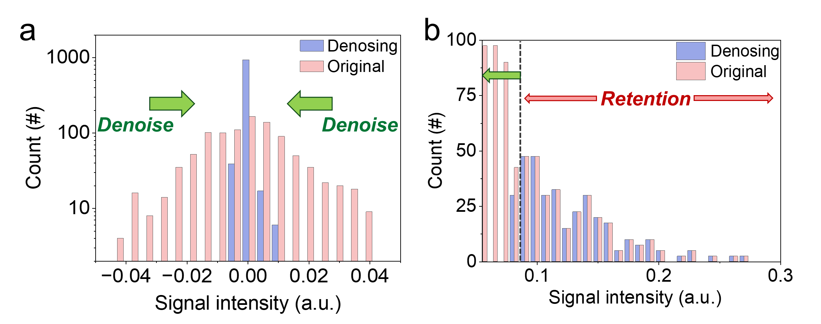
Fig. S25 Intensity distribution of signals before and after denoising. a Weak signals (<0.07), typically noise, are largely suppressed to 0–0.01, b while strong feature signals (>0.1) are fully preserved.

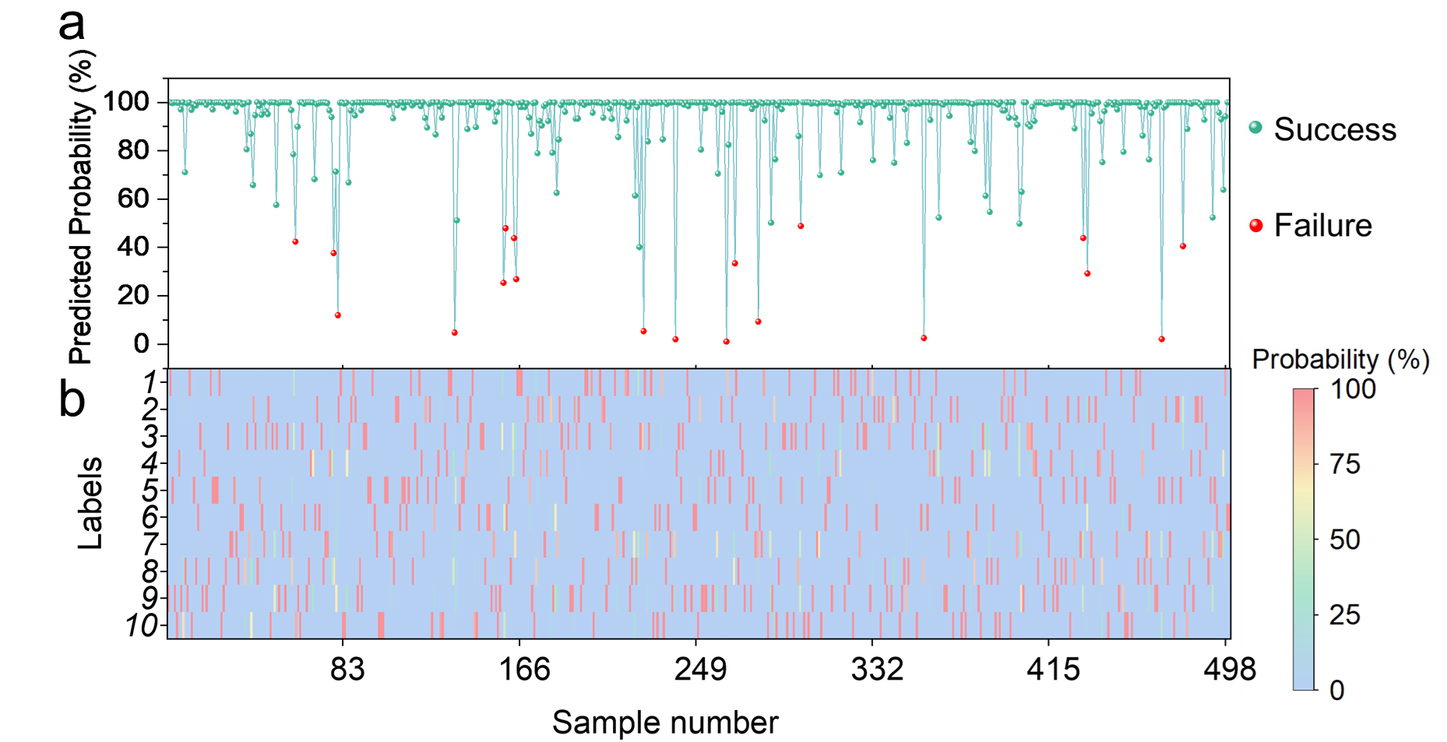
Fig. S26 Distribution of prediction results for 500 sample points after 10 epochs. a The predicted probabilities of the true labels by the system, where green points represent successful predictions, the majority of which exceed 99%, while red points represent failed predictions, accounting for 3.8% of the total sample size. b Distribution map of recognition probabilities for ten labels across the 500 samples.

Fig. S27 Post-training correlation between recognition accuracy and epochs for varying SNR audio signals: Lower SNR (1-5 dB) signals show greater training difficulty, yet maintain robust recognition accuracy after SR-BSID processing.

Table 1 Comparison of key metrics among state-of-the-art devices^{1–17}

Reference
1. Mou, N. I., Zhang, Y., Pai, P. & Tabib-Azar, M. [1]Steep sub-threshold current slope (∼2 mV/dec) Pt/Cu2S/Pt gated memristor with lon/Ioff > 100. Solid-State Electronics 127, 20–25 (2017).
2. McGuire, F. A. et al. Sustained Sub-60 mV/decade Switching via the Negative Capacitance Effect in MoS2 Transistors. ACS Publications https://pubs.acs.org/doi/full/10.1021/acs.nanolett.7b01584 (2017) doi:10.1021/acs.nanolett.7b01584.
3. Hua, Q. et al. A Threshold Switching Selector Based on Highly Ordered Ag Nanodots for X‐Point Memory Applications. doi:10.1002/advs.201900024.
4. Sonde, S. et al. Silicon compatible Sn-based resistive switching memory. doi:10.1039/C8NR01540F.
5. Zhou, X. et al. A high performance electroformed single-crystallite VO2 threshold switch. doi:10.1039/C9NR08364B.
6. Huang, X. et al. Steep-slope field-effect transistors with AlGaN/GaN HEMT and oxide-based threshold switching device. Nanotechnology 30, 215201 (2019).
7. Wang, Y., Yuan, Q., He, N., Sun, Y. & Wen, D. [10]Ovonic threshold switching device and its application to logic gate function and steep slope in field effect transistors. Surfaces and Interfaces 30, 101895 (2022).
8. Song, B., Xu, H., Liu, S., Liu, H. & Li, Q. [15]Threshold Switching Behavior of Ag-SiTe-Based Selector Device and Annealing Effect on its Characteristics. IEEE J. Electron Devices Soc. 6, 674–679 (2018).
9. Song, B. et al. An ovonic threshold switching selector based on Se-rich GeSe chalcogenide. Applied Physics A 125, 1–6 (2019).
10. Speckbacher, M. et al. Directed Assembly of Nanoparticle Threshold‐Selector Arrays. Adv Elect Materials 5, 1900098 (2019).
11. Liu, Y. et al. A Robust and Low‐Power Bismuth Doped Tin Oxide Memristor Derived from Coaxial Conductive Filaments. Small 16, (2020).
12. Guo, X. et al. SiO2/Ta2O5 heterojunction ECM memristors: physical nature of their low voltage operation with high stability and uniformity. Nanoscale 12, 4320–4327 (2020).
13. Teja Nibhanupudi, S. S. et al. Ultra-fast switching memristors based on two-dimensional materials. Nat Commun 15, 2334 (2024).
14. Kim, S. J. et al. Reliable and Robust Two-Dimensional Perovskite Memristors for Flexible-Resistive Random-Access Memory Array. ACS Nano 18, 28131–28141 (2024).
15. Chen, Z.-J. et al. A flexible artificial synapse based on the two-dimensional CuInS2 memristor for neural morphology calculation. Materials Science in Semiconductor Processing 188, 109203 (2025).
16. Yang, X. et al. Solution-Processed Hydrogen-Bonded Organic Framework Nanofilms for High-Performance Resistive Memory Devices. Advanced Materials 35, 2305344 (2023).
17. Li, P. et al. Dual-layer volatile memristor with ultralow voltage slope. Applied Physics Letters 124, (2024).

