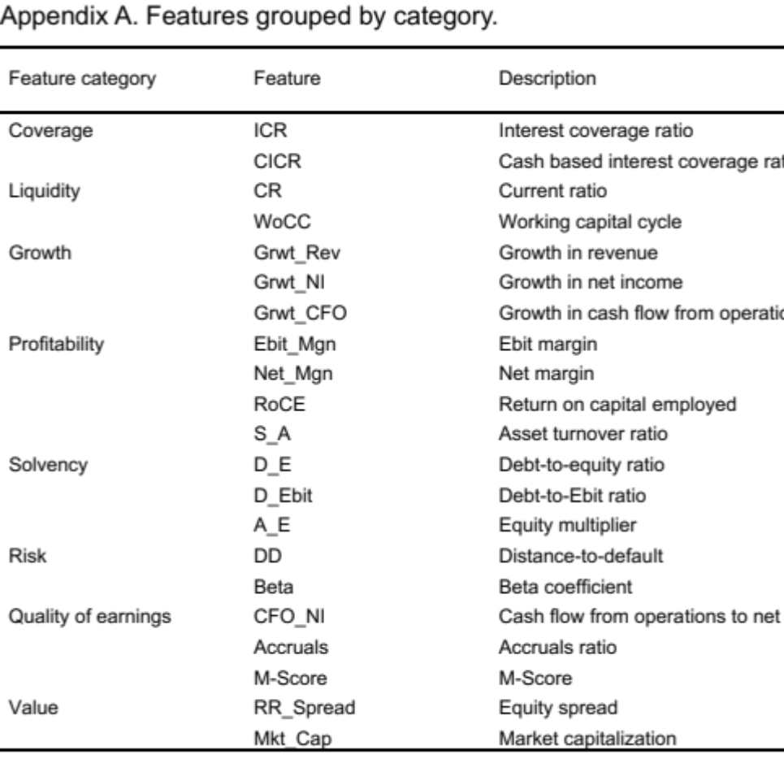

Appendix B. Descriptive statistics by credit-rating group.
 | Group A |  |  |  |  |  | Group B |  |  |  |  |  | Group C
 | Avg. | Median | Std. dev. | Max | Min |  | Avg. | Median | Std. dev. | Max | Min |  | Avg. | Median | Std. dev. | Max | Min
ICR | 1.42 | 0.93 | 1.69 | 4.29 | 0.10 |  | -0.37 | -0.34 | 0.24 | 0.18 | -0.58 |  | -0.36 | -0.50 | 0.43 | 1.18 | -0.79
CICR | 1.09 | 0.11 | 2.16 | 4.95 | 0.00 |  | -0.26 | -0.27 | 0.17 | 0.09 | -0.44 |  | -0.28 | -0.34 | 0.23 | 0.61 | -0.46
CR | -0.26 | -0.27 | 0.09 | -0.16 | -0.38 |  | -0.29 | -0.30 | 0.24 | 0.22 | -0.75 |  | 0.17 | -0.28 | 1.32 | 5.22 | -0.75
WoCC | -0.13 | 0.03 | 0.76 | 0.86 | -1.23 |  | -0.48 | -0.42 | 0.32 | -0.10 | -1.21 |  | 0.33 | -0.09 | 1.22 | 4.35 | -0.55
S_A | -0.24 | -0.22 | 0.49 | 0.51 | -0.70 |  | -0.65 | -0.64 | 0.51 | 0.72 | -1.24 |  | 0.33 | 0.01 | 1.18 | 3.42 | -1.24
Grwt_Rev | -0.01 | 0.00 | 0.15 | 0.19 | -0.22 |  | 0.12 | -0.22 | 1.05 | 2.96 | -0.76 |  | -0.07 | -0.22 | 1.13 | 4.03 | -1.65
Grwt_NI | 0.19 | 0.32 | 0.29 | 0.45 | -0.24 |  | 0.32 | 0.04 | 0.98 | 2.43 | -1.04 |  | -0.25 | -0.01 | 0.75 | 0.97 | -2.06
Grwt_CFO | -0.14 | -0.11 | 0.12 | 0.01 | -0.29 |  | 0.29 | -0.15 | 1.54 | 4.93 | -0.34 |  | -0.17 | -0.24 | 0.53 | 1.46 | -1.00
Ebit_Mgn | 1.33 | 1.67 | 1.02 | 2.46 | -0.02 |  | -0.39 | -0.31 | 0.43 | 0.19 | -0.81 |  | -0.45 | -0.43 | 0.78 | 1.32 | -2.50
Net_Mgn | 1.05 | 1.45 | 0.72 | 1.76 | 0.20 |  | -0.12 | -0.03 | 1.30 | 1.35 | -3.53 |  | -0.22 | -0.26 | 0.66 | 0.79 | -2.07
RoCE | 1.64 | 1.45 | 1.20 | 3.57 | 0.42 |  | -0.41 | -0.37 | 0.30 | 0.26 | -0.72 |  | -0.20 | -0.35 | 0.78 | 1.85 | -1.79
D_E | -0.22 | -0.23 | 0.04 | -0.16 | -0.25 |  | -0.21 | -0.22 | 0.04 | -0.12 | -0.25 |  | 0.13 | -0.19 | 1.29 | 5.28 | -0.25
D_Ebit | -0.22 | -0.23 | 0.01 | -0.20 | -0.23 |  | -0.21 | -0.21 | 0.02 | -0.16 | -0.23 |  | 0.11 | -0.21 | 1.24 | 5.09 | -0.32
A_E | -0.61 | -0.26 | 0.92 | -0.01 | -2.25 |  | -0.06 | -0.15 | 0.36 | 0.70 | -0.37 |  | 0.21 | -0.08 | 1.23 | 4.76 | -0.92
DD | 0.38 | 0.19 | 0.55 | 1.03 | -0.34 |  | 0.18 | 0.21 | 0.19 | 0.48 | -0.13 |  | -0.21 | 0.11 | 1.32 | 0.53 | -5.41
Beta | -0.50 | -0.19 | 0.95 | 0.66 | -1.48 |  | 0.01 | 0.18 | 0.88 | 1.66 | -1.48 |  | 0.13 | 0.08 | 1.09 | 2.40 | -1.48
CFO_NI | 0.19 | 0.18 | 0.04 | 0.25 | 0.15 |  | -0.30 | 0.20 | 1.72 | 0.41 | -5.46 |  | 0.13 | 0.17 | 0.35 | 0.34 | -1.22
Accruals | 0.16 | -0.06 | 0.53 | 1.04 | -0.24 |  | -0.30 | -0.07 | 1.65 | 1.23 | -4.96 |  | 0.14 | 0.01 | 0.43 | 1.00 | -0.63
M-Score | -0.16 | -0.15 | 0.05 | -0.11 | -0.22 |  | -0.17 | -0.19 | 0.09 | 0.06 | -0.24 |  | 0.15 | -0.20 | 1.37 | 5.63 | -0.24
RR_Spread | 0.02 | -0.05 | 0.37 | 0.61 | -0.41 |  | -0.11 | -0.12 | 0.07 | 0.01 | -0.19 |  | 0.06 | -0.15 | 1.38 | 5.35 | -1.73
Mkt_Cap | 1.31 | 0.71 | 1.99 | 3.76 | -0.49 |  | -0.12 | -0.17 | 0.35 | 0.72 | -0.49 |  | -0.42 | -0.47 | 0.12 | 0.04 | -0.49

