Supporting Information
Immobilization of hydroaminase-expressing recombinant Escherichia coli whole-cell biocatalysts for the production of β-alanine
Li Ma^{[a], [b]}, Yuyu Wang^{[a]}, Ruiqi Liu^{[a]}, Jingjia Hu^{[a]}, Xiaobing Zheng^{[a]}, Xiaoyang Yue^{[a]}, Guanhua Liu^{[a]}, Liya Zhou*^{[a]}, Ying He*^{[a]}
Dr. L. Ma, Y. Wang, R. Liu, J. Hu, X. Zheng, Dr. X. Yue, Dr. G. Liu, Prof. Dr. L. Zhou, Dr. Y. He
School of Chemical Engineering and Technology
Hebei University of Technology
Tianjin 300401, China
E-mail: liyazhou@hebut.edu.cn
- L. Ma, Yanjun Jian
National-Local Joint Engineering Laboratory for Energy Conservation in Chemical Process Integration and Resources Utilization
Hebei University of Technology, Tianjin 300130, China

目录
Analytical methods 1
Purification and structural identification of β - alanine 1
Reusability of whole cell catalysis 1
Structural identification of β - alanine 1
Results and discussion 3
Reusability of whole cell catalysts 3
Supporting figures 4
HPLC traces 5
References 6

Analytical methods

Purification and structural identification of β - alanine
Centrifuge the reaction mixture at 12000 r/min for 10 minutes and collect the upper reaction solution. Add a certain amount of activated carbon to the reaction solution for decolorization, and filter after 30 minutes to obtain a clear decolorized solution. The decolorized clear solution was concentrated using a rotary evaporator, and the concentration of β - alanine in the concentrated solution was identified by HPLC. After the purity of β - alanine was greater than 95%,^{[1]} it was vacuum freeze-dried, and the resulting crystal was β - alanine. Determine the structure of β - alanine using ¹H NMR and ¹³C NMR.

Reusability of whole cell catalysis
Reusability of whole cell catalysis is used to investigate the reusability of whole cell synthesis of β - alanine. After the reaction, the reaction solution is centrifuged, and the whole cells are washed three times with buffer before being put into the next batch of reaction. By measuring the content of β - alanine in each batch, calculating the yield, and examining the reusability of whole cell catalysts.

Structural identification of β - alanine
The ¹H NMR of β - alanine is shown in Figure S1. There are three different types of hydrogen in the spectrum, with the deuterium solvent peak on the far left and the remaining peaks being methylene hydrogen in β - alanine, with an integrated area of 1:1. The ¹³C NMR of β - alanine is shown in Figure S1. There are three carbon peaks in the ¹³C spectrum, corresponding to the three carbon atoms in the structure of β - alanine. Prove the successful synthesis of β - alanine through nuclear magnetic resonance.
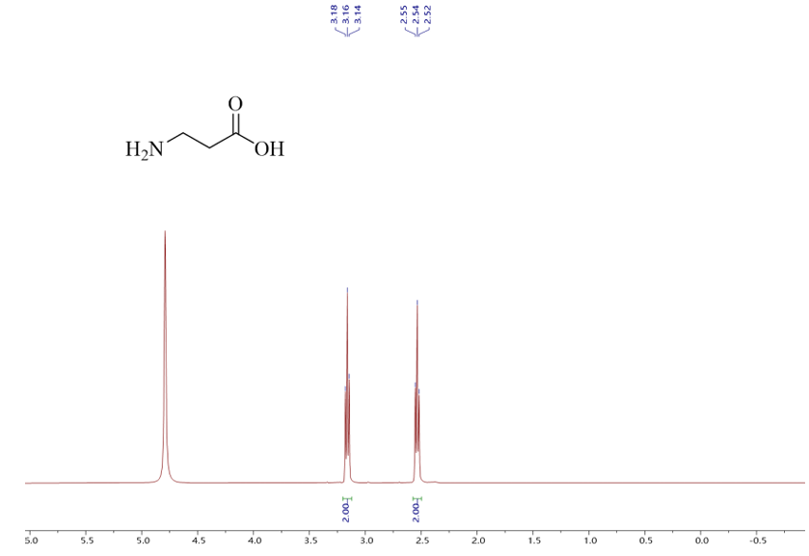Figure S1 ¹H NMR spectra of β-alanine.

Results and discussion

Reusability of whole cell catalysts
Whole cell catalysts have a complete cellular structure, and compared to crude enzyme solutions, they are easy to recover and can be reused multiple times after the reaction. After one batch of whole cell catalyst reaction, there is usually still high enzyme activity. The reusability of aspartic acid lyase whole cell catalyst was investigated Figure S2. According to the experimental results, when reused for the fourth time, the yield of β - alanine is only about 10%. The overall stability of cells, tolerance to adverse environments, and ease of recovery can be improved through immobilization methods.
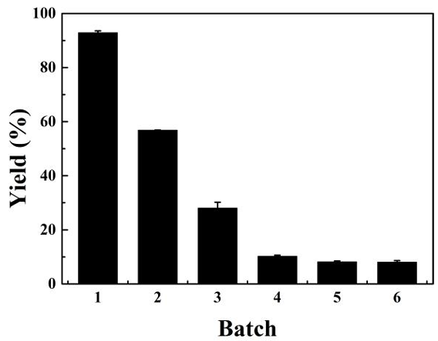
Figure S2 Reusability of free cells.

Supporting figures
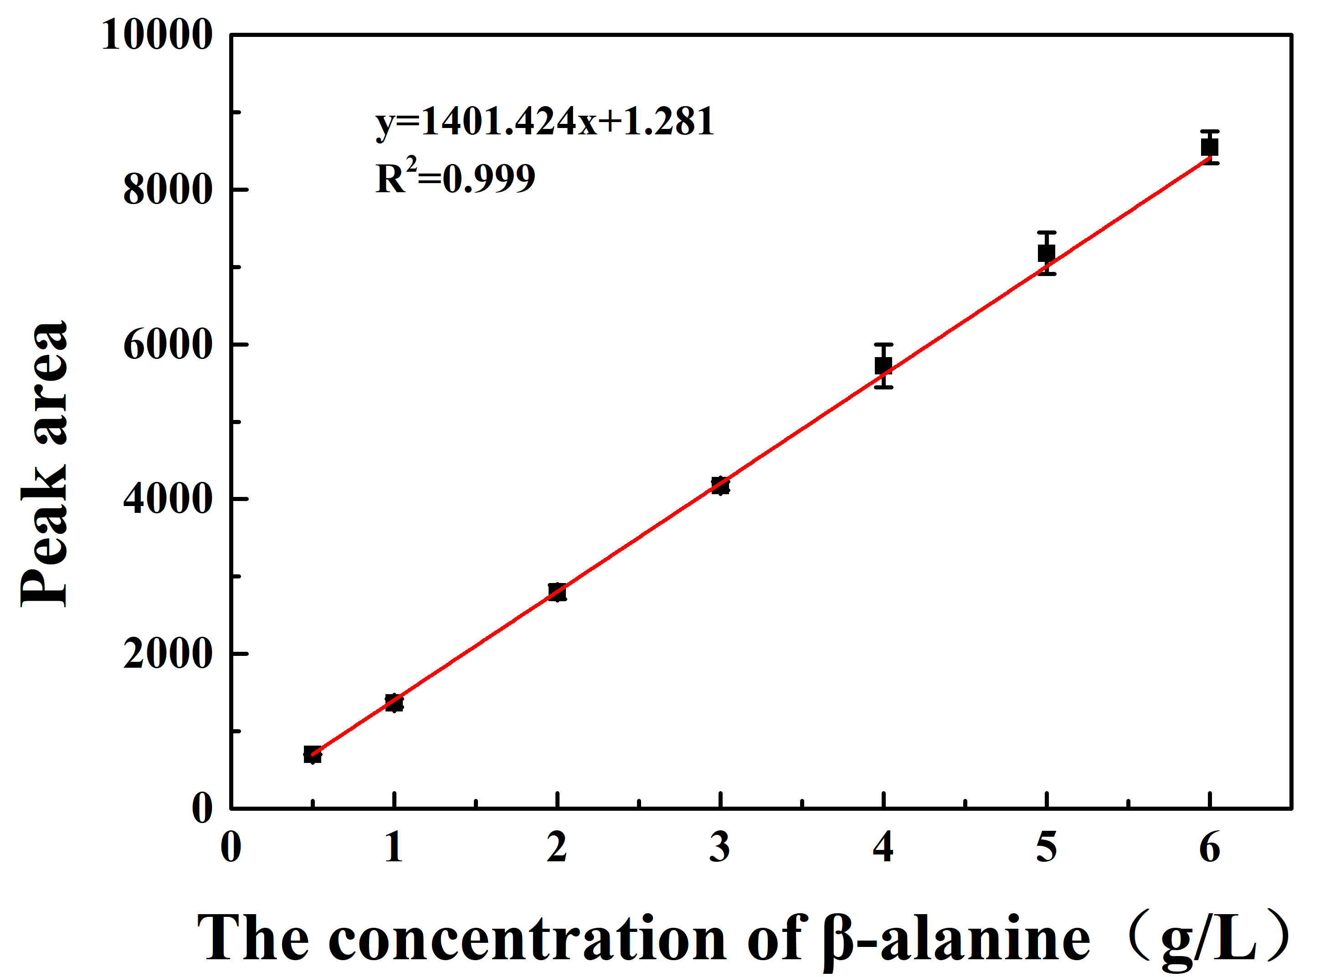
Figure S3 Standard curve for beta-alanine.

HPLC traces
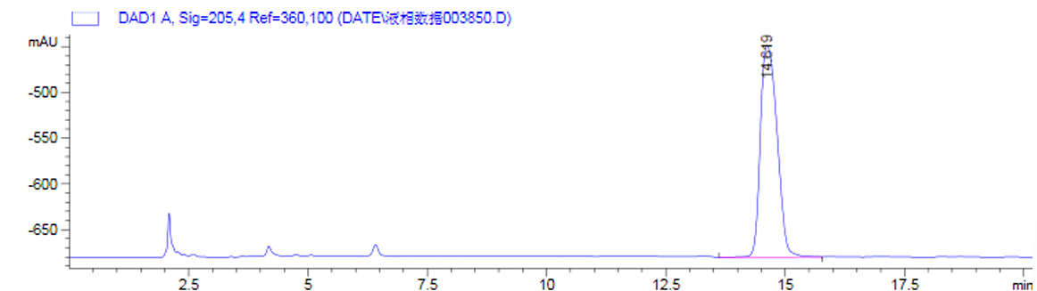
HPLC chromatogram of β-alanine.
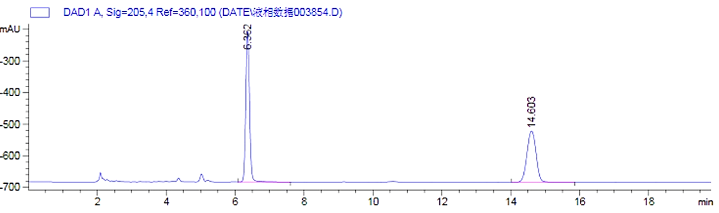
HPLC chromatogram of the reaction solution.
HPLC analysis:
Amino column, phosphate Buffer ( pH 4.5, 50 mmol/L) / acetonitrile= 3:7, flow rate = 1.0 mL/min, wavelength = 205 nm.

References
[1] X. Huang, Z. Zhang, M. Hong, Y. Xia, Amino acids and biological resources. 2008 119(03), 46-50.

