Supporting Information

Eco-Friendly Fabrication of Carbon Nanotubes-Reduced Graphene Oxide-Silicon for High Current Density Anode Materials of LIB

Sun Kyung Kimª, Ki-Min Rohª, Hee Dong Jang^{a*}

ª Resources & Materials Research Center, Korea Institute of Geoscience & Mineral Resources, Daejeon, 34132, Republic of Korea.

*Corresponding author: Tel: 82-42-868-3612; Fax: 82-42-868-3415
E-mail address: hdjang@kigam.re.kr

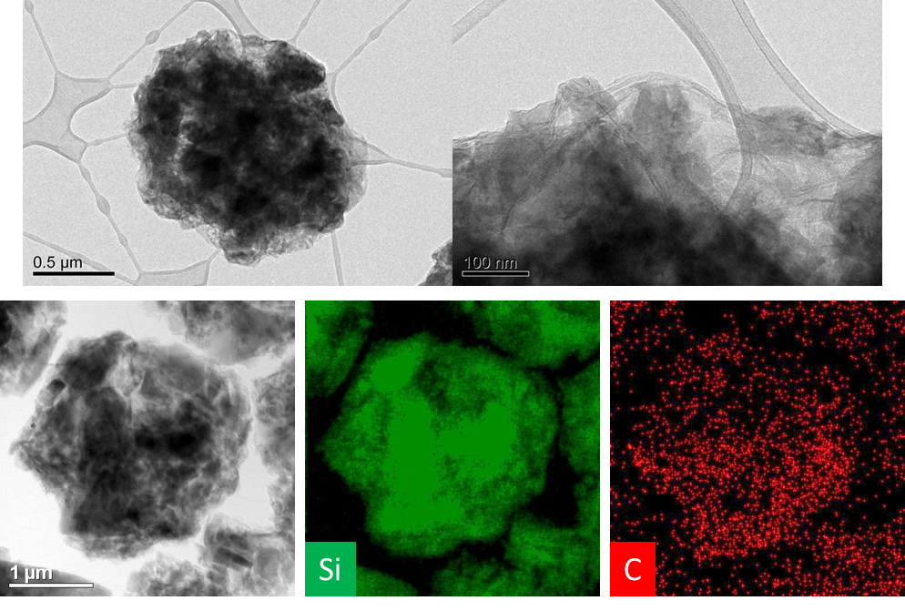
Figure S1. TEM and EDS mapping images of CNTs-RGO-Si composites (CNT-GO colloid: 3 milling times).

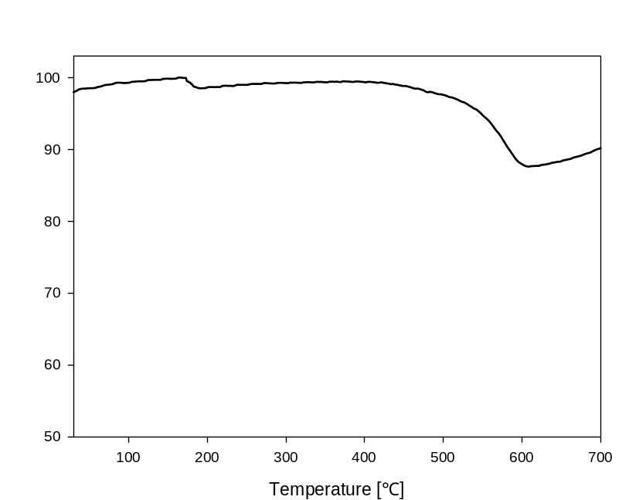
Figure S2. TGA curves of CNTs-RGO-Si composites (CNT-GO colloid: 3 milling times).

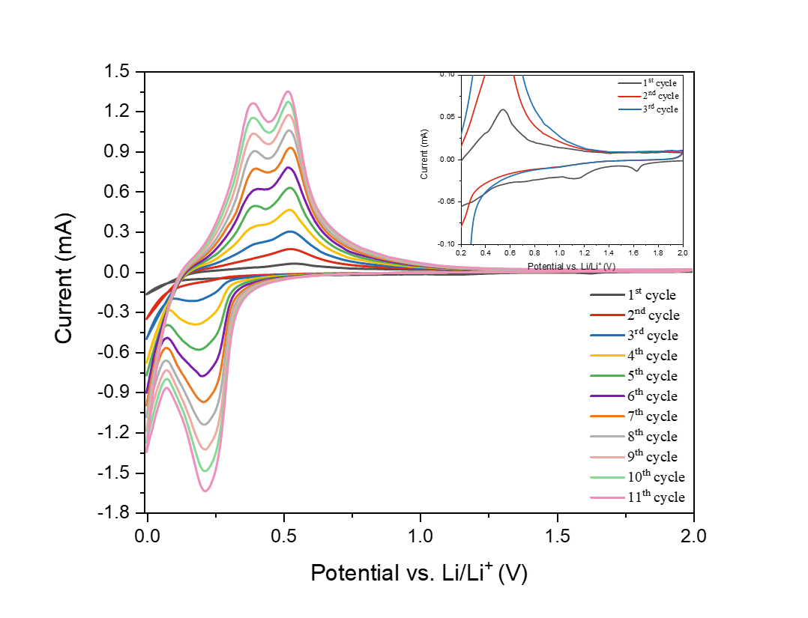
Figure S3. Cyclic voltammetry curves of CNTs-RGO-Si composites (CNT-GO colloid: 3 milling times).

