SUPPLEMENTARY FIGURES

Extracellular contractile injection systems for high efficiency protein delivery to plants

Mark G. Legendre¹, Carlos A. Heredia¹, Clair Colee¹, Gozde S. Demirer^{1,#}

¹Chemistry and Chemical Engineering Division, California Institute of Technology, Pasadena, CA, USA
#corresponding author: gdemirer@caltech.edu

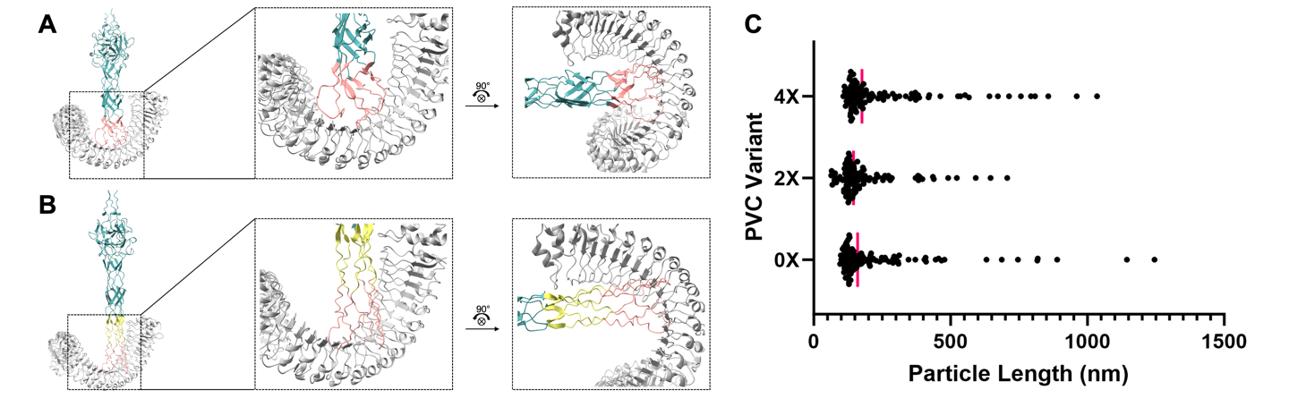

Supplementary Figure 1. Flg22 epitope alignments and size distributions of PVC variants. (A) ChimeraX alignment of the flg22 epitope (salmon) from the 0xlinker PVC variant AlphaFold-predicted tail fiber body (teal) to the flg22 peptide in the FLS2–flg22 crystal structure (PDB: 4MN8, gray). (B) ChimeraX alignment of the flg22 epitope (salmon) from the 2xlinker PVC variant AlphaFold-predicted structure (tail fiber body, teal; linker, yellow) to the flg22 peptide in the FLS2–flg22 crystal structure (PDB: 4MN8, gray). (C) Length distribution of n = 100 PVCs for each member of the FLS2-binding PVC library (the 0x, 2x, and 4x linker variants). Vertical red bars represent data medians (0X: 160.8 nm, 95% CI [136.2-203.1]; 2X: 145.6 nm, 95% CI [130.3-158.4]; 4X: 176.0 nm, 95% CI [157.6-204.4]).

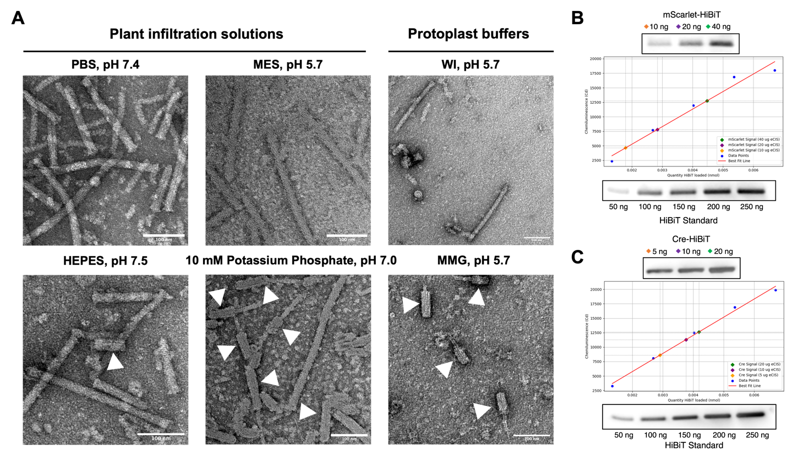

Supplementary Figure 2. Characterizing PVC cargo loading capacity and stability. (A) Representative negative stain TEM images of PVCs prepared in various suspension buffers. White arrows indicate contracted PVC sheaths. Scale bar, 100 nm. (B) Denaturing western blot band intensity analysis on PVCs loaded with mScarlet protein tagged with HiBiT. Band intensities measured using FIJI image processing package and a standard linear regression performed on a HiBiT standard (Promega N3010). (C) Denaturing western blot band intensity analysis on PVCs loaded with Cre recombinase tagged with HiBiT. Band intensities measured using FIJI image processing package and a standard linear regression performed on a HiBiT standard.

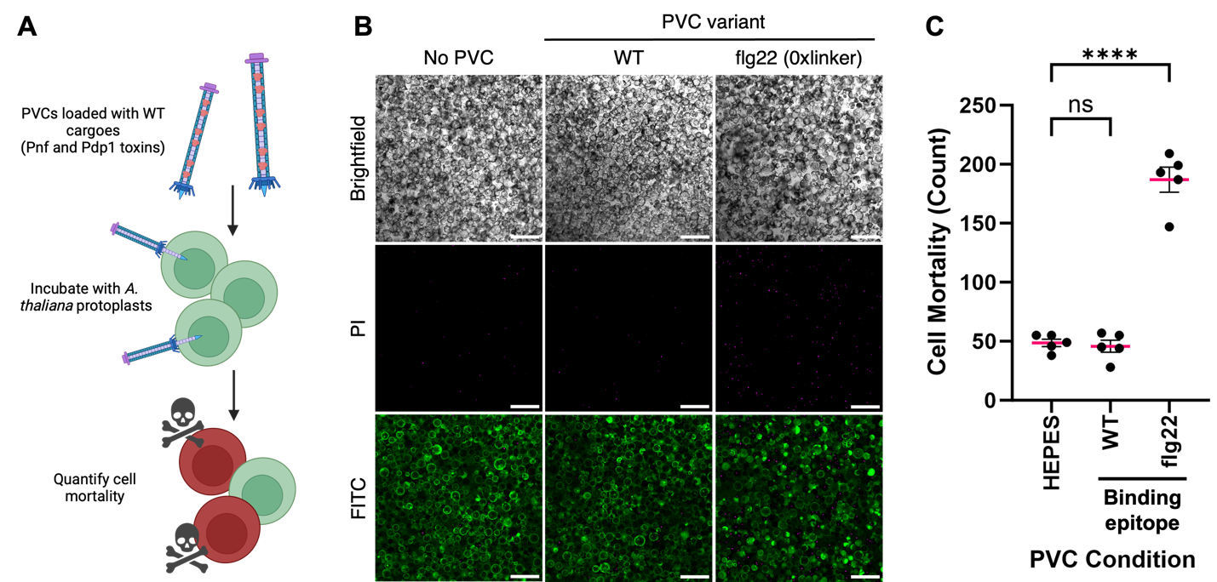

Supplementary Figure 3. FLS2-targeting PVCs deliver WT payloads to plant cells. (A) Schematic of PVC-mediated toxin effector delivery in A. thaliana protoplasts, where cell mortality is measured using a propidium iodide (PI)/fluorescein isothiocyanate (FITC) live/dead stain. (B) Representative confocal microscopy images of A. thaliana protoplasts stained (PI/FITC) 24 h following challenge with PVCs harboring toxin payloads. Scale bar, 200 nm. (C) Quantification of cell mortality (defined as number of PI-stained nuclei) from confocal images for HEPES buffer control, no binding control, and a 0xlinker PVC experimental sample. Data are mean ± SEM with n = 5 biological replicates, one-way ANOVA with Tukey post hoc test. ****P < 0.0001. ns, not significant.

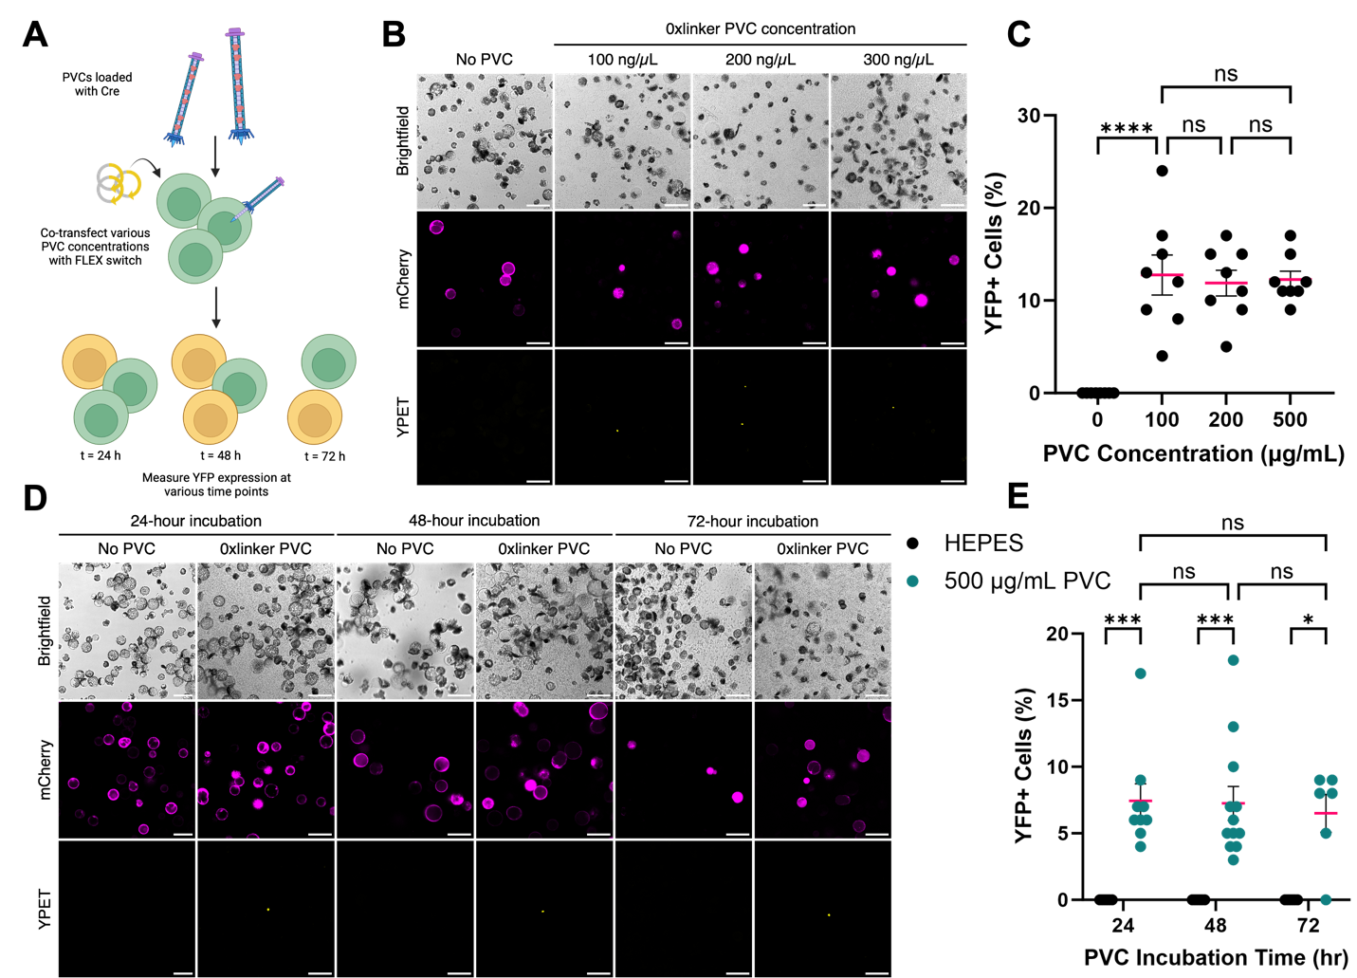

Supplementary Figure 4. Optimizing experimental parameters for PVC delivery assays. (A) Schematic applying the Cre delivery assay to screen for optimal PVC concentrations and incubation times in A. thaliana protoplasts. (B) Representative confocal microscopy images of A. thaliana protoplasts harboring the FLEX vector and challenged with the 0xlinker PVC variant at different concentrations. Scale bar, 100 µm. (C) Quantification of percentage of YFP+ cells from confocal images in B for HEPES buffer control, and 100, 200, and 500 μg/mL 0xlinker PVC challenge. (D) Representative confocal microscopy images of A. thaliana protoplasts harboring the FLEX vector and challenged with 500 μg/mL of the 0xlinker PVC variant. Images were captured at 24 h-increment time points. Scale bar, 100 µm. (E) Quantification of percentage of YFP+ cells from confocal images in D. At every time point, a 500 μg/mL 0xlinker PVC experimental sample is compared to a HEPES buffer control. Data in C, E are mean ± SEM with n = 8 (C) or n > 5 (E) technical replicates, one-way ANOVA with Tukey post hoc test. *P < 0.05, ***P < 0.001 and ****P < 0.0001. ns, not significant.

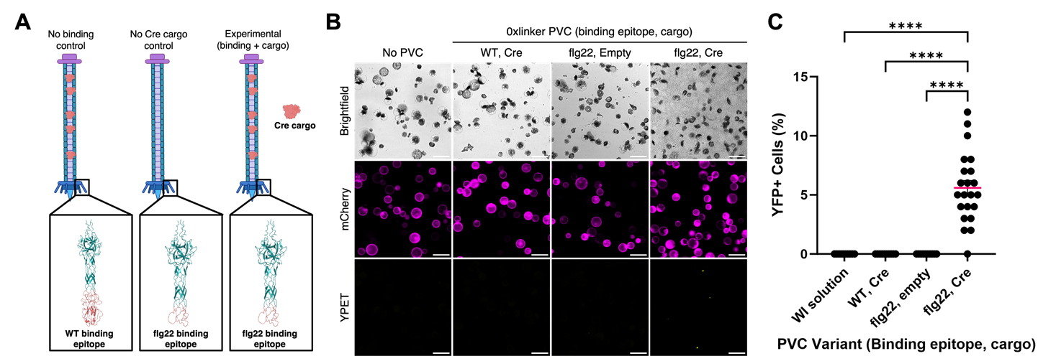

Supplementary Figure 5. The flg22 binding epitope is required for PVC activity in plant cells. (A) Illustration of the PVC variants required to provide proper controls for all Cre-delivery experiments. A no binding control probes the function of the flg22 epitope, and a no cargo control probes the function of the Cre cargo. (B) Representative confocal microscopy images of A. thaliana protoplasts harboring the FLEX vector and challenged with 500 μg/mL PVC variants from panel A. Scale bar, 100 µm. (C) Quantification of percentage of YFP+ cells from confocal images for WI solution control, no binding control, no cargo control, and a 0xlinker PVC experimental sample. Data are mean ± SEM with n > 10 technical replicates, one-way ANOVA with Tukey post hoc test. ****P < 0.0001.

