Supplementary table 1: Baseline EORTC-QLQ BIL21

EORTC-QLQ 30 | Mean (SD)
Physical Functioning | 80.6 (19.4)
Role Functioning | 75.8 (30.2)
Emotional Functioning | 75.8 (24.0)
Cognitive Functioning | 80.3 (25.6)
Social Functioning | 66.7 (39.4)
Global health status | 68.9 (20.8)
Fatigue | 40.4 (25.5)
Nausea/vomiting | 13.6 (19.5)
Pain | 27.3 (23.9)
Dyspnea | 24.2 (21.6)
Insomnia | 27.3 (29.1)
Appetite loss | 18.2 (17.4)
Constipation | 21.2 (27.0)
Diarrhea | 6.1 (13.5)
Financial Problems | 33.3 (39.4)
EORTC BIL21
Anxiety symptoms | 43.8 (29.1)
Eating symptoms | 15.3 (18.1)
Jaundice symptoms | 4.6 (10.0)
Pain symptoms | 27.1 (22.2)
Treatment side effects | 30.6 (26.4)
Tiredness symptoms | 55.6 (32.1)
Weight loss | 19.4 (33.2)
Drains | 2.8 (9.6)

Supplementary figure 1: Physical functioning
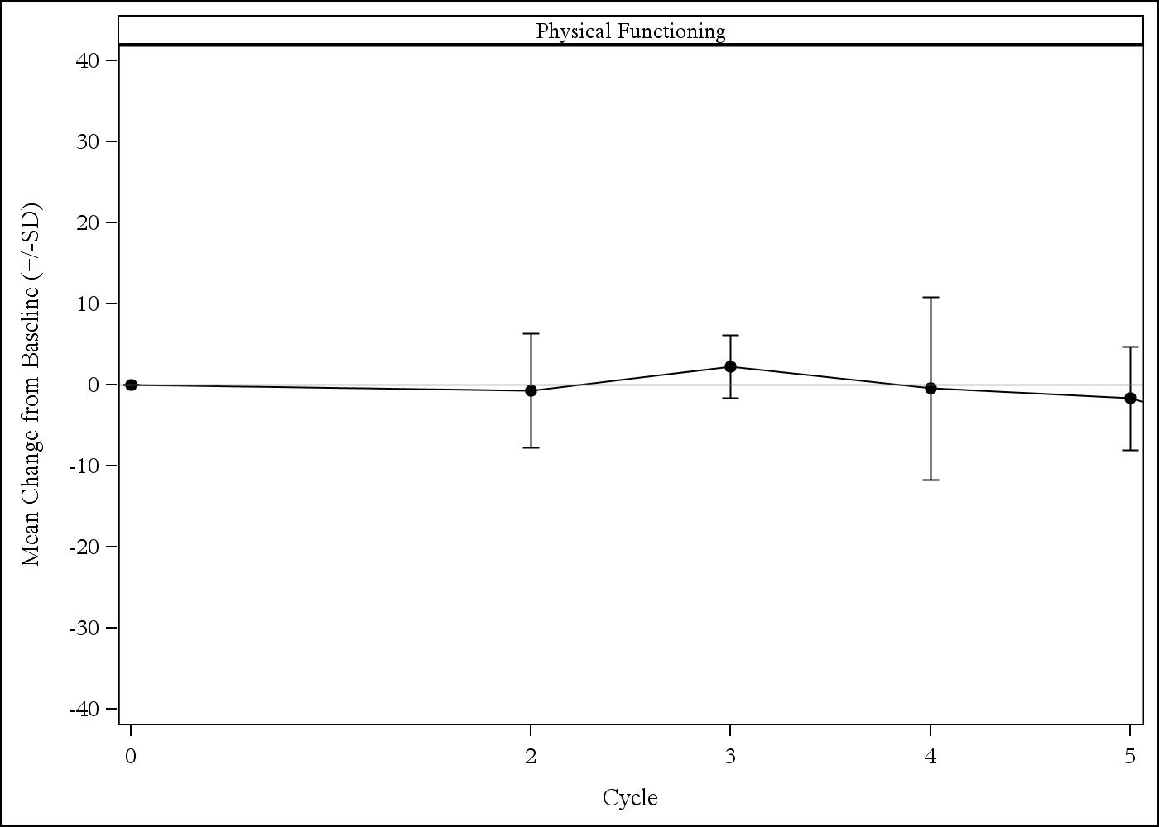

Supplementary figure 2: Role functioning

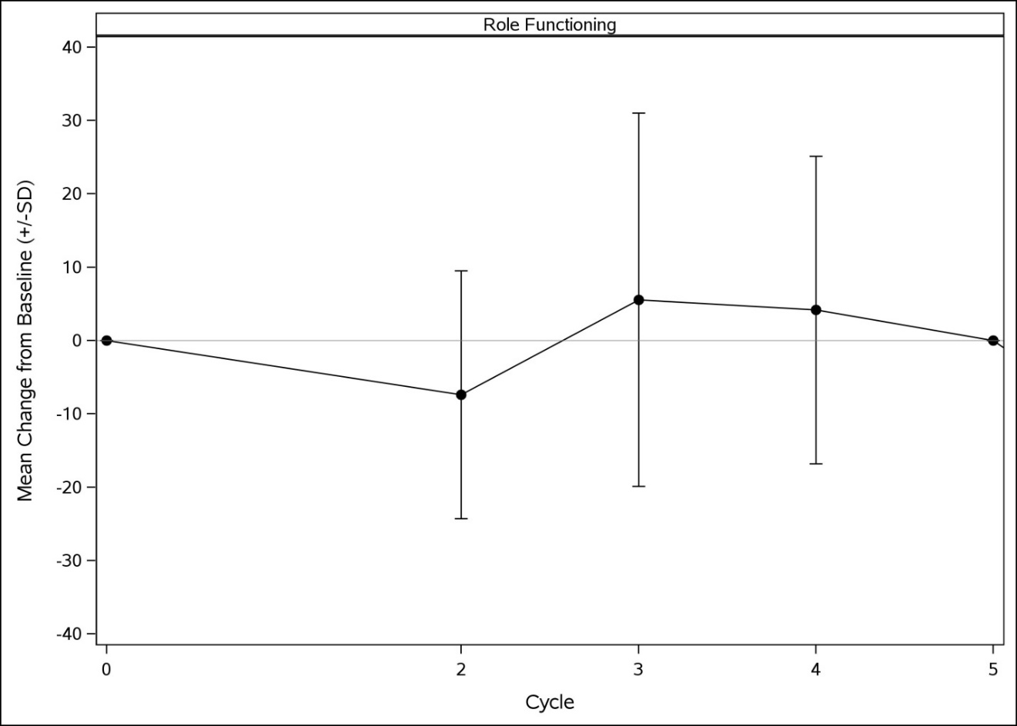

Supplementary figure 3: Emotional functioning

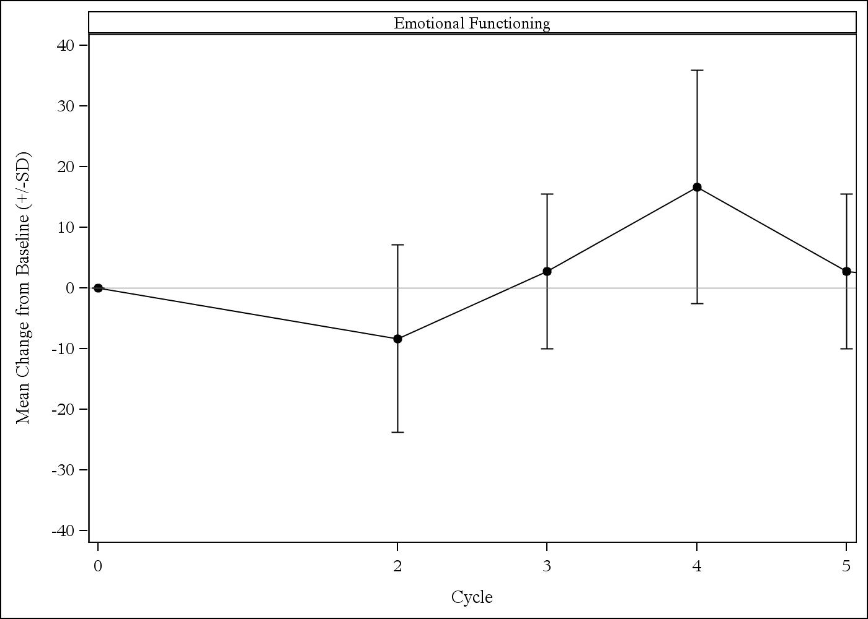

Supplementary figure 4: Social functioning

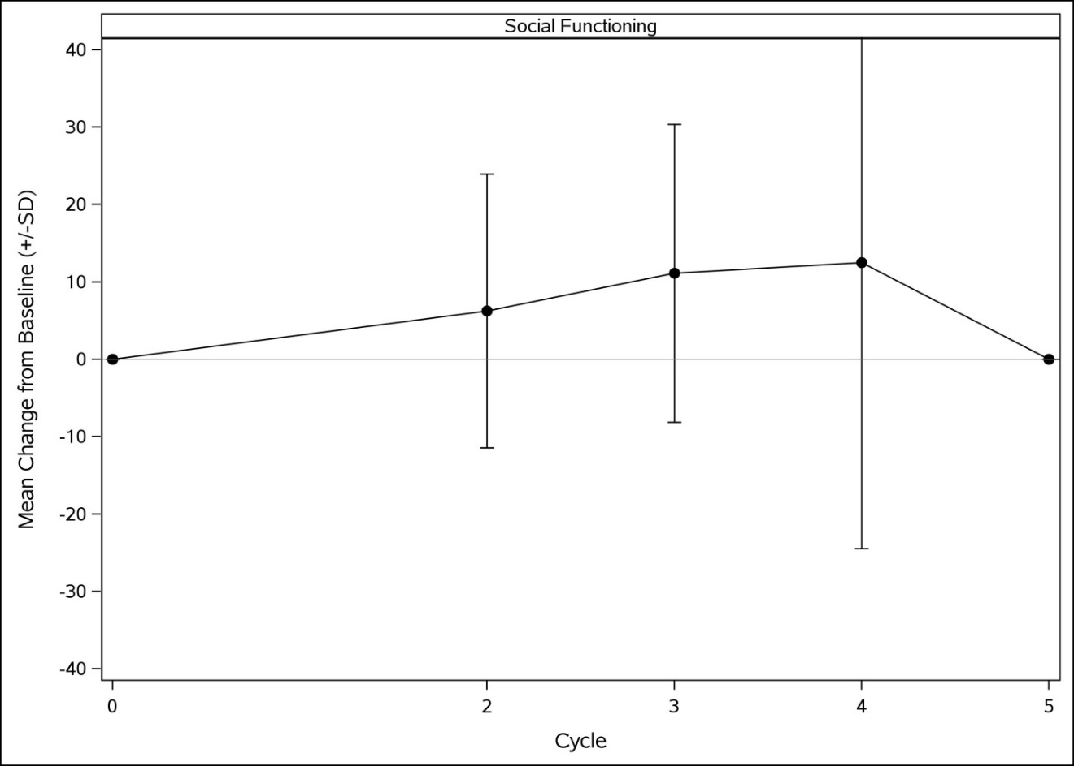

Supplementary figure 5: Cognitive functioning

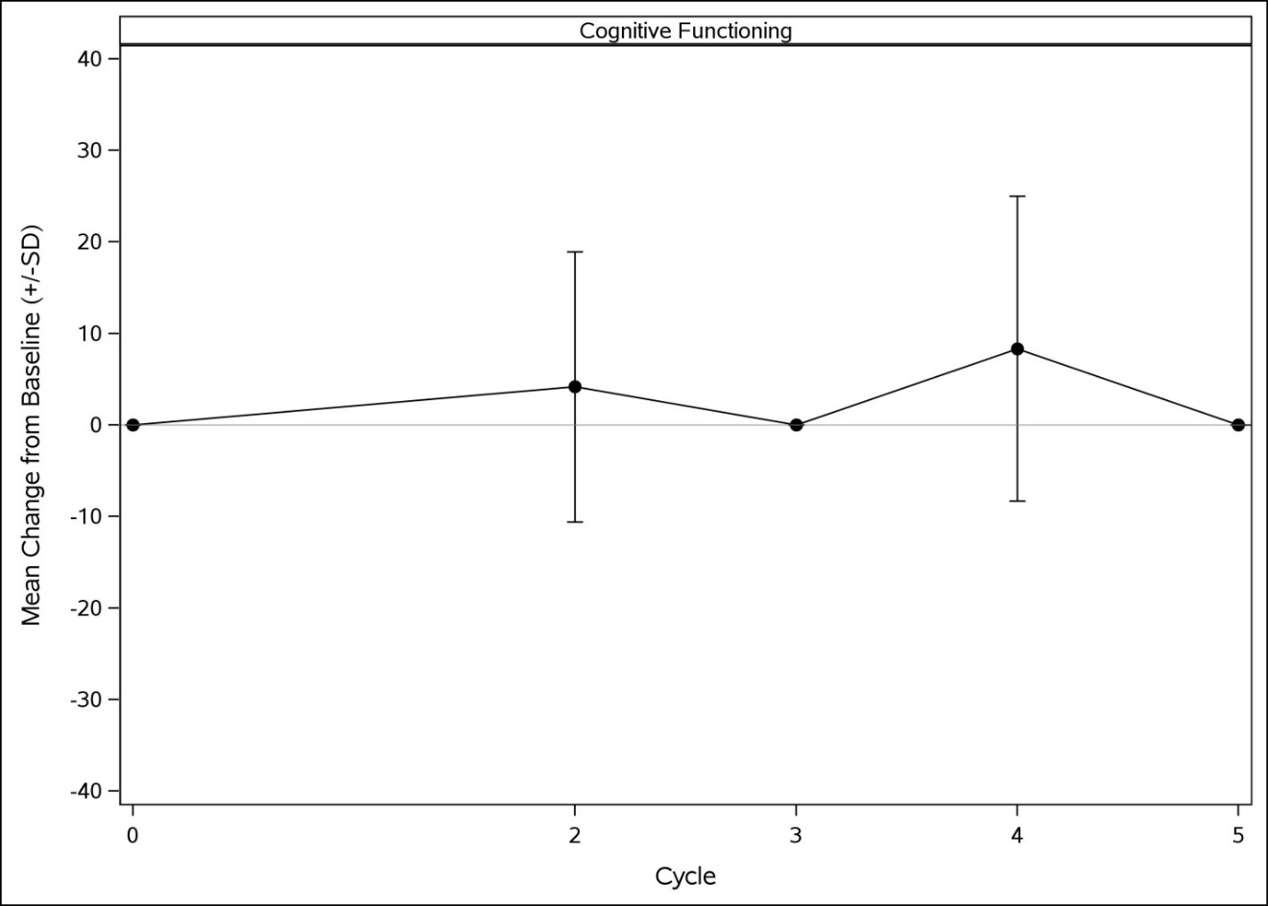

Supplementary figure 6: Global QoL

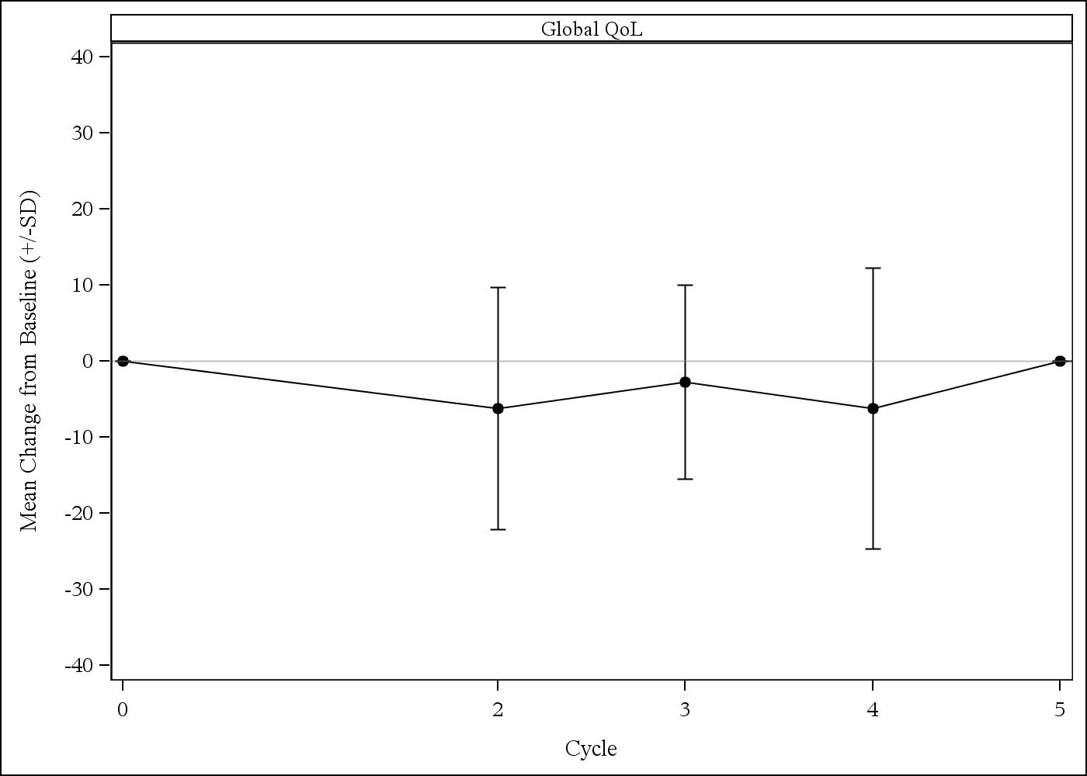

Supplementary figure 7: Tiredness- EORTC BIL-21

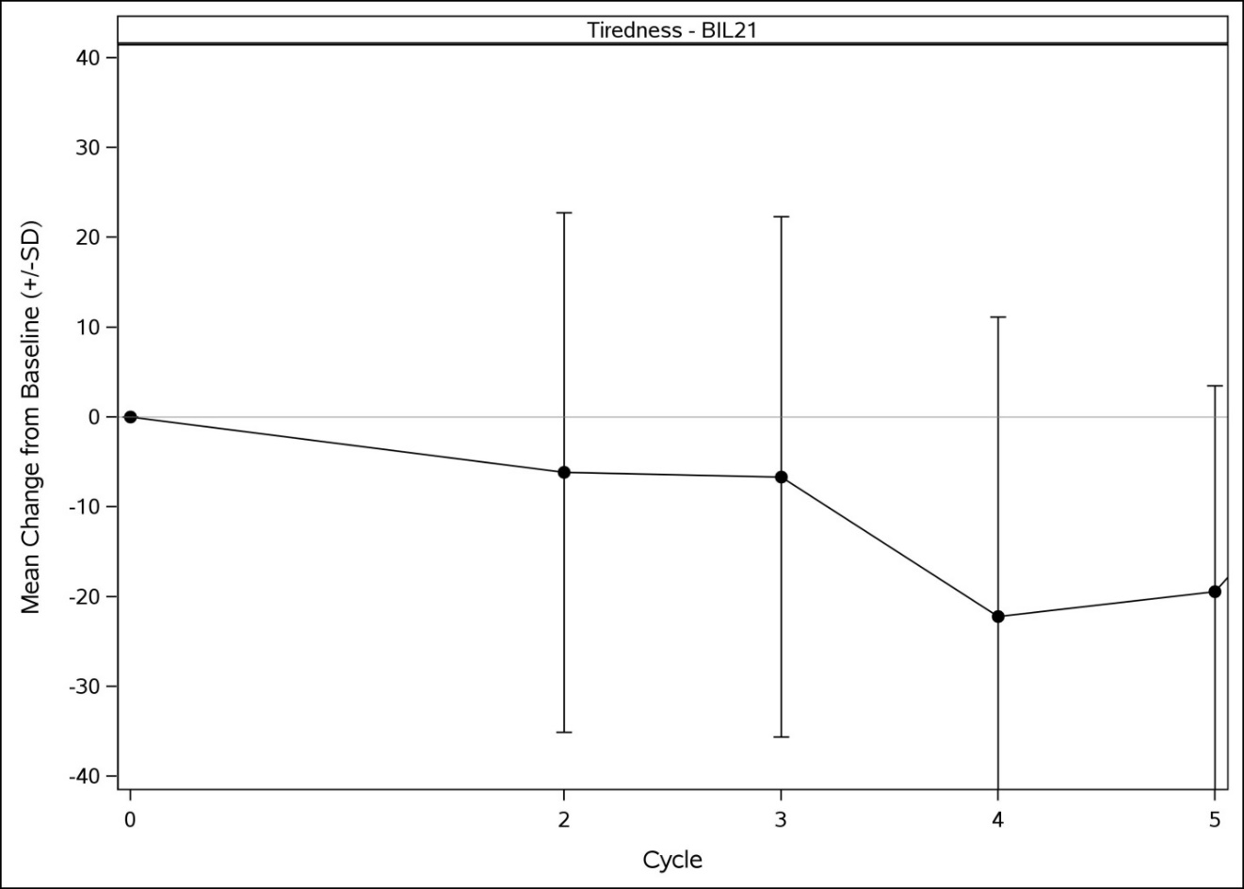

Supplementary figure 8: Skindex symptoms

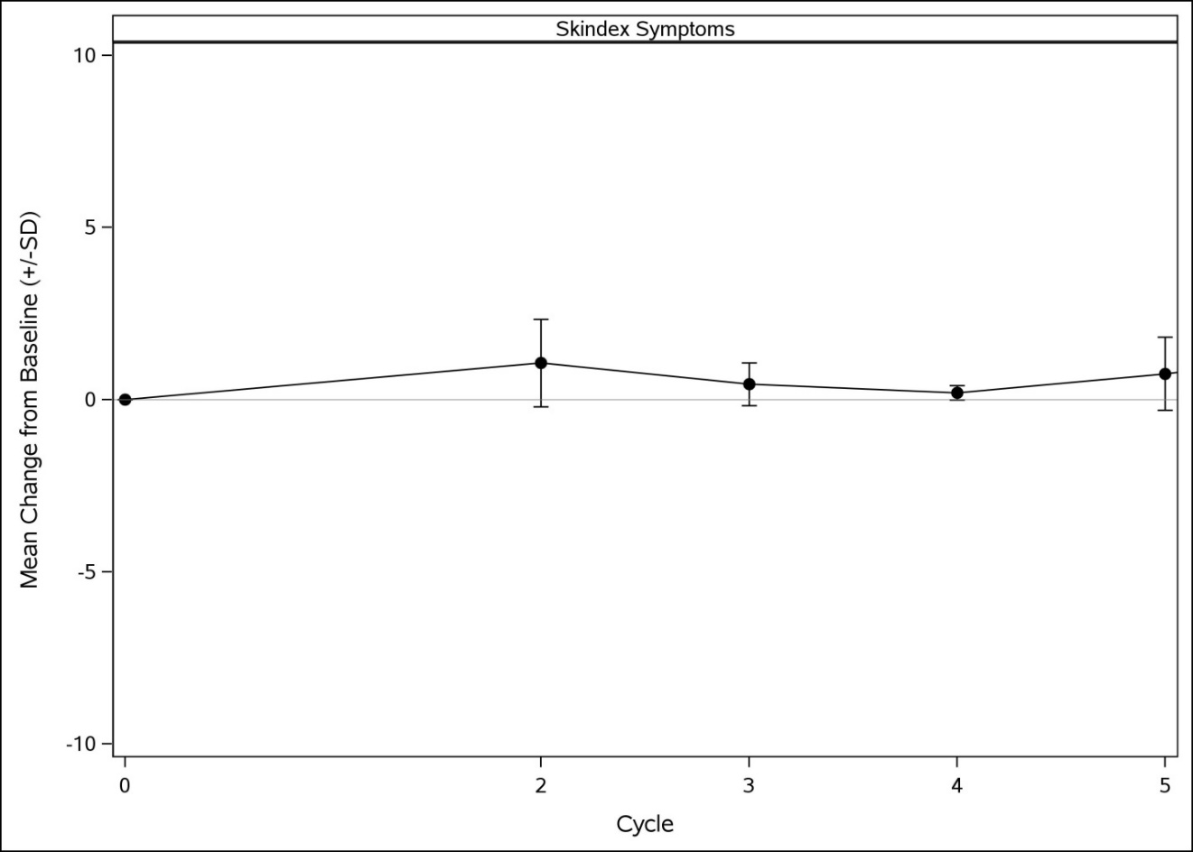

Supplementary figure 9: Skindex emotional

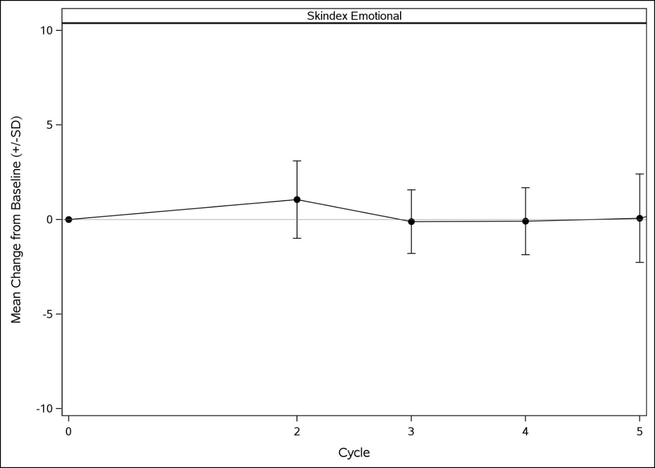

Supplementary figure 10: Skindex functional

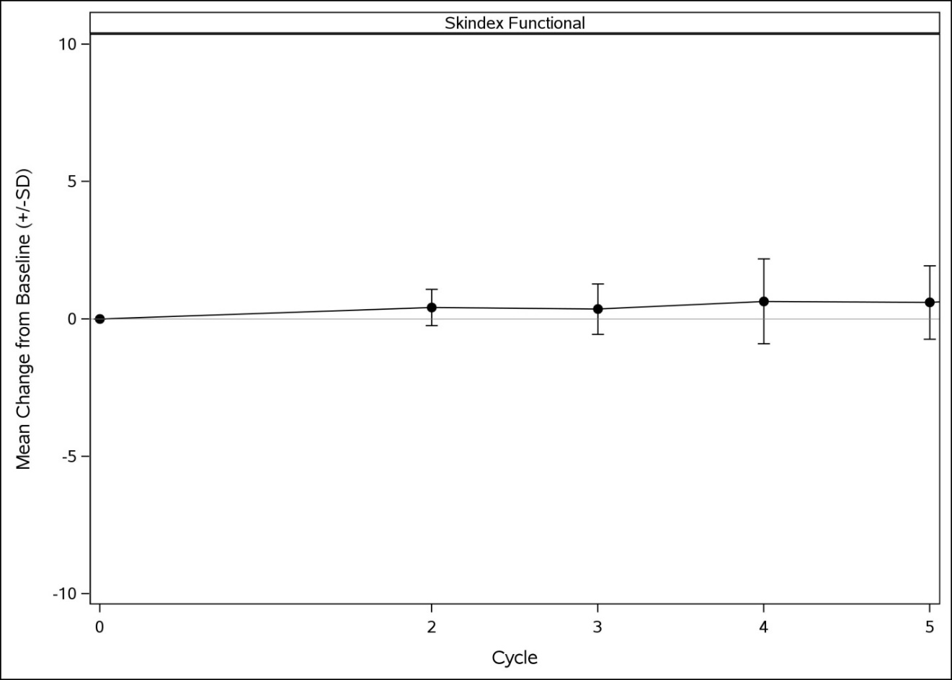

Supplementary figure 11: Bowel function score

