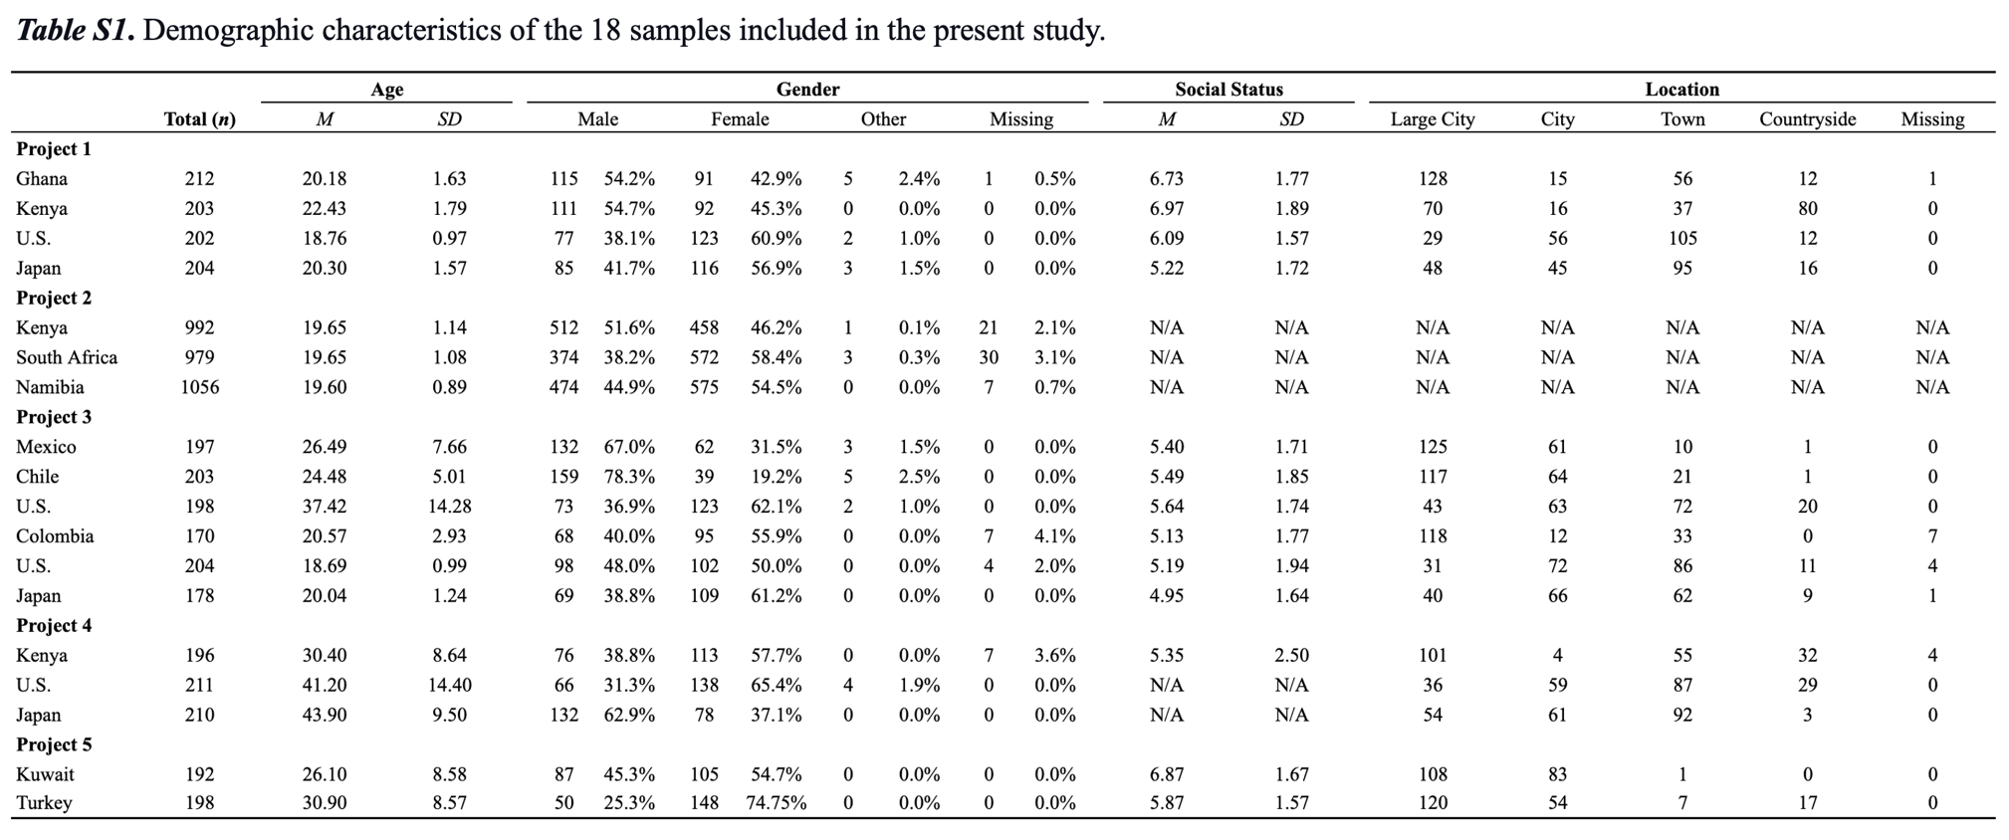
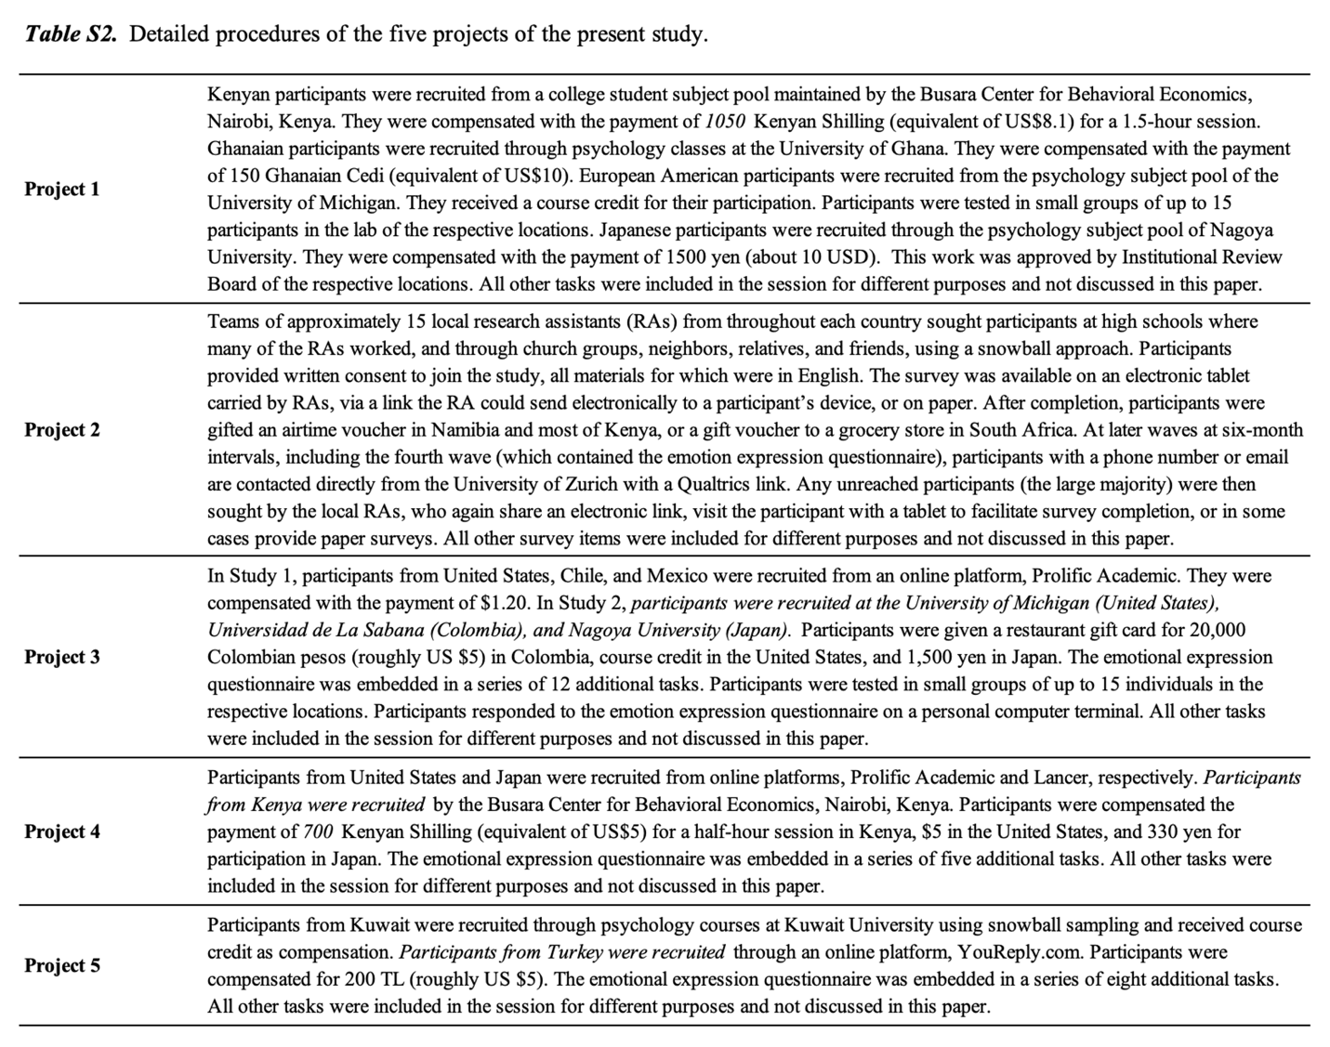
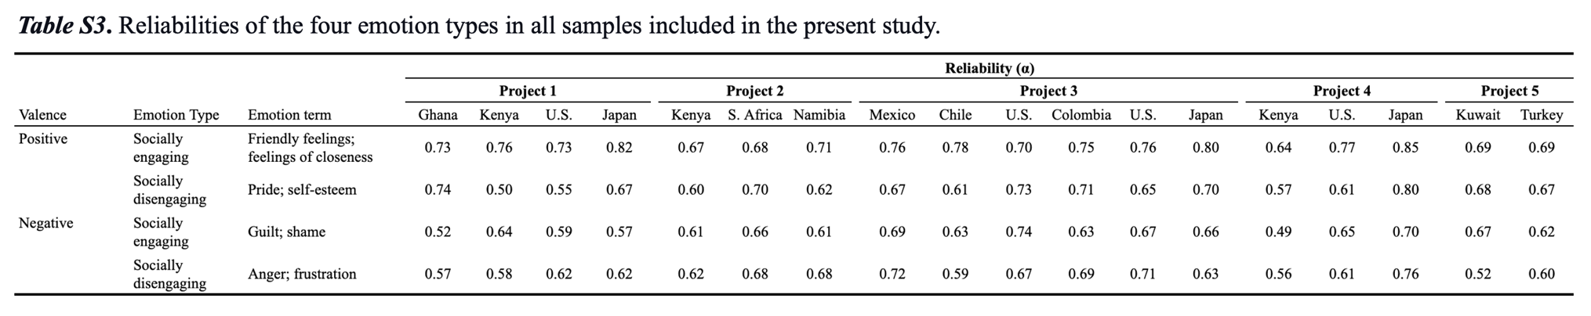
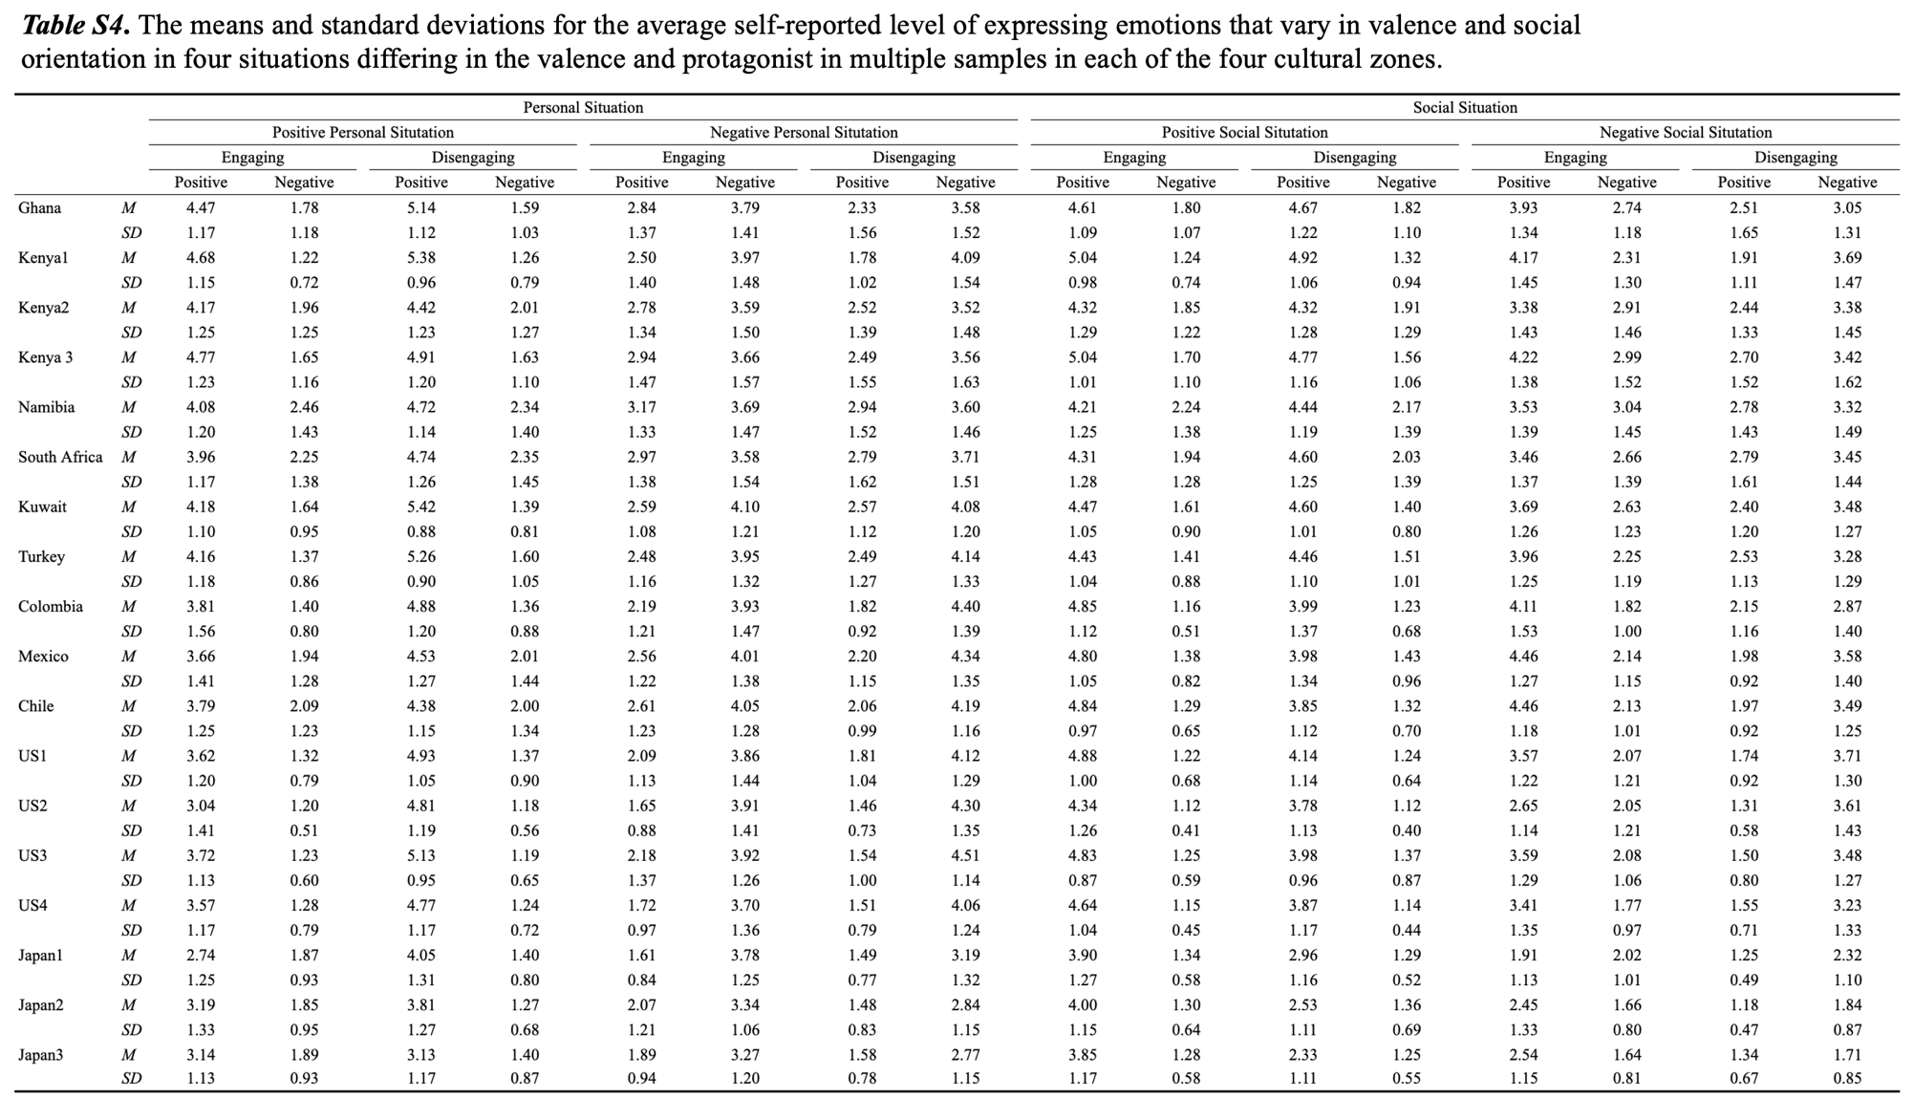
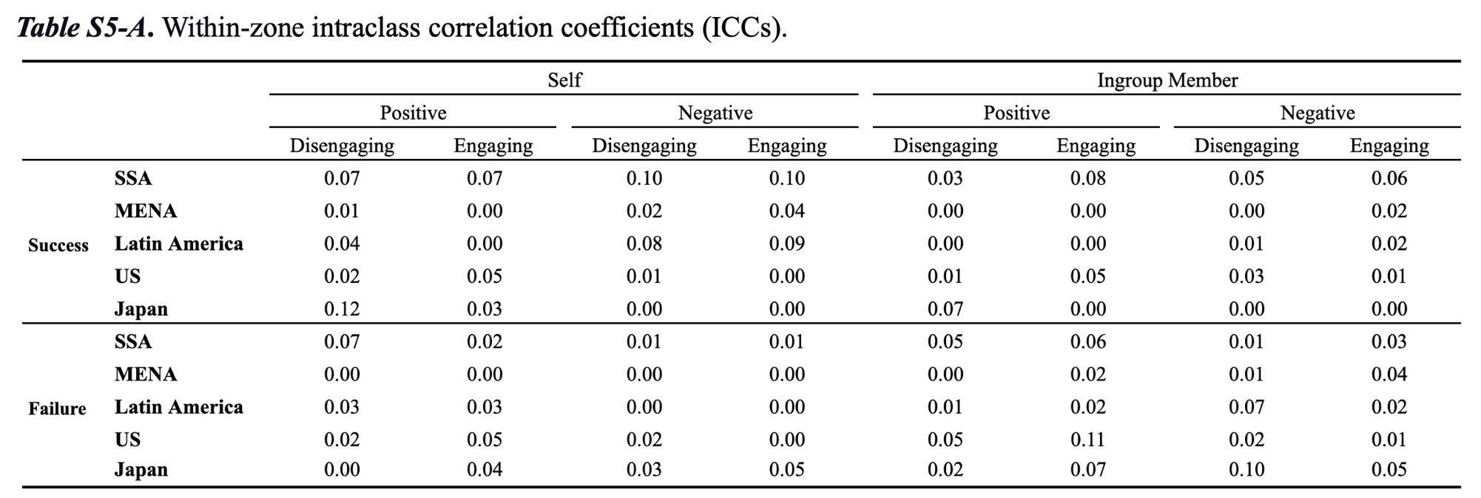
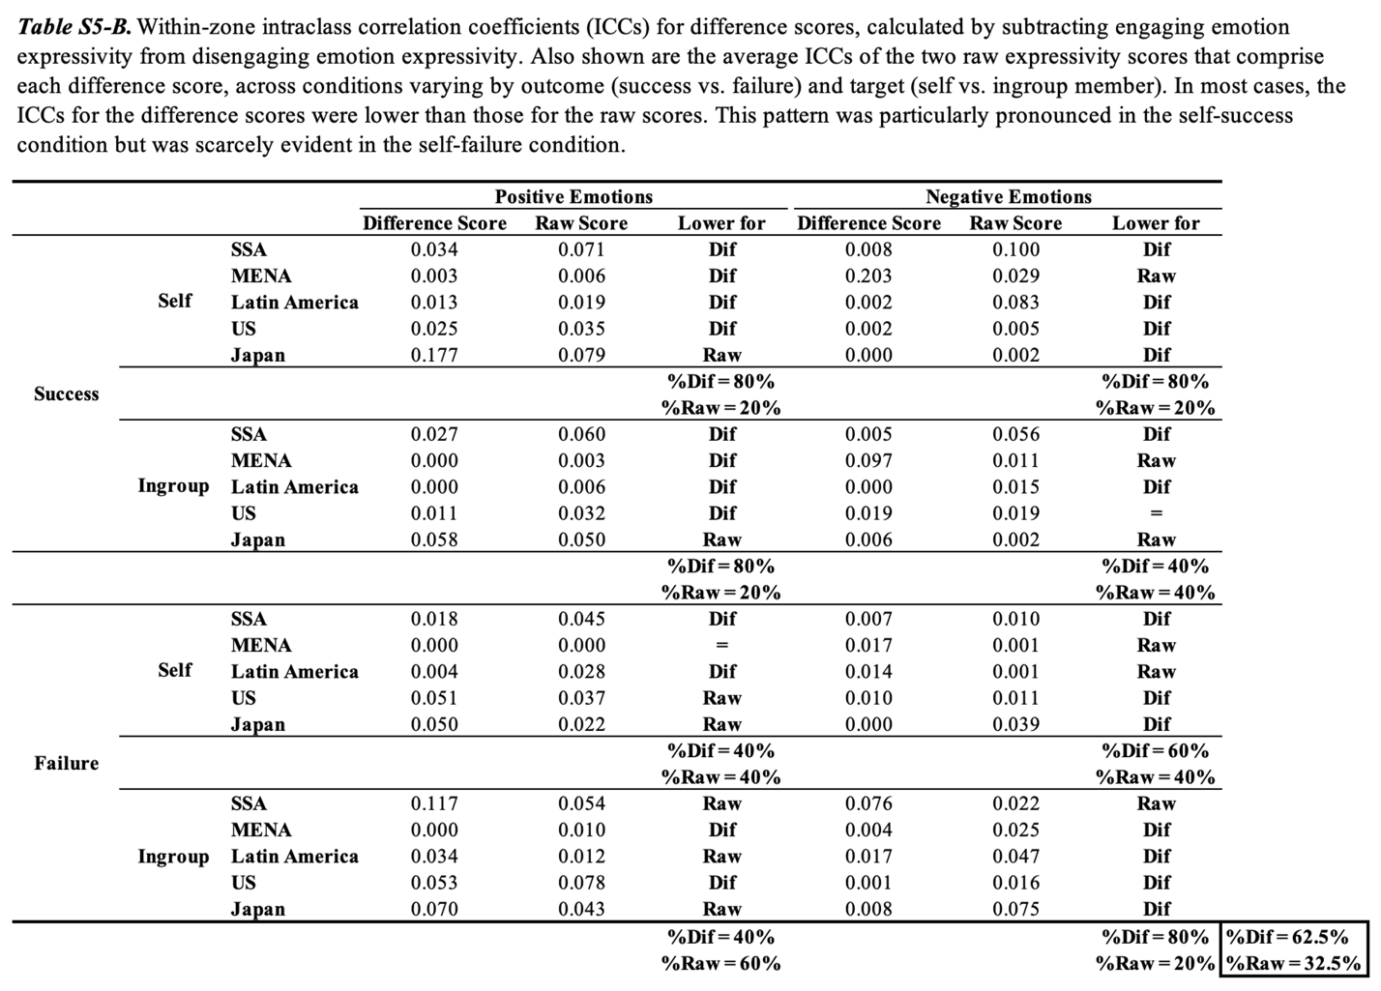
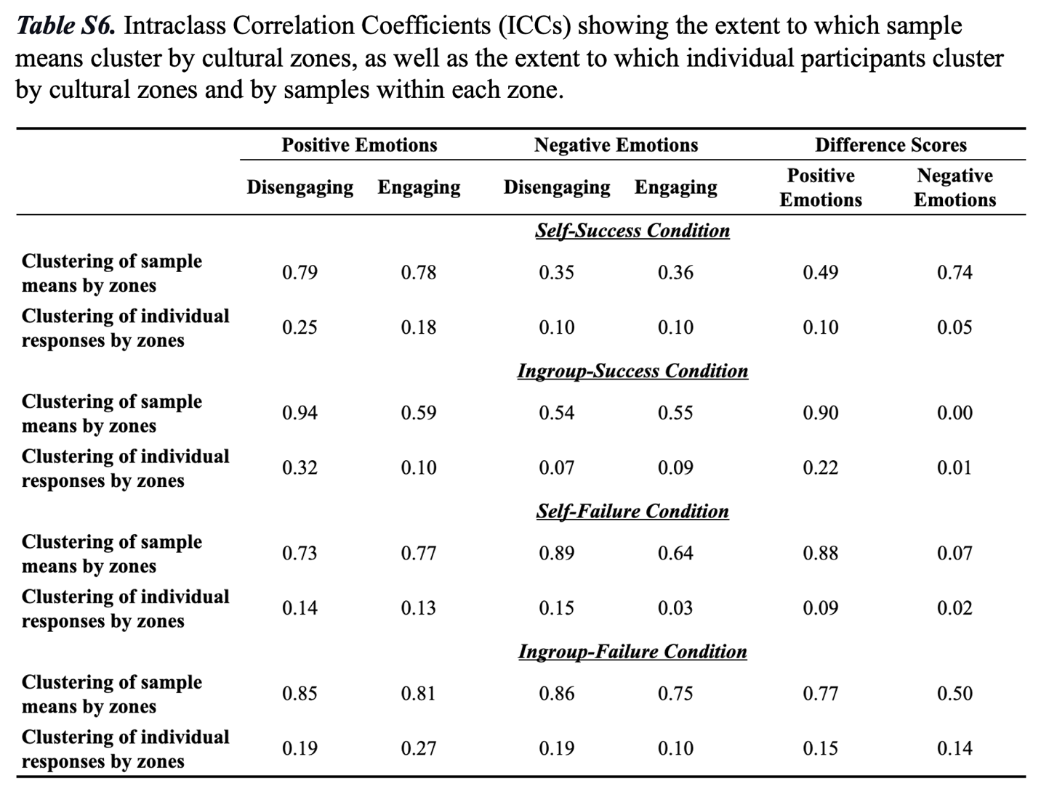
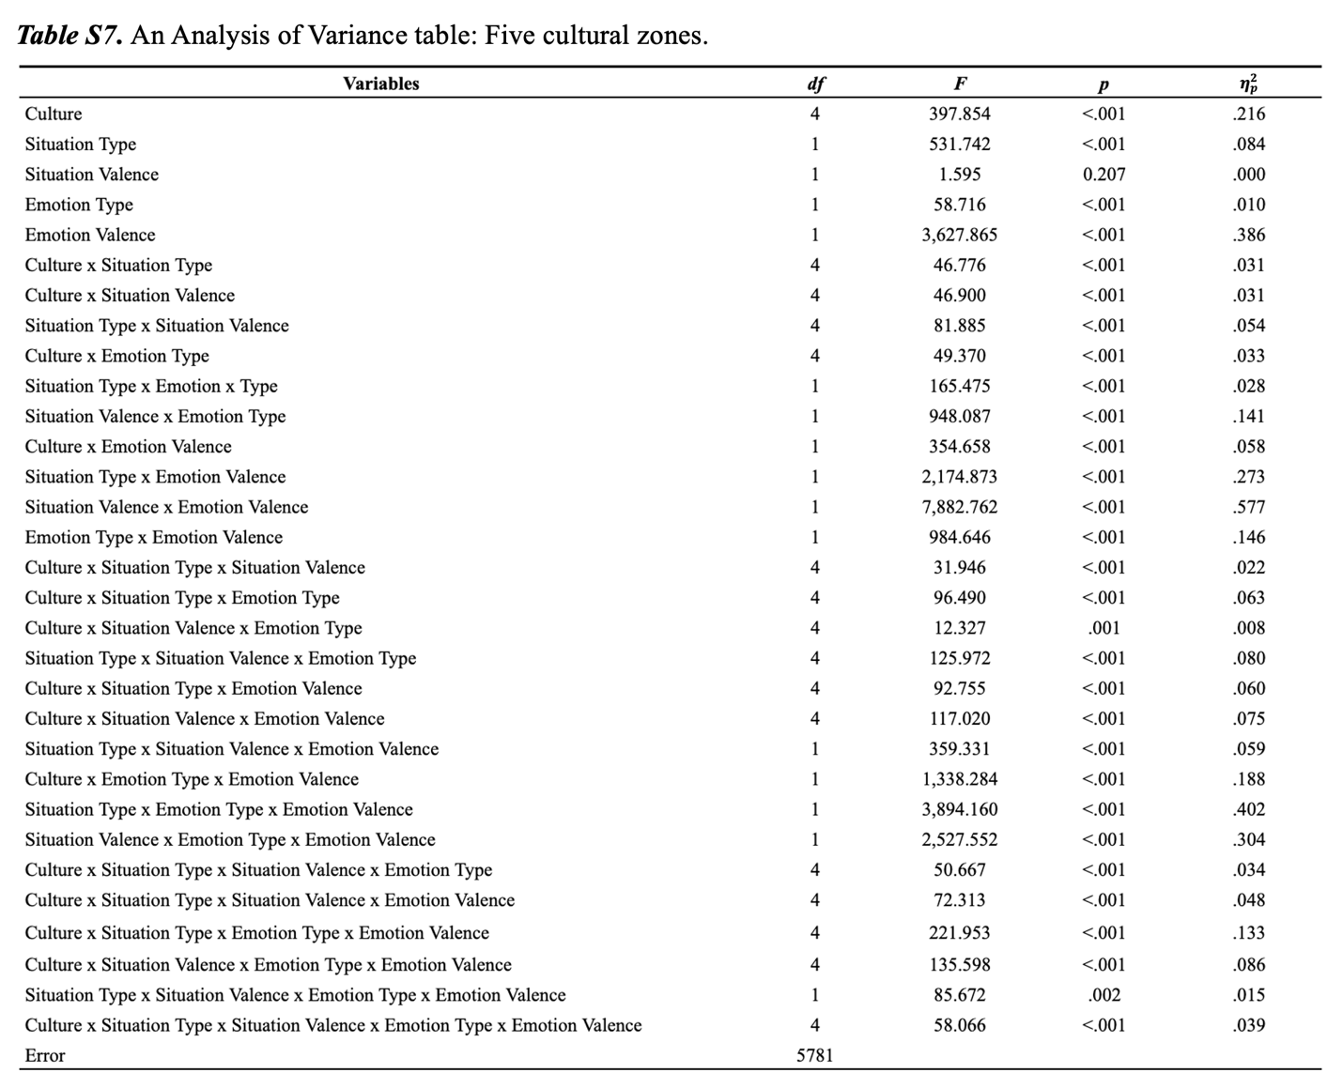
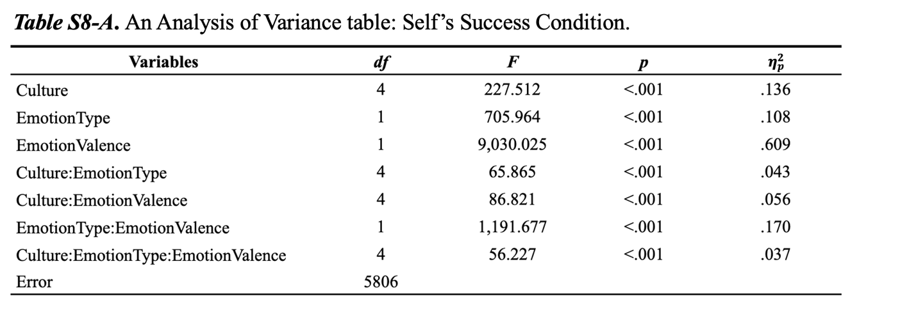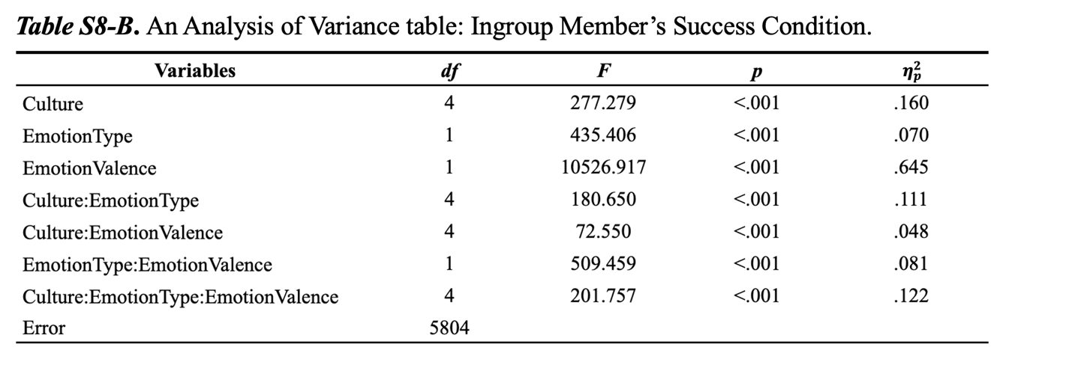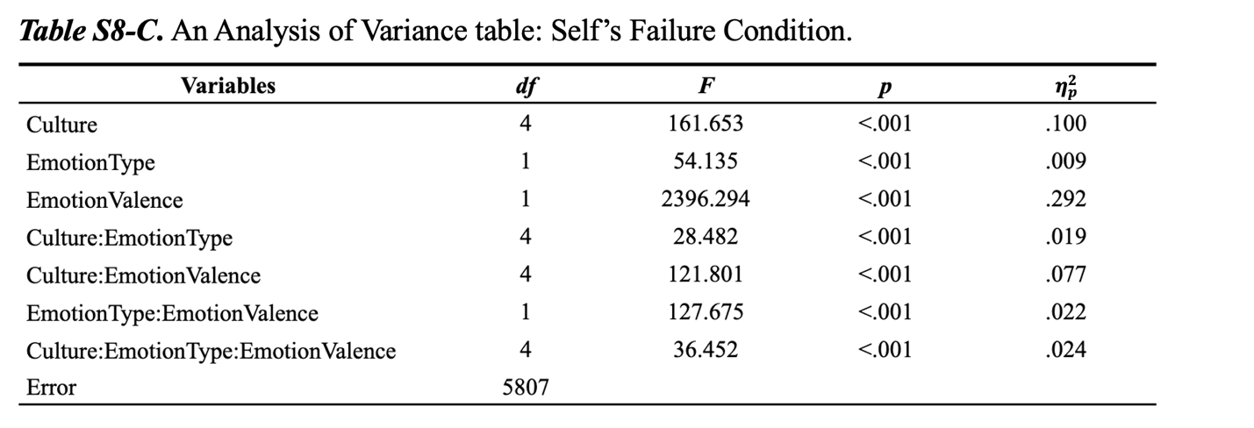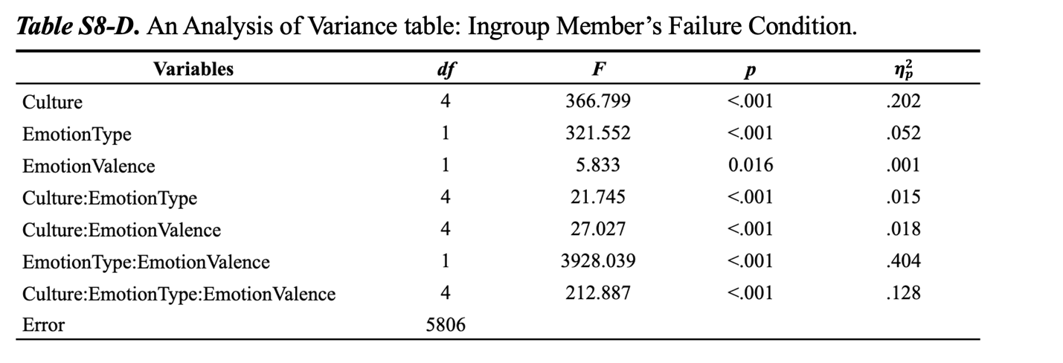
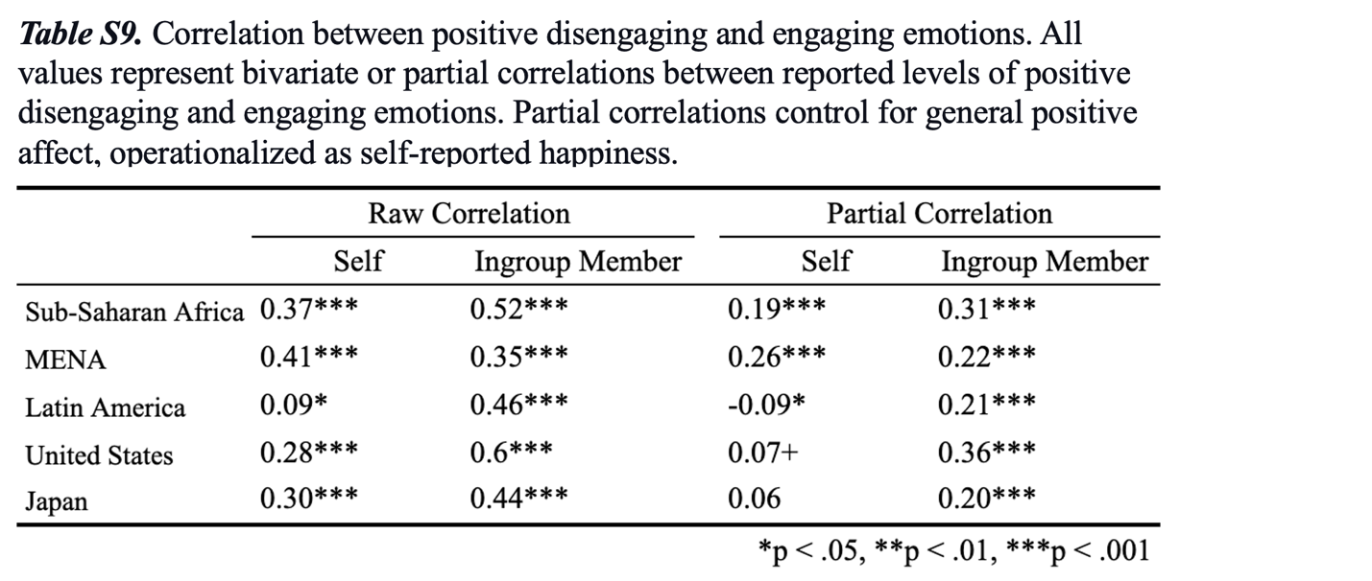

Table S10. Local IRB approval information.

Project | Country | Name of Review Board/Institution | Contact Person | Protocol Number
Project 1 | Ghana | University of Ghana | Annabella Osei-Tutu | ECH 281/ 22-23
 | Kenya | Busara Center for Behavioral Economics | Busara Center for Behavioral Economics | EUISERC/APP/280/2023
 | United States | University of Michigan | Shinobu Kitayama | HUM00229098
 | Japan | Nagoya University | Keiko Ishii | NUPSY-231012-M-01
Project 2 | Kenya | National Commission for Science, Technology and Innovation (NACOSTI) | Stephen Asatsa | NACOSTI/P/22/22656
 | Namibia | National Commission on Research Science and Technology (NCRST) | Elizabeth Shino | Certificate no: RCIV00022018  Authorization no: 202212009
 | South Africa | University of the Free State General/Human Research Ethics Committee  (UFS GHREC) | Luzelle Naude | UFS-HSD2021/1906/21/3
Project 3  Study 1 - Prolific | Chile | University of Michigan | Cristina Salvador | HUM00167318
 | Mexico | University of Michigan | Cristina Salvador | HUM00167318
 | United States | University of Michigan | Cristina Salvador | HUM00167318
Project 3  Study 2 - in-person | Colombia | Universidad de La Sabana | Sandra Idrovo Carlier | N/A*
 | United States | University of Michigan | Cristina Salvador | HUM00167318
 | Japan | Nagoya University | Keiko Ishii | NUPSY-190925-M-06
Project 4 | Kenya | Busara Center for Behavioral Economics | Busara Center for Behavioral Economics | EUISERC/APP/280/2023
 | United States | University of Michigan | Erin Wang | HUM00256153
 | Japan | University of Michigan | Erin Wang | HUM00256153
Project 5 | Kuwait | Kuwait University | Othman Alkhadher | N/A*
 | Turkey | University of Michigan | Erin Wang | HUM00256153

*Local IRBs did not require formal approval for non-experimental studies that involved no vulnerable populations and did not use deception. Data collection in these locations was covered by the University of Michigan IRB (HUM00167318 and HUM00256098)
