Supplementary Information

 |  | Week 1 | Week 2 | Week 3 | Week 4 | Week 5
Group 1 | No lesson. Surveys + pretest Scan | Lesson 1  Pre questions and Scan before and after | Lesson 2  Pre questions and Scan before and after | Lesson 3  Pre questions and Scan before and after | No lesson, surveys, post test, post test scan | No lesson
Group 2 | No lesson. Surveys + pretest Scan | No lesson | Lesson 1  Pre questions and Scan before and after | Lesson 2  Pre questions and Scan before and after | Lesson 3  Pre questions and Scan before and after | No lesson  No lesson, surveys, post test, post test scan

Table 2: Each student was assigned randomly to one of 2 groups. Each group did 3 lessons over 3 weeks, but they started at different times. (The reason for splitting the students into three groups is to account for extraneous factors – logistics, parents’/teachers’ requests, exams, holidays etc.) Here is a timeline of the lessons. Students’ HRV was measured every week, before and after each lesson. Measurements were also taken when students didn't have lessons. This established a baseline to compare against.

Distress symptom | Users with overall increase | Users with overall decrease | Users with no net change | Average total change
Stress | 26 | 52 | 15 | -0.99
Anxiety | 27 | 37 | 29 | -0.49
Depression | 26 | 36 | 31 | -0.09
Table 3: Cumulative results across all Stress, Anxiety, and Depression.

Distress symptom | Before (mean) | After (mean) | Average Change | Paired t-test | Significant change
Stress | 7.89 (±4.61) | 6.90 (±4.93) | -0.99 (±3.70) | t=2.577, p=0.0116 | Yes (α=0.05)
Anxiety | 4.06 (±4.39) | 3.57 (±4.47) | -0.49 (±3.61) | t=1.322, p=0.1894 | No (α=0.05)
Depression | 4.35 (±4.42) | 4.27 (±4.86) | -0.09 (±3.50) | t=0.237, p=0.8132 | No (α=0.05)
Table 4: Before and after statistics for the DASS21-Y report.

Image type | True answers across all tests | False answers across all tests | Total count
City | 82244 (57.4%) | 61049 (42.6%) | 143293
Mountain | 11910 (74.4%) | 4097 (25.6%) | 16007
All | 94154 (59.1%) | 65146 (40.9%) | 159300
Table 5: Correct/incorrect responses based on images type

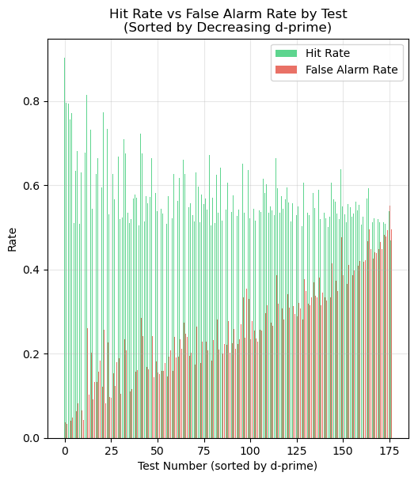 | 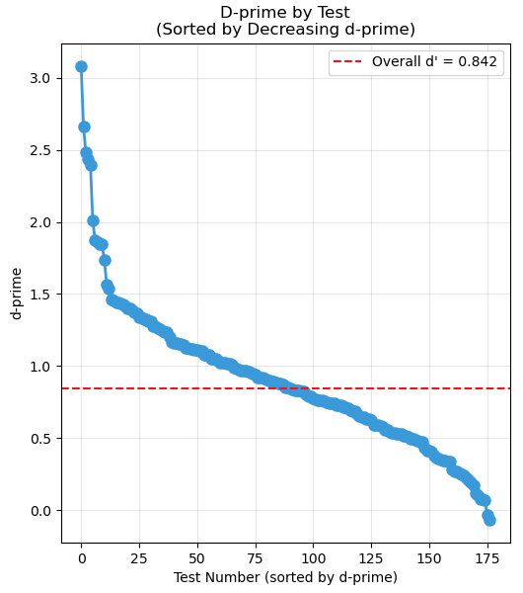
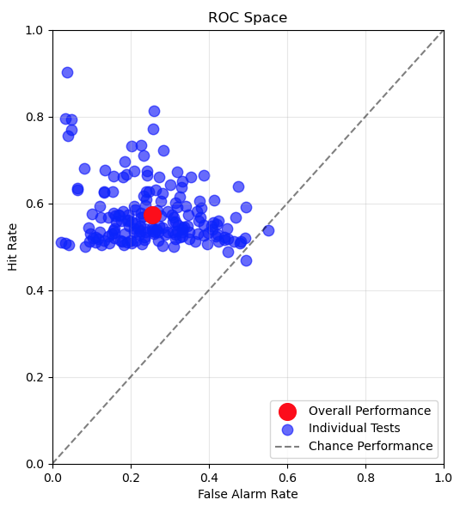 | 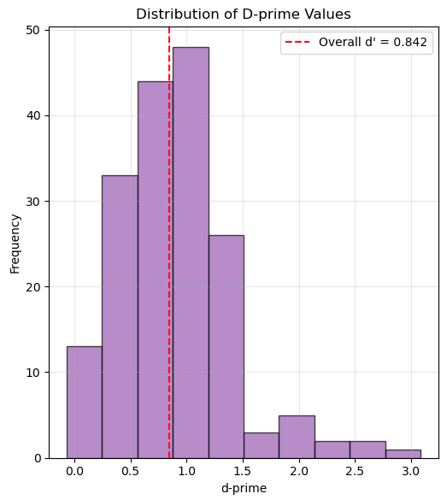

Total Tests: | 177 | Overall Hit Rate: | 0.574
Total City Trials: | 143293 | Overall False Alarm Rate: | 0.256
Total Mountain Trials: | 16007 | Overall d’: | 0.842
Total Hits: | 82244 | Mean Test d’: | 0.900
Total False Alarms: | 4097 | Std Test d’: | 0.504
Figure 4: Focus test results (hit rate, false alarm rate, d′)

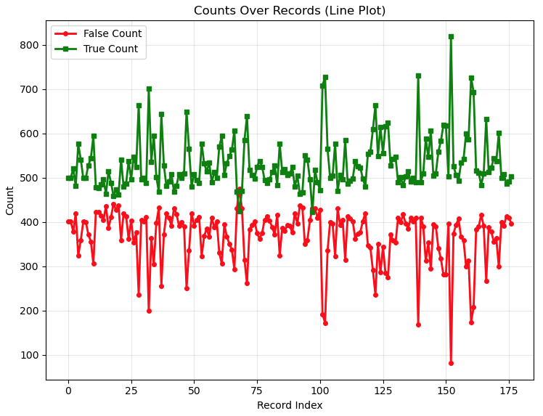 | 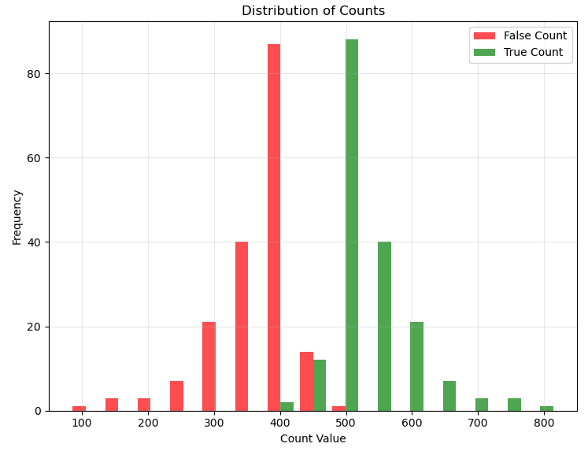
Figure 5: Number of correct/incorrect responses for the 177 focus tests and their frequency distributions. Students averaged 59.1% correct and 40.9% false responses. City hit rate was 57.4% and mountain false alarm rate 25.6%, matching [6]’s false alarms but far below its 97% hit rate—likely due to the brief 800 ms display and frustration from mistakes.

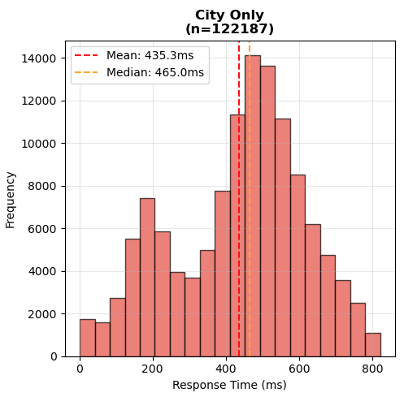 | 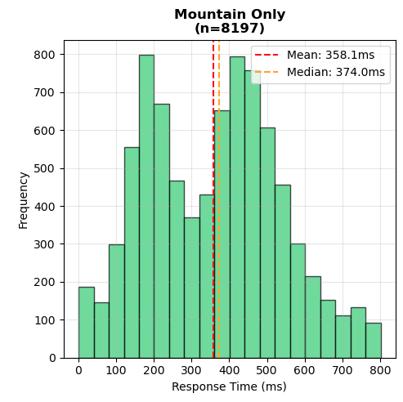
Figure 6: Binned response time distributions for city and mountain images. The mean response time is lower for cities (435.3ms) than for mountains (358.1ms) and there is a significant increase in the mountain graph for quick clicks (<250ms).

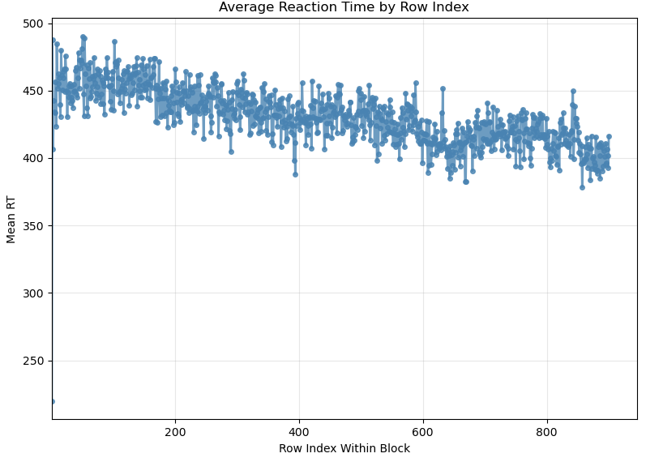 | 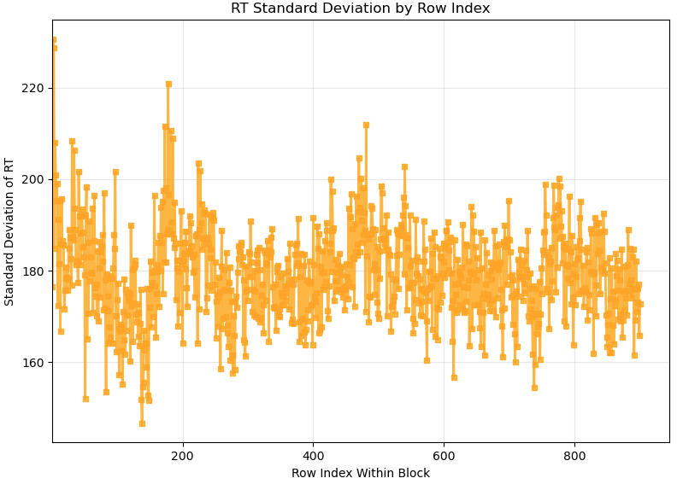
Figure 7: Average reaction time (left) and standard deviation (right) for each image position across all tests.

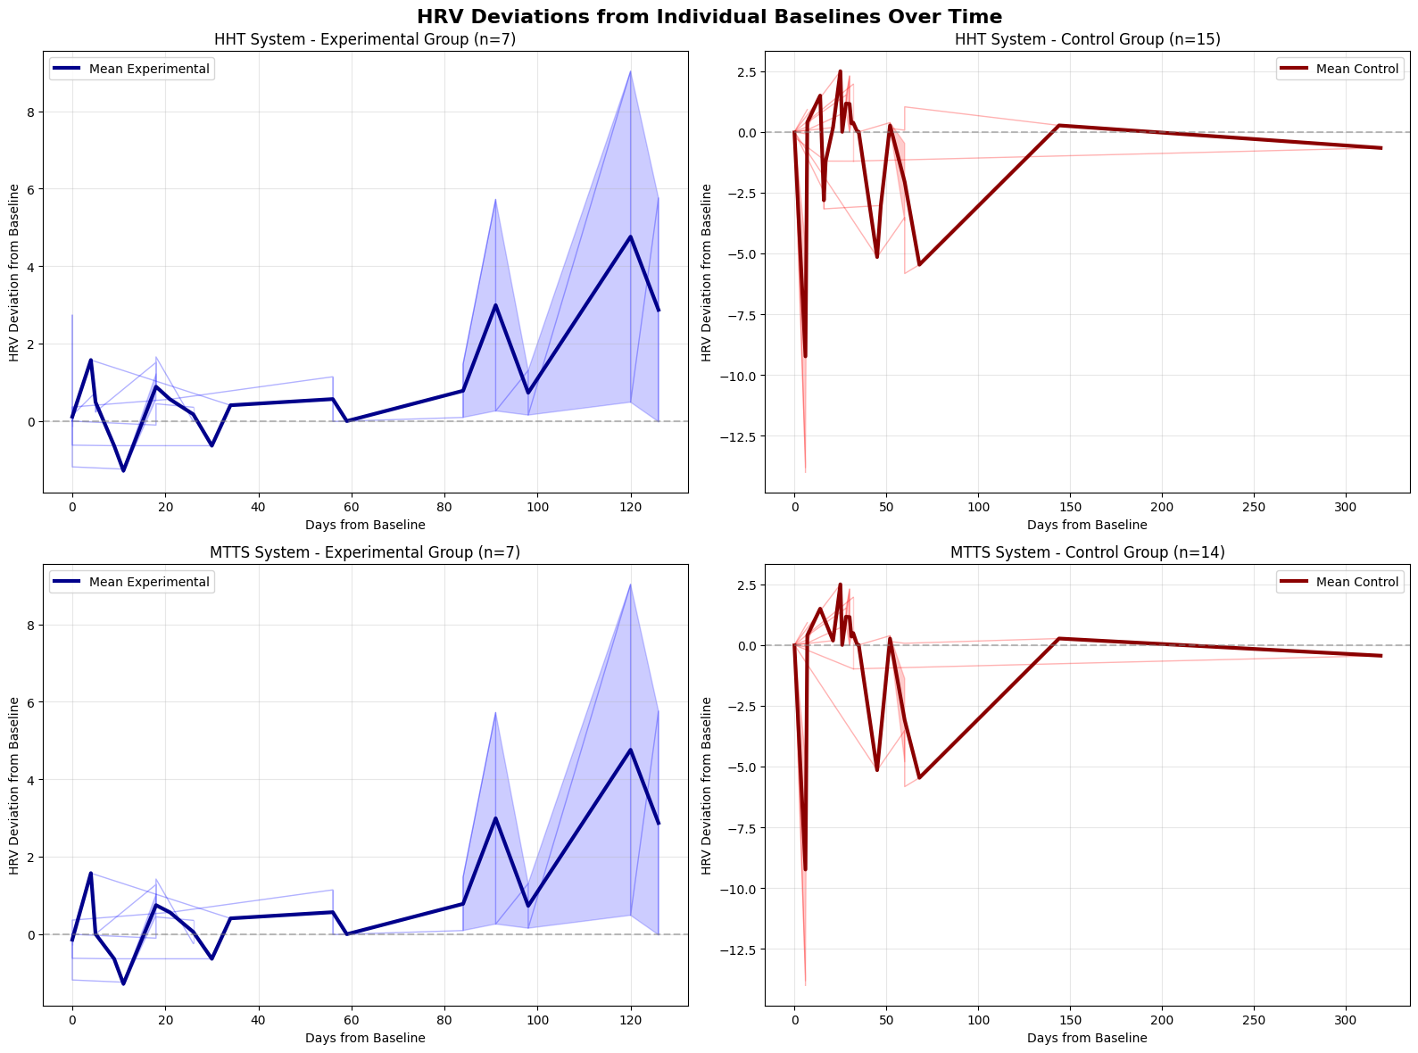
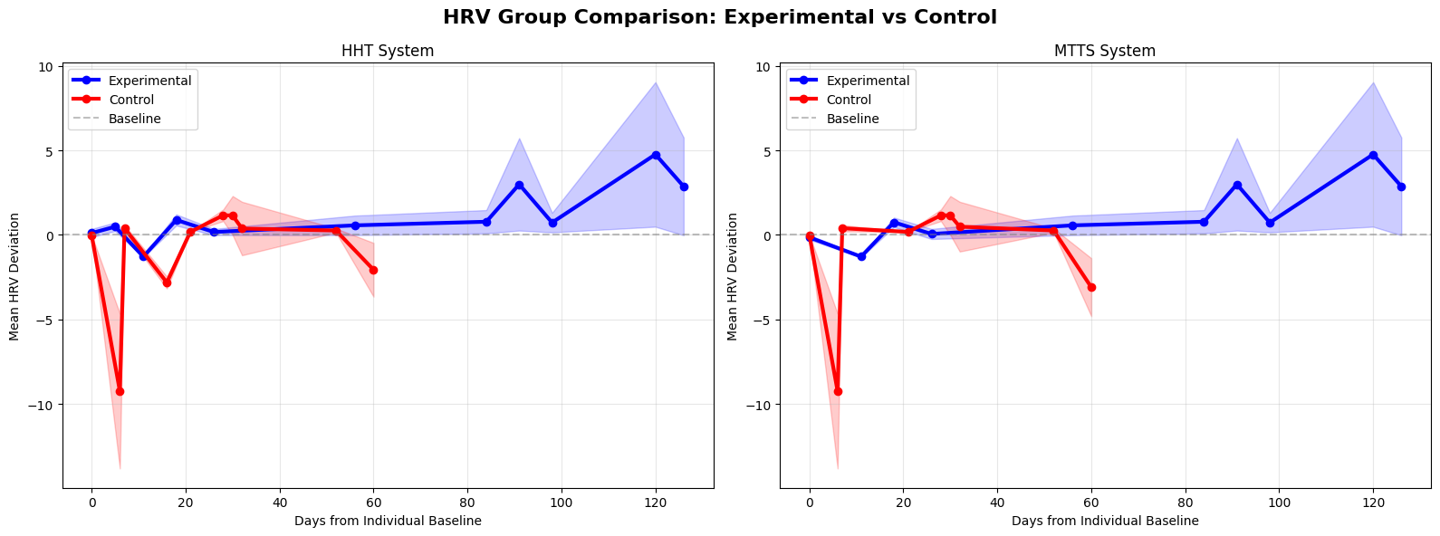
Figure 8: HRV Trajectory of Experimental and Control Groups

References

[1] Kuyken W, Ball S, Crane C, et al. Evid Based Ment Health 2022;25:99–109.
[2] There’s a strong push for more school psychologists, https://pubmed.ncbi.nlm.nih.gov/35820992/
https://www.apa.org/monitor/2024/01/trends-more-school-psychologists-needed
[3] Rosalind W. Picard, https://direct.mit.edu/books/monograph/4296/Affective-Computing
[4] Augment Me, Inc. Also, WotNow?!, https://augment-me.com
[5] See Learning, https://seelearning.emory.edu/en/home
[6] Helong Li, Sam Kwong, Lihua Yang, Daren Huang, and Dongping Xiao, Hilbert-Huang Transform for Analysis of Heart Rate Variability in Cardiac Health, IEEE/ACM TRANSACTIONS ON COMPUTATIONAL BIOLOGY AND BIOINFORMATICS, VOL. 8, NO. 6, NOVEMBER/DECEMBER 2011
[7] Xin Liu, Josh Fromm, Shwetak Patel, Daniel McDuff, Multi-Task Temporal Shift Attention Networks for On-Device Contactless Vitals Measurement, 34th Conference on Neural Information Processing Systems (NeurIPS 2020), Vancouver, Canada
[8] Esterman M, Noonan SK, Rosenberg M, Degutis J. In the zone or zoning out? Tracking behavioral and neural fluctuations during sustained attention. Cereb Cortex. 2013 Nov;23(11):2712-23. doi: 10.1093/cercor/bhs261. Epub 2012 Aug 31. PMID: 22941724.
[9] Lovibond, S.H. & Lovibond, P.F. (1995). Manual for the Depression Anxiety & Stress Scales. (2nd Ed.) Sydney: Psychology Foundation. https://maic.qld.gov.au/wp-content/uploads/2016/07/DASS-21.pdf
[10] Colleen Lennon, Hal Burdick, The Lexile Framework as an Approach for Reading Measurement and Success, April 2004. https://web.archive.org/web/20100103044012/http://lexile.com/m/resources/materials/Lennon__Burdick_2004.pdf https://hub.lexile.com/lexile-grade-level-charts/?_gl=1*1v9btgc*_up*MQ..*_ga*MTEyNjA0MzM1NS4xNzUwNzA1MDc4*_ga_5MVHL6N2MJ*czE3NTA3MDUwNzYkbzEkZzAkdDE3NTA3MDUwNzYkajYwJGwwJGgw
[11] Quantile, https://hub.lexile.com/quantile-grade-level-charts/
[12] ixl.com
[13] National Norms for IXL’s Diagnostic in Grades K-12, Yu Zhao, Ph.D. Zachary Mayne, Ph.D., January 2024
[14] iReady, https://www.curriculumassociates.com/programs/i-ready-learning
[15] Wickens, Thomas D. (2001). Elementary Signal Detection Theory. OUP USA. ch. 2, p. 20. ISBN 0-19-509250-3.
[16] Sakaki, M., Yoo, H. J., Nga, L., Lee, T. H., Thayer, J. F., & Mather, M. (2016). Heart rate variability is associated with amygdala functional connectivity with medial prefrontal cortex across younger and older adults. NeuroImage, 139, 44–52.
[17] Annika Huber, Julian Koenig, Bastian Bruns, Martin Bendszus, Hans-Christoph Friederich & Joe J. Simon, Brain activation and heart rate variability as markers of autonomic function under stress, Nature, https://www.nature.com/articles/s41598-025-12430-8
[18] Steinfurth ECK, Wendt J, Geisler F, Hamm AO, Thayer JF and Koenig J (2018) Resting State Vagally-Mediated Heart Rate Variability Is Associated With Neural Activity During Explicit Emotion Regulation. Front. Neurosci. 12:794. doi: 10.3389/fnins.2018.00794
[19] Thayer JF, Lane RD (December 2000). “A model of neurovisceral integration in emotion regulation and dysregulation". Journal of Affective Disorders. 61 (3): 201–216

