Supplementary Material
Differential influence of water and early vegetation on desert soil microbiome abundance and interaction
Ahmed Elhady^{1#}, Benedikt Schroeter^{2#}, Sabiha Parween¹, Maged M. Saad¹, Arne Naegel^{2*} and Heribert Hirt^{1,3*}
¹Darwin21 Desert Research Initiative, Biological and Environmental Science and Engineering Division, King Abdullah University of Sciences and Technology, 23955 Thuwal, Saudi Arabia
²Modular Supercomputing and Quantum Computing (MSQC), Goethe-Universität Frankfurt, 60325 Frankfurt am Main, Germany
³Max Perutz Laboratories, University of Vienna, Austria

#equal contribution
*Correspondance : naegel@em.uni-frankfurt.de ; heribert.hirt@kaust.edu.sa

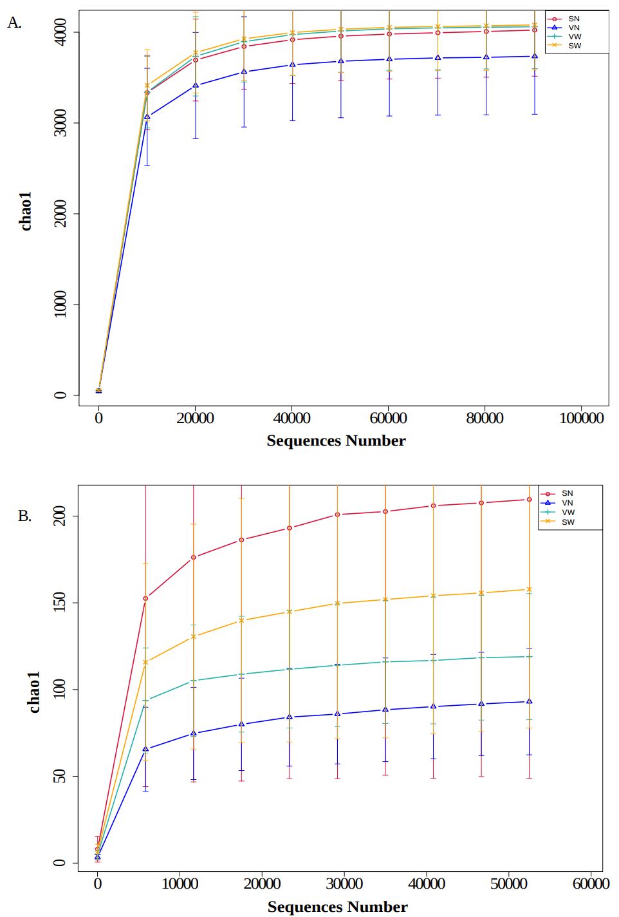
Figure S1 (A) and (B): Rarefaction curves confirm that sequencing depth was adequate, as the curves plateaued, demonstrating comprehensive sampling of microbial communities within each sample group.

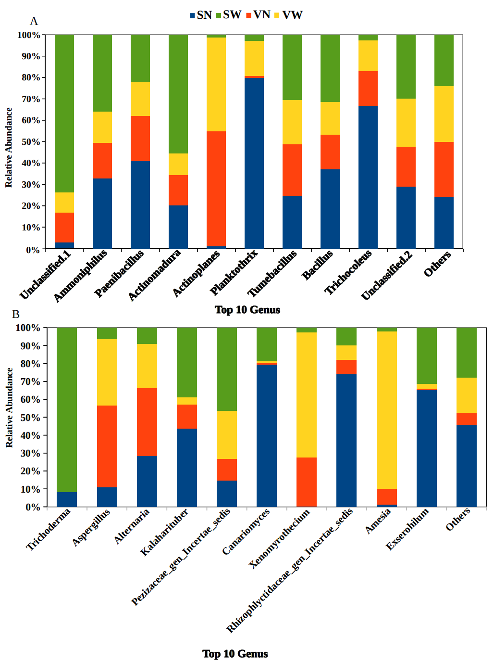
Figure S2. Relative abundance of top 10 bacterial (A) and fungal (B) genera under four soil treatments. SN, bare dry soil (dark blue); SW, bare soil, watered (green); VN, vegetated, non-watered soil (red); VW, vegetated, watered soil (yellow). Panel A shows the ten most abundant bacterial genera in descending order of mean abundance in VW treatment and an “Others” category that groups all remaining genera. Panel B shows the ten most abundant fungal genera in the same order and an “Others” category. Bars indicate mean relative abundance of each genus under each treatment.

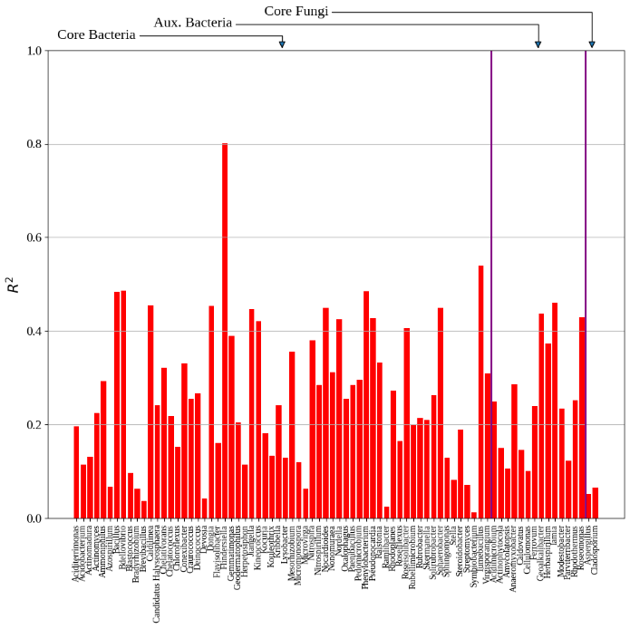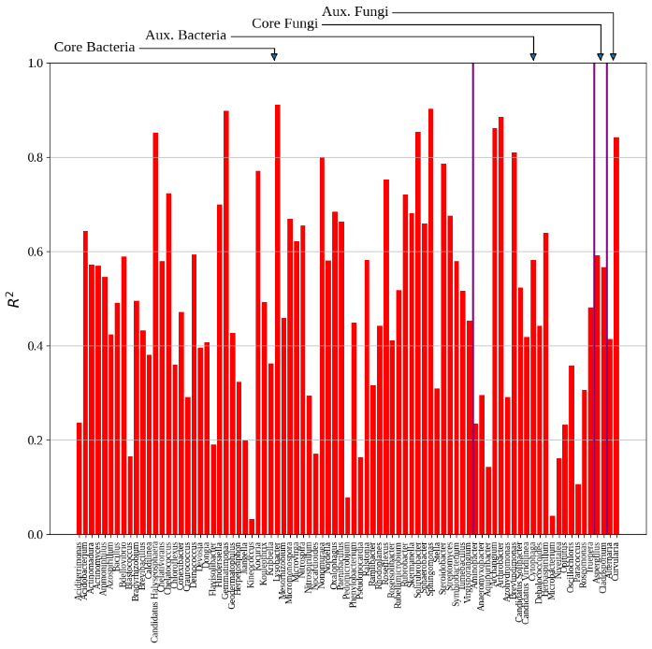
(a) SN (b) VN
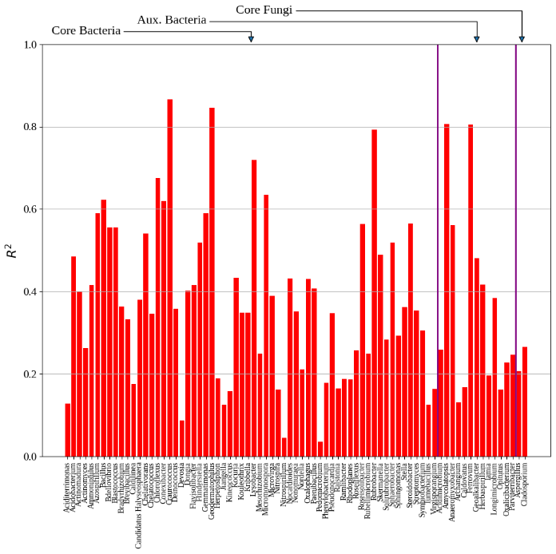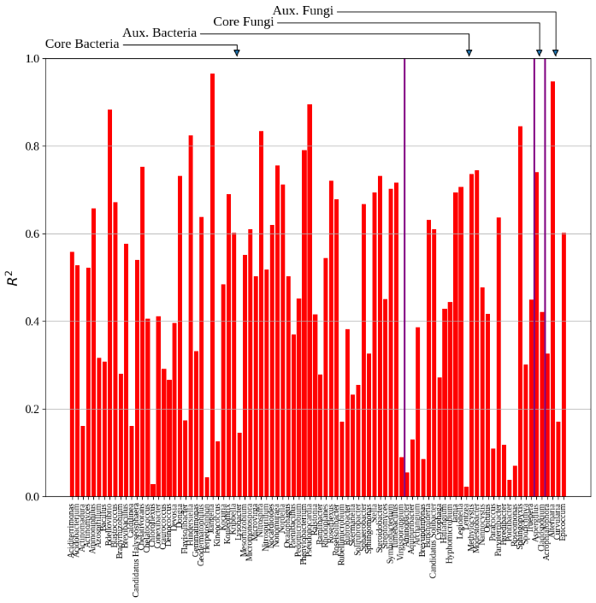
(c) SW (d) VW
Figure S3: Coefficients of determination (R²) per genus and treatment obtained during parameter estimation. The R² values reflect the proportion of variation in the approximated time derivatives of the log-transformed abundances that is explained by the fitted model. Importantly, they reflect the model’s ability to capture local growth dynamics rather than its capacity to predict global temporal trajectories.

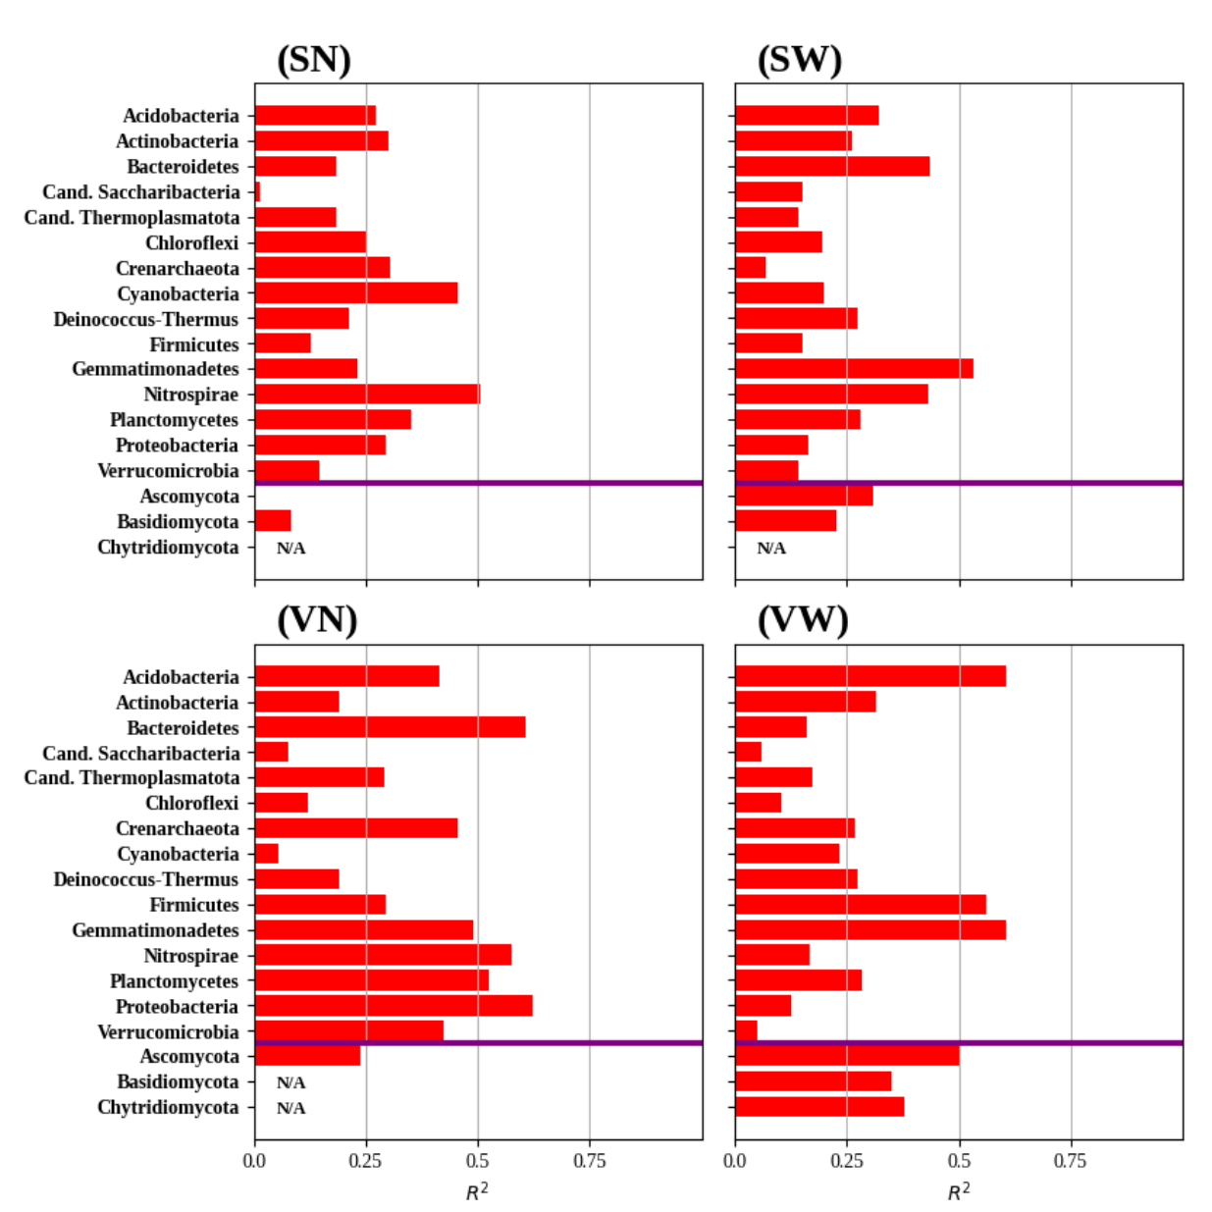
Figure S4 Coefficients of determination (R²) per phylum and treatment obtained during parameter estimation. The R² values reflect the proportion of variation in the approximated time derivates of the log-transformed abundances that is explained by the fitted model. Importantly, they reflect the model’s ability to capture local growth dynamics rather than its capacity to predict global temporal trajectories.

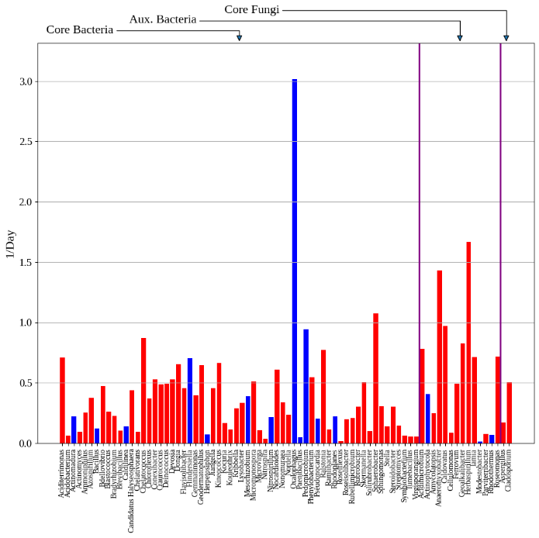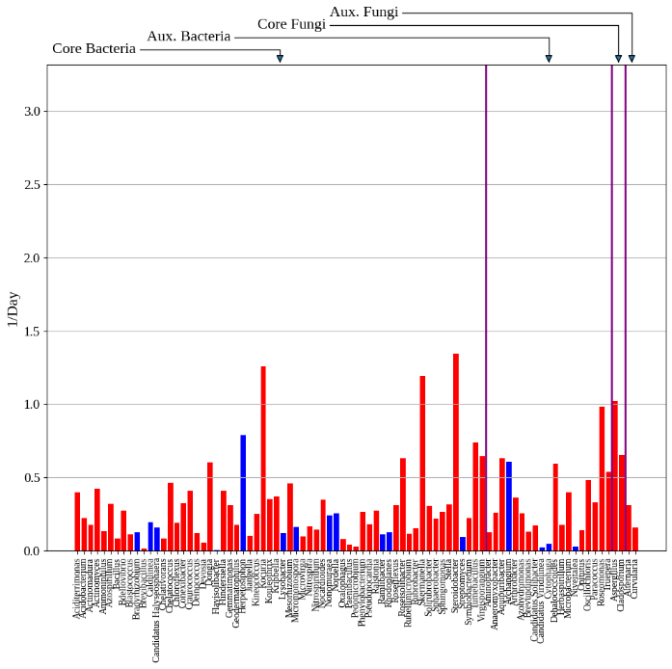
(a) SN (b) VN
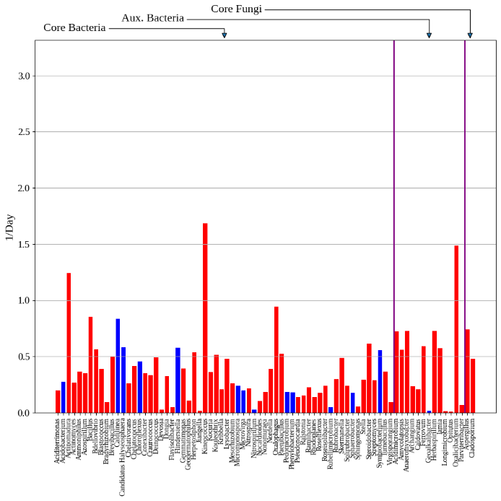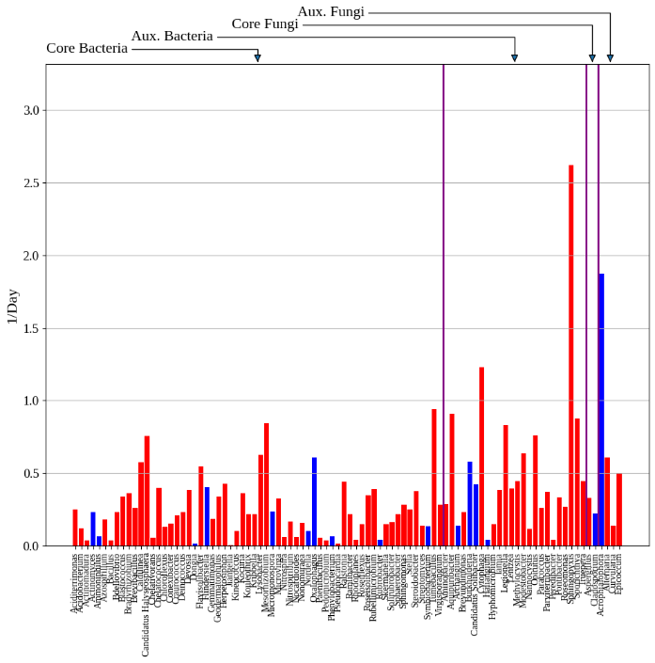
(c) SW (d) VW
Figure S5: Estimated intrinsic growth rates of the generalized Lotka-Volterra model for each genus across the four treatments. Each subplot corresponds to one treatment and is subdivided into core and auxiliary genera, grouped by bacteria and fungi.

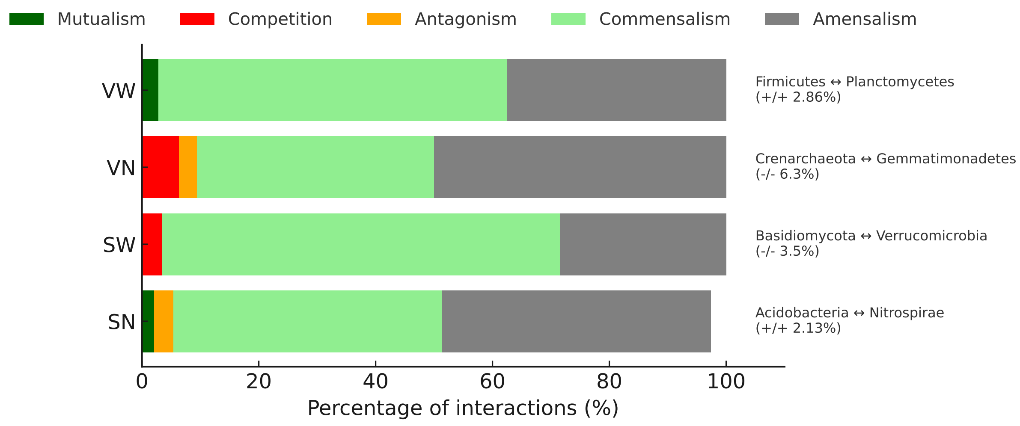Figure S6. The percentage of active phylum–phylum interactions inferred by generalized Lotka–Volterra modeling across the four water and vegetation treatments. Colors denote interaction types: dark green (mutualism), light green (commensalism), orange (antagonism), red (competition), and gray (amensalism). Key mutualistic and competitive phylum-level pairs are annotated at right with their interaction sign and percentage.

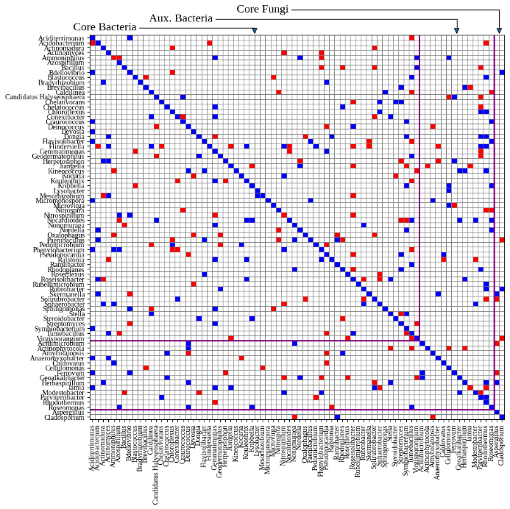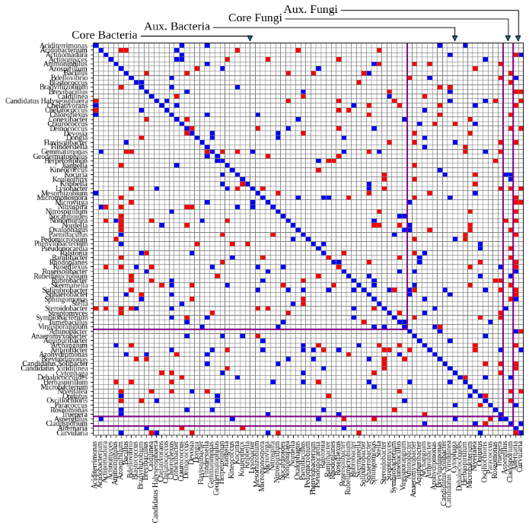
(a) SN (b) VN
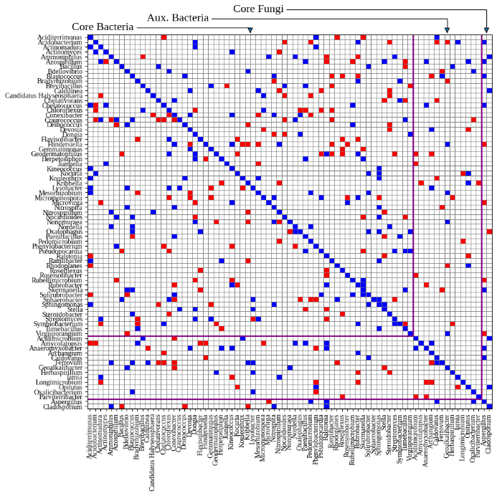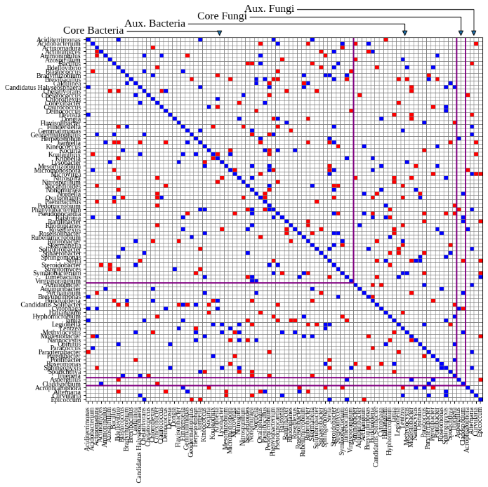
(c) SW (d) VW
Figure S7: Estimated interaction matrices of the generalized Lotka-Volterra model at genus level for the four treatments: 1) soil, non-watered (SN); 2) soil, watered (SW); 3) vegetation, non-watered (VN); 4) vegetation, watered (VW). Red, blue, and white indicate positive, negative, and zero interaction coefficients, respectively. Each subplot represents one treatment and organizes genera into core and auxiliary groups, further separated by bacteria and fungi.

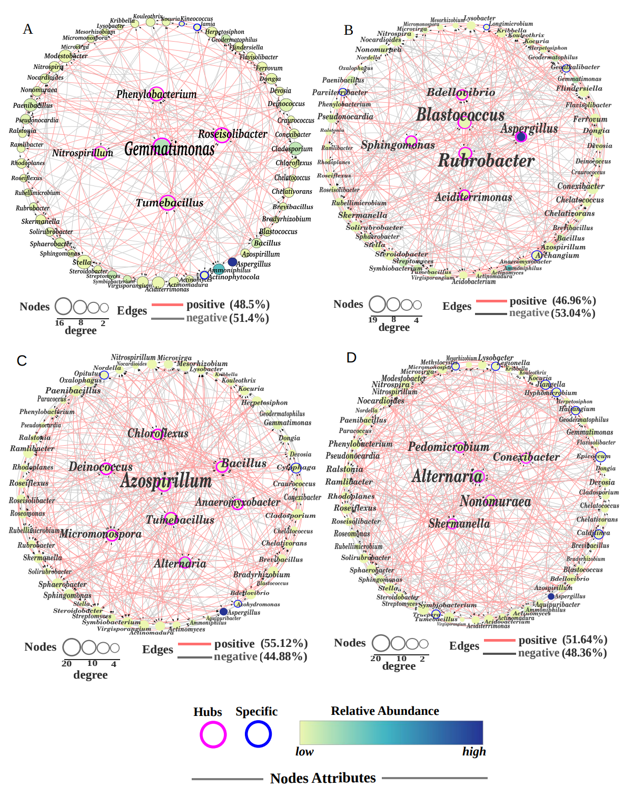
Figure S8: Soil microbial networks across four treatments: (A) SN: Soil, non-watered; (B) SW: Soil, watered; (C) VN: Vegetation, non-watered; and (D) VW: Vegetation, watered. Nodes are genera; node size reflects degree of connectivity; node fill color reflects relative abundance. Edges show interaction coefficients (positive in red; negative in grey). Magenta borders mark hub genera; blue borders mark taxa unique to each treatment. Node degree and edge proportions capture treatment-specific connectivity. Co-occurrence networks differed and expanded substantially with either resource input. The bare, non-watered soil (SN) network contained 60 taxa linked by 207 edges, while the watered soil (SW) and unwatered vegetated soil (VN) networks each increased to 61 taxa and 313–332 edges, respectively. The combined vegetated, watered soil (VW) produced the largest network, with 66 taxa and 335 edges. This indicates that additional water and vegetation both promoted more taxa and associations, and together they maximized network complexity. Remarkably, the ratio of positive (co-occurring) to negative (mutually exclusive) correlations shifted across water and vegetation treatments. Non-vegetated networks (SN and SW) contained slightly more negative than positive edges, with only ca. 48% of edges positive. By contrast, vegetated networks (VN and VW) reversed this pattern, with 51.6–55 % positive edges. These results suggest that introducing vegetation promoted co-occurring interactions among microbes, whereas barren soils favoured competitive or exclusive associations.

Tables

Table S1: Amplicon sequencing and quality metrics. (A) and (B): A total of 2,273,410 paired-end reads across 24 bacterial samples across four conditions using 16S rRNA gene amplicon sequencing were generated. Following quality filtering, chimera removal, and length trimming, 2,073,100 high-quality reads were retained, corresponding to 91.9% of the raw input. The average read length was 415 base pairs, with an average GC content of 52.64%. Quality scores remained high, with mean Q20 and Q30 values of 97.70% and 93.60%, respectively. Similarly, 24 fungal samples yielded 2,262,500 raw paired-end reads, of which 2,093,181 reads passed quality SN (Soil Non-watered), reflecting a 92.52% retention rate. The fungal reads had an average length of 260 base pairs, a GC content of 52.71%, and comparable quality with Q20 and Q30 scores of 97.72% and 93.60%, respectively.

Table S2: Alpha diversity indices for bacterial (A) and fungal (B) communities. Pielou evenness, Chao1 richness, Dominance, Good’s coverage, observed features, Shannon entropy, and Simpson diversity were computed for every sample, and group differences were evaluated with the Kruskal–Wallis test. (C) and (D)

Interaction types |  | Core network |  |  |  | Complete network
 |  | SN | SW | VN | VW | SN | SW | VN | VW
Possible interactions [#] |  | 4032 | 4032 | 4032 | 4032 | 6006 | 5852 | 7140 | 8372
Active interactions [#] |  | 202 | 308 | 260 | 244 | 313 | 415 | 503 | 534
Active interactions [%] |  | 5.01 | 7.64 | 6.45 | 6.05 | 5.21 | 7.09 | 7.04 | 6.38
Positive interactions [%] |  | 50.00 | 49.03 | 52.69 | 50.82 | 47.28 | 49.64 | 52.88 | 51.31
Mutualism | (+, +) [%] | 1.55 | 3.44 | 0.79 | 1.29 | 1.33 | 2.54 | 1.03 | 1.78
Antagonism | (+, -) [%] | 1.55 | 1.03 | 1.19 | 1.72 | 2.0 | 1.02 | 1.86 | 1.19
Competition | (-, -) [%] | 1.03 | 1.37 | 0.79 | 1.72 | 1.0 | 1.78 | 1.03 | 2.57
Commensalism | (+, 0) [%] | 47.42 | 43.99 | 51.38 | 48.93 | 44.67 | 46.19 | 51.03 | 49.41
Amensalism | (-, 0) [%] | 48.45 | 50.17 | 45.85 | 46.35 | 51.00 | 48.48 | 45.04 | 45.06
Table S3 Interaction metrics and interaction types in the soil microbiome across water and vegetation treatments at genus level.: Interaction coefficients derived from generalized Lotka–Volterra models fitted separately for each treatment at genus level; Core networks include genera present in all samples; complete networks include all detected genera; Self-interactions (diagonal coefficients) were excluded.

