Supporting Information
Green synthesis of Cu-doped ZnO nanocomposites using Phytolacca dodecandra root extract to improve photocatalytic and antibacterial activity and extend avocado shelf-life.
Natsanet Woldesenbet Rayya, Kebena Takele Etefa, Ahmed Awol Yimer, Guta Gonfa Muleta*, Tamene Tadesse Beyene*
Department of Chemistry, College of Natural Sciences, Jimma University, P.O.Box 378, Jimma, Ethiopia
* Corresponding Authors
Beyene, T.T (E-Mail: tamene.tadesse@ju.edu.et )

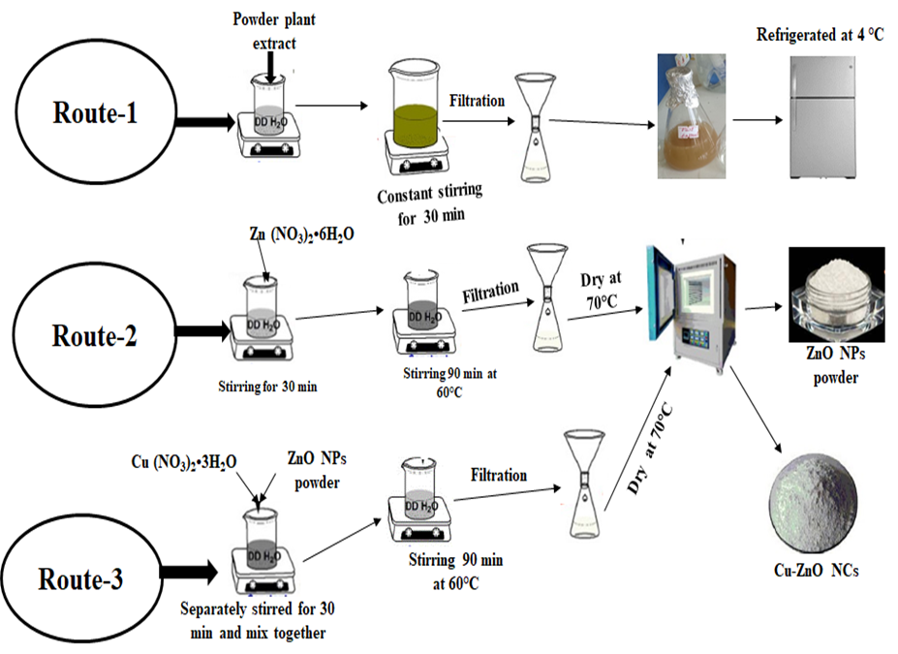
Figure S1. Schematic representation of Phytolacca dodecandra extraction, synthesis of ZnO NPs and Cu-ZnO NCs
A phytochemical test was carried out to confirm the distinct bioactive compounds found in the Phytolacca dodecandra root extract using a different kind of chemical (Figure S1). Understanding the relationship between a plant's phytoconstituents and bioactivity was desirable for the synthesis of compounds with specific activities. The higher intensity of colour observed in the ferric chloride and Forth tests suggests a significant presence of tannins and saponins in the plant material. These phytochemicals are characterized by functional groups such as hydroxyl (OH) and carbonyl (C=O), which play crucial roles as reducing and stabilizing agents in the synthesis of nanomaterials. The presence of these functional groups is essential for the effective reduction of metal ions and stabilization of nanoparticles during synthesis processes¹.

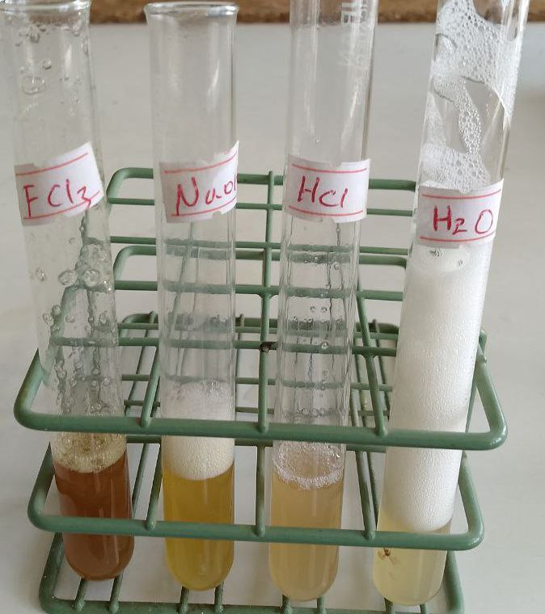
Figure S2. Photographic image taken during phytochemical tests for Phytolacca dodecandra root extract
4.2.1. Concentration of (Zn (NO₃)₂.6H₂O Optimization
Zn (NO₃)₂.6H₂O of 0.05, 0.1, and 0.15 M were used to study the formation of ZnO NPs while keeping constants for temperature, stirring time, plant extract volume, and pH. Zn (NO₃)₂.6H₂O concentration must correspond to the ratio of plant extract in order for ZnO NPs to be synthesized under ideal conditions. The concentration of Zn (NO₃)₂.6H₂O solution was increased from 0.05 to 0.1 M, which resulted in an increase in peak intensity (Figure S3a). As the reaction increases, more ZnO NPs can be produced, but by further increasing the concentration of Zn (NO₃)₂.6H₂O to 0.15 M, the intensity of the peak decreased, and the absorption peak became broader because of the deficiency of molecules of Phytolacca dodecandra root extract to act as capping agents, which cause aggregation of NPs.
The absorption peak demonstrates that increasing the ZnO concentration leads to the formation of larger, more numerous, and more uniformly distributed NPs. Specifically, the red-shift in the absorbance peak indicates the growth of NPs size, the increase in peak intensity suggests a higher number of NPs, and the narrowing of the peak width implies a more uniform size distribution. The result obtained was in close agreement with a recent report². Therefore 0.1 M Zn (NO₃)₂.6H₂O solution was taken at optimum condition to Synthesise both ZnO NPs and Cu-ZnO NCs.
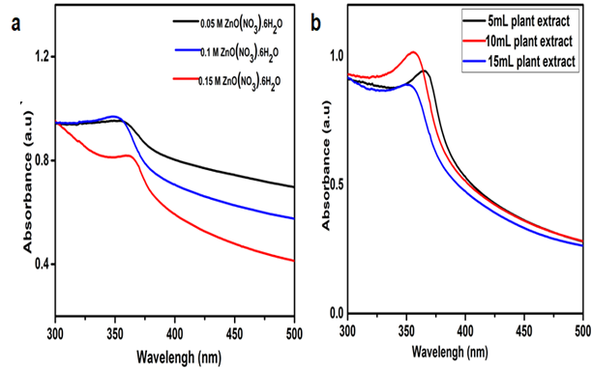
Figure S3. Effect of different parameter for synthesized ZnO NPs (a) Concentration of Zn (NO₃)₂•6H₂O (b) Volume of Phytolacca dodecandra root extract

4.2.2. Volume of Plant extracts optimization
The synthesis of ZnO NPs and Cu-ZnO NCs using plant extract is mainly influenced by the type of bio-molecules found in plant extract and the volume used³. The volume of plant extracts used in the synthesis of Nanomaterials play a significant role in the reducing of metal ions to reduced metal ⁴. The volume optimization of Phytolacca dodecandra root extract was investigated in order to determine the ideal amount of phytolacca dodecandra root extract for the reduction of Zn²⁺ and Cu²⁺ ions. The UV-Vis spectra of ZnO NPs are displayed in (Figure S3b). Based on the information given, these spectra's main results relate to the formation of ZnO NPs after a 90-minute reaction time.
When Phytolacca dodecandra root extract was added to a 10 mL volume instead of a 5 mL. A higher concentration of plant extract would raise the nucleation rate and result in the formation of smaller ZnO NPs, as shown by the narrower peak that appeared. However, a border absorption peak was seen when the plant extract amount was increased to 10 to 15 mL. Particle size increased as a result of the rapid decrease of zinc ions, which promotes the growth of NPs and NCs. This phenomenon was referred to as broadness of peak, and it might be produced by the agglomeration of NPs and NCs.⁴.Therefore, it was determined that 10 mL of Phytolacca dodecandra root extract was the optimum amount for the synthesis of ZnO NPs and Cu-ZnO NCs. In this study, the outcome closely matched the findings reported in the literature⁵ regarding the impact of plant extract volume on the environmentally friendly synthesis of Cu-ZnO NCs.
4.2.3. Effect of pH
The pH is one of the factors that affect the size and shape of NPs and NCs ⁶. The role of pH on nanomaterial synthesis could be seen in its effect on capping and stabilizing ability and subsequently the growth of the NPs and NCs. The presence of OH ions in an alkaline pH environment might enhance the reducing and stabilizing capabilities of the biomolecules in the Phytolacca dodecandra root extract due to the better accessibility of functional groups present in the Phytolacca dodecandra root extract for nucleation at alkaline pH ⁷.
Phytolacca dodecandra root-synthesized ZnO NPs were examined over a pH range from 5 to 12. The synthesis of ZnO NPs using 10 mL of Phytolacca dodecandra root extract and 0.1 M of Zn (NO₃)₂•6H₂O was carried out at different pH values, namely pH 5, 7, 9, 10, 11, and 12. It was started from pH 5 because the pH of phytolacca dodecandra root was 4.7. A broader absorption peak was observed at this acidic pH (Figure S4 a), but most of time, NPs synthesized in acidic conditions of pH ≤ 7 were relatively larger in size, approximately 158 nm⁸. The intensity of NPs narrowed as pH ascended from 7 to 11, almost reaching a more intense peak at pH 11, confirming the formation of small-size NPs. However, the broader spectrum was created by raising the solution's pH to a level of 12 or higher, which indicates the formation of large sizes NPs. The final result matched what was reported in the literature⁹,which demonstrated that ZnO NPs were produced with an optimum pH of 11.Thus, the data obtained indicates that at an acidic pH, NPs aggregate rather than nucleate, and at an alkaline pH, a large number of nuclei produced rather than aggregation¹⁰.
4.2.4. Effect of temperature
Temperature is one of the major factors that significantly influence the shape, size, stability, and yield of the NCs synthesized via a green route. In most cases, the synthesis of NPs using green technology requires temperatures less than 100 °C or ambient temperature. The effect of temperature on the green synthesis of ZnO NPs and Cu-ZnO NCs was studied by varying it from 50°C-70°C while keeping all the other factors constant (Figure S4 b). As the temperature increased from 50-70 °C, the absorption peak become sharp, and especially at 60°C narrow peak of ZnO NPs was formed. This might be related to increasing reaction temperature improving the reaction rate and high temperature increasing the nucleation. When the temperature is further increased to 70°C during the green synthesis of nanoparticles, the absorbance peak typically becomes broader. This broadening indicates that the nanoparticles are experiencing a wider distribution of sizes. As the temperature rises, the rate of particle nucleation and growth increases, which can cause the nanoparticles to aggregate. Therefore, 60 ºC was the optimum temperature for synthesized ZnO NPs and Cu-ZnO NCs.
4.2.5. Effect of reaction time
Reaction time is essential for the synthesis and stability of NPs and NCs. The effect of reaction time was studied in the green synthesis of ZnO NPs and Cu-ZnO NCs. The effect of reaction time was conducted by analysing the sample through the UV-Vis spectrum by every 30 min difference from 60 min to 120 min for ZnO NPs (Figure S4 c). ZnO NPs UV-Vis spectrum displayed a small intensity peak at 60 min, and intensity of the peak increased, and the peak became narrowed as the time progressed to 90 min. This indicated enhanced nucleation rate and formation of small-sized NPs. By further increasing reaction time, the absorbance peak became broader, which might lead to an increase in particle size. This was caused by overgrowth or aggregation of NPs, affecting their size, distribution, and stability¹¹ . Therefore, 90 min was the optimum time for synthesized ZnO NPs and Cu-ZnO NCs
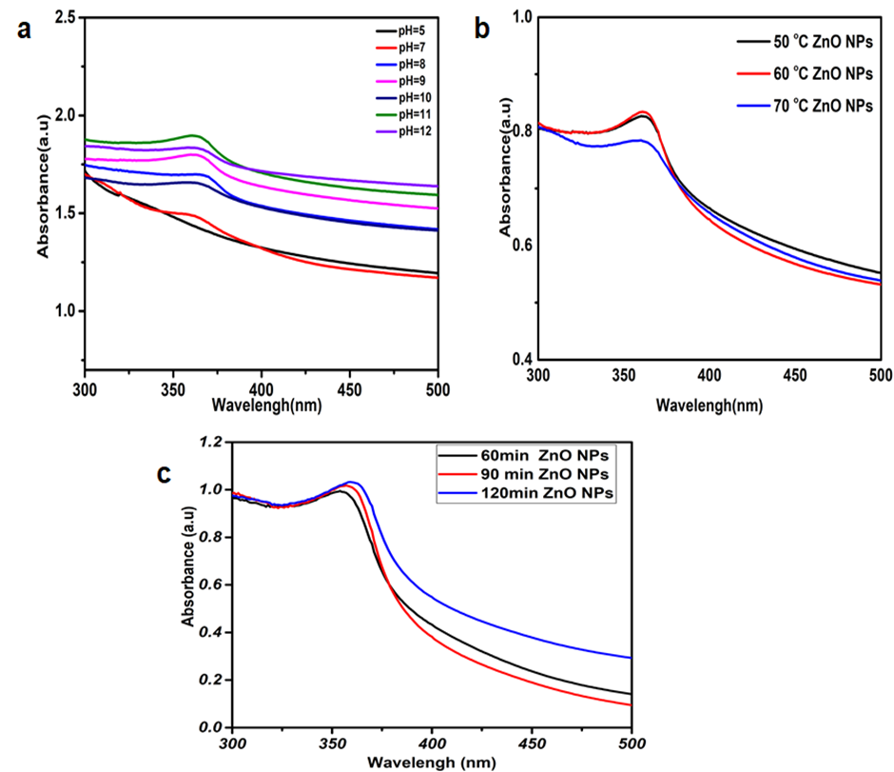
Figure S4. Effect of different parameter for synthesized ZnO NPs (a) Effect of pH (b) Effect of temperature and (c) Effect of reaction time
4.2.6 Ratio of dopant optimization
The absorption peak of Cu-ZnO-NCs was affected by the concentration of dopant¹². This study investigated the impact of varying dopant concentrations (0.012M, 0.008M, and 0.005M) on the absorption peaks of ZnO NPs, maintaining other parameters constant. It was observed that increasing the dopant concentration from 0.005M to 0.008M led to a redshift in the absorption wavelength from 356 nm to 372 nm (Figure S5 a and b). However, when the concentration was raised to 0.012M, the absorption peak shifted back to 368 nm (Figure S5 c). This variation influenced the optical band gap values, indicating that a 92-8% dopant ratio (0.008M) was optimal for synthesizing Cu-ZnO-NCs, aligning with recent literature¹³ findings
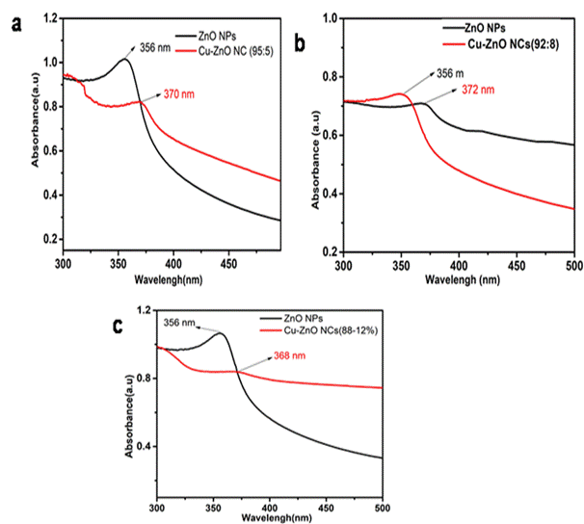
Figure S5. Effect of dopant ratio on UV-Vis absorption peak of Cu-ZnO NCs peak (a) 88-12% (b) 95-5% and (c) 92-8%
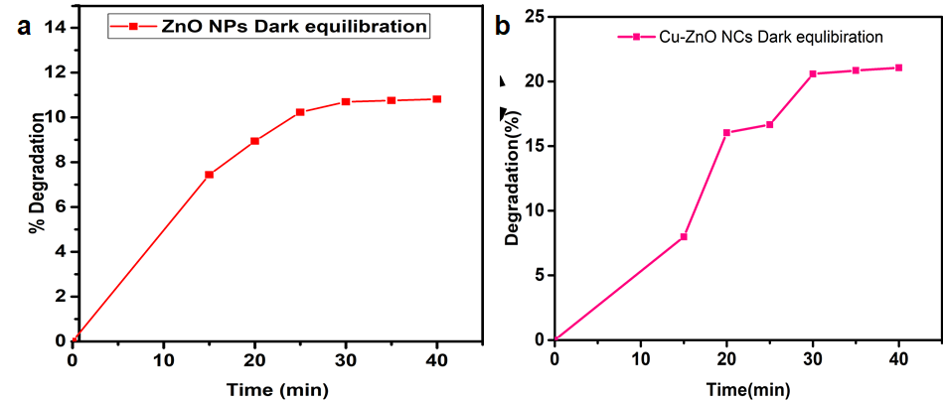
Figure S6. a)Dark-adsorption-desorption equilibration of ZnO NPs b) Dark-adsorption-desorption equilibration of Cu-ZnO NCs

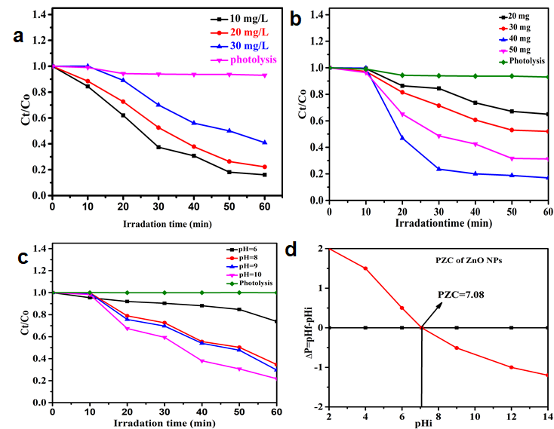
Figure S7. Effects of different parameter for photocatalytic activities of ZnO NPs a) Initial dye concentration b) catalyst dosage c) pH and d) point of zero charge

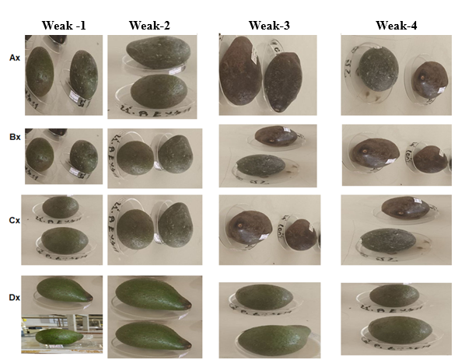
Figure S8. Effect of Phytolacca dodecandra root extract, ZnO NPs and Cu-ZnO NCs change on avocado fruits in four Weak with compare to each control centres
Whereas Ax=control (without catalyst), Bx=Phytolacca dodecandra coated, Cx=ZnO NPs coated and Dx=Cu-ZnO NCs coated
The most significant and frequently applied criterion for evaluating the quality and quantity of fresh products was moisture content, weight content of fruits, pH of fruits content and titratable acidity (TA)
Table S1. Weight loss of avocado fruits on four weak
Type of sample | First weak  Weight (g) | Second weak  Weight (g) | Third Weak  Weight (g) | Fourth Weak  Weight (g) | Weight loss (%)
Control | 160.30±0.25 | 150.40±0.11 | 146.10±0.19 | 141.60±0.28 | 21.84±0.12
Phytolacca dodecandra extract | 157.40±0.21 | 152.90±0.16 | 150.00±0.13 | 147.30±0.30 | 13.00±0.31
ZnO NPs | 140.30±0.60 | 138.80±0.08 | 135.20±0.19 | 131.70±0.31 | 12.90±0.28
Cu-ZnO  NCs | 314.80±0.24 | 311.40±0.25 | 309.10±0.17 | 304.00±0.45 | 4.90±0.23

Table S2.Moisture loss of avocado fruits on four weak
Sample | Weak one  Mass (g) | Weak two  Mass (g) | Weak three  Mass (g) | Weak four  Mass (g)
Control | 41.70±0.24 | 49.25±0.41 | 58.73±0.16 | 66.26±0.37
Phytolacca dodecandra | 17.44±0.32 | 20.78±0.09 | 25.10±0.26 | 33.03±0.34
ZnO NPs | 13.50±0.42 | 23.35±0.18 | 26.68±0.22 | 31.37±0.32
Cu-ZnO NCs | 5.10±0.13 | 7.60±0.15 | 8.49±0.33 | 9.50±0.17

Table S3. Effect of avocado fruits coating by Phytolacca dodecandra extract, ZnO NPs and Cu-ZnO NCs on the changes in TA%
Sample | Weak one  (%) | Weak two  (%) | Weak three  (%) | Weak four  (%)
Control | 2.90±0.23 | 2.50±0.19 | 2.00±0.14 | 1.22±0.12
Phytolacca dodecandra | 3.04±0.13 | 2.76±0.46 | 2.27±0.15 | 2.10±0.16
ZnO NPs | 3.24±0.07 | 3.14±0.36 | 3.06±0.09 | 2.70±0.19
Cu-ZnO NCs | 3.84±0.41 | 3.44±0.31 | 3.34±0.17 | 3.25±0.12

Table S4. Effect of avocado fruit coating on the changes in pH
Sample | Weak one | Weak two | Weak three | Weak four
Control | 6.70±0.06 | 6.82±0.08 | 6.97±0.03 | 7.23±0.06
Phytolacca dodecandra | 6.55±0.01 | 6.63±0.13 | 6.65±0.17 | 6.79±0.05
ZnO NPs | 6.47±0.11 | 6.51±0.19 | 6.55±0.15 | 6.66±0.10
Cu-ZnO NCs | 6.42±0.50 | 6.44±0.06 | 6.47±0.07 | 6.48±0.09

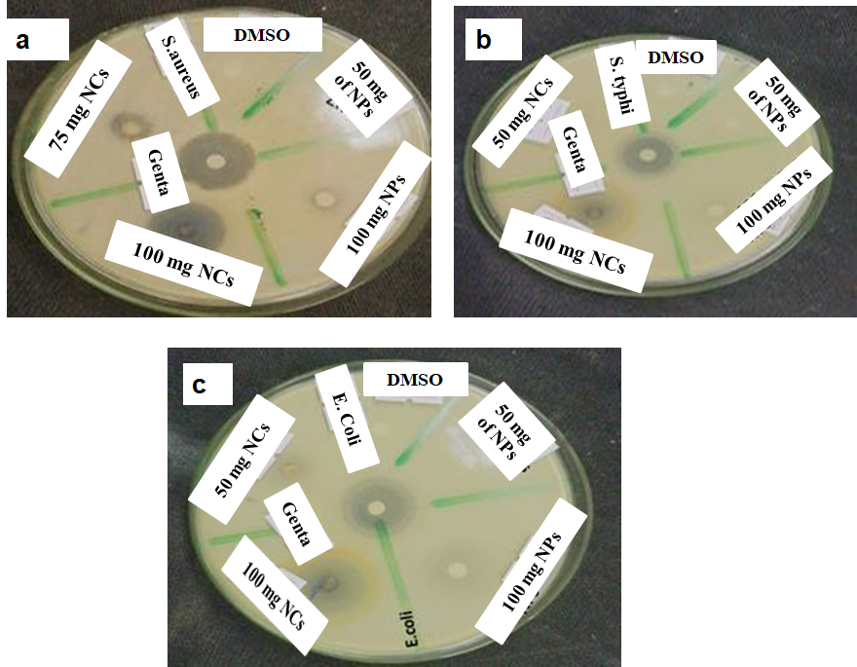
Figure S9 .Effect of concentration of ZnO NPs and Cu-ZnO NCs on selected bacteria’s
Reference
(1) Etefa, K. T.; Rayya, N. W.; Nemera, D. J.; Muleta, G. G.; Beyene, T. T. Sustainable Preparation of Ag-ZnO Nanocomposites Using Persea Americana Peel Extract for Superior Antibacterial, Antioxidant, and Photocatalytic Efficacy. Mater Sci Eng B 2025, 321 (May). https://doi.org/10.1016/j.mseb.2025.118562.
(2) Shawono, B. G.; Etefa, K. T.; Muleta, G. G.; Kai, Z.; Beyene, T. T. Eco-Friendly Synthesis of Ag-Doped CuO Nanocomposites Using Solanum Tuberosum Peel Extract, Showcasing Enhanced Antimicrobial, Antioxidant, and Photocatalytic Performance. Inorg Chem Commun 2025, 180 (May). https://doi.org/10.1016/j.inoche.2025.114993.
(3) Nouren, S.; Bibi, I.; Kausar, A.; Sultan, M.; Nawaz Bhatti, H.; Safa, Y.; Sadaf, S.; Alwadai, N.; Iqbal, M. Green Synthesis of CuO Nanoparticles Using Jasmin Sambac Extract: Conditions Optimization and Photocatalytic Degradation of Methylene Blue Dye. J King Saud Univ - Sci 2024, 36 (3), 103089. https://doi.org/10.1016/j.jksus.2024.103089.
(4) Dutta, A. K.; Maji, S. K.; Adhikary, B. γ-Fe2O3 Nanoparticles: An Easily Recoverable Effective Photo-Catalyst for the Degradation of Rose Bengal and Methylene Blue Dyes in the Waste-Water Treatment Plant. Mater Res Bull 2014, 49 (1), 28–34. https://doi.org/10.1016/j.materresbull.2013.08.024.
(5) Radulescu, D. M.; Surdu, V. A.; Ficai, A.; Ficai, D.; Grumezescu, A. M.; Andronescu, E. Green Synthesis of Metal and Metal Oxide Nanoparticles: A Review of the Principles and Biomedical Applications. Int J Mol Sci 2023, 24 (20). https://doi.org/10.3390/ijms242015397.
(6) Kumar, N.; Pratibha; Upadhyay, A.; Trajkovska Petkoska, A.; Gniewosz, M.; Kieliszek, M. Extending the Shelf Life of Mango (Mangifera Indica L.) Fruits by Using Edible Coating Based on Xanthan Gum and Pomegranate Peel Extract. J Food Meas Charact 2023, 17 (2), 1300–1308. https://doi.org/10.1007/s11694-022-01706-6.
(7) Marciniak, L.; Nowak, M.; Trojanowska, A.; Tylkowski, B.; Jastrzab, R. The Effect of Ph on the Size of Silver Nanoparticles Obtained in the Reduction Reaction with Citric and Malic Acids. Materials (Basel) 2020, 13 (23), 1–12. https://doi.org/10.3390/ma13235444.
(8) Husam, M. K. The Effect of PH , Temperature on the Green Synthesis and Biochemical Activities of Silver Nanoparticles from Lawsonia Inermis Extract. J Pharm Sci Res 2022, 10 (1), 2022–2026.
(9) Endeshaw, S. B.; Tufa, L. T.; Goddati, M.; Lee, J.; Silalahi, V. C.; Lee, D.; Murthy, H. C. A.; Sabir, F. K. Croton Macrostachyus Leaf Extract-Mediated Green Synthesis of ZnO Nanoparticles and ZnO/CuO Nanocomposites for the Enhanced Photodegradation of Methylene Blue Dye with the COMSOL Simulation Model. ACS Omega 2024, 9 (1), 559–572. https://doi.org/10.1021/acsomega.3c06155.
(10) Li, B.; Zhou, Q.; Liu, Y.; Wei, Z.; Zeng, W. Enhanced Ethanol Sensing Properties Based on W-Doped NiO Flower-like Microstructure: Beneficial Improvement from Loose to Dense Morphology. Mater Lett X 2021, 10, 100075. https://doi.org/10.1016/j.mlblux.2021.100075.
(11) Khairunnisa, S.; Wonoputri, V.; Samadhi, T. W. Effective Deagglomeration in Biosynthesized Nanoparticles: A Mini Review. IOP Conf Ser Mater Sci Eng 2021, 1143 (1), 012006. https://doi.org/10.1088/1757-899x/1143/1/012006.
(12) Jung, D. W.; Duncan, K. L.; Wachsman, E. D. Effect of Total Dopant Concentration and Dopant Ratio on Conductivity of (DyO1.5)x-(WO3)y-(BiO1.5)1-x-Y. Acta Mater 2010, 58 (2), 355–363. https://doi.org/10.1016/j.actamat.2009.08.072.
(13) Bukhari, A.; Ijaz, I.; Gilani, E.; Nazir, A.; Zain, H.; Saeed, R. Green Synthesis of Metal and Metal Oxide Nanoparticles Using Different Plants ’ Parts for Antimicrobial Activity and Anticancer Activity : A Review Article. 2021.

