Supplementary Information
Table S1 The sequences of primers for qPCR used in rapeseed
Primer name | Accession number | Sequence (5’→3’)
BnActin | LOC106418315 | F: CTGACCGTATGAGCAAAG  R: CCACCGAACCAGAAGGCAGA
BnGAPDH | LOC106382350 | F: TGTGCCAATCTACGAGGGTTT  R: TTTCCCGCTCTGCTGTTGT
BnAUX1 | LOC106376940 | F: CAGGAACATCAGTTTCACAGTG  R: ATCTGTGATTTCAGCTGCATTC
BnPIN1 | LOC106389334 | F: TGTACTACACTTCCTCCTCCAT  R: TCGTACATATCTTTGCCGGTGA
BnCPC | LOC106454426 | F: CAAGGCCAAAGCTTCGTGTT  R: CACCTGTCTCCGACGAGTTT
BnTRY | LOC106444610 | F: TCGTAGGCGATAGGTGGGAA  R: CACAGCCCAAGAAGGAGGTT
BnTTG | LOC106348252 | F: CCTCCCACCAAGCTCATGTT  R: TGTTGAGGACGGATACTGGC
BnGL2 | LOC106356883 | F: ACACAGATGGTGATCGCAGG  R: TCTGTCTGCCTCTTGTGCAG

Table S2 The sequences of primers for qPCR used in Arabidopsis
Primer name | Accession number | Sequence (5’→3’)
AtActin 2 | AT3g18780 | F: ACAACCGGTATTGTGCTGGA  R: GAAGACGGAGGATGGCATGA
AtGAPDH | AT1g13440 | F: TTGGTGACAACAGGTCAAGCA  R: AAACTTGTCGCTCAATGCAATC
AtAUX1 | AT2G38120 | F: CAGCCGCCGCACATG  R: ACCCTGACTCGATCTCTCAAAGA
AtPIN1 | AT1G73590 | F: CGTGGAGAGGGAAGAGTTTA  R: AACATAGCCATGCCTAGACC
AtCPC | AT2G46410 | F: CGAAGAGGTGAGTAGTATCG  R: CGACGCCGTGTTTCATAA
AtTRY | AT5G53200 | F: GTCGGTGATAGGTGGGAT  R: GACGGTGAGGCTTGGTAT
AtROP2 | AT1G20090 | F: CCGATCTTGCGGCAGAGATGGCGT  R: CTTATCACAAGAACGCGCAACGGTT
AtTTG1 | AT5G24520 | F: TTCCTTCGATTGGAACGATGTA  R: GCAAGTCTTAACAAAGGCGTAT
AtGL2 | AT1G79840 | F: TCTTTAGAGATGAAGCTCGTCG  R: CTGTCTTGTCCCTTGGATAAGT
AtGL3 | AT5G41315 | F: CAAAACGAGGAAGACGATTCAA  R: CAACGCCTGAAGAAGAAGATTC

Table S3 Effects of MWCNTs on root hair density (number mm⁻¹) in various plant species
MWCNTs (mg/L)
 | 0 | 10 | 50 | 100 | 200 | 500 | 1000 | 2000 | 5000
Arabidopsis (5 d) | 14.28±1.16b | 18.42±1.79a | 10.36±1.14c | 8.85±2.03c | 5.22±1.17d | 4.32±1.13d | 3.21±1.01e | - | -
Rice (3 d) | 21.34±1.36c | 21.45±2.30c | 27.58±2.07b | 30.32±2.96ab | 32.19±3.21ab | 33.26±2.85a | 30.15±2.47ab | 25.67±2.18b | 22.32±2.53bc
Tomato (3 d) | 45.21±3.23c | 44.36±2.19c | 51.49±2.44b | 60.17±3.09a | 55.31±3.27ab | 50.37±2.39b | 45.26±2.13c | 40.21±2.36d | 38.54±3.17d
Chinese cabbage  (3 d) | 14.28±1.27c | 18.36±2.06b | 20.59±1.36a | 17.18±1.97b | 11.67±1.08d | 10.25±1.15de | 8.13±1.56e | - | -
Wheat (3 d) | 19.17±1.39c | 19.53±2.12c | 25.05±1.54b | 28.27±1.64a | 28.56±2.18a | 26.21±1.84ab | 22.52±1.71bc | 20.39±1.58c | 18.83±1.69c
Radish (3 d) | 30.28±2.36d | 32.92±2.73cd | 39.58±3.47bc | 47.37±3.96ab | 52.63±3.57a | 42.29±3.17b | 35.26±3.28c | 28.32±3.45d | 22.16±2.83e
Alfalfa (3 d) | 23.29±1.59b | 24.03±1.62b | 26.27±2.35ab | 28.35±2.09a | 24.55±2.61ab | 22.17±2.53bc | 18.21±1.75c | - | -

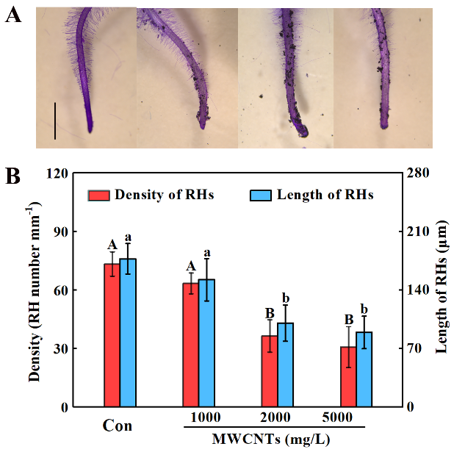
Fig. S1
Fig. S1. High concentrations of MWCNTs inhibited rapeseed root hair growth. Two-day-old rapeseed seedlings were treated with indicated concentrations of MWCNTs for 3 days. Afterwards, corresponding photograph of root hairs were taken (A). Scale bar = 1 mm. Meanwhile, the root hair density (B; left) and length (right) were measured. The sample without chemicals was the control (Con). Values are means ± SE of three independent experiments with at least three replicates for each. Within each set of experiments, bars with different letters are significantly different at P < 0.05 according to Duncan’s multiple range test.
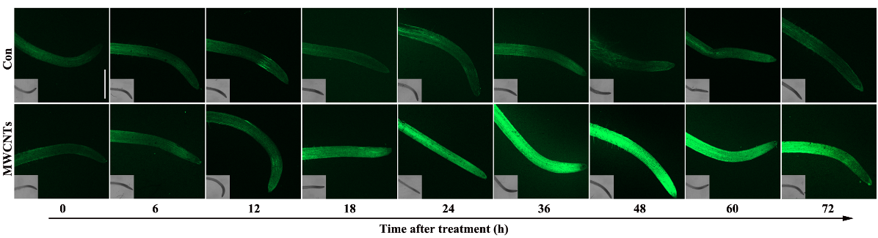
Fig. S2

Fig. S2. MWCNTs-induced NO. Two-day-old rapeseed seedlings were treated with indicated concentrations of MWCNTs for 3 days. Afterwards, the time-course analysis of DAF-FM-dependent fluorescence in root tissues was provided. Scale bar = 1 mm. R.U., relative units.
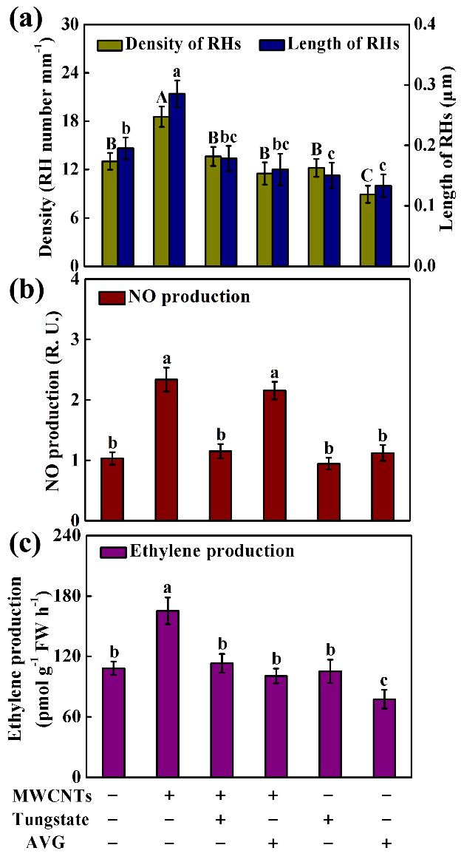
Fig. S3
Fig. S3. Ethylene might act downstream of MWCNTs induction of NO synthesis in Arabidopsis root hair development. Five-day-old seedlings were treated with 10 mg/L MWCNTs, 50 μM tungstate, and 2 μM AVG, alone or their combinations. After treatments for 5 d, root hair (RH) density (A; left) and length (A; right), NO (B) and ethylene production (C) were detected. Within each set of experiments, bars with different letters are significantly different at P < 0.05 according to Duncan’s multiple range test.

