Unveiling genetic architecture of white matter microstructure through unsupervised deep representation learning of fractional anisotropy images
Xingzhong Zhao¹, Ziqian Xie¹, Wei He¹, Hyun Yong Koh¹, Myriam Fornage^{2,3}, Degui Zhi^{1, *}

1. McWilliams School of Biomedical Informatics, University of Texas Health Science Center, Houston, TX, 77030, USA.
2. School of Public Health, University of Texas Health Science Center, Houston, TX, 77030, USA
3. McGovern Medical School, University of Texas Health Science Center, Houston, TX, 77030, USA

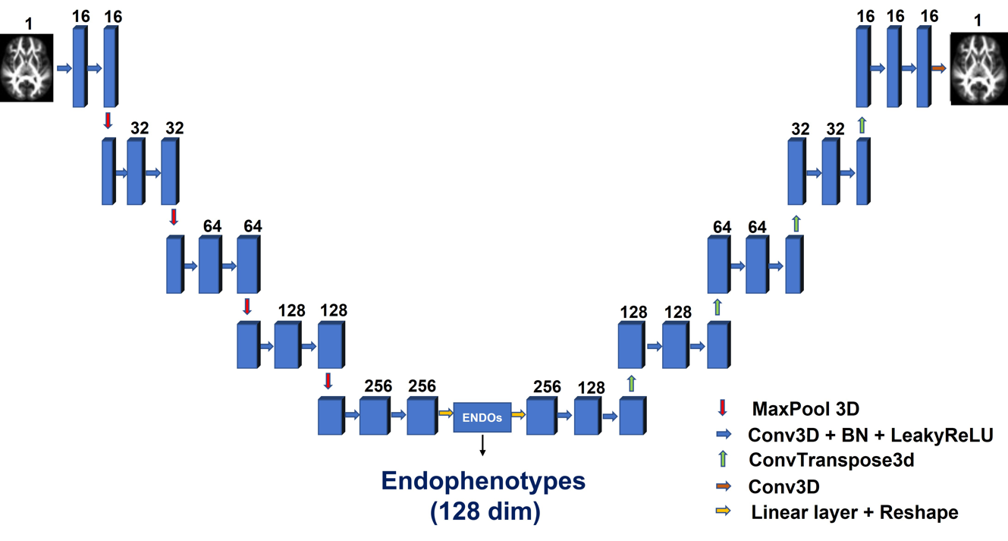
Figure S1 | Network architecture of UDR-WM.

Figure S2｜ The association within 128 UDIP-FA based on genotype and phenotypes. The bottom left triangle displays phenotypic correlations, estimated using Pearson’s correlation coefficient. Prior to computation, the effect of the writing variable on UDIP was regressed out using linear regression. The top right triangle shows genetic correlations, calculated using LD Score Regression (LDSC). The number in this row and column means the dimension of UDIP-FA. All correlation coefficients are presented as absolute values.

Figure S3 | Each row corresponds to a UDIP-FA dimension. CSF: cerebrospinal fluid; GM: grey matter; WM: white matter. Higher K–S statistic values indicate stronger enrichment.
Figure S4 | Spatial visualization of the dimension 1 and dimension 2 for UDIP-FA. The first row is the observed t-value of the UDIP dimension 1 and dimension 2 at different regions of white matter tracts that obtain from PerDI. Second row is showing the significantly enriched WM regions of dimension 1 and dimension 2.

Figure S5 | The workflow for the multi-stage GWAS for UDIP-FA. The GWAS study was conducted in two phases: a GWAS discovery phase (N = 17,376) and a replication phase (N = 8,499), each including 128 unsupervised deep imaging phenotypes (UDIPs). For both phases, single-variant GWAS were performed on each UDIP using FastGWAS. Subsequently, multi-variant GWAS analyses were conducted using JAGWAS to jointly assess variant effects across all UDIPs within each phase. Meta-analysis was then performed on the 128 single-variant GWAS results across the two phases to generate 128 META GWAS. Finally, a multi-variant meta-GWAS was conducted using JAGWAS on the combined meta-GWAS results to identify joint genetic associations across phenotypes.
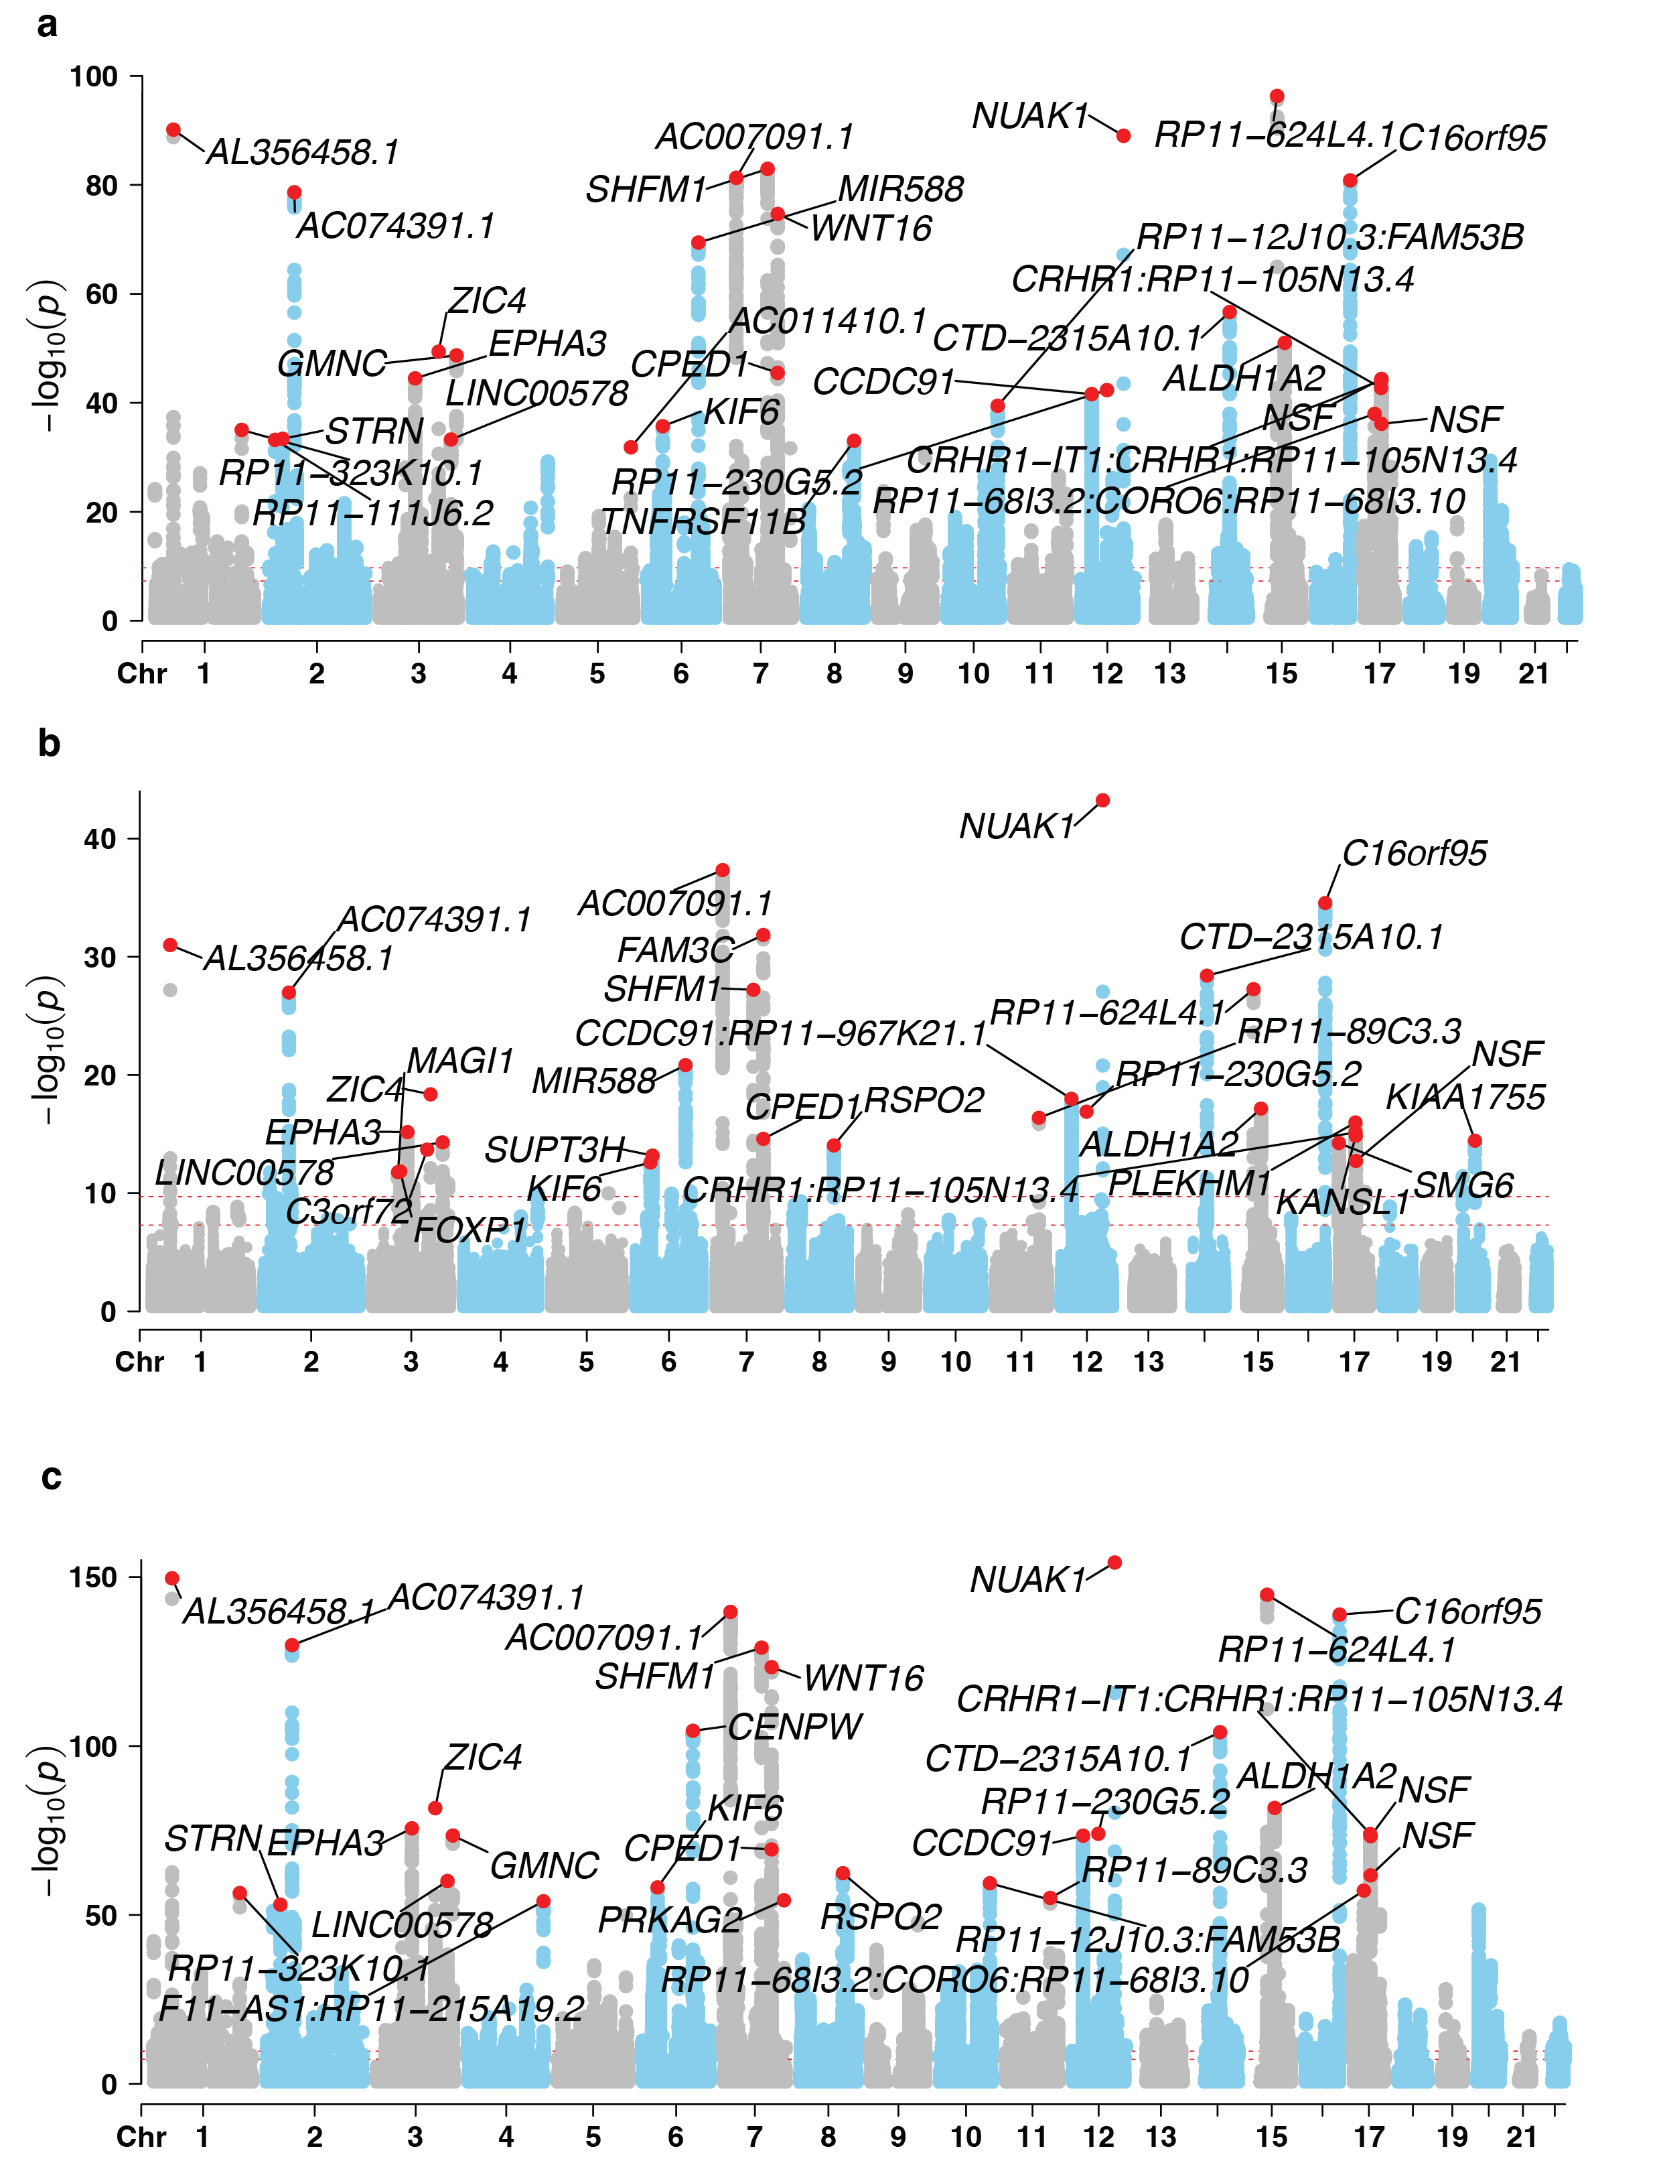
Figure S6 | Manhattan plots for the multivariate GWAS (mvGWAS) of UDIP-FA. (a) mvGWAS results from the discovery cohort, (b) replication cohort results, and (c) a meta-analysis combining both cohorts. Manhattan plot annotations highlight the top 30 most significant loci.

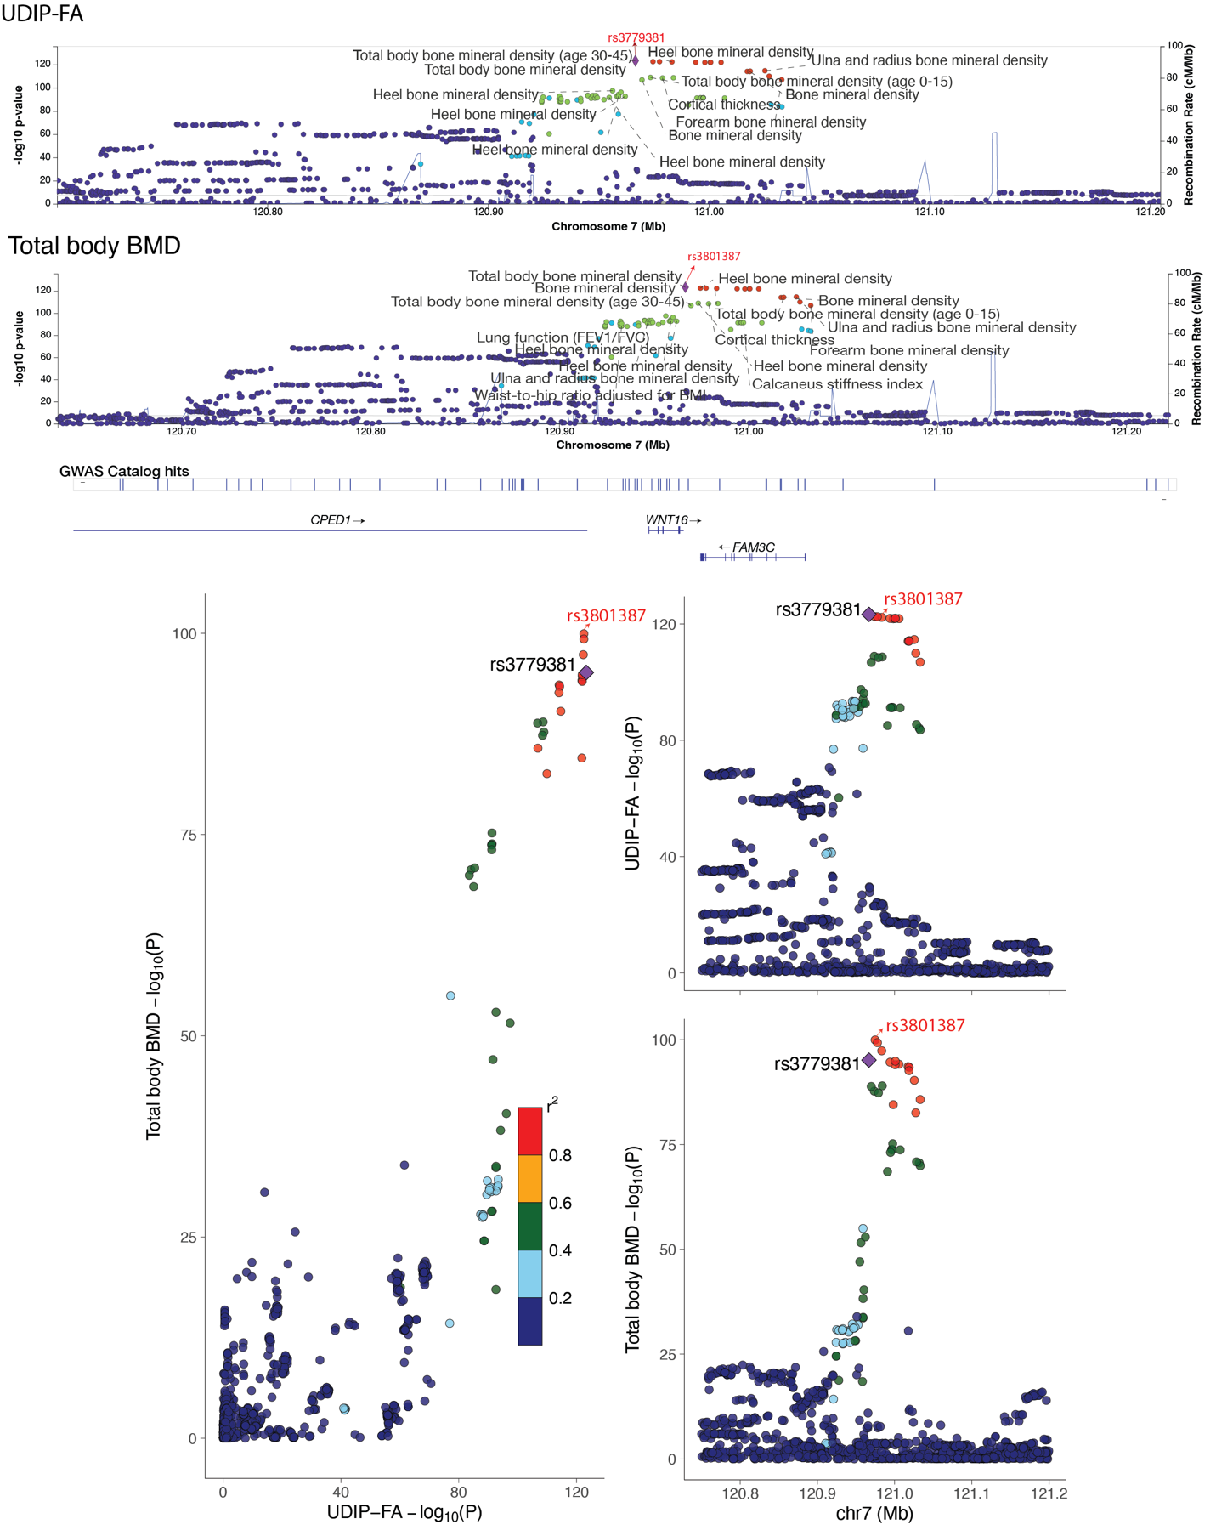
Figure S7 | SNP colocalization between UDIP-FA and Total body BMD at 7q31.31 region. (Top) Regional association plots for UDIP-FA (top panel) and total body BMD (bottom panel) at chromosome 7p14.3. –log₁₀(P) values from GWAS are plotted for each SNP against their genomic position (hg19), with nearby traits from the GWAS Catalog annotated for reference. Two genome-wide significant lead SNPs (rs3779381 and rs3801387) are highlighted in red. The recombination rate is overlaid in blue to indicate local LD structure. (Bottom left) Scatter plot showing the relationship between the –log₁₀(P) values of SNPs for UDIP-FA and total body BMD at this locus. Points are color-coded by linkage disequilibrium (r²) with the lead SNP rs3801387. (Bottom right) Regional association plots for the same locus zoomed in between 120.8 Mb and 121.2 Mb on chromosome 7, showing –log₁₀(P) values for UDIP-FA (top) and total body BMD (bottom). SNPs are colored by LD (r²) with rs3801387, emphasizing a shared association peak near the WNT16 gene. Nearby gene annotations (e.g., CPED1, WNT16, FAM3C) are shown for reference.
Figure S8 ｜ The gene overlap between different gene mapping methods for meta mvGWAS of UDIP-FA.

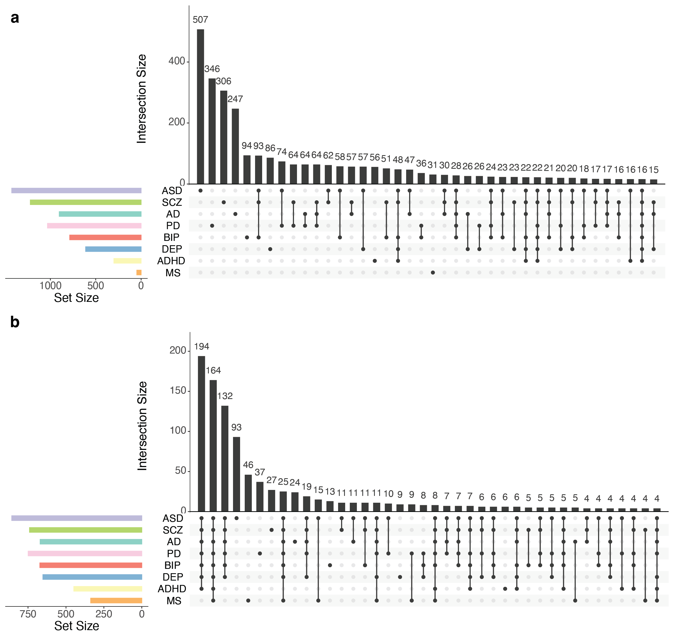
Figure S9 | The upset plots of the overlap between the interacted risk genes of UFAGS for diverse brain disorders in the brain-specific transcriptional regulatory network (TRN), co-expression, and protein-protein interaction (PPI) network. (a) brain-specific TRN (b) brain-specific co-expression network. AD, Alzheimer’s disease; ADHD, Attention deficit hyperactivity disorder; ASD, Autism spectrum disorder; BIP, Bipolar disorder; MDD, Major depressive disorder; PD, Parkinson’s disease; SCZ, Schizophrenia.

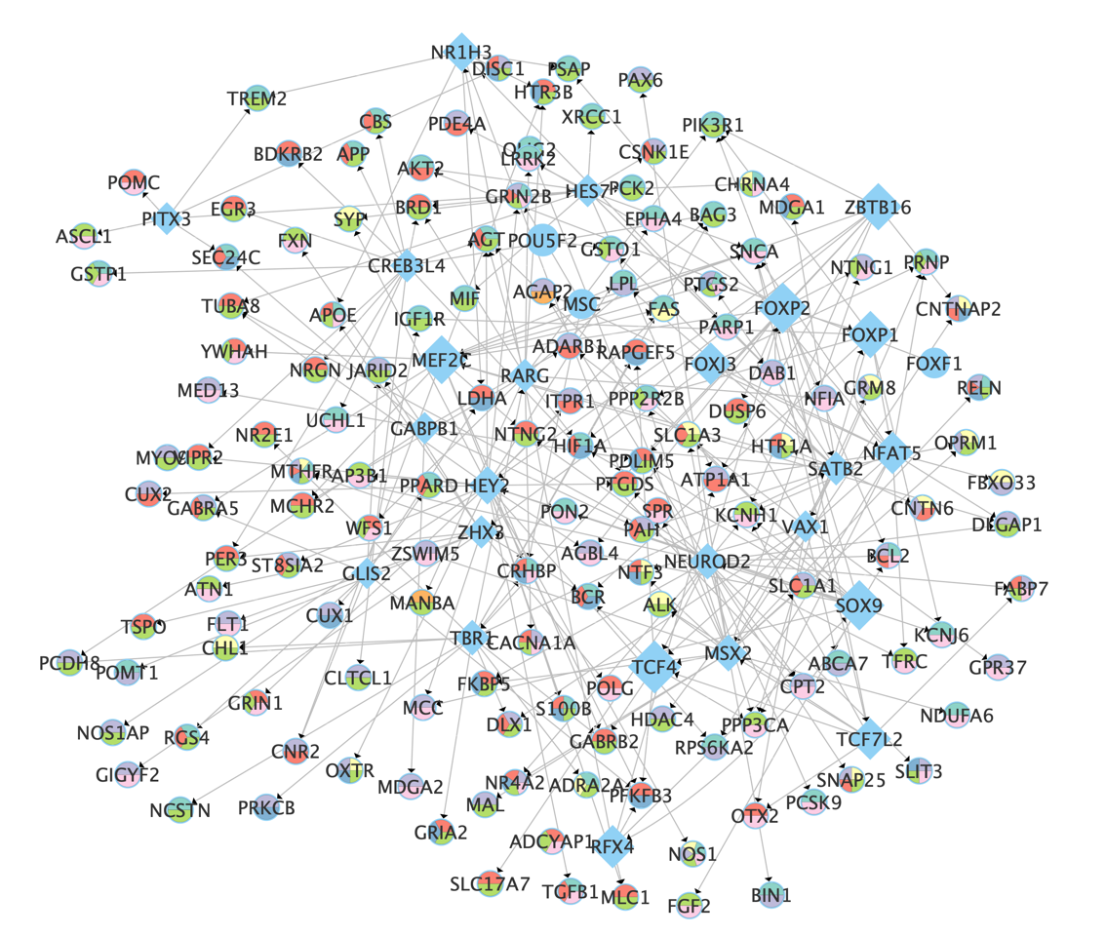
Figure S10 | Network visualization of pivotal hub modules for UFAGs in the TRN network. Diamonds represent UFAGs, circles denote disease risk genes, and pie chart colors indicate gene overlap across different brain disorders, with the same color annotation as in Figure 5.

