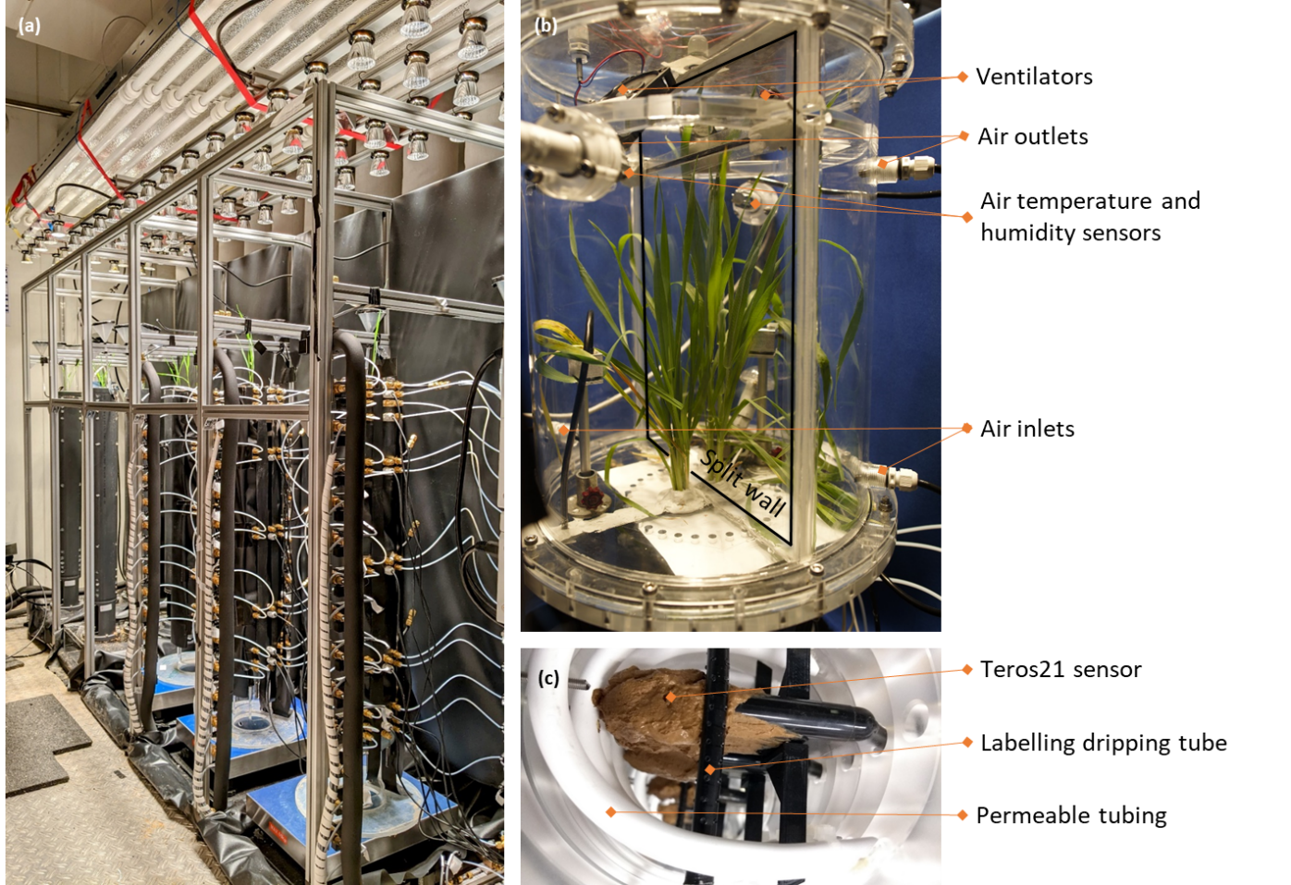
Supplementary material
Fig S1 (a) Experimental set-up with three acrylic columns for water stable isotope measurements, set on blue balances and under light panels. (b) Split plant chamber with an air inlet and outlet for each half, ventilators and an air temperature and humidity sensor. (c) Acrylic soil column with permeable tubes (for water stability measurements), Teros21 sensors (matric potential) and label drip tubes before filling the column with soil.
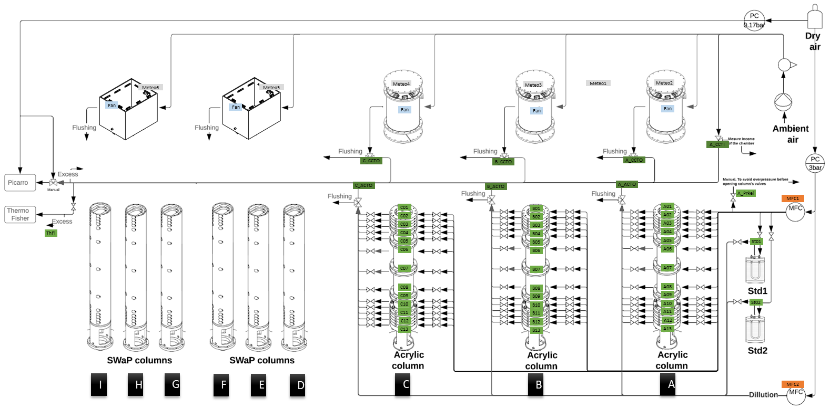
Fig S2 Schematic diagram of the air circuit in the experiment carried out to measure RWU profiles using stable isotope measurements of water. Each acrylic column is equipped with 13 permeable tubes opened and closed by valves (A1 to C13). The air inlet to the soil columns is controlled by the MFC1 and the pressure can be released by the A_PrRel valve. The sampled water vapor is then diluted with dry air by MFC2, and directed to the analyzer or flushed via the 3-way valves. A(B/C)_ACTO. The Std1 and Std2 calibration standards are measured the same way. Ambient air is pushed into the plant chambers, regulated by manual valves, and measured by the analyzer via the three-way valve A_CCTI. The outlet from each plant chamber is either flushed or directed to the analyzer via the 3-way valves A(B/C)_CCTI

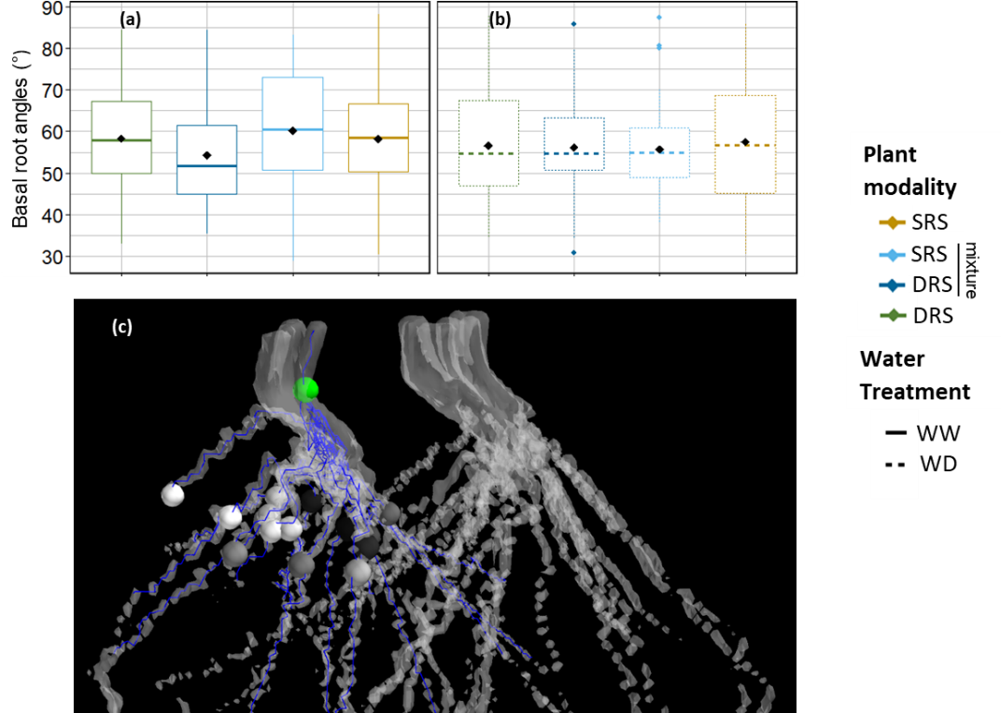
Fig S3 Distributions of basal root angles for the well watered (“WW”, line, panel a) and water deficit (“WD”, dots, panel b) treatments, and for the three plant modalities (DRS in monoculture, dark green color; DRS in mixture, dark blue color; SRS in mixture, light blue color; SRS in monoculture, orange color) measured on the in situ 3D MRI scans at the booting stage.
Screenshot of a 3D MRI root scan analysis to measure the root angles of two wheat plants in a soil column (panel c). In blue the seminal roots are traced, in white to black the position of the root seminal at 2cm from the green the stem reference point to calculate the angles.

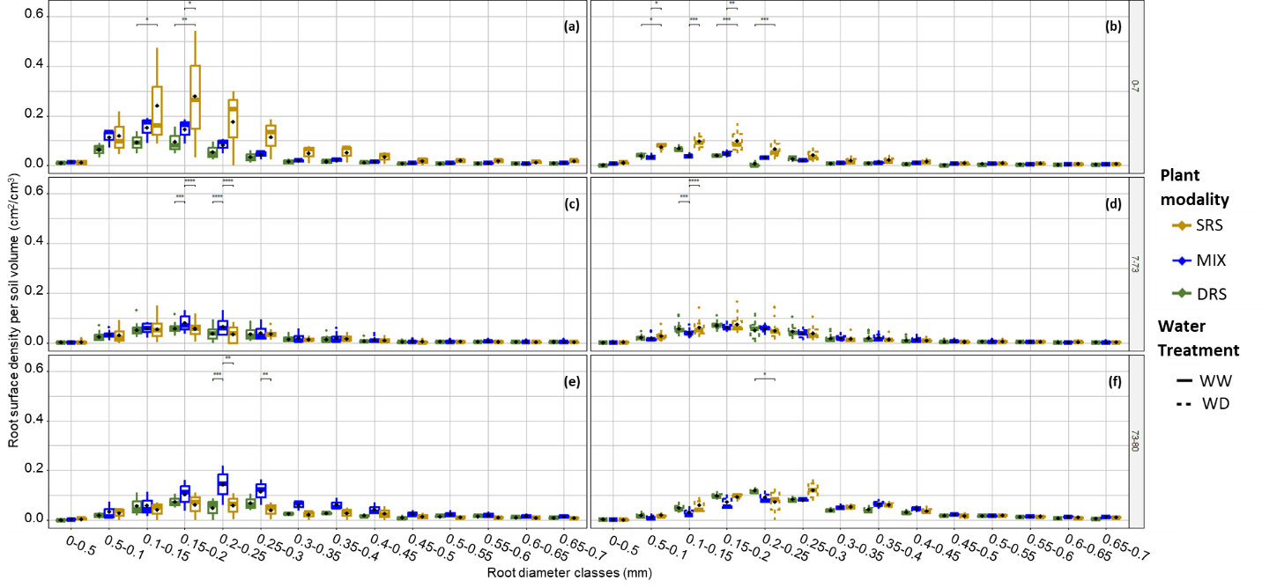
Fig S4 Distributions of the root surface density per soil volume (cm2 cm-3) as per root diameter class, measured for the destructive root sample scans at the booting stage, for the well-watered (“WW”, lines, panel a, c, e) and water deficit (“WD”, dots, panel b, d, f) treatments, in the topsoil (0-7cm depth, panel a, b), intermediate soil layers (7-73cm depth, panel c, d) and subsoil (73-80cm depth, panel e, f), among the plant modalities (DRS in monoculture, dark green color; Mixture – MIX, blue color; and SRS in monoculture, orange color) (n=3 in top- and subsoil, n=18).

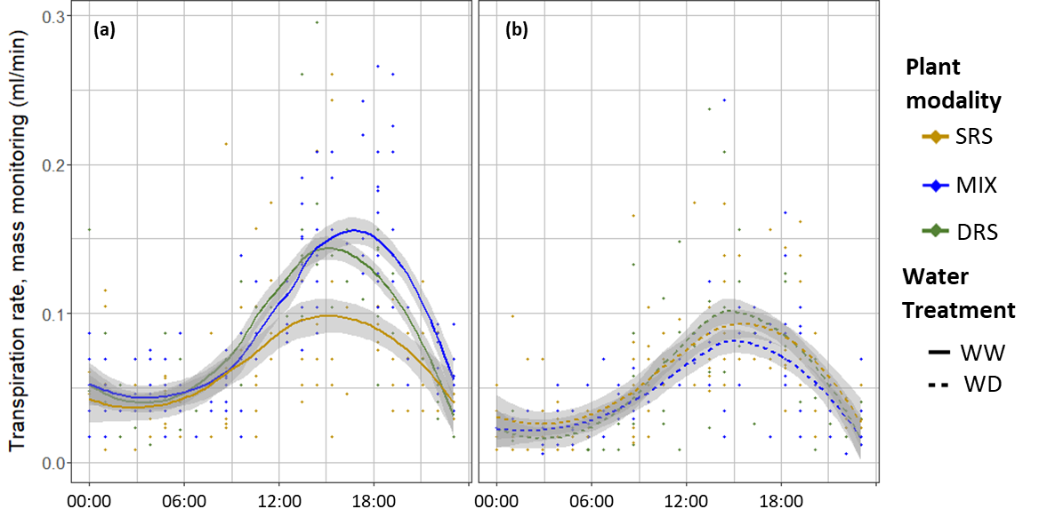
Fig S5 Measurement points modeled by LOESS (Locally Estimated Scatterplot Smoothing) regression with 95% confidence interval from 39 to 43 DaS of transpiration rate (in mL/min) monitored continuously by scale bellow the soil columns, for the three crop modalities (DRS in monoculture, dark green color; Mixture – MIX, blue color, and SRS in monoculture, orange color) under well watered (“WW”, lines, panel a) and water deficit (“WD”, dots, panel b) conditions.

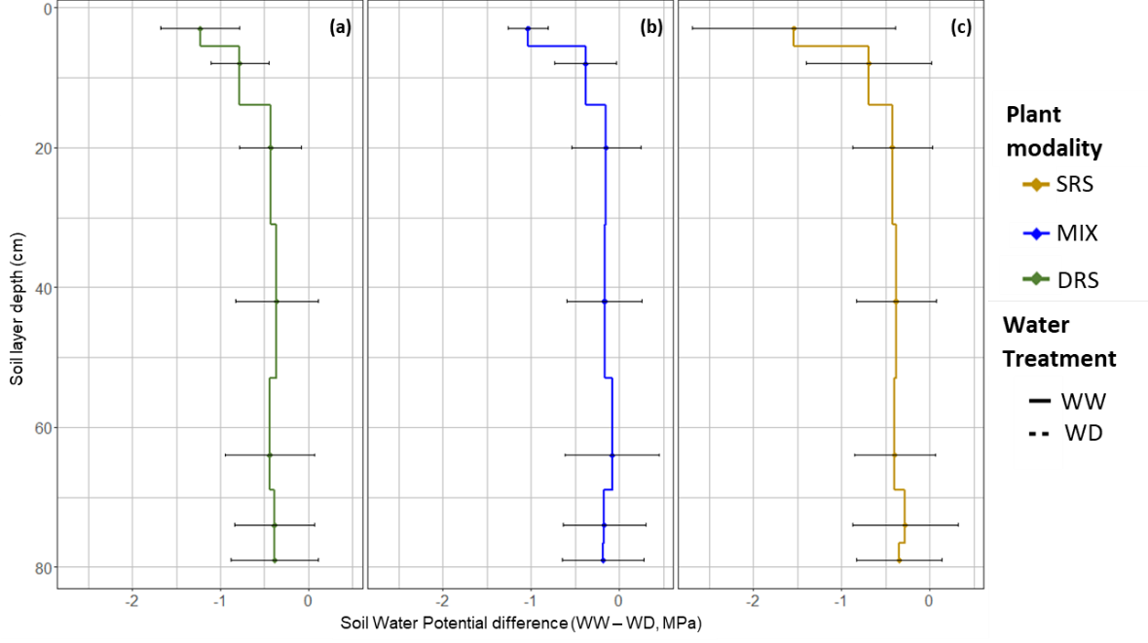
Fig S6 Soil matric potential difference, expressed as MPa, measured with the Teros21 sensors, between absolute values of matric potential in water deficit (“WD“) and well watered (“WW”) conditions for the three plant modalities (DRS in monoculture, dark green color, panel a; Mixture – MIX, blue color, panel b; SRS in monoculture, orange color, panel c), across ten soil layers (0-2; 2-4; 4-7; 7-14; 14-30; 30-52; 52-69; 69-76; 76-78; 78-80 cm). Standard deviations are indicated by black bars.

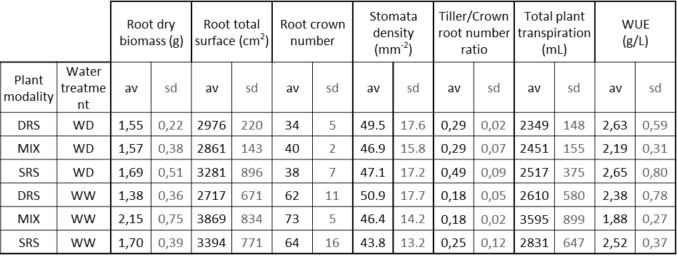
Table S1 Total root dry biomass (g) and surface (cm²), crown root number (-), stomata density (mm⁻²), tiller to crown root number ratio (-),total cumulated plant transpiration (mL) and overall water use efficiency (WUE, g/L) recorded at the soil column scale (two plants) at the elongation stage (43 DaS) among the plant modality and water treatment (n=3).

