Appendix: Supplementary Material

PACTPPg: Effect of dosage
pH/  Dose  (mg/L) |  | COD (mg/L) |  |  | Ammonia nitrogen (mg/L) |  |  | Turbidity (NTU) |  |  | Colour (ADMI) |  |  | Suspended solids  (mg/L)
 |  | I | F | R % | I | F | R % | I | F | R % | I | F | R % | I | F | R %
Control |  | 2166 | 1409 | 34.9 | 786.99 | 621.37 | 21.0 | 157 | 85.6 | 45.5 | 2537 | 2308 | 9.0 | 198 | 116 | 41.4
7 | 500 | 2166 | 1385 | 36.1 | 786.99 | 621.71 | 21.0 | 157 | 85.3 | 45.7 | 2537 | 2012 | 20.7 | 198 | 94 | 52.5
7 | 1000 | 2166 | 1219 | 43.7 | 786.99 | 586.52 | 25.5 | 157 | 75.7 | 51.8 | 2537 | 1408 | 44.5 | 198 | 66 | 66.7
7 | 1500 | 2166 | 1113 | 48.6 | 786.99 | 571.12 | 27.4 | 157 | 62.3 | 60.3 | 2537 | 1006 | 60.3 | 198 | 45 | 77.3
7 | 2000 | 2166 | 1072 | 50.5 | 786.99 | 504.5 | 35.9 | 157 | 47.3 | 69.9 | 2537 | 753 | 70.3 | 198 | 32 | 83.8
7 | 2500 | 2166 | 881 | 59.3 | 786.99 | 499.36 | 36.5 | 157 | 28.9 | 81.6 | 2537 | 439 | 82.7 | 198 | 25 | 87.4
7 | 3000 | 2166 | 938 | 56.7 | 786.99 | 570.36 | 27.5 | 157 | 25.2 | 83.9 | 2537 | 440 | 82.7 | 198 | 17 | 91.4
7 | 3500 | 2166 | 768 | 64.5 | 786.99 | 540.07 | 31.4 | 157 | 16.9 | 89.2 | 2537 | 434 | 82.9 | 198 | 8 | 96.0
7 | 4000 | 2166 | 711 | 67.2 | 786.99 | 616.83 | 21.6 | 157 | 5.03 | 96.8 | 2537 | 368 | 85.5 | 198 | 4 | 98.0

Removal percentages at pH 7 of leachate and 500-4000 mg/L of PACTPPg

PACTPPg: Effect of leachate pH
pH/  Dose  (mg/L) |  | COD (mg/L) |  |  | Ammonia nitrogen (mg/L) |  |  | Turbidity (NTU) |  |  | Colour (ADMI) |  |  | Suspended solids  (mg/L)
 |  | I | F | R% | I | F | R % | I | F | R % | I | F | R % | I | F | R %
Control |  | 2509 | 2132 | 15.0 | 680.67 | 451.35 | 33.7 | 163.2 | 115.2 | 29.4 | 2534 | 2502 | 1.3 | 244 | 182 | 25.4
3 | 2500 | 2509 | 1884 | 24.9 | 680.67 | 347.47 | 49.0 | 163.2 | 101.6 | 37.7 | 2534 | 1993 | 21.3 | 244 | 92 | 62.3
4 | 2500 | 2509 | 1763 | 29.7 | 680.67 | 393.89 | 42.1 | 163.2 | 98 | 40.0 | 2534 | 1210 | 52.2 | 244 | 80 | 67.2
5 | 2500 | 2509 | 1466 | 41.6 | 680.67 | 395.37 | 41.9 | 163.2 | 42.4 | 74.0 | 2534 | 676 | 73.3 | 244 | 32 | 86.9
6 | 2500 | 2509 | 1239 | 50.6 | 680.67 | 424.89 | 37.6 | 163.2 | 37.66 | 76.9 | 2534 | 539 | 78.7 | 244 | 28 | 88.5
7 | 2500 | 2509 | 1008 | 59.8 | 680.67 | 417.49 | 38.7 | 163.2 | 7.42 | 95.5 | 2534 | 178 | 93.0 | 244 | 2 | 99.2
8 | 2500 | 2509 | 1196 | 52.3 | 680.67 | 425.4 | 37.5 | 163.2 | 8.08 | 95.0 | 2534 | 273 | 89.2 | 244 | 4 | 98.4
9 | 2500 | 2509 | 1251 | 50.1 | 680.67 | 432.0 | 36.5 | 163.2 | 10.82 | 93.4 | 2534 | 406 | 84.0 | 244 | 20 | 91.8
10 | 2500 | 2509 | 1253 | 50.1 | 680.67 | 448.43 | 34.1 | 163.2 | 38.2 | 76.6 | 2534 | 572 | 77.4 | 244 | 24 | 90.2

Removal percentages at 2500 mg/L of PACTPPg and varied leachate pH 3-10

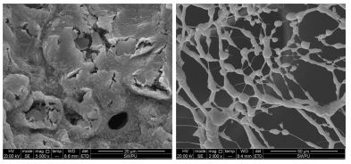
(a) (b)
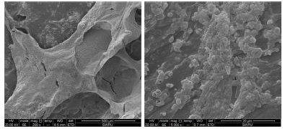
(c) (d)
Images of polydimethyldiallylammonium chloride (PDM) (Wang et al., 2016)

The weight and atomic percentages, and spectrum of elements detected in PAC by EDX
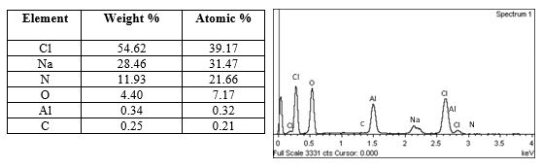

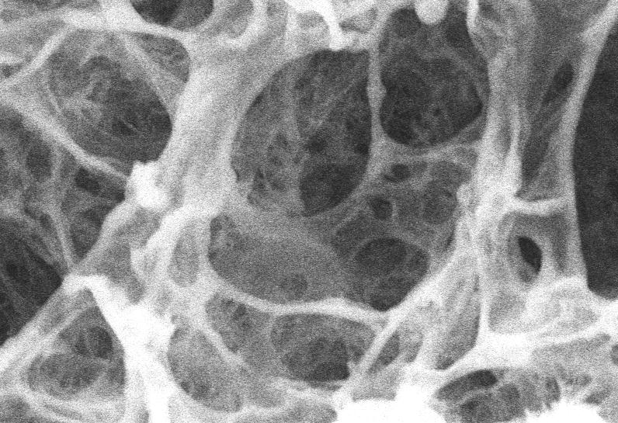
SEM image of tapioca starch in 1% stock solution at 600× magnification (Azizan, 2019)

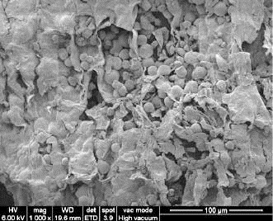
SEM image of cassava peel at 1.00kx magnification (Versino et al., 2015)

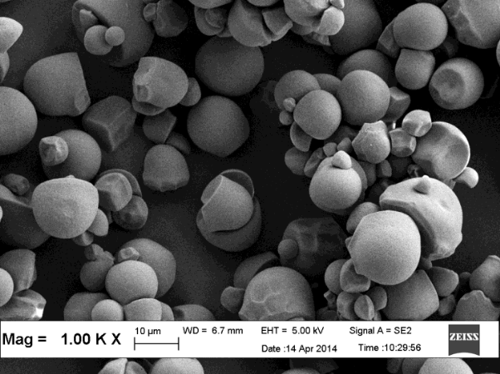
SEM image of raw tapioca starch/flour at 1.00k× magnification (Shaylinda, 2015)

The weight and atomic percentages, and spectrum of elements detected in TPP by EDX
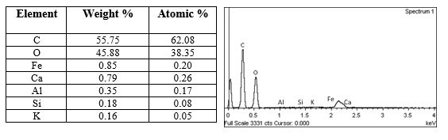

Functional group analysis of coagulants and produced sludge
Frequency Range | Visible Intensity | Dominant functional group | Vibration types | Coagulant | Coagulant | Coagulant
 |  |  |  | PACTPPg | PAC | TPP
3640-3400 | S, B | Alcohols | Hydrogen-bonded O-H stretch
3600-3100 | S, B | Alcohols, phenols | Hydrogen-bonded O-H stretch | 3231.46 |  | 3275.75
3500-3100 | M | Amines-primary (two peaks) | N-H stretch
3500-3100 | M | Amines-secondary | N-H bend | 3231.46 |  | 3275.75
3400-3250 | M | 1º, 2º amines, amides | N-H stretch | 3231.46 |  | 3275.75
3400-2400 |  | Carboxylic acids | Hydrogen-bonded O-H stretch | 3231.46  2518.62  2511.76 | 3013.07  2410.91 | 3275.75  2931.24
3300-3200 |  | Alkynes | ≡C-H stretch | 3231.46 |  | 3275.75
3300-2500 | M | Carboxylic acids | O-H stretch | 3231.46  2518.62  2511.76 | 3013.07 | 3275.75  2931.24
3100-3000 | M | Alkenes | C=C-H asymmetric stretch |  | 3013.07
3100-3000 |  | Aromatic rings | C=C-H asymmetric rings |  | 3013.07
3000-2850 | S | Alkanes | H-C-H asymmetric & symmetric stretch |  |  | 2931.24
3000-2800 | S | Alkanes | C-H stretch |  |  | 2931.24
2850-2800 |  | Aldehydes | C-H stretch off C=O
2750-2700 |  | Aldehydes | C-H stretch off C=O
2360-2100 | S | Silicane | Si-H stretch |  | 2163.44 | 2168.01
2300-2200 | M | Nitriles | C≡N
2200-2100 |  | Alkynes | C≡C
1755-1650 |  | Esters | C=O
1750-1625 |  | Ketones | C=O | 1629.79
1750-1625 |  | Aldehydes | C=O | 1629.79
1675-1600 | M | Alkenes | C-C=C symmetric stretch | 1629.79 | 1635.14 | 1640.37
1670-1600 | M | Amides | C=O stretch | 1629.79 | 1635.14 | 1640.37
1650-1580 | M | 1º amines | N-H bend | 1629.79 | 1635.14 | 1640.37
1640-1560 | M | Amines-primary | N-H bend | 1629.79 | 1635.14
1640-1550 | M | Amides | N-H bend | 1629.79 | 1635.14
1600-1580 | S | Aromatic rings | C-C=C symmetric stretch
1600-1500 |  | Nitro groups | N=O stretch
1550-1475 | S | Nitro compounds | N-O asymmetric stretch
1550-1450 |  | Amines-secondary | N-H bend
1500-1450 | S | Aromatic rings | C-C=C asymmetric
1500-1440 |  | Alkanes | H-C-H bend
1500-1400 | M | Aromatics | C-C stretch | 1414.23 |  | 1417.26
1470-1450 | M | Alkanes | C-H bend
1450-1350 | S | Sulphates | S=O stretch | 1414.23  1359.32 |  | 1417.26
Frequency Range | Visible Intensity | Dominant functional group | Vibration types | Coagulant | Coagulant | Coagulant
 |  |  |  | PACTPPg | PAC | TPP
1440-1400 |  | Carboxylate | C=O
1400-1370 |  | Oxo-groups
1400-1300 | S | Nitro groups | N=O bend | 1359.32 |  | 1336.97
1370-1350 | M | Alkanes | C-H rock | 1359.32
1320-1000 | S | Alcohols, carboxylic acids, esters, ethers | C-O stretch/  C-O-C stretch | 1151.24  1078.08  1018.07 | 1097.96 | 1150.60  1077.04  1103.78
1300-1150 | M | Alkyl halides | C-H wag | 1151.24 |  | 1150.60
1300-1000 |  | Esters, ethers | C-O stretch/ C-O-C stretch | 1151.24  1078.08  1018.07 | 1097.96 | 1150.60  1077.04  1103.78
1250-1020 | M | Aliphatic amines | C-N stretch | 1151.24  1078.08 | 1097.96 | 1150.60  1077.04  1103.78
1200-1100 | S | Phosphates | P=O stretch | 1151.24 |  | 1150.60  1103.78
1200-  890 |  | Oxo-bridges
1110-1000 | S, B | Slicates | Si-OR stretch | 1078.08  1018.07 | 1097.96 | 1077.04  1103.78
1000-650 | S | Alkenes | =C-H & =CH₂ bend |  | 979.26 | 998.73  801.32  763.29  706.86
910-665 | S, B | 1º, 2º amines | N-H wag |  | 838.29 | 801.32  763.29  706.86
900-675 | S | Aromatics | C-H ‘’oop’’ |  | 838.29 | 801.32  763.29  706.86
850-550 | M | Alkyl halides | C-CL stretch |  | 838.29 | 801.32  763.29  706.86
700-610 | S, B | Alkynes | C≡C-H:C-H bend
690-515 | M | Alkyl halides | C:Br stretch
600-485 |  | Alkyl halides | C-l stretch

FTIR infrared (IR) spectral database
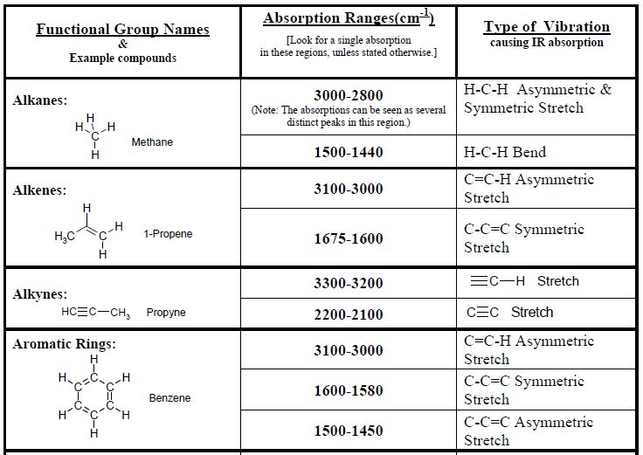
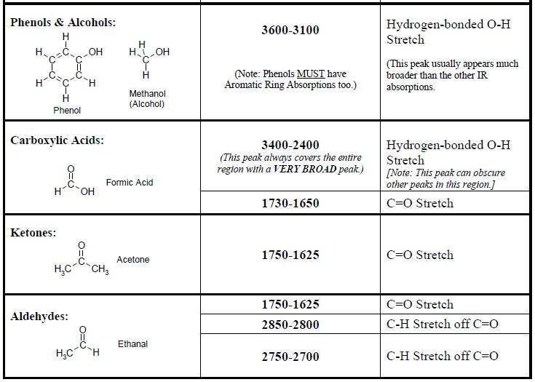

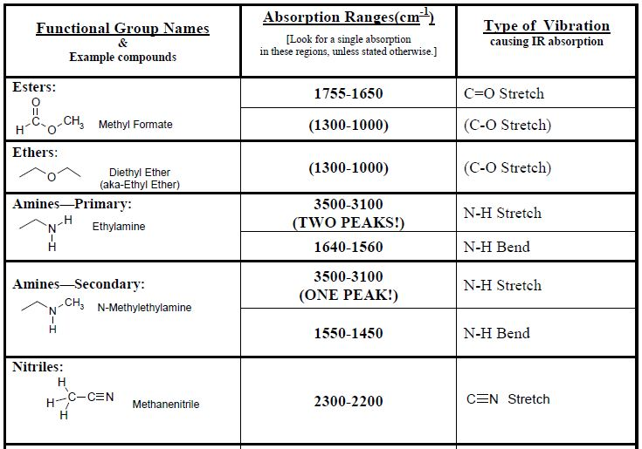
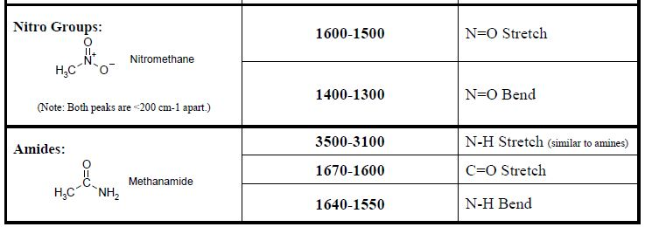

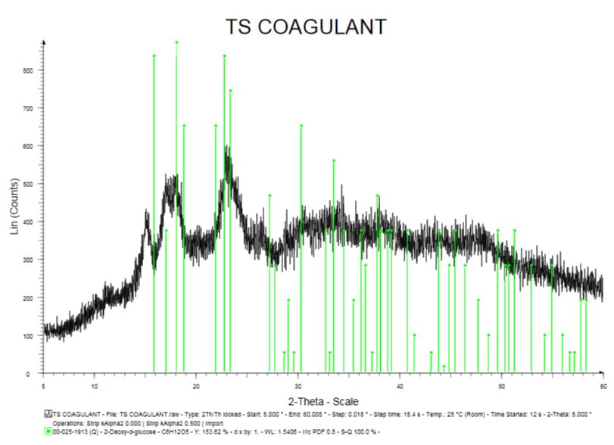
XRD analysis on the tapioca starch coagulant (Azizan, 2019)

