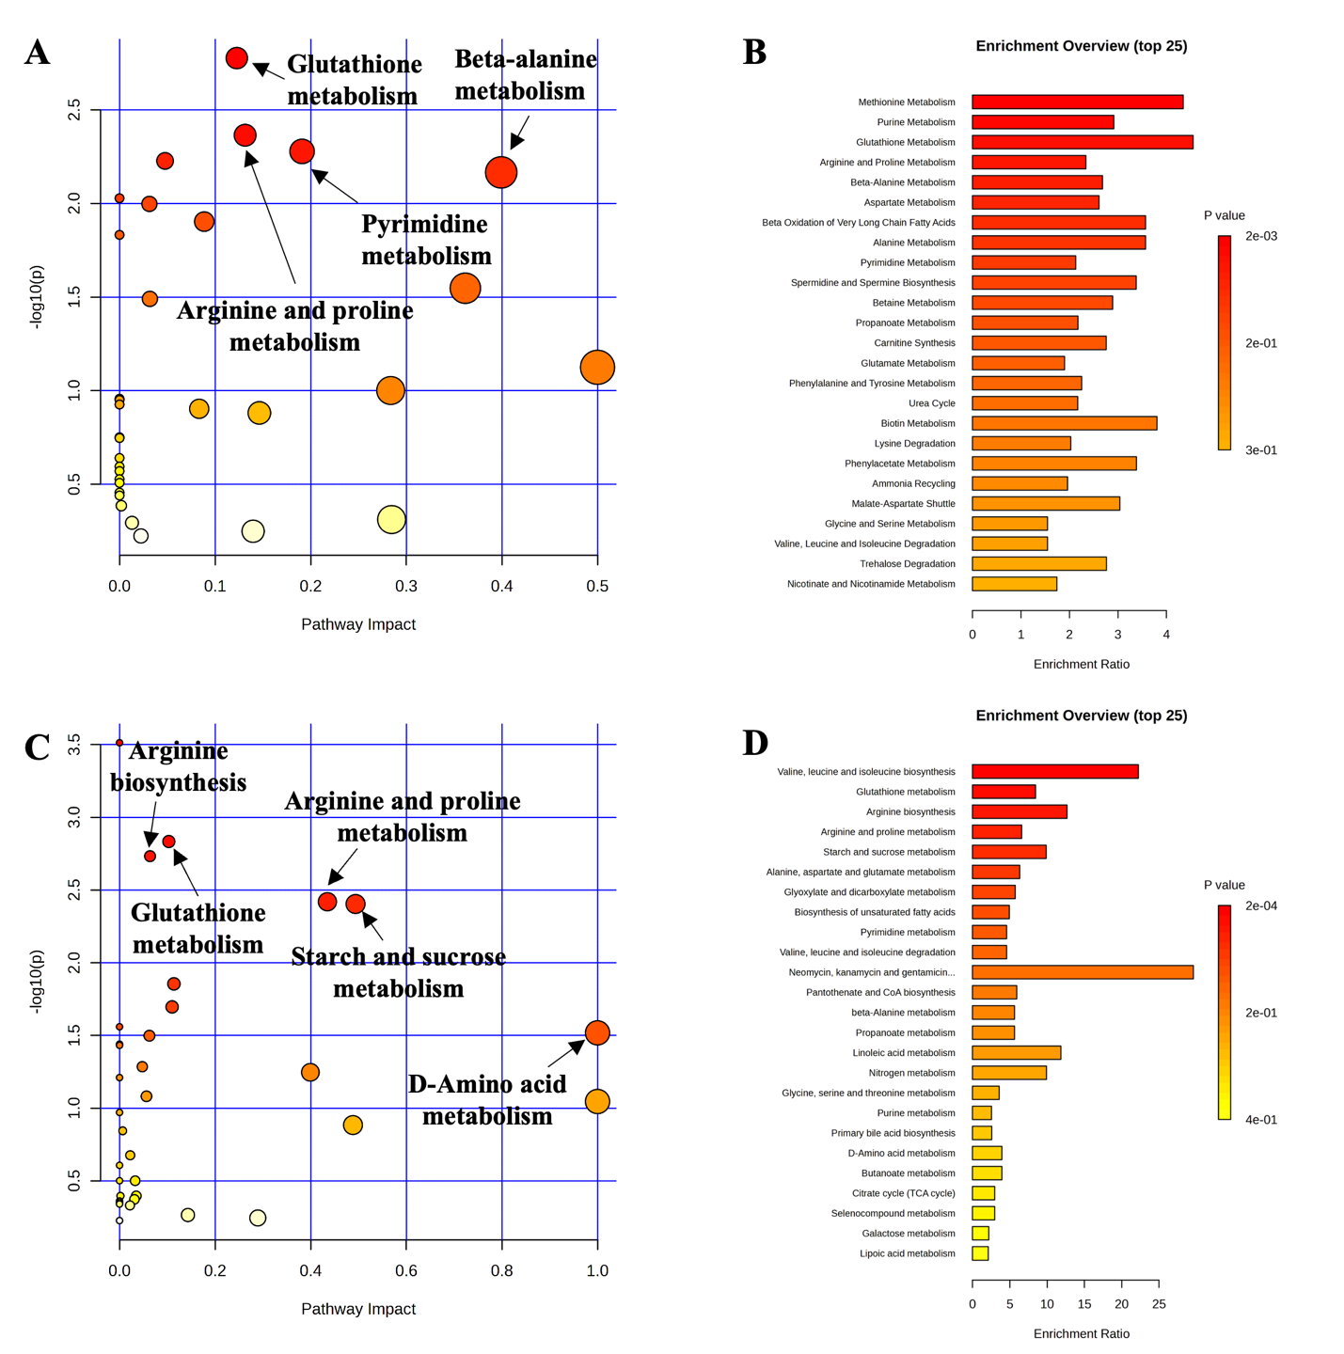
Supplementary Figure 1. Significantly changed pathways in distal colon digesta between the negative control (NC) and positive control (PC) on day 5 and 11 post-inoculation, respectively (A, C). The x-axis represents the pathway impact values and the y-axis represents the -log(P) values from the pathway enrichment analysis. Metabolite set enrichment analysis (B, D) shows the metabolic pathways were enriched in NC compared to PC on day 5 and 11 post-inoculation, respectively (B, D). Both pathway analysis and metabolite set enrichment analysis were performed using identified metabolites with VIP > 1
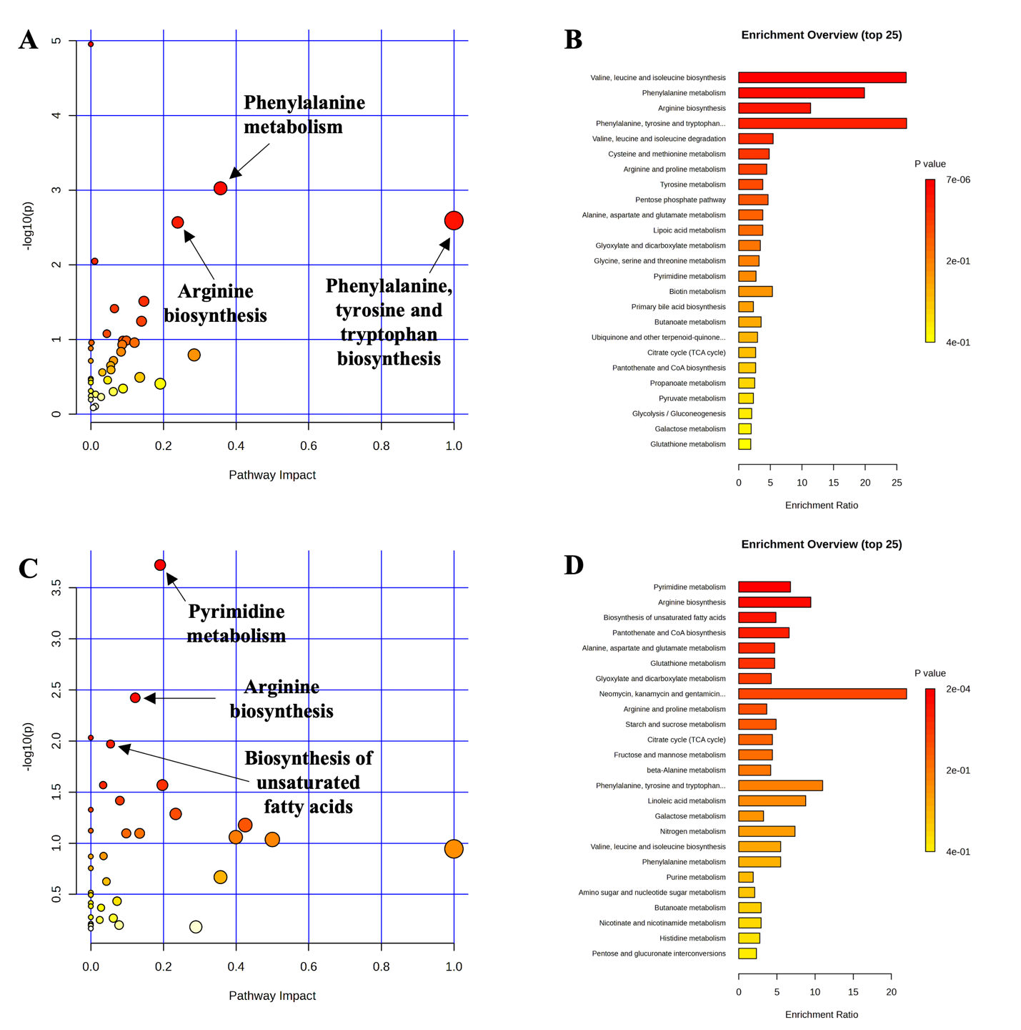
Supplementary Figure 2. Significantly changed pathways in distal colon digesta between the positive control (PC) and Bacillus subtilis (BS) on day 5 and 11 post-inoculation, respectively (A, C). The x-axis represents the pathway impact values and the y-axis represents the -log(P) values from the pathway enrichment analysis. Metabolite set enrichment analysis (B, D) shows the metabolic pathways were enriched in PC compared to BS on day 5 and 11 post-inoculation, respectively (B, D). Both pathway analysis and metabolite set enrichment analysis were performed using identified metabolites with VIP > 1
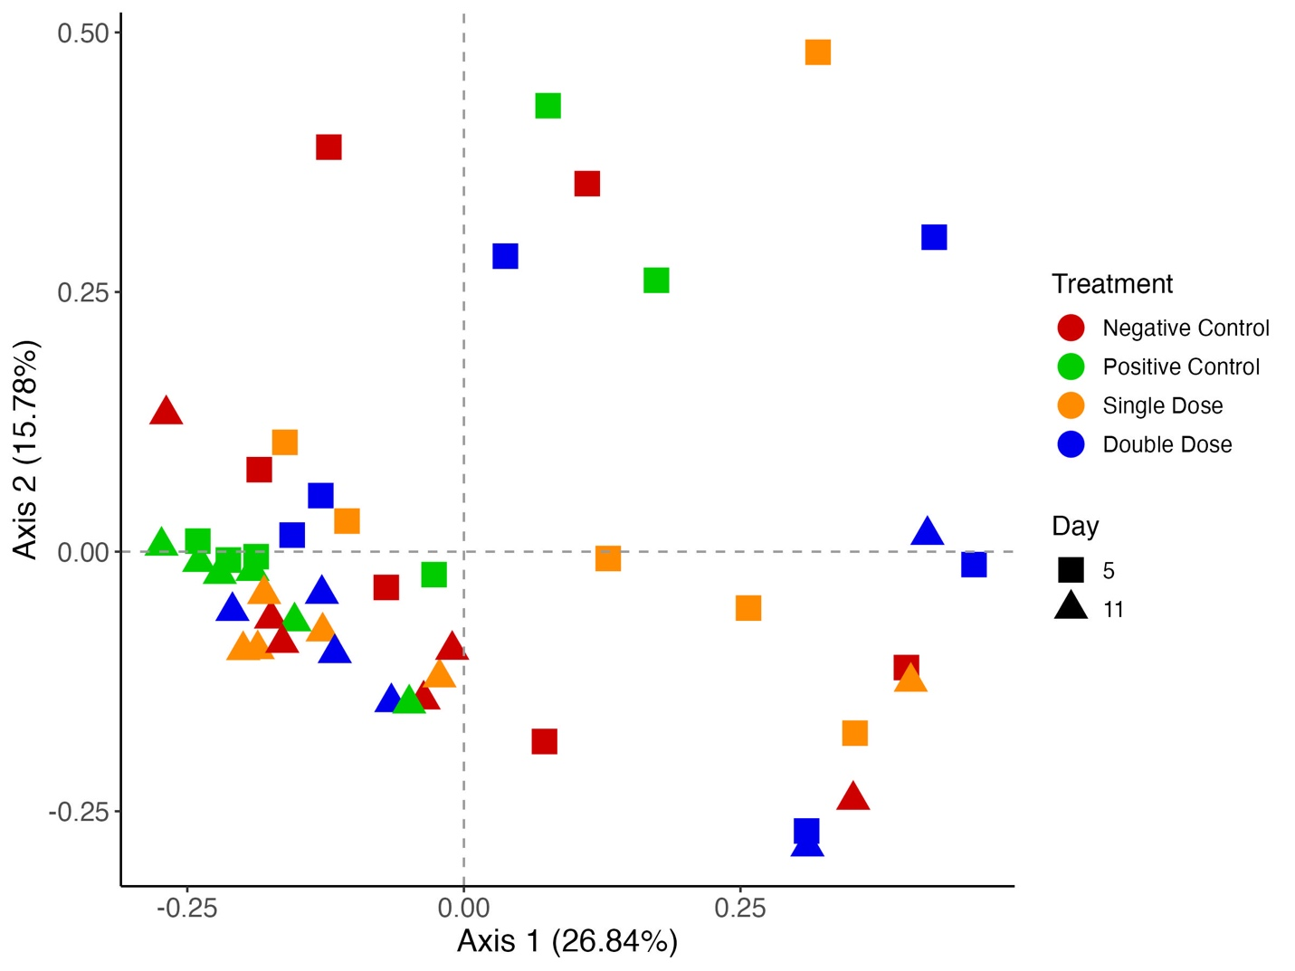 Supplementary Figure 3. Beta diversity of colon digesta of enterotoxigenic Escherichia coli (ETEC) F18 challenged pigs fed diets supplemented with different doses of Bacillus subtilis on day 5 and 11 post-inoculation. Data were analyzed by principal coordinate analysis (PCoA) based on the Bray-Curtis dissimilarity. Symbols indicate dietary treatments and colors indicate different sampling dates. Negative Control = control diet, without ETEC challenge, Positive Control = control diet, with ETEC challenge, Single Dose = control diet plus 1.28 × 10⁹ CFU/kg Bacillus subtilis, with ETEC challenge, and Double Dose = control diet plus 2.56 × 10⁹ Bacillus subtilis, with ETEC challenge
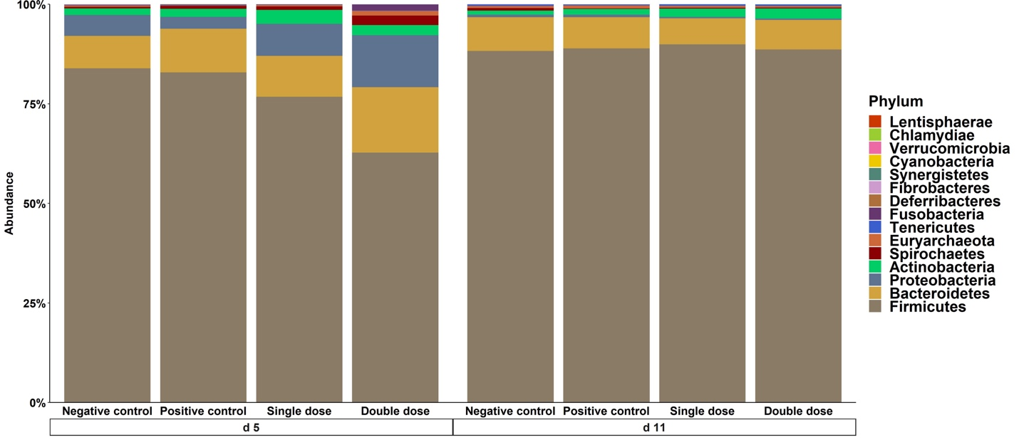
Supplementary Figure 4. Stacked bar plot showing the relative abundance of phylum in colon digesta of enterotoxigenic Escherichia coli F18 challenged pigs fed diets supplemented with different doses of Bacillus subtilis on day 5 and 11 post-inoculation. Negative Control = control diet, without ETEC challenge, Positive Control = control diet, with ETEC challenge, Single Dose = control diet plus 1.28 × 10⁹ CFU/kg Bacillus subtilis, with ETEC challenge, and Double Dose = control diet plus 2.56 × 10⁹ Bacillus subtilis, with ETEC challenge

