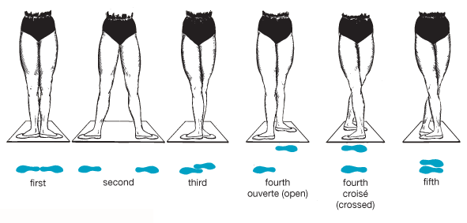
Five foot positions in ballet（In this article, the second foot position is chosen）

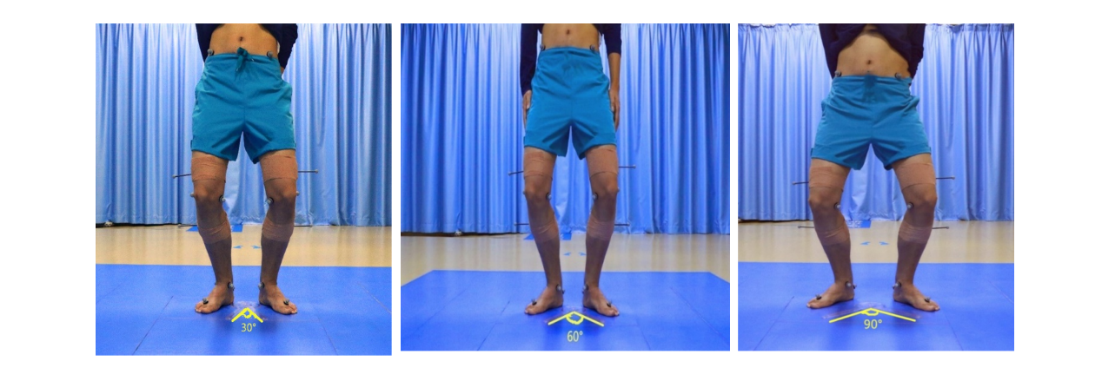
Example of angles of foot turn out

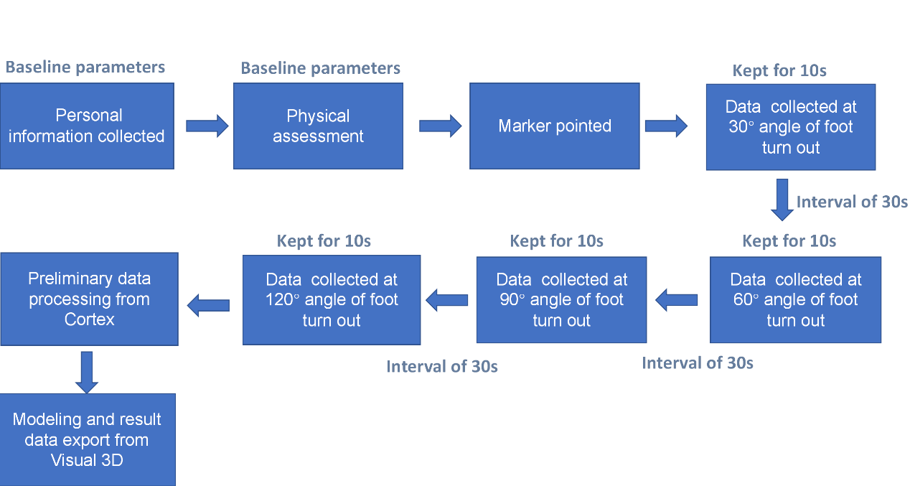
The data collection process

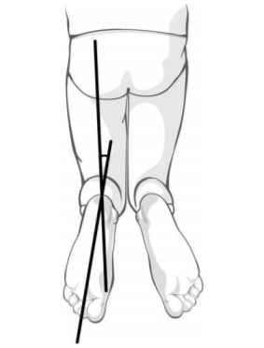
Thigh-Foot Angle (TFA) measurement
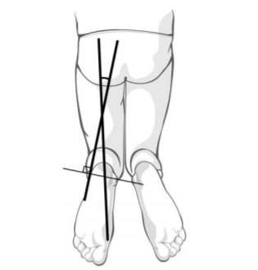
Transmalleolar Axis (TMA) measurement

Table：Comparison of physical assessment data between two groups
 | CP(mean and 95% CI) | TD (mean and 95% CI) | Z/x² value | p value
Hip flexion ROM | 135.0(126.2~138.0) | 135.0(133.50~140.0) | -1.70 | 0.089
Hip extension ROM | 11.0(10.0~12.76) | 12.00(11.00~13.00) | -1.383 | 0.167
Hip internal rotation ROM | 70.0(79.50~65.5) | 67.00(61.25~75.00) | -1.693 | 0.091
Hip external rotation ROM | 40.0(37.25~49.75) | 45.00(40.00~54.00) | -1.861 | 0.063
Hip abduction ROM | 51.5(44.00~58.00) | 54.00(50.00~60.00) | -2.031 | 0.042*
Knee flexion ROM | 150.0(144.0~152.0) | 149.00(140.00~153.00) | -0.540 | 0.589
Knee extension ROM | 1.00(0.00~2.00) | 0.00(0.00~3.00) | -0.384 | 0.701
Popliteal angle | 40.00(37.00~53.75) | 35.00(30.00~38.75) | -4.564 | <0.001*
Ankle dorsiflexion ROM (Knee ext) | 5.50(-2.50~10.00) | 10.00(4.25~15.00) | -3.109 | 0.002*
Ankle dorsiflexion ROM (Knee flexn) | 19.00(10.00~21.75) | 20.00(15.00~28.00) | -2.388 | 0.017*
Ankle plantar flexion ROM | 32.00(28.50~37.00) | 35.50(32.00~40.00) | -2.318 | 0.020*
TFA | -8.50(-11.75~-5.00) | -14.50(-18.75~-10.00) | -4.552 | <0.001**
TMA | -9.50(-15.00~-5.00) | -15.50(-20.00~-11.00) | -3.828 | <0.001**
Q angle | -2.00(-3.00~-2.00) | -3.00(-4.00~-2.00) | -2.323 | 0.020*
Ely test(Rectus femoris muscle tension test） | + | - | 5.165 | 0.023*
Thomas test(Iliopsoas muscle tension test) | + | - | 11.429 | 0.001*
Mann-Whitney U test was used while the quantitative data of physical evaluation did not meet the normality test. The sign of the inversion/varus/adduction angles are positive, the sign of the eversion/valgus/ abduction angles are negative. *p<0.05; **p<0.001. TFA, Thigh-foot angle. TMA, Transmalleolar axis.

Table：Angles and moments of lower limb joint on X-Y-Z axis with increasing FADP
 | 30°of FADP |  | 60°of FADP |  | 90°of FADP |  | 120°of FADP |  | Within-group p | Between-group p | Interaction p
 | CP | TD | CP | TD | CP | TD | CP | TD
Ankle angle on X axis(°) | 18.58±5.75 | 18.19±4.27 | 17.58±5.47 | 18.10±5.24 | 16.02±5.70 | 17.40±5.62 | 14.74±6.15 | 15.71±5.96 | <0.001** | 0.693 | 0.508
Ankle angle on Y axis(°) | 1.82±2.50 | 3.09±1.94 | 4.11±3.90 | 4.33±2.08 | 3.90±4.82 | 5.45±2.63 | 3.68±6.22 | 6.18±2.98 | <0.001* | 0.172 | 0.155
Ankle angle on Z axis(°) | -11.67±8.40 | -11.73±4.21 | -14.26±8.71 | -13.48±4.00 | -16.50±8.49 | -15.22±4.16 | -18.18±9.45 | -18.26±4.0 | <0.001* | 0.818 | 0.365
Ankle moment on X axis（Nm/kg） | 0.20±0.14 | 0.20±0.13 | 0.20±0.16 | 0.24±0.13 | 0.18±0.13 | 0.22±0.13 | 0.17±0.11 | 0.25±0.15 | 0.365 | 0.306 | 0.064
Ankle moment on Y axis（Nm/kg） | -0.016±0.07 | -0.045±0.05 | -0.025±0.08 | -0.056±0.05 | -0.028±0.07 | -0.060±0.06 | -0.020±0.06 | -0.079±0.08 | 0.001* | 0.078 | 0.004*
Ankle moment on Z axis（Nm/kg） | 0.031±0.04 | 0.054±0.05 | 0.011±0.03 | 0.040±0.04 | 0.002±0.034 | 0.008±0.04 | -0.007±0.04 | -0.022±0.04 | <0.001** | 0.340 | 0.005*
knee angle on X axis(°) | 38.77±10.56 | 34.08±9.44 | 37.98±10.26 | 34.54±10.40 | 39.56±12.57 | 35.18±10.33 | 41.59±11.08 | 35.43±11.24 | 0.149 | 0.146 | 0.608
knee angle on Y axis(°) | 0.22±4.69 | 0.83±1.96 | 0.60±4.05 | 0.80±2.04 | 0.54±3.67 | 0.69±2.04 | 0.769±4.28 | 1.22±2.78 | 0.418 | 0.723 | 0.773
knee angle on Z axis(°) | -2.74±3.40 | -4.06±3.03 | -5.39±3.74 | -5.96±3.60 | -6.60±4.0 | -7.96±3.12 | -7.37±5.01 | -11.24±3.69 | <0.001** | 0.114 | 0.002*
knee moment on X axis（Nm/kg） | 0.245±0.30 | 0.50±0.35 | 0.246±0.28 | 0.51±0.37 | 0.267±0.32 | 0.53±0.36 | 0.275±0.33 | 0.50±0.37 | 0.193 | 0.021* | 0.431
Knee moment on Y axis（Nm/kg） | 0.11±0.44 | 0.055±0.062 | 0.062±0.283 | 0.043±0.06 | 0.028±0.12 | 0.05±0.076 | 0.013±0.08 | 0.034±0.07 | 0.232 | 0.921 | 0.362
knee moment on Z axis（Nm/kg） | 0.0008±0.033 | 0.0040±0037 | 0.0027±0.031 | -0.001±0.030 | -0.0022±0.037 | -0.0089±0.034 | -0.0040±0.035 | -0.0133±0.061 | 0.127 | 0.572 | 0.327
Hip angle on X axis(°) | 32.38±12.73 | 30.13±12.48 | 32.29±12.93 | 31.09±13.75 | 34.25±13.24 | 29.34±11.65 | 34.89±12.69 | 30.79±12.57 | 0.574 | 0.415 | 0.371
Hip  angle on Y axis(°) | -8.60±8.76 | -5.40±2.93 | -10.80±7.54 | -7.13±4.30 | -14.63±8.43 | -10.07±4.80 | -17.36±8.33 | -12.87±5.33 | <0.001** | 0.049* | 0.578
Hip angle on Z axis(°) | -5.85±9.41 | -10.85±5.45 | -11.14±9.42 | -15.18±6.98 | -15.08±8.12 | -22.49±6.10 | -16.42±8.29 | -26.74±6.43 | <0.001** | 0.006* | <0.001**
Hip moment on X axis（Nm/kg） | 0.023±0.11 | -0.004±0.20 | 0.007±0.11 | 0.005±0.21 | -0.0002±0.11 | -0.10±0.18 | -0.016±0.12 | -0.03±0.20 | 0.044* | 0.789 | 0.745
Hip moment on Y axis（Nm/kg） | 0.050±0.12 | 0.166±0.093 | 0.031±0.91 | 0.148±0.089 | 0.022±0.093 | 0.132±0.109 | -0.007±0.093 | 0.070±0.115 | <0.001** | 0.001* | 0.185
Hip moment on Z axis（Nm/kg） | 0.0007±0.02 | -0.023±005 | -0.003±0.028 | -0.012±0.04 | -0.0002±0.024 | -0.010±0.04 | 0.003±0.029 | -0.013±0.04 | 0.236 | 0.174 | 0.121
pelvis angle on X axis(°) | 16.17±7.10 | 16.36±9.21 | 15.17±7.85 | 16.41±9.27 | 16.45±8.07 | 14.35±7.44 | 15.61±7.16 | 17.36±9.02 | 0.624 | 0.908 | 0.200
Pelvis  angle on Y axis(°) | 3.25±1.89 | 2.25±1.69 | 3.28±2.22 | 2.53±2.04 | 3.31±2.06 | 2.79±2.05 | 4.00±1.86 | 2.58±1.85 | 0.252 | 0.082 | 0.402
pelvis angle on Z axis(°) | 5.94±4.64 | 2.51±2.04 | 6.98±5.44 | 3.15±1.93 | 6.87±6.35 | 3.54±2.58 | 7.50±5.67 | 3.17±2.03 | 0.377 | 0.001* | 0.833

