Supplementary material
Localized Carbon Deposition Enables Non-Invasive Trimming of Photonic Integrated Circuits
Rongyang Xu^{1†}, Zhongyu Tang^{1†}, Liam McRae¹, Akhil Varri², Frank Brückerhoff-Plückelmann¹, Xinyu Ma¹, Julian Rasmus Bankwitz¹, Julius Römer¹, Ravi Pradip¹, Qinlin Zhang¹, Lennart Meyer¹, Zhe zhao², Jelle Dijkstra¹, Harish Bhaskaran³, Rasmus R. Schröder⁴, Wolfram H. P. Pernice¹*, and Shabnam Taheriniya¹*
¹ Kirchhoff-Institute for Physics, Heidelberg University, Im Neuenheimer Feld 227, 69120 Heidelberg, Germany
² Institute of Physics, University of Münster, Heisenbergstraße 11, 48149 Münster, Germany
³ Department of Materials, University of Oxford, Parks Road, Oxford OX1 3PH, Oxfordshire, UK
⁴ BioQuant, Heidelberg University, Im Neuenheimer Feld 267, 69120 Heidelberg, Germany
† These authors contributed equally to this work
*wolfram.pernice@kip.uni-heidelberg.de; shabnam.taheriniya@kip.uni-heidelberg.de

S1. FIB sample stage
The actual configuration of the FIB sample stage differs from the schematic diagram shown in the main text. In actual operation, the sample is tilted at an angle of 54°, allowing the obliquely mounted ion beam to strike the sample surface perpendicularly, while the electron beam is incident from the top to observe the sample, as shown in Fig. S1.
Fig. S1. Schematic of the actual FIB sample stage

S2. Sample fabrication
Fig. S2 shows the fabrication process of photonic structures prior to carbon deposition. First, the chip is cleaned with acetone and isopropanol, followed by spin-coating a 300-nm-thick negative-tone resist (Allresist AR-N 7520 series). Patterns are defined using electron-beam lithography, followed by development with MF-319 developer. The exposed resist serves as an etching mask. The silicon nitride regions not covered by the resist are etched using reactive ion etching (Oxford 80 RIE) with CHF₃ and O₂ gases. Finally, the resist mask is removed via oxygen plasma treatment.
Fig. S2. Fabrication process of photonic structures.

S3. Mach-Zehnder Interferometer
To evaluate the insertion loss, we fabricated multiple Mach-Zehnder interferometers and selectively deposited 20 μm-long carbon strips on the lower arms as shown in Fig. S3. This approach allows extraction of the insertion loss directly from the transmission spectra, effectively eliminating the influence of fabrication-induced variations in the grating couplers. An average insertion loss of approximately 0.14 dB was obtained for the deposited carbon, based on measurements from multiple samples.
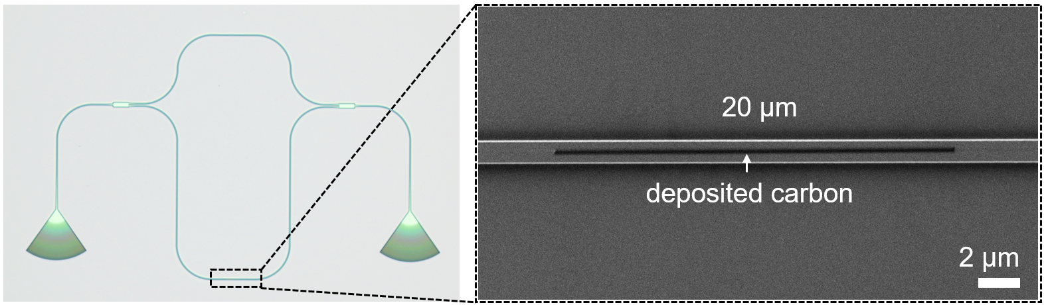
Fig. S3. Optical image of the Mach-Zehnder Interferometer and SEM image of carbon deposited on the lower arm.

S4. Transmission after annealing
Because annealing can accelerate the stabilization of the optical response, we measured the transmission of multiple devices after cumulative hot plate annealing at 200℃ for 10, 20, 30, and 50 minutes. The transmission of all devices shows similar trends over time. Fig. S4 shows the transmission of a TE₁ mode asymmetric directional coupler (A-DC). The insertion loss decreases from 9.21 dB to 1.62 dB, as measured 5 days after carbon deposition. Two days later, the A-DC was placed on a hot plate for annealing treatment. During the first 20 minutes of cumulative annealing, a gradual decrease in the light transmission of the A-DC was observed. Although a further decrease was seen after 30 minutes, this is likely due to measurement errors, as the transmission after 50 minutes returned to the same level as that at 20 minutes.
In addition, ring resonators were used to further verify the effect of annealing treatment after carbon deposition on the stability of the optical response. Fig. S5a shows a focused ion beam image of a ring resonator after carbon deposition. The response of the ring resonator was first measured before carbon deposition. Three days later, the same device was measured again, both before and after 30 minutes of annealing treatment. A red shift of 1.6 nm was observed, which decreased to 1 nm after annealing. The ring resonator was measured once more after nearly four weeks, and the resonant peak remained unchanged, as shown in the zoomed-in image in Fig. S5b, confirming the stability of the optical response over time.
Fig. S4. Transmission of the TE₁ mode A-DC after carbon deposition changes with time. Optical response can be stabilized by annealing on a hot plate at 200 ℃ for more than 20 minutes.
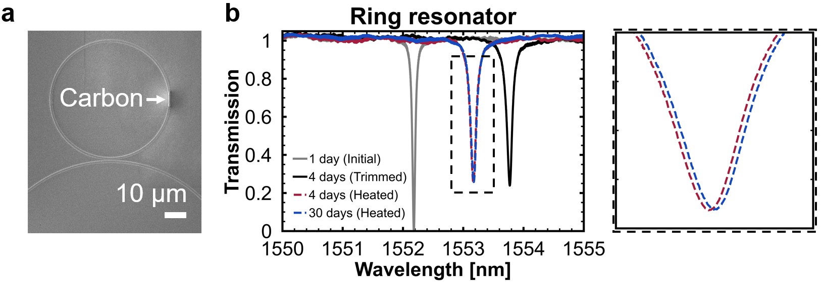
Fig. S5. (a) A focused ion beam image of a ring resonator after carbon deposition. (b) Transmission peaks of the ring resonator before and after carbon deposition and annealing treatment. The day on which carbon deposition was performed was defined as day one.

