Appendix B
Database validation against DiGBcoast coastline dataset

Figure 1-3 represents the validation of generated coastline database against DiGBcoast coastline dataset for different sandy beaches within the study area.

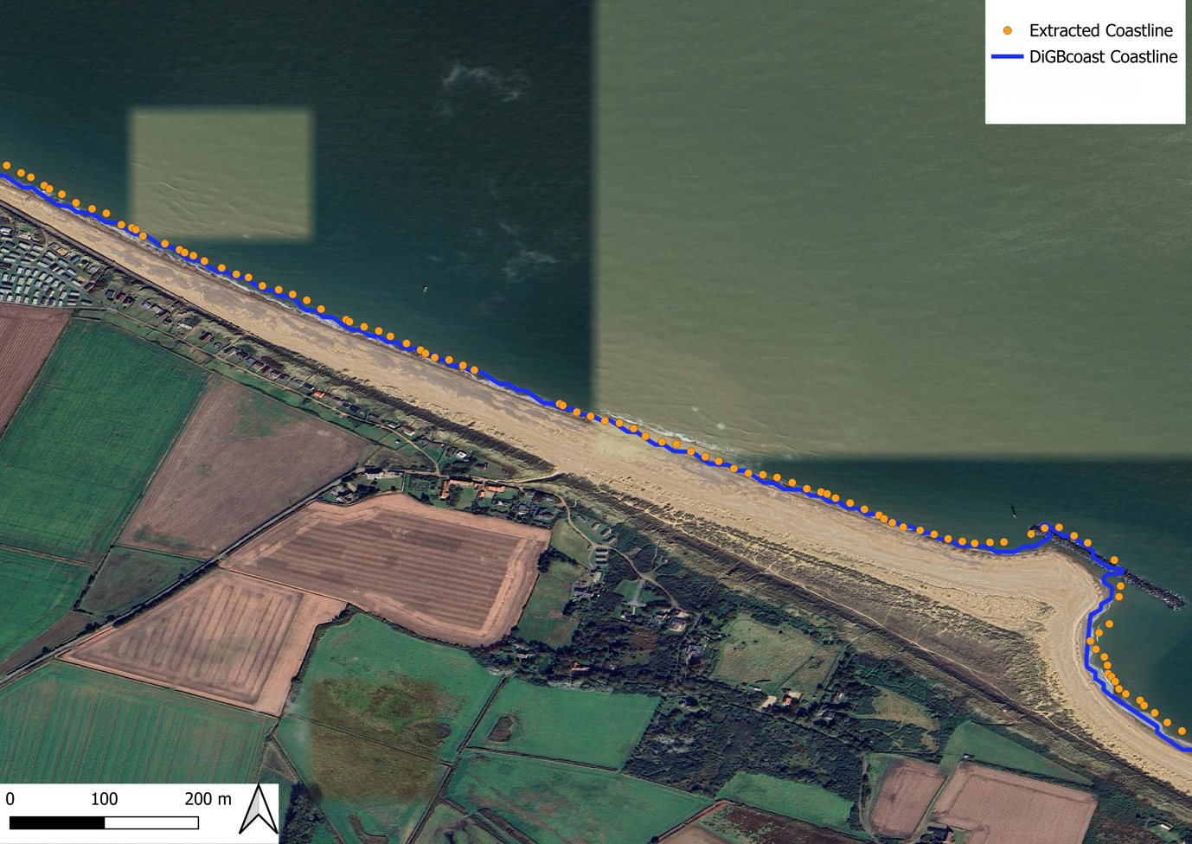
Fig. 1. Validation of extracted coastline for the year 2020 at a sandy beach near Happisburgh, Norwich, England

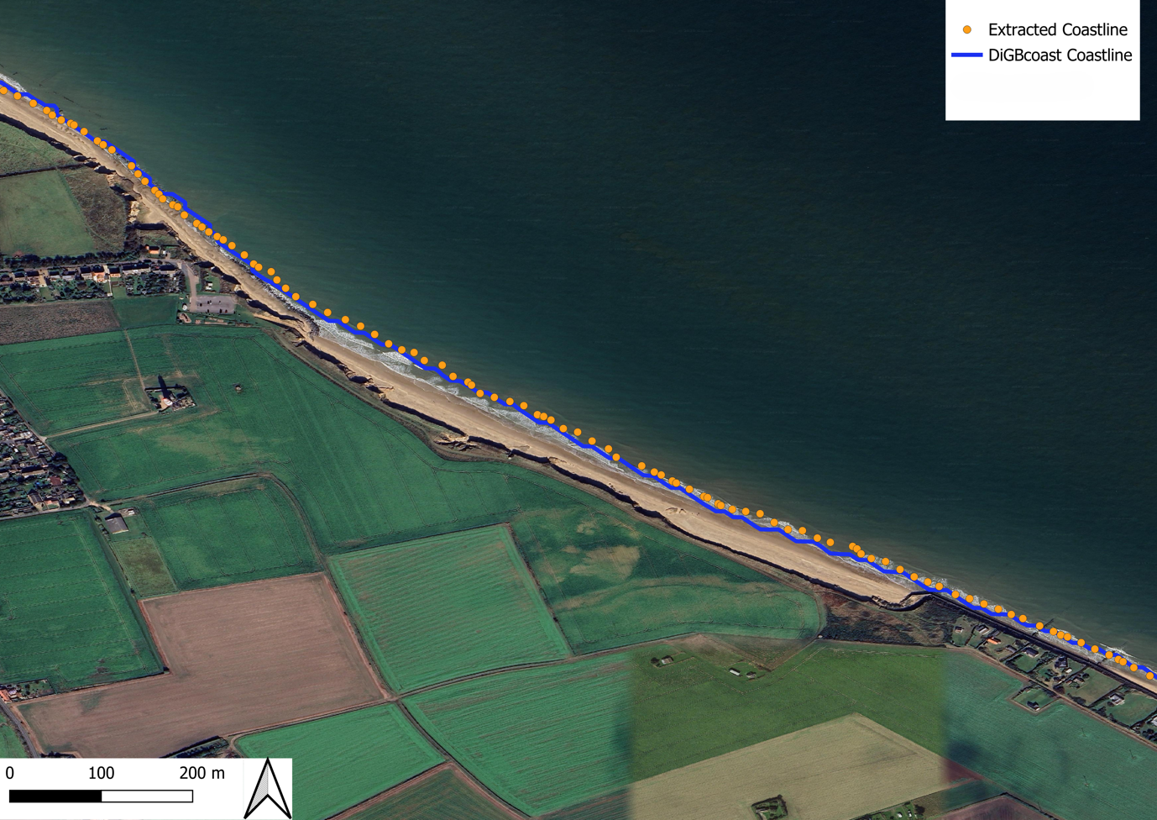
Fig. 2. Validation of extracted coastline for the year 2020 at a sandy beach near Happisburgh, Norwich, England

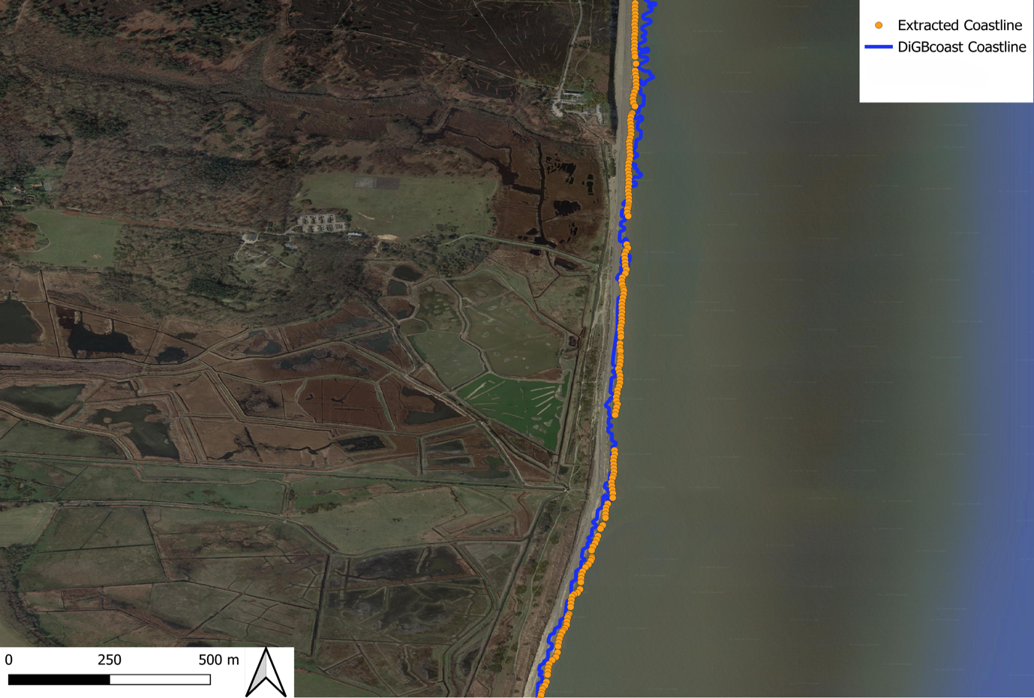
Fig. 3. Validation of extracted coastline for the year 2017 at a sandy beach near Leiston, England

