Sup-Figure 1.
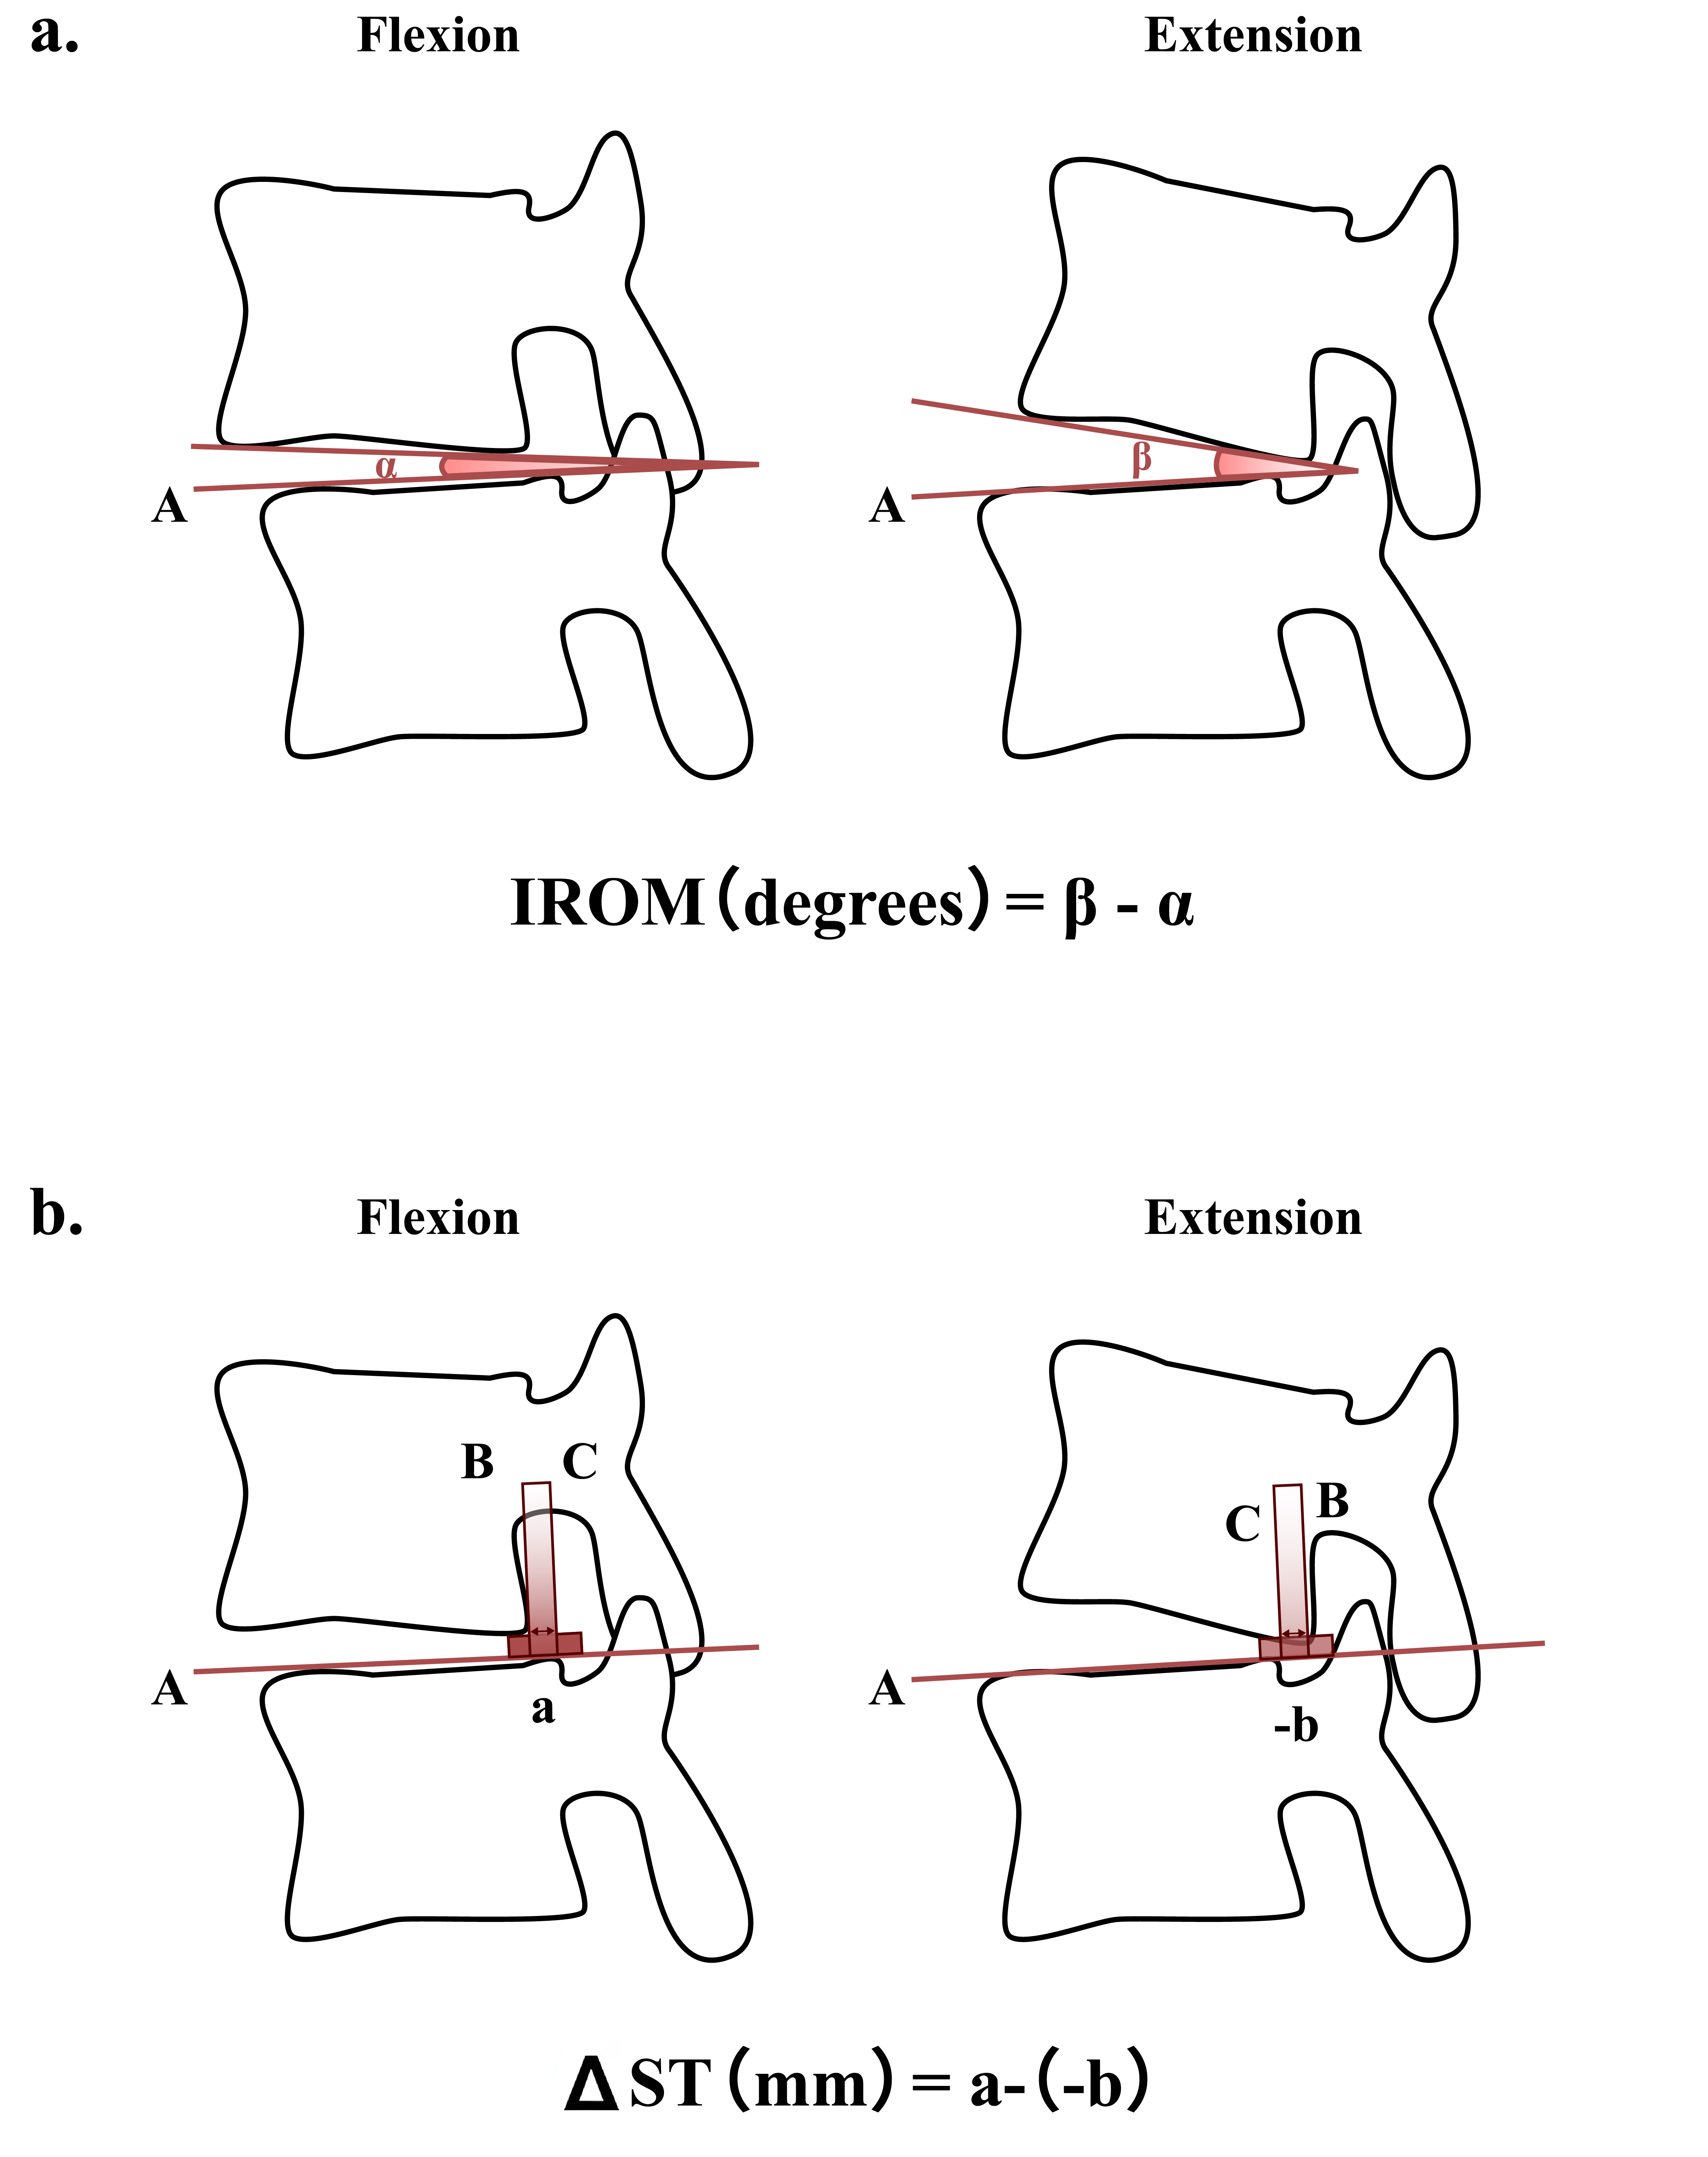
Measurement methods of intervertebral range of motion (IROM) and sagittal translation (ΔST): (a) IROM was assessed by measuring the angle between two lines: one along the lower endplate of the upper vertebra and the other along the upper endplate of the lower vertebra. This angle, representing the intervertebral disc angle, was measured during flexion and extension. A ventrally opened wedge was considered positive. IROM was calculated as the extension angle minus the flexion angle. (b) Sagittal translation was evaluated based on a previously described method[1]. A reference line (Line A) was drawn along the upper endplate of the lower vertebra. From there, two perpendicular lines were extended: one from the postero-inferior corner of the upper vertebra (Line B) and one from the postero-superior corner of the lower vertebra (Line C). The distance between these lines defined the sagittal translation, with a positive value indicating anterior displacement of the upper vertebra. ΔST was determined by subtracting the translation value in extension from that in flexion.

Sup-Table 1. The hyperparameters for each model
Model | Hyperparameter
DenseNet121 | Batch size | Initial learning rate | Optimizer | L2 regularization | Dropout rate | LR scheduler | Epochs | Early stopping
SVM | Cost | Gamma | Degree | Kernel
RF | Maxdepth | Min.node.size | Number of trees
In this study, hyperparameter tuning was conducted in two stages using a grid search strategy. In the first stage, DenseNet121 was fine-tuned as a feature extractor with the following hyperparameter space: batch sizes (randomly selected between 16 and 128), initial learning rates (uniformly distributed between 1×10^(-5) and 1×10^ (-2), optimizers (Adam, AdamW, SGD), L2 regularization (uniformly distributed between 1×10^(-6) and 1×10^ (-2), dropout rates (uniformly distributed between 0.1 and 0.7), learning rate schedulers (StepLR, CosineAnnealingLR). For each hyperparameter combination, we employed 10-fold cross-validation to ensure robust performance evaluation. The training dataset was divided into 10 folds, with the model trained and validated on each fold over 40 epochs. This approach enabled us to average performance metrics across folds, providing a reliable estimate of each combination’s effectiveness on unseen data. We then selected the hyperparameter combination with the highest average performance and retrained the model using the entire training dataset. Finally, the optimized model was tested on the test set to assess its generalization capability. Early stopping was employed to prevent overfitting and gradient explosion. The performance of each model was primarily evaluated using the AUC. In the second stage, deep features extracted from the optimized DenseNet121 model were used as inputs for training three types of classifiers: Support Vector Machine (SVM), Random Forest (RF), and Softmax. Each classifier was independently optimized using grid search. The hyperparameter space for SVM included kernel type (linear, RBF, polynomial), cost parameter , gamma, and degree (for polynomial kernels); for RF, the number of trees, maximum tree depth, and minimum node size were tuned. The Softmax classifier served as a baseline and did not require additional hyperparameter tuning. The performance of each model was primarily evaluated using the AUC.

1. Iguchi T, Kanemura A, Kasahara K, et al. Lumbar instability and clinical symptoms: which is the more critical factor for symptoms: sagittal translation or segment angulation? Journal of spinal disorders & techniques. 2004;17(4):284-90.http://dx.doi.org/10.1097/01.bsd.0000102473.95064.9d.

