TITLE

NEUROSCIENCES AND PERSON-CENTERED PSYCHOTHERAPY IN PATIENTS WITH DEMENTIA: A SYSTEMATIC REVIEW OF NON-PHARMACOLOGICAL INTERVENTIONS

Author: Maria Skotida
Affiliation: Aristotle University of Thessaloniki

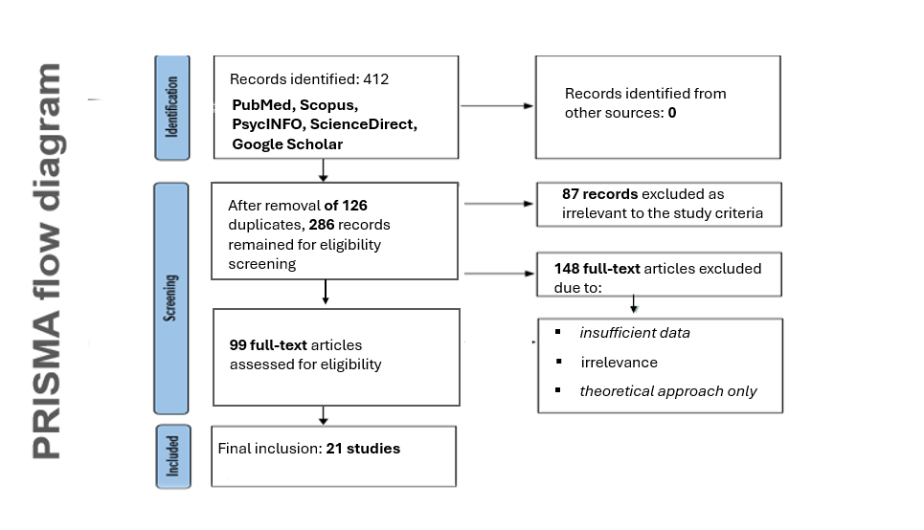

Table Ι. Therapeutic Approaches, Benefits, and Limitations
Therapeutic Approach | Benefits | Limitations
PCT | Adaptable to all stages of dementia, empathy, long-lasting effects | Requires change in care system attitudes
CBT | Positive outcomes in early stages | Not applicable in middle/advanced stages
Behavioral Interventions | Short-term reduction of “challenging” behaviors | Does not incorporate emotional experience
Music Therapy | Immediate impact on mood | Temporary effect, requires infrastructure
VIPS (PCT application) | Holistic, reduction of medication, applicable in care units | Requires training and structural changes

- .
Figure 1. Conceptual model of Person-Centered Therapy mechanisms in dementia.
Person-Centered Therapy (PCT)

Emotional Safety & Empathy

Biological Mechanisms
- ↓ Cortisol
- ↓ Stress regulation
- ↑ Oxytocin
- ↑ Neuroplasticity

Clinical Outcomes
- Improved mood
- Reduced agitation
- Better communication
- Enhanced quality of life

Table ΙΙ. Summary of Selected Studies on Person-Centered Therapy (PCT) in Dementia
No. | Author(s) | Year | Type of Intervention | Main Findings
1 | Sass et al. | 2021 | PCT | Improvement in mood and communication
2 | Terkelsen et al. | 2020 | PCT + caregiver assessment | Reduction in anxiety and depression among caregivers
3 | Frederiksen et al. | 2023 | PCT | Relief for caregivers, enhanced emotional connection
4 | Judge et al. | 2023 | PCT | Reduction in aggression, improved cooperation
5 | Nguyen et al. | 2021 | PCT vs Behavioral | Greater acceptance by patients, less authoritarian approach
6 | Powers et al. | 2023 | PCT + Reminiscence therapy | Increased emotional engagement and sense of identity
7 | Kindblom et al. | 2021 | Music therapy vs PCT | PCT provides longer-lasting effects
8 | Liu et al. | 2022 | PCT | Reduction of caregiver burnout, improved care relationship
9 | Brooker et al. | 2022 | PCT – VIPS framework | Care model with reduced medication use
10 | Martinez et al. | 2022 | CBT vs PCT | PCT effective across all stages of dementia
11 | Siegel | 2022 | Neurobiological effect of PCT | Reduced cortisol, improved homeostasis
12 | Davidson & McEwen | 2021 | PCT | Increased neuroplasticity through relationship
13 | Uvnäs-Moberg et al. | 2023 | PCT | Increased oxytocin, reduced medication use
14 | Kumfor et al. | 2022 | PCT | Reduction in depression index, improved mood regulation
15 | Brooker & Latham | 2021 | PCT in long-term care | 40% reduction in antipsychotic medication
16 | Kim & Park | 2022 | PCT – Meta-analysis | Stabilization of cognitive decline, improved functionality
17 | Saragih et al. | 2022 | PCT without pharmacological support | Improved mood and adaptation
18 | Panza et al. | 2020 | PCT vs other psychosocial interventions | Better quality of life and engagement
19 | Moon & Adams | 2023 | PCT with cultural adaptation | Increased effectiveness in minority groups
20 | Cheston et al. | 2020 | PCT – Group therapy | Reduction in symptoms of isolation
21 | Spector et al. | 2021 | PCT + cognitive support | Combined benefit in communication and cognition

Table ΙΙΙ Summary of Findings of the Selected Studies by Research Question
Study | Research Question 1 | Research Question 2 | Research Question 3 | Research Question 4
Saragih et al. (2022) | Reduction of disorganization, improved adaptation with consistent application of PCT | — | — | PCT as an alternative in cases of pharmacological treatment failure
Kim & Park (2022) | Slowing of cognitive decline, strengthening of meaningful dialogue and daily functioning | — | — | Reduction in antipsychotic use, enhanced cooperation
Powers et al. (2023) | Emotional connection through reminiscence therapy | — | — | —
Judge et al. (2023) | Improvement of behavior through stable therapeutic relationship | — | — | —
Frederiksen et al. (2023) | Reduction of caregiver burnout through person-centered practices | — | — | —
Nguyen et al. (2021) | — | Superiority of PCT over behavioral intervention in free expression and emotional safety | — | —
Martinez et al. (2022) | — | Limitations of CBT in early stages, superiority of PCT due to emotional approach | — | —
Kindblom et al. (2021) | — | Music therapy provides short-term benefits, whereas PCT delivers stable and lasting effects | — | —
Brooker et al. (2022) | — | Application of the VIPS model, enhancement of cooperation and emotional stability | Improvement of neurophysiological markers, reduced medication use | Integration of PCT into daily care systems with measurable outcomes
Liu et al. (2022) | — | Caregivers with PCT: less exhaustion, more positive attitudes toward patients | — | —
Davidson & McEwen (2021) | — | — | Strengthening of neuroplasticity and social responsiveness through therapeutic relationship | —
Uvnäs-Moberg et al. (2023) | — | — | Increased oxytocin levels and reduced need for pharmacological sedation in PCT environment | —

