Supplementary Table 1. Comparison of Baseline Demographic Characteristics in Rezum and UroLift Cohorts Before and After Matching
Patients in All Cohorts
 | Before Matching |  |  | After Matching
 | (Cohort 1)  Rezum | (Cohort 2)  UroLift | P-value | (Cohort 1)  Rezum | (Cohort 2)  UroLift | P-value
Number | 792 | 2,439 |  | 784 | 784
Age (year) | 68.2±8.1 | 66.3±8.8 | <0.001 | 68.1±8.0 | 68.0±8.1 | 0.977
PSA (ng/mL) | 2.5±2.8 | 2.2±5.5 | 0.188 | 2.5±2.8 | 2.3±2.6 | 0.297
BMI (kg/m²) | 28.4±4.7 | 29.1±5.3 | <0.001 | 28.4±4.8 | 28.9±5.2 | 0.230
Continuous variables were expressed as means ± standard deviation (SD). BMI: Body Mass Index

Supplementary Table 2. Age-Stratified Comparison of Baseline Demographic Characteristics in Rezum and UroLift Cohorts Before and After Matching
Age-Stratified Comparison Beforer Matching
 | Rezum |  |  | UroLift
 | Aged ≥40 to <65 | Aged ≥65 | P-value | Aged ≥40 to <65 | Aged ≥65 | P-value
Number | 260 | 532 |  | 975 | 1,464
Age (year) | 59.1±4.2 | 72.7±5.3 | <0.001 | 57.6±5.1 | 72.1±5.2 | <0.001
PSA (ng/mL) | 2.0±1.9 | 2.8±3.2 | 0.004 | 1.8±2.0 | 2.4±6.9 | 0.051
BMI (kg/m²) | 28.6±4.8 | 28.0±4.7 | 0.156 | 29.8±5.8 | 28.6±4.9 | <0.001
Age-Stratified Comparison After Matching
 | Rezum |  |  | UroLift
 | Aged ≥40 to <65 | Aged ≥65 | P-value | Aged ≥40 to <65 | Aged ≥65 | P-value
Number | 260 | 260 |  | 975 | 975
Age (year) | 59.1±4.2 | 72.7±5.3 | <0.001 | 57.6±5.1 | 72.1±5.2 | <0.001
PSA (ng/mL) | 2.0±1.9 | 2.6±2.8 | 0.140 | 1.8±2.0 | 2.1±2.4 | 0.180
BMI (kg/m²) | 28.6±4.8 | 28.4±5.0 | 0.681 | 29.8±5.8 | 28.8±4.6 | 0.026
Continuous variables were expressed as means ± standard deviation (SD). BMI: Body Mass Index

1a.
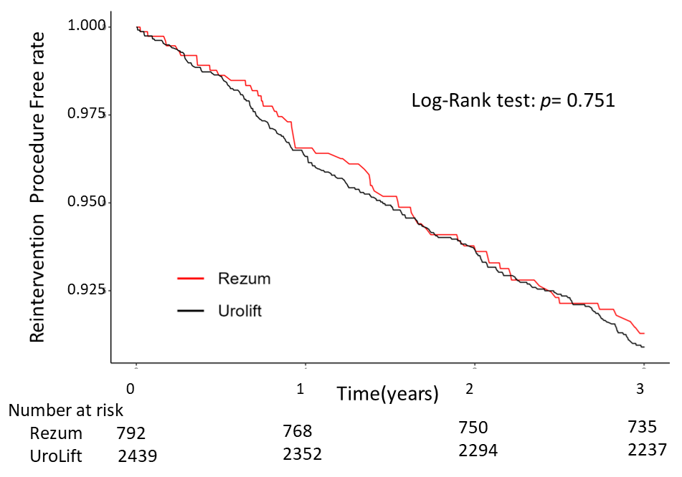
1b.
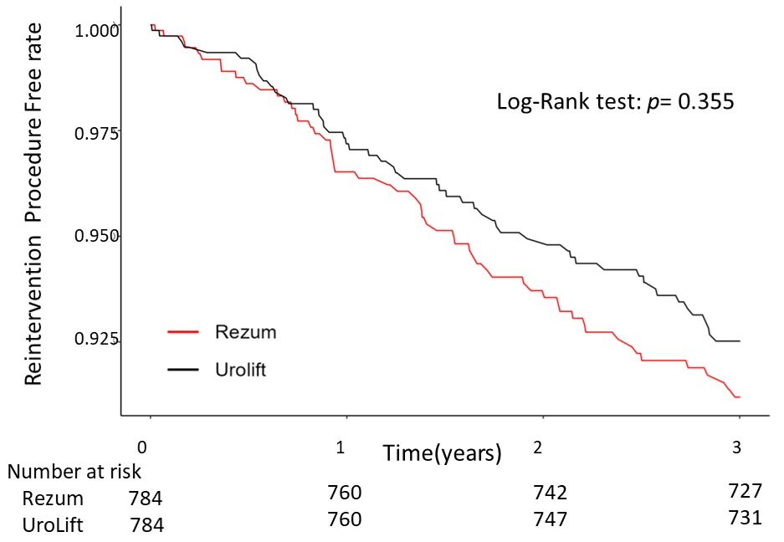

Supplementary Figure 1. Kaplan–Meier Curves for Reintervention-Free Survival in the Overall Cohort: (1a) Before Matching, (1b) After Matching
2a.
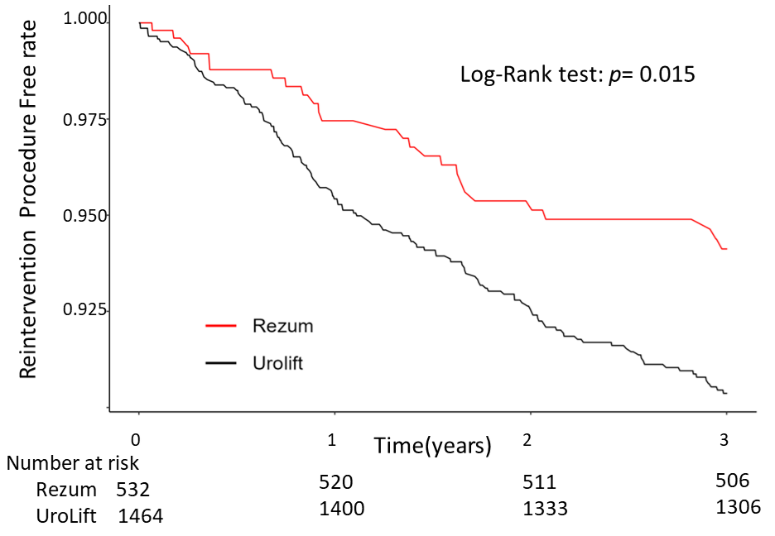
2b.
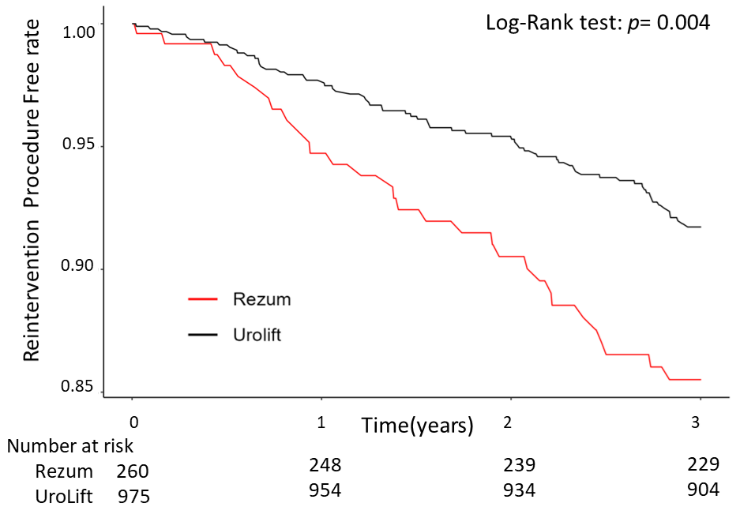

Supplementary Figure 2. Kaplan–Meier Curves for Reintervention-Free Survival by Age Subgroups Before Matching: (2a) Patients Aged ≥65 Years (2b) Patients Aged ≥40 to <65 Years

3a.
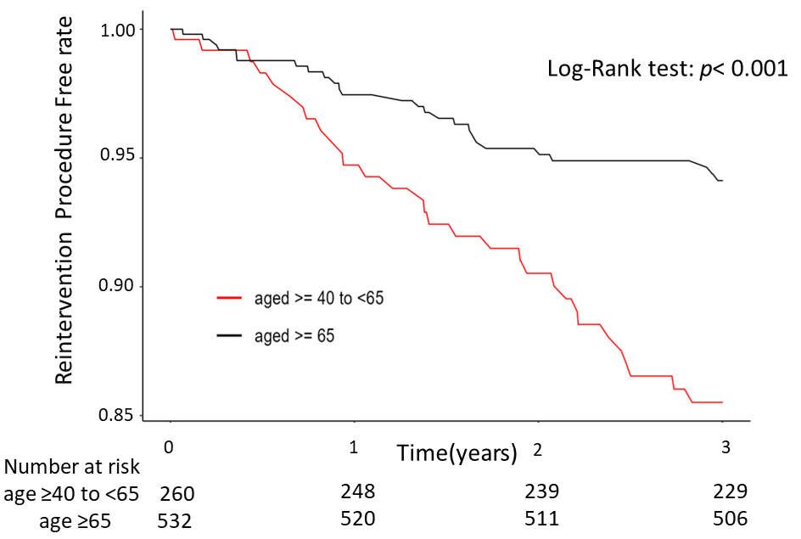
3b.
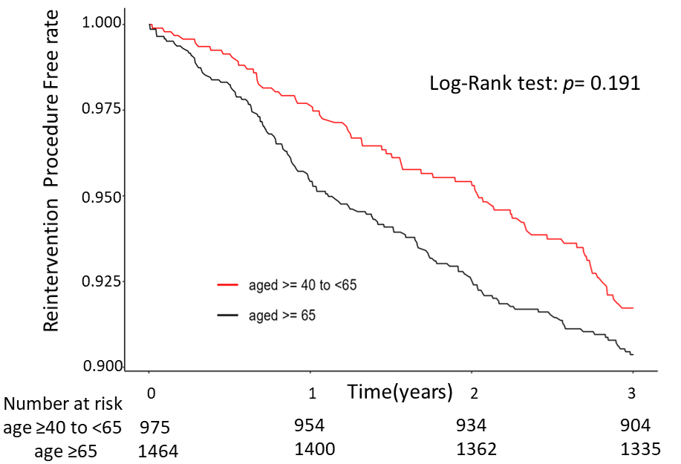

Supplementary Figure 3. Kaplan–Meier Curves for Procedure-Specific Reintervention-Free Survival by Age Group Before Matching: (3a) Age-Stratified Rezum Cohort (3b) Age-Stratified UroLift Cohort.

