Table 1 Characteristics of patients in the IC +CCRT and CCRT +AC before PSM

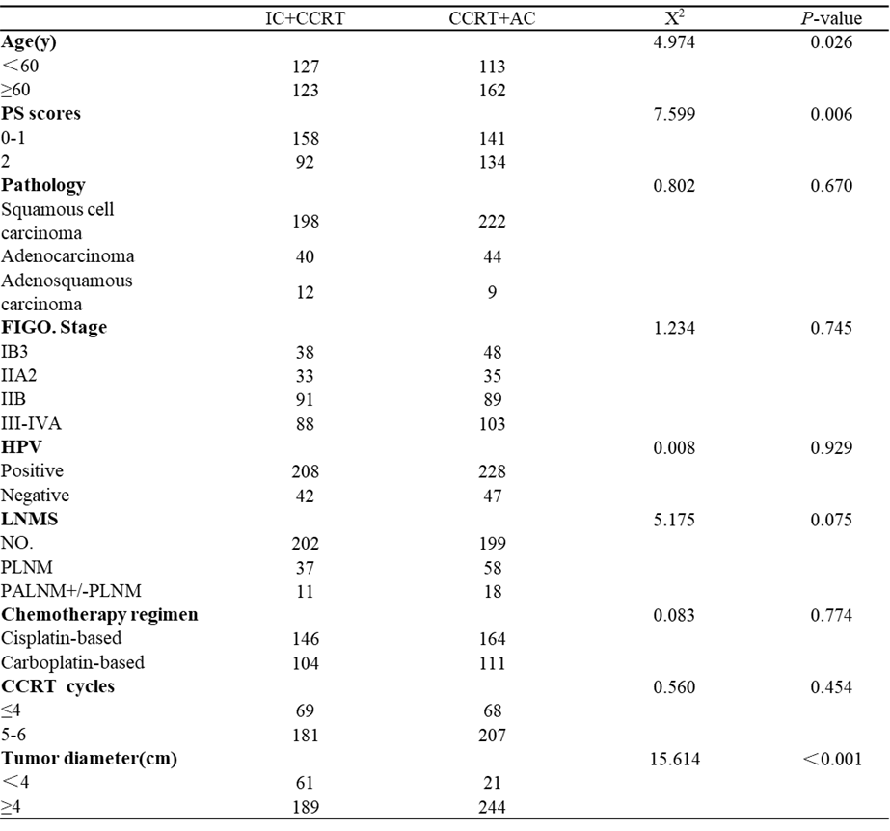

Table 2 Characteristics of patients in the IC +CCRT and CCRT +AC after PSM

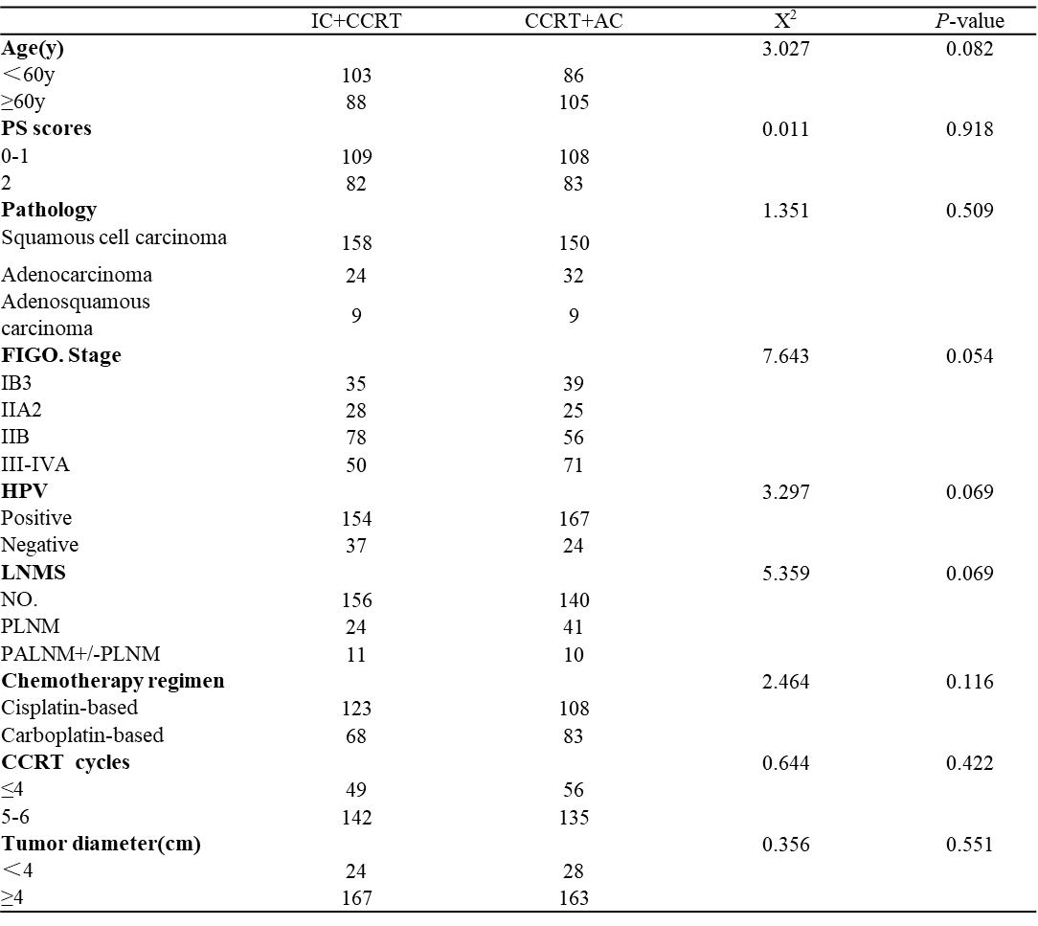

Table 3 Univariate and multivariate analysis for OS with IC+CCRT and CCRT+AC

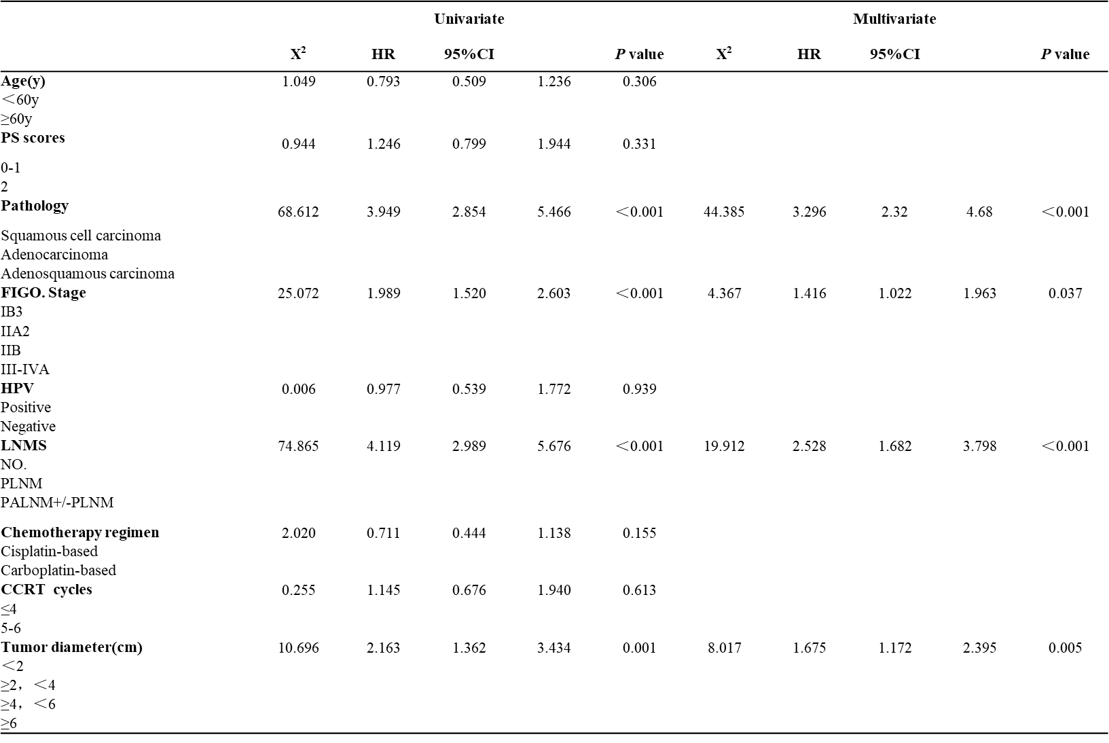

Table 4 Univariate and multivariate analysis for PFS with IC+CCRT and CCRT+AC
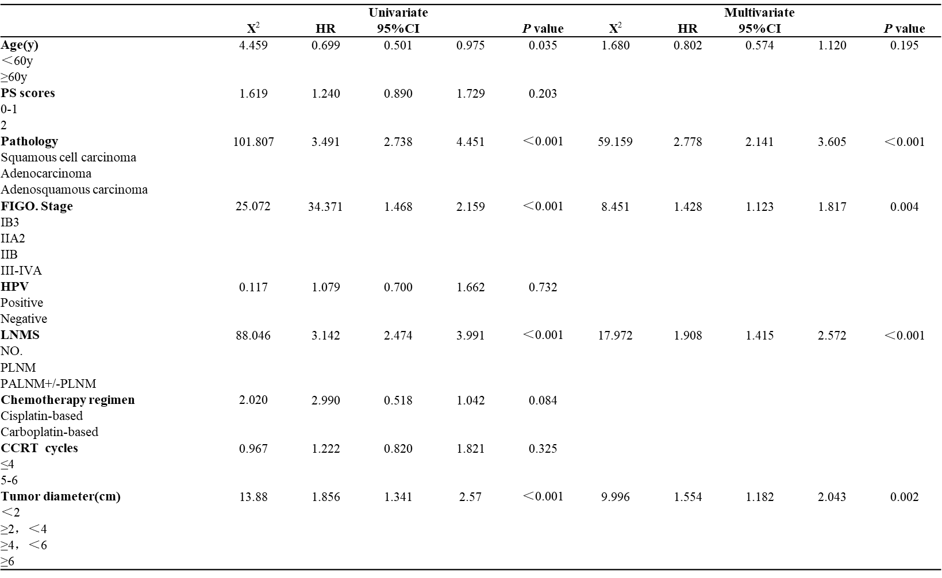

Table 5 Univariate and multivariate analysis for LRFS with IC+CCRT andCCRT+AC

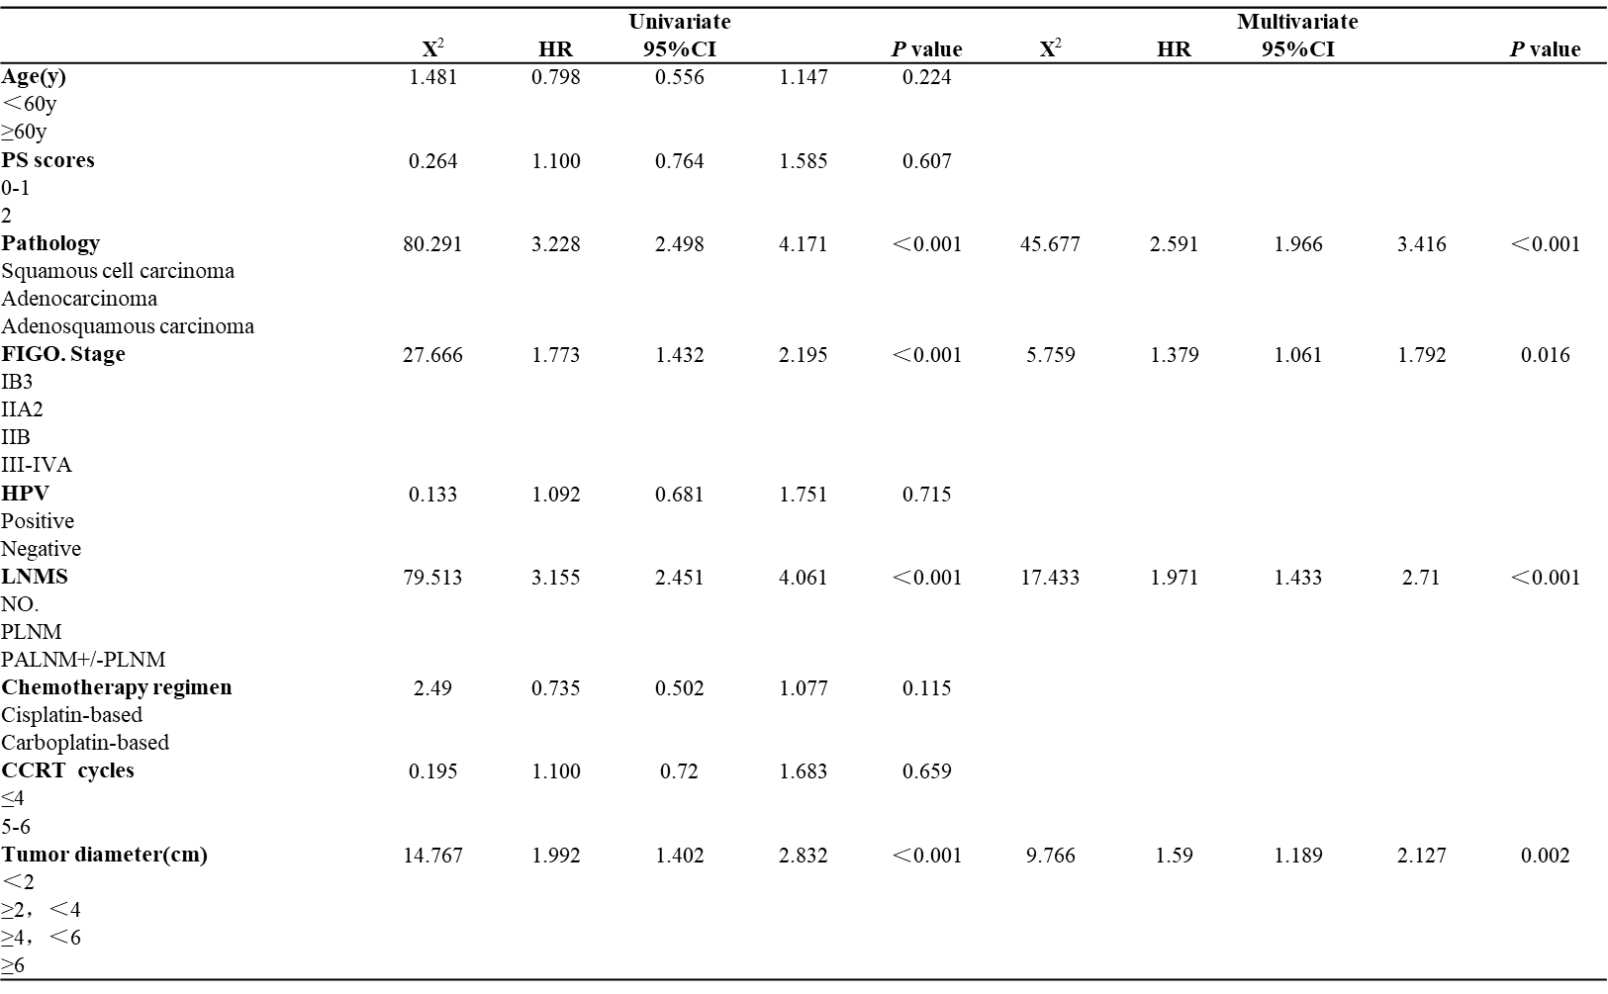

Table 6 Univariate and multivariate analysis for DMFS with IC +CCRT and CCRT+AC

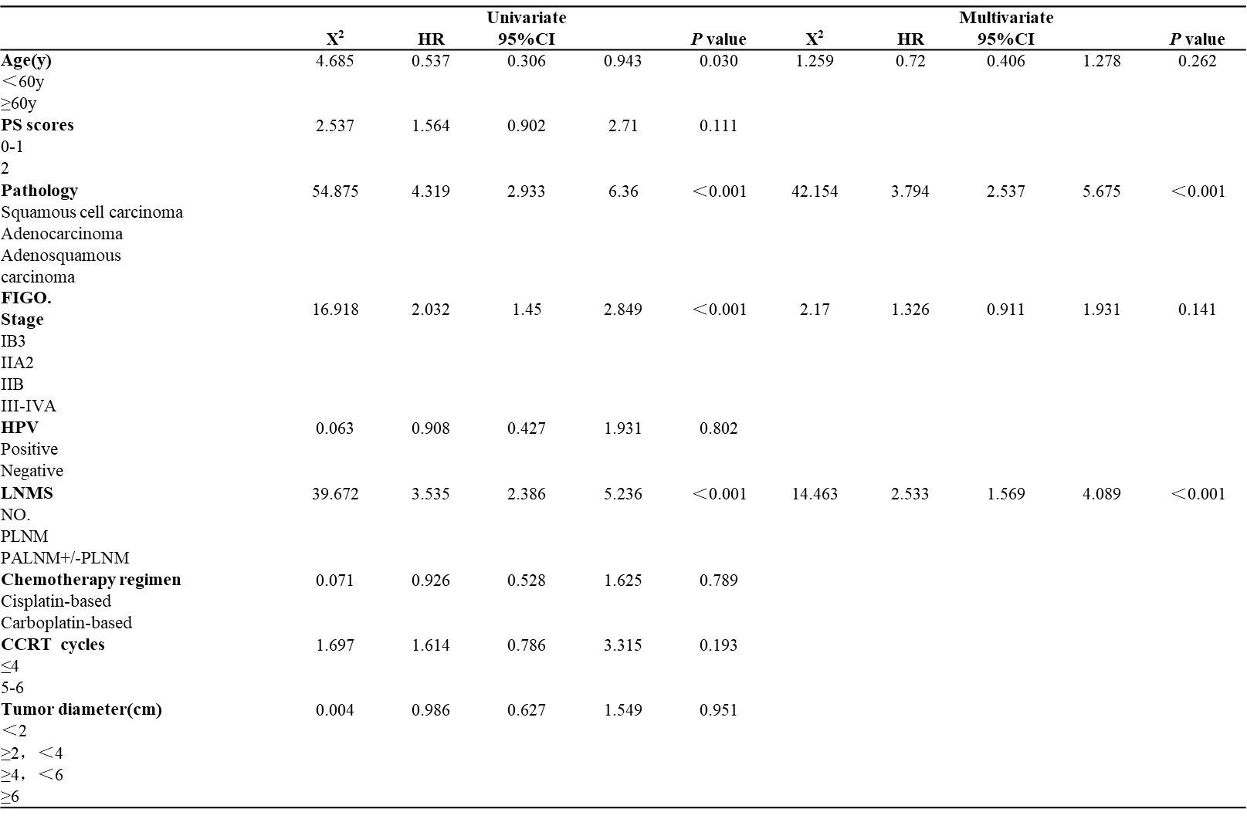

Table 7 Toxicities of patients in the IC +CCRT and CCRT +AC after PSM
