Mesostructured Bimetallic MFI Zeolite for Efficient Aromatization of Light Naphtha to BTX Aromatics
Muhammad Waqas ª, Tatinaidu Kella ª, Ziyauddin S. Qureshi ^{a,b} *, Yaming Jin ^{c}, and Abdullah Aitani ^{a,d}, and Hassan Alasiri ^{a,d}
ª Interdisciplinary Research Center for Refining & Advanced Chemicals, King Fahd University of Petroleum & Minerals, Dhahran 31261, Saudi Arabia
^{b} Chemistry Department, King Fahd University of Petroleum & Minerals, Dhahran 31261, Saudi Arabia
^{c} Research & Development Center, Saudi Aramco, Dhahran 31311, Saudi Arabia
^{d} Chemical Engineering Department, King Fahd University of Petroleum & Minerals, Dhahran 31261, Saudi Arabia
* Corresponding author E-mail: zqureshi@kfupm.edu.sa

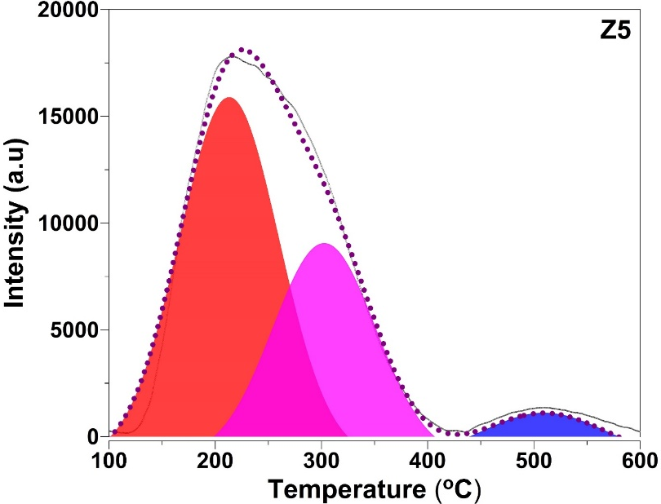
Figure S1. NH₃-TPD profiles of parent Z5 material.

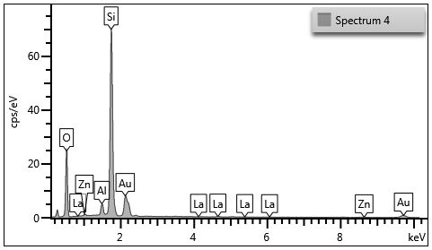
Figure S2. EDX spectrum of 2%La-1%Zn/Z5-AT material.

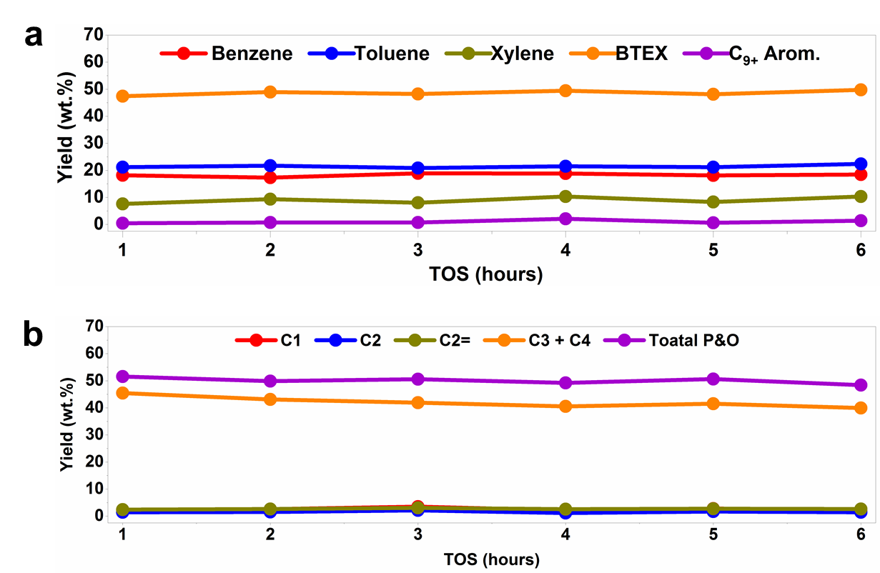
Figure S3. The stability test results of Z5-AT catalysts sample; (a) liquid yield stability, (b) gas yield stability.

Table S1. The acid quantities of several zeolite samples as calculated from NH₃-TPD profiles.
Catalyst | Amount NH₃ desorbed (mmol/g)
Catalyst | I  100-350 ºC | II  Above 350 ºC | Total
Z5 | 0.280 | 0.038 | 0.318
Z5-AT | 0.230 | 0.075 | 0.305
1%Zn/Z5-AT | 0.202 | 0.059 | 0.261
2%La/Z5-AT | 0.195 | 0.067 | 0.262
2%La-1%Zn/Z5-AT | 0.233 | 0.071 | 0.304

Table S2. Comparative analysis of literature on bifunctional materials for naphtha catalytic aromatization
Sr no. | Catalyst | Feed | Reaction conditions |  |  | Aromatic yield  (wt. %) | ref
Sr no. | Catalyst | Feed | Temperature  (ºC) | Pressure  (MPa) | WHSV  (h⁻¹) | Aromatic yield  (wt. %) | ref
1 | Zn-Ga/ZSM-5 | light naphtha | 500 | 0.1 | 1 | 64.8 | 1
2 | Pt-Zn/ZSM-5 | light naphtha (C₅-C₇) + C₁ | 400 | 3 | 1 | 56.1 | 2
3 | Ni/ZSM-5 | Heavy naphtha (C₆-C₁₄) | 450 | 0.5 | 1 | 68.8 | 3
4 | Ga/H-ZSM-5 (desilicated) | full-range naphtha | 550 | 0.1 | 6 | 59.2 | 4
5 | Ag-Ga/ZSM-5 | Full range naphtha | 550 | 1 |  | 67.2 | 5
6 | Pd/Al₂O₃ | bionaphtha | 375 | 0.5 |  | 72.7 | 6
7 | Pt/Ce-Y | hydrofined naphtha | 490 | 0.7 | 2 | 42.8 | 7
8 | Ni-Mo/Al₂O₃-HZSM-5 | FCC naphtha | 420 | 1.5 | 2 | 35.3 | 8
9 | Zn-P/ZSM-5 | FCC naphtha (75-120 ºC) | 470 | 0.1 | 1 | 39.9 | 9
10 | 2%La-1%Zn/Z5-AT | light naphtha | 550 | 1 | 1 | 72.7 | This work

References
- Hodala, J. L.; Halgeri, A. B.; Shanbhag, G. V.; Reddy, R. S.; Choudary, N. V.; Rao, P. V. C.; SriGanesh, G.; Shah, G.; Ravishankar,R. Aromatization of C5-rich Light Naphtha Feedstock over Tailored Zeolite Catalysts: Comparison with Model Compounds (n-C₅-n-C₇). ChemistrySelect 2016, 1, 2515−2521.
- Jarvis, J.; He, P.; Wang, A.; Song, H. Pt-Zn/HZSM-5 as a highlyselective catalyst for the Co-aromatization of methane and lightstraight run naphtha. Fuel 2019, 236, 1301−1310.
- Sharifi, K.; Halladj, R.; Royaee, S. J.; Nasr, M. R. J. A newapproach for gasoline upgrading: Coupling octane enhancement anddesulfurization of heavy straight-run naphtha over Ni/HZSM-5catalyst. Catal. Comm. 2018, 115, 31−35.
- Ummer, A. C.; Akhtar, M. N.; Alnaimi, E.; Ding, L.; Alasiri, H.S. Aromatization of Commercial Full Range Naphtha Over ModifiedHierarchical ZSM-5 Catalyst. ChemistrySelect 2021, 6, 11541−11550.
- Ummer, Aniz Chennampilly, et al. "Understanding the Promotional Effect of Silver in Naphtha Reforming over a Ga/ZSM-5 Catalyst to Enhance Liquid Yield." The Journal of Physical Chemistry C, 2024, 128.5: 1971-1981.
- Mishra, A.; Ali, S. S.; Verma, V.; Farooqui, S. A.; Sinha, A. K.Dehydro-aromatization of renewable bio-naphtha over Pd/γ-Al2O3catalyst. Fuel 2022, 325, 124883−124892.
- Zhang, P.; Yang, Y.; Li, Z.; Liu, B.; Hu, C. Preparation,characterization and naphtha aromatization performance of thecatalytic reforming catalyst Pt/MY (M = Mg, Ba or Ce). Catal.Today 2020, 353, 146−152.
- Wan, H.; Zhang, R.; Qin, Y.; Lu, C.; Zhang, X.; Song, L.Morphology control and aromatization of ZSM-5/KL compositezeolite. J. Petrochem. Univ. 2015, 28, 1−6.
- Zhao, L.; Zhu, J.; Wang, H. Y.; Wei, M.; Ma, J.; Bai, Y. Z.Aromatization of FCC gasoline over modified HZSM-5 catalyst. Pet.Sci. Technol. 2007, 25, 577−584.

