Multi-omics integration reveals sex-based differences in the circulating extracellular vesicle lipidome and miRNome of alcohol use disorder patients

Carla Perpiñá-Clérigues^{1,2}, Susana Mellado¹, Cristina Galiana-Roselló², Saritha Kodikara³, Blanca Martín-Urdiales¹, Miguel Marcos⁴, Kim-Anh Lê Cao³, Francisco García-García²*, and María Pascual¹*

¹Department of Physiology, School of Medicine and Dentistry, University of Valencia, 46010 Valencia, Spain
²Computational Biomedicine Laboratory, Príncipe Felipe Research Center, 46012 Valencia, Spain
³Melbourne Integrative Genomics, School of Mathematics and Statistics, University of Melbourne, Melbourne, VIC, Australia
⁴Department of Internal Medicine, University Hospital of Salamanca, University of Salamanca, Institute of Biomedical Research of Salamanca (IBSAL), 37007 Salamanca, Spain

* These authors contributed equally to this work

Corresponding authors:
María Pascual, Department of Physiology, University of Valencia, Avda. Blasco Ibáñez, 15. 46010 Valencia, Spain. Tel: (+34) 961625635, Fax: (+34) 963864642. E-mail: Maria.Pascual@uv.es
Francisco García-García, Computational Biomedicine Laboratory, Príncipe Felipe Research Center, C/ Eduardo Primo Yúfera, 3. 46012 Valencia, Spain. Tel: (+34) 963289680, Fax: (+34) 963289701. E-mail: fgarcia@cipf.es

Table S1. Cross-omic sample correspondence. Samples in the same row represent the same individual across different omics. Empty cells indicate no available data for that omic.
Lipid Sample | miRNA Sample | Integration Sample | Age
AUD_F1 | AUD_Female2 | AUD_female1 | 31
AUD_F2 | AUD_Female3* | - | 41
AUD_F3 | AUD_Female4 | AUD_female2 | 45
AUD_F4 | AUD_Female5 | AUD_female3 | 58
AUD_F5 | - | - | 25
AUD_M1 | - | - | 57
- | AUD_Male2 | - | 41
AUD_M2 | AUD_Male3 | AUD_male1 | 55
AUD_M3 | AUD_Male4 | AUD_male2 | 33
AUD_M4 | AUD_Male5 | AUD_male3 | 51
AUD_M5 | AUD_Male6 | AUD_male4 | 38
AUD_M6 | AUD_Male7 | AUD_male5 | 52
C_F1 | C_Female1 | C_female1 | 42
C_F2 | C_Female2 | C_female2 | 28
C_F3 | C_Female3 | C_female3 | 49
C_F4 | C_Female6 | C_female4 | 30
C_F5 | C_Female4 | C_female5 | 51
- | C_Female5 | - | 31
C_F6 | - | - | 27
C_M1 | C_Male1 | C_male1 | 45
C_M2 | C_Male2 | C_male2 | 43
C_M3 | C_Male3 | C_male3 | 44
C_M4 | C_Male4 | C_male4 | 38
C_M5 | C_Male5 | C_male5 | 52
C_M6 | - | - | 51
*Sample removed during quality control filtering.

Table S2. Nucleotide sequences of the primers used for qPCR of micro-RNAs.
MicroRNA | Chromosome  location | Accession  Number (#) | Mature primer sequences (5’ to 3’)
hsa-miR-370-3p | Chr.14: 100911139 - 100911213 [+] on Build GRCh38 | MIMAT0000722 | GCCUGCUGGGGUGGAACCUGGU
hsa-let-7b-5p | Chr.22: 46113686 - 46113768 [+] on Build GRCh38 | MIMAT0000063 | UGAGGUAGUAGGUUGUGUGGUU
hsa-miR-194-5p | Chr.1: 220118157 - 220118241 [-] on Build GRCh38 | MIMAT0000460 | UGUAACAGCAACUCCAUGUGGA

Table S3. Summary of significant results for Differential Expression Analysis.
 | UP | DOWN | TOTAL
IF | 4 | 3 | 7
IM | 12 | 4 | 16
IS | 0 | 0 | 0
IF (AUD Impact in Females): AUD females vs. control females, IM (AUD Impact in Males): AUD males vs. control males, IS (Impact of Sex in AUD): Sex-dependent differences in AUD (IF − IM). Significance BH p-value ≤ 0.05.

Table S4. Significant GSA results for the three comparisons (IF, IM, IS) and their intersections.

 | GO |  |  | KEGG
 | BP | CC | MF | KEGG
IF | 127 | 63 | 51 | 35
IM | 636 | 223 | 273 | 93
IS | 650 | 208 | 232 | 96
IF & IM & IS  LOR < 0 IF  LOR > 0 IM | 66 | 43 | 40 | 20
IF & IM & IS  LOR > 0 IF  LOR < 0 IM | 1 | 1 | 2 | 1
The table reports the number of significantly enriched functional terms (Gene Ontology: BP, CC, MF; KEGG pathways) identified in:
- Individual comparisons:
  - IF (AUD Impact in Females): AUD females vs. control females.
  - IM (AUD Impact in Males): AUD males vs. control males.
  - IS (Impact of Sex in AUD): Sex-dependent differences in AUD (IF − IM).
- Intersections of all three comparisons (IF & IM & IS). These represent terms that are:
  - Simultaneously significant in IF, IM, and IS
  - Further filtered by expression direction:
  - LOR < 0 in IF & LOR > 0 in IM: Terms where miRNAs are down-regulated in AUD females but up-regulated in AUD males.
  - LOR > 0 in IF & LOR < 0 in IM: Terms where miRNAs are up-regulated in AUD females but down-regulated in AUD males.
Key observations:
- The intersection identifies pathways robustly associated with AUD that show sex-opposed expression patterns.
- The dramatic difference in term counts (66 vs 1) reveals most shared pathways show female down-regulation/male up-regulation in AUD.
- Few pathways exhibit the opposite pattern (female up-regulation/male dow-nregulation).
GO (Gene Ontology), BP (Biological Process), CC (Cellular Component), MF (Molecular Function), KEGG pathways (Kyoto Encyclopedia of Genes and Genomes pathways), LOR (log odd ratio; positive = higher in AUD group or female-biased, negative = higher in controls or male-biased).
(See Materials and Methods and FigureS1 for detailed comparison definitions and statistical thresholds.)

Table S5. Abbreviation of the different lipid subclasses.

CAR | Acylcarnitine
Cer_ADS | Ceramide α-hydroxy fatty acid-dihydrosphingosine
Cer_AP | Ceramide α-hydroxy fatty acid-phytosphingosine
Cer_AS | Ceramide α-hydroxy fatty acid-sphingosine
Cer_NDS | Ceramide non-hydroxy fatty acid-dihydrosphingosine
Cer_NP | Ceramide non-hydroxy fatty acid-phytosphingosine
Cer_NS | Ceramide non-hydroxy fatty acid-sphingosine
Chol. esters | Cholesterol esters
DAG | Diacylglycerol
FA | Fatty acid
FAHFA | Fatty acid ester of hydroxyl fatty acid
HexCer_NDS | GlucosylCeramide/HexosylCeramidesnon-hydroxyfatty acid-dihydrosphingosine
HexCer_NS | GlucosylCeramide/HexosylCeramidesnon-hydroxyfatty acid-sphingosine
LPC | Lyso-phosphatidylcholine
LPE | Lyso-phosphatidylethanolamine
MGDG | Monogalactosyldiacylglycerol
OxPC | Oxidized phosphatidylcholine (OxPC)
OxPC-O | Oxidized etherphosphatidylcholine (OxEtherPC)
PA | Phosphatidic acid
PC | Phosphatidylcholine
PC-O | Etherphosphatidylcholine (EtherPC)
PE | Phosphatidylethanolamine
PE-O | Etherphosphatidylethanolamine (EtherPE)
PI | Phosphatidylinositol
SHexCer | SulfoglucosylCeramide/SulfohexosylCeramide
SM | Sphingomyelin
TAG | Triacylglycerol (TG)

Table S6. Compilation of disease-associated microRNAs and lipids identified in this study and supported by previous literature.
Category | microRNA/lipid | Condition | Sex-differences | References
Alcohol / TLR4 | hsa-miR-194-5p | AUD |  | Ref
Alcohol / TLR4 | hsa-miR-148a-3p | AUD |  | Ref1, Ref2, Ref3
Alcohol / TLR4 | hsa-miR-21-5p | AUD |  | Ref1, Ref2
Alcohol / TLR4 | hsa-miR-148a-5p | AUD |  | Ref
Alcohol / TLR4 | hsa-miR-486-5p | AUD |  | Ref
Alcohol / TLR4 | hsa-miR-146a-5p | Male |  | Ref
Alcohol / TLR4 | hsa-miR-16-5p | Male |  | Ref
Cancer | hsa-miR-363-3p | AUD |  | Ref1, Ref2, Ref3, Ref4
Cancer | hsa-miR-589-5p | AUD |  | Ref1, Ref2
Cancer | hsa-miR-7706 | AUD |  | Ref
Cancer | hsa-miR-194-5p | AUD |  | Ref1, Ref2, Ref3
Cancer | hsa-miR-148a-3p | AUD |  | Ref1, Ref2
Cancer | hsa-miR-21-5p | AUD |  | Ref1, Ref2, Ref3
Cancer | hsa-miR-148a-5p | AUD |  | Ref
Cancer | hsa-miR-130b-3p | AUD |  | Ref1, Ref2
Cancer | hsa-miR-223-5p | AUD |  | Ref
Cancer | hsa-miR-99b-3p | AUD |  | Ref
Cancer | hsa-miR-192-5p | AUD |  | Ref
Cancer | hsa-miR-486-5p | AUD |  | Ref
Cancer | hsa-miR-197-3p | Interaction | ♀ < ♂ | Ref1, Ref2
Cancer | hsa-miR-1260b | Interaction | ♀ < ♂ | Ref1, Ref2, Ref3
Cancer | hsa-miR-199b-5p | Interaction | ♀ > ♂ | Ref
Cancer | hsa-miR-582-5p | Interaction | ♀ > ♂ | Ref1, Ref2
Cancer | hsa-miR-361-3p | Interaction | ♀ > ♂ | Ref
Cancer | hsa-miR-146a-5p | Male |  | Ref1, Ref2
Cancer | hsa-miR-24-3p | Male |  | Ref
Cancer | hsa-miR-424-3p | Male |  | Ref
Cancer | hsa-miR-1294 | Male |  | Ref
Cancer | hsa-miR-152-3p | Male |  | Ref
Cancer | hsa-miR-145-3p | Male |  | Ref1, Ref2
Cancer | hsa-miR-1271-5p | Male |  | Ref
Cancer | hsa-miR-425-3p | Male |  | Ref
Cancer | hsa-miR-454-3p | C |  | Ref1, Ref2, Ref3
Cancer | hsa-let-7b-5p | C |  | Ref
Cancer | hsa-miR-148b-3p | C |  | Ref1, Ref2, Ref3
Cancer | hsa-miR-331-3p | C |  | Ref
Cancer | hsa-miR-181d-5p | C |  | Ref
Cancer | hsa-miR-548e-5p | Female |  | Ref
Cancer | hsa-miR-139-5p | Female |  | Ref
Cancer | hsa-miR-299-3p | Female |  | Ref
Cancer | hsa-miR-144-3p | Male |  | Ref
Cancer | hsa-miR-30d-5p | Male |  | Ref
Cancer | Cer_NDS d41:2 | AUD |  | Ref
Cancer | LPE 18:0 | AUD |  | Ref
Cardiovascular | hsa-miR-589-5p | AUD |  | Ref1, Ref2
Cardiovascular | hsa-miR-192-5p | AUD |  | Ref
Cardiovascular | hsa-miR-197-3p | Interaction | ♀ < ♂ | Ref
Cardiovascular | hsa-miR-16-5p | Male |  | Ref
Cardiovascular | LPE 18:0 | AUD |  | Ref
Cardiovascular | SM d44:2 | AUD |  | Ref
Inflammatory / Immune | hsa-miR-589-5p | AUD |  | Ref
Inflammatory / Immune | hsa-miR-194-5p | AUD |  | Ref
Inflammatory / Immune | hsa-miR-148a-3p | AUD |  | Ref1, Ref2
Inflammatory / Immune | hsa-miR-21-5p | AUD |  | Ref1, Ref2, Ref3, Ref4
Inflammatory / Immune | hsa-miR-148a-5p | AUD |  | Ref
Inflammatory / Immune | hsa-miR-130b-3p | AUD |  | Ref
Inflammatory / Immune | hsa-miR-192-5p | AUD |  | Ref
Inflammatory / Immune | hsa-miR-146a-5p | Male |  | Ref
Inflammatory / Immune | hsa-miR-144-3p | Male |  | Ref
Inflammatory / Immune | hsa-let-7b-5p | C |  | Ref
Inflammatory / Immune | hsa-miR-331-3p | C |  | Ref
Inflammatory / Immune | hsa-miR-548e-5p | Female |  | Ref
Inflammatory / Immune | hsa-miR-145-3p | Male |  | Ref
Inflammatory / Immune | hsa-miR-199b-5p | Interaction | ♀ > ♂ | Ref
Inflammatory / Immune | LPE 18:0 | AUD |  | Ref
Metabolic | hsa-miR-589-5p | AUD |  | Ref
Metabolic | hsa-miR-148a-3p | AUD |  | Ref
Metabolic | hsa-miR-192-5p | AUD |  | Ref
Metabolic | hsa-miR-21-5p | AUD |  | Ref1, Ref2
Metabolic | hsa-miR-664a-3p | Male |  | Ref
Neurodegenerative / Neurological | hsa-miR-589-5p | AUD |  | Ref
Neurodegenerative / Neurological | hsa-miR-192-5p | AUD |  | Ref
Neurodegenerative / Neurological | hsa-miR-146a-5p | Male |  | Ref
Neurodegenerative / Neurological | hsa-miR-152-3p | Male |  | Ref
Neurodegenerative / Neurological | Cer_NDS d41:2 | AUD |  | Ref
Neurodegenerative / Neurological | LPE 18:0 | AUD |  | Ref
Other | hsa-miR-363-3p | AUD |  | Ref
Other | hsa-miR-194-5p | AUD |  | Ref
Other | hsa-miR-7706 | AUD |  | Ref1, Ref2
Other | hsa-miR-192-5p | AUD |  | Ref
Other | hsa-miR-10399-5p | AUD |  | Ref
Other | hsa-miR-556-5p | C |  | Ref
Psychiatric disorders | hsa-miR-589-5p | AUD |  | Ref
Psychiatric disorders | hsa-miR-21-5p | AUD |  | Ref
Psychiatric disorders | hsa-miR-192-5p | AUD |  | Ref
Psychiatric disorders | hsa-miR-197-3p | Interaction | ♀ < ♂ | Ref
Psychiatric disorders | hsa-miR-145-3p | Male |  | Ref
Psychiatric disorders | hsa-miR-144-3p | Male |  | Ref
Psychiatric disorders | hsa-miR-139-5p | Female |  | Ref
Category: Disease group or biological context associated with the listed microRNAs or lipids based on previous literature. Condition: Experimental group in which the feature was positively correlated (AUD: alcohol use disorder; C: control; Interaction: feature associated with Component 3). Sex-differences: For features correlated with Component 3, this column indicates which sex in the AUD group showed higher expression.

Table S7. AUD-Sex Signature Based on Multi-omics Integration (Component 3)
FEATURE | PATTERN | DEA |  | FEATURE | PATTERN | DAA
hsa-miR-1301-3p | I |  |  | Cer_NS d18:1_24:1_neg | I | x
hsa-miR-199b-5p | I |  |  | Cer_NS d18:1_22:0_neg | II | x
hsa-miR-361-3p | I |  |  | Cer_NDS d42:2 RT:12.673_neg | II | x
hsa-miR-500a-3p | I |  |  | FA 17:0 RT:3.302_neg | II
hsa-miR-874-3p | I |  |  | FA 20:0 RT:10.332_neg | II | #
hsa-miR-1260b | II |  |  | FA 21:0 RT:4.952_neg | II
hsa-miR-1843 | III |  |  | FA 22:0 RT:5.151_neg | II | #
hsa-miR-197-3p | III |  |  | FAHFA 16:0_9:0 RT:4.463_neg | II
hsa-miR-582-5p | III |  |  | PC 39:4_ pos | II | x
hsa-miR-6852-5p | III |  |  | SM d18:2_18:0_neg | II
I | AUD_Female, C_Male
II | AUD_Male, C_Female
III | One sex remains stable

This panel includes 20 features (lipids and miRNAs) identified through block.sPLS. The pattern indicates the group where the feature is higher in each sex (AUD or Control group). X in the DEA and DAA columns indicates statistical significance (adjusted p-value < 0.01) in the IS comparison in the individual regression analyses (DEA/DAA); # denotes a trend towards significance (0.05 < adjusted p-value < 0.055). AUD: Alcohol Use Disorder, DEA: Differential Expression Analysis of miRNome, DAA: Differential Abundance Analysis of lipidome, F: female, M: male, IS: Impact of Sex Comparison.

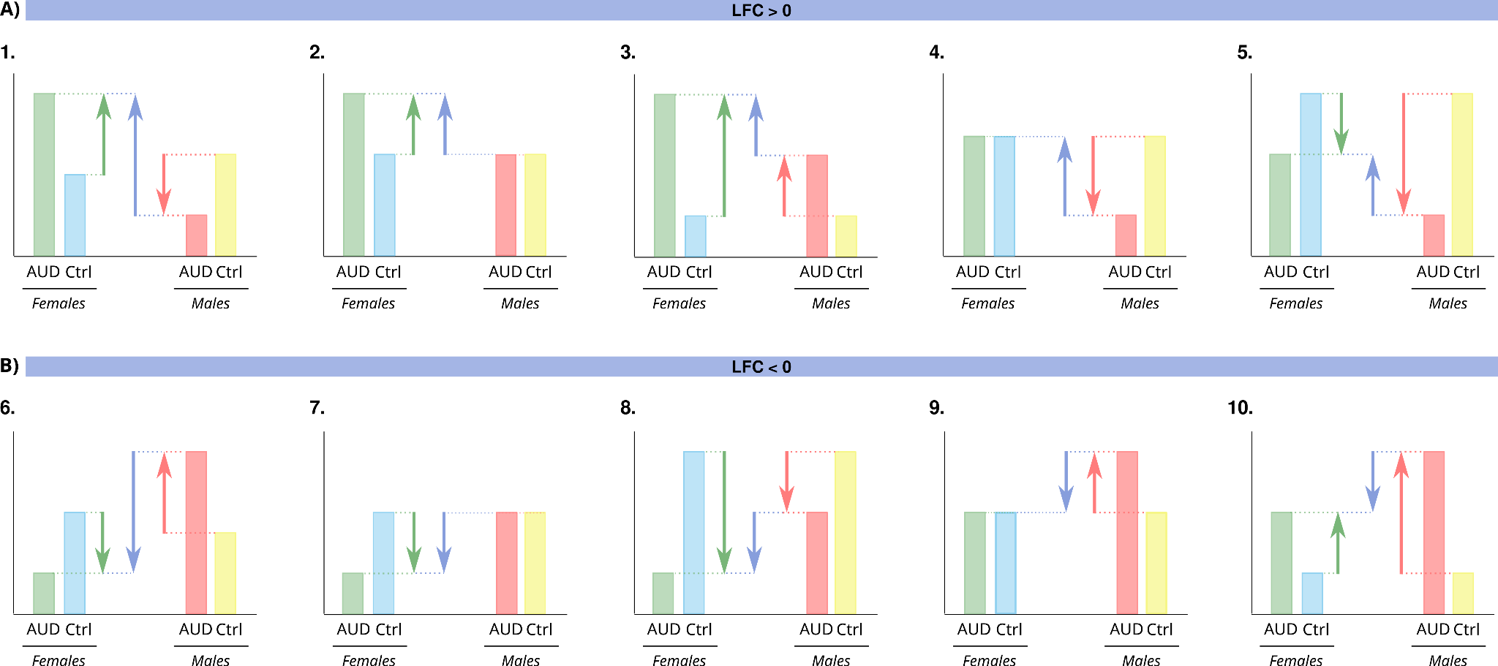Figure S1. Bar chart representing the possible causes of a positive (A) and negative (B) LFC/LOR in the IS comparison, depending on the IF or IM comparison.

Interpretation of functional enrichment results (Figures S2–S5)
Dot plots display significant functional terms (GO biological processes, cellular components, molecular functions, and KEGG pathways) from gene set analysis (GSA) that are significant in both comparisons IF and IM.
Comparisons shown:
- Sex-specific AUD effects:
  - IF (AUD Impact in Females): AUD females vs. control females.
  - IM (AUD Impact in Males): AUD males vs. control males.
- Sex-dependent modulation in AUD (IS): IF − IM (highlighting terms where AUD effects differ by sex).
- Overall AUD impact (C): AUD vs. controls.
Key observations:
- Cuando un término GO/KEGG pathway es significativo en IF y IM con valor de LOR opuesto, para comprobar que ese patrón opuesto también es significativo vemos el resultado en la comparativa IS. The intersection de las comparativas IF, IM y IS identifies pathways robustly associated with AUD that show sex-opposed expression patterns.
- La comparativa C nos determine if the inclusion of sex reveals different results.
- IN general, few pathways exhibit the opposite pattern (female up-regulation/male down-regulation), normalmente muestran patrón de (female down-regulation/male up-regulation).

Key patterns:
- Sex-opposed responses: Terms significant in both IF and IM with opposite LOR directions (e.g., down-regulated in females but up-regulated in males) are validated in IS. The intersection of IF, IM, and IS identifies robust sex-divergent pathways.
- Consistent trends: Most shared terms exhibit female down-regulation / male up-regulation in AUD. Few pathways show the inverse pattern (female up-regulation / male down-regulation).
- Sex stratification relevance: Comparison with C reveals whether sex-independent analyses mask sexually dimorphic effects.

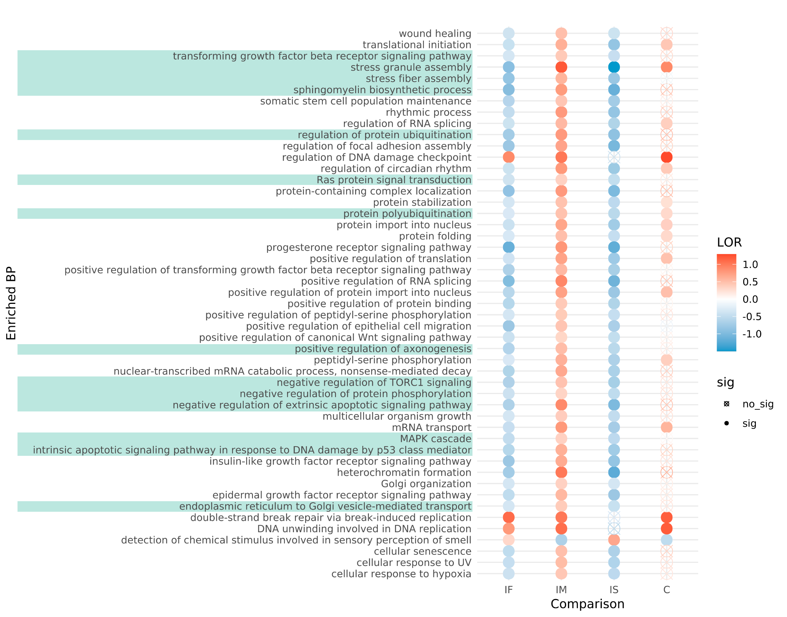Figure S2. Gene Set Analysis (GSA) results showing enriched biological processes (BP) across different comparisons. Each row represents a significantly enriched BP term, with color intensity indicating the log odds ratio (LOR) of enrichment. Red denotes positive LOR values (overrepresentation in the first group of the comparison), while blue represents negative LOR values (overrepresentation in the second group). Comparisons include AUD Impact in Females (IF), AUD Impact in Males (IM), Impact of Sex in AUD (IS), and the overall comparison (C). Filled circles indicate statistically significant terms, while empty circles denote non-significant results. Highlighted terms (shaded rows) correspond to key BP relevant to AUD.

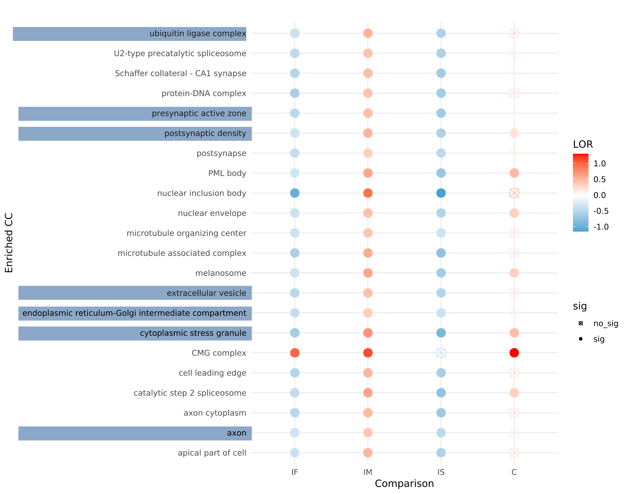
Figure S3. Gene Set Analysis (GSA) results showing enriched cellular components (CC) across different comparisons. Each row represents a significantly enriched CC term, with color intensity indicating the log odds ratio (LOR) of enrichment. Red denotes positive LOR values (overrepresentation in the first group of the comparison), while blue represents negative LOR values (overrepresentation in the second group). Comparisons include AUD Impact in Females (IF), AUD Impact in Males (IM), Impact of Sex in AUD (IS), and the overall comparison (C). Filled circles indicate statistically significant terms, while empty circles denote non-significant results. Highlighted terms (shaded rows) correspond to key CC relevant to AUD.
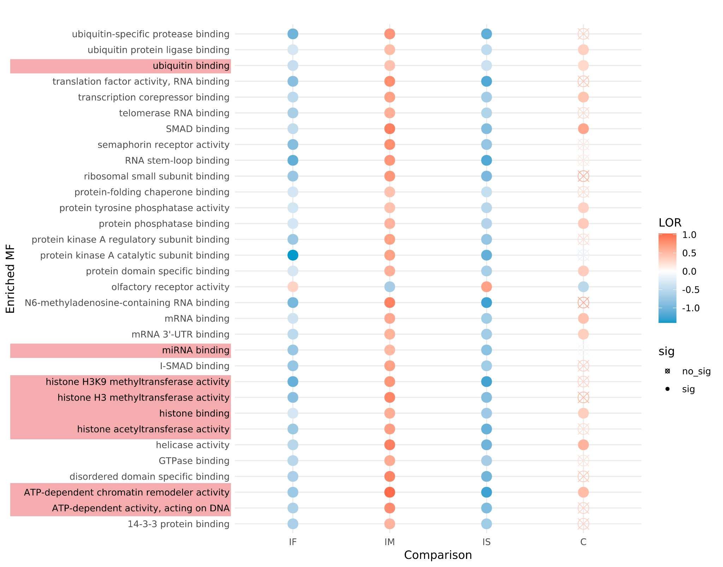

Figure S4. Gene Set Analysis (GSA) results showing enriched molecular functions (MF) across different comparisons. Each row represents a significantly enriched MF term, with color intensity indicating the log odds ratio (LOR) of enrichment. Red denotes positive LOR values (overrepresentation in the first group of the comparison), while blue represents negative LOR values (overrepresentation in the second group). Comparisons include AUD Impact in Females (IF), AUD Impact in Males (IM), Impact of Sex in AUD (IS), and the overall comparison (C). Filled circles indicate statistically significant terms, while empty circles denote non-significant results. Highlighted terms (shaded rows) correspond to key MF relevant to AUD.

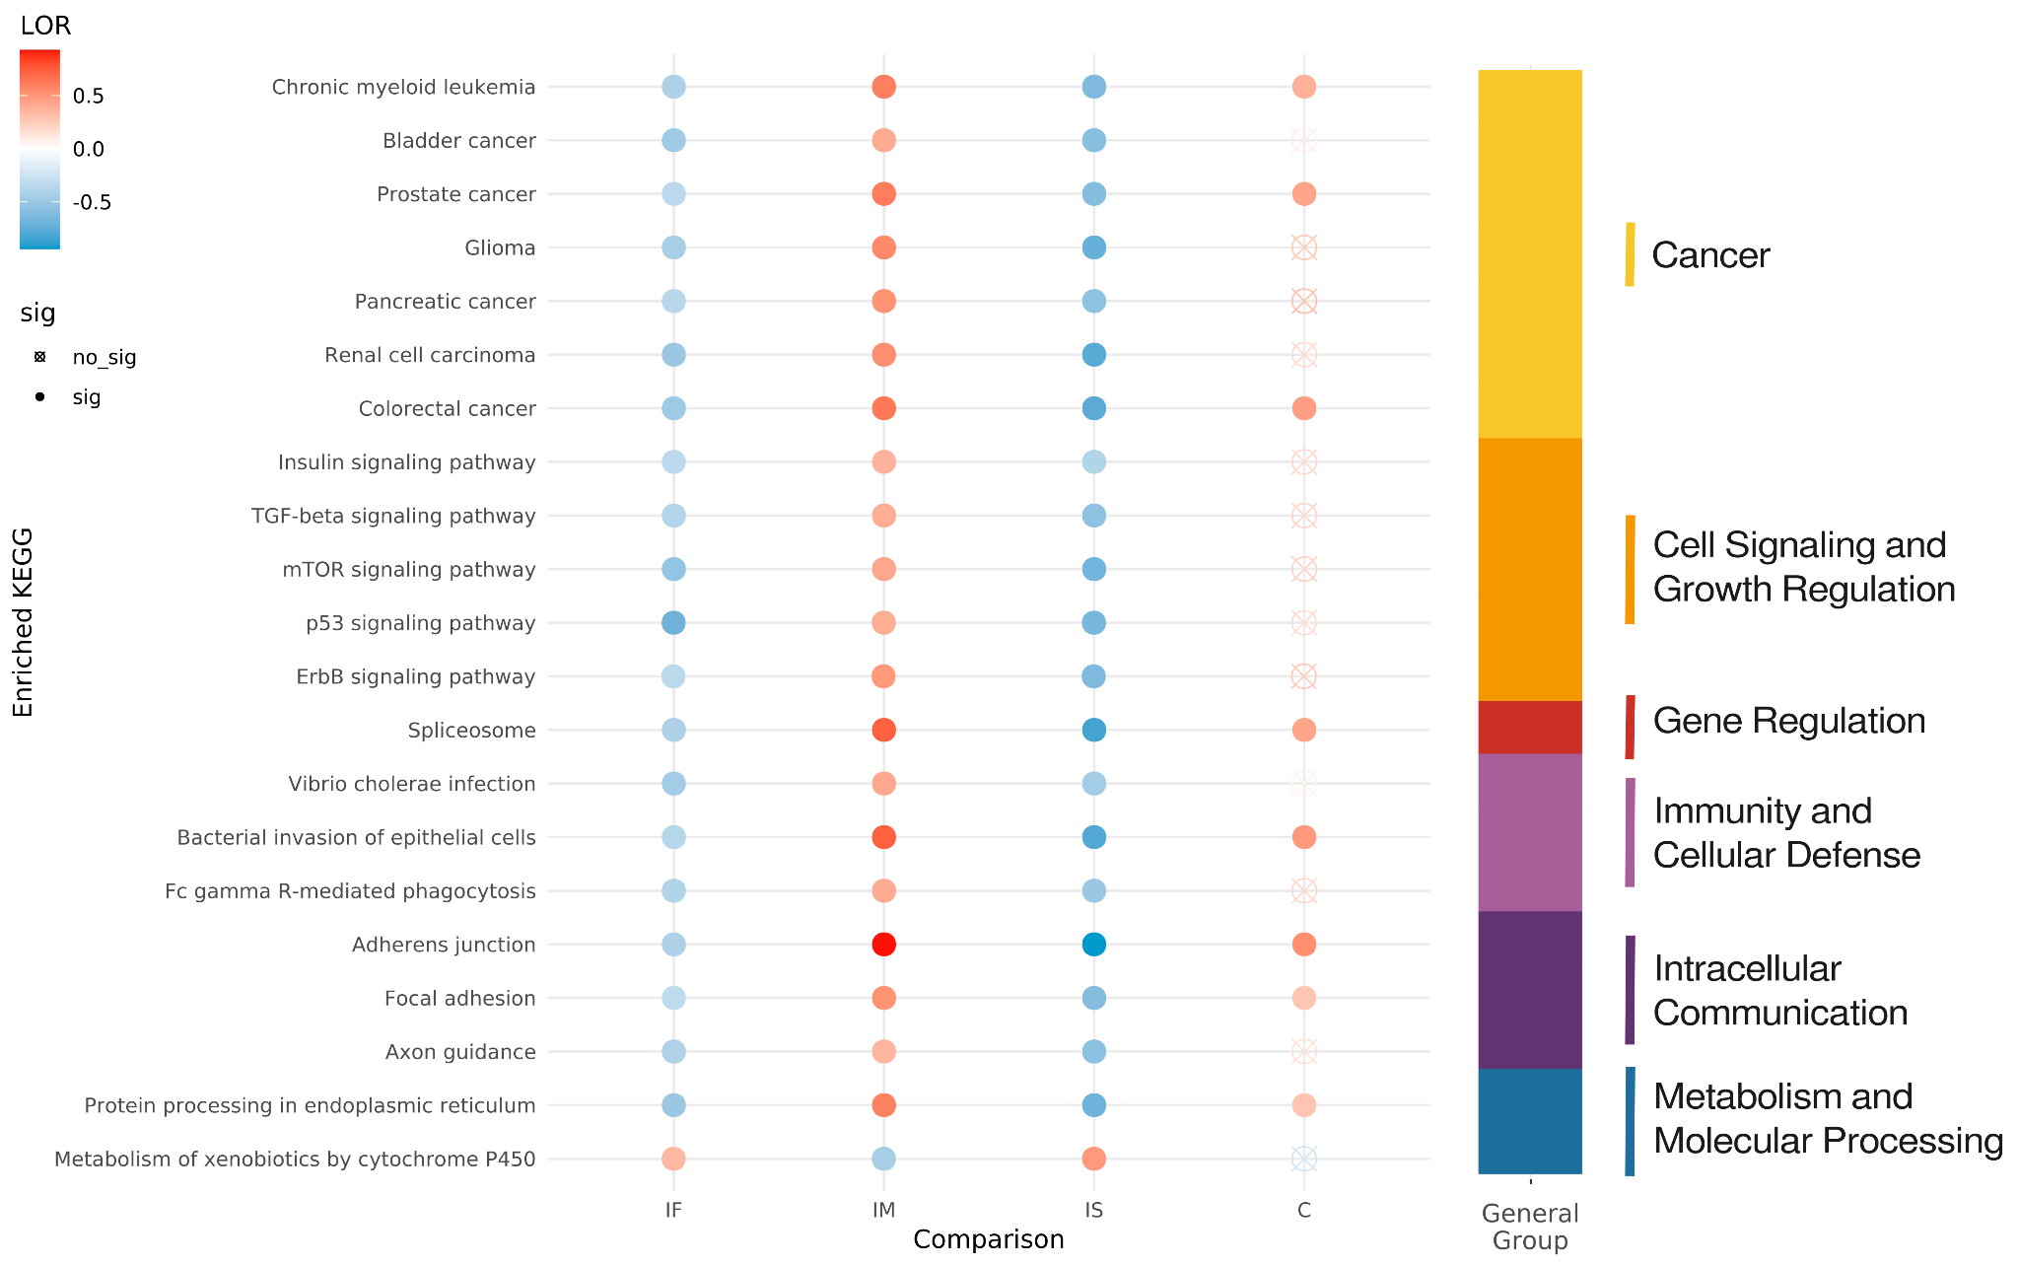
Figure S5. Gene Set Analysis (GSA) results showing enriched KEGG pathways across different comparisons. Each row represents a significantly enriched KEGG pathway, with color intensity indicating the log odds ratio (LOR) of enrichment. Red denotes positive LOR values (overrepresentation in the first group of the comparison), while blue represents negative LOR values (overrepresentation in the second group). Comparisons include AUD Impact in Females (IF), AUD Impact in Males (IM), Impact of Sex in AUD (IS), and the overall comparison (C). Filled circles indicate statistically significant terms, while empty circles denote non-significant results.
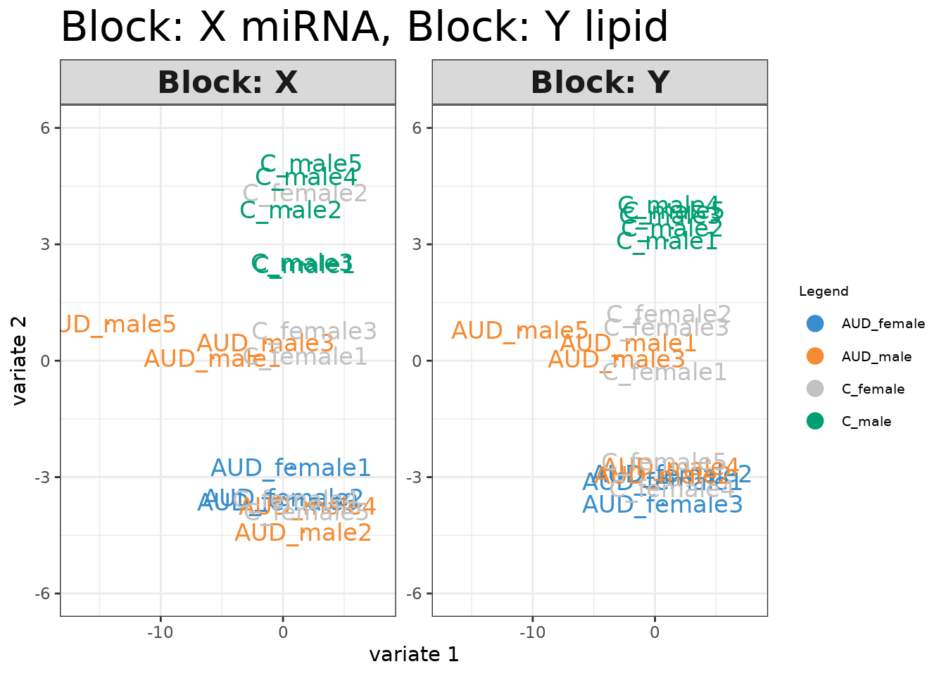

Figure S6. Sparse Partial Least Squares (sPLS) analysis integrating miRNA (Block X) and lipid (Block Y) data. The plot displays sample distributions based on the first two variates, with colors representing the four experimental groups: AUD females (blue), AUD males (orange), control females (gray), and control males (green). The separation of groups reflects the contribution of miRNA and lipid features in distinguishing between conditions.

